Active vs Passive PhL 10.27.11

Visio pictures are in two locations now:

(1) the simple ones are in "active and passive.vsd" located with the doc you are reading.
(2) the fancier ones are in "tensor App C support.vsd" stored with the tensor paper stuff.

Perhaps ignore sections 1,2,2A below, they are just "historical", I did not want to trash them.

1. Preliminary Discussion on the two views of rotation: passive and active 1
2. How might one apply the above discussion to an arbitrary vector V instead of r ? 3
2A. Repeat the above but use 1,2,3 notation and add comments as needed. 5
3. How should the above be modified if V' = RV where R is not a rotation? 8
4. Start over with rotations, doing things the right way 9
5. We try now to construct these three pictures for a general transformation that is not a rotation. 11
Fact: The Active View is only viable if the two spaces have the same metric tensor. 12

1. Preliminary Discussion on the two views of rotation: passive and active

These are my original and oldest notes I could find on this subject. They were part of this document:

D:\Work\My Interests\Physics\E&M\Electrostatics\in-hole Iris Green's and Bowl, Smythe Probs 38-42\Smythe Problem 38 Hard Way\2, How to Actively Rotate the Bowl.doc

When I wrote these notes on 6.15.10, I intended to move them to their own document, and today 10.27.11 I am finally doing that, 16 months later. I was of course trying to understand the fancy bowl rotation I was doing in an obscure electrostatics problem I was solving "the hard way".

The original pictures (no longer needed) were in

/ method of inversion support.vsd

I learned about XP Visio thumbnail viewing just now,

This simple subject is always confusing, even if you have done it 500 times before, so I feel these brief notes are justified, and I will refer back to these notes later on. The problem is mainly with "the words" you use. If you cannot say the words, then you do not really understand what you are doing.

Imagine two coordinate systems S and S'. A unit vector in S would be , one in S' would be '. In the passive view, we can think of a vector r as having components x,y,z in S, and x',y',z' in S'. In order to indicate this unambiguously, we might write

r = (x,y,z) = (x',y',z')'

r = (r•) + (r•) + (r•) = (r•') ' + (r•') ' + (r•') '
= x + y + z = x' ' + y' ' + z' '

where we add the extra prime after the rightmost paren to say these are components in S'. There is only one vector r, and we "measure it" in two different coordinate systems and therefore we get two different triplets of numbers to represent r. Here is the usual picture one draws to illustrate this situation, where S and S' are related by some z rotation, and we only show the x,y plane,

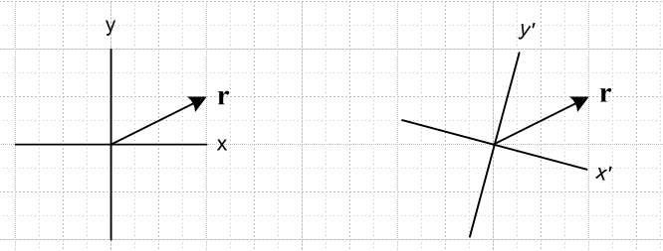

We might say S' = Rz(-ψ )S by which we mean for example ' = Rz(-ψ ) and in our picture perhaps we have ψ = 10 degrees ( points to the viewer + RH rule ). So this is the classic "passive view" where we have "the same vector" in space (it could be any vector, not just a position vector), and we observe it from two coordinate systems, where S' is "back rotated" relative to S by ψ degrees.
Notice that we have no need at this point for the notation r' . There is no vector r'.
Now, a person working in coordinate system S' gets tired of drawing pictures tilted all the time and wants them to be aligned with paper. That person would draw the right side picture this way

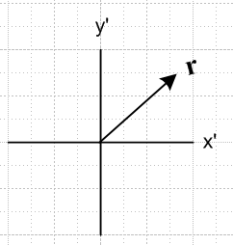

In other words, that person takes the right picture above and rotates everything by Rz(ψ) including the axes. For example, (' in new picture) = Rz(ψ) ( ' in old tilted picture). The vector is still just r and is still being drawn in the space S'.
Now our person decides it is painful to constantly put primes on the axis labels, and comes up with a new idea which is the active viewpoint. That person says: " instead of keeping r fixed and back-rotating S to get S', I will instead just always work in coordinate system S and I will forward-rotate vector r and I will call that forward rotated vector r'. " So this person then replaces the above picture with this newer one, where r' = Rz(ψ) r :

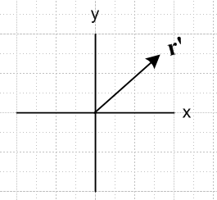

[ Note that then ( in newer picture) = Rz(ψ) ( ' in old tilted picture) ] Now that person can write:

r = (x,y,z)
r' = (x',y',z')

and gets the benefits that both triplets are in S space so we don't have to have a notation (-,-,-)' to indicate a triplet in S', our pictures are not tilted, and we have simple axis labels (no primes needed).
Summary: We have a single vector r which we wish to observe from (and "work with" in) two different coordinate systems S and S'. Why we might want to do this is unmentioned. We know that our vector will have different components in S and S': x,y,z and x',y',z' . We might have various algebraic manipulations to do with one or the other of these component sets, for example. Instead of thinking of these two sets of components x,y,z and x',y',z' as the components of the same vector r in two systems S and S', we can instead create a new vector r' in system S such that the components of r' in S are x',y',z' . We can then draw these two vectors r and r' in the same picture with S as coordinates, where r' = Rz(ψ) r,

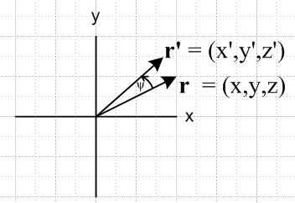

Now in a single picture we have a graphic representation of all six components.

Note added 11.20.16: Note in the above discussion that we have

passive view: ' = Rz(-ψ ) = R-1 " rotate the basis vectors backwards"
active view: r' = Rz(ψ) r = R r " rotate the vector r forwards"

2. How might one apply the above discussion to an arbitrary vector V instead of r ?

Let's try a copy-and-edit approach and see what happens: I think everything works just fine.

Imagine two coordinate systems S and S'. A unit vector in S would be , one in S' would be '. In the passive view, we can think of a vector V as having components Vx,Vy,Vz in S, and V'x,V'y,V'z in S'. In order to indicate this unambiguously, we might write

V = (Vx, Vy, Vz) = (V'x, V'y, V'z)'

V = (V•) + (V•) + (V•) = (V•') ' + (V•') ' + (V•') '
= Vx + Vy + Vz = V'x ' + V'y ' + V'z '

where we add the extra prime after the rightmost paren to say these are components in S'. There is only one vector V, and we "measure it" in two different coordinate systems and therefore we get two different triplets of numbers to represent V. Here is the usual picture one draws to illustrate this situation, where S and S' are related by some z rotation, and we only show the x,y plane,

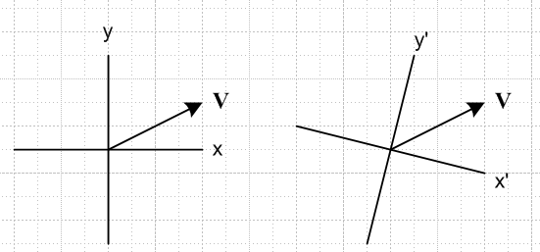

We might say S' = Rz(-ψ )S by which we mean for example ' = Rz(-ψ ) and in our picture perhaps we have ψ = 10 degrees ( points to the viewer + RH rule ). So this is the classic "passive view" where we have "the same vector" in space (it could be any vector, not just a position vector), and we observe it from two coordinate systems, where S' is "back rotated" relative to S by ψ degrees.
Notice that we have no need at this point for the notation V' . There is no vector V'.
Now, a person working in coordinate system S' gets tired of drawing pictures tilted all the time and wants them to be aligned with paper. That person would draw the right side picture this way

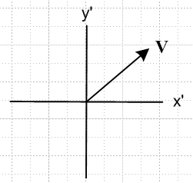

In other words, that person takes the right picture above and rotates everything by Rz(ψ) including the axes. For example, (' in new picture) = Rz(ψ) ( ' in old tilted picture). The vector is still just V and is still being drawn in the space S'.
Now our person decides it is painful to constantly put primes on the axis labels, and comes up with a new idea which is the active viewpoint. That person says: " instead of keeping V fixed and back-rotating S to get S', I will instead just always work in coordinate system S and I will forward-rotate vector V and I will call that forward rotated vector V'. " So this person then replaces the above picture with this newer one, where V' = Rz(ψ) V :

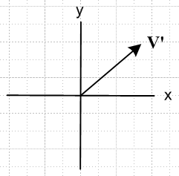

[ Note that then ( in newer picture) = Rz(ψ) ( ' in old tilted picture) ] Now that person can write:

V = (Vx, Vy, Vz)
V' = (V'x, V'y, V'z)

and gets the benefits that both triplets are in S space so we don't have to have a notation (-,-,-)' to indicate a triplet in S', our pictures are not tilted, and we have simple axis labels (no primes needed).
Summary: We have a single vector V which we wish to observe from (and "work with" in) two different coordinate systems S and S'. Why we might want to do this is unmentioned. We know that our vector will have different components in S and S': Vx,Vy,Vz and V'x,V'y,V'z . We might have various algebraic manipulations to do with one or the other of these component sets, for example. Instead of thinking of these two sets of components Vx,Vy,Vz and V'x,V'y,V'z as the components of the same vector V in two systems S and S', we can instead create a new vector V' in system S such that the components of V' in S are V'x,V'y,V'z . We can then draw these two vectors V and V' in the same picture with S as coordinates, where V' = Rz(ψ) V,

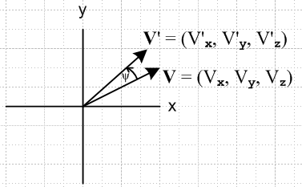

Now in a single picture we have a graphic representation of all six components.

2A. Repeat the above but use 1,2,3 notation and add comments as needed.

Imagine two coordinate systems S and S'. A unit vector in S would be , one in S' would be '. In the passive view, we can think of a vector V as having components V1,V2,V3 in S, and V'1,V'2,V'3 in S'. In order to indicate this unambiguously, we might write

V = (V1, V2, V3) = (V'1, V'2, V'3)'

V = Σn(V•) = Σn(V•') '
ΣnVn = ΣnV'n '

where we add the extra prime after the rightmost paren to say these are components in S'.

Comment Added: In order to show the first two equations are reasonable, we do this

V • = [Σn(V•) ]• = Σn(V•) δnm = (V•) since • = δnm

V • ' = [Σn(V•') ']• ' = Σn(V•') δnm = (V•') since '•'= δnm

So the "first line" above requires that the be an orthonormal basis in x-space
and the "second line" requires that the ' be an orthonormal basis in x'-space.

There is only one vector V, and we "measure it" in two different coordinate systems and therefore we get two different triplets of numbers to represent V. Here is the usual picture one draws to illustrate this situation, where S and S' are related by some z rotation, and we only show the x,y plane,

We might say S' = Rz(-ψ )S by which we mean for example ' = Rz(-ψ ) and in our picture perhaps we have ψ = 10 degrees ( points to the viewer + RH rule ). So this is the classic "passive view" where we have "the same vector" in space (it could be any vector, not just a position vector), and we observe it from two coordinate systems, where S' is "back rotated" relative to S by ψ degrees.
Notice that we have no need at this point for the notation V' . There is no vector V'.
Now, a person working in coordinate system S' gets tired of drawing pictures tilted all the time and wants them to be aligned with paper. That person would draw the right side picture this way

In other words, that person takes the right picture above and rotates everything by Rz(ψ) including the axes. For example, (' in new picture) = Rz(ψ) (' in old tilted picture). The vector is still just V and is still being drawn in the space S'.
Now our person decides it is painful to constantly put primes on the axis labels, and comes up with a new idea which is the active viewpoint. That person says: " instead of keeping V fixed and back-rotating S to get S', I will instead just always work in coordinate system S and I will forward-rotate vector V and I will call that forward rotated vector V'. " So this person then replaces the above picture with this newer one, where V' = Rz(ψ)V :

[ Note that then ( in newer picture) = Rz(ψ) ( ' in old tilted picture) ] Now that person can write:

V = (V1, V2, V3)
V' = (V'1, V'2, V'3)

and gets the benefits that both triplets are in S space so we don't have to have a notation (-,-,-)' to indicate a triplet in S', our pictures are not tilted, and we have simple axis labels (no primes needed).
Summary: We have a single vector V which we wish to observe from (and "work with" in) two different coordinate systems S and S'. Why we might want to do this is unmentioned. We know that our vector will have different components in S and S': V1,V2,V3 and V'1,V'2,V'3 . We might have various algebraic manipulations to do with one or the other of these component sets, for example. Instead of thinking of these two sets of components V1,V2,V3 and V'1,V'2,V'3as the components of the same vector V in two systems S and S', we can instead create a new vector V' in system S such that the components of V' in S are V'1,V'2,V'3 . We can then draw these two vectors V and V' in the same picture with S as coordinates, where V' = Rz(ψ) V,

Now in a single picture we have a graphic representation of all six components.

3. How should the above be modified if V' = RV where R is not a rotation?

Here I am just getting some small clarification. These notes were done after I got all those e E u and U vectors figured out in the tensor doc.

Consider these two expansions for vector V, taken from my new Tensor doc:

V = ΣnVn un

V = ΣnV'n en

Both these expansions are in x-space, both sums add up to the same vector V in that space. You draw the vector once in x-space, then you see it as having two sets of components, the Vn and the V'n.

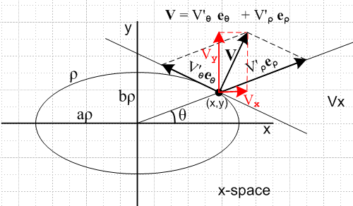

This is the "passive view" picture that I have been looking for. Same vector in same space. This is the analogy of

but I see that this picture is not done right, so let's fix it! Here is the right picture

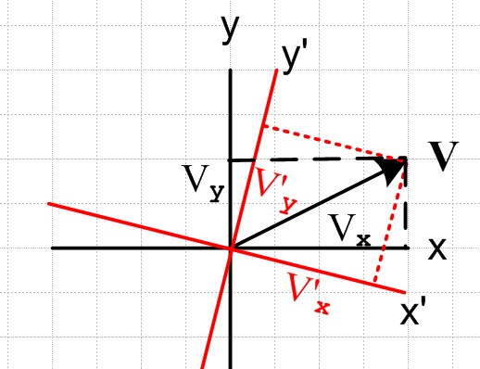

There is one vector, we view it with respect to two different coordinate systems, both of which are drawn in the same space. This is the "passive rotation" idea.
Here then is the "active view" for rotations

4. Start over with rotations, doing things the right way

For rotations, we can have three points of view: Passive, Active, and Two Spaces. These are shown in the three figures below.

For the passive view, we have the same V expanded in two ways:

V = ΣnVn Vn = V•
V = ΣnV'n' V'n = V• '

Notice in the picture that we show ' = R-1 (where R = Rz(π/8), say)

In the active view, we have V' = RV and V' is then shown in the same space with V. Expansions are now

V = ΣnVn Vn = V•
V' = ΣnV'n V'n = V'• // compare this line to the second line above.

In this situation we have V' = R V and we get the usual notion that in active the vector goes one way, but in the passive the basis vectors go the other way. Note that, using scalar product facts

V'n = V'• = [R V] • [R ' ] = V • [RTR] ' = V • '

In the two spaces view, we have,

V = ΣnVn Vn = V• // in x-space
V' = ΣnV'n' V'n = V'• ' // in x'-space // does not match any line above

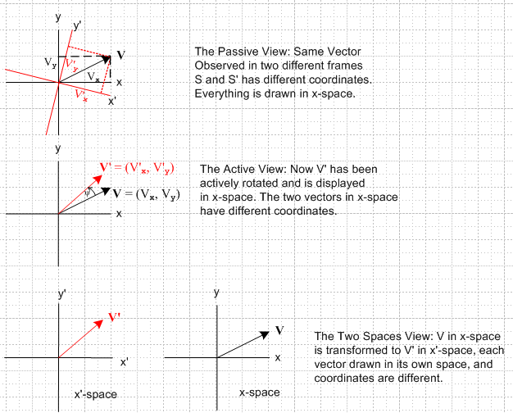

The two spaces have the same metric tensor, g = 1. In the Active View, the transformed vector V' is drawn in x-space along with vector V, and everything is reasonable because both spaces have the same metric tensor. The length and components of V' are accurately represented in the Active View picture.

5. We try now to construct these three pictures for a general transformation that is not a rotation.

For the passive view, we have the same V expanded in two ways:

V = ΣnVnun Vn = V • Un // if x-space Cartesian, then un = Un =
V = ΣnV'nen V'n = V • En

This seems to work out OK, see the picture below. The en are non-orthogonal in this example. Every vector is Cartesian, the graphics works, all is well. But if x-space is non-Cartesian, we have the usual graphics problems.

For the active view I tried to physically rotate the non-orthogonal en type components keeping them the same length. I knew that |en| = |e'n|. The picture just makes no sense whatsoever! Once you alter the strange angles between the en , you no longer have a Cartesian anything, so this active view just does not even exist. The problem is that that two spaces have different metric tensors. I think this makes no sense even in an orthogonal system because of this unequal metric tensors business. Not a useful picture to draw of view to take, in any event. In contrast, the passive view picture above is perfectly reasonable.

The Two Spaces picture is OK too, except the geometry of the x'-space picture is wacko which cannot be avoided. At least it correctly represents the equation on the second line here. The vector space part works, it is the norm and distance parts that don't work right.

V = ΣnVnun Vn = V • Un x-space
V' = V'n e'n V'n = V • E'n x'-space

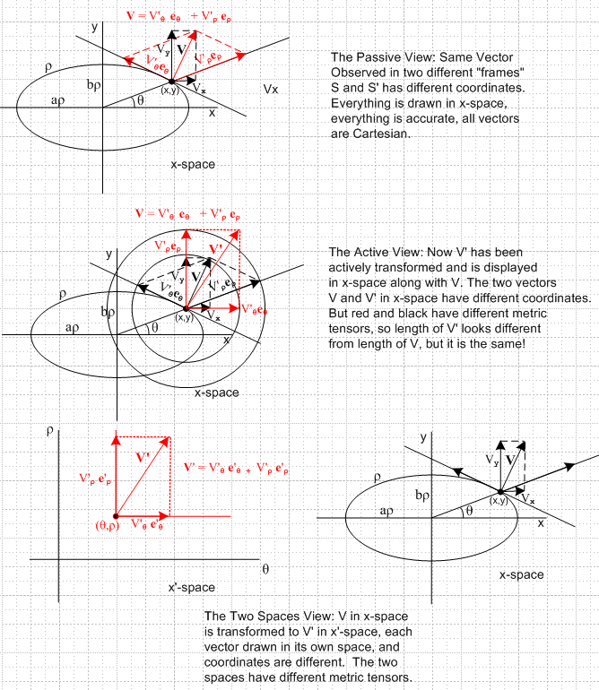

So somewhat to my surprise, it is the Passive View that sort of wins out here, and the Active View has to be completely discarded .

Fact: The Active View is only viable if the two spaces have the same metric tensor. They could both be Lorentz Spaces, for example. Maybe not Cartesian, but at least both vectors are treated the same way. Of course in this case, neither x-space nor x-space has "good graphics". You could make my "Cartesian view" for both spaces, as I did for my x'-space, and then you can actively transform 4-vectors around, but they will change graphic length!. I think a vector in the upper light cone stays in that light cone for example. You would plot the arrow tip using the Cartesian grid, and that is why lengths will be wrong because you will see Cartesian lengths, not covariant lengths.

_________________________________________________________

