Differential Operators in Curvilinear Coordinates PhL 9.3.08

[ Read through these notes on 11.7.09 about to delve into oblate spheroidal coordinates. These notes are very good, and I have no book which presents the stuff in this way. ]

These notes were made to clarify unclear parts of M&M chapters 4 and 5 on this subject.

General comments: 1
Divergence 1
Definition of div A 2
Passing Comments. 3
Pause to comment on the properties of the 6 basis vectors. 4
Now, using this skewed volume, how might we compute divA ? 5
The volume. 5
The surface integral. 6
Conclusions of all the above work. 9
Footnote 1: 10
Gradient. 11
Definition of the gradient. 11
The A• grad(φ) operator 13
Laplacian. 13
Lemma on the components of the basis vectors related to g_{ij} 13
Curl. 15
Definition of the J ≡ curl B 15
Curvilinear Curl. 16
Summary of Results: 19
Divergence 19
Gradient 20
A• grad(f) 20
Laplacian 21
Curl 21
Summary of Orthogonal Analysis Results 22
The Vector Laplacian 23
Cartesian Evaluation 23
Curvilinear Evaluation 23
The second term 23
The first term. 24
Combining the two terms. 24

General comments:

You need to have an "operational definition" of each differential operator, and then apply that definition on your coordinate system of interest. The Cartesian forms of these operators are NOT "form invariant" if you move to a general curvilinear coordinate system, or even to one that happens to be orthogonal. M&M I think were a little weak in their presentation because they did not define the operators very clearly.

Divergence

What is the divergence of a vector field, known as divA or ∇•A ?

I think it is best NOT to define this as "what it comes out being" in Cartesian coordinates. Instead define it this way:

Definition of div A

The ρ = div A is a scalar field that you get by considering a small volume around a point of interest, doing ∫A•dS over the surface of this volume, and dividing by the volume. In the limit, the volume is shrunk down around a point, and then the resulting divA is the value of the function ρ at that point. This is what I would call an "operational definition". You carry out some operation to obtain div A. We like to call it ρ because it reminds of divE = ρ of electrostatics fame. This process is well described in my Purcell book. The term "divergence" is telling us the total "flow" of A out through the surface! Of course "flow" suggests a time rate of change of something, but this flow is at an instant of time. It is the total "flux" of A emerging from a point. I don't know the correct word, but divergence seems good.

If you carry out this operation using a volume that is a little "rectangular solid" in Cartesian space, you obtain the usual formula that divA = ∂iAi.

Now suppose we are at some point q → r in a non-orthogonal curvilinear coordinate system. At this point (in the neighborhood of this point) we have three non-orthogonal non-unit vectors which M&M like to call e(i) with a lower label. They call them in fact ei and don't use that paren thing. Here is my picture:

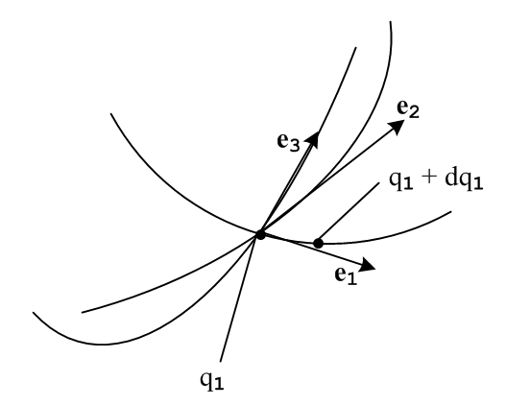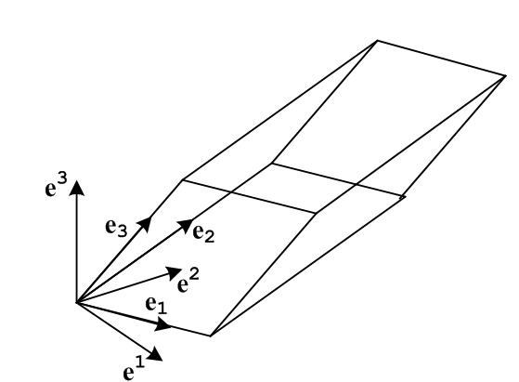

The intersection dot marks the location of the point r(q1, q2, q3) in Cartesian space = E3 and the right dot marks the location of the point r (q1+ dq1, q2, q3) for some positive dq1. The arrow e1 shows the direction you go (in 3D Cartesian space) to move from the left to the right point. The idea is that dq1 > 0, so the arrows ei (known as covariant basis vectors) point in the direction you go in E3 if you increase qi by a small positive amount. Usually this is stated as

ei ≡ ∂r/∂qi

The picture at the right is a highly magnified blowup of a small volume element at the intersection point of the picture on the left, but I did not scale the arrows to show this. I arranged them so that 1 x 2 = 3 roughly.

Passing Comments. ("ped" means the parallelepiped shown above )

(0) We know that ei ≡ ∂r/∂qi so we CAN'T arbitrarily set the normalization of the ei, it is fixed by the transformation! I was wrong about this and have repaired all comments below.

(1) We know that metric tensor is gij ≡ ei• ej (proof next paragraph) where • means the normal E3 dot product. The three vectors ei as defined in M&M page 193 have fixed and in general non-unit normalization, so if follows that the metric tensor gij also has fixed normalization. The metric tensor is a matrix built from the dot products of our three vectors, and is therefore a function of the angles between them AND their lengths.
[ Show gij ≡ ei• ej. Recall that g'kp = Tki Tpj gij where Tab ≡ $\begin{matrix}∂xb \\ ∂x'a\end{matrix}$ . Here we have xb = Cartesian and x'a = qa. Thus since ei ≡ ∂r/∂qi we can identify [ei]k ≡ ∂xk/∂qi = Tik . Also we know gij = δij in Cartesian, we then have that g'kp = Tki Tpi = [ek]i [ep]i = ek • ep . In the new q space we refer to the metric tensor as g, not g', so in the q space we have just shown that gkp = ek • ep. PhL 11.7.09 ]

(2) Notice also that gij as so defined is going to be a function of r, which means a function of q. In normal E3 space q = r, even if axes are skewed, we would have gij = constant.

(3) the "far corner" of the ped would be labeled q1 + dq1, q2 + dq2, q3 + dq3. These are not the picture coordinates in E3, these are in the q-space which is not drawn by me. The far corner is located in E3 in my drawing at the location r(q1 + dq1, q2 + dq2, q3 + dq3) where ri = xi = Tbi x'b = Tbi qb is the inverse transformation .

(4) Notice that all coordinates like qi use the "contravariant" upper indices.

(5) The dimensions of the ped can be computed from ds2 = gijdqidqj. [ See integration doc ] If we vary only q1, as for the lower left edge of the ped in my drawing, then only one term survives in this double sum and we have ds2 = g11(dq1)2, so the length of this ped edge (in E3) is given by ds1 = $\sqrt{g11}$dq1 . Thus, we know the length of all ped edges: length2 = gii which is also ei• ei .

|dsi| = Qidqi Q1 = $\sqrt{g11}$, etc // Qi here are as defined by M&M

(6) notice that, if we denote the magnitude of ei by just ei, then

ei• ei = gii = ei2 = Qi2 => ei = Qi = $\sqrt{gii}$

similarly we would have ei = $\sqrt{gii}$ but no Q name for this.
____________________________________________________________________

Now is the right time to introduce that "contravariant basis vectors" because we are going to need them very soon. We first define

v ≡ e3• e1x e2 = e1x e2• e3 = e1• e2x e3 = [e1 e2 e3]

the last in in M&M page 147 notation. And we know all cyclics are the same. For the vectors as I have drawn them, this volume v is positive. Also, I proved in my notes what is claimed on M&M p 195, namely

v = $\sqrt{g}$ where g = det(gij)

a fact which is not immediately obvious.

Then we define the contravariant basis vectors this way

e1 ≡ e2 x e3 / v
e2 ≡ e3 x e1 / v
e3 ≡ e1 x e2 / v
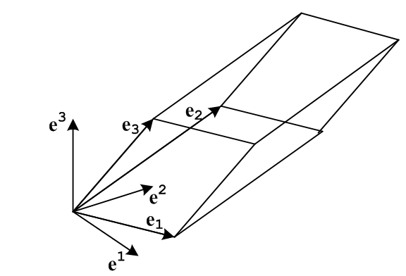

These new basis vectors are normal to the ped surfaces now. For example e1 is the out-directed normal of the right surface, and e2 outgoing for the back-right surface, and e3 outgoing for the top surface. Since these surfaces are not at right angles, these new vectors are not orthogonal (nor are they normalized). And I imply nothing in the drawing about the length of these vectors, notice each is scaled by v.

Note added: Claim that ei x ej = v εijk ek If i=j LHS = 0 and RHS = 0. If ij=12 get e1 x e2 = ve3.
Also claim ei x ej = (1/v) εijk ek , see a few lines below.

Pause to comment on the properties of the 6 basis vectors.

e1 • e2 = 0 e1 • e3 = 0 e1• e1 = e2 x e3• e1/ v = v/v = 1 => ei • ej = δij

The first two are obvious since a•axb = 0 and the third shows why we added the /v factor when defining the contra basis vectors!
Now compute :

v2 e2 x e3 = (e3 x e1) x (e1 x e2) = (e3 x e1• e2) e1 – (e3 x e1• e1) e2 = (e3 x e1• e2) e1 = v e1

which shows that we can reverse solve to get [ see vector identity page back side for the above ]

e1 = v e2 x e3
e2 = v e3 x e1
e3 = v e1 x e2

which agrees with M&M page 193, something I had not shown before
Now recall that we had

v = e3• e1x e2 etc

Notice that if you look at the ei in terms of the ei, you see a factor 1/v, but going the other way you see factor v. So if we were to call this factor v', both transformations look exactly the same, so we would conclude that

v' = e3• e1x e2 etc = 1/v

so e3• e1x e2

1/v = e3• e1x e2 = e1x e2• e3 = e1• e2x e3 = [e1 e2 e3] = v'

but I won't be using the symbol v'.

Now we are going to be talking about the area of the back surface, and to do that we need to know what the ds1 edges of our ped are! We can write, using our result from above that |dsi| = Qidqi,

ds2 = | ds2| 2 = Q2dq2 2 = the actual edge vector in our picture.

and in general

dsi = Qidqi i = the actual edge vector in our picture.

Now, using this skewed volume, how might we compute divA ?

For our discussion here, let's just call the coordinates qi and not have them be primed (as if we "came from" a Cartesian system by a T matrix). I am trying to match somewhat page 193 of M&M.

The volume.

The area of the near ped surface is | ds1 x ds3 |. This follows from the usual absinφ which you get from parallelogram = two triangles, each one half the base times height. But earlier we showed that

dsi = Qidqi i = ei dqi i = dqiei

So we then have

dS2 = ds3 x ds1 = dq1 dq3 e3 x e1 // agrees M&M page 194 equation E

|dS2| = | ds3 x ds1| = dq1 dq3 | e3 x e1 |

A slice of volume which starts at this ped face would have volume equal to | ds1x ds3| * δs2 cosθ, where θ is that angle between e2 and e3 x e1, and where δs2 is the small distance shown below. In the picture below, I have shown this last vector e3 x e1 translated from its normal origin. The thickness of the slab is dt = δs2 cosθ. If you add up all the slabs, you get ped volume = | ds1x ds3| * ds2 cosθ where ds2 is the total edge distance across the top below.

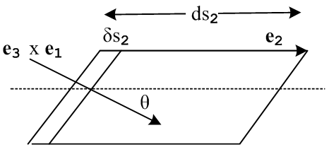

We can thus write

volume = | ds3 x ds1| * ds2 cosθ = (ds3 x ds1) • ds2 =

= dq1 dq3 e3 x e1 • dq2e2 = dq1dq2dq3 e3 x e1• e2 =

= v dq1dq2dq3 = $\sqrt{g}$ dq1dq2dq3 // agrees MM 5-7a page 195

The surface integral.

Look at the back area. We can write this directed vector area as follows:

dSback = ds3 x ds1 = dq1 dq3 e3 x e1 = dq1 dq3 v e2

Side Note Inserted Here: Notice that |dSback| = dq1 dq3 v e2 = dq1 dq3 v $\sqrt{g22}$ and
we know that v = $\sqrt{g}$ so we have |dSback| = dq1 dq3 $\sqrt{g g22}$ where g = det(gij). Now as shown on page 196 M&M it happens that g g22 = G22 which is a cofactor of gij and G22 = ∂g/∂g22 so we
can write this area in the following obscure forms

|dSback| = | ds3 x ds1| = dq1 dq3 $\sqrt{g g22}$ = dq1 dq3 $\sqrt{G22}$ = dq1 dq3 $\sqrt{∂g/∂g22}$

And we know that G22 = g11g33 - g13g31 so one more way

|dSback| = dq1 dq3 $\sqrt{g11g33 - g132}$ // agrees page 195 M&M

Now we want to dot this somehow with A. But how do we express A?

A = a1 e1 + a2 e2 + a3 e3 // remember that ei are not unit vectors !

The dot product will pick out only the a2 term, recall ei • ej = δij , so we get

A• dSback = v a2 dq1 dq3 = $\sqrt{g}$ a2 dq1 dq3 // eval at qback

where the functions v (or g ) and a2 are evaluated at q = qback where we imagine some average value of q for the back surface which we call qback . Since the front surface normal points the opposite direction, we can write

A• dSfront = -v a2 dq1 dq3 = -$\sqrt{g}$ a2 dq1 dq3 // eval at qfront

The contribution of these two surfaces to ∫A•dS is

partial ∫A•dS = dq1 dq3 { [$\sqrt{g}$ a2 ] |back – [$\sqrt{g}$ a2 ] |front }

Now, what do we use for qback? First, here are the labels of the four back surface corners, and then we average them to get the label for the midpoint on the back surface:

(q1, q2 + dq2, q3+ dq3 )
(q1+ dq1, q2 + dq2, q3+ dq3 )

(q1, q2 + dq2, q3 )
(q1+ dq1, q2 + dq2, q3 )

qback = (q1+ ½ dq1, q2 + dq2, q3+ ½ dq3 )

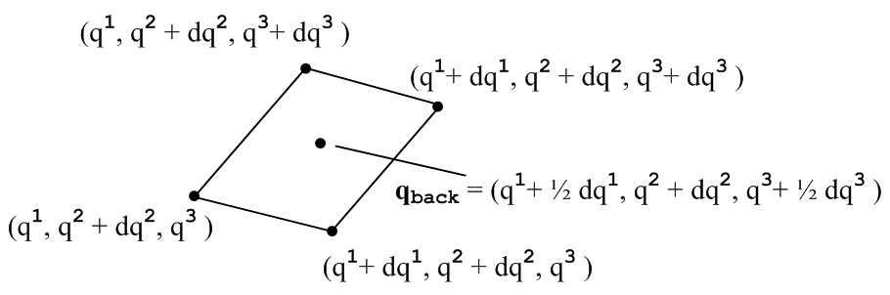

On the front surface opposite this back surface, we have dq2 = 0 for all points, so we have

qfront = (q1+ ½ dq1, q2 , q3+ ½ dq3 )
qback = (q1+ ½ dq1, q2 + dq2, q3+ ½ dq3 )

This is probably more detail than we need, but I want to make sure I get it right (this time!).
Now, we may consider some function f(q) and say

f(qback) – f(qfront) = (∂2f) dq2

The important point is that the 1 and 3 coordinates are the same front and back, so we can take the limit on them already and just set them to q1 and q3. So we now have

partial ∫A•dS = dq1 dq3 { [$\sqrt{g}$ a2 ] |back – [$\sqrt{g}$ a2 ] |front }

= dq1dq3 {∂2($\sqrt{g}$a2) dq2 } = dq1dq2dq3 ∂2($\sqrt{g}$a2)

A crucial thing to note here is that in general g and gij are functions of q and are therefore not the same on the front and back surfaces of our little piped. We have to treat g(q) the same way we treat a2(q). Since we stated that g = v = e3• e1x e2, we are merely noting that this combination of the basis vectors has a different value on the back than on the front surface. The little triad of vectors is shifting in some manner as you go to the back surface.

It seems obvious now that our total surface integral is this:

dq1dq2dq3 ∂i($\sqrt{g}$ai) // summed on i

If we divide this by our volume from above

volume = $\sqrt{g}$ dq1dq2dq3

we find that

div A = (1/$\sqrt{g}$) ∂i($\sqrt{g}$ai) // agrees with 5-20a M&M page 196 caveat

Now, let's make the usual change from ai to Ai according to

A = a1 e1 + a2 e2 + a3 e3 = A1 e1/e1 + A2 e2/e2 + A3 e3/e3

saying ai = Ai/ei = Ai/Qi Then we have

div A = (1/$\sqrt{g}$) ∂i($\sqrt{g}$Ai/Qi)

and this agrees with 5-20a with the understanding that his Vi should really be vi !!! If we had a situation where the gij are constants, such as a non-orthogonal Euclidian space, we could move the other factors out of the ∂i and we would get

div A = ∂i(Ai)/Qi

where the three terms are weighted differently, and in E3 of course Qi = 1.

Now let's go to the orthogonal case with our general formula. We know then that

g = det(gij) = Πi gii = Q12Q22Q32

so we get

div A = (1/Q1Q2Q3) * { ∂1 (Q2Q3 A1) + cyclic }

and this agrees with (5.20) MM page 175 !!

Conclusions of all the above work.

(1) If we define the divergence of A by the Purcell operational method, and just apply this method to the strangely shaped parallelepiped instead of the rectangular solid, we arrive at this general conclusion for any curvilinear coordinates, including non-orthogonal ones:

div A = (1/$\sqrt{g}$) ∂i($\sqrt{g}$Ai/Qi) A = A1 u1 + A2 u2 + A3 u3 ui unit vectors

where g = v = det(gij) and Qi2 = gii

where an example of a unit vector might be u3 = in spherical coordinates. My derivation completely bypasses M&M 5-90 and there is no need for Christoffel symbols introduced on page 167.

(2) If we reduce this general result to orthogonal coordinates, we obtain

div A = (1/Q1Q2Q3) * { ∂1 (Q2Q3 A1) + cyclic }

and this agrees exactly with M&M page 175 5-20 and with general literature, such as Wolfram who uses h1 = Qi and who uses conventional lower case indices on the vector field components:

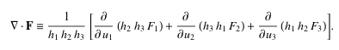

(3) We must conclude, therefore, that M&M 5-90 on page 196 is correct ONLY if we interpret the Vi on the RHS of that equation as being components of V in this sense:

V = V1 e1 + V2 e2 + V3 e3

where ei = dr/dqi are in general NOT unit vectors. We might call this "the tensor sense" of Vi. Notice that the full vector V appears on the left hand side, and better to write the LHS as div(V) because when you write it as ∇•V you are awfully tempted to think of this as ∂iVi in any coordinates, because we think of • as being the E3 dot product. The notation div V puts us more into the flavor of that procedural definition.

For "analysis" work, we would not use this definition of the Vi. We would instead use

V = V1 u1 + V2 u2 + V3 u3

M&M in other places resolved this confusion by using the following tensor sense components

V = v1 e1 + v2 e2 + v3 e3

so that lower-case vi are the "tensor sense" components of V. I like this notation, so I would have written 5-90 in the following manner:

∇•V = vi,i = ∂ivi + vj {ij,i} V = v1 e1 + v2 e2 + v3 e3

= (1/$\sqrt{g}$) ∂i($\sqrt{g}$vi)

where this last result appears as 5-20a, which agrees with my result derived above.
Therefore, we can identify ∇•V with the contraction of the vi,i tensor only if we use the tensor sense vector field components. If we use the unit vector components, we would have to say

∇•V = ∂i(Vi/Qi) + (Vj/Qj) {ij,i}

So if we are willing to define the following vector

v = (V1/Q1, V2/Q2, V3/Q3)

then we can conclude that

∇•V = ∂i(vi) + vi {ij,i} = vi, i

and we can then identify the "covariant divergence" of vector v with ∇•V. Of course when you write the bolded vector without a component index, there is no distinction between V and v.

M&M should have said more about this on page 196 because the reader has absolutely no way of knowing how the Vi in 5-90 are related to V which appears on the LHS. At least they commented on this general subject on the preceding page.

__________________________________________________________________________

Footnote 1: Let's probe back on page 169. He proves (and I verified it) that his covariant derivative is a tensor.

Ai,j ≡ [ ∂iAi - {ij,h}Ah ] this is a tensor

Notice that the A index is covariant here, not contravariant! If you try to raise the i index everywhere, you have to "do something" about the {} symbol. Well, without proof, he says in 4-71 that the following is how you can raise the i index

Ai,j ≡ [ ∂jAi - {hj,i}Ah ]

Notice that the "do something" was to swap the i and h indices in the {} symbol! So let's assume this is in fact correct. Then we can write

Ai,i ≡ [ ∂iAi - {hi,i}Ah ] = [ ∂iAi - {ji,i}Aj ]

and this then gives us equation 5.90. So there was more to that than first blush, but it seems correct.

____________________________________________________________________________

Gradient.

Definition of the gradient.

Our "definition of the gradient" in r-space is this: // here, g is just an arbitrary function

g(r+dr) = g(r) + grad (g) • dr
or
δg(r) = grad (g) • δr

But suppose r = r(q). Then we can write this as

g(r(q)+dr) = g(r(q)) + grad (g) • dr

Now consider

dr = ds2 = | ds2| 2 = Q2dq2 2 = dq2 e2

where ds2 is the amount of r-space displacement that results from a displacement of dq2 in q-space (and at the same time dq1 = dq3 = 0). We have used the above equation in our divergence discussion and justified it there completely, no need to repeat that. Then we have

g(r(q)+ ds2) = g(r(q)) + grad (g) • ds2

Suppose we write

grad (g) = aiei

which is a general expansion for any vector field in r-space, and where ai= ai(q) are three functions we wish to determine, since then we will know grad (g) is, which is our goal here. Well, we then find that

grad (g) • ds2 = aiei • dq2 e2 = a2 dq2

But now let's ponder how g(r(q)) changes when we move only in the q2direction in r-space. We can regard g(r(q)) = G(q) = G(q1, q2, q3). If we change only q2 then we know that

dg = ∂2Gdq2 = ∂2g(r(q)) dq2 // ∂2 means ∂/∂q2

But this is the same as

dg = g(r(q)+ ds2) – g(r(q)) = grad (g) • ds2 = a2 dq2

We conclude, comparing our last two equations, that

a2 = (∂2g)

We can do this in each of the three directions separately. We then conclude that

grad (g) = (∂ig) ei // which agrees with page 196 5-9a

We could rewrite this as follows, using our well-known page 194 fact that ei = gij ej ,

grad (g) = (∂ig)gij ej

If we want to see the gradient in terms of the unit vectors uj we use uj= ej/Qi and then we have

grad (g) = (∂ig)gij/Qj uj = gij (∂ig)Qj uj

Now of we have orthogonal coordinates, we get

grad (g) = (∂ig)gij Qj uj = gii (∂ig) Qi uj

= (1/gii) (∂ig) Qi uj = (1/Qi)2(∂ig) Qi uj

= (1/Qi) (∂ig) uj

For example, for spherical coordinates we should have

grad (g) = (1/1) ∂rg + (1/r) ∂θg + (1/rsinθ) ∂φg

and this agrees with my old sheet on the subject.
To summarize, we have found that:

grad (g) = gij (∂ig)Qj uj // general curvilinear coordinates

grad (g) = (1/Qi) (∂ig) uj // orthogonal curvilinear coordinates.

____________________________________________________________________________

The A• grad(φ) operator

Now one more for the road. What is this operator

A• grad(g)

We know this fact right off the bat:

grad (g) = (∂ig) ei

Therefore,

A• grad(g) = [akek] • (∂ig) ei = ak(∂ig) δki = ai(∂ig)

Now as usual we have ai = Ai/ei = Ai/Qi so

A• grad(g) = (Ai/Qi) (∂ig)

This is not an easy result to find on the web. The result is the same on non-orthogonal as in orthogonal coordinates. In sphericals it would be this:

A• grad(g) = Ar (∂rg) + (1/r) Aθ (∂θg) + (1/rsinθ) Aφ (∂φg)

I think this is the form that got me launched on all this curvilinear stuff!

Question to leave the day with: Are all the "vector identities" true in general curvilinear coordinates?

Laplacian.

Lemma on the components of the basis vectors related to gij

We need to know now about the components of the basis vectors, something we did not do above and which M&M don't talk about. It's pretty easy, in retrospect:

ei= Σk [ei]k ek just as we write A = Σk Ak ek

Dot both sides with ej on the right:

gij = ei• ej = Σk [ei]k ek• ej = [ei]j

Therefore, we have lots of results I was not really aware of. We only showed the first, but all must be true because we know that gik is a rank 2 tensor.

gik = [ei]k

gik = [ei]k

gik = δik = [ei]k

gik = δik = [ei]k

Now derive a formula for the Laplacian. First, here is our above result for div A,

div A = (1/$\sqrt{g}$) ∂i($\sqrt{g}$Ai) A = A1 e1 + A2 e2 + A3 e3

where g = v = det(gij)

And here is the gradient result, in one of its forms,

grad (f) = (∂if) ei = (∂if)gijej

In order to "plug in" this grad expression, I think we need to get its component

[grad (f)]k = (∂if) [ei]k = gik (∂if)

then plugging this in gives

div grad (f) = (1/$\sqrt{g}$) ∂k($\sqrt{g}$Ak) = (1/$\sqrt{g}$) ∂k{$\sqrt{g}$ gki (∂if)} = ∇2f

and this agrees with M&M 5-21a on page 197.

Note added: can do it without mentioning components of ei, as follows

grad (f) = [grad (f)]i ei

Dot both sides with ek.

grad (f)• ek = [grad (f)]k

Thus

[grad (f)]k = grad (f)• ek = (∂if)gijej •ek = (∂if) gik = gik(∂if) // as above

orthogonal: gii = 1/gii = 1/Qi2 and $\sqrt{g}$ = $\sqrt{det(gij)}$ = (Q1Q2Q3) so

div grad (f) = (1/(Q1Q2Q3)) ∂i{(Q1Q2Q3)/Qi2 (∂if)} = ∇2f // M&M page 175 eq 5-21

Curl.

I want to approach this operationally same as div.

Definition of the J ≡ curl B:

We imagine a circulation integral around a loop subtended by a surface. The line integral is this:
Γ= B•ds . We divide this by the "flux" of J through the loop ∫J•dA (which would be the current in E&M, ignoring constants). We shrink the loop down and make it planar and make it point in some direction so that dA = dA. We then say ∫J•dA ≈ J• dA. Then we have

J • = lim( Γn /dA) or (curl B)• = lim( B•ds)n / dA

So our definition is giving us the definition of the component of the curl in an arbitrary direction . If the curl is non-zero in some direction, it says that the circulation is non zero at that point! This is certainly an interesting property of a vector field, that a little line integral around a loop would give a nonzero result.
As an example, imagine a uniform current density J in space, J = J . At any point, we know that curlB = J ≠ 0. So a tiny integral in the x-y plan Γ = B•ds = J dA and curlB•n = Γ/dA = J. In this case, the vector curlB points in the direction of J.
Now think E3 space for the moment, and we could compute curl B in each direction and we get a vector result. This vector must point in some direction. This is the direction of course in which | curlB| is the largest. In general we have curlB• = | curlB| cosθ and this is largest when points in the curlB direction.
So, as you try your little circulations, you will find that it is largest in some direction and that is where the curl points. This does not mean that the local B lines are making circles around this point. For example, consider again our uniform J. We know that B = Jr/2 increases with radius, so we have this situation inside our fat wire with uniform J assumed,

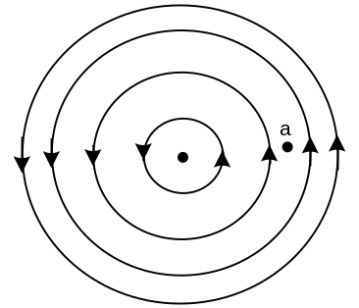

The curl at point a is the same as it is at the center. At point a the field lines to the right are stronger than they are to the left, so you get non-zero curl there.
Now let's use the operational method to find the curl in Cartesian E3. Use midpoints as estimates:

Γz = B•ds ≈
Bx(x + dx/2,y )dx + By(x + dx,y + dy/2)dy - Bx(x + dx/2,y+dy )dx - By(x,y + dy/2)dy

= dx { Bx(x + dx/2,y )- Bx(x + dx/2,y+dy )} + dy { By(x + dx,y + dy/2) - By(x,y + dy/2))}
= dx { -∂yBx dy } + dy { ∂xBy dx} = (∂xBy – ∂yBx) dxdy

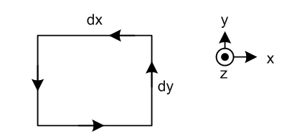

and then Γz /(dxdy) = (∂xBy – ∂yBx) = (curlB)x.

In this way we arrive at the usual formula which is

(curl B)i = εijk∂jBk

Comparing this to the usual A x B cross product formula, we see why the notation is used:

curlB = ∇ x B

and just as A • AxB = 0, we see that ∇• ∇ x B = 0 , in detail: ∂i εijk∂jBk = 0
What about tensor interpretation?

(∂iBj – ∂jBi) ≡ Qij

We know this is a real tensor because the Christoffel guys cancel, but I am not sure that fact helps us right now.

Curvilinear Curl. With the above as introduction, lets try to find the curl in curvilinear coordinates, starting with the basic definition given above. Let's try working with the following situation,

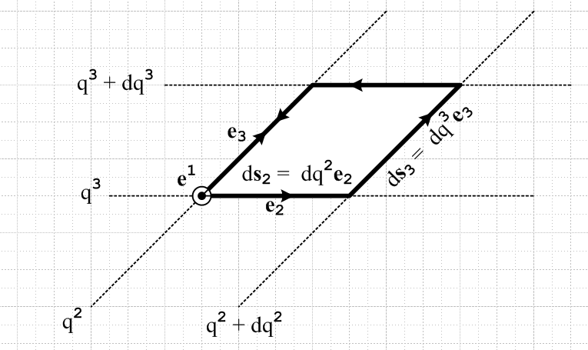

We know that e1 ≡ e2 x e3 / v, so we have adjusted our view so e1 is coming out of the plane of paper, and put e2 and e3 where they might be. The horizontal dotted lines are lines of constant q3 and the slanted dotted lines are those of constant q2 . We are heavily zoomed in on our curvilinear coordinates so these lines appear straight when in fact they are curved. The parallelogram is very tiny.
From our divergence section above, we can write the edge segments and the area vector as

ds2 = dq2e2 ds3 = dq3e3

dS1 = ds2 x ds3 = dq2 dq3 e2 x e3 = dq2 dq3 v e1

Now we want to compute the CCW circulation integral. We get

Γ = B•ds ≈ { B(q2 + ½ dq2, q3) – B(q2 + ½ dq2, q3+ dq3) } • ds2
+ { B(q2 + dq2, q3 + ½ dq3) – B(q2, q3+ ½ dq3) } • ds3

= X • dq2e2 + Y • dq3e3 = { Xiei } • dq2e2 + { Yiei } • dq3e3

= X2 dq2 + X3 dq3

= { B2(q2 + ½ dq2, q3) – B2(q2 + ½ dq2, q3+ dq3) } dq2

+ { B3(q2 + dq2, q3 + ½ dq3) – B3(q2, q3+ ½ dq3) } dq3

= { – ∂3B2 dq3} dq2+ { ∂2B3 dq2} dq3

= { ∂2B3 – ∂3B2} dq2dq3 where B = Biei

Next, we want to compute

∫J•dA ≈ J•dA = J• dq2 dq3 v e1 = J1 dq2 dq3 v where J = Jiei

Therefore we conclude that

J1 = (1/$\sqrt{g}$) ( ∂2B3 – ∂3B2) = [ curl B ]1

or

Ji = (1/$\sqrt{g}$) εijk ∂jBk = [ curl B ]i

or

J = (1/$\sqrt{g}$) { (∂2B3 – ∂3B2) e1 + (∂3B1 – ∂1B3) e2 + (∂1B2 – ∂2B1) e3 } = Ji ei

= curl B

And this agrees with M&M page 197 equation 5.22a apart from the overall minus sign which is used for "tensor analysis", but is not used for "analysis analysis".
So, the good news is that I started from the definition of the curl, and I got the general M&M result.

Now, how could I write the general result showing B and J in contravariant indices? There is only one way:

Ji = (1/$\sqrt{g}$) εijk ∂j( gkaBa)

Here, the components on J and B were defined in terms of e-type basis vectors, so we have to regard the above equation as saying

ji = (1/$\sqrt{g}$) εijk ∂j( gkaba)

Then we can convert to conventional unit-basis vectors in the usual manner, such as

ba = Ba/Qa M&M p 194 D

and we get

Ji/Qi = (1/$\sqrt{g}$) εijk ∂j( gkaBa/Qa)

and this then is our final general result:

Ji = (Qi /$\sqrt{g}$) εijk ∂j( gkaBa/Qa)

or

Ji = (1/$\sqrt{g}$) εijk Qi ∂j(gkaBa/Qa)

J = (1/$\sqrt{g}$) εijk Qi ui∂j(gkaBa/Qa)

or in matrix form

J = curl B = (1/$\sqrt{g}$) $\left|\begin{matrix}Q1 u1 & Q2 u2 & Q3 u3 \\ ∂1 & ∂2 & ∂3 \\ g1jBj/Qj & g2jBj/Qj & g3jBj/Qj\end{matrix}\right|$ // general

Now we can "go orthogonal" and to say gkaBa/Qa = gkk Bk/Qk = Qk Bk

J = (1/$\sqrt{g}$) εijk Qi ui∂j(Qk Bk)

and in matrix form

J = curl B = (1/$\sqrt{g}$) $\left|\begin{matrix}Q1 u1 & Q2 u2 & Q3 u3 \\ ∂1 & ∂2 & ∂3 \\ Q1 B1 & Q2 B2 & Q3 B3\end{matrix}\right|$ $\sqrt{g}$ = Q1Q2Q3 // orthogonal

So finally the curl is done!

Summary of Results:

There are often many ways to write things, and we want to show the general cases and then the orthogonal cases. The form that we would use in conventional vector analysis is marked analysis , and this is always one of the orthogonal cases. Things are always more complicated when the object in question is a vector rather than a scalar, ie, in the cases F = ∇f and B = ∇xA . You always have to state on which set of basis vectors (normalized or not) your vectors are expanded, and in the vector cases you have to do this for the vector on each side of the equation.

Divergence

definition: div A = limit ( ∫A•dS/ Volume ) surface surrounds Volume

div A = (1/$\sqrt{g}$) ∂i($\sqrt{g}$Ai) where A = Aiei $\sqrt{g}$ = det(gij)

= Ai,i ≡ ∂iAi + Aj {ij,i} where A = Aiei {ij,k} = Christoffel symbol

div A = (1/$\sqrt{g}$) ∂i($\sqrt{g}$Ai/Qi) where A = Aii Qi = $\sqrt{gii}$

orthogonal: same as above, except can write $\sqrt{g}$ = $\sqrt{det(gij)}$ = (Q1Q2Q3) so we have

div A = $\frac{1}{Q1Q2Q3}$ ∂i(Q1Q2Q3Ai) where A = Aiei

div A = $\frac{1}{Q1Q2Q3}$ ∂i(Q1Q2Q3Ai/Qi) where A = Aii

= $\frac{1}{Q1Q2Q3}$ [ ∂1(Q2Q3A1) + cyclic] where A = Aii analysis

Gradient

definition: f(r+dr) = f(r) + grad (f) • δr ei = Qii

F = grad (f) = (∂if) ei = (∂if)gij ej ;

if F = Fiei , then Fi = (∂if)
if F = Fii , then Fi = Qi(∂if)

if F = Fjej , then Fj = gji(∂if)

orthogonal: causes gii = 1/gii = 1/Qi2 and gii = Qi2 = ei• ei so Qi = | ei|

F = grad (f) = (∂if) ei = (1/Qi2) (∂if) ei

= (1/Qi) (∂if) i

if F = Fiei , then Fi = (∂if)
if F = Fii , then Fi = Qi(∂if)

if F = Fjej , then Fj = (1/Qi)2(∂if)
if F = Fjj , then Fj = (1/Qi) (∂if) analysis

A• grad(f)

definition: A• grad(f) = A • [(∂if) ei] = Ajej • (∂if) ei = Aj (∂if)

A• grad(f) = Ai(∂if) where A = Aiei

A• grad(f) = (Ai/Qi) (∂if) where A = Aii analysis

orthogonal does not make any difference.

Laplacian

definition: ∇2f = div grad (f) = ∇•(∇f)

div grad (f) = (1/$\sqrt{g}$) ∂k{$\sqrt{g}$ gki (∂if)} = ∇2f

orthogonal: gii = 1/gii = 1/Qi2 and $\sqrt{g}$ = $\sqrt{det(gij)}$ = (Q1Q2Q3) so

div grad (f) = $\frac{1}{Q1Q2Q3}$ ∂i{(Q1Q2Q3)/Qi2 (∂if)}

= $\frac{1}{Q1Q2Q3}${ ∂1{(Q2Q3)/Q1 *(∂1f)} + cyclic } analysis

Curl
definition: (curl B)• = limit ( B•dl) / area )
where differential planar area is perp to and the circulation path is around this area.

[ curl B ]i = (1/$\sqrt{g}$) εijk ∂jBk = (1/$\sqrt{g}$) εijk ∂j( gkaBa) where B = Biei = Biei

J = curl B = (1/$\sqrt{g}$) εijk ∂jBk ei where B = Biei J = Jiei for coef 1
= (1/$\sqrt{g}$) εijk ∂j( gkaBa) ei where B = Biei J = Jiei for coef 2
= (1/$\sqrt{g}$) εijk( ∂jBk) Qi i where B = Biei J = Ji i for coef 3
= (1/$\sqrt{g}$) εijk ∂j( gkaBa) Qi i where B = Biei J = Ji i for coef 4

J = curl B = (1/$\sqrt{g}$) εijk ∂j(Bk/Qk) ei where B = Bii J = Jiei for coef 5
= (1/$\sqrt{g}$) εijk ∂j( gkaBa/Qa) ei where B = Bii J = Jiei for coef 6
= (1/$\sqrt{g}$) εijk ∂j(Bk/Qk) Qi i where B = Bii J = Ji i for coef 7
= (1/$\sqrt{g}$) εijk ∂j( gkaBa/Qa) Qi i where B = Bii J = Ji i for coef 8

= (1/$\sqrt{g}$) (rewrite of case 8)

orthogonal: Have to rewrite them all with gkaBa = gkkBk = Qk2Bk and (1/$\sqrt{g}$) =$\frac{1}{Q1Q2Q3}$.

[ curl B ]i = $\frac{1}{Q1Q2Q3}$ εijk ∂jBk = (1/$\sqrt{g}$) εijk ∂j( gkaBa) where B = Biei = Biei

J = curl B = $\frac{1}{Q1Q2Q3}$ εijk ∂jBk ei where B = Biei J = Jiei for coef 1
= $\frac{1}{Q1Q2Q3}$ εijk ∂j(Qk2Bk) ei where B = Biei J = Jiei for coef 2
= $\frac{1}{Q1Q2Q3}$ εijk( ∂jBk) Qi i where B = Biei J = Ji i for coef 3
= $\frac{1}{Q1Q2Q3}$ εijk ∂j(Qk2Bk) Qi i where B = Biei J = Ji i for coef 4

J = curl B = $\frac{1}{Q1Q2Q3}$ εijk ∂j(Bk/Qk) ei where B = Bii J = Jiei for coef 5
= $\frac{1}{Q1Q2Q3}$ εijk ∂j(QkBk ) ei where B = Bii J = Jiei for coef 6
= $\frac{1}{Q1Q2Q3}$ εijk ∂j(Bk/Qk) Qi i where B = Bii J = Ji i for coef 7
= $\frac{1}{Q1Q2Q3}$ εijk ∂j(QkBk) Qi i where B = Bii J = Ji i for coef 8
analysis
= $\frac{1}{Q1Q2Q3}$ (rewrite of case 8) MM p176

We can throw in here our vector Laplacian mess as follows:

Summary of Orthogonal Analysis Results

We can now collect all the orthogonal analysis results and change to the usual operator notation:

∇•A = $\frac{1}{Q1Q2Q3}$ [ ∂1(Q2Q3A1) + cyclic] where A = Aii analysis

∇(f) = (1/Qi) (∂if) i analysis

A• ∇(f) = (Ai/Qi) (∂if) where A = Aii analysis

∇2(f) = $\frac{1}{Q1Q2Q3}${ ∂1{(Q2Q3)/Q1 *(∂1f)} + cyclic } analysis

∇ x B = $\frac{1}{Q1Q2Q3}$ εijk ∂j(QkBk) Qi i analysis
= $\frac{1}{Q1Q2Q3}$

The Vector Laplacian

You often see the object F = ∇2A where we act on a vector with ∇2. What does this even mean? How would you define it to mean anything? The answer is that the ∇2 operator has a different definition when you apply it to a vector:

∇2f = ∇•(∇f) scalar Laplacian
∇2A =∇(∇•A) – ∇ x (∇ x A) vector Laplacian

This object in fact occurs on my vector identity page in just this way, I never noticed it.

Cartesian Evaluation

Thus we have in Cartesian coordinates that

[∇2A]i = ∂i(∂aAa) - εijk∂j( εkab∂aAb) = (∂i∂aAa) - εijk εkab (∂j∂aAb)

We can examine the second term and find:

- εijk εkab (∂j∂aAb) = εkji εkab (∂j∂aAb) = εkbi εkac (∂a∂bAc)

= { δabδic – δacδib } (∂a∂bAc) = (∂b∂bAi) – (∂a∂iAa)

So our result is

[∇2A]i = (∂i∂aAa) - εijk εkab (∂j∂aAb) = (∂i∂aAa)+ [(∂b∂bAi) – (∂a∂iAa)]

= (∂b∂bAi) = ∇2Ai

However, this is only true in Cartesians.

Curvilinear Evaluation

In curvilinear, you have to figure out the whole mess

∇2A = grad( div A) – curl (curl A)

The second term

We shall see below that just curl A by itself is a huge mess. When J = curl B for example we will get as our "analysis result"

Ji = (1/$\sqrt{g}$) εijk Qi ∂j(gkaBa/Qa)

Suppose then that J = curl B and B = curl A. Then we have

Ji = (1/$\sqrt{g}$) εijb Qi ∂j(gbaBa/Qa)

Ba = (1/$\sqrt{g}$) εask Qa ∂s(gkcAc/Qc)

so

Ji = (1/$\sqrt{g}$) εijb Qi ∂j(gba[Ba]/Qa)

= (1/$\sqrt{g}$) εijb Qi ∂j(gba[(1/$\sqrt{g}$) εask Qa ∂s(gkcAc/Qc)]/Qa)

= (1/$\sqrt{g}$) εijb εask Qi ∂j( gba(1/$\sqrt{g}$) ∂s(gkcAc/Qc) ) // general

which is a true horror story! This simplifies slightly in orthogonals to:

Ji = (1/$\sqrt{g}$) εija εask Qi ∂j( gaa (1/$\sqrt{g}$) ∂s(gkkAk/Qk) )

and replacing gaa= Qa2 we get

Ji = (1/$\sqrt{g}$) εija εask Qi ∂j(Qa2 (1/$\sqrt{g}$) ∂s(Qk Ak) ) // orthogonal

So much then for our curl curl term, and don't forget the minus sign later, second term is – Ji.

The first term.

From our same "analysis results" we have these general results

f =∇•A = (1/$\sqrt{g}$) ∂i($\sqrt{g}$Ai/Qi)

[∇(f)] = gja (∂af)Qa uj

so insert the first into the second to get

∇(∇•A) = gja (∂a[f])Qa uj = gja (∂a[(1/$\sqrt{g}$) ∂i($\sqrt{g}$Ai/Qi)])Qa uj

Combining the two terms.

So our completely general result seems to be this:

∇2A =∇(∇•A) – ∇ x (∇ x A)

= gja (∂a[(1/$\sqrt{g}$) ∂i($\sqrt{g}$Ai/Qi)])Qa uj

– (1/$\sqrt{g}$) εijb εask Qi ∂j( gba(1/$\sqrt{g}$) ∂s(gkcAc/Qc) ) ui

In the first term replace i → s then j→ i

∇2A =∇(∇•A) – ∇ x (∇ x A)

= gia ∂a[(1/$\sqrt{g}$) ∂s($\sqrt{g}$As/Qs)] Qa ui

– (1/$\sqrt{g}$) εijb εask Qi ∂j( gba (1/$\sqrt{g}$) ∂s(gkcAc/Qc) ) ui // general

which is a real monster. For orthogonals, the second term is slightly simpler and we can also simplify the first term also slightly, so we get

∇2A =∇(∇•A) – ∇ x (∇ x A)

= (1/Qi) ∂i[(1/$\sqrt{g}$) ∂s($\sqrt{g}$As/Qs)] ui

– (1/$\sqrt{g}$) εija εask Qi ∂j(Qa2 (1/$\sqrt{g}$) ∂s(Qk Ak) ) ui // orthogonal

which is still a pretty good mess and of course $\sqrt{g}$ = Q1Q2Q3 . Note that you cannot expand the double ε in terms of δ's because the pair does not have a free sum on a due to the Qa2 factor. For each value of i. there are two non-zero εask choices, and for each of those, there are two for εask, so for each i there are four terms in the second term above.
Just as a cursory check, suppose we now assume Cartesian. Then what does the above reduce to?

∇2A =∇(∇•A) – ∇ x (∇ x A)

= ∂i[∂s(As)] ui

– εija εask ∂j(∂s(Ak)) ui // orthogonal

Now we have a free sum on the ε pair, so we can write the second term as

+ εaji εask ∂j(∂s(Ak) ) ui = + {δjsδik - δjkδis } ∂j(∂s(Ak) ) ui

= ∂j(∂j(Ai) ) ui - ∂j(∂i(Aj) ) ui

so our full answer is then

∂i[∂j(Aj)] ui + ∂j(∂j(Ai) ) ui - ∂j(∂i(Aj) ) ui = ∂j(∂j(Ai) ) ui = ∇2Ai ui

and we recover the Cartesian result.
We are then left with this as our best orthogonal result

∇2A =∇(∇•A) – ∇ x (∇ x A)

= (1/Qi) ∂i[(1/$\sqrt{g}$) ∂s($\sqrt{g}$As/Qs)] ui

– (1/$\sqrt{g}$) εija εask Qi ∂j(Qa2 (1/$\sqrt{g}$) ∂s(Qk Ak) ) ui // orthogonal

Suppose we just look at the i=1 term in this second term only. Here are the four terms we get

– (1/$\sqrt{g}$) ε123 ε312 Q1 ∂2(Q32 (1/$\sqrt{g}$) ∂1(Q2 A2) ) u1
– (1/$\sqrt{g}$) ε123 ε321 Q1 ∂2(Q32 (1/$\sqrt{g}$) ∂2(Q1 A1) ) u1
– (1/$\sqrt{g}$) ε132 ε231 Q1 ∂3(Q22 (1/$\sqrt{g}$) ∂3(Q1 A1) ) u1
– (1/$\sqrt{g}$) ε132 ε213 Q1 ∂3(Q22 (1/$\sqrt{g}$) ∂1(Q3 A3) ) u1
=
– (1/$\sqrt{g}$) Q1 ∂2(Q32 (1/$\sqrt{g}$) ∂1(Q2 A2) ) u1
+ (1/$\sqrt{g}$) Q1 ∂2(Q32 (1/$\sqrt{g}$) ∂2(Q1 A1) ) u1
+ (1/$\sqrt{g}$) Q1 ∂3(Q22 (1/$\sqrt{g}$) ∂3(Q1 A1) ) u1
– (1/$\sqrt{g}$) Q1 ∂3(Q22 (1/$\sqrt{g}$) ∂1(Q3 A3) ) u1
=
– (Q1 /Q2Q3 ) ∂2( ∂1(Q2 A2) Q3/Q1Q2 ) u1
+ (Q1 /Q2Q3 ) ∂2( ∂2(Q1 A1) Q3/Q1Q2 ) u1
+ (Q1 /Q2Q3 ) ∂3( ∂3(Q1 A1) Q2/Q1Q3 ) u1
– (Q1 /Q2Q3 ) ∂3( ∂1(Q3 A3) Q2/Q1Q3 ) u1

The first term meanwhile is this

(1/Q1) ∂1[(1/Q1Q2Q3) { ∂1(Q2Q3A1) + cyclic } ] u1

It remains a horrible mess, enough!

I have not fully checked the above results for the vector Laplacian. Some day if I ever need to use it, I can come back here and check things. The presumably correct results are reported on my old printed sheet and I have never used them. It does not seem to add much simplicity to a problem in spherical coordinates because my printed result shows about 21 terms! This would be something for Maple to worry about. It would compute out everything if you could just get things entered.

