A Quick Tour of Standard Orthogonal Coordinate Systems PhL 11.8.09

Following the ordering in M&M p 177. Pictures from wiki, one from Wolfram. I could make my own pictures with Maple.

5.3 Cartesian 1
5.4 Spherical 1
5.5 Cylindrical ( = extruded 2D polar) 2
5.6 Confocal Ellipsoidal (aka Ellipsoidal) 2
5.x 2D Elliptical , as needed for the next three 3D coordinate systems 3
5.7 Prolate Spheroidal 4
5.8 Oblate Spheroidal 4
5.9 Elliptical Cylindrical ( = extruded 2D elliptical) 5
5.10 Conical 6
5.11 Confocal Paraboloidal (Parabolic coordinates) 6
5.12 Parabolic Coordinates 2D and 3D, which is just a rotation of the 2D 7
5.13 Parabolic Cylindrical ( = extruded 2D parabolic) 7
5.14 Bipolar cylindrical 2D and 3D -- ( 3D = extruded 2D bipolar) 8
5.15 Toroidal (aka Bispherical ) (= rotated 2D bipolar) 9

________________________________________________________________________

5.3 Cartesian

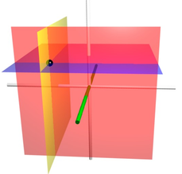

________________________________________________________________________

5.4 Spherical

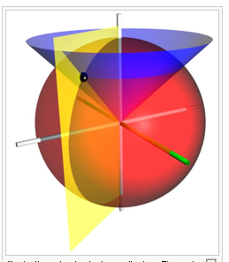

________________________________________________________________________

5.5 Cylindrical ( = extruded 2D polar)

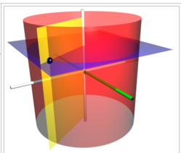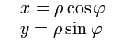

________________________________________________________________________

5.6 Confocal Ellipsoidal (aka Ellipsoidal)

The trick here is that ξ, η and ζ have different legal ranges relative to the constants, and this causes the three equations to have different signs for the terms and hence be different type surfaces. Only the ξ surfaces are ellipsoids, others are hyperboloids. Each (ξ, η, ζ) maps to 8 points (x,y,z) so 1 ↔ 8, see this just looking at the picture. This is the only coordinate system in this survey that has general ellipsoids as a constant variable surface. Very messy MF section, Laplace solutions are Lame functions.

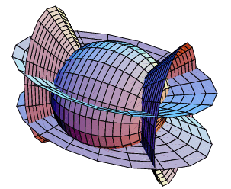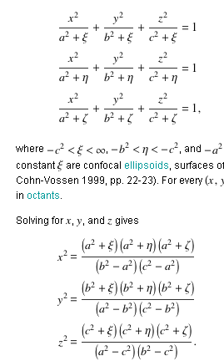

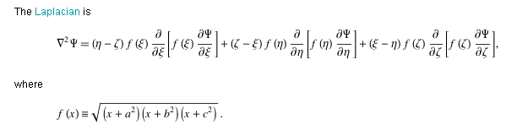

________________________________________________________________________

5.x 2D Elliptical , as needed for the next three 3D coordinate systems

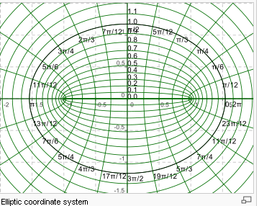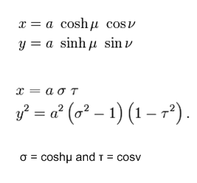

This is the form appropriate for extension to prolate spheroidal below where I think σ = chu and τ = η. If we were doing this 2D for the oblate, we would have σ2 + 1 above where σ = shu = ξ and τ = η.

5.7 Prolate Spheroidal
-- hyperbola in xz plane centered on the z axis rotated about the z axis

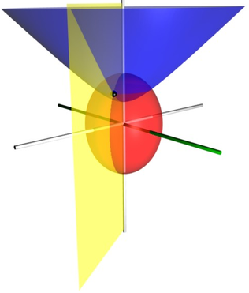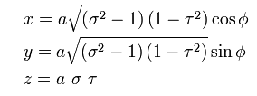

________________________________________________________________________

5.8 Oblate Spheroidal
-- hyperbola in xz plane centered on x axis, rotated about the z axis

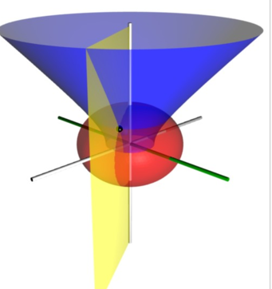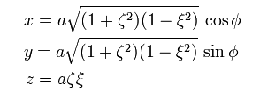

In MF these are written

x = a $\sqrt{ξ2+1}$$\sqrt{1-η2}$cosφ = a $\sqrt{ξ2+1}$sinν cosφ
y = a $\sqrt{ξ2+1}$$\sqrt{1-η2}$sinφ = a $\sqrt{ξ2+1}$sinν sinφ
z = a ξ η = a ξ cosν

________________________________________________________________________

5.9 Elliptical Cylindrical ( = extruded 2D elliptical)

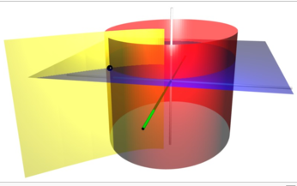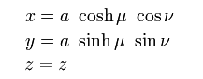

Notice that the yellow here is not a plane, it is a piece of an extruded hyperbola.
________________________________________________________________________

5.10 Conical

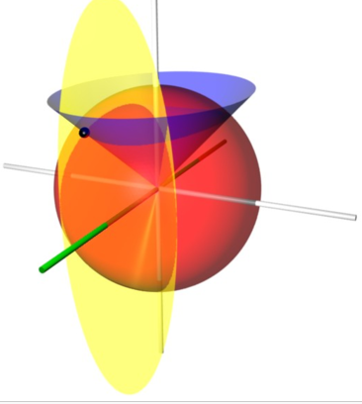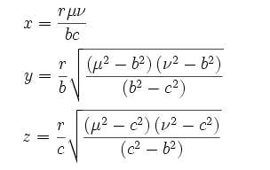

One should understand that the cones in this picture both, in general, have elliptical cross sections, so strictly speaking these are not really "cones", they are "elliptical cones".

________________________________________________________________________

5.11 Confocal Paraboloidal (Parabolic coordinates)
Here x and y are different, so blue and red are not surfaces of revolution, but the picture does not show it very well.
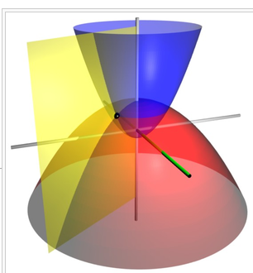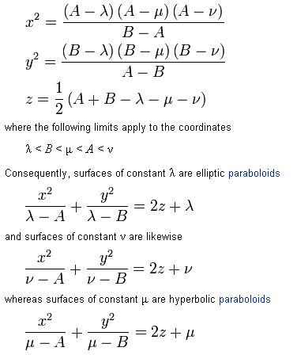
________________________________________________________________________

5.12 Parabolic Coordinates 2D and 3D, which is just a rotation of the 2D

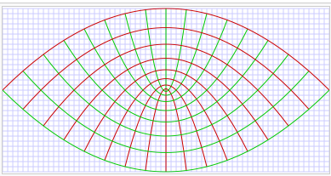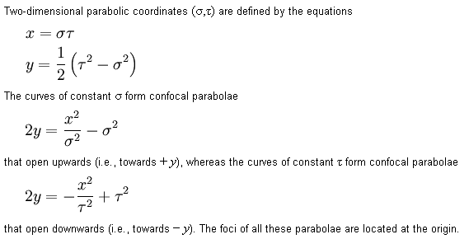

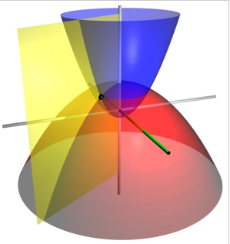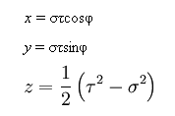

________________________________________________________________________

5.13 Parabolic Cylindrical ( = extruded 2D parabolic)
(a blue slice gives same 2D parabolic seen above)

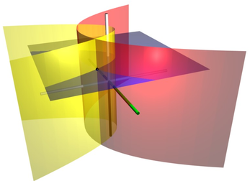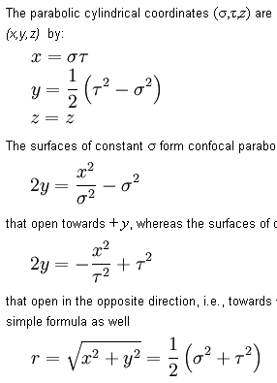

________________________________________________________________________

5.14 Bipolar cylindrical 2D and 3D -- ( 3D = extruded 2D bipolar)

Here is the 2D bipolar coordinates situation. This is Ahlfors's Steiner Circles of his page 85 and dust jacket. All curves are exact circles so when you rotate this below (about vertical axis) to get 3D toroidal, the toroid donut has a circular cross section. Perhaps use this to get the potential of a metal donut.

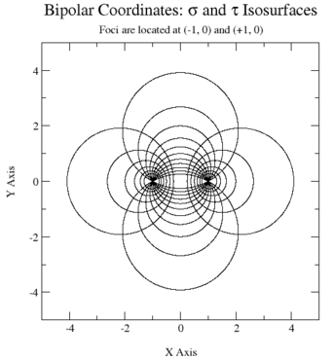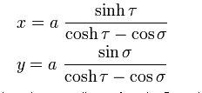

This below is the Bipolar Cylindrical system, just an extrusion of the above 2D bipolar. I have added lines showing the two bipolar axes, and this shows that the red is Apollonius encircling one pole, while the yellow touches both poles.
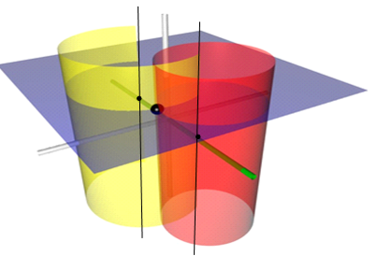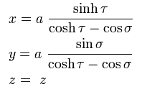

________________________________________________________________________

5.15 Toroidal (aka Bispherical ) (= rotated 2D bipolar)

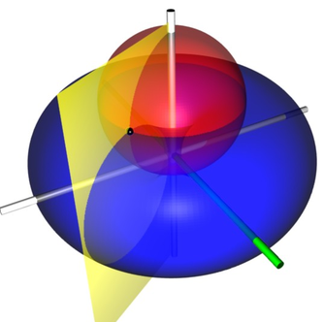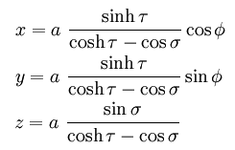

There should be an upper red spheroid and a mirror image lower one.

________________________________________________________________________

