Are the period of h(x) and the order of one of its α's related? PhL 6.29.13

This doc has two items to be added to Galois. The first is a new proof of (5.35) which I have already installed. The second is my theorem that order = period, and I now need to ponder where that should go. I did so, and it too is now installed as Chapter 5 (k). Everything useful is now extracted from this doc!

All items in this doc have been added to Galois doc.

Where to put order = period? It involves conjugate sets and min polys so Chap 5 on min polys seems a good place. My use of "period" in Galois was merely as a test one could use to identify a primitive polynomial. I never really USED it for anything significant and thus did not care much about it.
I guess it can really only go as a new section at the end and then it would be (k).

________________________________________________________________________________

Is there a connection between the order of α and the period of h(x) whose first factor is that α ? In (2.3.11) they seem to be equal. I make no connection between these two integers in either document.

The period of h(x) is the smallest n which appears here: g(x) = (xn-1)/h(x)

The order of α is the smallest n such that αn = 1.

The element α is what appears in this formula for a minimum polynomial

m(x) = (x - α) • (x - αp) • (x - αp$^{2}$) • (x - αp$^{3}$) ... .... (x - αp$^{k-1}$) αp$^{k}$= α k ≤ m (5.17)

Here I am not assuming h(x) is a primitive polynomial. Notice that if αn = 1 then this is true for all elements of the conjugate set of α, but it is not clear whether n would be the smallest integer for which this would be true for some given element. Now perhaps write

g(x)h(x) = (xn- 1)

Here n is the smallest integer for which we can make this equation be true (the period). Certainly then

g(α)h(α) = (αn- 1)

Since h(α) = 0 for any conjugate set α, we know that αn = 1 for such an α. But could there be some smaller value, call it m, for which this is true? Could the period be smaller than the order?

In GA I introduce the period in (5.9).
In GA I introduce the order in (4.17) and (4.18). The order of α is the order of the cyclic subgroup generated by α, and this agrees with order being smallest integer n such that αn = 1.

In Fact 6 I come up with a formula for order:

Fact 6: If β is any element of (α,n,•), then the order of β divides n, the order of α. More specifically, we claim that [order of β] = n/GCD(k,n) where β = αk. (4.21)

Note that implicitly through (α,n,•) the above says that n is the order of α. So if I know the order of one element, I can compute that of others and it can be different. If α is a primitive element, I know that it has order q-1.

Can I find a non-primitive h(x) which has order ≠ period?

Let's go back to the min poly formula

h(x) = (x - α) • (x - αp) • (x - αp$^{2}$) • (x - αp$^{3}$) ... .... (x - αp$^{k-1}$) αp$^{k}$= α k ≤ m (5.17)

and let's assume that n is the period of h(x) so that g(x) = (xn-1)/h(x) has the smallest n.

Question: Do all elements of the conjugate group of α have the same order?

I spent time in the blue below which I will later delete, and found that the answer is YES.

The general element is αp$^{i}$ for i = 0 to k-1. Assume that α has order n. Then from the formula above we know

n' ≡ order of αp$^{i}$ = n/GCD(pi,n)

Example: Suppose n = 4, p = 2 and i = 2. Then n' = 4/GCD(4,4) = 4/4 = 1 !!! So then n' ≠ n.

Can I find an explicit example? Where have I stated the order of any α for some actual example?

OK, let's work on all the min polys of GF(24) which I at least know.

p1(x) = (x - α)(x - α2)(x - α4) (x - α8) = x4 + x + 1
p7(x) = (x - α7)(x - α14)(x - α13)(x - α11) = x4 + x3 + 1
m3(x) = (x - α3)(x - α6)(x - α12)(x - α9) = x4 + x3 + x2 + x + 1
m5(x) = (x - α5)(x - α10) = x2 + x + 1 GA (6.21)

How can I compute the period of each h(x) and the order of α ? I think the period is easy. I just try 15, 5 and 3 and find the smallest of these three integers for which Rem = 0.

x4 + x + 1 period = 15
x4 + x3 + 1 period = 15
x4 + x3 + x2 + x + 1 period = 5 3 does not work
x2 + x + 1 period = 3 5 does not work

Now how do I compute the order of some α involved in the above? What is α in the above list?? I know it is some primitive element due to the fact that p1 is a primitive polynomial. I know then a whole set of elements which are primitive, all those appearing in p1 and p7. There are 8 of these including α. All of these 8 guys have order 15 because they are primitive. They are generators of GF(16) - 0. But what are the orders of all the other 7 elements? Since α has order 15, we can say

n' = order of αk = 15/GCD(k,15)

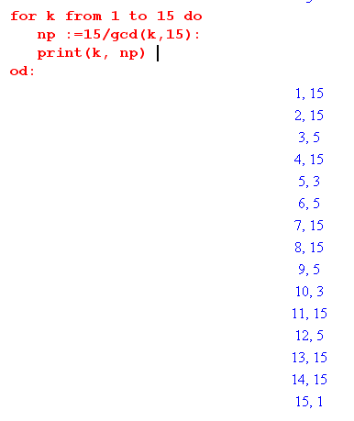

I confirm that the prim poly elements all register 15 for order. But then

m3(x) = (x - α3)(x - α6)(x - α12)(x - α9)

order α3 = 5
order α6 = 5
order α12 = 5
order α9 = 5

Hmmm. Next we have

m5(x) = (x - α5)(x - α10)

order α5 = 3
order α10 = 3

This is not what I expected. I thought I showed that in a min poly the orders of the factors could be different. Let's go back to my formula

n' ≡ order of αp$^{i}$ = n/GCD(pi,n)

Now if α is a primitive element, then we know order α = pm - 1 = n and then we are saying

n' ≡ order of αp$^{i}$ = (pm - 1)/GCD(pi, pm - 1)

If it is true (as seems likely) that GCD(pi, pm - 1) = 1 for i = 1..k-1, then all conjugate elements have the same order as I found in my example above. In this case we consider

GCD(2i, 24 - 1) = GCD(2i, 15)

Since the first term is even and the second is odd, the result is always 1. The only chance is if 2i were an even multiple of 15, but i does not go far enough for that to be true. I think I studied exactly this problem somewhere in Galois! It is not in an appendix. It was some pure math fact that I needed somewhere. I was showing two things could not be equal. How do I search for such an artifact with no handle? I found it by scanning through, see (9.27)

Lemma 1: There is no integer n such that, given m and p>1, (pm-1)/(p-1) = pn-1. (9.27)

So although similar, this is not quite related. So lets roll our own.

Theorem (?): GCD(pi, pm - 1) = 1 for p prime and i = 1,2....m

Assume there exists integer N > 1 such that

GCD(pi, pm - 1) = N

Then there exist integers I and J such that

pi/N = I pi = NI
(pm - 1)/N = J pm - 1 = NJ (pm - 1 )/pi = J/I

If p is prime, then p is odd. Then pi is odd since odd*odd = odd. And pm - 1 is even. then

odd = NI
even = NJ

If N were even, then I is odd and J could be even or odd. going nowwhere.

How about Bezout.

• Euclidean Algorithm and Bezout's Identity. The Euclidean Algorithm is a set of instructions one can use to find d = GCD(n1,n2) for any integers n1 and n2. Bezout's Identity says that this common divisor d can be expressed in the following manner, where a and b are integers,

d = a n1 - b n2 { replace b with -b to get the usual form of this identity} (1.43)

You are given n1 and n2, and regardless of whether you have computed d = GCD(n1, n2), you know that there exist two integers a and b (either could be negative) such that d = a n1 - b n2 .

OK, set n1 = pi and n2 = pm - 1. Then integers a and b exist such that

N = a pi - b (pm-1)

I am learning nothing new here. How about a counter example search. Maple seems to say that the result is true no matter what integer p is, does not have to be prime. Start over:

Theorem (?): GCD(pi, pm - 1) = 1 for p = integer and m = integer range i = 1 to m

pi/N = I pi = NI
(pm - 1)/N = J pm - 1 = NJ (pm - 1 )/pi = J/I

We can write pm = pi pm-i so then

pm - 1 = NJ
pi pm-i - 1 = NJ
NI pm-i - 1 = NJ

This last line then says

N(I pm-i - J) = 1

I pm-i - J = 1/N

But if N > 1, the left side is an integer and the right side is a fraction QED!!!

So if nothing else, I have come up with a new Fact. But I see this is just Fact 15 of (5.35), I have already been up this little canyon. But maybe I have here a better proof

Here is my new proof to install into Galois

******************************************************************************

Equation (5.3) already exists and states this fact. Here I just have a better proof with a separate Lemma and a nice Maple verification. Here is the previous proof:

Fact 15:
(a) All roots (elements) of the conjugate set of α have the same order.
(b) If α is primitive, that order is q-1 and all elements are then primitive. (5.35)

Proof: The order n of α is defined in (4.17) item (e) as the order of the cyclic group generated by α, and (4.16) states that this order must divide evenly into q-1 which is the order of {GF(q)-0}. From (4.21) we know that order(αp) = n/GCD(p,n). Since n must divide pm - 1, we write pm - 1 = nk . Now consider

GCD(p,n) = GCD(p, [pm - 1]/k) .

Since p is prime, this thing is 1 unless the second argument is a multiple of p. Assume that [pm - 1]/k is a multiple N of p, so then pm - 1 = kNp = Mp. But this then implies that (pm - 1)/p = pm-1 - 1/p = M. But this is impossible since 1/p is not an integer (ignoring p=1), so [pm - 1]/k cannot be a multiple of p, and thus GCD(p,[pm - 1]/k) = 1. We conclude then that order(αp ) = order(α) = n. Continuing in this way, we show that all elements of the conjugate set of α have the same order. Part (b) is a trivial corollary.

I just like the new proof better and it does not need p = prime. I just installed it, DONE.

Fact 15: (a) All elements of a conjugate set have the same order.
(b) If α is primitive then all elements of the conjugate set of α are primitive (order q-1). (5.35)

Proof: (b) If α is primitive, it has order q-1 by definition. From part (a), all other elements of the conjugate set have order q-1. They are thus all primitive elements of GF(q).
(a) According to (5.17), the elements of a conjugate set of α all have the form αp$^{i}$ where i ranges from 0 to some k ≤ m. From (4.17) (l) we know the order of α must divide pm-1 so write [order of α] ≡ n = (pm-1)/K where K is an integer. According to (4.21),

[order of αp$^{i}$] = n / GCD( pi, n) = [order of α] / GCD( pi, (pm-1)/K) .

If we can show that GCD( pi, (pm-1)/K) = 1, then our Fact is proven since [order of αp$^{i}$] = [order of α].

Lemma: Show that GCD( pi, (pm-1)/K) = 1 for i = 0,1....m (note that m ≥ i ) . (5.35a)

Assume that GCD( pi, (pm-1)/K) = N > 1. Then we can write

pi/N = I => pi = NI
[(pm-1)/K]/N = J => (pm-1) = NJK

where I and J are integers. Write pm = pi pm-i where m-i ≥ 0 so then the last equation above becomes

(pi pm-i -1) = NJK .

But pi = NI so we have

(NI pm-i -1) = NJK
N(I pm-i - JK) = 1
(I pm-i - JK) = 1/N .

Since the left side is an integer and the right side is a fraction, we have a contradiction, so N = 1. Notice that the fact that p = prime was not necessary in this Lemma proof.
It never hurts to test a proof in Maple. Here we search through all GF(pm) for a range of p and m to see if we encounter any cases of GCD( pi, (pm-1)/K) ≠ 1. The commented-out print line is used for debug.

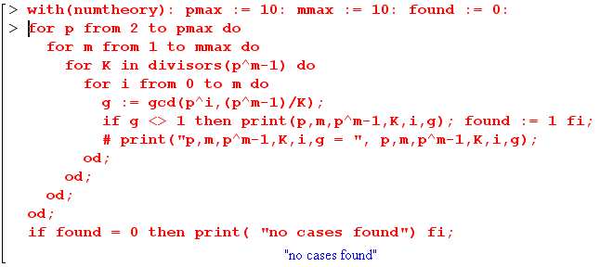

******************************************************************************

I think the following fact is true and I will try to prove it. This is a first shot, better one below.

Fact: The order of any of the GF(q) elements which form a minimum polynomial m(x) is equal to the period of h(x).

I have found this to be true in one example and I suspect it is true in general. We write

m(x) = (x - α) • (x - αp) • (x - αp$^{2}$) • (x - αp$^{3}$) ... .... (x - αp$^{k-1}$) αp$^{k}$= α k ≤ m (5.17)

Here α is not in general a primitive element, so it just has some order N which is a divisor of q-1.

Let N be the order of α: αN = 1 N is smallest so true
N must divide q-1 evenly

Let n be the period of m(x) m(x)g(x) = (xn-1) n is smallest integer so true
=> αn = 1 doing the {x} trick
n must divide q-1 evenly

So at least period n is a candidate for order N, but there could be some smaller N.

So assume the order of α is some N < n. We seek a contradiction. I do have this extra fact

N = [order of α] = s/GCD(k,s) where α = βk s = order of β (4.21)

In this last line, I can regard β as a primitive element if I want, and there will be some k such that α = βk. In this case, I know s = q-1 so we have

N = [order of α] = (q-1)/GCD(k,q-1) where α = βk β = primitive element of GF(q)

m(x)g(x) = (xn-1)
k n-k n

How exactly does one compute the period of m(x) ? Is the only way to do trial and error division to see if there is a remainder for each of the divisors of q-1? This has been my impression.

Let's examine some known fields. For GF(32) we have q-1 = 31 so it has no divisors so we can learn nothing from this case. For GF(16) there are only 4 min polys and order = period for all of them. For GF(8) all the polys are prims. So I have no ready-made examples to ponder.

Go back again to what we know already:

g(x) = (xn-1)/m(x) n is smallest integer so no remainder

g(x)m(x) = (xn-1)

g({x})m({x}) = ({x}n - 1)

But what do I know about {x}? It is hard to find this in GA, it is all spread out.

Locating {x} information in GA
Notation first introduced above (3.14)
More on this above (6.2)
Here is (6.5):

Fact 1: f(α) = 0 for α = {x} . { α may or may not be a primitive element of GF(q) } (6.5)

Here f(x) is used in R/I think for GF(q). So {f(x)} = 0 since no remainder on f(x) division. So f({x}) = 0. So OK, I know that I am using my m(x) to create GF(q) so I do know that m({x}) = 0.

I can then continue the above

g(x)m(x) = (xn-1) where no smaller n works

g({x})m({x}) = ({x}n - 1)

g({x}) 0 = ({x}n - 1)

{x}n = 1

Can this be run either way? No!

{ f(x) } = { g(x) } does not imply f(x) = g(x)

It does imply Rem( f(x)/m(x) ) = Rem (g(x)/m(x))

f(x) = qf(x)m(x) + rf(x)
g(x) = qg(x)m(x) + rg(x)

I need either a proof or a counterexample. I cannot stop until one or the other is found. A web scan turned up the P&W min poly list which I am now studying on web though I have it as well. I quote

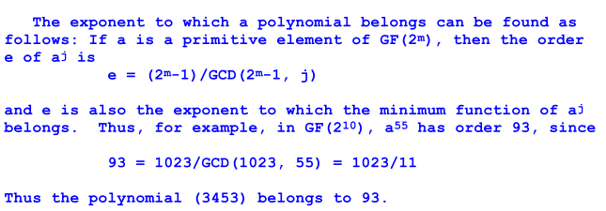

The first equation says that e is the order of aj . Now I think that

"h(x) has period n" ↔ "n is the exponent to which min function h(x) belongs"

so in his example, the GCD formula shows that in GF(210), if α is a prim element, then α55 has order 93 and this should be the period of h(x) which is the min poly of α55. How does he know that (3453) in octal is such a min poly? Well, here is his table for GF(10)

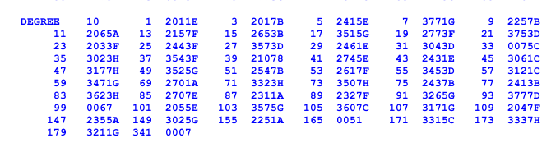

and you see 3453D next to 55, which means it is a min poly of α55.

Next we have this

What is a residue? I have to go get the book and search. I only refer to "residue class ring", never residue by itself. WP also use "residue class" exclusively, never "residue" along until page 209 where we get this

......
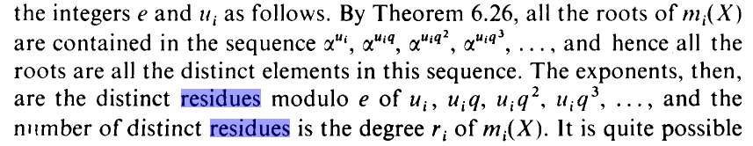

The roots of m(x) are the conjugate set of αμi in his example, like my statement

exponents = { s, sp, sp2, sp3, ..... spk-1 }. and { αs, αsp, αsp$^{2}$, αsp$^{3}$ , .... αsp$^{k-1}$ } .

In my symbols, let order of α be n so that αn = 1 and n is smallest. So I have this list of exponents, and for sure each one can be written as some αm where m is from 0 to 1-1, and I think this m is the "residue". So basically

"residue module n of exponent" = Rem(exponent/n).

For example, if α15 = 1, then α16 = α1 and 1 is the residue of 16.

Here is another possible meaning of "residue" :

residue modulo f(x) of x4 = Rem(x4 / f(x))

This is not really the same usage exactly, but I get the point. In the second usage, residue is just the usual remainder.

OK, I give up on the method they outline involving all this residue stuff. I don't think it contains anything new even if I could decode the language. I am more interested in the table. Here is part of it

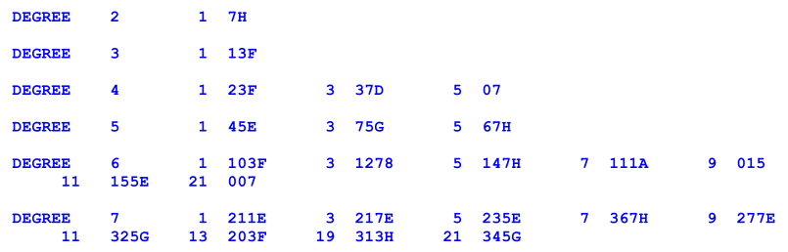

The number in front of each octal deal is the power of (x-αi) in the first factor of the min poly. This then lets you use the general rule to wrote out the factored form I think using the usual exponent sequence.

I can compare this to my own stuff. When I list off all min polys for GF(23) I get

GF(23)

p1(x) = (x - α)(x - α2)(x - α4) = x3 + x + 1 = 1011 = 138
p3(x) = (x - α3)(x - α6)(x - α5) = x3 + x2 + 1 (6.20)

So this is his table item 13F. He earlier says

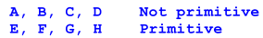

Idea: If a polynomial has degree < m, I know it can still be a min poly. I think he only puts the above letters on min polys that have the full degree m.

so yes, this is primitive. Next,

GF(24)

p1(x) = (x - α)(x - α2)(x - α4) (x - α8) = x4 + x + 1 = 10011 = 238
p7(x) = (x - α7)(x - α14)(x - α13)(x - α11) = x4 + x3 + 1 = partner of above
m3(x) = (x - α3)(x - α6)(x - α12)(x - α9) = x4 + x3 + x2 + x + 1 = 11111 = 378
m5(x) = (x - α5)(x - α10) = x2 + x + 1 = 111 = 78 (6.21)

For some reason he puts no label on this 07 one, why is that? It is not of degree 4, that is true. I would say it was "not primitive" since not even the right degree, but I guess that is obvious. See idea above.

So I understand his table. Now let's ponder GF(26) which is one I did not do and has 26-1 = 63 which factors and is therefore interesting. He has

For example

103 = 001000011 = 1+x+x6

I think for the first time here, I am doing Maple code to compute the period of some h(x).

I run this into my little Maple searcher for the period and find

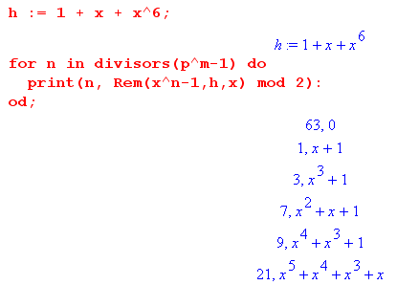

Thus the period is 63 since this is the smallest one that works, and that is the case for any primitive one, His next one is 1278 which doesn't even make sense, it might be 127B. Let's skip that one.

Next is

111A = non prim =001001001 = 1+ x3 +x6

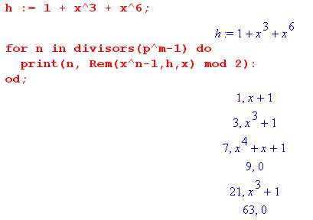

So this one has period = 9. Next

015 = 001101 = 1 + x2 + x3

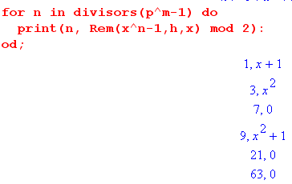

and this one then has period 7. Next,

007 = 111 = 1 + x + x2

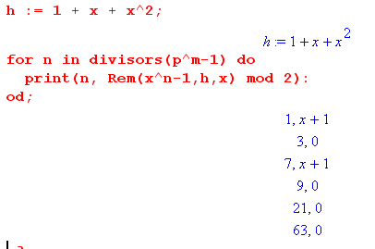

So this one has period 3. That is all the non prims. So here is a list

αk
103 1+x+x6 period = 63 α1 order = 63
111 1+ x3 +x6 period = 9 α7 order = 9
015 1 + x2 + x3 period = 7 α9 order = 7
007 1 + x + x2 period = 3 α21 order = 3

So now I have a period column and I know the first element of the min poly. The order column will be added next and I will use

[order of β] = n/GCD(k,n) where β = αk n = 63

So the idea that order = period persists through the case GF(26) !!!

So I am starting to think my little theorem might actually be true since lots of examples have order = period.

The case of GF(212) has as much RICHER variety of non-prim polys.

Maple problems

(1) How can I enter something like 3218 and have it convert that to a decimal number 3*64+2*8+1 = 209.

• Here is one way:

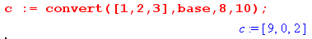

where all ordering is backwards and I have to enter the number backwards.

• Here is another way

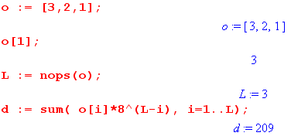

At least this way I can enter the octal digits in a natural order.

I have now written a Maple program where you enter the WP octal thing and it computes the order and the period, and they ALWAYS come out the same, I tried some m = 12 cases. Maybe this is always true for p = 2.

So I guess I better find a proof! I am on my own here, have no idea how I would look this up somewhere.
I think maybe I have it.

HERE IS MY PROOF!!

Done need this part

Aside: Here is another way to show cannot have N > n. Suppose that were the case. Then we have

αN = αn αN-n

1 = 1 αN-n

αN-n = 1

But since N is the order of α, there cannot be some smaller integer N-n such that αN-n = 1. So we can rule out the case N > n.

So here is the Fact and Proof:

__________________________________________________________________________________

Fact: If h(x) is any minimum polynomial of GF(q) of degree k, then the order of any member of the conjugate set of h(x) equals the period of h(x).

Proof: First of all, we know from (5.35) that all members of such a conjugate set have the same order, which we shall call N. Recall that the order of some α in GF(q) is the smallest integer N for which αN = 1. The period, on the other hand, is the smallest integer n such that h(x) divides evenly into (xn-1), so
(xn-1)/h(x) = some polynomial g(x) with no remainder.
The k elements ai of the conjugate set of h(x) comprise all the roots of h(x), so h(ai) = 0 for any conjugate set element. Since these are all the roots of h(x), if one finds that h(β) = 0, then β must be one of the conjugate set elements. We know that h({x}) = 0 because we know {h(x)} = 0 since there is no remainder when h(x) is divided by h(x) in the representation GF(pm) = R/h(x). Since h({x}) = 0, we conclude that {x} must be one of those ai conjugate set elements. Therefore, the order of {x} is N. We now denote this particular ai root by the name α.
Now consider these steps:

g(x)h(x) = (xn-1) // period n is the smallest integer that makes this possible

g({x}) h({x}) = ({x}n-1) // apply {...} to both sides and use the rules of (3.14)

g(α)h(α) = (αn-1) // {x} has name α

0 = (αn-1) // since h({x}) = h(α) = 0

αn = 1 .

Thus, we see that n is a candidate value for N, the order of {x} = α and all other conjugate set elements. Since we are finding here that αn = 1 for period n, we certainly know that the order N ≤ n since N is supposed to be the smallest possible integer for which αN = 1. Thus we have ruled out N > n.

We shall now also rule out N < n and conclude therefore that N = n.

Suppose N = order of α = {x} and n = period of h(x) with N < n. Since the order is less than the period, we must get a non-zero remainder r(x) when (xN-1) is divided by h(x),

(xN-1)/h(x) = q(x) + r(x)/h(x) or (xN-1) = q(x)h(x) + r(x) where r(x) ≠ 0.

This says that ({x}N-1) = r({x}) or (αN - 1) = r(α) where α = {x}. But since N is the order of α, we know that αN = 1 so we then find that r(α) = 0, but r(x) ≠ 0, and the degree of r(x) is < k.
We assumed that h(x) was the minimum polynomial for α. Thus, h(x) has this form:

h(x) = (x-α)(x- a1)(x-a2).....(x-ak-1) h(x) in R, all ai in GF(q), deg h(x) = k

Since r(α) = 0, it has this form:

r(x) = (x-α) (x-b1)(x-b2)..... r(x) in R, bj = unknown but in GF(q), deg r(x) < k

Both h(x) and r(x) have the form for a minimum polynomial of α, but since r(x) has the lower degree, it must be the true minimum polynomial of α which then has degree < k. But this contradicts our original assumption that h(x) is the minimum polynomial of α and has degree k. Therefore we cannot have N < n.

The conclusion is that n = N so the period n of a minimum polynomial is the same as the order N of any of the elements of the conjugate set of that minimum polynomial.

Comment: If irreducible h(x) in R degree k < m is not a minimum polynomial of GF(q) (white region of Fig 5.5) , then it cannot be written in the usual factored form shown above, and therefore it cannot divide into xn - 1 for any n, even for n = q-1. Such a polynomial therefore has no period whatsoever. Of course it also has no conjugate set, so we cannot talk about the order of conjugate set elements. The point is just that if h(x) is not a minimum polynomial, this Fact makes no sense at all.

________________________________________________________________________________

Here are some notes before the above was found and I am flailing away with various "plans".

Again: could it be that n > N ? In this case

αn = αN αn-N

1 = 1 αn-N

αn-N = 1

I am now stuck at 5:45 PM June 29, 2013. I don't see how to rule out this possibility, but I just know that it is not possible because I looked at lots of min poly cases. I am missing some ingredient!

Plan A. Assume that N > n. For example, suppose pm-1 = 63 and we have (1,3,7,9,21,63} as candidates, and suppose order N = 3 and period n = 9. Then it must be that we get a non-zero remainder here:

(x3-1)/h(x) = q(x) + r(x)/h(x) or (x3-1) = q(x)h(x) + r(x) where r(x) ≠ 0.

This says that ({x}3-1) = r({x)) or (α3 - 1) = r(α) where α = {x}. But since order N = 3, we know that α3 = 1 so we then get that r(α) = 0, but r(x) ≠ 0.

Injected comment later: If r(α) = 0 and r(x) ≠ 0, then r(x) is a candidate for being a min poly of α. Clearly r(x) is of degree < k . But h(x) is supposed to be a min poly for α and has degree k. This is a contradiction, we cannot have such an r(x) ≠ 0 when we put the order N = 3 into our equation.

Then the form of r(x) must be

r(x) = (x-α) (x-A)(x-B)... total degree < 3

Then since α is also a root of h(x) we get

(x3-1) = q(x) (x-α) (x-A')(x-B').. + (x-α) (x-A)(x-B)...

= (x-α) [ q(x) (x-A')(x-B').. + (x-A)(x-B)... ]

This says that α is also a root of (x3- 1) so α3 = 1, but we already know that.

Plan B. It must be something about h(x) that I am ignoring. Recall the general form for the exponents of the elements of conjugate set is this

exponents = { s, sp, sp2, sp3, ..... spk-1 }. = { βs, βsp, βsp$^{2}$, βsp$^{3}$ , .... βsp$^{k-1}$ } .

I know that every one of these elements on the right has order N = 3 in my example

h(x) = (x - βs)(x - βsp)(x - βsp$^{2}$)....(x- βsp$^{k-1}$ ) degree k

where β here is a primitive element! One of these things is {x} = α. Suppose all these conj elements have order N. Then I should be able to show that this is a no-remainder division

(xN-1)/ {(x - βs)(x - βsp)(x - βsp$^{2}$)....(x- βsp$^{k-1}$ )} = g(x)

which says

(xN-1) = g(x)(x - βs)(x - βsp)(x - βsp$^{2}$)....(x- βsp$^{k-1}$ )

I want to show the above is true if I know that every conj element has order N. For example, βNsp$^{2}$ = 1.
Dead in the water!

Plan C. Maybe browse through GA looking at the various "proof methods" used. Maybe I will find some method I have forgotten about.

• I have not used the fact that pα = 0 for any α in GF(q).

• [order of βsp$^{i}$] = n/GCD(k,n) where βsp$^{i}$ = αk and n = order of α. What should I take α to be? Suppose I select α = β which is a primitive element. Then I have

[order of βsp$^{i}$] = n/GCD(k,n) where βsp$^{i}$ = βk and n = (order of β ) = q-1

This seems to say that

[order of βsp$^{i}$] = (q-1)/GCD(spi,q-1)

Now back up. Suppose n is the period and N is the order, then we have

(xn-1) = g(x)(x - βs)(x - βsp)(x - βsp$^{2}$)....(x- βsp$^{k-1}$ )

N = (q-1)/GCD(spi,q-1) // this is the same for i = 0,1,2,,,k-1 !

I cannot relate this formula to the information of the previous line. But if the same for all those i values, let's consider i = 0 so then

N = (q-1)/GCD(s,q-1)

so I have now related order N to the s thing in those exponents of h(x). Still dead in the water.

• An idea from (4.25). The ai here form a cyclic subgroup of GF(q).

xn - 1 = (x - a1)• (x - a2)• (x - a3)• ... (x - an) . (4.25)

If I factor g(x) I would get

(xn-1) = (x-g1)(x-g2) ..... (x - βs)(x - βsp)(x - βsp$^{2}$)....(x- βsp$^{k-1}$ )
n-k k

and maybe all these factors form a cyclic subgroup of order n! A new idea at least. I don't know if this thing works in this direction, however. Next to the above one can always write

(xq-1 - 1 ) = (x - 1)•(x - a2)•(x - a3)•(x - a4)•......(x - aq-1) . // q-1 factors

The previous line contains some subset of these factors.

• (5.4) seems interesting :

Fact 1: If p(x) lies in R and p(α) = 0, then p(x) = q(x)h(x) of α . In other words, p(x) having a root α must be a multiple of any minimum polynomial h(x) of α. (5.4)

The proof of this Fact suggests a new path

Plan A Revisited. Assume that N > n. For example, suppose pm-1 = 63 and we have (1,3,7,9,21,63} as candidates, and suppose order N = 3 and period n = 9. Then it must be that we get a non-zero remainder here:

(x3-1)/h(x) = q(x) + r(x)/h(x) or (x3-1) = q(x)h(x) + r(x) where r(x) ≠ 0.

This says that ({x}3-1) = r({x)) or (α3 - 1) = r(α) where α = {x}. But since order N = 3, we know that α3 = 1 so we then get that r(α) = 0, but r(x) ≠ 0.
If r(α) = 0 and r(x) ≠ 0, then r(x) is a candidate for being a min poly of α. Clearly r(x) is of degree < k. But h(x) is supposed to be a min poly for α and has degree k. This is a contradiction, we cannot have such an r(x) ≠ 0 when we put the order N = 3 into our equation.

Can I make this fly. Suppose N = order of α = {x} and n = period of h(x) with N < n ( 3 < 9 above). Since the order is less than the period, we get a non-zero r(x) here:

(xN-1)/h(x) = q(x) + r(x)/h(x) or (xN-1) = q(x)h(x) + r(x) where r(x) ≠ 0.

This says that ({x}N-1) = r({x}) or (αN - 1) = r(α) where α = {x}. But since N is the order of α, we know that αN = 1 so we then get that r(α) = 0, but r(x) ≠ 0.
If r(α) = 0 and r(x) ≠ 0, then r(x) is a candidate for being a min poly of α. Clearly r(x) is of degree < k. But h(x) is supposed to be a min poly for α and has degree k. This is a contradiction, so we cannot have the situation N < n.
It remains then to rule out the situation N > n.

Therefore, (xN-1)/h(x) must divide evenly where N is the order. It is possible that this might be true for some n < N as well.
If I can rule out the n < N case ( period < order), we have it!!!

