Maple Program to Compute Conjugate Sets and mark Primitives PhL 7.2.13

This is all done and installed as Chapter 5 (k), I like it.

I didn't realize I was so close to having this capability! Looking at section below Galois (5.24) I have almost the whole thing done! What I need basically is to mark which ones are primitives and to make Maple filter out stuff which I did by hand.

There are two filters required:

(1) if an exponent set replicates another one, throw the new one out
(2) throw out duplicate elements within a set.

But not quite there yet. I have a series of things to learn how to do.

Here is how to take the exponents, get them into a sequence joe and then a list and sort them into a list bob.

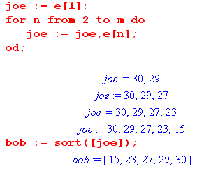

How do I remove duplicate elements from a list? Answer: convert it to a set and then back to a list.

1. Conversion between Set and Sequence

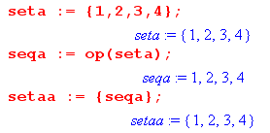

2. Conversion between List and Sequence

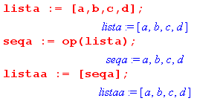

3. Conversion between Set and List. Note how to filter duplicate items!

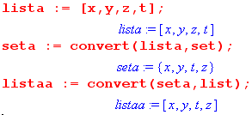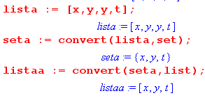

4. Convert between Array and a List

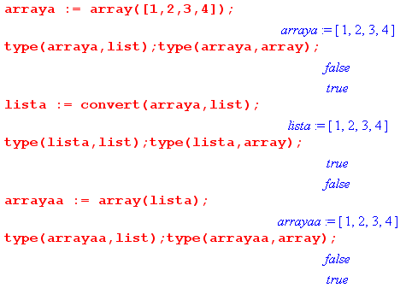

I am now very close to what I want. For example

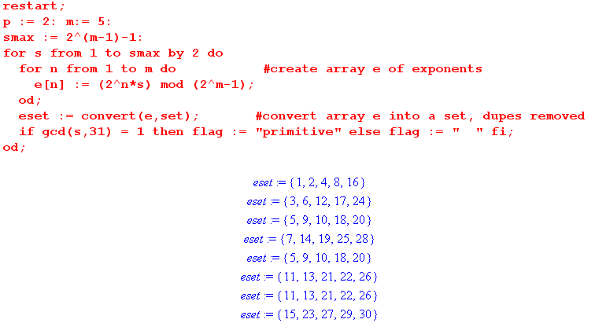

It only remains to somehow throw out the duplicate sets.

OK, I have now advanced a bit to this point:

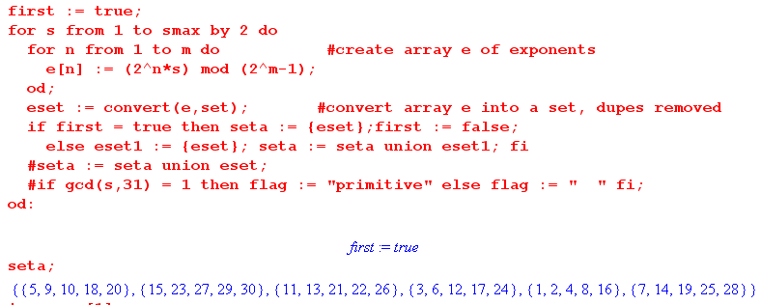

I maintain a set of sets, and as a result, duplicate sets of exponents are automatically removed.

Now all that remains is to get a primitive p symbol in there somehow. OK, here we are

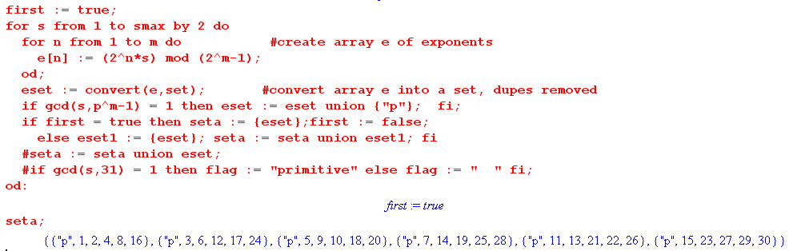

I find that the sets are not always sorted, so want to convert to a list and then I can use the sort command because you cannot sort a set.

I have moved a long quite a bit now. One bug is that Prog sometimes goes to the start of my list!

OK, it is now all done and I pronounce it good! It has been installed.

