Totient Function PhL 7.7.13

This is development material for Appendix G. I think all matters are resolved.

I am looking at this little Euler's Theorem proof

http://philosophyforprogrammers.blogspot.com/2011/07/clever-proof-of-eulers-theorem.html

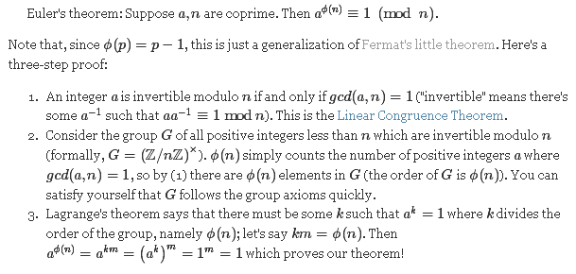

1. Definition of the totient function φ(n).

So if you count the number of integers coprime to integer n which are less than n, you get φ(n).

First, lets verify this against my little table.

coprimes to n φ(n)
n = 1 1 1
n = 2 1 1
n=3 1,2 2
n=4 1,3 2
n = 5 1,2,3,4 4
n=6 1,5 2
n = 7 1,2,3,4,5,6 6

For prime number, φ(n) is always n-1.

2. Why is the number of primitive elements of GF(pm) equal to φ(q-1) ?

We know that pm-1 = q-1 which has a set of divisors which I know about, but I don't think that is the relevant item. Rather, recall this Fact

Fact 6: If β is any element of (α,n,•), then the order of β divides n, the order of α. More specifically, we claim that [order of β] = n/GCD(k,n) where β = αk. (4.21)

My corollary (stated in App E or F maybe). Let the group be (α,q-1,• ) = {GF(q) - 0} so n = q-1. Here α is a primitive element of GF(q). Then the Fact says

[order of β] = (q-1)/GCD(k,q-1) where β = αk

A corollary to this would be

β = αk is a primitive element if GCD(k,q-1) = 1 where k = 1,2...q-2 because αq-1 = 1

Thus, for each k that is coprime to q-1 and is less than q-1, we get a primitive element which is different since all these powers are different. Thus

Number of primitive elements = number of integers k that are coprime to q-1 ≡ φ(n)

Wow, that was pretty easy.

3. If a and n are coprime, then there exists an inverse of a inside mod n

OK, let a be an element of mod(n). We seek an inverse b of a such that ab = 1.

OK, this leads to many details: Linear Congruence Theorem, and (a,b) notation for gcd(a,b).

One claim is this: ( this is NOT in B&M except when (c,m) = 1.

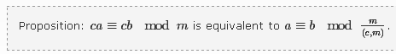

http://math453spring2009.wikidot.com/lecture-7 is where I saw the above.

If I can prove this, then this proof of LCT makes sense:

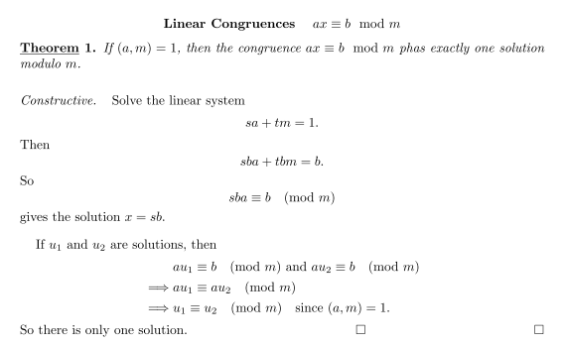

and then I can apply this to the inverse idea and then to the group idea G and then get Euler's Theorem. This is definitely another Appendix if I want to do it. I have already made pretty good progress.

I am stuck now showing that (a,b) = (a+b,b). Proof supposedly in 3.6 of this book

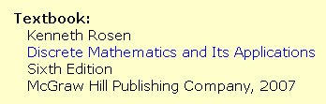

Well, I got the book (parts missing) and found the proof. Here it is

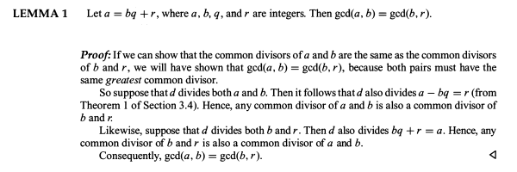

July 9, 2013. But found in my Euler's Theorem proof:

Fact 11: (Euler's Theorem). For any a in Gn, aφ(n) = 1 mod n . (G.17)

Proof: Fact (1.9e) says that for any a in group G, an = 1 where n is the order of the group. What that means here is a•a•a...•a = 1 where we have φ(n) factors of a since from Fact 10 the order of Gn is φ(n). The operation • is that of Zn of which Gn is a subset. For elements in Zn we know that a•b= ab mod n. Thus, a•a•a...•a = aφ(n) mod n if we interpret aφ(n) as aaaa..a (integer multiplication). Thus, we have Euler's Theorem:

a•a•a...•a = aφ(n) mod n = 1 or aφ(n) = 1 mod n

This theorem was proved by Euler in 1763. The theorem and the totient function φ(n) play a major role in current day RSA public key cryptography.

I state the theorem only for a in Gn , but the real theorem says it is valid for all integers a. I have verified this in wiki. Hopefully I just have to modify things a bit. // I just added (1.31a,b) to formally state the mod arithmetic rules, I used these rules many times but never stated them!

Suppose b is some arbitrary integer. Then

bφ(n) mod n = (bbbb...b) mod n = [ b mod n]φ(n)

so now at least we have b inside Zn. If b mod n happens to be in Gn, then we know [ b mod n]φ(n) = 1. But suppose b is NOT in Gn. Then what happens? We know only that b is in Zn. This ring is additively cyclic. Is it • cyclic as well? No, it is not a • cyclic group because it is not even a group since inverses are missing. Since Zn is not a group, we cannot use any group theory theorem. Consider:

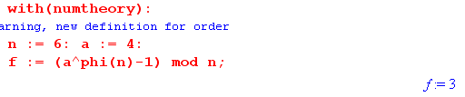

This shows that Euler's Theorem is NOT VALID for G6 and a = 4. So OK, wiki and I both have this right.

Now look at Fermat. In this case p = 7 say, then
***************

Example: Z8 = {0,1,2,3,4,5,6,7} = Mod(8,+,•)
G8 = {1,3,5,7} with • operation of Z8. Note that φ(8) = 4.
3 • 3 = 9 mod 8 = 1 ∈ G8 3-1 = 1 5 • 5 = 15 mod 8 = 7 ∈ G8 5-1= 7
3 • 5 = 15 mod 8 = 7 ∈ G8 5 • 7 = 35 mod 8 = 3 ∈ G8
3 • 7 = 21 mod 8 = 3 ∈ G8 7 • 7 = 49 mod 8 = 1 ∈ G8 7-1 = 1

Thus, G8 is closed under • and all elements have an inverse.

Hold this for a moment

In the above we may take (α,n,•) to be (α,q-1,•) where the cyclic group is all of {GF(q) - 0) }, as will be shown in Big Theorem 1 (4.30) below. The order this cyclic group is n = q-1. Thus, Fact 6 specialized to this case says [order of β] = (q-1)/GCD(k,q-1) where β = αk . Here α is an element of GF(q) which has order n=q-1 so that αq-1 = 1. Such an element α is said to be a "primitive element", as described near (4.30) below. We have then proven this Corollary to Fact 6:

Corollary. If α is a primitive element of GF(q), and if GCD(k,q-1) = 1, then the element β = αk is also a primitive element. this already appears as (4.32) below! (4.21a)

