Index of non-trivial Maple Code for Galois doc PhL 7.11.13

This file includes all Maple items in the exact order they appear in Galois doc. page numbers change, sections are hard to find, I think one can just do a visual search. For each non-trivial item below, I will try to identify the mws file in which it is located. So if you want to find the code for some item in Galois, find that item below and then note the file name. The Galois mws files are now in a single folder.

Note: Witzend can search mws file for any text, but type it right! That is how I did things here.

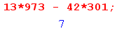 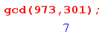 nowhere

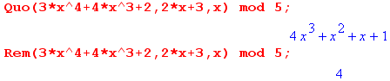 nowhere

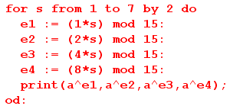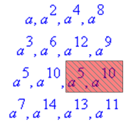 galois main.mws

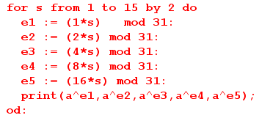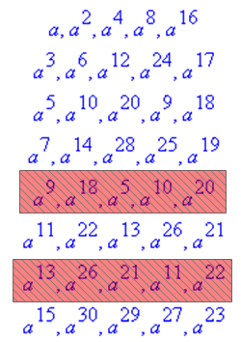 galois main.mws

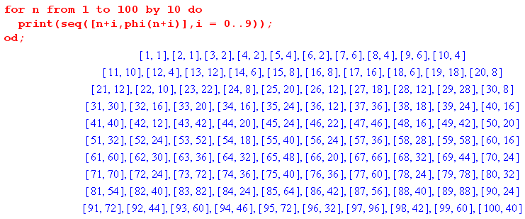
phi.mws
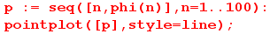 phi.mws

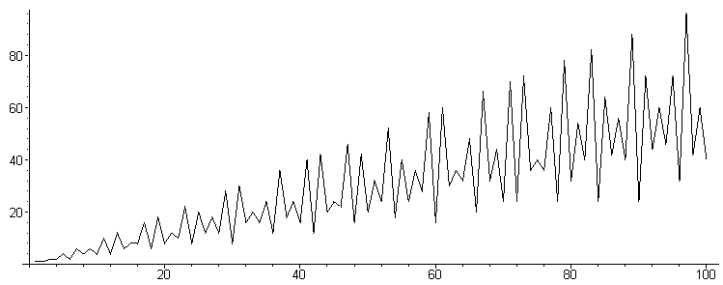
phi.mws

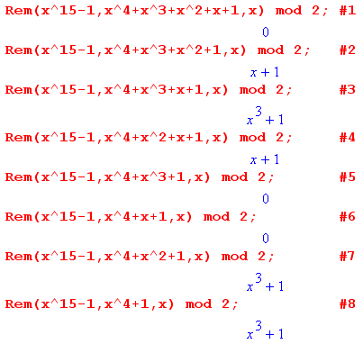 galois main.mws

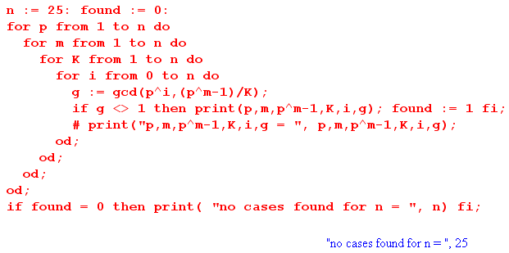
test5_35a.mws

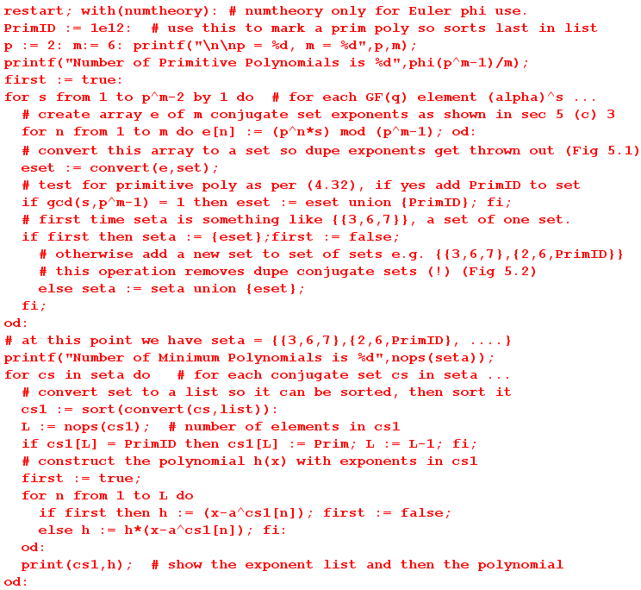
show conj sets.mws

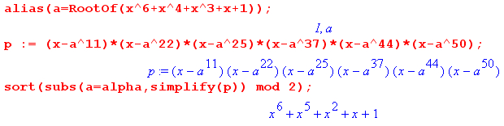 galois main.mws

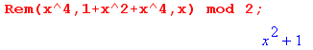 galois main.mws

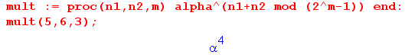 galois main.mws

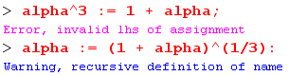 cannot find this

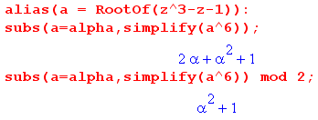 galois main.mws

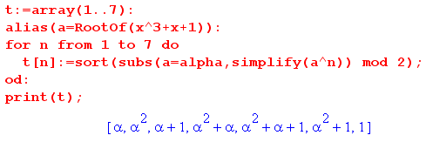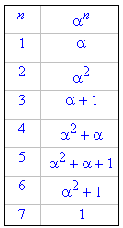 galois main.mws

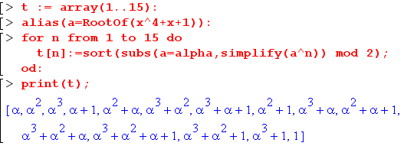 galois main.mws

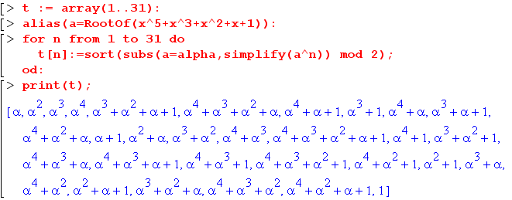 galois main.mws

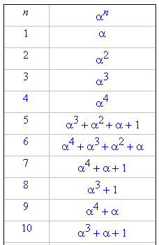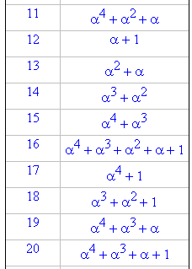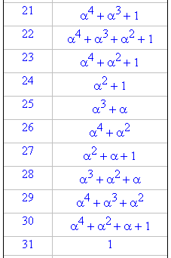
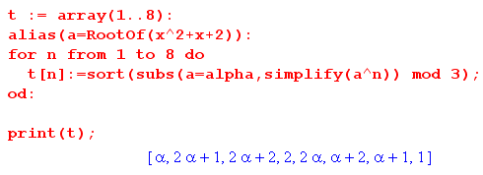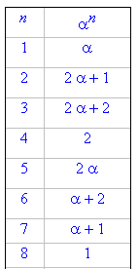 galois main.mws

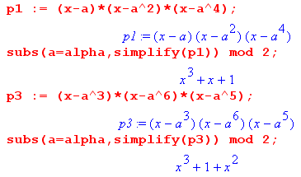 galois main.mws

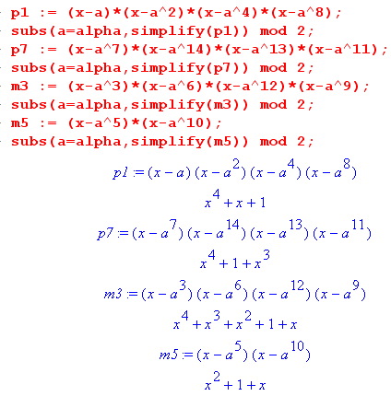 galois main.mws

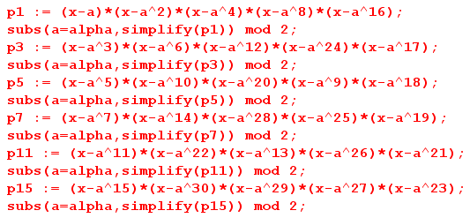 galois main.mws

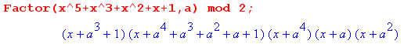 galois main.mws

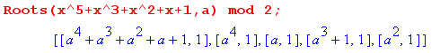 galois main.mws

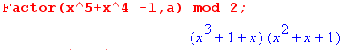 galois main.mws

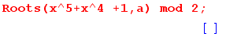 galois main.mws

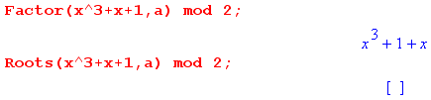 galois main.mws

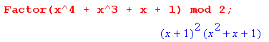 galois main.mws

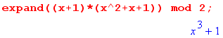 galois main.mws

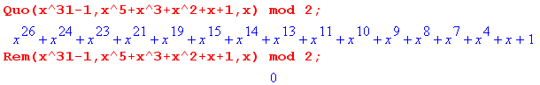 galois main.mws

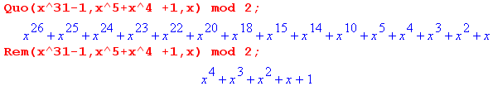 galois main.mws

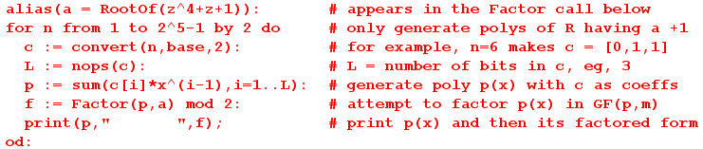 galois main.mws

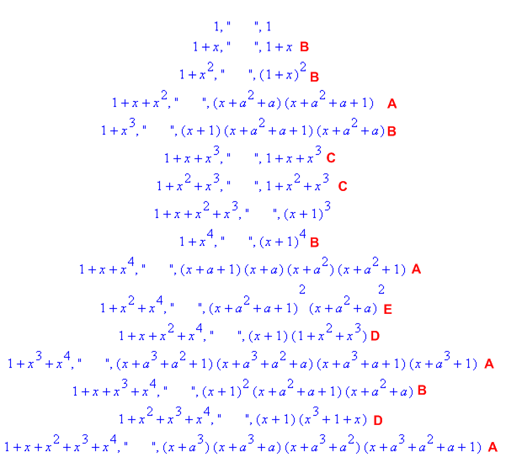 Visio

search for period.mws
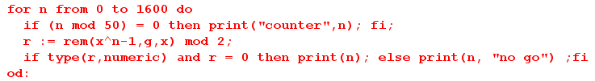
search for period.mws

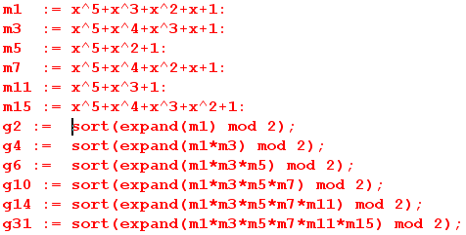 galois main.mws

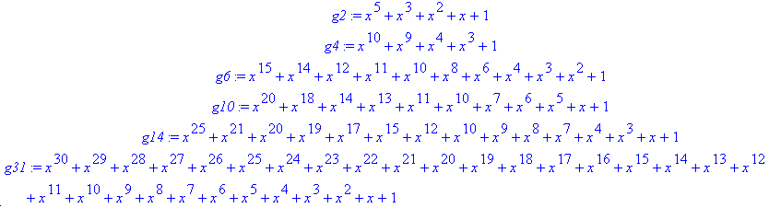
galois main.mws

(d) Maple program to construct the matrix representation of GF(pm)

The code is self-documented. The p,m values selected in this code are for GF(23).

matrix rep.mws
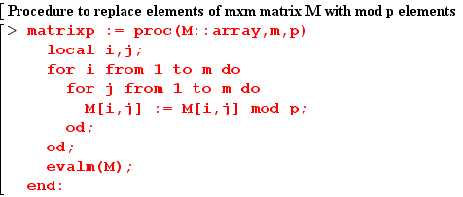 matrix rep.mws

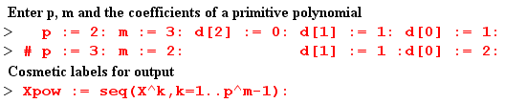 matrix rep.mws

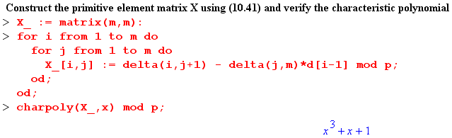 matrix rep.mws

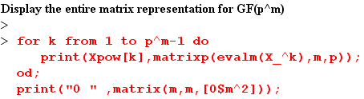

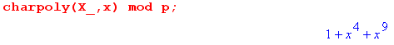 matrix rep.mws

In this case brute force calculation should give X511 = I. Maple cheerfully does the job:

matrix rep.mws

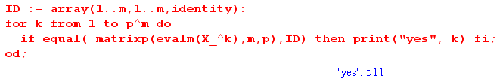 matrix rep.mws

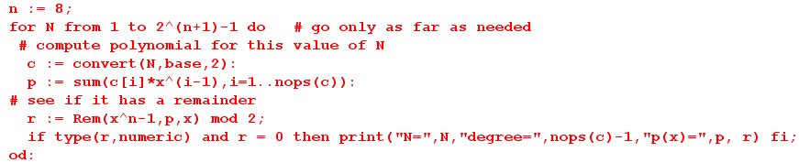
test2.mws

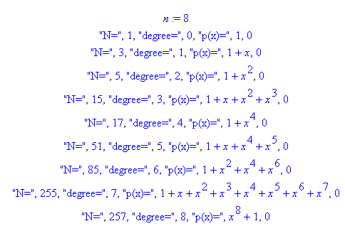 test2.mws

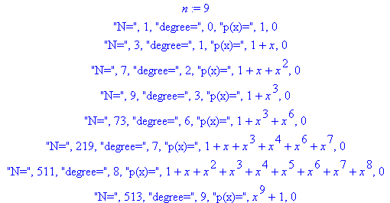 test2.mws

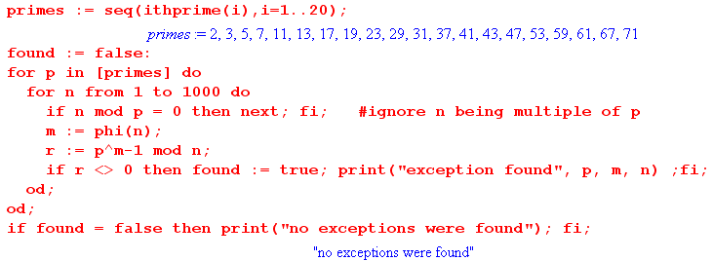
search divisors for n.mws

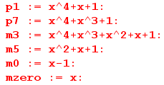 search divisors for n.mws

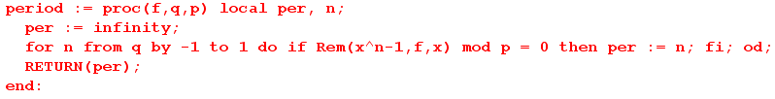

search divisors for n.mws

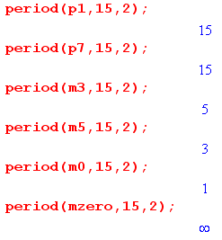 search divisors for n.mws

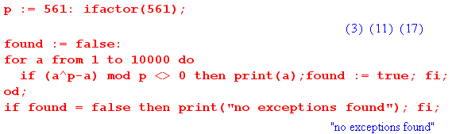App G.mws

