Ellipse in Polar Coordinates PhL 11.13.16

Start with an ellipse centered at the origin,

$\frac{x2}{a2}$ + $\frac{y2}{b2}$ = 1

We want to shift this horizontally to the right so that the center of the ellipse is at xc = +c.

$\frac{(x-c)2}{a2}$ + $\frac{y2}{b2}$ = 1 (1)

which says the xc = c. Here is a picture of this shifted ellipse

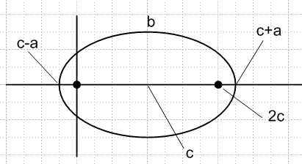

This puts the left focal point at the origin!

Write as (1) as :

f ≡ b2(x-c)2 + y2a2 - a2b2 = 0 .

Now make these replacements:

x = rcosθ
y = rsinθ
b = $\sqrt{a2-c2}$
c = εa

and do it all in Maple:

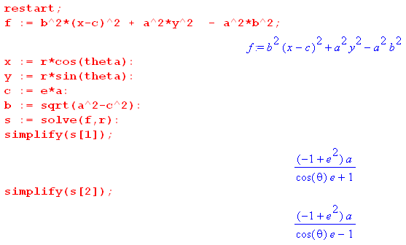
There are two solutions which are

r± = $\frac{a(1-ε2)}{1± ε cos(θ)}$

Why are there two solutions? Well, it was a quadratic equation in r. I know from my setup above if we set θ = π we should get r = a-c (see picture) . Let's test the two results

r+ = $\frac{a(1-ε2)}{1+ ε cos(θ)}$ = $\frac{a(1-ε2)}{1- ε}$ = a(1+ε) = a + c

r- = $\frac{a(1-ε2)}{1- ε cos(θ)}$ = $\frac{a(1-ε2)}{1+ ε}$ = a(1-ε) = a -c

Only r- is correct, while r+ is spurious for my positioning of the ellipse.

Suppose I started shifting the other way. That is like taking c → -c and that is like ε → -ε. So in that case the correct solution is r+.

Here are the conclusions:

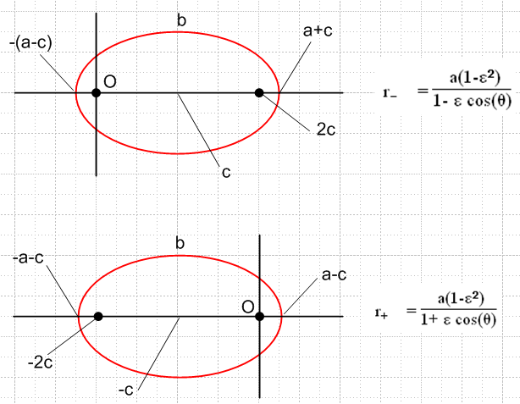

Fact: In either polar coordinate representation of the ellipse, the origin is at a focal point of the ellipse.

Final check:

r+(θ=0) = $\frac{a(1-ε2)}{1+ ε 1}$ = a(1-ε) = a - c correct
r-(θ=0) = $\frac{a(1-ε2)}{1- ε 1}$ = a(1+ε) = a + c correct

Just as a final look, here are the angles θ for the two ellipse cases

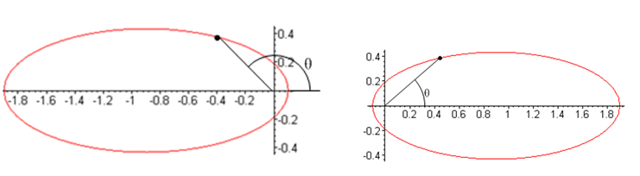

In each case θ takes the full range 0 to 2π since the origin lies inside the ellipse.

