Hyperbola PhL 1.15.16

1. Centered Cartesian hyperbola.

Start with a hyperbola centered at the origin,

$\frac{x2}{a2}$ - $\frac{y2}{b2}$ = 1 (0)

Here is a quick implicitplot of this function [ note that c = $\sqrt{a2+b2}$ = $\sqrt{5}$, ε = c/a = $\sqrt{5}$/2. ]

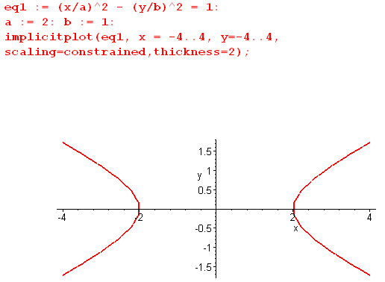

Comment: If you swap the signs of the two terms on the left of the equation (0), you get a hyperbola with upper and lower branches instead of left and right branches.

Now solve the equation for y:

(y/b) = ± $\sqrt{(x/a)2- 1}$

To get a real solution, you must have |x/a| > 1 so |x| > a. In the plot we have |x| > 2.
You get y = 0 when |x/a| = 1 or x = ±a . Plot confirms.
To get y = b, you need (x/a)2 = 2 so |x/a| = $\sqrt{2}$ so x = ± $\sqrt{2}$a. In our example this is 2$\sqrt{2}$ = 2.8

To get from ellipse to hyperbola, you need to take b → ±ib to get that minus sign on the second term. As a result, you get c2 = a2- b2 → a2+b2. For the example above, c2 = 4+1 = 5, c = $\sqrt{5}$ = 2.24. Note here that the eccentricity is ε = c/a = $\sqrt{5}$/2.

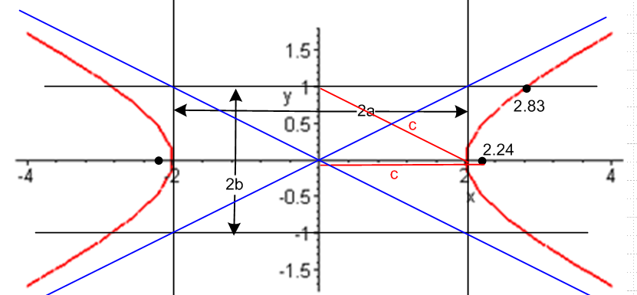

The above shows "the central box" and two representations of the distance c. The focal points are ±c relative to the origin, by definition and by continuation from the ellipse. The ellipse string rule said this

$\sqrt{(x+c)2 + y2}$ + $\sqrt{(x-c)2 + y2}$ = 2a or | r + c | + | r - c | = 2a

c = $\sqrt{a2-b2}$

Somehow the new string rule becomes this (Schaum)

$\sqrt{(x+c)2 + y2}$ - $\sqrt{(x-c)2 + y2}$ = 2a for right side of the hyperbola

Comments: For the ellipse, you could "see" parameters a and b at once, and c = $\sqrt{a2-b2}$told you where to put the two foci. For the hyperbola you can only "see" the parameter a. How can you determine b and c just looking at the picture and not knowing the Cartesian equation? One way is to draw the asymptotes as I have done in blue. You already have the two vertical black lines x = ±a. The intersection of the upper right asymptote with the right black vertical line gives you y = b. So this is a somewhat indirect way to get the distance b. Once you then have the horizontal black lines, you have the diagonal c as shown.

2. Doing a shift right by c to get a polar coordinates version of the hyperbola

We want to shift the above horizontally to the right so that the left focus is at the origin. That means we shift x by c so we then have

$\frac{(x-c)2}{a2}$ - $\frac{y2}{b2}$ = 1 ⇒ (y/b) = ± $\sqrt{(x-c)2/a2- 1}$ (1)

Just to make sure we did this right, here is an implicitplot of the above equation

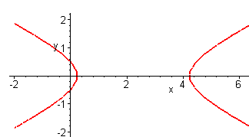

The center of the ellipse is at x = c because that is how much we shifted.

Now y = 0 when |x-c| = a, these points are when distance of x from c (center point) = a.

Write (1) as

f ≡ b2(x-c)2 - y2a2 - a2b2 = 0

Now make these replacements:

x = rcosθ
y = rsinθ
b = $\sqrt{c2-a2}$
c = εa

and do it all in Maple:

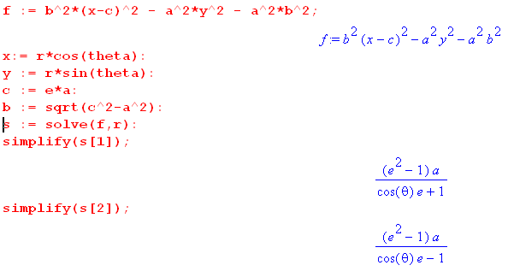

So we can write these two solutions for ε > 0

r± = $\frac{a(ε2-1)}{εcos(θ) ± 1}$ = $\frac{a(1-ε2)}{-εcos(θ) ∓ 1}$ = $\frac{a(1-ε2)}{∓ 1-εcos(θ)}$ = ∓ $\frac{a(1-ε2)}{1±εcos(θ)}$

Recall that the ellipse equations were

r± = $\frac{a(1-ε2)}{1± ε cos(θ)}$ // ellipse

so the equations are not quite the same, there is an extra leading ∓ sign. So let's go with our first form that has a positive numerator for the hyperbola,

r± = $\frac{a(ε2-1)}{εcos(θ) ± 1}$ // hyperbola

We have another new "feature" which is that all θ are no longer allowed because we cannot have a negative radius. The legal range requires

εcos(θ) ± 1 > 0
or
εcos(θ) > ∓ 1
or
cos(θ) > ∓ 1/ε

Let's take the solutions one at a time.

r+ = $\frac{a(ε2-1)}{εcos(θ) + 1}$ cos(θ) > - 1/ε

For the range 0,2π this condition says θ < cos-1(-1/ε) =cos-1(-2/$\sqrt{5}$) = 2.678

For both signs, it says

-2.678 < θ < 2.678

If I plot this solution for -2.6 to 2.6 it looks like this:

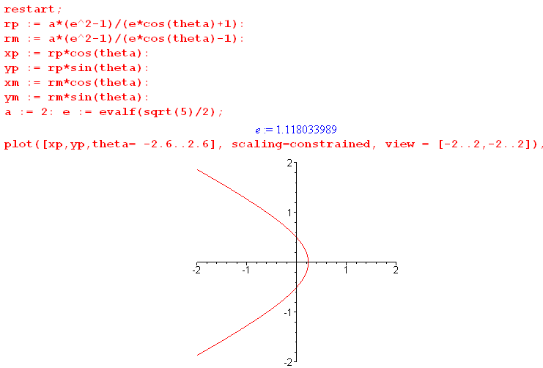

so the r+ solution seems to generate the left side of the hyperbola. Look at θ

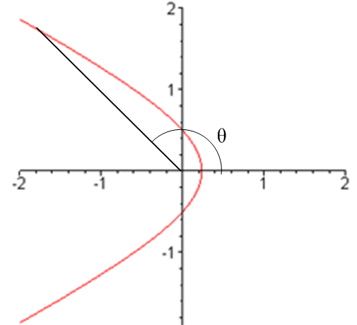

You can see that -2.678 < θ < 2.678 makes sense in terms of this picture.

Digression: What happens if I try to plot outside this range? For example

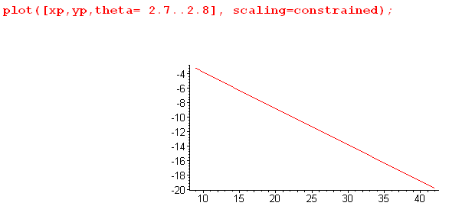

Why do we get a straight line in this case? It is not really a straight line, for example

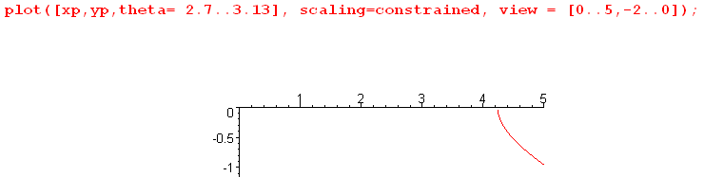

I will just ignore this, even though it probably makes the right side hyperbola.

So far then I know that

r+ = $\frac{a(ε2-1)}{εcos(θ) + 1}$ cos(θ) > - 1/ε -2.678 < θ < 2.678 in example

gives the left branch of the hyperbola. Now what does the other solution say?

r- = $\frac{a(ε2-1)}{εcos(θ)- 1}$ cos(θ) > + 1/ε -.464 < θ < .464

Here is a plot of this solution

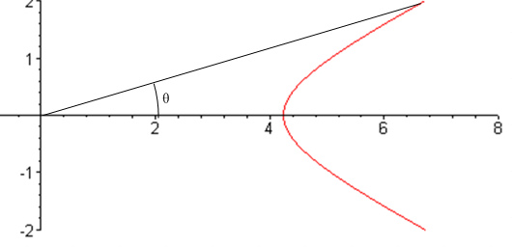

So for θ in the legal range for this side, we get the right branch of the hyperbola and the picture shows that the legal range of θ "makes sense".

Conclusion:

(1) When you express a left-right hyperbola of this form

$\frac{x2}{a2}$ - $\frac{y2}{b2}$ = 1 (0)

in polar coordinates, you get separate equations for the two branches of the hyperbola:

r+ = $\frac{a(ε2-1)}{εcos(θ) + 1}$ cos(θ) > - 1/ε -cos-1(-1/ε) < θ < cos-1(-1/ε) left branch

r- = $\frac{a(ε2-1)}{εcos(θ)- 1}$ cos(θ) > + 1/ε -cos-1(1/ε) < θ < cos-1(1/ε) right branch

In each case the range of θ is restricted, though θ is the "usual" polar angle. The value of r± is not restricted and runs off to infinity on the asymptotes.

(2) The left focus is located at the origin.

(3) The "picture" is this when before the hyperbola is shifted to the left:

The value of a is clear from the picture, but you have to draw the blue asymptotes to determine b, and then the graphic diagonal tells you c, which you let fall down so you can put a dot at c.

(4) We still have ε = c/a but now ε > 1. And b2 = c2- a2 for the hyperbola and clearly c > a from the pic.

(5) string rule is now on distance differences rather than sums.

(6) here is the general picture after the shift

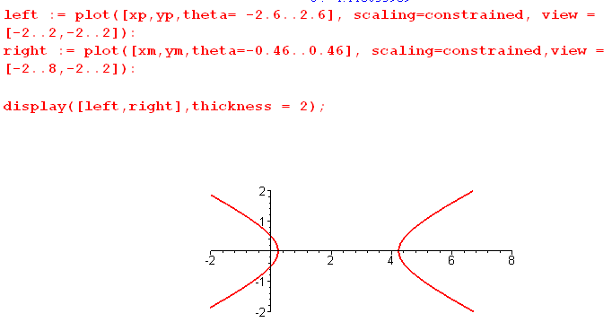

It is not really a pleasant picture. The left focus is at the origin and that is the goal. θ is always measured in the usual manner relative to the origin. Here for the right side:

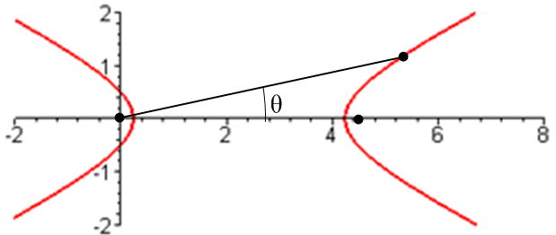

3. Doing a shift left by c to get a new polar coordinates version of the hyperbola

Now consider

$\frac{(x+c)2}{a2}$ - $\frac{y2}{b2}$ = 1 ⇒ (y/b) = ± $\sqrt{(x-c)2/a2- 1}$ (1)'

If I put this into the same Maple program as above, I get two perhaps new solutions:

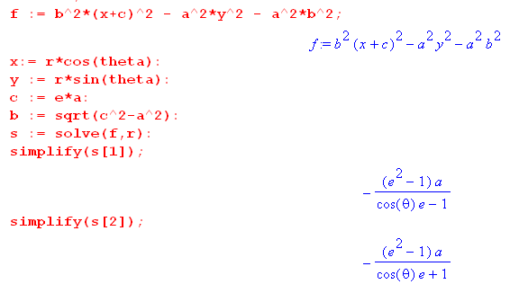

Now the right focus is at the origin instead of the left focus. The two solutions are now

r± = - $\frac{a(ε2-1)}{εcos(θ) ± 1}$ = - $\frac{a(ε2-1)}{± 1+ εcos(θ)}$ r+ = - $\frac{a(ε2-1)}{1+ εcos(θ)}$

Again we study these one at a time. The requirement for r being + is now

εcos(θ) ± 1 < 0 // this was > 0 in the right shift case

εcos(θ) < ∓ 1
or
cos(θ) < ∓ 1/ε

In the two cases we have

θ+ = cos-1(-1/ε) = 2.68
θ- = cos-1(+1/ε) = .464

But how the "physical ranges" of θ are different

For r+ the legal range is now (-3.14, -2.68) union with (2.68,3.14).

For r- the legal range is now (-3.14, -.464) union with (.464,3.14).

Here then are the two parts of the r+ curve which we see is the left branch.

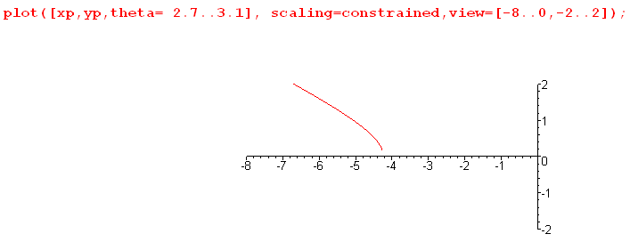
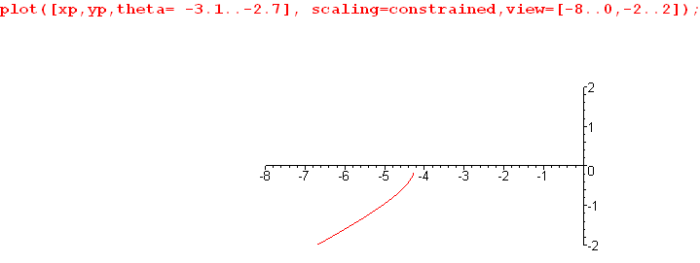

By going to the (0,2π) range I can get this with a single shot for r+ :

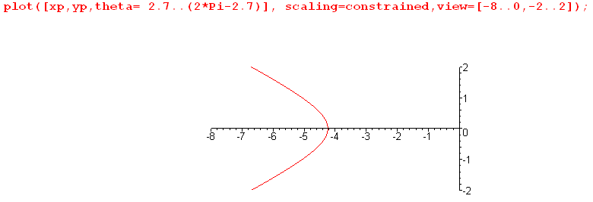

r+ = - $\frac{a(ε2-1)}{1+ εcos(θ)}$ and cos(θ) < - 1/ε

The above is the setup for Goldstein repulsive scattering where scattering center is at the origin. This matches his equation (3-64) on page 83. Now we can work on his picture a bit:

So r- is probably going to be the right branch:

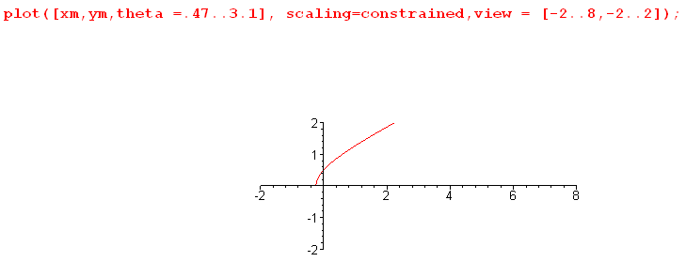

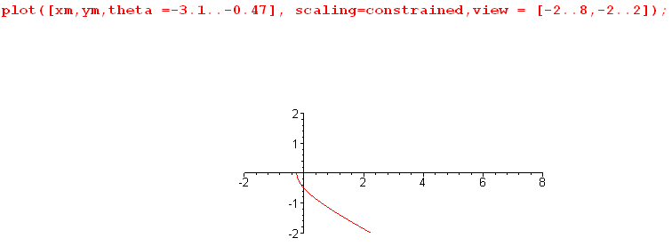

And here then is the whole thing in a single shot

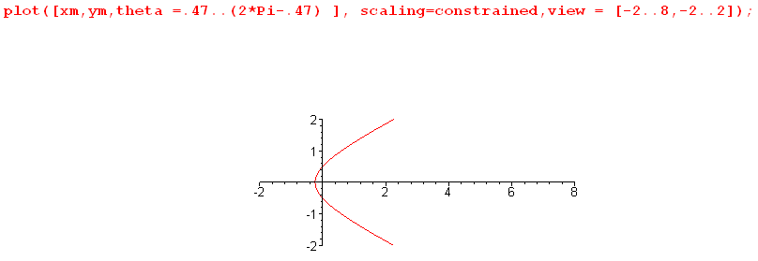r- = - $\frac{a(ε2-1)}{-1+ εcos(θ)}$

If the red line indicates the path of a scattered particle, then there is an attractive potential at the origin! Alternatively, this same path would agree with a repulsive potential at the left side origin. This is what Goldstein's page 84 drawing is showing.

Now take the r+ branch shown above and rotate it to get

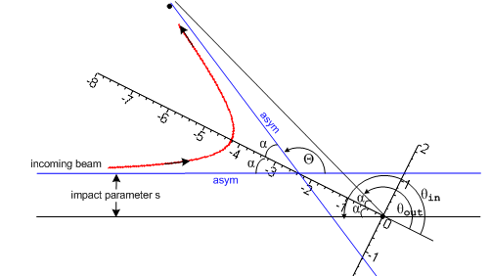

Here the asymptotes are blue. If we take the outgoing particle position to be very far away, the tilted asymptote and the black line are parallel.
We are now only interested in particle positions very far away on both the input and output side (r very large). I show θin as the angle of a distant incoming particle on the hyperbola, and θout for the outgoing. The official scattering angle here is Θ, while the polar angle is θ. Notice that

θin - θout = π - Θ ≡ Φ = 2α

But we also see that
∂
θout = π - α = π - Φ/2
θin = π + α = π - Φ/2

I know that at the extreme ends of the hyperbola

cos(θout) = cos(θin) = -1/ε

since these make r→∞. Then we find lots of facts:

cos(π-Φ/2) = - 1/ε = -cos(Φ/2) ⇒ cos(Φ/2) = 1/ε

sin(Θ/2) = sin([π-Φ]/2) = sin(π/2 - Φ/2) = cos(Φ/2) = 1/ε

I am now happy with all the equations on page 83, and there are quite a few. It took a while.

We don't really care about the hyperbola equation and the red line anymore (and its equation). We are now doing S matrix scattering. I know for the red hyperbola branch that cos(θ) < - 1/ε for all points on the hyperbola. That is to say, I know that

cos(θ) < - 1/ε for θout < θ < θin

I would guess that α

cos(θout) = -1/ε
cos(θin) = -1/ε

Goldstein's Fig 3-14 really does show that

cos(π-Φ/2) = -1/ε

π - Φ/2 = θout

π + Φ/2 = θin

