A Geometry Paradox and Related Issues PhL 12.9.13

See Resolution title line in red below. The resolution is that you need to regard 2D f(x,y) = 0 as an extruded surface in 3D (extruded ellipse say), and then when you rotate that surface, you get a rotated extruded ellipse and a rotated z = 0 plane whose intersection with the rotated extruded ellipse is a rotated floating ellipse. So the rotation maps surface into surface.

Paradox density seems to increase with age, not a good sign.

Paradox:

(1) Whereas: if in space S' you write the equation of a plane figure like an ellipse, line or circle, the equation has the general form f(x',y') = 0 which one could solve to get y' = g(x') and this would then describe that curve in 2D space in S' space.

(2) If you view this from a rotated space S in terms of coordinates x,y,z, it would seem that you should end up with an equation of the form F(x,y,z) = 0 which could then be solved as z = G(x,y).

(3) Here is the paradox: one would expect a rotated ellipse to be a curve, whereas z = G(x,y) is the equation of a surface in 3D space, not a curve in 3D space. So what's the deal here?

Preliminary. I finally found my rotation matrix

Rz(φ) Ry(θ) = 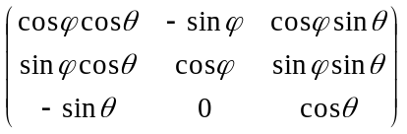$\left(\begin{matrix}0 \\ 0 \\ 1\end{matrix}\right)$

So in this case I would write

$\left(\begin{matrix}x \\ y \\ z\end{matrix}\right)$ = $\left(\begin{matrix}x' \\ y' \\ 0\end{matrix}\right)$

I just entered this matrix into Maple so I could get its inverse:

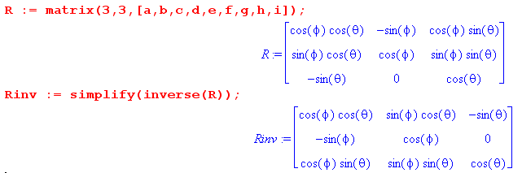

Here I will use primes to represent the figure in the original 2D space, and the non-prime coordinates to represent the figure in the rotated space, which is to say in effect, the rotated figure. Then

x = cosφcosθ x' -sinφy' x' = cosφcosθ x + sinφcosθ y -sinθ z
y = sinφcosθ x' + cosφ y' y' = -sinφ x +cosφ y
z = -sinθx' z' = cosφsinθ x + sinφsinθ y + cosθ z

Simple Paradox Example. So let's try out a very simple 2D figure: a line through the origin y' = x' which is a "curve" in 2D space (x',y'). In the rotated frame here is what this looks like:

y' = x'
or
-sinφ x +cosφ y = cosφcosθ x + sinφcosθ y -sinθ z (*)

The equation (*) has this form

z = f(x,y)

and therefore it should be a surface, not a curve. My paradox is still alive! The form of the equation is this

z = Ax + By

which is the equation of a plane which passes through the origin, it is not a rotated line.

However, the third equation of the set on the right ways this, since z' = 0 for the original planar figure,

0 = cosφsinθ x + sinφsinθ y + cosθ z

This is the equation of a second plane passing through the origin. It has to be true. So probably the rotated line will be the intersection of these two planes. Here again are the planes

-sinφ x +cosφ y = cosφcosθ x + sinφcosθ y -sinθ z
0 = cosφsinθ x + sinφsinθ y + cosθ z
or
sinφ x -cosφ y + cosφcosθ x + sinφcosθ y -sinθ z = 0
cosφsinθ x + sinφsinθ y + cosθ z = 0
or
(sinφ + cosφcosθ)x + (sinφcosθ-cosφ)y = sinθ z
cosφsinθ x + sinφsinθ y = - cosθ z

I have plotted these two planes in Maple:

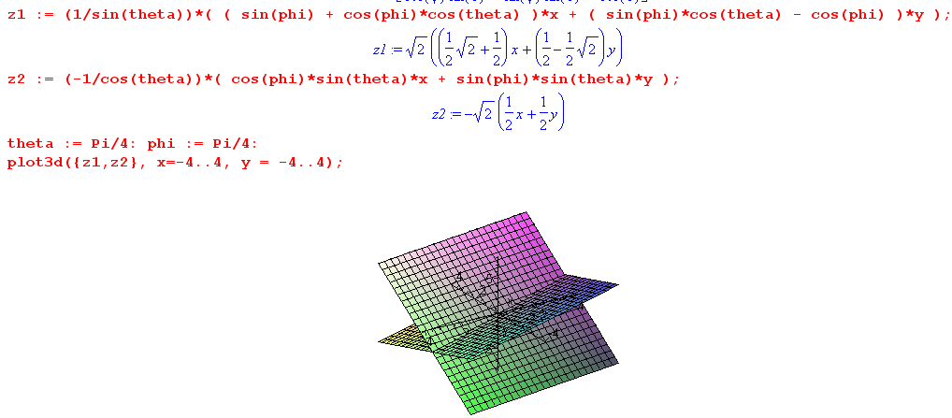

and you see the two planes through the origin, and the intersection of these two planes is the rotated line.

More generally, suppose we had some general f(x',y') = 0 as our 2D curve. Then we end up with

f(x',y') = 0
or
f(cosφcosθ x + sinφcosθ y -sinθ z, -sinφ x +cosφ y) = 0 // specific for figure
cosφsinθ x + sinφsinθ y + cosθ z = 0 // always the same

Suppose f described an ellipse,

Ax'2 + By'2 = 1

Then our two equations are

A [cosφcosθ x + sinφcosθ y -sinθ z]2 + B[-sinφ x +cosφ y]2 = 1
cosφsinθ x + sinφsinθ y + cosθ z = 0 // always the same

I would guess that the first equation defines an ellipsoidal surface with center at the origin, and then the rotated ellipse is the intersection of that ellipsoid with a the second line's plane through the origin. [wrong guess]

Note: It is not obvious to me that the first equation is an ellipsoid [it is not!! It is an extruded ellipse.] . Nor -- if it were an ellipsoid -- is it obvious to me that slicing an ellipsoid with an arbitrary plane through its center gives an ellipse. [I have no idea whether this would give an ellipse or not, not relevant ]

Now view this differently. Suppose we start with this surface in 3D

f(cosφcosθ x + sinφcosθ y -sinθ z, -sinφ x +cosφ y) = 0 F(x,y,z) = 0

If we take an arbitrary point (x,y,z) on this surface, that corresponds to some (x',y',z') in frame S'. We will find that

f(x',y') = 0
z' = cosφsinθ x + sinφsinθ y + cosθ z

Those points on the surface F(x,y,z) = 0 which happen to give z' = 0 will map into the 2D ellipse in frame S'. We can think of this inverse mapping as some G(x',y',z') = 0. This is some surface in S' whose intersection with the z' = 0 plane is an ellipse! I think the surface in S' is an extruded ellipse! The reason is that every point on F(x,y,z) = 0 yields a point in S' such that f(x',y') = 0 and it is z' which varies.

So now I claim that the rotation does this mapping:

extruded ellipse in S' ⇔ some surface in S

But the mapping is just a rotation, so that surface in S must also be an extruded ellipse!

Suppose then that we start with these two equations which described the extruded ellipse in S' :

f(x',y') = 0 f(cosφcosθ x + sinφcosθ y -sinθ z, -sinφ x +cosφ y) = 0
cosφsinθ x + sinφsinθ y + cosθ z = z0

z' = z0 z0 = any real number

When viewed from space S, these equations become

f(cosφcosθ x + sinφcosθ y -sinθ z, -sinφ x +cosφ y) = 0
cosφsinθ x + sinφsinθ y + cosθ z = z0

Here is a plot in S space of the first equation:

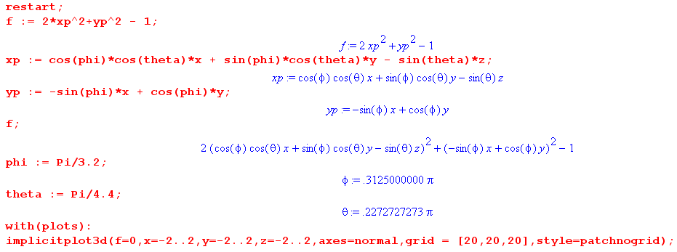

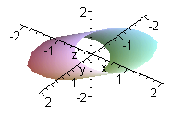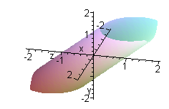

You see that indeed the surface f(cosφcosθ x + sinφcosθ y -sinθ z, -sinφ x +cosφ y) = 0 is an extruded ellipse in the space S.

Resolution of the Paradox:

When in space S' you specify a 2D curve by f(x',y') = 0, you are saying nothing about z'. In fact z' can be any value you want, so lets say z' = z0 . For z0 = 0, the 2D curve happens to lie in the z' = 0 plane. As you vary z0 over all real values, you generate an "extruded" version of the shape f(x',y') = 0. This extruded shape is of course a "surface" in 3D. The rotation which takes S' to S rotates this extruded surface so that rotation does a logical mapping of an extruded surface with axis in the z' direction, to an extruded surface whose axis lies in some general direction. Then if you are interested in your 2D figure f(x',y') = 0, you regard it as the intersection of the extruded surface in S' with the plane z' = 0. In the rotated space, the rotated figure there will be the intersection of the rotated extruded surface with the rotated z' = 0 plane. Here then are the equations of the rotated extruded surface and the rotated z' = 0 plane:

f(cosφcosθ x + sinφcosθ y -sinθ z, -sinφ x +cosφ y) = 0
cosφsinθ x + sinφsinθ y + cosθ z = 0

In the simple example of the line x' = y', the extruded line in S' is of course a plane, and the intersection of that plane with z' = 0 is the line x' = y' of interest, the figure. In the rotated space S, the plane x' = y' gets rotated and so does the plane z' = 0, and it is the intersection of these planes that is the rotated line.

In the ellipse example, we start with the extruded ellipse in S' space which is intersected by the plane z' = 0. Then in S space we have an extruded ellipse (NOT an ellipsoid) which gets intersected by the plane perpendicular to it which is the rotated z/ = 0 plane.

So the Paradox was that I failed to think of the original figure as its extruded self due do non-specification of z'. Then we have a surface rotating into a surface, and all is well.

The second equation above can be written

• r = 0 where = (nx,ny,nz) = (cosφsinθ, sinφsinθ, cosθ)

This is the normal to the plane which slices the extruded figure in S space. Thus, is also the direction of the axis of the extruded figure in S space. The slicing plane passes through the origin, so it is uniquely specified by .

