Ellipse forms in rotated system PhL 12.9.13

1. Ellipsoid in 3D centered at the origin 1
1a. Another approach to the arbitrary origin-centered ellipsoid 2
2. Ellipsoid in 3D at arbitrary location. 5
3. Rotated general conic section 6
4. Most general form for a 2D ellipse centered at the origin 7
5. How do you describe a general origin-centered ellipse in 3D ? 11
6. A special ellipse of interest in 2D 11
6a. Another approach to the parametric ellipse. 14
7. Now here is some stuff from wiki. 15
General ellipse 15
8. A special ellipse of interest in 3D 17

____________________________________________________________________________________

OVERVIEW: (written 12.11.13) .// this acts as a full review of this doc

This was an "exploratory document", the canoe paddling into various side canyons, so things are a little disorganized.

In Section 1 I write the general form for an ellipsoid centered at the origin with (a,b,c) as a focus and with semi-major axis A. It is a poly of degree 2 of a certain form:

(A2-a2)x2 + (A2-b2) y2 + (A2-c2)z2 - [(2ab)xy + (2ac)xz + (2bc)yz] + A2(a2 + b2 + c2 - 1) = 0

In Section 1a I start with ellipsoid Ax'2+By'2+Cz'2 = 1 and I try to express this in R(θ,φ) rotated coordinates (x,y,z), but the result is a big mess of the form α x2+β y2+ γ z2 + δ xy + ε zx + κzy = 1. It is of course still a quadric since the rotational coordinate transform is linear. I state the "slicing plane" and when I combine the slicing plane equation with the rotated ellipsoid equation, I get an equation for the floating ellipse projected onto the z = 0 plane. I quote "Jerry and George" for support of this last idea. Then I realize from them that the "equation of a floating ellipse" is r(t) = A cos(t) + Bsin(t) + r0. where r0 is the origin. For an origin-centered ellipse write this as is r(t) = A cos(t) + Bsin(t) and then express and in terms of , and and then r(t) = a nice equation for your floating ellipse. I did not work this all out.
I then digress onto the question of what r(t) = A cos(φ) + Bsin(φ-φ0) describes since this is similar to my original problem where x = Acos(φ-a) etc. . This means r2 = A2cos2φ + B2sin2(φ-φ0) and you can then seek the value of φ that produces the max and min of r2 and these will be the semi-major axis directions. I solved this last problem in Maple and this led to a huge confusion and then resolution of an issue with the tan-1(x) function and how Maple deals with branches, as outlined in /calculus/a math problem.doc. The claim here is that r(t) = A cos(φ) + Bsin(φ-φ0) describes an ellipse, but I don't really prove this idea till a later section (Section 6).

Section 2 was written right after I wrote Section 1 and before Section 1a was inserted. In Section 2 I put the two ellipsoid foci and (a,b,c) and (d,e,f) and this gives a huge messy quadric for that ellipsoid which has all the quadric terms:

Ax + By + Cz + Dx2 + Ey2 + Fz2 + Gxy + Hyz + Ixz + J = 0
This is really not that helpful.

In Section 3 I write the general 2D quadric equation and remind myself that this describes some 2D "conic section" and if you include z, it is an "extruded into z" conic section. If you then rotated this surface, you get a "rotated extruded ellipse", say. The slicing plane cuts across this thing and the intersection of the rotated extruded ellipse with the rotated z = 0 slicing plane is an ellipse. The slicing plane can be interpreted as • r = 0 since points on it are perp to its normal.

In Section 4 I start with a 2D ellipse x'2/A2+ y'2/B2 = 1 and I rotate it by θ and get this "most general form for a rotated ellipse in 2D" :

[A-2cos2θ + B-2sin2θ]x2 + [2(A-2-B-2)sinθcosθ] xy + [A-2sin2θ + B-2 cos2θ] y2 = 1

which I interpret as dx2 + ey2 + fxy = 1. I then tackle the inverse question: given dx2 + ey2 + fxy = 1, how do you know if this is an ellipse or not? I verify the wiki claim that it is an ellipse if f2-4ed < 0 . The reason is that, in this case, you can solve for A,B,θ in terms of d,e,f which then fit "the most general form". I then go on to derive the characteristics of an ellipse stated as dx2 + ey2 + fxy = 1. I get expressions for A,B and θ as follows:

B-2 = (1/2) [ e + d + $\sqrt{f2 + (e-d)2}$]

A-2 = (1/2) [ e + d - $\sqrt{f2 + (e-d)2}$] A > B

θ = (1/2)tan-1[ f, d-e ]

Note that if f = 0, then B-2 = e and A-2 = d and θ = 0 all as you would expect.

Section 5 got aborted. I kept thinking there was some f(x,y,z) = 0 that would describe a floating ellipse, but of course f(x,y,z) = 0 is a surface while a floating ellipse is a curve, so this can never fly. All you can say in terms of surfaces is that the general floating ellipsoid has some surface equation, and there is a slicing plane normal to its major axis, and the intersection of these two surfaces is a floating ellipse.

In Section 6 I address the pair of parametric equations x = A' cos(t-a) and y = B' cos(t-b) since these are two of the three equations from the electron motion that got me into this whole subject. I first show that this can be written as a quadric of the form dx2 + ey2 + fxy = 1 and I then verify that f2 < 4ed so for the first time I have proven that this parametric equation pair really describes an ellipse. I then come up with expressions for the axes A and B and the rotation angle θ for this ellipse:

B-2, A-2 = (1/2) csc2(b-a) $\frac{1}{A'2B'2}$ [ A'2+ B'2 ± $\sqrt{A'4 + B'4 - 2A'2B'2[1 + cos(b-a)]}$ ]
θ = (1/2)tan-1[2cos(b-a)(A'B'), A'2-B'2 ]

In Section 6a I reconsider the same parametric pair x = A' cos(φ-a) and y = B' cos(φ-b) and I take the approach of writing r2 and finding the angles that max and min r2, an idea presented earlier (but I don't do all the work, just assume φA is computed). If φA is the angle of the semi major axis, then one can write

r(t) =A cos(ψ) +B sin(ψ) = Rz(φA) = Rz(φA)

where ψ is some new local angle on the rotated ellipse that starts at θ = 0 for the major axis. In retrospect, I can imagine writing the floating ellipse in 3D this way

r(t) =A cos(ψ) +B sin(ψ) = R(θA φA) = R(θA φA)

where θA and φA are the spherical coordinates of the rotation which takes the semi major axis into its position in the rotated figure. Again, I have never worked all this out in detail, but I can see how it goes. Note that and are each a linear combination of , and .

Section 7 looks at some wiki claims. One is the idea that f2-4ed < 0 for an ellipse. Another is a strange pair of parametric equations which yield an ellipse, and I show that these are equivalent to my pair of equations.

In Section 8 for the first time I consider all three equations at once

x = A' cos(t-a)
y = B' cos(t-b)
z = C' cos(t-c)

I am finally getting around to the problem I was interested in after engaging many battles. I give here a proof that these equations really do describe a floating ellipse. I do not attempt to compute the equation of this ellipse in terms of the 6 parameters shown. One would have to find the and and this still seems to be to be a difficult problem that I don't want to attempt at this time.
__________________________________________________________________________________

General Form for a Rotated Ellipse

One of my ongoing problems is that I don't know the general polynomial form for a rotated ellipse.
[ as we shall see, there is no such polynomial! ]

1. Ellipsoid in 3D centered at the origin

Note: I start with focus at r1 and semimajor a. But later I convert to r1→ (a,b,c) and a→ A.

Consider an ellipse which we know is centered at the origin. Then its foci are at some r1 and -r1 . So

| r - r1| + |r + r1| = 2a a = semimajor axis (becomes A below)

This is really the equation of the ellipsoid with those two foci. We continue,

$\sqrt{(x-x1)2 + (y-y1)2 + (z-z1)2}$ + $\sqrt{(x+x1)2 + (y+y1)2 + (z+z1)2}$ = 2a

Square both sides

(x-x1)2 + (y-y1)2 + (z-z1)2 + (x+x1)2 + (y+y1)2 + (z+z1)2

+ 2$\sqrt{(x-x1)2 + (y-y1)2 + (z-z1)2}$$\sqrt{(x+x1)2 + (y+y1)2 + (z+z1)2}$ = 4a2

Isolate the square roots

2$\sqrt{(x-x1)2 + (y-y1)2 + (z-z1)2}$$\sqrt{(x+x1)2 + (y+y1)2 + (z+z1)2}$

= (x-x1)2 + (y-y1)2 + (z-z1)2 + (x+x1)2 + (y+y1)2 + (z+z1)2 - 4a2

Then square both sides

4 [(x-x1)2 + (y-y1)2 + (z-z1)2][ (x+x1)2 + (y+y1)2 + (z+z1)2]

= [(x-x1)2 + (y-y1)2 + (z-z1)2 + (x+x1)2 + (y+y1)2 + (z+z1)2 - 4a2]2

Or

4 [(x-x1)2 + (y-y1)2 + (z-z1)2][ (x+x1)2 + (y+y1)2 + (z+z1)2]

- [(x-x1)2 + (y-y1)2 + (z-z1)2 + (x+x1)2 + (y+y1)2 + (z+z1)2 - 4a2]2 = 0

I set r1 = (a,b,c) and semimajor axis to A. Here is what Maple gives for the above equation
[Maple code in geometry paradox 1.mws ]

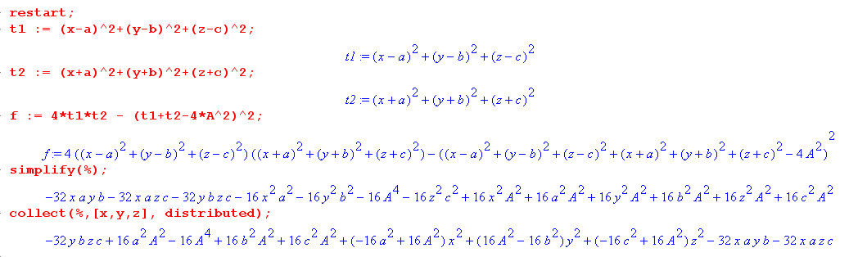
which I now write out

(-32bc)yz + 16A2(a2-1 + b2+c2) + 16(A2-a2)x2 + 16(A2-b2) y2 + 16(A2-c2)z2 - (32ab)xy - (32ac)xz
or

16(A2-a2)x2 + 16(A2-b2) y2 + 16(A2-c2)z2 - [(32ab)xy + (32ac)xz + (32bc)yz]
+ 16A2(a2 + b2+c2-1)
or
(A2-a2)x2 + (A2-b2) y2 + (A2-c2)z2 - [(2ab)xy + (2ac)xz + (2bc)yz] + A2(a2 + b2 + c2 - 1) = 0

OK, live and learn. This is the general form of an ellipsoid in 3D centered at the origin. The expression on the left on the web is called either "a polynomial of degree 2" or "a polynomial in two variables of degree 2". There is no special name like multinomial for such an animal. This is a general ellipsoid centered at the origin. There are only 4 allowed parameters here: a,b,c,A So if you are given the above as a general form with 7 coefficients (6 after scaling), in general it will not be an ellipsoid through the origin.

1a. Another approach to the arbitrary origin-centered ellipsoid

Start with

Ax'2+By'2+Cz'2 = 1

Take this to S space using

x = cosφcosθ x' -sinφy' x' = cosφcosθ x + sinφcosθ y -sinθ z
y = sinφcosθ x' + cosφ y' y' = -sinφ x +cosφ y
z = -sinθx' z' = cosφsinθ x + sinφsinθ y + cosθ z

So we end up in S space with

A[cosφcosθ x + sinφcosθ y -sinθ z]2
+ B[-sinφ x +cosφ y]2+ C[cosφsinθ x + sinφsinθ y + cosθ z]2 = 1

Here is maple computing (Maple code is in rotate3.mws )

f = Ax'2+By'2+Cz'2- 1

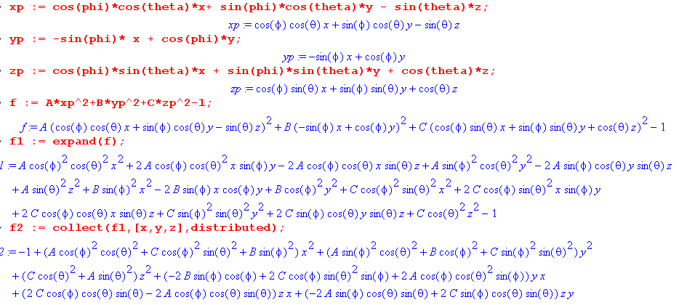

On the last line you see the general form

f = α x2+β y2+ γ z2 + δ xy + ε zx + κzy - 1

So this is the ellipsoid in terms of A,B,C and the rotation angles θ and φ. Recall that the equation of the slicing plane is this

nxx + nyy + nzz = 0

If you solve this last equation for z and insert that into the first, you get something of this form

f = α' x2+β' y2 + δ' xy - 1

I think this describes the view of the floating 3D ellipse from along the z axis, so you cannot see the z values. This is a projection of the ellipse onto the z = 0 plane, you could say.* The equation meets the requirement that the point be both on the ellipsoid and on the slicing plane, so the points must be on that floating ellipse. This projected locus is surely an ellipse, it certainly has the right form. I think the idea here is that if you start with a general floating ellipse, its projections onto the x=0, y=0 and z = 0 planes will be ellipses. Then I am pretty sure that the reverse is also true. If all projections are ellipses, then the thing being projected is also an ellipse. [ later I prove this. some section below ]

* Here is someone who agrees with my statement about projection:

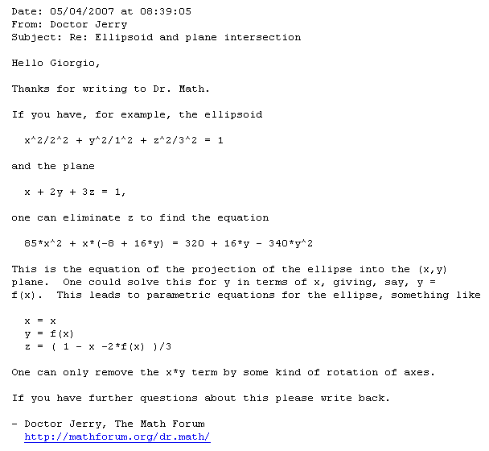

This guy (and George) do note that this is one way you could describe your floating ellipse:

r(t) = A cos(t) + Bsin(t) + r0 // origin at r0

where and are the appropriate unit vectors. Then our usual centered ellipse is just this

r(φ) = A cos(φ) + Bsin(φ)

I think I like this way of writing things. This thing is obviously aligned. What then would this be

r(t) = A cos(φ) + Bsin(φ- φ0) a = 0 b = φ0 - π/2 perhaps

r2 = A2cos2φ + B2sin2(φ-φ0) (*)

Comment: This problem is studied in Section 6a in more detail where I assume this more general form

r(t) = A' cos(φ-a) + B' cos(φ- b)

But here I go ahead and outline a calculus problem that caused me trouble at first.

Where does r of (*) reach is maximum value? That will tell you the orientation of the rotated ellipse.[wrong]

Note added: The solution value φ given below which makes r2 max merely tells you the value of parameter φ which causes maximum r. The x-axis value of φ is given by sin(φ-φ0) = 0 so φ = φ0. So you have to subtract φ0 from the solution below to get the ellipse orientation angle. See Section 6 for a better solution to this whole problem!

I asked Maple about this and got this response: (Maple code lower down in rotate3.mws)

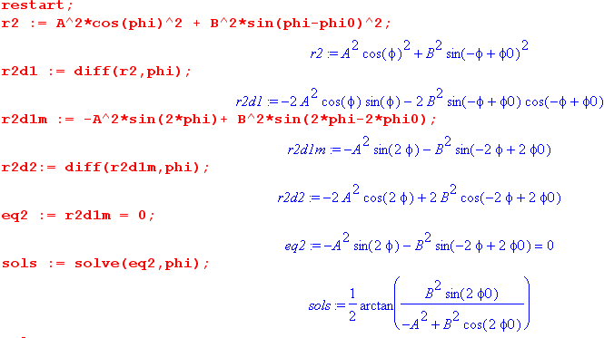

I was confused by this until writing "A Math Problem" now in the math/calculus area. This solution is in fact one of four solutions spaced by π/2 which lie in the range (-π.π). Maple knows about them and can be made to show them this way

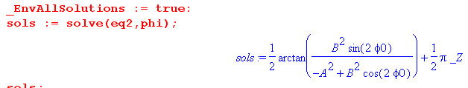

which just means add (π/2)*N where N is any integer. In this manner, we obtain the four angles where our rotated ellipse has min and max r value.

Peculiar checking fact: Go back to our start and set A = 0

r(t) = A cos(φ) + Bsin(φ- φ0) = Bsin(φ- φ0)

r2 = A2cos2φ + B2sin2(φ-φ0) = B2sin2(φ-φ0)

If A = 0, this is a degenerate ellipse which is vertical. The formula above gives

angle = (1/2)tan-1 [tan(2φ0] = φ0

Then we add π/2 and conclude that φ = φ0 + π/2 is where this thing has its max value. That seems right from the r2 equation above, and it is right in general. This is φ where the vertical ellipse achieves its peak value.

2. Ellipsoid in 3D at arbitrary location.

This section continues from section 1 above, not section 1a.

Now suppose we put one focus at (a,b,c) and the other focus at (d,e,f). This certainly will generate an arbitrary ellipsoid, not necessarily centered at the origin. In this case we get this huger mess

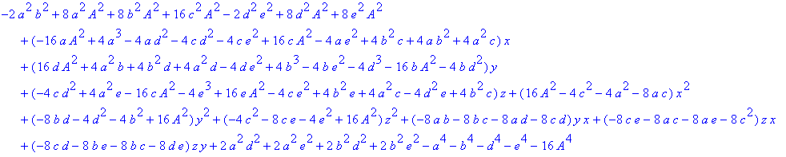

which has the form

Ax + By + Cz + Dx2 + Ey2 + Fz2 + Gxy + Hyz + Ixz + J = 0

where there are now 10 parameters. Scaling the entire equation leaves 9 parameters. But we have only a,b,c,d,e,f,A as our allowed parameters which is 7 parameters. Therefore, a general polynomial of degree 2 is not always an ellipsoid!

If you are handed a general polynomial of degree 2 like that shown above, you can always "complete the square" for each variable. For example Dx2 → D(x-α)2 = Dx2 - 2αDx + Dα2. Selecting α can then cancel the linear term Ax and then the above equation is reduced to

D(x-α)2 + E(y-β)2 + F(z-γ)2+ Gxy + Hyz + Ixz + J' = 0

There are still 10 (or 9 by scaling) parameters so this does not seem to buy much.

3. Rotated general conic section

It is a fact that an arbitrary polynomial in x and y is a conic section (or degenerate case). So

Ax'2 + By'2 + Cx' + Dy' + Ex'y' + F = 0 conic section

In S' space, this is an extruded conic section, extruded in the z' direction.

There are 5 coefficients here after scaling. If you view this equation in a rotated space S, you get

Ax'2 + By'2 + Cx' + Dy' + Ex'y' + F = 0
or
A[cosφcosθ x + sinφcosθ y -sinθ z]2 + B[-sinφ x +cosφ y]2 + C[cosφcosθ x + sinφcosθ y -sinθ z]2
+ D[-sinφ x +cosφ y] + E[cosφcosθ x + sinφcosθ y -sinθ z][ -sinφ x +cosφ y] + F = 0

and

0 = cosφsinθ x + sinφsinθ y + cosθ z

The big equation above is a polynomial of degree 2 in x,t,z which has the general form (new var's)

Ax + By + Cz + Dx2 + Ey2 + Fz2 + Gxy + Hyz + Ixz + J = 0

So again there are 9 parameters here, but you would have to solve for the 5 conic coefficients. Thus, most such surfaces are not rotated conic section extrusions. In general these are paraboloids, ellipsoids and hyperboloids of one and two sheets. As wiki shows, there are in fact 16 different kinds of these quadric surfaces you can get. Some of them are extrusions, most are not.

Example: Consider an extruded ellipse so only A and B are nonzero. Then the rotated extruded ellipse has this equation in S space:

Ax'2 + By'2 = 0

A[cosφcosθ x + sinφcosθ y -sinθ z]2 + B[-sinφ x +cosφ y]2 = 0

which has the form

αx2 + βy2 + γz2 + cxy + dyz + exz + h = 0

α = Acos2φcos2θ + B2sin2φ
etc.

If you slice this extruded ellipse with the plane through the origin

• r = 0 where = (nx,ny,nz) = (cosφsinθ, sinφsinθ, cosθ)

you obtain the most general ellipse curve you can have sitting in 3D space centered at the origin. The equation of the slicing plane is this

cosφsinθ x + sinφsinθ y + cosθ z = 0 ⇔ • r = 0

4. Most general form for a 2D ellipse centered at the origin

Before rotation we have

x'2/A2+ y'2/B2 = 1 A>B so A = major

A 2D rotation has this form

x' = cosθ x + sinθ y
y' = -sinθ x + cosθ y

so we insert that to get

A-2[cosθ x + sinθ y]2+B-2[-sinθ x + cosθ y]2 = 1
or
A-2[ cos2θ x2 + sin2θ y2 + 2sinθcosθ xy] + B-2[ sin2θ x2 + cos2θ y2 - 2sinθcosθ xy] = 1
or
[A-2cos2θ + B-2sin2θ]x2 + [2(A-2-B-2)sinθcosθ] xy + [A-2sin2θ + B-2 cos2θ] y2 = 1

Whereas Ax2+ By2 + Cx + Dy + Dxy + F = 1 is in general some conic section, the form above is the special case which is an ellipse centered at the origin. The general case has 6 = 5 parameters, while the ellipse has 3 parameters which are A,B,θ.

Now, suppose someone hands you the following equation

dx2 + ey2 + fxy = 1

and asks you if this is an ellipse or not. One way to answer that question would be to try to solve these three equations for A,B and x, where I have just replaced θ,A-2,B-2 by x,a,b for Maple's sake

d = acos2x + bsin2x a = A-2 b = B-2
e = asin2x + bcos2x A and B are the semis
f = 2(a-b)sinxcosx x = θ of rotation

If solutions exist for a,b,x, then you know you have an ellipse. Maple has trouble unless I simplify the three expressions shown, then it gets a reasonable solution as follows: ( Maple code in temp1,mws)

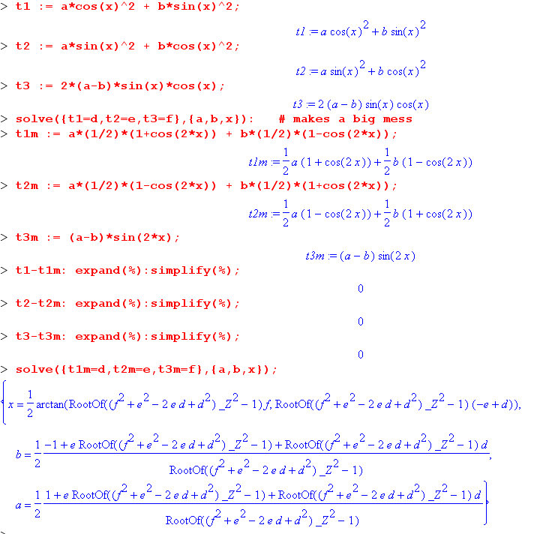
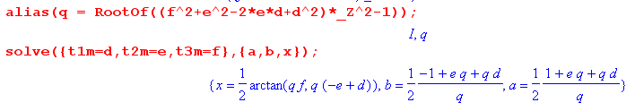
So as long as the root q is real, we seem to have a definite solution here for x,a,b which solves the three equations. Now the root thing is just this

[f2+e2-2ed+d2] q2 = 1

The condition for q to be real is then

f2 + (e-d)2> 0

but this condition is always met. So we then just have

q =1/ $\sqrt{f2 + (e-d)2}$ or 1/q = $\sqrt{f2 + (e-d)2}$

Well, another condition for "ellipse" is that we need a>0 and b> 0. That says

b: q(e+d)-1 > 0 => (e+d) > 1/q = $\sqrt{f2 + (e-d)2}$
a: q(e+d)+1 > 0 => (e+d) > -1/q = - $\sqrt{f2 + (e-d)2}$

Since q > 0, the first condition is more stringent, so our condition is

(e+d) >$\sqrt{f2 + (e-d)2}$
or
(e+d)2 > f2 + (e-d)2
or
2ed > f2-2ed
or
4ed > f2
ir
f2-4ed < 0

which agrees with what I saw in wiki. Note for below that

a = (1/2) [ e + d + 1/q] = (1/2) [ e + d + $\sqrt{f2 + (e-d)2}$] = A-2

b = (1/2) [ e + d - 1/q] = (1/2) [ e + d - $\sqrt{f2 + (e-d)2}$] = B-2

Theorem: If you are handed dx2 + ey2 + fxy = 1 with f2-4ed < 0, then you know this is an ellipse centered at the origin. You know more that this of course. You also know that:

(1) the angle θ that describes the amount of rotation of this ellipse from its aligned position is

θ = (1/2)tan-1[ y=qf, x=q(d-e) ] q = 1/ $\sqrt{f2 + (e-d)2}$
or
θ = (1/2)tan-1[ f, d-e ]

where recall that θ + N(π/2) are also solutions, and I am not sure whether the θ shown will line up the major or minor axis with the x axis, but I could figure it out if I had to.

(2) the values of a and b are:

a = (1/2) [ e + d + $\sqrt{f2 + (e-d)2}$] = A-2
b = (1/2) [ e + d - $\sqrt{f2 + (e-d)2}$] = B-2

So it is not hard to learn about the rotated ellipse nature from dx2 + ey2 + fxy .

5. How do you describe a general origin-centered ellipse in 3D ?

Not an ellipsoid, but an ellipse. We know that the ellipsoid looks like this

(A2-a2)x2 + (A2-b2) y2 + (A2-c2)z2 - [(2ab)xy + (2ac)xz + (2bc)yz] + A2(a2 + b2 + c2 - 1) = 0

where the point (a,b,c) is one of the foci and A,B are the usual semi axes.

The slicing plane through the origin is just the plane perp to = as noted above.

cosφsinθ x + sinφsinθ y + cosθ z = 0 ⇔ • r = 0

I don't really have more than this right now.

6. A special ellipse of interest in 2D

The equations defining this presumed ellipse are these

x = A' cos(t-a)
y = B' cos(t-b) (*)

Warning: For general a,b, quantities A' and B' are NOT the major half axes. That is why I have put a prime on them. I do have in mind however that A' > 0 and B' > 0 and still have most general case.

Aside: If a = 0 and b = π/2, this becomes x = A'cos(t) and y = B'sin(t) which is "standard form" for an aligned ellipse in parametric form. In this case we may conclude that A' = A and B' = B, the two half axes. I will run this check on the general solution below.

This parametric form (*) certainly seems "ellipse-like", but how can you show it really is an ellipse centered at the origin? Here is a brute force attempt to answer that question. First rewrite the above as,

t - a = cos-1(x/A')
t - b = cos-1(y/B') .

We can eliminate the parameter t from the first two equations to get

cos-1(x/A') + a = cos-1(y/B') + b
or
cos-1(x/A') - cos-1(y/B') = b - a

Take the cosine of both sides:

cos [cos-1(x/A') - cos-1(y/B')] = cos(b-a)
or
cos [α - β] = cos(b-a) α = cos-1(x/A') β = cos-1(y/B')

Now use

cos(α-β) = cosαcosβ +sinαsinβ

to get

(x/A') (y/B') + $\sqrt{1-(x/A')2}$$\sqrt{1-(y/B')2}$ = cos(b-a)

Isolate the square root

$\sqrt{1-(x/A')2}$$\sqrt{1-(y/B')2}$ = cos(b-a) - (x/A') (y/B')

Square both sides

[1-(x/A')2] [1-(y/B')2] = cos2(b-a) + (x/A')2 (y/B')2 - 2 cos(b-a) (x/A') (y/B')

The highest terms cancel and we then have

1 -(x/A')2-(y/B')2 = cos2(b-a) - 2 cos(b-a) (x/A') (y/B')

or
(x/A')2 + (y/B')2 - 2 cos(b-a) (x/A') (y/B') = 1 - cos2(b-a)
or
(1/A'2)x2 + (1/B'2)y2 + [-2cos(b-a)/(A'B')] xy = 1 - cos2(b-a) // converted to poly

Now I will convert this to "standard form" as follows:

(1/A'2)x2 + (1/B'2)y2 + [-2cos(b-a)/(A'B')] xy = 1 - cos2(b-a)

(1/A'2)x2 + (1/B'2)y2 + [-2cos(b-a)/(A'B')] xy = sin2(b-a)

csc2(b-a) (1/A'2)x2 + csc2(b-a) (1/B'2)y2 + csc2(b-a) [-2cos(b-a)/(A'B')] xy = 1

which we can interpret as

dx2 + ey2 + fxy = 1

Recall from above that the condition that this be an ellipse around the origin is

f2 < 4ed

So we can check that here:

d = csc2(b-a) (1/A'2) e = csc2(b-a) (1/B'2) f = csc2(b-a) [-2cos(b-a)/(A'B')]

csc4(b-a) [-2cos(b-a)/(A'B')]2 < 4 csc2(b-a) (1/B'2) csc2(b-a) (1/A'2) ?

[-2cos(b-a)/(A'B')]2 < 4 (1/B'2) (1/A'2) ?

4cos2(b-a) < 4 ?

cos2(b-a) < 1 yes!

So we know without further ado that this "figure" is a rotated ellipse. That was something that was not fully obvious at the start, but now we have proven it is so.

We also know from earlier that

1/q2 = f2 + (e-d)2 = csc4(b-a) [(-2cos(b-a)/(A'B'))2 + (1/A'2 - 1/B'2)2 ]

= csc4(b-a) [(-2cos(b-a)/(A'B'))2 + ($\frac{B'2-A'2}{A'2B'2}$)2]
= csc4(b-a) [(-2cos(b-a)/(A'2B'2) + (B'2- A'2)2/A'4B'4]

= csc4(b-a) [(-2cos(b-a)(A'2B'2) + (B'2- A'2)2] / (A'4B'4)

= csc4(b-a) [-2cos(b-a)A'2B'2 + (B'2- A'2)2] / (A'4B'4)

= csc4(b-a) [-2cos(b-a)A'2B'2 + B'4 + A'4 - 2A'2B'2] / (A'4B'4)

= csc4(b-a) {A'4 + B'4 - 2A'2B'2[1 + cos(b-a)] } / (A'4B'4)

Then

1/q = csc2(b-a) $\frac{1}{A'2B'2}$ $\sqrt{A'4 + B'4 - 2A'2B'2[1 + cos(b-a)]}$

We also know that the major axes are given by

A-2 = (1/2) [ e + d + 1/q]
B-2 = (1/2) [ e + d - 1/q] .

Now from above we have

e+d = csc2(b-a) (1/B'2) + csc2(b-a) (1/A'2) = csc2(b-a)[ (1/B'2)+ (1/A'2) ] = csc2(b-a) $\frac{A'2+B'2}{A'2B'2}$

so that

A-2, B-2 = (1/2) csc2(b-a) [$\frac{A'2+B'2}{A'2B'2}$±$\frac{1}{A'2B'2}$$\sqrt{A'4 + B'4 - 2A'2B'2[1 + cos(b-a)]}$]

= (1/2) csc2(b-a) $\frac{1}{A'2B'2}$ [ A'2+ B'2 ± $\sqrt{A'4 + B'4 - 2A'2B'2[1 + cos(b-a)]}$ ]

Meanwhile, we have from earlier that

θ = (1/2)tan-1[ f, d-e ]

= (1/2)tan-1[csc2(b-a) [-2cos(b-a)/(A'B')], csc2(b-a) (1/A'2) - csc2(b-a) (1/B'2) ]

= (1/2)tan-1[-2cos(b-a)/(A'B')], (1/A'2) - (1/B'2) ]

= (1/2)tan-1[2cos(b-a)(A'B'), A'2-B'2 ]

Check result:

a = 0 and b = π/2 => cos(b-a) = cos(π/2) = 0
csc(b-a) = 1/sin(π/2) = 1

A-2,B-2 = (1/2) $\frac{1}{A'2B'2}$ [ A'2+ B'2 ± (A'2-B'2)] = { 1/A'2, 1/B'2 }

and we get the expected result that A = A' and B ' B'. Also

θ = (1/2)tan-1[2cos(b-a)(A'B'), A'2-B'2 ] = (1/2)tan-1[0] = 0

as expected.

Summary: We started with

x = A' cos(t-a)
y = B' cos(t-b)

and first we proved that this is the locus of an ellipse centered at the origin. Then we went on to obtain properties of that ellipse. Those properties are:

Semimajor A and Semiminor B axes:

B-2, A-2 = (1/2) csc2(b-a) $\frac{1}{A'2B'2}$ [ A'2+ B'2 ± $\sqrt{A'4 + B'4 - 2A'2B'2[1 + cos(b-a)]}$ ]

Angle of main axis from the x-axis (with admitted ambiguity)

θ = (1/2)tan-1[2cos(b-a)(A'B'), A'2-B'2 ]

6a. Another approach to the parametric 2D ellipse.

Go back again to the parametric form. Note that A' and B' are NOT the semi-major axes in this parametric form!!

x = A' cos(φ-a)
y = B' cos(φ-b)

r2 = A'2cos2(φ-a) + B'2cos2(φ-b)

In the previous section I showed that this locus is an ellipse centered at the origin.

As outlined in the end of section 1a above, it is an easy calculus problem to find the angles where r2 has its max and min values. Imagine that we do that, and we find this special value of φ :

φ = φA, φA ± π causes r2 to have is max value which we will assume is A

We can then define

= Rz(φA) = Rz(φA)

and then points along the major axis of the ellipse and along the minor axis. The ellipse can then be represented as

r(t) =A cos(θ) +B sin(θ)

where now θ is an angle measured away from the r = A max point on the rotated ellipse. We have to compute A,B from A',B' and φA somehow.

7. Now here is some stuff from wiki.

General ellipse
In analytic geometry, the ellipse is defined as the set of points of the Cartesian plane that, in non-degenerate cases, satisfy the implicit equation^{[18][19]}
provided
To distinguish the degenerate cases from the non-degenerate case, let ∆ be the determinant of the 3×3 matrix [A, B/2, D/2 ; B/2, C, E/2 ; D/2, E/2, F ]: that is, ∆ = (AC − B²/4)F + BED/4 − CD²/4 − AE²/4. Then the ellipse is a non-degenerate real ellipse if and only if C∆ < 0. If C∆ > 0, we have an imaginary ellipse, and if ∆ = 0, we have a point ellipse.^{[20]:p.63}

So they claim that the 6 parameter form is an ellipse if that one condition is met! That would have been a simpler thing to check. I had this

(1/A2)x2 + (1/B2)y2 + [-2cos(b-a)/(AB)] xy + cos2(b-a) = 1

Q = [-2cos(b-a)/(AB)]2 - 4(1/A2) (1/B2)

QA2B2 = [-2cos(b-a)]2 - 4 = 4cos2(b-a) - 4 = -4sin2(b-a) < 0 !!

So that would have been a MUCH faster test, though it does not give you the ellipse equation.

Next they claim

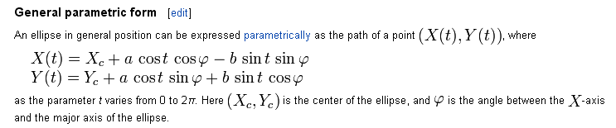

I can compare this to my equations

X(t) = A cos(t-α) = 0 + Acostcosα + Asintsinα
Y(t) = B cos(t-β) = 0 + Bcostcosβ + Bsintsinβ

Now I try to identify

Acostcosα + Asintsinα = acost cosφ - bsintsinφ
Bcostcosβ + Bsintsinβ = acost sinφ - bsint cosφ

The first equation requires that

Acosα = acosφ
Asinα = -bsinφ => tanα = -(b/a)tanφ tanφ = -(a/b)tanα

The second equation requires that

Bcosβ = asinφ
Bsinβ = -bcosφ => tanβ = -(b/a)cotφ tanφ = -(b/a)cotβ

So given my equations, does my form does not meet the wiki form ??
Think of a,b,φ as three unknowns and A,B,α,β as knowns. Then try:

a = 1 tanφ = -(1/b)tanα tanφ = -(b/1)cotβ

Then -(1/b)tanα = -(b/1)cotβ => b2 = tanα tanβ

So there is my solution for the wiki parameters:

a = 1,

b =$\sqrt{tanα tanβ}$

tanφ = -b cotβ = - $\sqrt{tanα tanβ}$/tanβ = - $\sqrt{tanα/tanβ}$

So at least I have some external support that my equation really is an ellipse.

8. A special ellipse of interest in 3D

Consider now these three equations:

x = A' cos(t-a)
y = B' cos(t-b)
z = C' cos(t-c)

We know that any pair of these equations produces an ellipse in that pair's plane. Thus, whatever the 3D curve is which these three equations define, that curve's projection in all three planes is an ellipse!

I claim that the 3D curve is in fact itself an ellipse, but the problem is: how do you prove that claim?

This was my original question and I don't have an answer to it!

Maybe the general curve here is NOT an ellipse! We can maybe find a counter example by taking an ellipse in the x,y plane, rotate it about the z axis, and project it back onto the x,y plane. I found an MS paper by a lady that looks at this simplest case and concludes that the projection of an ellipse really is an ellipse, but she does not do the skew case.

I then found a fancier paper that I think does the general case and concludes once again that the projection of a floating ellipse is an ellipse.

Idea: I bet you could show that the projection of a general floating ellipse is still a quadratic form, and the only closed such form is an ellipse!

Well OK. If you know that the projection was an ellipse on only ONE plane and that was it, you could jimmy the floating figure in the direction away from the viewer and he would not see distortions, and so you could have the projection of a non-ellipse be an ellipse. But any such jimmy distortion would show up in either of the other orthogonal projections and those projections would clearly NOT be ellipses. I think this is a full argument if presented correctly. Here I will try.

(1) I know from "surface problem.doc" that the floating figure is planar.
(2) I know that the projection of the floating figure onto any of the orthogonal planes is an ellipse.
(3) Therefore, if I take one of those projection ellipses, I can project it back onto the figure plane, and this projection then has to be the figure! But it also has to be an ellipse, because I know that the projection of any ellipse onto a plane is also an ellipse.
(4) Thus I have shown that the figure must be an ellipse.

My conclusion: Yes, the locus defined by the three parametric equations above really is an ellipse.

