A surface problem PhL 12.8.13

I reviewed this doc on 12.10.13, all is OK now. I certainly had a lot of misconceptions when I first started into this stuff.

1. Preparatory Problem 1
2. Main Problem 2
3. Can you show the figure is really a floating ellipse? It at least is planar. 5
4. The 2D case of two parametric equations 7

1. Preparatory Problem

Suppose you are given these two equations

x2 + y2 = a2 (1)
x2 + z2 = b2 (2)

Does this imply a unique locus in 3D space? Multiply second by (a2/b2)

x2 + y2 = a2
(a2/b2)x2 + (a2/b2)z2 = a2

Now subtract to get

x2[1-(a2/b2)] + y2 - (a2/b2)z2 = 0 (3)

This is a hyperboloid of some kind in 3D space, and that surface is the solution of the two equations.
[wrong]

Comments:

(a) Equations (1) and (2) represent "extruded circles" and so each equation really is a surface in 3D space. They are two perpendicular cylinders whose axes pass through the origin. If the cylinders have different radii, I think the intersection will be two circles in 3D space which have the diameter of the smaller cylinder and which are parallel to each other (just draw a picture).

(b) Any point which lies on one of these two circles (that is, any point which is an intersection point of the two cylinders) will also lie on surface (3) . This surface happens to be a double cone, one of the quadric surfaces in the list you see here,

http://en.wikipedia.org/wiki/Quadric

This cone includes the origin as its waist point. So probably this double cone is the one you would naturally draw to get those two parallel circles. Any point on either circle will also lie on this cone thing.

(c) This cone equation (3) is NOT the locus of the solutions of (1) and (2) . Only a tiny part of the cone is the locus of those solutions, namely two circles on the double cone. So the solutions of (1) and (2) are curves, and these curves lie on the cone surface (3).

(d) This conclusion does not seem very exciting. When I first started this doc, I thought (3) was the "surface of intersection" and that all points on (3) would be solutions of (1) and (2), and therefore I had obtained some magic single equation to describe the solution locus.

2. Main Problem

Note: This set of equations arose in my Transmission Lines work when I considered the path of an electron (or chunk of electrons) inside a round wire as it was responding to three electric fields, each having a different phase and magnitude. In that consideration, (x,y,z) was a local coordinate system at a point and the directions are r,θ,z. I had no idea that finding the trajectory from the three equations was such a difficult problem and I digressed several days on that problem. Even the 2D problem is hard with the first two equations of the set below. In that case, A and B are NOT the semi-major axes of the resulting ellipse unless it happens that a = b.

Suppose you have these three equations

x(t) = cos[ωt - a] A
y(t) = cos[ωt - b] B
z(t) = cos[ωt - c] C

ωt - a = cos-1(x/A)
ωt - b = cos-1(y/B)
ωt - c = cos-1(z/C) .

Solving the first pair for ωt and equating gives first below, first and third gives second

cos-1(x/A) + a = cos-1(y/B) + b
cos-1(x/A) + a = cos-1(z/C) + c

cos-1(x/A) - cos-1(y/B) = b - a
cos-1(x/A) - cos-1(z/C) = c - a

Take the cosine of both sides and use

cos(α-β) = cosαcosβ +sinαsinβ

where α = cos-1(x/A) and β = cos-1(y/B) so that cosα = x/A and sinα = $\sqrt{1-(x/A)2}$. Result is

(x/A) (y/B) + $\sqrt{1-(x/A)2}$$\sqrt{1-(y/B)2}$ = cos(b-a)
(x/A) (z/C) + $\sqrt{1-(x/A)2}$$\sqrt{1-(z/C)2}$ = cos(c-a)

Let x' = x/A and so on to get

x'y' + $\sqrt{1-x'2}$$\sqrt{1-y'2}$ = cos(b-a)
x'z' + $\sqrt{1-x'2}$$\sqrt{1-z'2}$ = cos(c-a)

Now I will reuse symbols α and β for a new purpose right here:
Now temporarily drop the primes to reduce clutter

xy + $\sqrt{1-x2}$$\sqrt{1-y2}$ = cos(b-a) = cos(α) = cos(1)
xz + $\sqrt{1-x2}$$\sqrt{1-z2}$ = cos(c-a) = cos(β) = cos(0) = 1

Now multiply first by cos(β) and second by cos(α)

cosβ [xy + $\sqrt{1-x2}$$\sqrt{1-y2}$] = cosαcosβ (1)

cosα [xz + $\sqrt{1-x2}$$\sqrt{1-z2}$] = cosαcosβ (2)

and subtract to get

cosβ [xy + $\sqrt{1-x2}$$\sqrt{1-y2}$] - cosα [xz + $\sqrt{1-x2}$$\sqrt{1-z2}$] = 0 (3)

and this is the "orbit" in 3D space!

More Comments:

(c) The original 3 equations define a floating ellipse. as I later learned.

(d) As we traverse that floating ellipse in 3D space, we also traverse the projected ellipse (1) in the xy plane, and the projected ellipse (2) in the xz plane. Thus, for a given point (x,y,z) on the floating ellipse, we associate a certain point (x,y) on the (1) ellipse, and a certain point (x,z) on the (2) ellipse. Such a point (x,y,z) will also satisfy equation (3) which is some very weird surface (plotted below), Thus, the entire floating ellipse will lie on the weird surface (3), as shown below, but in retrospect I don't see what this has to do with the price of eggs. I was originally looking for a "surface" to represent the floating ellipse, but that notion is completely wrong since a curve is not a surface in 3D.

Write as

cosβ [xy + $\sqrt{1-x2}$$\sqrt{1-y2}$] = cosα [xz + $\sqrt{1-x2}$$\sqrt{1-z2}$] // num check OK

Now let cosβ = d = cos(c-a) and cosα = e = cos(b-a) so

d [xy + $\sqrt{1-x2}$$\sqrt{1-y2}$] = e [xz + $\sqrt{1-x2}$$\sqrt{1-z2}$]
or

d$\sqrt{1-x2}$$\sqrt{1-y2}$ - e$\sqrt{1-x2}$$\sqrt{1-z2}$ = exz - dxy

Square both sides:

d2(1-x2)(1-y2) + e2(1-x2)(1-z2) - 2ed (1-x2) $\sqrt{1-y2}$$\sqrt{1-z2}$ = x2(ez-dy)2

Then

2ed (1-x2) $\sqrt{1-y2}$$\sqrt{1-z2}$ = d2(1-x2)(1-y2) + e2(1-x2)(1-z2) - x2(ez-dy)2

Then square both sides again

4e2d2(1-x2)2(1-y2) (1-z2) = [d2(1-x2)(1-y2) + e2(1-x2)(1-z2) - x2(ez-dy)2]2

Or

4e2d2(1-x2)2(1-y2) (1-z2) - [d2(1-x2)(1-y2) + e2(1-x2)(1-z2) - x2(ez-dy)2]2 = 0

This is f(x,y,z) = 0 where f is an 8th degree polynomial, at least it appears that way. But when Maple multiplies this all out it gets this for the LHS:

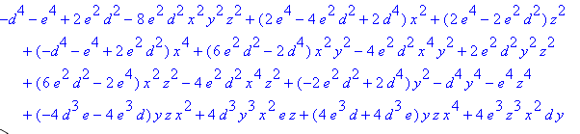

which is only a 6th degree polynomial. Recall that

For d = 1 and e = cos(1) here is the orbit surface with a wireframe display for reasons to come. It is sort of cylindrical with pieces missing, but the cylinder sides are warped.

This Maple code is in surface problem 1.mws. In the previous version without the 1 the ellipse missed the surface!! I had some error which I later found.

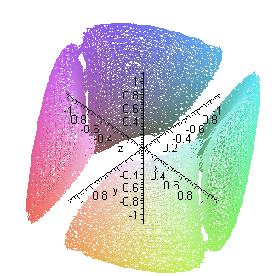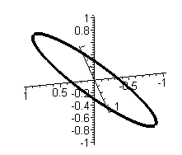

which is a hollow thing on which our near-elliptical paths must reside. Consider this simple case:

x(t) = cos[ωt]
y(t) = cos[ωt]
z(t) = cos[ωt]

The locus here is a 3D line segment, and it does NOT lie on a sphere. The next simplest case is maybe this which corresponds with the surface above

x(t) = cos[ωt] a = 0
y(t) = cos[ωt-1] b = 1 d = cos(c-a) = cos(0) = 1
z(t) = cos[ωt] c = 0 e = cos(b-a) = cos(1)

The locus here looks like a tilted ellipse, as shown on the right above. I was finally able to superpose these two pictures,

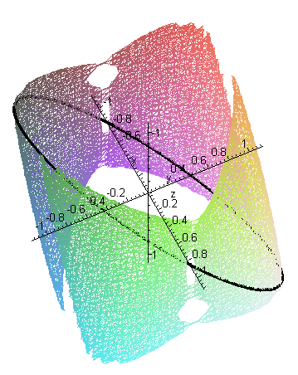

and sure enough, that ellipse thing lies right on the surface as you tumble the picture. The Maple file is called "surface problem.mws".

3. Can you show the figure is really a floating ellipse? It at least is planar.

I think the ellipse thing is always planar, why is that?

x1 = A cos(t1-a)
y1 = B cos(t1-b)
z1 = C cos(t1-c)

x2 = A cos(t2-a)
y2 = B cos(t2-b)
z2 = C cos(t2-c)

If these two points always lie on the same plane, that plane must have a normal n such that

n • (r1- r2) = 0 for any t1 and t2

This says

nx(x1-x2) + ny(y1-y2) + nz(z1-z2) = 0

nx(A cos(t1-a)- A cos(t2-a)) + ny(B cos(t1-b)- B cos(t2-b)) + nz(C cos(t1-c)- C cos(t2-c)) = 0

nx [ A (C1Ca+S1Sa) - A (C2Ca+S2Sa) ]
+ ny [ B (C1Cb+S1Sb) - B (C2Cb+S2Sb) ]
+ nz [ C (C1Cc+S1Sc) - C (C2Cc+S2Sc) ] = 0

C1[ nxACa + nyBCb+ nzCCc] + S1[ nxASa + nyBSb+ nzCSc]
- C2[ nxACa + nyBCb+ nzCCc] - S2[ nxASa + nyBSb+ nzCSc] = 0

This will be true provided we can find n such that

nxACa + nyBCb+ nzCCc = 0

nxASa + nyBSb+ nzCSc = 0

nx2 + ny2 + nz2 = 1

But this is only 3 equations in 3 variables, so we know there is a solution, and therefore we know that n exists, and therefore we know that the curve is planar! The above read

n•D = 0
n•E = 0
|n| = 1

So normal is

n = D x E

nx = DyEz- DzEy = BCbCSc - CCcBSb = BC(ScCb- CcSb) = BC sin(c-b)

ny = DzEx- DxEz = CCc ASa- ACaCSc = AC sin(a-c)

nz = AB sin(b-a)

So there you have it. The curve is always planar, but I don't think it is an ellipse! [ yes it is ]

x = A cos(t-a)
y = B cos(t-b)
z = C cos(t-c)

[ Later in "ellipse forms in rotated...doc" I use the above fact that the figure is planar along with the fact that its three projections are ellipses, and finally the fact that the projection of an ellipse is always an ellipse to show that the figure must be an ellipse! ]

4. The 2D case of two parametric equations

Consider

x = Acos(t-a)
y = Bcos(t-b)

Prove one of the following:
• for arbitrary A,B,a,b this curve is always an ellipse [ this is the correct option ]
• for some A,B,a,b this curve is NOT an ellipse (counter example)

In a coordinate system rotated by θ we would have

x' = xcosθ + ysinθ
y' = -xsinθ + ycosθ

In this new system we then have

x' = Acos(t-a)cosθ + Bcos(t-b)sinθ
y' = - Acos(t-a)sinθ + Bcos(t-b)cosθ

and an ellipse would have this form

α2x'2 + β2y'2 = 1
or

α2 [Acos(t-a)cosθ + Bcos(t-b)sinθ]2 + β2[- Acos(t-a)sinθ + Bcos(t-b)cosθ]2 = 1

If you can solve this for α,β,θ such that the equation is true for all t, then it is an ellipse. I throw this into Maple and it gets a huge messy solution for α, β and θ.

Why is this problem so hard? [ Maple needed some assistance and then gave simple results. ]

[ In "ellipse forms in rotated...doc I show that these two parametric equations really do describe an ellipse that is rotated in the x,y plane, and I get lots of info about that rotated ellipse! ]

