Comments on Fredholm integral equations PhL 3.17.11

Up to now, Stak has been my only real source on this subject. Some of the terms he uses are no longer current as best I can tell. Here are two examples:

Stakgold Current usage
operator is "completely continuous" operator is "compact"
integral operator is "Hilbert-Schmidt" integral operator is "square integrable"
compact has sequential definition compact has topological definition

1. Concerning the square-integrable (=H-S) property. 1
2. The Liouville Transformation 1
3. The question of Green's Function kernel being square integrable 3
4. Stakgold Theorem 6 on page 220 4
5. Strange situation of a linear function f(x) with an M bound 5
5. Continuity and boundedness for linear operators and linear functionals. 6
6. Continuity and boundedness for the kernel of an integral equation 6
7. Compact = completely continuous 7
8. Other properties of symmetric and square-integrable kernels? 7

1. Concerning the square-integrable (=H-S) property.

My RN book gives a little history along with its presentation. It is true that Schmidt in 1907 realized that square-integrable got you what you wanted, even if k(x,y) is not strictly bounded, so the H-S term was invented. If you think about the L2 space of functions (square integrable over the domain a,b), we don't worry too much about functions which are not L2 except as special cases. The direct analogy for a kernel, which is after all just a mapping K: R2→ R, is that a reasonable kernel should be square integrable over its domain which is the square. RN refer to the space of such kernels as bolded L2. Just as we can think up functions which are not square integrable, we can also think up kernels which are not square integrable, but I suspect that these are special case kernels and are not the meat and potatoes of integral equation theory. Whether a Green's Function kernel is square integrable seems to depend on the nature of the ODE operator L, see below. [Stakgold shows in his Theorem 6 on page 135 that the Green's function kernel g(x,y) for L = Laplace is always square integrable for n = 2 and 3 dimensions.]

2. The Liouville Transformation

I found a book by Levitan (Marriott has it) which addresses this subject, and is in Google books. Early in his book Levitan points out

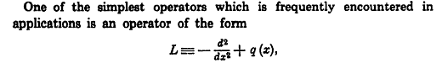

If we now switch to a PDF I have saved called "sturm liouville catalog.pdf" (2003) , we learn that with some conditions, any Stak type self-adjoint ODE can be converted to the above form by something called a Liouville Transformation. I quote from this pdf:

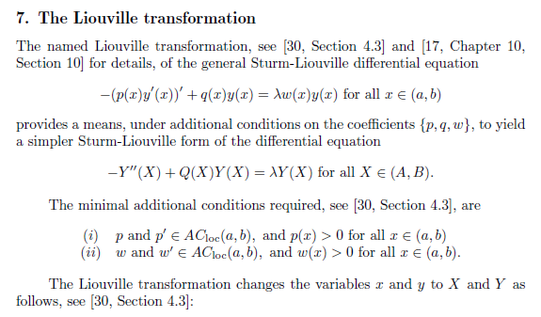

You may wonder what ACloc means, and our author W.N. Everitt has the answer. I think in Stak language AC means "absolutely continuous" which pretty much means differentiable, and I think the loc label means it is also locally integrable, the LI term used by Stak. In any event, notice that in the capital letters shown above, the first derivative which might be called R(X)Y'(X) is not present.
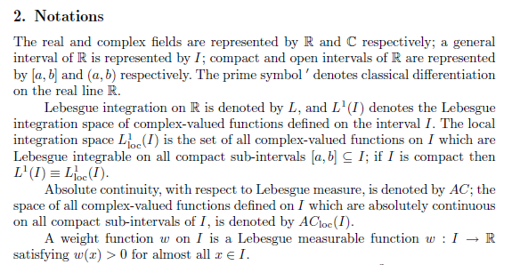

We can continue now to show the details of this Liouville Transformation. The idea is that you go from variable x in (a,b) to variable X in (A,B) and at the same time, you go from y(x) to Y(X) as shown. If we write X = l(x), then there is presumably some inverse which he writes as x = L(X). The last line then shows the Q(X) function you end up with. Very interesting IMHO.
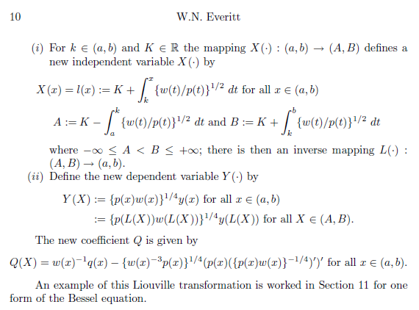

Something very similar to this but not quite the same is given in Stak page 279 in Chapter 4, and the resultant form of the ODE is called "the normal form" of the ODE.

3. The question of Green's Function kernel being square integrable

I found a book by Levitan (Marriott has it) which addresses this subject, and is in Google books. This was a difficult web search I might add, the subject here is very narrow with difficult search handles. Levitan early on defines q(x) in the sense of Q(X) above when he writes

So his q(x) is what you get after doing the LT on your ODE. Then Levitan talks about square integrability of Green's Functions as follows. You see that the condition for square integrability is a condition on the function q(x) which seems to be that [ q(x) ]-3/2 be an L1 function.

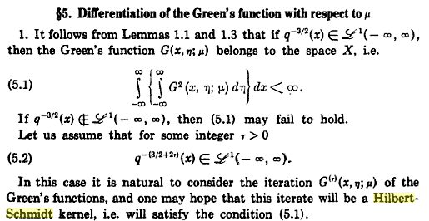

Here is the Lemma the he refers to

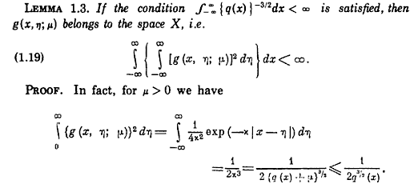

I don't follow his proof, but right now I am just looking for "the facts, Maam, just the facts". The conclusion then is that a Green's Function is square integrable if the ODE has certain properties which are reflected in q(x). As stated above, probably almost all interesting self-adjoint ODE's satisfy this q(x) property and therefore have square-integrable Green's functions (that is, g(x,y) is Hilbert-Schmidt).

4. Stakgold Theorem 6 on page 220

On pages 219-220 Stak has a certain logic presentation. The section title back on page 214 shows that he is restricting his interest kernels k(x,y) which are both symmetric and H-S (square integrable). Here is his logic flow:

Theorem 4: Every function "of the form g = Kf" can be expanded on the EF's of K which have non-zero eigenvalues.

Theorem 5: The EF's of K (including those with zero eigenvalue) form a complete set.

Theorem 5A. If μ=0 is NOT an eigenvalue, then you can say that the EF's of K with non-zero EV's form a complete set.

Theorem 6. He then takes an arbitrary self-adjoint L with homogenous BC's and converts it to an integral equation for which μ=0 is not an EV. That integral equation has g(x,y) as its kernel as in (3.42a). Since g(x,y) is assumed to be square-integrable, and since we know it is symmetric, we can apply Theorem 5A to conclude that the EF's of this integral equation form a complete set. But these are the same EF's of the ODE we started with. Therefore any self-adjoint EV ODE of the form Lφ = λφ with homo BC's has EF's which form a complete set. I think Stak regards this as a very major result, and is a payoff for studying integral equations in the first place. I presume this is a complete set on L2.

5. Strange situation of a linear function f(x) with an M bound

For a function f(x), being continuous means the graph of the function has no vertical jumps. The usual language is that, given any ε such that | f(x)-f(x0) | < ε, we can find δ such that this will be true if
|x-x0| < δ. So as x→x0, f(x)→f(x0) and you get the same answer from either side, which rules out a vertical jump of the graph. A continuous function is therefore a "reasonable function" in my book. This also means the function is not some kind of pathological function such as 1 on rationals and 0 on other reals. A continuous function is a "physical world function".
Although one never does this for a function, I will do it anyway. Suppose we know that f(x) is bounded in the following sense

M = max ( |f(x)|/|x|) for all x in (a,b)

In order for there to exist some finite M above, if interval (a,b) includes x=0, we have to have f(0) = 0, just something to note. For the moment, we allow (a,b) to be anywhere. So let c = min (|a|,|b|) so that |x| ≥ c. Then 1/|x| < 1/c and we conclude that |f(x)|/|x| < |f(x)|/c. I guess I will restrict so that neither a nor b can be 0 so that c > 0, just so we can continue this didactic discussion. Now suppose f(x) were bounded in the normal sense |f(x)| ≤ K. then we have

|f(x)|/|x| ≤ |f(x)|/c ≤ K/c => max ( |f(x)|/|x|) ≤ K/c

We have then shown this: as long as a and b ≠ 0, then for any interval (a,b) if f(x) is bounded, then we also have our M type bound.
In any event, lets assume that we have this M bound just discussed for f(x) on (a,b)

M = max ( |f(x)|/|x|) for all x in (a,b)

Then of course we have

|f(x)|/|x| ≤ M for all x in (a,b) => |f(x)| ≤ M |x| for all x in (a,b)

Now in addition to this, suppose also that f(x) is a linear function, meaning f(x) = Ax + B. But we noted above that f(0) must be 0, so assume f(x) is a linear function of the form f(x) = Ax. Then we know that

| f(x)-f(x0) | = | f(x-x0) | ≤ M |x-x0|

This then is a situation where continuity is guaranteed due to the existance of bound M, that is the point of our rambling here. As we take |x-x0| → 0, the existence of M forces | f(x)-f(x0) |→ 0. In terms of ε and δ, if you specify some ε, then I can select δ = (1/2)ε/M. Then

|x-x0| < δ => |x-x0| < (1/2)ε/M => M |x-x0| < ε/2

Then we have

| f(x)-f(x0) | ≤ M |x-x0| < ε/2

and thus for any ε I have found a δ such that | f(x)-f(x0) | < ε.
This section is obviously highly contrived and is only intended to set up the presentation for linear functionals or operators. In the function case, since the only function we are allowed to have is f(x) = Ax, it is obvious that the function is continuous from the get-go. Still, we showed that if f(x) has an M-bound, then it is continuous, and in this odd sense we have shown that bounded => continuous. In fact, we also showed that K bound => M bound => continuous. I won't try to show it the other way.

5. Continuity and boundedness for linear operators and linear functionals.

We can just do the operator T case since the functional fits into it. Notice that "linear operator" is not so restrictive as "linear function" in the previous section. One of the linear operator rules is L(ax) = aL(x). In Stak Chapter 2, this appears on page 135 for a linear functional and on page 140 for a linear operator, which Stak refers to as a "transformation". In either case, linear implies that L(0) = 0. In our function case this severely restricted us to f(x) = Ax, but for operators we have plenty of linear operators available, a rich supply, unlike in the function case. The world is bigger here.
The bounded => continuity argument, however, goes exactly as above:

M = max ( |T(x)|/|x|) for all x in R ≡ || T ||

where R is some region of x space, whatever space that happens to be. Then of course

| T(x)-T(x0) | = | T(x-x0) | ≤ M |x-x0|

and we get exactly the same idea then that x→x0 => T(x)→T(x0) which is called "T is continuous".

6. Continuity and boundedness for the kernel of an integral equation

Imagine a finite square (a,b) and that we have |k(x,y)| ≤ K. Then the integral of k(x,y)2 over the square is certainly less than area * K2. So if k(x,y) is bounded, then it is certainly square integrable on the square. So in this case, we see that any kernel which is bounded is also square integrable or Hilbert-Schmidt, as long as the square is finite. Now most Green's functions we have as Stakgold examples, including that for the string, are bounded over the square. For the string, no matter where you put the deflection point ξ, the kernel k(x,ξ) is bounded. So I think that most ordinary Green's Functions are bounded, and therefore when they appear as kernels in integral equations, they are square integrable and this the completeness of eigenfunctions argument above applies.

7. Compact = completely continuous

Stak shows, starting with an analysis of separable kernels (in which p and q are L2 functions), that any square integrable kernel generates an integral operator K which is completely continuous = compact. So all H-S kernels are compact. But from Stak Chapter 2 general operator work, we know that compact operators have eigenfunctions which form a complete set. That is the main point in the overall logic flow. Above we showed that Theorem 6 shows that EF's of a symmetric H-S integral equation are complete (because H-S => compact) implies that the self-adjoint ODE has a complete set of EF's. Here we are commenting that the reason the H-S symmetric kernel EF's are complete is that such a kernel is compact!

8. Other properties of symmetric and square-integrable kernels?

(a) EV's are real and EF's of different EV are orthogonal.

(b) If EV μ ≠ 0, the (geometric I think) multiplicity of μ is finite. Only EV μ = 0 can have infinite multiplicity. Thus μ = 0 is the only possible limit point for a sequence of EV's.

(c) || K || = ||| K ||| = |μ1|. The norm of the operator equals the largest eigenvalue!

(d) The solution of Ku = μu + f (inhomo Fred 2) is straightforward in terms of the EF's φn , as outlined in Stakgold section 3.4. If course you have to first find these EF's!

(e) The Neumann series solution converges to the unique solution of inhomo Fred 2.

(f) The nth iterated kernel may be written as : kn(x,ξ) = Σiμin φi(x) i(ξ) for n ≥ 2. Under certain conditions, this is true for n = 1 and we have k(x,ξ) = Σiμi φi(x) i(ξ) (called Mercer's Theorem). We are familiar with this result when k(x,ξ) is a Green's function in cases we study. Also, ∫dx k(x,x) = Σμi . The extra condition for Mercer is that there are only a finite number of negative eigenvalues (there can be an infinite number of positive ones) ( or vice versa). For many BV problems, the spectrum is only on the positive real axis, and then Mercer is happy and our g(x,ξ) double sum is affirmed.

(g) ∫dx kn(x,x) = Σiμin for n ≥ 2

These properties form the basis of various approximation methods for solving integral equations of this type.

