A First Course in Integral Equations PhL 8.19.10

Chapter 1: Introductory Concepts [ 1 ] 2
Chapter 2: Fred equations [ 31 ] 3
Section 2.2. Adomian Decomposition. 3
Section 2.3. The Direct Computation Method [43] 4
Section 2.4. The Successive Approximations Method [48] 5
Section 2.5. The Successive Substitutions Method [52] 5
Section 2.6. Comparison between Alternative Methods [56] 5
Section 2.7. Fred 1 [59] 6
Chapter 3: Volterra equations [ 67 ] 6
Section 3.3. Series Solution [77] 6
Section 3.4. Convert Volterra to IVP [82] 6
Chapter 4: Integro-Differential equations (IDEs) [ 103 ] 6
Section 4.2. Fred I-D equations [105] 6
Section 4.2.2. Adomian Decomposition [109] 6
Section 4.2.3. Convert to Fred [118] 7
Section 4.3. Volterra IDE's [105] 7
Chapter 5: Singular Integral Equations [ 139 ] 7
Section 5.2. Abel's Problem [141] 7
Section 5.3. Weakly Singular Volterra Equations [150] 7
Chapter 6: Nonlinear Integral Equations [ 157 ] 8
Section 6.2. Nonlinear Freds [158] 8
Section 6.2.2. Adomian Decomposition Method [163] 8
Section 6.3. Nonlinear Volterras [173] 8

Marriott QA 431 W36 1997.

Before opening this little book, my only teaching source on integral equations was Stakgold Chapter 3. I also have the huge Polyanin handbook, second edition, on which I wrote some notes. Stakgold was written in 1967, so we have taken a sudden jump into the future of 30 years. Are their new methods?

The Wazwaz book was published by World Scientific in 1997. The author seems an unassuming fellow, Abdul-Majid Wazwaz, hailing from "Saint Xavier University USA" which seems to be in Chicago (if you drop the Saint, you get another school in Cincinnati!). World Scientific is based in Singapore, founded in 1981, does technical books mainly, has a website. Amazon $30, two good reviews. My first observation is a rash of spelling errors in the preface.



The guy has clearly "found a home" from which he can "operate", an operating base.

The book is about 200 pages and in the Preface the author states that he will avoid all theory and just do the practical stuff, since other books do the theory. He has LOTS of simple examples, which everybody likes.

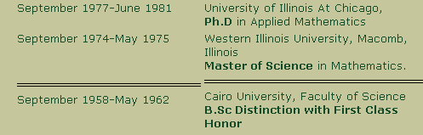

I presume he is from Cairo or at least Egypt.

Chapter 1: Introductory Concepts [ 1 ]

In his general form u = f + Ku he puts the endpoints as α(x) and β(x), just to show I think that you might have a Volterra like situation. Example 1 shows how a first order ODE integrates to an integral equation. We then have the "classification" of integral equations: Fred, Volterra, Singular, "integro-differential". His standard Fred form is φu = f + λKu on (a,b). Set φ = 0 to get Fred 1. Set φ = 1 to get Fred 2. Similarly you can have Volterra 1 and 2. Operator is linear but he does not really show what this means. An integro-differential just has a combination of integrals and derivatives of u. Singular integral equations have infinite endpoints OR the kernel blows up somewhere in the interval. Right off the bat we see our Abel and generalized Abel kernels on page 8 and he comments that these are "weakly singular" which probably means you have a somewhat soft singularity where the radical blows up (0 < α < 1). He uses the Fred and Volterra terms even if a power of u appears inside the integral (ie, even if non-linear). Exercises page 10, all very good. Uses my RHS notation! He does not include a series solution in his definition of "closed form solution". He implies a series that cannot be written in terms of some known standard function(s). He then shows the reader how in general you differentiate an integral which has x dependent endpoints, something correctly called the Leibnitz Rule. He then shows you use this rule to start with a Volterra and end up with an ODE. He then shows you can start with an arbitrary ODE with "initial value" BC's (an initial value problem or IVP) and you can convert this to a Volterra equation. Next he takes an ODE with more general BC's and converts this to a Fred equation. A great start.

Chapter 2: Fred equations [ 31 ]

We have our u = f + λKu with K = "kernel" and λ = "parameter". First case of interest is a separable kernel (finite sum of products), also known as a degenerate kernel. He requires that K be integrable on the square, but does not use the phrase Hilbert-Schmidt. He states without proof that if |λ| is less than the quantity [max(K)*(b-a)]-1, then a unique solution will exist.

Section 2.2. Adomian Decomposition.

Now at once we run into what he calls the Adomian Decomposition Method which I have never heard of. Methinks Waz is one of a handful of promoters of this method, and I just happened to pick this book at Marriott. He gives four references 1986-1994 (one is a book I now have). The claim is that this method works for non-linears, differentials, and so on, and it gives a series form of the solution. What about convergence? Waz begs off on this. So here is the idea. First, just assume a solution u = Σn un and jam this in. For a Fred we get

u = f + λKu

Σn un = f + λK Σn un

Σn un = f + Σn λK un

Now arbitrarily say that u0 = f. You then have

u1 + u2 + ... = λKu0 + λKu1 + ...

Then, again arbitrarily, force a term by term identification like this:

u0 = f
u1 = λKu0
u2 = λKu1
...
un+1 = λKun

This is then a mechanical prescription for finding a solution! I get it. But how does this compare with the usual iterated kernel method.

u = f + λKu = f + λK(f + λKu) = f + λK(f + λK(f + λKu)) etc

= f + λKf + λ2K2f + ... = f + (λK + λ2K2 + λ3K3 + ....) f

= ( 1 + λK + λ2K2 + λ3K3 ....)f

Here we also have a series of terms we might call the vi and they are

v0 = f
v1 = λKv0 = λKf
v2 = λKv1 = (λK)2 f
v3 = λKv2 = (λK)3 f

This is a different series! It would be appropriate for λ << 1, it could converge quickly whereas the decomposition series might not converge.
So fine. Example 1 on page 35 shows how this works. You get a strange looking series which in fact adds up to x2. Example 2 shows an even stranger series in which the first term is the solution, and all the other terms cancel away. These terms are called "self cancelling noise terms". Third example this same thing happens.
Now comes the "modified decomposition method" on p 38. This can be used when the inhomo f(x) consists of multiple terms. Assume this is the case, write f = f1+ f2 where f1 is then one or maybe 2 terms, and f2 is all the remaining terms. Then do the little iteration to find this slightly different sequence:

u0 = f1
u1 = f2 + λKu0
u2 = λKu1
...
un+1 = λKun

Why is this useful? Example 4 gives an example where f1 = e3x and f2 = two other terms. We find in this example that u0 = e3x and u1 = 0 and hence all other un = 0! This does seem a contrived example. I think the general claim is that if you do things right, you can get all those "self cancelling noise terms" to go away at once in this simple manner.
I shall now look on the web about this Adomian thing. There are 12,000 of hits, but most concern a specific problem, usually a non-linear problem. The wiki page is weak, I find no overview. George Adomian (1922-1996) was Armenian and was at U of Georgia. His book is "Solving Frontier Problems of Physics: The decomposition method". It is clear that Waz is an energetic fan of Adomian. I was able to find a PDF and will take a look at it now.

Section 2.3. The Direct Computation Method [43]

When the kernel factors into g(x)h(t), it is pretty trivial to solve your integral equation. You define the integral as some constant α, get the solution, then compute the right value of α. The name of this method seems a little strange.

Section 2.4. The Successive Approximations Method [48]

Start with u = f + λKu . Select u0 = some arbitrary g. Then define

u0 = g

u1 = f + λKg

u2 = f + λKu1 = f + λK(f + λKg) = f + (λK)f + (λK)2g

u3 = f + λKu2 = f + λK(f + (λK)f + (λK)2g ) = f + (λK)f + (λK)2f + (λK)3g

As long as the terms get smaller and smaller, so that (λK)ng → 0, you get the same answer I wrote above

u = ( 1 + λK + λ2K2 + λ3K3 ....)f

where in the "last term" it does not matter whether you have f or g. Notice that these un are not a "series" which you add, as I did earlier. The un is a sequence of functions and we hope that un→ u. The un are the "successive approximations". One usually picks g = 0,1 or x (usually not f). He then has his usual set of examples, and shows in one that u0 = 0 or x gives the same result.
So we can summarize this method like so:

u0 = g
un+1 = f + λKun n = 0,1,2,3....

At each iteration state, you do a single integral.

Section 2.5. The Successive Substitutions Method [52]

By this Waz means my original sequence

u = ( 1 + λK + λ2K2 + λ3K3 ....)f

Of course it is not much fun doing all these multiple integrals. He gives his usual examples.

Section 2.6. Comparison between Alternative Methods [56]

Waz did not mention any NxN lattice methods, or variational methods, or the Galerkin method, and so on. These are all beyond his book. In this section he has a page of comparison, then picks a particular integral equation and solves it by all four of his methods.

Section 2.7. Fred 1 [59]

Up to this point we have been doing Fred 2 with f ≠ 0. Now we have u = λKu with I know is an EV equation. He only just mentions this fact. He does some simple examples with 1 or 2 term separable kernels and finds some eigenvalues.

Chapter 3: Volterra equations [ 67 ]

He does not point out that Volterra is a subset of Fred with a triangular kernel. The Adomian and modified Adomian go through without any change really. Then we come to

Section 3.3. Series Solution [77]

Jam in a standard power series and match powers on both sides to get your an coefficients. He does simple cases so you don't see complications. His example kernels are always just powers.

Section 3.4. Convert Volterra to IVP [82]

Here we reverse what was done earlier. Just differentiate your Volterra, and then evaluate each level at x = 0 you get an ODE with initial value BC's. In his example, he gets an ODE and then solves that ODE.

Section 3.5 is successive approximations, goes through as with Fred. Then Section 3.6 substitutions method is exactly as before. The fact that the interval depends on x does not change things in many cases. He does his comparison of methods in Section 3.7. This time we have 5 methods, and again he picks a simple Volterra equation and solves it all 5 ways. Note that the "direct computation" method went away, lowering us from 4 to 3. But then we added the series and ODE methods, so we have 5. In Section 3.8 he again looks at Volterra 1 which he writes as f = Ku with no λ this time. This is NOT an EV problem. Rather, you differentiate it to get a Volterra 2 equation and apply those 5 methods! One requirement is that K(x,x) ≠ 0 since you have to divide by it. Examples are given.

Chapter 4: Integro-Differential equations (IDEs) [ 103 ]

Based on nature of endpoints, classify these as Fred or Volterra, then linear or not.

Section 4.2. Fred I-D equations [105]

He assumes a factorizable kernel to make things simple. The sample I-D equation is ∂nu = f+Ku along with initial values. We then use the "direct computation method" of course. Examples are given.

Section 4.2.2. Adomian Decomposition [109]

This will be something new. Still has factorizable kernel. He defines L = ∂n and will make use of L-1. I might copy some of these pages. We started here with ∂nu = f + g ∫h u and we end up with this iteration

u0 = (polynomial of degree n-1 involving the BC bk ) + L-1f

un+1 = ( ∫h un ) L-1g

So again we have a direct prescription, and again we have the cancelling noise terms to think about. He gives several long examples and in most he figures out how to get that noise cancellation.

Section 4.2.3. Convert to Fred [118]

If you have a simple factorizable kernel, you can just integrate the IDE to get a Fred one. This works if the IDE has a simple form like the ones he has considered so far.

Section 4.3. Volterra IDE's [105]

Here we are offered the series solution method and then more decomposition method with L-1. Then we can convert our Volterra IDE to a regular Volterra. Then another alternative is to convert IDE to an ODE, going the other direction.

Chapter 5: Singular Integral Equations [ 139 ]

As noted earlier, endpoints go to ∞, or kernel blows up somewhere. Example of this second case is Abel, and we are again reminded that Abel in 1823 was a pioneer in the integral equation world. Author is not going to worry about ∞ endpoint problems, and instead will do the Abel case. This is Volterra, and it is only "weakly singular".

Section 5.2. Abel's Problem [141]

Waz describes the tautochrome problem and then gives various examples of "Abel problems" in which he puts various functions on the LHS and finds u(t) using his general inversion formula that he gets doing a Laplace transform. In 5.2.1 he replaces the 1/2 denominator exponent with α with 0 < α < 1 and calls this the generalized Abel integral equation. He again does Laplace and ends up with this result:

f(x) = $^{\int_{0}^{x}{}}$dt u(t)/(x-t)α => u(x) = sin(απ)/π ∂x $^{\int_{0}^{x}{}}$dt f(t)/ (x-t)1-α 0 < α < 1

This agrees with my derivation and with Polyanin as I quote in Sned Ch 2. (It was a dual set that I had a disagreement with Poly in Sned ch 3). Notice that the above left equation is a Volterra 1 equation.

Section 5.3. Weakly Singular Volterra Equations [150]

Waz now looks at a Volterra 2 equation u = g + βKu with K = 1/$\sqrt{x-t}$(only). He gets right into the Adomian method again and we get our usual well-defined iteration sequence. He rolls out his first example p 151. I now see his point about the cancellation stuff. If you compute your u0 and u1 starting terms, if you see a cancellation between a term in u1 and a term in u0, then it is usually "the other term in u0" that is then the complete answer. You have not proven cancellation, but you can try the answer you get and see if it is the full answer. Waz then does three examples here. In the first two we detect this cancellation, while in the third example we get a series without such cancellation.
Weakly singular means (I think) that the kernel 1/$\sqrt{x-t}$, though divergent at x = t, is still integrable there. Similarly you might say 1/$\sqrt{x}$ is singular but integrable at x = 0.

Chapter 6: Nonlinear Integral Equations [ 157 ]

The general form would be u = f + λKF(u) where perhaps F(u) = un with n > 1. With a factorizable kernel, you can as usual use the "direct computation method" to solve the problem. But we are really now interested in:

Section 6.2. Nonlinear Freds [158]

Section 6.2.2. Adomian Decomposition Method [163]

Waz keeps describing certain methods as "reliable", as a sort of buzzword. We treat here u = f + λKun specifically. And now along comes the "famous" Adomian polynomial. We are supposed to write

un = Σn=0∞ An(t)

We still have our series idea that u(x) = Σi=0∞ ui(x) [ Waz overloads n which is not nice.]

There is an explicit rule for computing the An which certainly looks a bit obscure. I think you have to restrict to F(u) = poly(u) to make the claim true (otherwise I don't thing the An are polys!). Well wait, maybe the An are polynomials in the functions ui . I guess that is the point as shown top p 165. But then he gives another example where we have A1 = u1 exp(u0) which is not a poly in this sense, so I don't really understand. So OK. Install Σi ui(x) on the LHS, and install Σn An(t) on the RHS. Then identify

u0 = f
u1 = λKA0
u2 = λKA1
etc

and this is perfectly well defined. You need the An of course, he has not given a closed form for them.
He now has some comments on p 167: (i) the solution you get by this method may not be unique; (ii) the same noise cancellation idea applies here; (iii) you can compute the An for any messy F(u). He then does three examples. Very good.

Section 6.3. Nonlinear Volterras [173]

Waz opens with a power series method with the usual examples. He then does the Adomian method, which seems to follow through with no changes, except of course x is in the endpoints of the iterated terms.

Appendix A [ 183] Useful simple indefinite integrals

Appendix B [ 187] Useful integrals involving 1/$\sqrt{x-t}$

Appendix C [ 189] Some basic series forms of elementary functions

Appendix D [ 191] A few special functions

Answers to Exercises [193]

References [ 205]

Four Adomians are given, 1986-1994 (guy died in 1994!) There are 25 total. Only classic is Tricomi and Volterra 1959 Dover.

As noted above, there is lacking a clear presentation of the Adomian topic, and his book is not clear either. I did find a paper that is a little better and I quote from it:

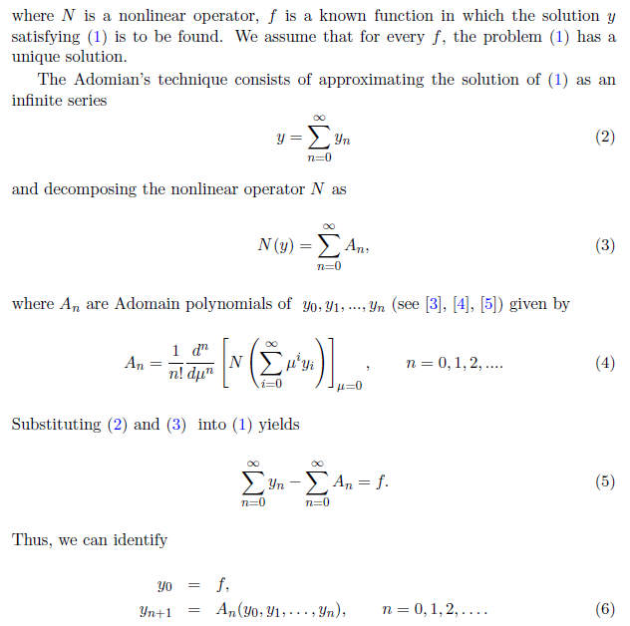
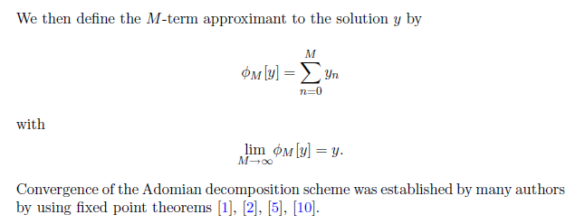

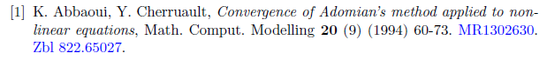
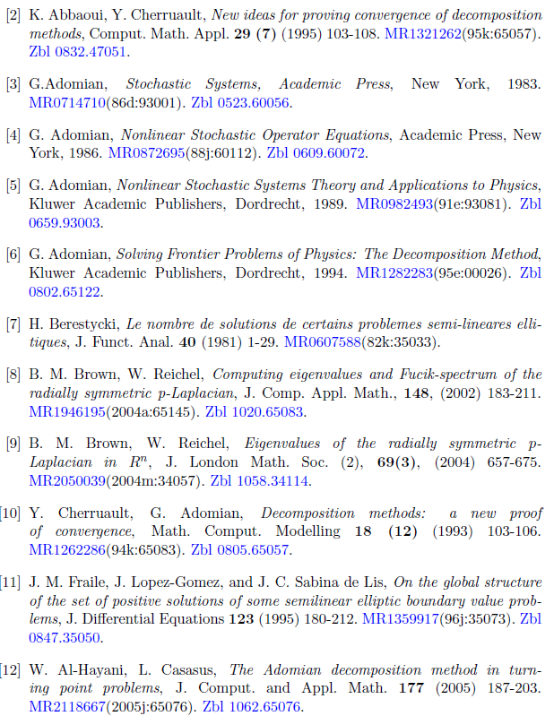

Nobody is yet saying how this method actually works. Wolfram comments on this fact. There are various papers discussing the subject, but I guess I have had enough for now. Polyanin has no mention of Adomian. I think this "method" flies under the official radar, it might not be quite ready for prime time.

