Polyanin & Manzhirov: Handbook of Integral Equations PhL 8.2.10

I have never seen a book containing this kind of information before, so I am happy to have it. The first edition was 1998 with some ~500 pages ( have it only in Russian), the second edition is 2008 with 1143 pages and I have this in English.
The front matter is 35 pages before numbering begins, so if you want a certain page, you have to add 35 to it to get the djvu page number. But easier to just search on page number!

Here is the organizational structure of the handbook:

The term "first kind" is in the sense of a first kind Fredholm equation Ky = f in Stak notation. Within this world, we know we can have fixed integration endpoints for an interval (a,b), or we can have one endpoint be the variable "x", which Stak calls the Volterra form. So here we are opening with this Volterra kind of equation.

We then go down a long list of possible kernels, making it easy for the user to find what is needed:

rational, algebraic, expo, hyperbolic, log, trig, inverse trig, combinations, then some special functions.

This consumes some 121 pages the book, about 10%.. Here are some random samples from this large section:

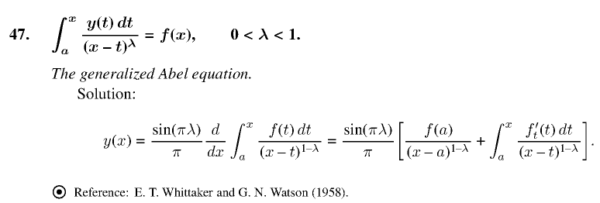

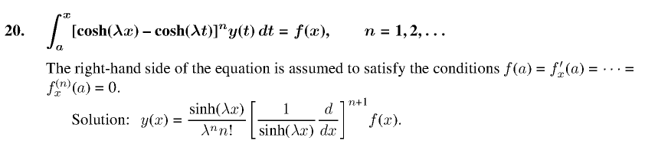

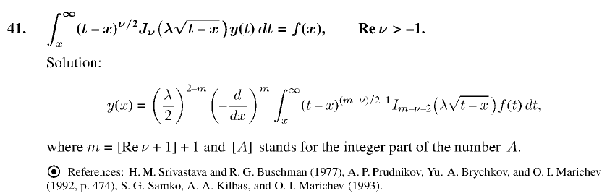

Some solutions have references with the circled dot, but other have none.

We still have the Volterra x as either the upper or lower integration endpoint, but now we have a driving function, so the general form is y - λ Ky = f. If f = 0 you have the homo equation y = λKy with some eigenvalues λ and with some homo solutions. The general solution is then y = yhomo + yparticular. If λ is not an EV, then there will be no homo solution component. I think the authors only give a particular solution and let you worry about possible homo solutions as a separate problem.

How do you solve such an integral equation? From our Stak notes we have this, where I change a few names of things:

The basic situation is that we want to solve the integral equation y = f + λKy as

y = (1 - λK)-1f = (1 + λK + λ2K2 + ....) f = f + Σm=1λmKm f = (1 + R) f

where R/λ is called the Resolvent. This is just the sum of the Neumann series Stak mentions below.

Thus our solution looks like this

y = f + R f

Here is an example

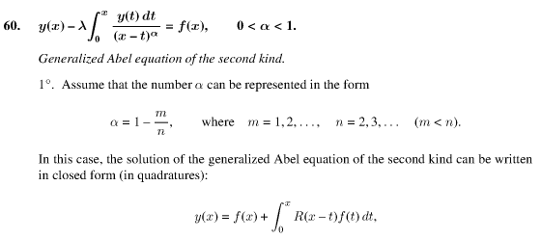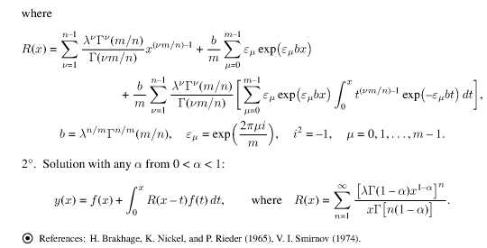

Even in the second case here the solution is pretty complicated, being an infinite sum of integrals of
(x-t)(1-α)n-1 f(t). Here is a simpler example

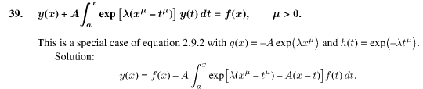

with a simpler resolvent which is just a single integral, no sum.
As before, the authors go through the "usual list" of possible kernels (almost all elementary; the only specials here are some Bessels), and the driving function is always you generic f(x). At the very end, they consider generic separable kernels, and K(x,t) = K(x-t) type kernels.
This section runs 127-217 so is about 90 pages, another 10% of the book!

We know what this means, so here is an example: (we are now back to first kind equations Ky = f(

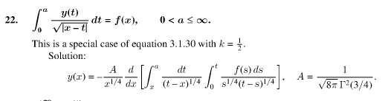

This section runs p 217- 300, so another 83 pages or so. The special functions section is much larger here than in the Volterra case. Here is an interesting example

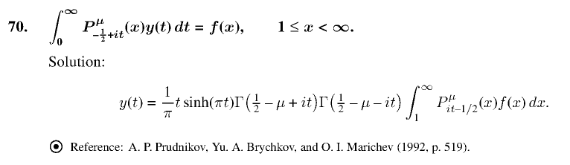

Toward the end we have our first "dual integral "section. Each member of the pair is "first kind" meaning is of the form Ky = f, and these are the duals I have been studying in Sneddon of late, and this is where I think I found an error. As usual, kernels are listed off : trig, Bessel, and conical type Bessel. There are only about 5 pages of "duals".

The logical next section. I notice that this book refers to "powers" as "power law functions". Another 90 page section, going to page 392. The usual "resolvent form" solutions.

We then move into NONLINEAR stuff:

about 10 pages to p 403

about 30 pages to p 431. Here is an example where the driving term is a constant A:

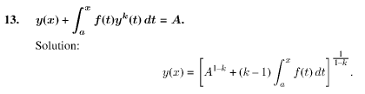

Sometimes the solution is given in an "implicit form" meaning that y(t) is the end point of an integral which has f(u) in the integrand. I have not really studied this nonlinear world at all.

about 20 pages

about 50 pages!

This Section 9 concerns using "standard transforms" to solve integral equations:

Laplace, Mellin, Fourier, Fourier Sine and Cosine,

Others: Hankel, Meijer, Kontorovich-Lebedov, Y transform,

Page 517 has a very nice summary table of all these transforms!

Whereas before we had specific solutions, here we have "theory" sort of Stakgold like. And for the first time we see the term Volterra appearing. So here we have the "first kind" Volterra equation theory.

So of course we then have the second kind Volterra theory.

So here is our general theory for "first kind" with fixed endpoints on a finite interval (a,b). Section 12.9 gives some theory for dual integral equations. Some "exact solutions" are repeated here. There is a discussion of "regularization" which I have seen mentioned elsewhere. Then notion of an "ill-posed problem".

And here we have second kind with fixed endpoints. Lots of Stak stuff here. Mention of Fredholm determinants, the "alternative", symmetric kernels, Carleman and Wiener-Hopf, lots and lots of methods each with its own little section!

They talk about the "principle value" integral as in Stak, and do not use the tick notation. A big theorem here about what analytic continuation means. Mention of "the Riemann problem" about which I know nothing, this goes on and on.

All this "singular stuff" refers to having a factor 1/(x-t) in your integral, which makes it a Cauchy type integral. It does not refer to endpoints going infinite as in Stak. Then more on regularization.

I will skip this one thank you.

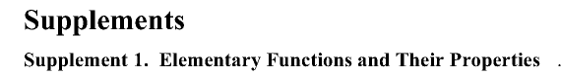

of elementary functions

of elementary and some Bessel stuff (the Weber discontinuous ones are here)

Supplements 5,6,7,8,9,10 are tables of transforms for:
Laplace and then inverse Laplace
Fourier cosine and then Fourier sine
Mellin and then inverse Mellin

This talks variations, then Stieltjes and Lebesgue integration, then normed linear and Hilbert spaces

References: Sneddon is there for Fourier and Integral Transforms, but NOT for duals!! I am pretty amazed to see that.

Index: pretty detailed.

Meta Summary:

Part I: Exact solutions of integral equations
LINEAR
Fred 1 Volterra
Fred 2 Volterra
Fred 1 fixed endpoints
Fred 2 fixed endpoints
NONLINEAR
Fred 1 Volterra
Fred 2 Volterra
Fred 1 fixed endpoints
Fred 2 fixed endpoints

Part II: Methods and Theory Section
LINEAR
using integral transforms
Fred 1 Volterra
Fred 2 Volterra
Fred 1 fixed endpoints
Fred 2 fixed endpoints
singular integral equations
NONLINEAR
one section
MULTIDIMENSIONAL INTEGRAL EQUATIONS
RELATION TO ODEs and maybe PDEs

Part II: Appendices
elementary functions, sums and infinite series.
some definite and indefinite integrals
tables of many transforms
special functions

References
Index

