Evaluation of an integral PhL 6.23.10

I am tired of doing this integral from scratch over and over again, so it will now enter the database. I did the integral below, using Maple as a starting point, then I did the second integral using Wolfram for the indefinite integral. Wolfram agreed with Maple on the first integral. I found both these definite integrals in GR7 p 408 with a monstrous huge swap error and I reported this error today to Dan Zwillinger. In any event, here are the correct results for these two related integrals: ( non-AS argument convention)

$^{\int_{0}^{π}{}}$dx(1 /$\sqrt{a ± bcosx}$) = (2 /$\sqrt{a+b}$) K($\sqrt{2b/(a+b)}$) a > b > 0

$^{\int_{0}^{π}{}}$dx $\sqrt{a ± bcosx}$ = (2 $\sqrt{a+b}$) E($\sqrt{2b/(a+b)}$) a > b > 0

and the argument of the complete elliptic function is in the range (0,1).

Doing the first integral

The integral in question is this one.

I = $^{\int_{0}^{2π}{}}$dx/$\sqrt{a - bcosx}$ = 2 $^{\int_{0}^{π}{}}$dx/$\sqrt{a - bcosx}$ a > b

This is not the same as the integral treated in a nearby document which has cosx also in the numerator.

1. Our first adjustment is this

I = (2/$\sqrt{a}$) $^{\int_{0}^{π}{}}$dx/$\sqrt{1 - fcosx}$ ≡ (2/$\sqrt{a}$) J f = b/a f < 1

2. According to Maple we have this for integral J

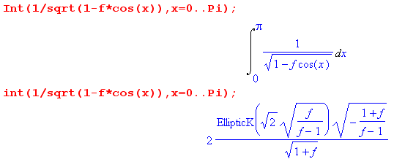

which I can simplify to read

J = 2 K($\sqrt{2f/(f-1)}$) /$\sqrt{1-f}$

3. GR has useful data on the K function (complete elliptic of first kind). In that data, symbols k and k' are both used, and they are connected by k2+ k'2= 1 (GR p 904). Suppose we make a local definition

k2 = 2f/(1+f) k'2 = (1-f) /(1+f) => k2+ k'2= 1

Then what we really have above is this, where I pick +i arbitrarily

J = 2 K(i k/k') /$\sqrt{1-f}$

We can then use GR page 908 which says

K(i k/k') = k'K(k)

so we then get

J = 2 k'K(k) /$\sqrt{1-f}$ = 2 ($\sqrt{1-f}$/$\sqrt{1+f}$) K(k) /$\sqrt{1-f}$ = 2 K(k)/ $\sqrt{1+f}$

= 2 K($\sqrt{2f/(f+1)}$)/$\sqrt{1+f}$

So we can now look back at our two results so far:

J(f) = 2 K($\sqrt{2f/(f-1)}$) /$\sqrt{1-f}$ = 2 K($\sqrt{2f/(f+1)}$)/$\sqrt{1+f}$ f = b/a (*)

Notice this important fact

J(-f) = 2 K($\sqrt{2[-f]/([-f]-1)}$) /$\sqrt{1-[-f]}$ = 2 K($\sqrt{2f/(f+1)}$)/$\sqrt{1+f}$ = J(f)

which says our result is the same whether we use +b or -b in our integral!

For f < 1 which is our interest so far, the second form in (*) has a real number as the K argument, and this real number is in the range 0,1:

k2 ≡ 2f/(1+f) < 1 => 2f < 1+f => f < 1

and we like to have an argument in this range for a K function. This suggests this idea,

J = $^{\int_{0}^{π}{}}$dx/$\sqrt{1 - fcosx}$ = 2 K($\sqrt{2|f|/(|f|+1)}$)/$\sqrt{1+|f|}$ valid |f| < 1

and we end up with our K argument in the (0,1) nice range. Another way to say it is this:

J = $^{\int_{0}^{π}{}}$dx/$\sqrt{1 ± fcosx}$ = 2 K($\sqrt{2f/(f+1)}$)/$\sqrt{1+f}$ valid f < 1

which requires many fewer symbols and gives the same K arg range (0,1).

4. Here then is our result:

I = $^{\int_{0}^{2π}{}}$dx/$\sqrt{a - bcosx}$ = (2/$\sqrt{a}$) $^{\int_{0}^{π}{}}$dx/$\sqrt{1 - fcosx}$

= (4/$\sqrt{a}$) K(k)/$\sqrt{1+f}$

where f = b/a < 1 and

k = $\sqrt{2f/(f+1)}$ = $\sqrt{2b/(a+b)}$

Meanwhile, we have

$\sqrt{a}$$\sqrt{1+f}$ = $\sqrt{a+b}$

so our final result may be written

I = 4K($\sqrt{2b/(a+b)}$) /$\sqrt{a+b}$ b/a < 1 arg of K is in range (0,1)

So what we claim to have shown is this:

$^{\int_{0}^{π}{}}$dx/$\sqrt{a - bcosx}$ = 2K($\sqrt{2b/(a+b)}$) /$\sqrt{a+b}$ a > b

Using our trick above, we can extend this result to say

$^{\int_{0}^{π}{}}$dx/$\sqrt{a ± bcosx}$ = 2K($\sqrt{2b/(a+b)}$) /$\sqrt{a+b}$ a > b > 0

This integral is not in my GR4, but it was tacked onto the end of section 3.66 in GR7 where it appears as the second of this pair:

WRONG!!! K and E are swapped!!!!!

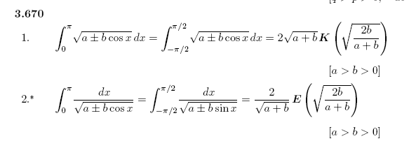
Unfortunately, GR7 has an E instead of a K in its result and gives no reference for either of these results, leaving us in some doubt. Is Maple wrong?
Wolfram claims this indefinite integral

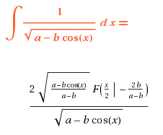

and we know from AS p 589 that F(0|m) = 0 so nothing from the lower endpoint, and then F(π/2|m) is the K function (not the E function), so Wolfram agrees with me. In more detail, this upper endpoint evaluation is:

2 $\sqrt{(a+b)/(a-b)}$F(π/2|-2b/(a-b))/$\sqrt{a+b}$ = 2 F(π/2|-2b/(a-b))/$\sqrt{a-b}$

= 2 F(π/2, $\sqrt{-2b/(a-b)}$)/$\sqrt{a-b}$ = 2 K($\sqrt{-2b/(a-b)}$)/$\sqrt{a-b}$

= 2 K($\sqrt{2b/(a+b)}$) /$\sqrt{a+b}$ // using our symmetry rule noted earlier

= my result, not the GR7 result

Conversely, Wolfram says also

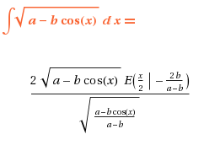
This is a very similar situation, notice the similarity of the factors. Again, only the upper endpoint contributes, and if we again change the sign of b, the answer is

= 2 $\sqrt{a+b}$ E($\sqrt{2b/(a+b)}$)

So that clinches it! GR7 has swapped the E and K in its two equations! I will report this right now.
Here is the email I just sent:

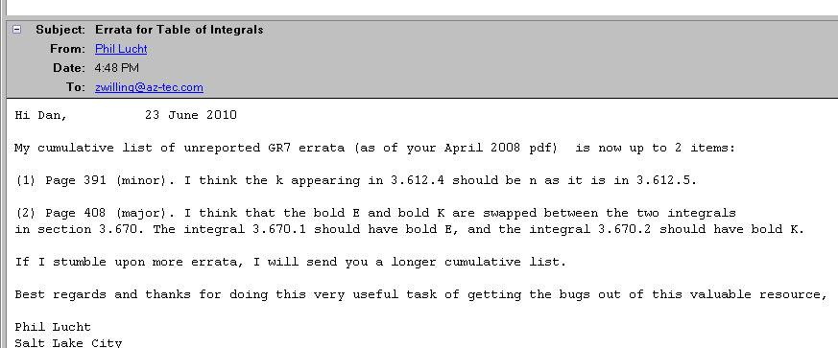

with copy in the GR7 directory.

NOTE ADDED: Marilyn asked me about Wolfram alpha, and it allows you to do definite integrals, unlike their regular online integrator site which says in its FAQ (not set up for definite integrals). Here are some examples:

http://www.wolframalpha.com/

The syntax is provided by their Help examples

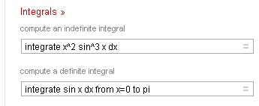

And here I apply this syntax to the current integral of interest , indefinite as in their integrator online,
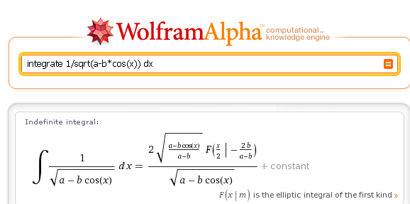

which, by the way, is followed by lots of useful other info, such as alternate forms and power series expansion of the result.

And here is the definite integral I want

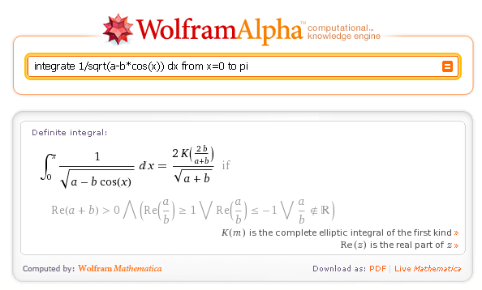

but you see here that they are using the AS convention that k2 is the argument of K. While we're at it, here is the other definite integral I am doing in this doc. But strangely, it cannot do this one!

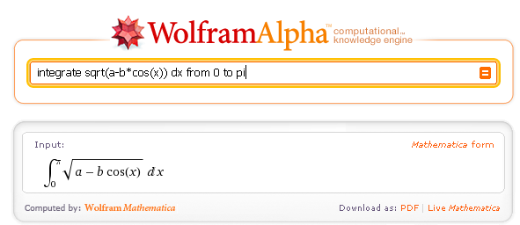

$^{\int_{0}^{π}{}}$dx $\sqrt{a ± bcosx}$ = (2 $\sqrt{a+b}$) E(2b/(a+b)) a > b > 0

