GR7 notes PhL 2.12.11

1. Where do you find "series" in this giant book?

(a) The Chapter 0 introduction Finite Sums first has FINITE sums where the summands are certain simple rational functions of k, and then the same combined with binomial coefficients.

Then after a short theory section, GR7 has "examples" of INFINITE series sums of similar summands. There are 6 full pages of such sums (I think PBM has more).

(b) Chapter 1 on "elementary functions" shows series FOR such functions. In the expo opening section, there is only one series OF such functions

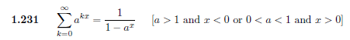

Then starting on page 36 we have some series OF trig and hyper functions. Then a few OF for log. Then a few more, and that is it.

So the idea here is that series involving elementary functions (only) are going to be in this section. There is no later book section on this topic.

(c) sums involving "special functions" are in the chapter on Special Functions, which has this contents

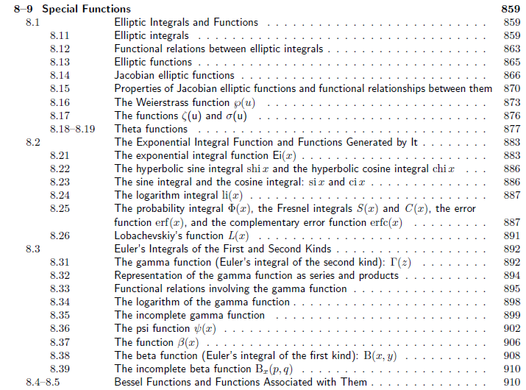
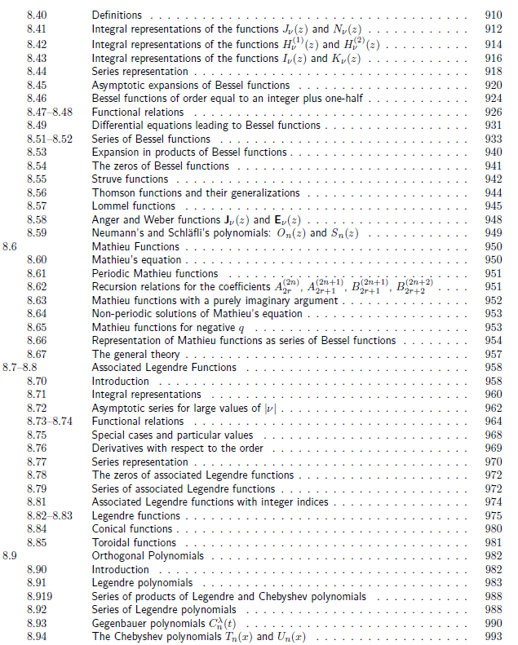
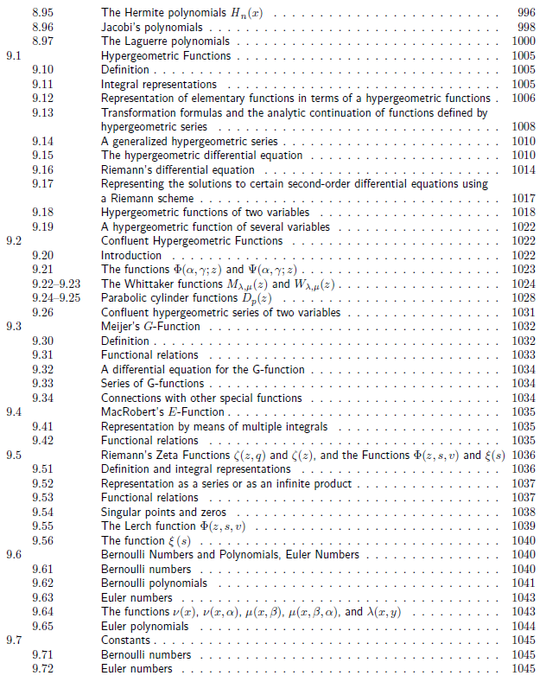

However, if we want to find sums whose integrands are Gamma Functions, we browse the pages above and we find that there are no sums presented! Whereas there are many series given involving Bessel functions.

