Gradshteyn Ryzhik PhL 1.18.10

Summary: I have downloaded the most current 7th version as a PDF. It is $60 on Amazon. I also have a PDF of new errata for this edition through April 2008. Some history is given below. There is a web site for reporting errata and for seeing the current status.

About GR:

I have never investigated errata for my 1965 Fourth Edition. Now that I am relying heavily on this book, it is perhaps time I check things out a bit.

First of all, let's look at the edition history:

I go to http://www.mathtable.com/gr/ and see this information:

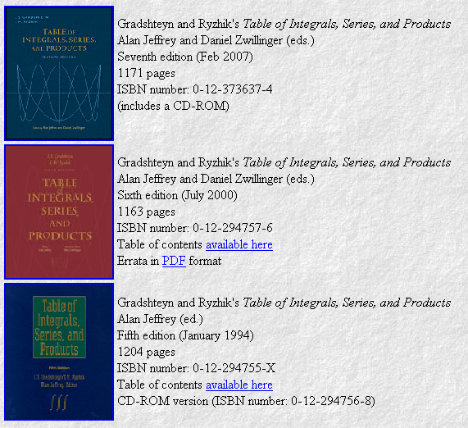

which shows the years of publication of editions 5,6, and 7. You can see that for the last three editions, the editors have been Alan Jeffrey (Newcastle upon Tyne) and Daniel Zwillinger. The above site has much to say. My 1965 4th Ed has Jeffrey as the "translation editor", but "prepared by" is two Russian names Ger and Tse.
Jeffrey has a low web profile. He must be 40+45 = 85 years old now, just a guess, so probably Zwillinger is the main workhorse. He has an instant large web page. PhD 1983 Caltech. I follow this to a list of errata even for the 7th edition! http://www.mathtable.com/errata/ It is April 11, 2008 so the errata has not been brought in for a year.
The same page as the picture above has more interesting info:

so here is the list of "proofs" ( derive the integrals) http://www.math.tulane.edu/~vhm/Table.html
Wow, I like it! My integral of interest today however has not been proven yet.

Now a lot about errata:

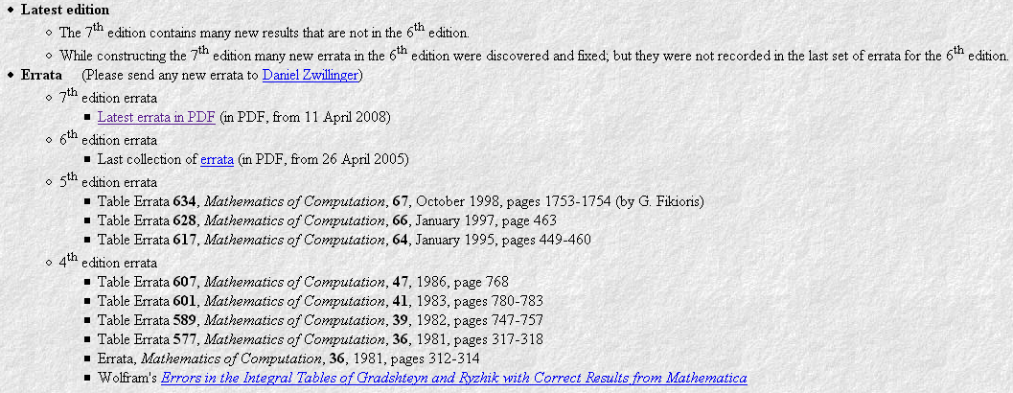

That same MC journal that had the Bateman stuff. See above for link to 7th ed errata which I downloaded.

The TILU link is dead. I looked up Fateman, he has taken it down for now.

Send email to Alan Jeffrey at Alan.Jeffrey@newcastle.ac.uk
Send email to Daniel Zwillinger at zwilling@az-tec.com

So I have gotten everything off the above page which was http://www.mathtable.com/gr/

The current 7th edition Amazon price today is a mere $60 with free shipping. This is without CD ROM. I think a CD ROM was made in 1996. Well, I think this comes with the 7th edition if you just buy it, this is what some reviewers say. I could ask.

Download 7th Ed PDF.

I just found this 7th Edition in PDF at scribd and am bringing it in, it is 7.3 MB. I have to assume this incorporates all errata since 1965 ! I have it and it comes up OK, index on the left. The cover of the book says CD included on it. The cover Amazon presents shows the "CD included" icon upper right, so it must have the CD.

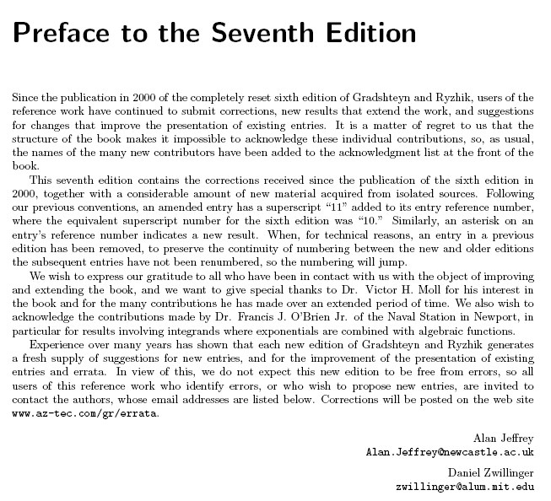
Nothing is said about the history of this book! But I have found a nice Wolfram article

http://www.stephenwolfram.com/publications/recent/specialfunctions/

and here is what he has to say: (he says quite a lot in fact about other things)

I still don't know the full story. But here's what I know.... In 1936 Iosif Moiseevich Ryzhik had a book entitled Special Functions published by the United Moscow-Leningrad Scientific-Technical Publisher. Ryzhik died in 1941, either during the siege of Leningrad, or fighting on the Russian front. In 1943, a table of formulas was published under Ryzhik's name by the Governmental Moscow-Leningrad Technical-Theoretical Publisher. The only thing the book seems to say about its origins is that it's responding to the shortage of books of formulas. It says that some integrals marked in it are original, but the others mostly come from three books--a French one from 1858, a German one from 1894, and an American one from 1922. It explains that effort went into the ordering of the integrals, and that some are simplified by using a new special function s equal to Gamma[x+y-1]/(Gamma[x]Gamma[y]). It then thanks three fairly prominent mathematicians from Moscow University. That's basically all we know about Ryzhik. It's more than we know about Euclid--but not much.
OK, so now for the next part of the story. Israil Solomonovitch Gradshteyn was born in 1899 in Odessa, and became a professor of mathematics at Moscow State University. But in 1948, he was fired as part of the Soviet attack on Jewish academics. To make money, he wanted to write a book. And so he decided to build on Ryzhik's tables. Apparently he never met Ryzhik. But he created a new edition, and by the third edition, the book was known as Gradshteyn-Ryzhik.
Gradshteyn died of natural causes in Moscow in 1958. Though somehow there developed an urban legend that one of the authors of Gradshteyn-Ryzhik had been shot as a piece of anti-Semitism on the grounds that an error in their tables had caused an airplane crash.
Meanwhile, starting around 1953, Yurii Geronimus, who had met Gradshteyn at Moscow State University, began helping with the editing of the tables, and actually added the appendices on special functions. Later on, several more people were involved. And when the tables were published in the West, there were arguments about royalties. But Geronimus is now still alive and well and living in Jerusalem, and Oleg phoned him last week.
I guess integrals are timeless. They don't really bear the marks of the human creators. So we have the tables, but we really don't quite know where they came from.
_____________________________

My integral of interest today is unaltered (the second one below) [ and nothing in the errata 2008 ]

