Maple plots of the sech^2 integral PhL 2.1.11

Overview (1/2 page, written 2.3.11). 1
1. Plotting the ch(bτ) sech²(πτ) integral., 1
2. Plotting the cos(aτ) sech²(πτ) integral. 4
3. Repairing the ch(bτ) sech²(πτ) integral. 6
4. What is really happening here in terms of analytic continuation? 9

__________________________________________________________________________________

Overview (1/2 page, written 2.3.11).

In Section 1 I am just curious to know if there is "something strange" going on with my ch(bτ)sech2(πτ) Mehler integral that I used in my Capacitance v2 doc. I was missing the π part of the bowl capacitance, and was starting to think it might be due to my use of this integral. I had assumed the integral was valid for the entire range |b| < 2π since the LHS obviously converges there, and we just think of doing "analytic continuation" of the RHS. So I plot the integral expecting to get a monotonically increasing function, but am very surprised to find a completely different shape, a sort of cusp thing with peak at b = π. When I then correct for my (-1)η phase stuff, it gets even worse, I get a discontinuity at b = π! Clearly something is very wrong. I don't yet know what it is.

In Section 2 I decide to plot the cos(aτ) integral from which I derived the malfunctioning integral used above. But the plot here comes out just fine, no problemo. Along the way I discover that Maple has trouble evaluating the Mehler P function at certain points and therefore cannot plot it. But Wolfram comes to the rescue and I confirm my expectation of how the Mehler P varies with τ, sine like.

In Section 3 I show that if we make the simple replacement on the right hand side ,

tan-1[ $\sqrt{y-cosb}$/$\sqrt{1+cosb}$] = cot-1 [$\sqrt{1+cosb}$/$\sqrt{y-cosb}$]

then our Maple plot does exactly what it should, and our evaluation is then valid on |b| < 2π.

In Section 4 I think of the above replacement as tan-1(1/z) = cot(z). The proper analytic continuation of the thing on the left as you pass through z=0+ to z=0- is given by the thing on the right. If you instead use the official principle branch of tan-1 (..), then you are not continuing, you are jumping across a cut, and in doing this you create an error in the amount of -π.
___________________________________________________________________________________

1. Plotting the ch(bτ) sech2(πτ) integral.,

The integral is this (from "doing Mehler...")

$^{\int_{0}^{∞}{}}$dτ Piτ-1/2(y) ch(bτ) sech2(πτ) = ($\sqrt{2}$/π ) (1/$\sqrt{y-cosb}$) tan-1[ $\sqrt{y-cosb}$/$\sqrt{1+cosb}$] // sec 11

Both sides are symmetric in b. We presume the integral converges then for 0 < b < 2π for real b. I am wondering what the RHS looks like as b traverses this range, for a given y > 1. I expect that as b runs from 0 to 2π, the integral gets larger because we are more and more counteracting the convergence effect of the 1/cosh2(πτ) factor. It should get larger monotonically.
So, does anything strange happen in a Maple plot? Yes, it has a cusp at π, which seems wrong.

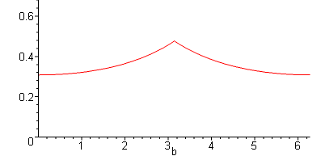

I think this might relate to the "analytic adjustment" I should make according to

f(z) ≡ $\sqrt{1+cosb}$ for z in the range (-∞,∞)

= (-1)η | $\sqrt{1+cosb}$| where η = floor[(b+π)/2π]

Here is what this does to this f(z):

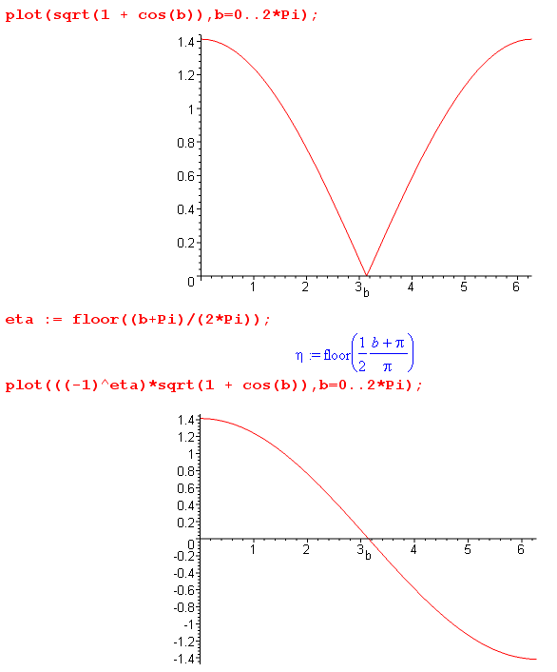

Now let's put this adjustment into our original integral RHS. But things don't look improved! :

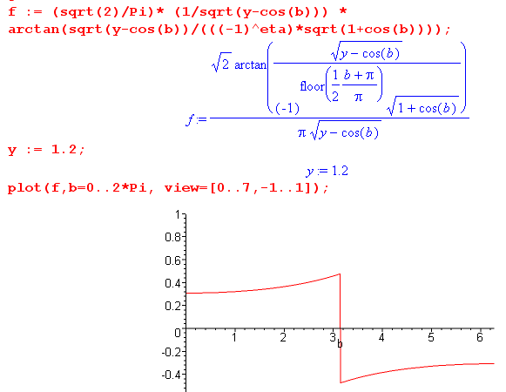
As we sweep b left to right, when b = π-ε we get arctan(+∞) which is +π/2, then at b = π+ε this jumps suddenly to arctan(-∞) which is -π/2. This is not the behavior I expect from the LHS integral!

I think my integral LHS = RHS is only valid for b in the (0,π) range, that is what I am learning in this doc, and what I want to understand.

Recall this step in the derivation

F(1,1/2; 3/2; z) = [tanh-1$\sqrt{z}$]/$\sqrt{z}$ = tan-1[ $\sqrt{y-α}$/$\sqrt{1+α}$] ( $\sqrt{1+α}$ / $\sqrt{y-α}$ ) (10.28)

where we had α = cha.

2. Plotting the cos(aτ) sech2(πτ) integral.

Since we got the ch(bτ) result from the cos(aτ) result, we might want to make sure the cos(aτ) result is not doing anything unusual!

$^{\int_{0}^{∞}{}}$dτ Piτ-1/2(y) cos(aτ) sech2(πτ) = ($\sqrt{2}$/π ) (1/$\sqrt{y-cha}$) tan-1[ $\sqrt{y-cha}$/$\sqrt{1+cha}$] // sec 10

Here you would expect the LHS to drop off monotonically as a increases from 0. There might be some doubt about that depending on the way the P function oscillates. If it were cos(yτ)-like, you might possibly build to a resonance peak near a ≈ y and then drop off from there. I tried to plot this P function in Maple, but it takes forever at certain τ values such as this evalf(LegendreP(I*6/4-1/2,y)). It will sit there for a > minute thinking about this evaluation just at a single point, even with Digits = 3. I am a bit amazed at that. But Wolfram online can do it just fine, for example:

[ later I am unable to duplicate this problem in Maple and it seems to plot the thing below just fine. ]

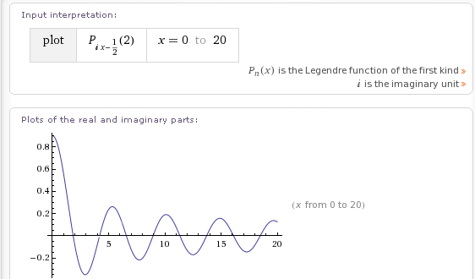

This is the shape I expected to see, very Bessel like with a long trig tail.
So here is the Maple result for our cos(aτ) integral:

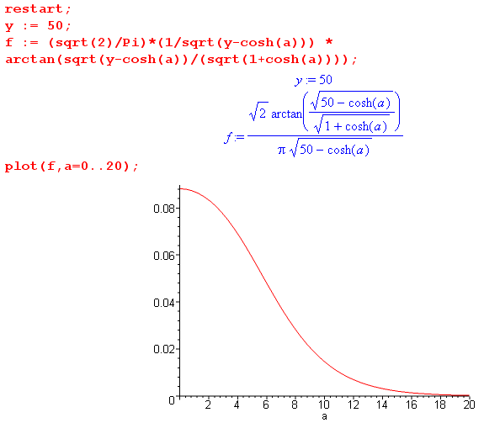

So that delayed peak you might expect simply does not occur, it seems monotonic. Notice also that the argument of arctan goes imaginary when cha = 50 which is around a = 4, but so does the denominator, and Maple takes all this into account and the result is silky smooth.

So my conclusion is that this integral

$^{\int_{0}^{∞}{}}$dτ Piτ-1/2(y) cos(aτ) sech2(πτ) = ($\sqrt{2}$/π ) (1/$\sqrt{y-cha}$) tan-1[ $\sqrt{y-cha}$/$\sqrt{1+cha}$] // sec 10

is valid for all real a. It is of course even in a, so we only think about (0,∞). No restrictions.

3. Repairing the ch(bτ) sech2(πτ) integral.

OK, let's get back to our problem child integral.
But first: Here is a plot of tan-1x from Schaum

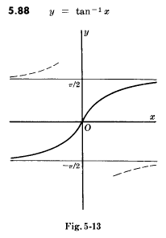

and I am thinking about tan-1[ $\sqrt{y-cha}$/$\sqrt{1+cha}$]. When we write the letters "tan-1", we imply the function shown above as the dark curve. This is a "branch" of the function, it is a continuous curve. We could have picked the branch above or the branch below. We could even have picked the upper solid curve and then dotted curve above that. Those two combined would still provide a "function" in the sense that for every x, there is only one y. This function looks like so:

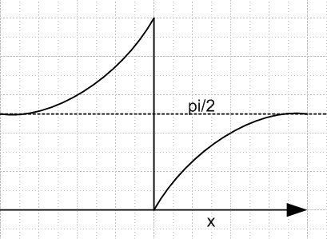 Fig 1

If we were to use this function, then when the argument of tan-1(x) takes a sudden jump from +∞ to -∞, the value of tan-1(x) stays at π/2 and nothing dramatic happens. But people usually don't use this peculiar branch because it has that nasty discontinuity at x = 0 and x = 0 is usually a region of great interest. Maple of course thinks in terms of the above Figure 5.13 when it things tan-1(x).

But there is a way out! And a very simple one at that. First, we need to convince ourselves of this simple fact:

tan-1(A/B) = cot-1(B/A).

Let's just assume that A and B are arbitrary positive real numbers. Then we can draw a triangle

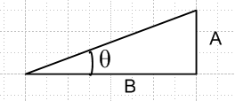

Given arbitrary A and B, this triangle defines a certain θ lying in 0,π/2 and no one would deny the truth of our claim that tan-1(A/B) = cot-1(B/A). Now suppose quantity B is passing through a zero from 0+ to 0- and we are dealing with branch 5-13 above. The function tan-1(A/B) makes a sudden jump from π/2 to -π/2. If we could use our Fig 1 branch, this would not happen, it would jump from π/2 to π/2.
Consider our integral again,

$^{\int_{0}^{∞}{}}$dτ Piτ-1/2(y) ch(bτ) sech2(πτ) = ($\sqrt{2}$/π ) (1/$\sqrt{y-cosb}$) tan-1[ $\sqrt{y-cosb}$/$\sqrt{1+cosb}$] // sec 11

Both sides are well defined for b in the range (0,π). We know that the LHS is going to be continuous through the point b = π. The integral will be the same at b = π+ε and at π-ε. We know that because nothing strange happens to the LHS at this value of b. If we want to extend our equation beyond this point, we have to find an "interpretation" (analytic continuation) of the RHS which is continuous at b = π. The letters tan-1 on this RHS are ambiguous as written. The correct "branch" to use in this case of tan-1 is the Fig 1 branch, but it is a bit clumsy to have to use this non-standard branch. Normal identities might not work right, for example.
So the simple way is to make this replacement

tan-1[ $\sqrt{y-cosb}$/$\sqrt{1+cosb}$] = cot-1 [$\sqrt{1+cosb}$/$\sqrt{y-cosb}$]

Things work well now only because this is what the standard principle branch of cot-1 looks like:

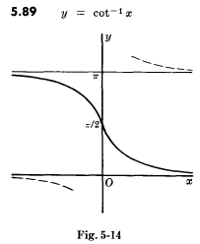

Now as our problematic factor $\sqrt{1+cosb}$ passes through $\sqrt{0}$ at b = π and changes sign (according to our analytic analysis of f(z) = $\sqrt{1+cos(z)}$, see elsewhere! ), we are at the point on the branch marked by the π/2 value. But now we get this π/2 value for $\sqrt{1+cosb}$ = +0 or -0-, things are continuous. Notice that this standard branch is all on the positive side of y = 0, and it is a continuous curve. I think this is going to solve my problem.
Now let's redo our Maple plot with this change installed.

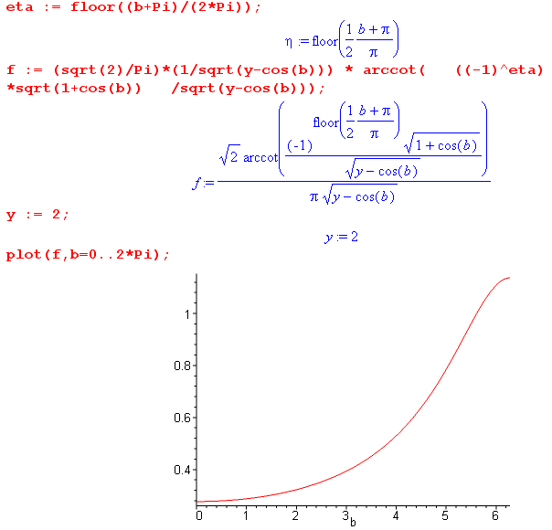

This plot is for the convergence range of the LHS which is b in (0,2π). The RHS however can be plotted beyond this range, but there it is not equal to the LHS (but might be considered a continuation of the function of complex b defined by the LHS where it converges. Here is a sample extended plot:

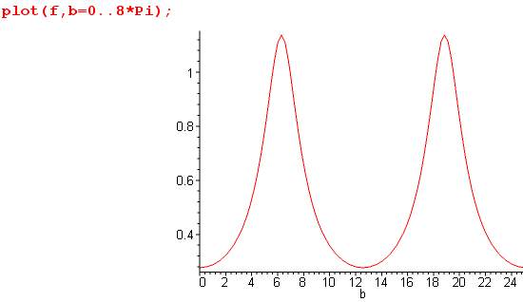

But right now at least, I only care about the LHS where it converges, so b in (0,2π). I hope this is going to fix my "capacitance problem" for the charged bowl.

4. What is really happening here in terms of analytic continuation?

Let's write

tan-1z = -i tanh-1(iz) Schaum page 31

tanh-1w = (1/2) ln [(1+w)/(1-w)] Schaum page 29

For this second function we can draw the cut structure easily

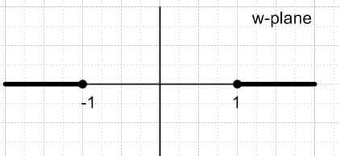

Then we have

tan-1z = -i tanh-1(iz) = (-i/2) ln [(1+iz)/(1-iz)] = (-i/2) ln [(i-z)/(i+z)]

and we can then say this is the cut structure for tan-1z "

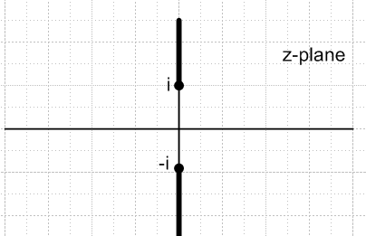

Now let's consider another function by taking z→1/z above

f(z) = tan-1(1/z) = -i tanh-1(i/z) = (-i/2) ln [(z+i)/(z-i)]

and the cut structure is now

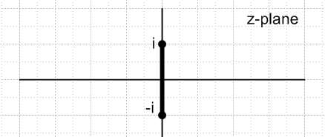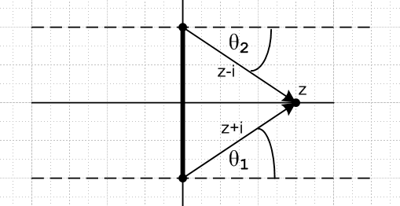

and this is our function of interest. As z moves from +0.1 to -0.1, we go through the cut to another sheet if we are "an ant" tracking analytic continuation. We want to learn about this sheet the ant gets to.

First, write

f(z) = tan-1(1/z) = (-i/2) ln [ { |z+i|exp(iθ1)} / { |z-i|exp(iθ2)} } ]

= (-i/2) [ ln(|z+i|/|z-i|) + i(θ1-θ2) ]

= (θ1-θ2)/2 – i (1/2) ln(|z+i|/|z-i|)

= (θ1-θ2)/2 = θ1 // z is on the x axis
We see that if z is on the positive x axis, the ln part = 0 and θ2 = -θ1 and this becomes just f(z) = θ1. So consider again starting at z = +0.1 and we go through the cut to z = -0.1. Nothing dramatic happens. We have θ2 = -θ1 at all times and thus f(z) = θ1 at all times. So maybe θ1 goes from π/2-ε to π/2+ε. The argument of tan-1 went from +∞ to -∞ during this little voyage. This is how you "analytically continue" something. If we were to make a plot of f(z) versus z for a journey z = +∞ toward 0, through the cut, and on to z = -∞, f(z) is of course always real, and here is what this plot looks like:

It is the solid line on this plot. But of course f(z) = tan-1(1/z) = cot-1(z), no surprise. This is why we get a clean picture of what is happening if we use the cot-1(z) principle branch.

Now suppose our ant "jumped over the cut" instead of going through it. That would be the same as rotating our lower arrow clockwise around the lower branch point. When we get done, θ2 stays the same, but θ1 has changed by -2π. Thus, on this new sheet we have

f(z) = (θ1+2π-θ2)/2 = (θ1-θ2)/2 - π

This is exactly what happens if we use the principle branch of tan-1(x) and go off the right end x=+∞ and reappear on the left end at x = -∞. The f(z) takes a sudden step from +π/2 to =-π/2, and this is like the ant jumping across the cut and getting that -π change noted above.

So the upshot of all this is that if we want to analytically continue the function

tan-1[ $\sqrt{y-cosb}$/$\sqrt{1+cosb}$]

as b passes through the point b = π-ε to π+ε, we have to either manually add back a π when we cross the boundary, or we replace the above with

cot-1 [$\sqrt{1+cosb}$/$\sqrt{y-cosb}$]

and then everything is smooth. So our big conclusion is that if we write

$^{\int_{0}^{∞}{}}$dτ Piτ-1/2(y) ch(bτ) sech2(πτ) = ($\sqrt{2}$/π ) (1/$\sqrt{y-cosb}$) cot-1 [$\sqrt{1+cosb}$/$\sqrt{y-cosb}$]

then both the LHS and the RHS are smooth analytically as we move b through π. The result is that we can use the above integral for |b| < 2π, whereas the other form is only good for |b| < π.

