Power series and f(x) constant in a finite region PhL 1.22.10

I keep having a certain wrong notion about expansions and will try to explain that and clarify it here.
See Main Conclusions of this Document section below.

Example 1 : sine Fourier expansion of a square wave. 1
A notion to be disabused. 2
The metal spherical cap Dirichlet problem. 3
Example 2 : Legendre Fourier expansion of a square wave. 3
Example 3 : Power expansion of a square wave. 6
Example 4 : Constant on part of the domain, variable on another 6
Example 5 : Potential above a metal disk. 8
Main Conclusions of this Document 11
Conditions on f(x) at x = 0 for a power series to exist there. 11
Conditions on f(x,y) at x,y = 0,0 for a power series to exist there. 12
When does the power series f(r,θ,φ) = Σ_{n} a_{n} r^{n} f_{n}(θ,φ) exist? 12

Example 1 : sine Fourier expansion of a square wave.

Consider the interval -π,π with a simple step function,

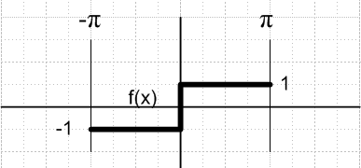

Expand f(x) on a trig Fourier Series, has only odd terms so get [ Schaum p 131 L = π]

f(x) = Σn=1∞ bn sin(nx) bn = (1/π) $^{\int_{-π}^{π}{}}$dx f(x) sin(nπ)

We extend f(x) to be periodic outside the window shown to make this work. The coefficient is this:

bn = (1/π) $^{\int_{-π}^{π}{}}$dx f(x) sin(nπ) = (2/π) $^{\int_{0}^{π}{}}$dx sin(nπ) = -(2/π)(1/n)cos(nx)|π0 = -(2/nπ)[(-1)n-1]

This is non-zero only for odd terms where it has the value (4/nπ). Thus we have

f(x) = Σn=odd (4/nπ) sin(nx)

In order to make the reader "a believer", we do a little Maple work:

restart;
f := n -> (4/Pi)*(1/n)*sin(n*x):
F := sum(f(2*i+1),i=0..10):
plot(F,x=-Pi..Pi);

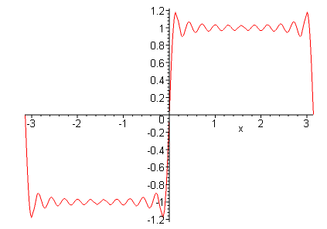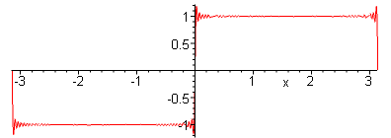

where we have added only the first 11 terms of the series on the left, and the first 61 on the right. The series of course really has well over a billion terms :-).

The slope of the above function is this:

f ' (x) = (4/π) Σn=odd cos(nx) = (4/π) Σn=odd cos(nx)

If x = 0 we get ∞. we know this thing is a delta function at the origin (and a negative delta at the edges). Here is a plot to go with the 61 term result above

slope := diff(F,x):
plot(slope,x=-Pi..Pi);

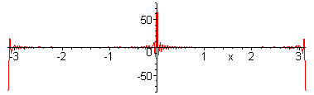

A notion to be disabused.

So convinced that the above expansion is correct, we now discuss it. We have:

f(x) = Σn An sin(nx) An = 0 n even
An = 4/(nπ) n odd

Here is the notion to be disabused: Imagine some point x1 = 1.435 say. We have f(x1) = 1.000000 exactly on our square wave. Now if we move just slightly to the right to x1 + ε, you would think that f(x) would have to change. It just seems unbelievable that f(x) would stay constant in fact under a large change in x within our interval. But that is exactly the case with this function f(x) as shown above. The slope is in fact 0 everywhere except at the origin and ends.
So we have to get rid of this false notion:

False Notion: If a function is constant on some finite region, and if you expand that function in terms of a set of basis functions, then only the constant term in the sum survives.

Now this notion is a true notion if the function is constant on "the entire region". In our 1D case, that entire region would be the entire interval, which in our example above is (-π,π). In a 3D situation, "the entire region" would refer to an entire enclosing Dirichlet boundary.

The notion is also a true notion if we happen to know that f(x), treated as a complex function f(z), is analytic on a disk containing our real interval. Obviously our step function above is not analytic at x = 0 which is right in the middle of our interval. It is "analytic" separately on the two sides.

See the Main Conclusions section at the end of this doc.

The metal spherical cap Dirichlet problem.

A case of interest for me at present is a Dirichlet problem such as the metal spherical cap. In that case, we have the potential being a constant on the cap, but not on the entire sphere. When we expand our potential in this way

V(r,z) = Σn An rn Pn(z)

we do in fact have V being a constant over a finite 2D region

V(a,z) = Σn An an Pn(z) = V0 for z in finite range (0,z0)

You want to say "gee, for some z in the middle of this 2D region, if we alter z slightly, how could V not change? " The reason is simple. If we knew the solution An for this problem ( it is given in our Canonical doc), we would find that the function has zero slope as a function of z, but only on the portion (0,z0) of the range.

Example 2 : Legendre Fourier expansion of a square wave.

Let's just repeat our first example, same square wave but this time on interval (-1,1) with Pn(x) as the basis functions:

f(x) = Σn∞ bn Pn(x) bn = (2n+1)/2 * $^{\int_{-1}^{1}{}}$dx f(x) Pn(x)

We know that only odd n will contribute, so our coefficients will be

bn = (2n+1)/2 * $^{\int_{-1}^{1}{}}$dx f(x) Pn(x) = (2n+1) $^{\int_{0}^{1}{}}$dx Pn(x)

This integral seems to appear in my new GR7

which says

$^{\int_{0}^{1}{}}$dx Pn(x) = $\sqrt{π}$2-1/[ Γ(1-n/2)Γ(n/2+3/2) ]

bn = (2n+1) $\sqrt{π}$2-1/[ Γ(1-n/2)Γ(n/2+3/2) ]

I know I could write this in terms of double factorials, but nothing on my gamma page is relevant. I would like to turn around the first gamma argument using

Γ(-z)Γ(z+1) = - π/sin(πz) z = n/2-1 z+1 = n/2

Γ(1-n/2)Γ(n/2) = - π/sin(π[n/2-1]) = +π /sin(πn/2) but n is only odd

sin(πn/2) = (-1)(n-1)/2 => Γ(1-n/2)Γ(n/2) = +π (-1)(n-1)/2

=> 1/ Γ(1-n/2) = (1/π) Γ(n/2) (-1)(n-1)/2

$^{\int_{0}^{1}{}}$dx Pn(x) = $\sqrt{π}$(1/2π) (-1)(n-1)/2 Γ(n/2) / Γ(n/2+3/2)
= $\sqrt{π}$(1/2π) (-1)(n-1)/2 Γ(n/2) / [ Γ(n/2+1/2)(n/2+1) ]
= (1/$\sqrt{π}$) (-1)(n-1)/2 Γ(n/2) / [ Γ(n/2+1/2)(n+2) ]

then we have for n odd

bn = (2n+1)/(n+2) * (1/$\sqrt{π}$) (-1)(n-1)/2 Γ(n/2) / Γ(n/2+1/2)

Speed of convergence of bn. Stirling says

x Γ(x) = Γ(x+1) → $\sqrt{2πx}$xx e-x

(n/2) Γ(n/2) → $\sqrt{2π(n/2)}$(n/2)(n/2) e-n/2

(n/2+1)Γ(n/2+1/2) → $\sqrt{2π(n/2+1/2)}$(n/2+1/2)(n/2 + 1/2) e-n/2-1/2

Γ(n/2) / Γ(n/2+1/2) = $\sqrt{2π(n/2)}$(n/2)(n/2) e-n/2 / $\sqrt{2π(n/2+1/2)}$(n/2+1/2)(n/2 + 1/2) e-n/2-1/2

= $\sqrt{n}$/$\sqrt{n+1}$ * [ (n/2)(n/2)/ (n/2+1/2)(n/2 + 1/2) ] * e1/2
Expand
(n/2+1/2)(n/2 + 1/2) = (n/2+1/2)1/2 (n/2+1/2)(n/2)

≈ (n/2)1/2 (n/2+1/2)(n/2)

We use our "e" doc result that limx→∞ (x+a)x = xx ea to get

≈ (n/2)1/2 (n/2)(n/2) e1/2
Therefore,

Γ(n/2) / Γ(n/2+1/2) → $\sqrt{n}$/$\sqrt{n+1}$ * [ (n/2)(n/2)/ (n/2+1/2)(n/2 + 1/2) ] * e1/2

≈ (n/2)-1/2

I have confirmed this in Maple for large n. So we have

bn = (2n+1)/(n+2) * (1/$\sqrt{π}$) (-1)(n-1)/2 Γ(n/2) / Γ(n/2+1/2)

→ (2/$\sqrt{π}$) (-1)(n-1)/2 (2/n)1/2 = 2 $\sqrt{2/π}$ (-1)(n-1)/2 /$\sqrt{n}$ n =odd

This is relatively slow convergence, but I think we do get convergence!

Back to our square wave. We have

f(x) = Σn,odd bn Pn(x) bn = (2n+1)/(n+2) * (1/$\sqrt{π}$) (-1)(n-1)/2 Γ(n/2) / Γ(n/2+1/2)
bn = (2n+1) $\sqrt{π}$2-1/[ Γ(1-n/2)Γ(n/2+3/2) ]

Now we are ready for some Maple verification:

restart:
Digits := 20:
b := n -> (2*n+1)*sqrt(Pi)*(1/2)/(GAMMA(1-n/2)*GAMMA(n/2+3/2)):
term := n -> b(n)*LegendreP(n,x):
F := sum(term(2*i+1),i=0..18):
plot(F, x=-1..1);

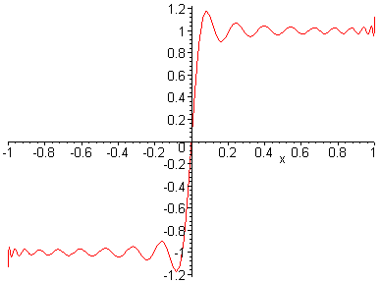

And there you are. It was a bit messier doing it in Legendres instead of sines.

Example 3 : Power expansion of a square wave.

Same as previous Example 2, but now use powers:

f(x) = Σn=1∞ bn xn

How now do we find the coefficients? This is a trick question! Since the powers don't form an orthogonal set, they are not a basis, just a spanning set. We can get arbitrarily close with an n-power fit as we increase n, but the coefficients keep moving. Probably the best fit you can get through x17, say, would be the coefficients you get from the Legendre expansion through P17(x), which gives this expansion: ( a plot using this shows it is reasonable)

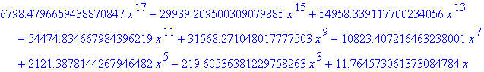

The coefficients are perhaps surprisingly large. This is mainly because the Pn(x) have large coefficients. They in turn have large coefficients because, for |x| < 1, numbers like x15 get pretty small unless boosted by such large coefficients. Also, we need to generate fairly steep slopes to have all the nodes.

So the bottom line is that the following expansion does not exist for our square wave f(x)

f(x) = Σn=1∞ bn xn

As noted in my Chap 2 Stakgold notes, the reason is that f(x) is not analytic (is discontinuous) at the point we are trying to do our power series, x = 0. So the radius of convergence is R = 0, in effect. More basically, there are no coefficients bn that you can write down!

Example 4 : Constant on part of the domain, variable on another

Let's go back to Example 2 where we modeled the square wave with a Legendre series.

f(x) = Σn,odd bn Pn(x) bn = (2n+1) $\sqrt{π}$2-1/[ Γ(1-n/2)Γ(n/2+3/2) ]

Now instead of the interval (-1,1), let's apply this to the interval (0,∞). It happens that this function increases very rapidly to the right of x = 1. If we have Maple plot the first 21 terms, we get this plot

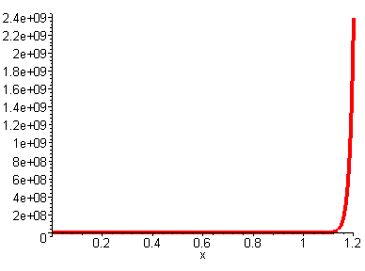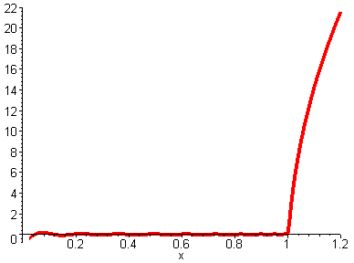
It is not clear that the curve "pulls away" from the constant right at 1.0, but this is more obvious if we plot the log of the function instead, as on the right.
The point is this: it is possible to have an expansion on some functions such that the resulting function is constant on a portion of the domain, and varies elsewhere. Our square wave was our first example showing this, but it happened to be constant on the other half of its domain as well. We could have drawn any function we wanted for the left half of the square wave, and our trig series would have reproduced it. Here we just have a quick example re-using what we already had.

Can we produce a similar example expanding on powers? Try this:

f(ρ) = $\sqrt{(ρ-a)2 + b2}$ + $\sqrt{(ρ+a)2 +b2}$

Near the point ρ = a, this function four branch points at ρ = ±a ± ib. (see drawings elsewhere) We can draw a disk centered at ρ = 0 and radius $\sqrt{a2+b2}$in which f is analytic, and which includes the point ρ = a. So we could represent f(ρ) as an infinite power series in this range, though I have not computed the coefficients (only even terms). In the limit b→0, this function gives an example of a function which is constant on (0,a) and varies in (a,∞). But staying a little away from the limit, we get something that looks pretty good. If we let a = 1 and b = .01, we get this plot of f(ρ) on x in (0,2).

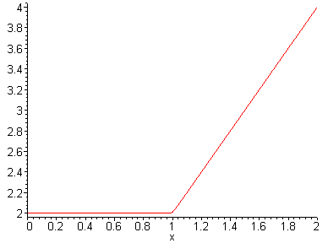

In fairness, our power series would only converge just slightly to the right of ρ = a, so I guess this is not a very impressive example using power series. In fact, we would have to say that in the range (0,a), this is more an example of only the constant term surviving! OK, just wanted to work this in.
I think the answer is that this does not work with powers! The point were the flat region ends will not be analytic, so the power series disk can never include that point. More on this below.

Example 5 : Potential above a metal disk.

(a) Suppose we try to model such a potential in this manner:

V(r,z) = Σn AnrnPn(z)

perhaps just in a region above the disk within r < a. Then our boundary condition on the disk is this:

V(r,z=0) = Σn AnrnPn(0) = V0

where r is in (0,a). Here we have our function V(r,0) being constant on "the entire interval", so the only solution is A0 = const and all other An = 0.

(b) Suppose we use the same potential form, but try to apply it to the entire region above the disk, so our range is then r in (0,∞). Now our condition becomes

V(r,z=0) = Σn AnrnPn(0) = V0 r ≤ a
V(r,z=0) = Σn AnrnPn(0) = unknown r > a

This situation then is a bit like our Dirichlet square wave above. Here we have V(r) constant on some part of the "interval" of interest. Also, we are analytic on the disk surface for r < a, so a power series like this at the origin should be "good". So it might be possible in this case to have some An coefficients that satisfy the above requirement?
I think the answer is here NO, you cannot have such a result, and in fact you really are forced to An = 0 except for A0.

A Silly Question

Lemma 1: Let f(x) = Σn=0 anxn and assume f(x) = 0 on all of [0,1]. Then an = 0 is a solution for the coefficients, and there are no other solutions.

Details and proof: Let the function f(x) = 0 on the closed interval [0,1]. We try to represent f(x) as a power series at x=0:

f(x) = Σn=0 anxn = a0 + a1x + a2x2 + ....

We know that one solution to this problem is an = 0 for all n. How do we know there is not some other solution where, similar to our studies above, the terms somehow cancel each other? How would we prove there was no other solution using only the tools of real analysis?
If we evaluate f(x) at x = 0, we learn that a0 = 0, so we know at least that much.
If we assume we can do term by term differentiation, we can show that

f ' (x) = a0 + 2a1x + 3 a2x2 + 4 a3x3 + ...
f '' (x) = 2a1 + 3*2 a2x + 4*3 a3x2 + ...
f ''' (x) = 3*2*1 a2 + 4*3*2 a3x + ...

f(n)(x) = n! an-1 + powers of x => f(n)(0) = n! an-1

Since all derivatives of f(x) = 0 are zero at x = 0 (assume we approach from above), we conclude that an = 0 for all n. So there is a shabby proof.
If we think of f(z) as a complex function, Ahlfors p 39 assures us that within the radius of convergence the series is an analytic function and we can differentiate term by term. So I think we may assume that our function f(z) is analytic at least with R = 1. So I think this boosts our shabby proof a bit.

Lemma 1A. A slightly more general idea is that if a smooth function has a convergent Taylor series expansion, that expansion is unique. We would show this by just computing the derivatives of f(x) at x = 0 and setting them to the coefficients as above. So for the function f(x) = 0, we have our unique Taylor series expansion with an = 0.

Lemma 2. Let f(x) = Σn=0 anxn be analytic R = 1, and assume f(x) = 0 on [0,1/2]. Then an = 0 is a solution for the coefficients, and there are no other solutions.

Details and proof: Suppose we are on the interval [0,1] and we know that f(x) = 0 on [0,1/2] and we know nothing about what f(x) is doing on the other half of the interval. ( We are trying to imitate a partial Dirichlet condition situation.) If we assume our proposed series converges on the unit disk, then the same series must converge on the radius 1/2 disk, and Lemma 1 shows that the series must have an = 0.
The conclusion here is that if f(x) = 0 on any finite region of our range starting at the origin, then all terms in the series are 0. ( We will apply lemma this to the charged disk below. )

Lemma 3: Let f(x) = Σn=0 anxn be analytic with R = 1, and assume f(x) = 0 on [0.25,0.75]. Then an = 0 is a solution for the coefficients, and there are no other solutions. Here is a supporting picture:

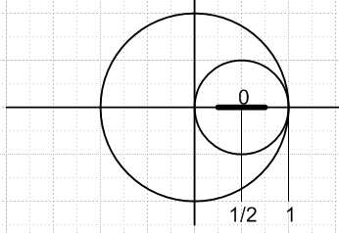

Details and proof: Suppose f(x) is known to be 0 for some finite interval out in the middle of our range, say at x = 1/2 for a range 1/4 in both directions. If we assume our f(z) is analytic in the unit disk, then we know we can make a convergent power series f(x) = Σn=0 bn(x-1/2)n about the center with R = 1/2. For that series, we have f(x) = 0 on a piece of the real axis touching the expansion point. We can thus apply Lemma 2 to conclude that f(x) = 0 identically in this entire disk with R = 1/2, with bn = 0. But now we have f(x) = 0 on the entire real interval [0,1]. We apply Lemma 1 to conclude that f(x) = 0 in the entire large disk with R = 1, and therefore an is the only "solution" for representation f(x) = Σn=0 anxn. We have now really proven the obvious extension, which is:

Lemma 3A. If f(z) is analytic in the unit disk, and if f(z) = 0 on some finite region of the real axis, then f(z) = 0 in the entire disk.

Another way. Look at constant segment and put a disk centered on it. We have f(z) = 0 in that disk by Lemma 1. If something else happens going off the edges of the disk, f(z) won't be analytic there because some derivative will be discontinuous at the edge. So f(z) has to be 0 in the larger disk everywhere.
[You might try to concoct some "test function" counter example to this argument, but I don't think you could find one. ] Think of a numerical computer iteration machine. You start with f(z) = 0 on the flat disk. Laplace is satisfied by curvature = 0 in both directions everywhere on this disk. As you iterate off the edges, nothing new can really happen unless you hit some kind of "singularity" (a source, say), so the machine just increases the flat disk in size until it hits a singularity or the boundary. We might call this a "thought machine" akin to thought experiments of Einstein's world.

I hope I have proven these theorems with the above fiddling:

Theorem 1: If f(z) is analytic in some region and f(z) = C (a constant) along some finite line segment within that region, then f(z) = C in the entire region. As a special case, that line segment could be on the real axis.

Theorem 2: Suppose f(z) = Σn=0 anzn is a convergent power series over a disk of radius R. We know that f(z) is then analytic in the disk. By Theorem 1, if f(z) = C along some finite line segment within the disk, then f(z) = C in the entire disk, and then of course an ≡ δn0C.

Remember that this is all for power series. If you are willing to expand on orthogonal basis functions, then if f(z) = C on some line segment within your region, you need not have f(z) = C in the entire region, as our opening example shows. The resulting f(z) will have a discontinuity at the end of the constant segment, but that is OK.

My motivating example once again: If we try to do a Smythian fit,

V(r,z) = ΣnanrnPn(z)

just above a charged metal disk at potential V0, and if we then evaluate on the surface we get

V(r,0) = ΣnanrnPn(0) = V0

This is a power series in r, not an orthogonal basis expansion in the r variable. Think of this as V(r) = Σn=0 anrn . We have V(r) = C =V0 on the interval [0,a/2], say (a = disk radius). Now think of r as a complex variable, and we can think of a different "disk", one in complex r space -- not to be confused with the charged disk! In this complex disk, we have V(r) = V0 on a finite line segment (on the real axis), so by Theorem 1 we have V(r) = V0 on this entire complex disk, and by Theorem 2 we have an ≡ δn0 V0. We are then forced to conclude that our Smythian fit results in V(r,z) = ΣnanrnPn(z) = V0 at all points above the charged disk, which is of course wrong, and just serves to point out that this "Smythian fit", although it satisfies the Laplace equation, is not able to match our boundary conditions in the charged disk problem.
One might ask: how do you know that V(r) above is analytic in the complex disk in r-space? Well, I just know that everything is smooth on the charged disk surface (away from the edges)

Main Conclusions of this Document

1. If f(z) is analytic in region R and is represented by a power series f(z) = Σnanzn, then if f(z) is constant on even a tiny (but finite) line segment within R (and probably on any finite piece of curve in R), then f(z) is constant over all of R. In this case, the only power series solution is the above with an = δn0a0.

2. In a real analysis sense, the above is true if f(x) is infinitely differentiable in region R on the real axis, perhaps this means C∞ (all derivatives are continuous at all points in R). If f(x) is "very smooth", then the corresponding f(z) will be analytic. In this situation, if f(x) is constant on some tiny but finite segment of the x-axis within R, then f(x) is constant on all of R.

3. If f(z) has a "kink" somewhere in region R (a discontinuity, or perhaps a sudden change in slope, curvature, or some higher derivative), then the series f(z) = Σnanzn will only be analytic in a disk that is small enough to avoid that kink. The real series f(x) = Σnanxn can converge only up the location of the kink. At the kink and beyond, this series cannot be valid.

4. An infinite series f(x) = Σnanxn cannot represent a function which has a kink inside the interval of representation. For example, you cannot represent a "hockey stick" type function this way. You cannot represent any function which is 0 or C on some finite part of the representation region, but not constant elsewhere in the region.

5. The above conclusions only apply to power series expansions. If you expand instead onto orthogonal basis functions, then all the above claims are false. If a function has a "kink", you can probably still represent it as a series f(x) = Σnanφn(x). In our first example above, we had φn(x) = sin(nx), and our "kink" was a huge whopping discontinuity right at x = 0 and at x = ± π -- our square wave. We could have altered example 1 to treat the following more complicated f(x):

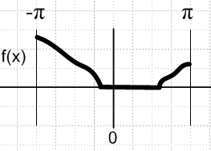

Here we have f(x) = Σnanφn(x) throughout the range (-π,π), and f(x) = 0 on a finite region inside, but still our single series representation gives the entire f(x) curve. Stakgold's example was f(x) = |x| which of course has a kink at x = 0. We might say that f(x) = Σnanφn(x) converges "uniformly" on (-π,π), just to work in that famous buzzword.

5a. [ added 4.14.10] In this last paragraph, since the φn(x) are orthogonal, we can of course use orthogonality to compute the an as integrals of f(x). Thus, we have in fact explicitly constructed a series f(x) = Σnanφn(x) which handles the "kinks" just fine. Perhaps an orthogonal set φn(x) allows for expansion of any "piecewise continuous function" which would include kinks, but I would have to go review that in Stakgold to confirm it. In the case of the power series f(z) = Σnanzn, the functions zn do NOT form an orthogonal set, and we cannot therefore use orthogonality to compute the an. This lends support to the idea that a power series cannot handle a kink, though it does not prove it. I think however that we have proved that fact elsewhere in this doc. This all goes back to that ancient discussion in Stakgold where we compare the spanning set tn to an orthogonal set φn(t) and where in the former case you can have the situation where the an of your partial sum fit keep "moving" so the infinite series does not exist.

Conditions on f(x) at x = 0 for a power series to exist there.

We could consider any point x = a, but to make it simple, consider the point x = 0. We are wondering if a power series Σn anxn exists or not at the point x = 0.

Theorem: If f(x) is not C∞ at x=0, the power series expansion f(x) = Σn anxn does not exist.
(C∞ means all derivatives are continuous at x = 0.)

Proof: If f(x) is a polynomial, the series Σn anxn exists and is finite and of course f(x) is C∞. For any other case, f(x) is an infinite series. In either case, we identify this series with the Taylor series where the coefficients are basically derivatives of f(x). In order for all the an to exist in our expansion, all the derivatives must exist. If some derivative f(n)(x) is discontinuous at x = 0, then that derivative does not exist. QED.

Comment #1: So, the existence of a power series expansion at a point requires not just that the function and its derivative be continuous. The curvature must be continuous, and so must all higher derivatives. I guess I was not clear on this obvious fact, before.

Comment #2. If f(z) is an analytic function, then f(x) is C∞ . The reason is that (1) an analytic function must have a well defined derivative that is the same in all directions in the complex plane, one of those being the real direction; (2) therefore if f(z) is analytic, f '(x) exists. (3) The derivative of an analytic function is also analytic (quote from Ahlfors). Therefore, we recur our argument to show that all derivatives must exist.

Comment #3. The function f(x) = e-1/x is C∞ at x = 0. Interestingly, if you do a Taylor series expansion about x = 0, you find that all derivatives vanish! So this function is exceedingly "flat" as it comes into the origin from the right. The power series expansion of this function gives f(x) = 0, so I guess you would have to say that this particular function does not have a power series expansion at x = 0 ! So this function is C∞ but has no power series. This does not violate our theorem. If f(x) is C∞ the power series still may not exist. I think this is called a bump function. I know this f(z) has an "essential singularity". So this function is not analytic at z = 0.

Comment #4. (a repeat) If f(z) is analytic at z = 0, the power series expansion for f(x) exists there.
Comment #5. In order for f(x) to have a power series expansion at x = 0, f(x) must be C∞ in some small but finite "ball" surrounding x = 0.

Conditions on f(x,y) at x,y = 0,0 for a power series to exist there.

1. If you want the double power series to exist, Σnmanmxnym, then f(x,y) must be C∞ in both directions in a ball around the point x = y = 0. You would prove this by first expanding on one variable, then in the second. We can generalize to any number of dimensions.

When does the power series f(r,θ,φ) = Σn an rn fn(θ,φ) exist?

Well, write f(r,θ,φ) = F(x,y,z). We know from above that we must have a ball around the origin in which all derivatives (including cross derivatives) exist and are continuous. In the spherical coordinates, that same ball is described by r ≤ ε . Suppose within this ball we have just a small but finite line segment on which f = constant. This is like the situation we studied in 1D and this is going to force some derivatives to be discontinuous within the ball. In particular, in a direction ξ along the line segment, we will find that ∂ξf or some higher derivative will be discontinuous as we go off the end of the line segment (assuming our function is not constant in the entire ball).
Now suppose this line segment of constant f actually touches the spherical coordinate origin. Then there is no ball of any size whatsoever that you can form around the origin, so the power series in this case does not exist!
If the spherical origin lies on a smooth surface of constant f, we can consider the tangent plane surface at that point. Then we have a tiny segment of constant f touching our origin and so no power series exists. Certainly if the origin lies on a flat plane of constant f, no series exists.

