Int 1 PhL 3.15.14

The integrals are these (all derived below)

- $^{\int_{0}^{2π}{}}$dθ $\frac{1}{1 + bcosθ + csinθ}$ = 2π/$\sqrt{1-(b2+c2)}$ assuming b2+c2 < 1

- $^{\int_{0}^{2π}{}}$dθ $\frac{1}{A + Bcosθ + Csinθ}$ = 2π / $\sqrt{A2-B2-C2}$ assuming B2+C2 < A2

- $^{\int_{0}^{2π}{}}$dθ ln(1 + bcosθ + csinθ) = 2π ln [ (1 + $\sqrt{1-b2-c2}$)/2] assuming b2+c2 < 1

- $^{\int_{0}^{2π}{}}$dθ ln(A + Bcosθ + Csinθ) = 2π ln [(A + $\sqrt{A2-B2-C2}$)/2] assuming B2+C2 < A2

and you cannot find this thing in this form in GR7. Maple can do some of these, but messes up on others, so don't ever trust Maple on this kind of integral!

1. Condition on b and c for reasonableness. 1
2. Contour Approach 2
3. Maple does the integral 6
4. Another way 6
5. Obvious related integral 7
6. Another related integral 7

1. Condition on b and c for reasonableness.

In order to avoid an infinite integrand, we have to make sure the denominator does not vanish. If b and c are much smaller than 1 in magnitude, there is never a problem. But if b = 1 and c = 0 or vice versa, there is a problem. We suspect there is some condition which makes sure

f(θ) = 1 + bcosθ + csinθ ≥ 0

We want to know where the min of f(θ) is located. To find that, we first set f'(θ) = 0:

-bsinθ + ccosθ = 0 => bsinθ = c cosθ => tanθ = c/b

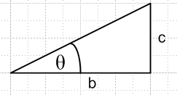

=> one of two possibilities:

sinθ = σc/$\sqrt{b2+c2}$
cosθ = σb/$\sqrt{b2+c2}$

where σ is either +1 or -1. The curvature is

f"(θ) = -bcosθ -csinθ = -b[σb/$\sqrt{b2+c2}$] - c[σc/$\sqrt{b2+c2}$] = -2σ(b2+c2)/$\sqrt{b2+c2}$ = -2σ$\sqrt{b2+c2}$

We want this to be positive to locate our min, so we need σ = -1. Thus our solution θ for the min is:

sinθ = -c/$\sqrt{b2+c2}$
cosθ = -b/$\sqrt{b2+c2}$

At this min location we want to have

1 + bcosθ + csinθ ≥ 0
or
1 + b[-b/$\sqrt{b2+c2}$] + c[-c/$\sqrt{b2+c2}$] ≥ 0
or
1 -b2/$\sqrt{b2+c2}$] -c2/$\sqrt{b2+c2}$] ≥ 0
or
1 - $\sqrt{b2+c2}$≥ 0
or
1 > $\sqrt{b2+c2}$
or
1 ≥ b2+c2

Conclusion: f(θ) will be positive definite as long as b2+c2 < 1.

2. Contour Approach

f = 1 + bcosθ + csinθ = 1 + (b/2)(z+z-1) + (c/2i)(z-z-1)

fz = z + (b/2)(z2+1) + (c/2i)(z2-1)

= z2[ b/2 + c/2i ] + z + [ 1 + b/2 - c/2i ]

= [ b/2 + c/2i ] (z-r1)(z-r2) = K(z-r1)(z-r2) = Kg

Write

I = $^{\int_{0}^{2π}{}}$dθ (1/f) = dz/[iz] (1/f) = (1/i) dz 1/(fz)

Then integral is

I = (1/iK) dz $\frac{1}{(z-r1)(z-r2)}$

At this point see where poles are located and then result will be

I = 2π/K * Σresidues

where there might be 0,1 or 2 residues in this sum!

The first step is to identify K and the roots r1 and r2. It's a little long-winded but :

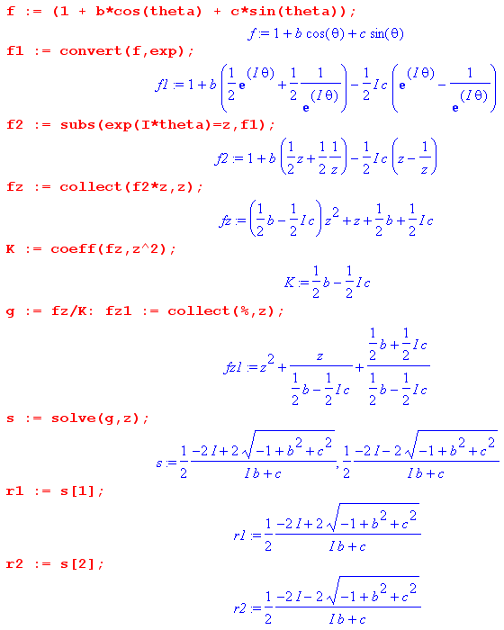

Now we want to see where these poles are located, so we seek the mags of the roots:

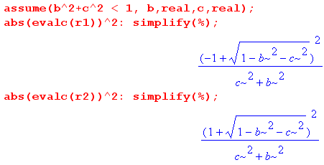
For r1 we think this is true

(-1+$\sqrt{1-(b2+c2)}$2 < (b2+c2) ?
or
-1 + 1 - (b2+c2) - 2$\sqrt{1-(b2+c2)}$ < (b2+c2) ?
or
- 2$\sqrt{1-(b2+c2)}$ < 2 (b2+c2) ?

Given our assumption noted above, this inequality is trivially true, so we find

|r1| < 1 and this root lies inside the contour

For r2 we think this is true

(1+$\sqrt{1-(b2+c2)}$2 > (b2+c2) ?
or
+1 + 1 - (b2+c2) + 2$\sqrt{1-(b2+c2)}$ > (b2+c2) ?
or
2$\sqrt{1-(b2+c2)}$ > 2 (b2+c2) -2 ?
or
2$\sqrt{1-(b2+c2)}$ > -2 [1 - (b2+c2)] ?
or
2 > -2$\sqrt{1-(b2+c2)}$

and this is obviously true, so we find

|r2| > 1 and this root lies outside the contour

The solution will then be

I = 2π/K * Σresidue (at z = r1)

Here then is this last step:

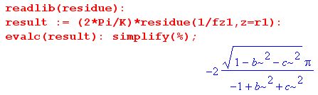

So the final integral seems to be

I = 2π/$\sqrt{1-(b2+c2)}$

3. Maple does the integral

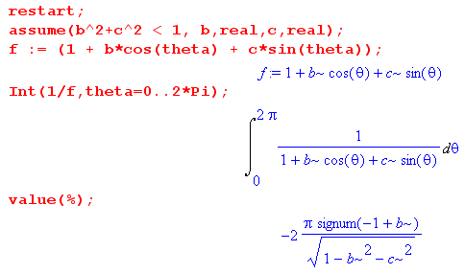
But we know that

-1 < b < 1 in order to guarantee that 1 > b2+c2

so then

-2 < -1+b < 0

which -1+b < 0 so sign(-1+b) = -1, and then Maple agrees.

4. Another way

Once we know that 1 > b2+c2 we can write

b = αcosφ α < 1. α2 = b2+c2 < 1
c = αsinφ

Then

f(θ) = 1 + bcosθ + csinθ = 1 + αcosφ cosθ + αsinφ sinθ

= 1 + α [cosφ cosθ + sinφ sinθ]

= 1 + α cos(θ-φ)

Then our integral is

I = $^{\int_{0}^{2π}{}}$dθ $\frac{1}{1 + α cos(θ-φ)}$ = $^{\int_{0}^{2π}{}}$dθ $\frac{1}{1 + α cosθ}$

We could to this using our contour method, but this one we can just look up in GR7,

and we set n = 0 to get

I = 2π/$\sqrt{1-α2}$= 2π/$\sqrt{1-(b2+c2)}$

which agrees with the previous two solutions. Of course

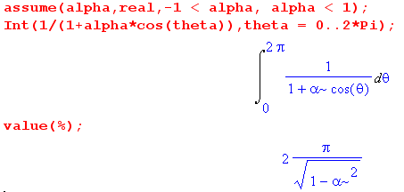

5. Obvious related integral

I = $^{\int_{0}^{2π}{}}$dθ $\frac{1}{A + Bcosθ + Csinθ}$ = 2π / $\sqrt{A2-B2-C2}$ assuming B2+C2 < A2

Confirm with Maple:

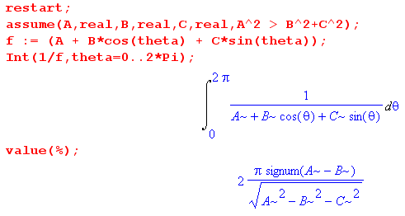

6. Another related integral

Consider

J = $^{\int_{0}^{2π}{}}$dθ ln(A + Bcosθ + Csinθ)

Notice that with our usual condition and also perhaps A > 0 the log argument is always positive, so the log is always some positive number, and the integral has to be real.

Then

dJ/dA = $^{\int_{0}^{2π}{}}$dθ $\frac{1}{A + Bcosθ + Csinθ}$ = 2π / $\sqrt{A2-B2-C2}$

J = 2π ∫dA/$\sqrt{A2-B2-C2}$ + k

But this is an easy integral

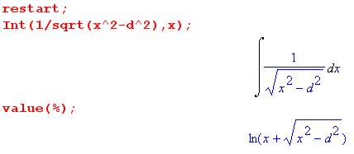 d2 = B2+C2

Then we have

J = 2π ln(A + $\sqrt{A2-B2-C2}$) + k

To determine the constant k, we set B = C = 0 and find

J = $^{\int_{0}^{2π}{}}$dθ ln(A + 0cosθ + 0sinθ) = 2π ln(A)

But our formula says

J = 2π ln(2A) + k = 2πln(A) + 2πln(2) + k => k = -2πln(2)

So our integral must then be

J = 2π ln(A + $\sqrt{A2-B2-C2}$) -2πln(2)

= 2π ln [(1/2) (A + $\sqrt{A2-B2-C2}$)]

Somehow Maple gets a result which does not depend on C! Maple says

J = 2π [ ln(A+B)-Iπ] [ wrong! ]

but this is garbage because we know the result is real. I will show that my result is correct by doing a few numerical integrations:

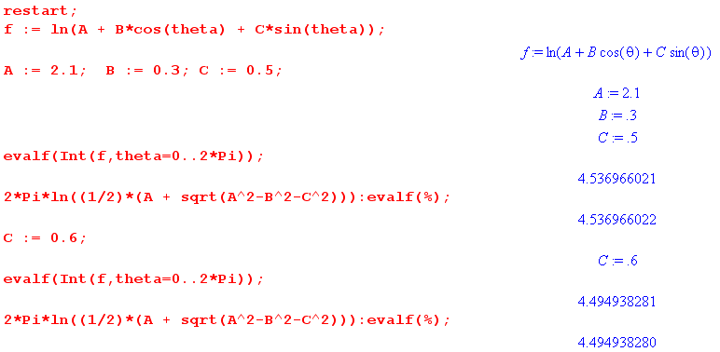
Clearly the result does depend on C. So here is what I have shown:

$^{\int_{0}^{2π}{}}$dθ ln(A + Bcosθ + Csinθ) = 2π ln [(A + $\sqrt{A2-B2-C2}$)/2] assuming B2+C2 < A2

This could be confirmed by looking at this simpler case

$^{\int_{0}^{2π}{}}$dθ ln(1 + bcosθ + csinθ) = 2π ln [(1 + $\sqrt{1-b2-c2}$)/2] assuming b2+c2 < 1

and then we do our same reparameterization

f(θ) = 1 + bcosθ + csinθ = 1 + αcosφ cosθ + αsinφ sinθ

= 1 + α [cosφ cosθ + sinφ sinθ]

= 1 + α cos(θ-φ) α2 < 1

Then we get

J = $^{\int_{0}^{2π}{}}$dθ ln(1 + α cosθ )

Maple can't even do this one, but GR7 can:

This says

J = 2π ln [ (1 + $\sqrt{1-α2}$)/2]

which then agrees with my result.

