The Euler Substitutions
Phil Lucht
Rimrock Digital Technology, Salt Lake City, Utah 84103
last update: Nov 5, 2016

The material in this document is copyrighted by the author.

1. Introduction 1
2. Comments about R = a + bx + cx² 3
3. A substitution that does not work 5
4. Method A 6
5. Method B 9
6. Method C 13
7. More forms for the integral of R^{-1/2} 15
References 20

1. Introduction

The phrase "Euler substitutions" refers to methods for evaluating certain integrals involving powers of x along with powers of the radical $\sqrt{a+bx+cx2}$. The topic is briefly reviewed in Section 2.25 (p 92) of Gradshteyn and Ryzhik [GR7]. Wiki suggests that the topic appears in many Russian calculus texts, and we have found it mentioned in a book by Piskunov. Our purpose below is to flesh out the details of the methods and to state the results in a systematic manner.

As an illustration, ∫dx 1/$\sqrt{a+bx+cx2}$is evaluated by each of the methods. The results are then transformed into other forms, and all the results are collected in (7.15).

The form of the general integral of interest is written this way

∫dx R(x,$\sqrt{a+bx+cx2}$) (1.1)

where R(r,s) refers to the ratio of two polynomials of variables r and s. Here is an example,

R(x,$\sqrt{a+bx+cx2}$) = $\sqrt{a+bx+cx2}$$\sqrt{a+bx+cx2}$$\sqrt{a+bx+cx2}$ . (1.2)

Since the numerator terms can be treated separately, one can limit one's interest to the following form,

R(x,$\sqrt{a+bx+cx2}$) = $\sqrt{a+bx+cx2}$$\sqrt{a+bx+cx2}$ . (1.3)

Ratios of polynomials are usually called "rational functions", hence the symbol R.

The specific example we shall study below is the following, shown here in one of its forms (4.9),

∫dx $\sqrt{a+bx+cx2}$ = $\sqrt{c}$ ln [ 2cx + b + 2$\sqrt{c}$$\sqrt{a+bx+cx2}$ ] + constant c > 0 . (1.4)

The above example serves as a good model to look at while some comments are presented concerning the general case.
• In general, any indefinite integral should really be written$^{\int_{}^{x}{}}$dx f(x) = F(x) + constant where the constant is arbitrary. One can always test a candidate F(x) by computing dF/dx to see if the result is f(x). This task is made easy using Maple or another computer calculus program.

• When there are parameters such as a,b,c shown above, that integration constant can be any function g(a,b,c) which is of course not a function of x.

• We shall use the symbol A B to mean A = B + constant in the above sense. Thus we can write

∫dx $\sqrt{a+bx+cx2}$ $\sqrt{c}$ ln [ 2cx + b + 2$\sqrt{c}$$\sqrt{a+bx+cx2}$ ]
$\sqrt{c}$ ln [ $\sqrt{c}$$\sqrt{a+bx+cx2}$$\sqrt{4ac-b2}$] . (1.5)

On the second line we have added a denominator which in effect creates the additive constant g(a,b,c) =
- (1/$\sqrt{c}$) ln($\sqrt{4ac-b2}$). Both forms shown above are "correct" and well-defined when c > 0 and 4ac-b2> 0.

• If one thinks of x having units of distance L, then dim(x) = L, dim(a) = L2, dim(b) = L and dim(c) = 1 make the integral be dimensionless. Then the second form above involves the log of a dimensionless ratio, whereas the first form does not, somewhat clarifying the dimensionless nature of the integral.

• As discussed more below, $\sqrt{a+bx+cx2}$is real for certain ranges of a,b,c,x and one can imagine that the integral being evaluated is over a range of x where $\sqrt{a+bx+cx2}$ is real. One normally thinks of a,b,c as real parameters.

• Once an integral is evaluated for "reasonable" values of the parameters like a,b,c, one can extend one or more of these parameters to the complex plane allowing one to analytically continue both sides of an integral evaluation. We shall give an example below in Section 7.

Having stated these general comments, we now look specifically at the object $\sqrt{a+bx+cx2}$.

2. Comments about R = a + bx + cx2

The letters a,b,c are defined consistently with GR7. It is probably more standard to write ax2+bx+c, in which case one has the familiar rote solution for the roots [-b ± $\sqrt{b2-4ac}$]/(2a), so in our current context one must remember that in fact the roots of a+bx+cx2= 0 are given by

α± ≡ [-b ± $\sqrt{b2-4ac}$]/(2c). (2.1)

The quantity b2-4ac is often called "the discriminant". GR7 define Δ to be the negative of this discriminant,

Δ ≡ 4ac - b2 . (2.2)

Also consistent with GR7 we define R by

R ≡ a+bx+cx2 = c [ x2 + (b/c)x + (a/c) ] = c(x-α+)(x-α-) (2.3)

and it is for this reason that we have used R above for the ratio of polynomials. Note that α± are the roots of R for c > 0, for c = |c|eiθ , and for c < 0.

Special case:

b2 = 4ac (Δ = 0) ⇒ α± = -b/(2c) ⇒ R = c(x-α+)2 ⇒ $\sqrt{R}$ = $\sqrt{c}$(x + b/(2c) ). (2.4)

Geometry

If b2 - 4ac > 0 then the roots in (2.1) are real. This means that the graphed function f(x) = a + bx + cx2 has two intersections with the x axis.
If c > 0, the parabola cups up. Therefore to the right of the upper root, x > α+, one has a + bx + cx2 > 0 and so $\sqrt{a+bx+cx2}$is real and well defined. It is also real for x < α-.
If c < 0, the parabola cups down. In this case $\sqrt{a+bx+cx2}$ is real and well defined for α- < x < α+. By well defined we simply mean that the square root implies a positive real number and we don't worry about branches of the square root function.

When talking about integrals involving $\sqrt{a+bx+cx2}$, it seems best to start with an integral over a range of x where a + bx + cx2 is positive, so then $\sqrt{a+bx+cx2}$is real and positive. There are four cases of interest:

Case 1: c > 0, b2- 4ac > 0 (real roots), cups up, x > α+ or x < α- to have real $\sqrt{a+bx+cx2}$

Case 2: c > 0, b2- 4ac < 0 (imag roots), cups up, all real values of x give real $\sqrt{a+bx+cx2}$

Case 3: c < 0, b2- 4ac > 0 (real roots), cups down, must have α- < x < α+ to have real $\sqrt{a+bx+cx2}$

Case 4: c < 0, b2- 4ac < 0 (imag roots), cups down, no real value of x gives real $\sqrt{a+bx+cx2}$ (2.5)

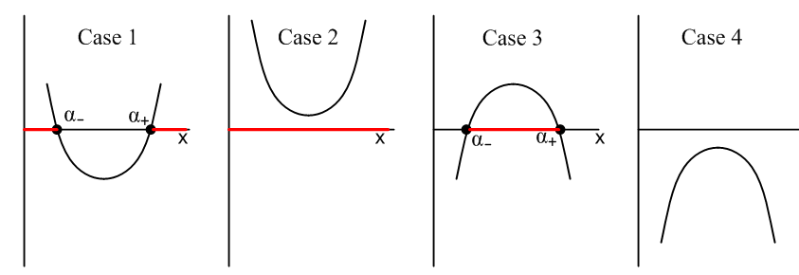 (2.6)

The red bars show the range of x which makes $\sqrt{a+bx+cx2}$be real.

We shall initially work in Case 2 below. This means c > 0 and b2- 4ac < 0.

3. A substitution that does not work

One's first inclination in evaluating integrals including $\sqrt{a+bx+cx2}$might be to make the substitution

t(x) = $\sqrt{a+bx+cx2}$ (3.1)

so that

R(x,$\sqrt{a+bx+cx2}$) → R(x(t),t) . (3.2)

But,

t2 = a+bx+cx2 ⇒ cx2 + bx + (a-t2) = 0

⇒ x(t) = $\sqrt{b2 - 4c(a-t2)}$ . (3.3)

The result then is,

R(x,$\sqrt{a+bx+cx2}$) → R($\sqrt{b2 - 4c(a-t2)}$, t) . (3.4)

The goal is to remove square roots from the integrand, but this method just replaces one square root with another square root and is thus not very useful, so we reject this substitution.

We are then led to three substitutions which are credited to Leonhard (brave lion) Euler (1707-1783) and are now known as "the Euler substitutions". We shall call them methods A,B and C and treat them one at a time. The painting shows Euler squinting at eiπ + 1 = 0 on the blackboard and wondering what it all means.

https://en.wikipedia.org/wiki/Leonhard_Euler

4. Method A

Instead of using the substitution (3.1), consider

t(x) = $\sqrt{a+bx+cx2}$ - $\sqrt{c}$x or t + $\sqrt{c}$x = $\sqrt{a+bx+cx2}$. (4.1)

When we finish this section we can replace $\sqrt{c}$→ -$\sqrt{c}$ everywhere and thereby generate an alternate result. One now has,

a + bx + cx2 = t2 + 2$\sqrt{c}$t x + cx2 . (4.2)

The key idea is that the two cx2 terms cancel out, giving

a + bx = t2 + 2$\sqrt{c}$t x ⇒ (b - 2$\sqrt{c}$t )x = (t2-a) ⇒

x(t) = $\sqrt{c}$ , (4.3)

an expression with no messy square roots, unlike (3.3). Then,

$\sqrt{a+bx+cx2}$ = t + $\sqrt{c}$x = t + $\sqrt{c}$$\sqrt{c}$ = $\sqrt{c}$$\sqrt{c}$ + $\sqrt{c}$$\sqrt{c}$$\sqrt{c}$
= $\sqrt{c}$$\sqrt{c}$$\sqrt{c}$ . (4.4)

Then our general replacement becomes

R(x,$\sqrt{a+bx+cx2}$) → R( $\sqrt{c}$, $\sqrt{c}$$\sqrt{c}$$\sqrt{c}$) . (4.5)

One may then compute

$\frac{dx}{dt}$ = $\frac{d}{dt}$($\sqrt{c}$) = $\sqrt{c}$$\sqrt{c}$$\sqrt{c}$ = $\sqrt{c}$$\sqrt{c}$$\sqrt{c}$$\sqrt{c}$

= 2 $\sqrt{c}$$\sqrt{c}$

so that

dx = 2 $\sqrt{c}$$\sqrt{c}$$\sqrt{c}$ dt . (4.6)

Our integral evaluation then becomes

$^{\int_{}^{x}{}}$dx R(x,$\sqrt{a+bx+cx2}$) = $^{\int_{}^{t(x)}{}}$dt 2 $\sqrt{c}$$\sqrt{c}$$\sqrt{c}$ * R( $\sqrt{c}$, $\sqrt{c}$$\sqrt{c}$$\sqrt{c}$)
where t(x) = $\sqrt{a+bx+cx2}$ - $\sqrt{c}$x . (4.7)

Notice that there are no messy square roots anywhere in the dt integrand. The integrand is now a rational function in the variable t : integrand = Poly1(t)/Poly2(t).

As noted earlier, one may replace $\sqrt{c}$→ -$\sqrt{c}$ (and c → c) to obtain the following alternative form,

$^{\int_{}^{x}{}}$dx R(x,$\sqrt{a+bx+cx2}$) = $^{\int_{}^{t(x)}{}}$dt 2 $\sqrt{c}$$\sqrt{c}$$\sqrt{c}$ * R( $\sqrt{c}$, $\sqrt{c}$$\sqrt{c}$$\sqrt{c}$)
where t(x) = $\sqrt{a+bx+cx2}$ + $\sqrt{c}$x . (4.8)

Example: Let R(x,$\sqrt{a+bx+cx2}$) = 1/$\sqrt{a+bx+cx2}$. Then using (4.8),

$^{\int_{}^{x}{}}$dx $\sqrt{a+bx+cx2}$ = $^{\int_{}^{t(x)}{}}$dt 2 $\sqrt{c}$$\sqrt{c}$$\sqrt{c}$ * $\sqrt{c}$$\sqrt{c}$$\sqrt{c}$

= 2$^{\int_{}^{t(x)}{}}$dt $\sqrt{c}$ = $\sqrt{c}$$^{\int_{}^{t(x)}{}}$dt $\sqrt{c}$

= $\sqrt{c}$ ln (t + [b/2$\sqrt{c}$] }|t(x)

= $\sqrt{c}$ln ( $\sqrt{a+bx+cx2}$ + $\sqrt{c}$x + [b/2$\sqrt{c}$] = $\sqrt{c}$ln ( $\sqrt{R}$ + $\sqrt{c}$x + [b/2$\sqrt{c}$] )

$\sqrt{c}$ ln [2 $\sqrt{c}$$\sqrt{R}$ + 2cx + b ] (4.9)

in agreement with (1.5) stated earlier without proof. To get the last line, we multiplied by 2$\sqrt{c}$ top and bottom inside the log, then dropped the constant term - (1/$\sqrt{c}$) ln (2$\sqrt{c}$), hence the sign .

From (4.7) we would have gotten instead

$^{\int_{}^{x}{}}$dx $\sqrt{a+bx+cx2}$ = - $\sqrt{c}$ln [- 2 $\sqrt{c}$$\sqrt{R}$ + 2cx + b ] . (4.10)

These seemingly different results are both valid since they differ by a constant independent of x :

$\sqrt{c}$ ln [2 $\sqrt{c}$$\sqrt{R}$ + 2cx + b ] - { - $\sqrt{c}$ln [- 2 $\sqrt{c}$$\sqrt{R}$ + 2cx + b ] }

= $\sqrt{c}$ln [ (2 $\sqrt{c}$$\sqrt{R}$ + 2cx + b)(- 2 $\sqrt{c}$$\sqrt{R}$ + 2cx + b) ] = $\sqrt{c}$ ln [ (2cx+b)2 - 4cR ]

= $\sqrt{c}$ ln [ (2cx+b)2 - 4c(a+bx+cx2 ] = $\sqrt{c}$ ln [ 4c2x2 + 4cbx + b2 - 4ca + 4cbx - 4c2x2 ]

= $\sqrt{c}$ ln [ b2 - 4ca ] . (4.11)

We then write,

$^{\int_{}^{x}{}}$dx $\sqrt{a+bx+cx2}$ $\sqrt{c}$ ln [2 $\sqrt{c}$$\sqrt{R}$ + 2cx + b ] - $\sqrt{c}$ln [- 2 $\sqrt{c}$$\sqrt{R}$ + 2cx + b ] . (4.12)

Just for the record, Maple comes up with the first of these forms (again apart from a constant) when asked directly to do the integral,

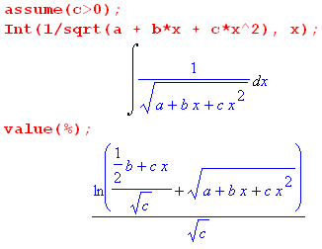 (4.13)
which is

$\sqrt{c}$ln [ $\sqrt{c}$$\sqrt{R}$$\sqrt{c}$] = $\sqrt{c}$ln [2 $\sqrt{c}$$\sqrt{R}$ + 2cx + b ] - $\sqrt{c}$ ln (2$\sqrt{c}$) .

In the special base that 4ac = b2 we know from (2.4) that $\sqrt{R}$ = $\sqrt{c}$(x + b/(2c) ) so (4.9) becomes

$^{\int_{}^{x}{}}$dx $\sqrt{R}$ $\sqrt{c}$ln ( 2 $\sqrt{c}$$\sqrt{R}$ + 2cx + b )
= $\sqrt{c}$ln ( 2 $\sqrt{c}$[$\sqrt{c}$(x + b/(2c) )] + 2cx + b )
= $\sqrt{c}$ln (2cx +b + 2cx + b ) = $\sqrt{c}$ln (4cx +2b )
$\sqrt{c}$ln (2cx +b ) c > 0, 4ac = b2 (4.14)

5. Method B

Here we mimic the previous section as closely as possible, using matching equation numbers.

Instead of using the substitution (3.1), consider

t(x) = ( $\sqrt{a+bx+cx2}$ - $\sqrt{a}$) / x or xt + $\sqrt{a}$ = $\sqrt{a+bx+cx2}$. (5.1)

When we finish this section we can replace $\sqrt{a}$→ -$\sqrt{a}$ everywhere and thereby generate an alternate result. One now has,

a + bx + cx2 = x2t2 + 2xt$\sqrt{a}$+ a (5.2)

The key idea is that the two a terms cancel out, giving

bx + cx2 = x2t2 + 2$\sqrt{a}$x t ⇒ b + cx = xt2 + 2$\sqrt{a}$t ⇒ x(c-t2) = 2$\sqrt{a}$t - b ⇒

x(t) = $\sqrt{a}$ , (5.3)

an expression with no messy square roots, unlike (3.3). Then,

$\sqrt{a+bx+cx2}$ = xt + $\sqrt{a}$ = $\sqrt{a}$ t + $\sqrt{a}$ = $\sqrt{a}$ + $\sqrt{a}$

= $\sqrt{a}$$\sqrt{a}$ . (5.4)

Then our general replacement becomes

R(x,$\sqrt{a+bx+cx2}$) → R( $\sqrt{a}$, $\sqrt{a}$$\sqrt{a}$) . (5.5)

One may then compute

$\frac{dx}{dt}$ = $\frac{d}{dt}$( $\sqrt{a}$) = $\sqrt{a}$$\sqrt{a}$ = $\sqrt{a}$$\sqrt{a}$$\sqrt{a}$

= 2$\sqrt{a}$$\sqrt{a}$
so that

dx = 2 $\sqrt{a}$$\sqrt{a}$ dt . (5.6)

Our integral evaluation then becomes

$^{\int_{}^{x}{}}$dx R(x,$\sqrt{a+bx+cx2}$) = $^{\int_{}^{t(x)}{}}$dt 2 $\sqrt{a}$$\sqrt{a}$ * R( $\sqrt{a}$, $\sqrt{a}$$\sqrt{a}$)
where t(x) = ( $\sqrt{a+bx+cx2}$ - $\sqrt{a}$) / x . (5.7)

Notice that there are no messy square roots anywhere in the dt integrand. The integrand is now a rational function in the variable t : integrand = Poly1(t)/Poly2(t).
.
As noted earlier, one may replace $\sqrt{a}$→ -$\sqrt{a}$ (and a → a) to obtain the following alternative form.

$^{\int_{}^{x}{}}$dx R(x,$\sqrt{a+bx+cx2}$) = $^{\int_{}^{t(x)}{}}$dt 2 $\sqrt{a}$$\sqrt{a}$ * R( $\sqrt{a}$, $\sqrt{a}$$\sqrt{a}$)
where t(x) = ( $\sqrt{a+bx+cx2}$ + $\sqrt{a}$) / x . (5.8)

Example: Let R(x,$\sqrt{a+bx+cx2}$) = 1/$\sqrt{a+bx+cx2}$. Then using (5.8),

$^{\int_{}^{x}{}}$dx $\sqrt{a+bx+cx2}$ = $^{\int_{}^{t(x)}{}}$dt 2 $\sqrt{a}$$\sqrt{a}$ * $\sqrt{a}$$\sqrt{a}$

= 2 $^{\int_{}^{t(x)}{}}$dt $\frac{1}{c-t2}$ = -2 $^{\int_{}^{t(x)}{}}$dt $\frac{1}{t2-c}$

Maple kindly computes this integral,

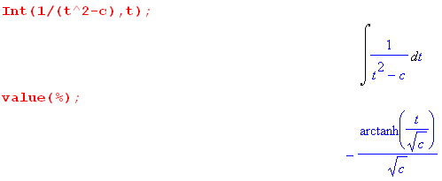 (5.8a)
so we continue,

$^{\int_{}^{x}{}}$dx $\sqrt{a+bx+cx2}$ = + $\sqrt{c}$ tanh-1 ($\sqrt{c}$)|t = t(x)

= $\sqrt{c}$ tanh-1$\sqrt{a+bx+cx2}$$\sqrt{a}$$\sqrt{c}$

= $\sqrt{c}$tanh-1($\sqrt{a}$$\sqrt{c}$) . (5.9)

From (5.7) we would have instead found

$^{\int_{}^{x}{}}$dx $\sqrt{a+bx+cx2}$ = $\sqrt{c}$tanh-1($\sqrt{a}$$\sqrt{c}$) . (5.10)

One might reasonably wonder how both these results can be correct since there is a sign difference. The answer is that the two forms differ by a constant independent of x. To show this, one can use

tanh-1 u = $\frac{1}{2}$ ln ( $\frac{1+u}{1-u}$) |u| < 1 // Spiegel 8.57
with
u = $\sqrt{a}$$\sqrt{c}$ ⇒ 1 ± u = $\sqrt{c}$$\sqrt{c}$ ± $\sqrt{a}$$\sqrt{c}$ = $\sqrt{c}$$\sqrt{R}$$\sqrt{a}$$\sqrt{c}$

so that

tanh-1($\sqrt{a}$$\sqrt{c}$) = $\frac{1}{2}$ ln [ $\sqrt{c}$$\sqrt{R}$$\sqrt{a}$$\sqrt{c}$$\sqrt{R}$$\sqrt{a}$]

tanh-1($\sqrt{a}$$\sqrt{c}$) = $\frac{1}{2}$ ln [ $\sqrt{c}$$\sqrt{R}$$\sqrt{a}$$\sqrt{c}$$\sqrt{R}$$\sqrt{a}$] .

The difference between these two arctangents is then

tanh-1($\sqrt{a}$$\sqrt{c}$) - tanh-1($\sqrt{a}$$\sqrt{c}$) = $\frac{1}{2}$ ln [ $\sqrt{c}$$\sqrt{R}$$\sqrt{a}$$\sqrt{c}$$\sqrt{R}$$\sqrt{a}$] - $\frac{1}{2}$ ln [ $\sqrt{c}$$\sqrt{R}$$\sqrt{a}$$\sqrt{c}$$\sqrt{R}$$\sqrt{a}$]

= $\frac{1}{2}$ ln [ $\sqrt{c}$$\sqrt{R}$$\sqrt{a}$$\sqrt{c}$$\sqrt{R}$$\sqrt{a}$ * $\sqrt{c}$$\sqrt{R}$$\sqrt{a}$$\sqrt{c}$$\sqrt{R}$$\sqrt{a}$ ] = $\frac{1}{2}$ ln [ $\sqrt{c}$$\sqrt{a}$$\sqrt{c}$$\sqrt{a}$]

= $\frac{1}{2}$ ln [ $\sqrt{a}$$\sqrt{c}$$\sqrt{a}$$\sqrt{c}$] = $\frac{1}{2}$ ln [ $\sqrt{a}$$\sqrt{c}$$\sqrt{a}$$\sqrt{c}$]

= $\frac{1}{2}$ ln [ $\sqrt{a}$$\sqrt{c}$$\sqrt{a}$$\sqrt{c}$ ] .

Therefore

$\sqrt{c}$tanh-1($\sqrt{R}$$\sqrt{a}$$\sqrt{c}$) - $\sqrt{c}$tanh-1($\sqrt{R}$$\sqrt{a}$$\sqrt{c}$) = $\sqrt{c}$ $\frac{1}{2}$ ln [ $\sqrt{a}$$\sqrt{c}$$\sqrt{a}$$\sqrt{c}$ ] (5.11)

which is a constant independent of x. Therefore we write

$^{\int_{}^{x}{}}$dx $\sqrt{a+bx+cx2}$ $\sqrt{c}$tanh-1($\sqrt{a}$$\sqrt{c}$) $\sqrt{c}$tanh-1($\sqrt{a}$$\sqrt{c}$) (5.12)

and we have now accumulated two more forms for this integral. Both forms can be verified by direct differentiation as Maple shows,

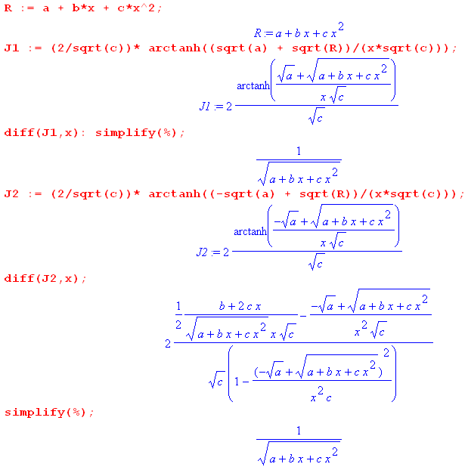 (5.13)

In the Maple language, a colon suppresses output from a command, while symbol % refers to the last computed quantity. In the diff(J1,x) line we suppress output and simplify to get 1/$\sqrt{R}$, but for J2 we show the typically messy expression Maple generates, followed by the simplified result.

6. Method C

Rename the roots of R = 0 to be α = α- and β = α+ . Recall that

a+bx+cx2 = c(x-α)(x-β) . (2.3)

Now, instead of using the substitution (3.1), consider

t(x) = $\sqrt{a+bx+cx2}$/ (x-α) = $\sqrt{c(x-α)(x-β)}$/ (x-α) = $\sqrt{c}$ $\sqrt{x - β}$$\sqrt{x - α}$ . (6.1)

When we finish this section we can do α ↔ β everywhere and thereby generate an alternate result.

Solving for x one finds

t2 = c (x-β)/(x-α) ⇒ t2(x-α) = c(x-β) ⇒ x(t2-c) = (αt2- cβ) ⇒

x(t) = $\frac{αt2- cβ}{t2-c}$ , (6.3)

an expression with no messy square roots, unlike (3.3). Then,

$\sqrt{a+bx+cx2}$ = (x-α)t = ($\frac{αt2- cβ}{t2-c}$-α)t = $\frac{t(αt2- cβ)}{t2-c}$ - $\frac{αt(t2-c)}{t2-c}$ = $\frac{αt3 - cβt - αt3 + cαt}{t2-c}$

= $\frac{c(α-β)t}{t2-c}$ . (6.4)

Then our general replacement becomes

R(x,$\sqrt{a+bx+cx2}$) → R($\frac{αt2- cβ}{t2-c}$, $\frac{c(α-β)t}{t2-c}$) . (6.5)

One may then compute

$\frac{dx}{dt}$ = $\frac{d}{dt}$($\frac{αt2- cβ}{t2-c}$) = $\frac{(t2-c)2αt - (αt2-cβ)2t}{(t2-c)2}$ = $\frac{2αt3 - 2αct - 2αt3+ 2cβt}{(t2-c)2}$ = 2 $\frac{- αct + cβt}{(t2-c)2}$

= 2 $\frac{c(β-α)t}{(t2-c)2}$
so that

dx = 2 $\frac{c(β-α)t}{(t2-c)2}$dt . (6.6)

Our integral evaluation then becomes

$^{\int_{}^{x}{}}$dx R(x,$\sqrt{a+bx+cx2}$) = $^{\int_{}^{t(x)}{}}$dt 2 $\frac{c(β-α)t}{(t2-c)2}$ * R($\frac{αt2- cβ}{t2-c}$, $\frac{c(α-β)t}{t2-c}$)
where t(x) = $\sqrt{a+bx+cx2}$/ (x-α) = $\sqrt{R}$/(x-α) . (6.7)

Notice that there are no messy square roots anywhere in the dt integrand. The integrand is now a rational function in the variable t : integrand = Poly1(t)/Poly2(t).

As noted earlier, one may swap α ↔ β to obtain the following alternative form,

$^{\int_{}^{x}{}}$dx R(x,$\sqrt{a+bx+cx2}$) = $^{\int_{}^{t(x)}{}}$dt 2 $\frac{c(α-β)t}{(t2-c)2}$ * R($\frac{βt2- cα}{t2-c}$, $\frac{c(β-α)t}{t2-c}$) (6.8)
where t(x) = $\sqrt{a+bx+cx2}$/ (x-β) = $\sqrt{R}$/(x-β) .

Example: Let R(x,$\sqrt{a+bx+cx2}$) = 1/$\sqrt{a+bx+cx2}$. Then using (6.7),

$^{\int_{}^{x}{}}$dx $\sqrt{a+bx+cx2}$ = $^{\int_{}^{t(x)}{}}$dt 2 $\frac{c(β-α)t}{(t2-c)2}$* $\frac{t2-c}{c(α-β)t}$ = - 2$^{\int_{}^{t(x)}{}}$dt $\frac{1}{t2-c}$

= +$\sqrt{c}$tanh-1($\sqrt{c}$)|t(x) // using (5.8a)

= $\sqrt{c}$tanh-1($\sqrt{x - β}$$\sqrt{x - α}$) (6.9)

Thus we arrive at yet another form for our ∫dx/$\sqrt{R}$integral. Maple verifies it as follows,

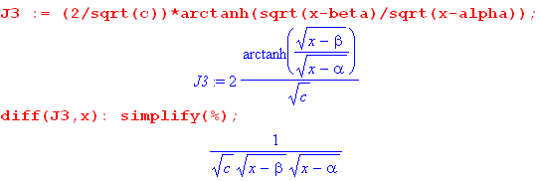

which is just 1/$\sqrt{a+bx+cx2}$. The result is clearly symmetric under α ↔ β, so one has

$^{\int_{}^{x}{}}$dx $\sqrt{a+bx+cx2}$ $\sqrt{c}$tanh-1($\sqrt{x-β}$$\sqrt{x- α}$) $\sqrt{c}$tanh-1($\sqrt{x-α}$$\sqrt{x- β}$) . (6.10)

We leave it to the reader to find the constant by which these two forms differ from each other and from those forms presented earlier.

7. More forms for the integral of R-1/2

Define

y ≡ $\sqrt{4ac-b2}$ . (7.1)

We wish to use the following identity with the above y,

sinh-1y = ln(y + $\sqrt{y2+1}$) |y| < ∞ // Spiegel 8.55 (7.2)

so we need to evaluate

y2 + 1 = ( $\sqrt{4ac-b2}$)2 + 1 = $\frac{(2cx+b)2}{4ac-b2}$+ 1 = $\frac{(2cx+b)2+ 4ac-b2}{4ac-b2}$ = $\frac{4c2x2 + 4cbx + b2+ 4ac-b2}{4ac-b2}$

= $\frac{4c(cx2+bx +a)}{4ac - b2}$ = $\frac{4cR}{4ac - b2}$ . (7.3)

Then

y + $\sqrt{y2+1}$ = $\sqrt{4ac-b2}$+ $\sqrt{c}$$\sqrt{R}$$\sqrt{4ac-b2}$ = $\sqrt{c}$$\sqrt{R}$$\sqrt{4ac-b2}$ .

Then from (7.2),

sinh-1($\sqrt{4ac-b2}$) = ln ($\sqrt{c}$$\sqrt{R}$$\sqrt{4ac-b2}$ ) ln (2cx + b + 2$\sqrt{c}$$\sqrt{R}$) (7.4)

where as usual we have thrown out a constant g(a,b,c). Comparing this result to (4.9)

$^{\int_{}^{x}{}}$dx $\sqrt{a+bx+cx2}$ $\sqrt{c}$ ln [2 $\sqrt{c}$$\sqrt{R}$ + 2cx + b ] (4.9)

we may conclude that

$^{\int_{}^{x}{}}$dx $\sqrt{a+bx+cx2}$ $\sqrt{c}$ sinh-1($\sqrt{4ac-b2}$) (7.5)

giving a commonly appearing form for the integral valid for c > 0 and 4ac - b2 > 0.

Analytic Continuation

We wish now to analytically continue this integral to c < 0. For the moment we assume a > 0 and draw this picture
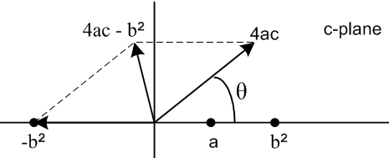 (7.6)

where vector c = |c| eiθ is aligned with the vector 4ac shown in the figure. One can see that as the 4ac vector is swung counterclockwise to the point θ = +π, the angle of the vector 4ac-b2 also moves to +π :

angle(c) = θ = 0 ⇒ angle(4ac-b2) = 0 // before swing, c>0
angle(c) = θ = π ⇒ angle(4ac-b2) = π // after swing, c<0 . (7.7)

We then write after the swing,

c = |c| eiπ = (-c)eiπ

(4ac-b2) = |4ac-b2| eiπ = |b2-4ac| eiπ = (b2-4ac)eiπ . (7.8)

Therefore (the phases are correlated here, you don't pick separate ± i for each square root),

$\sqrt{c}$ = $\sqrt{-c}$i

$\sqrt{4ac-b2}$ = $\sqrt{b2-4ac}$ i . (7.9)

We can then modify our integral above using these rules to get

$^{\int_{}^{x}{}}$dx (1/ = (1/$\sqrt{c}$) sinh-1 [ (2cx +b)/$\sqrt{4ac-b2}$] // (7.5)

= (1/[$\sqrt{-c}$i ]) sinh-1 [ (2cx +b)/($\sqrt{b2-4ac}$ i)]

= (-i)(1/$\sqrt{-c}$ ) sinh-1 [ -i(2cx +b)/$\sqrt{b2-4ac}$]

= - (-i)(1/$\sqrt{-c}$ ) sinh-1 [ i(2cx +b)/$\sqrt{b2-4ac}$] // Spiegel 8.64

= - i (-i)(1/$\sqrt{-c}$ ) sin-1 [ (2cx +b)/$\sqrt{b2-4ac}$] // Spiegel 8.93

= - $\sqrt{-c}$sin-1[ $\sqrt{b2-4ac}$] = + $\sqrt{-c}$sin-1[ $\sqrt{b2-4ac}$] , (7.10)

giving forms valid for c < 0 and b2-4ac > 0. Next we use this relation

sin-1(z) = - cos-1(z) + π/2 // Spiegel 5.74

- cos-1(z) (7.11)

to obtain two more forms,

$^{\int_{}^{x}{}}$dx (1/ + $\sqrt{-c}$cos-1[ $\sqrt{b2-4ac}$] = - $\sqrt{-c}$cos-1[ $\sqrt{b2-4ac}$] . (7.12)

Trust but verify,

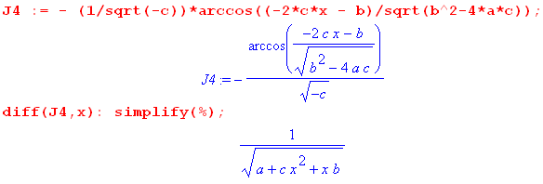 (7.13)

In these last integrals, we started with a > 0, but the results can be continued to a part of the range a < 0 where we have

b2-4ac > 0 ⇒ b2+4a|c| > 0 ⇒ 4a|c| > -b2 ⇒

a > -(b2/|c|) . (7.14)

Goldstein Classical Mechanics Typo

In the discussion of orbits with an inverse-square force law, Goldstein (1950) on page 77 writes the second integral in (7.12) omitting the leading minus sign. This error is repeated on page 93 of the later 2001 third edition of the book (Goldstein, Poole and Safko, all deceased), from which we quote, where a,b,c = α,β,γ ,

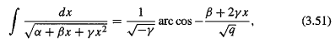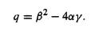

This results in another sign error in (3.54), but as it turns out, this error makes no difference in the key final result (3.55) due to the fact that cos(θ-θ') = cos(θ'-θ). That final result is this.

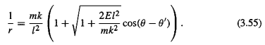

The inverse square force law is F = -k/r2, a particle has mass m, energy E, and angular momentum l . This last result shows that the orbits are conic sections expressed in polar coordinates r,θ where the radical is the orbit eccentricity ε. For a sun-planet system, m,r,θ refer to an equivalent one-body problem where m is the reduced mass, and r,θ are relative to the center of mass.

A summary of forms appearing in this document R = a + bx + cx2 (7.15)

$^{\int_{}^{x}{}}$dx $\sqrt{R}$ $\sqrt{c}$ln (2cx + b + 2 $\sqrt{c}$$\sqrt{R}$) // (4.9) c > 0

- $\sqrt{c}$ln (2cx + b - 2 $\sqrt{c}$$\sqrt{R}$ ) // (4.10) c > 0

$\sqrt{c}$ln (2cx +b ) // (4.14) c > 0, b2-4ac = 0

$\sqrt{c}$ ln [ $\sqrt{c}$$\sqrt{a+bx+cx2}$$\sqrt{4ac-b2}$] // (1.5) c > 0, b2-4ac < 0

$\sqrt{c}$tanh-1($\sqrt{a}$$\sqrt{c}$) // (5.9) c > 0, a > 0

$\sqrt{c}$tanh-1($\sqrt{a}$$\sqrt{c}$) // (5.10) c > 0, a > 0

$\sqrt{c}$tanh-1($\sqrt{x-β}$$\sqrt{x-α}$) // (6.9) c > 0, α,β roots of R

$\sqrt{c}$ sinh-1($\sqrt{4ac-b2}$) // (7.5) c > 0, b2-4ac < 0

- $\sqrt{-c}$sin-1 ( $\sqrt{b2-4ac}$) // (7.10) c < 0, b2-4ac > 0

+ $\sqrt{-c}$cos-1( $\sqrt{b2-4ac}$) // (7.12) c < 0, b2-4ac > 0

- $\sqrt{-c}$cos-1( $\sqrt{b2-4ac}$) // (7.12) c < 0, b2-4ac > 0

Four of these results appear in GR7 page 94 :

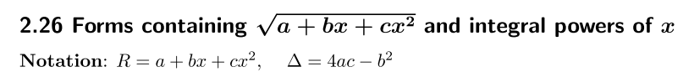 (7.16)
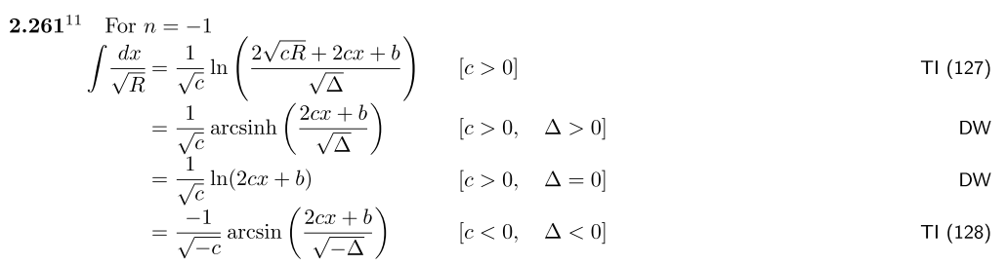

See also Spiegel 14.280 which, however, uses R = ax2+bx+c. Both Spiegel and GR7 present many integrals of the form xm ($\sqrt{R}$)n for m and odd n being various positive and negative integers.

Footnote concerning TI above. Adrian (Fedorovich) Timofeev (1882-1954) led a complicated life in Russia and wrote a few non-mathematical books about it (e.g., My Prison Diary).

http://adriantimofeev1.blogspot.com/2012/07/this-is-photos-from-life-in-1890-1915.html

References

Links were last checked on 5 Nov 2016.

https://en.wikipedia.org/wiki/Euler_substitution

http://planetmath.org/eulerssubstitutionsforintegration

K.N. Boyadzhiev, "Euler Substitutions" (Ohio Northern University, 2006), 5p. Has examples.
http://www2.onu.edu/~m-caragiu.1/bonus_files/EULER-SU.pdf

H. Goldstein, Classical Mechanics (Addison-Wesley, Boston, 1950).

H. Goldstein, C.P. Poole Jr. and J.L. Safko, Classical Mechanics, 3rd Ed. ( Addison-Wesley, New York, 2001) now rebranded by Pearson, London. Authors deceased 2005, 2015 and 2016.

[GR7] I.S. Gradshteyn and I.M. Ryzhik, Table of Integrals, Series, and Products, 7th Ed. (Academic Press, New York, 2007). The 8th edition came out Oct 2014. Editor Dan Zwillinger has errata for editions 6,7 and 8 at http://www.mathtable.com/errata .

N.S. Piskunov, Differential and Integral Calculus (Mir, Moscow, 1969). This 895 page text was translated from the Russian by G. Yankovsky (search the web). Section 12 pp 372-375 mentions the Euler substitutions with a few examples.

M.R. Spiegel, Schaum's Outlines: Mathematical Handbook of Formulas and Tables (McGraw-Hill, New York, 1968). Our page references are to this edition. The current version of this book is given below.

M.R. Spiegel, S. Lipschutz, M. and J. Liu, Schaum's Outlines: Mathematical Handbook of Formulas and Tables, 4th Ed. (McGraw-Hill, New York, 2012). John Liu was added for the 1999 2nd Ed, and Seymour Lipschutz joined for the 2008 3rd Ed. Not to be confused with a watered-down "Easy Outline" version. This low-cost paperback is an excellent fast reference for well-known mathematical facts.

