The Euler Substitutions
Phil Lucht
Rimrock Digital Technology, Salt Lake City, Utah 84103
last update: Nov 9, 2016

The material in this document is copyrighted by the author.

1. Introduction 1
2. Comments about R = a + bx + cx² 4
3. A substitution that fails, then three that succeed: A,B and C 5
4. Substitution A 7
5. Substitution B 10
6. Substitution C 14
7. More forms for the integral of R^{-1/2} 16
Appendix A: About Euler's original paper 21
Appendix B. Summary of the three Euler substitutions 26
References 27

1. Introduction

There are many techniques for the exact analytic evaluation of indefinite integrals. For example, Zwillinger provides a solid list of methods in Section III of his Handbook of Integration. In any such list, the very first method is usually "change of variables" by means of a "substitution". To take a trivial example which establishes the variable names we use below, consider how the substitution t = sinx helps in evaluating a trigonometric integral,

t(x) = sinx dt = cosx dx
$^{\int_{}^{x}{}}$sinx cosx dx = $^{\int_{}^{t(x)}{}}$t dt = (1/2) t2|t(x) = (1/2) sin2x . (1.1)

The phrase "Euler substitutions" refers to three substitutions used for evaluating certain integrals involving powers of x along with powers of the radical $\sqrt{a+bx+cx2}$. These substitutions are briefly reviewed in Section 2.25 (p 92) of Gradshteyn and Ryzhik [GR7]. Wiki suggests that these substitutions appears in many Russian calculus texts, and we have found them mentioned in a book by Piskunov.

Our very elementary purpose in this document is to flesh out the details of using these Euler substitutions and to state the results in a systematic manner.

As an illustration, ∫dx 1/$\sqrt{a+bx+cx2}$is evaluated using each of the substitutions. The results are then transformed into other forms, and all the results are collected in (7.17). This integral is of particular interest to the author because it is used in Goldstein's Classical Mechanics to derive equations for planetary orbits, and there seems to be a benign sign error in that development as noted below. Physicists spend a lot of time worrying about signs of things. Sometimes such errors are related to confusion about how branch cuts are "taken off" for functions of a complex variable, the choice of Riemann sheets, and other esoteric matters, but more often than not the sign error is caused by a trivial mistake in grade school algebra.

A certain class of functions of t are called rational functions and have the form

R(t) = $\frac{poly1(t)}{poly2(t)}$ (1.2)

where the numerator and denominator are just polynomials of t with non-negative powers. In fact negative powers are allowed and can be cleared by multiplying top and bottom by some tn . Any function having the form R(t) can easily be integrated using the method of partial fractions, and this topic is clearly outlined in Section 2.10 of GR7. In the discussion below, the Euler substitutions result in integrands of the form R(t) and then we know that the integration from that point on is just turning a crank.

Rational functions of two variables x and y are defined analogously to the above,

R(x,y) = $\frac{poly1(x,y)}{poly2(x,y)}$ (1.3)

where now the numerator and denominator are polynomials in x and y, such as 3x2 - 2xy9 + 4 - y.

The Euler substitutions apply to a class of functions of a single variable x which have this form

f(x) = R(x,$\sqrt{a+bx+cx2}$) . (1.4)

For example, a typical such function might be

R(x,$\sqrt{a+bx+cx2}$) = $\sqrt{a+bx+cx2}$$\sqrt{a+bx+cx2}$$\sqrt{a+bx+cx2}$ . (1.5)

Since the numerator terms can be treated separately, one can limit one's interest to the following form,

R(x,$\sqrt{a+bx+cx2}$) = $\sqrt{a+bx+cx2}$$\sqrt{a+bx+cx2}$ . (1.6)

As noted, the specific example we shall study is the following, shown here in one of its forms (4.9),

∫dx $\sqrt{a+bx+cx2}$ = $\sqrt{c}$ ln [ 2cx + b + 2$\sqrt{c}$$\sqrt{a+bx+cx2}$ ] + constant c > 0 . (1.7)

The above example serves as a good model to look at while reading the comments below concerning the general integrand shown in (1.4) .

Comments:
• In general, any indefinite integral should really be written$^{\int_{}^{x}{}}$dx f(x) = F(x) + constant where the constant is arbitrary. One can always test a candidate F(x) by computing dF/dx to see if the result is f(x). This task is made easy using Maple or another computer calculus program.

• When there are parameters such as a,b,c shown above, that integration constant can be any function g(a,b,c) which is of course not a function of x.

• We shall use the symbol A B to mean A = B + constant in the above sense. Thus we can write

∫dx $\sqrt{a+bx+cx2}$ $\sqrt{c}$ ln [ 2cx + b + 2$\sqrt{c}$$\sqrt{a+bx+cx2}$ ]
$\sqrt{c}$ ln [ $\sqrt{c}$$\sqrt{a+bx+cx2}$$\sqrt{4ac-b2}$] . (1.8)

On the second line we have added a denominator which in effect creates the additive constant g(a,b,c) =
- (1/$\sqrt{c}$) ln($\sqrt{4ac-b2}$). Both forms shown above are "correct" and well-defined when c > 0 and 4ac-b2> 0.

• If one thinks of x having units of distance L, then dim(x) = L, dim(a) = L2, dim(b) = L and dim(c) = 1 make the integral be dimensionless. Then the second form above involves the log of a dimensionless ratio, whereas the first form does not, somewhat clarifying the dimensionless nature of the integral.

• As discussed more below, $\sqrt{a+bx+cx2}$is real for certain ranges of a,b,c,x and one can imagine that the integral being evaluated is over a range of x where $\sqrt{a+bx+cx2}$ is real. One normally thinks of a,b,c as real parameters.

• Once an integral has been evaluated for "reasonable" values of the parameters like a,b,c, one can extend one or more of these parameters to the complex plane allowing one to analytically continue both sides of an integral evaluation. We shall give an example below in Section 7.

Having stated these general comments, we now look specifically at the object $\sqrt{a+bx+cx2}$.

2. Comments about R = a + bx + cx2

The letters a,b,c are defined consistently with GR7. It is probably more standard to write ax2+bx+c, in which case one has the familiar rote solution for the roots [-b ± $\sqrt{b2-4ac}$]/(2a), so in our current context one must remember that in fact the roots of a+bx+cx2= 0 are given by

α± ≡ [-b ± $\sqrt{b2-4ac}$]/(2c) . (2.1)

The quantity b2-4ac is often called "the discriminant". GR7 define Δ to be the negative of this discriminant,

Δ ≡ 4ac - b2 . (2.2)

Also consistent with GR7 we define R by

R ≡ a+bx+cx2 = c [ x2 + (b/c)x + (a/c) ] = c(x-α+)(x-α-) (2.3)

and it is for this reason that we have used R above for the ratio of polynomials. Note that α± are the roots of R for c > 0, for c = |c|eiθ , and for c < 0.

Special case:

b2 = 4ac (Δ = 0) ⇒ α± = -b/(2c) ⇒ R = c(x-α+)2 ⇒ $\sqrt{R}$ = $\sqrt{c}$[x + b/(2c)] (2.4)

Geometry

If b2 - 4ac > 0 then the roots in (2.1) are real. This means that the graphed function f(x) = a + bx + cx2 has two intersections with the x axis.
If c > 0, the parabola cups up. Therefore to the right of the upper root, x > α+, one has a + bx + cx2 > 0 and so $\sqrt{a+bx+cx2}$is real and well defined. It is also real for x < α-.
If c < 0, the parabola cups down. In this case $\sqrt{a+bx+cx2}$ is real and well defined for α- < x < α+. By well defined we simply mean that the square root implies a positive real number and we don't worry about branches of the square root function.

When talking about integrals involving $\sqrt{a+bx+cx2}$, it seems best to start with an integral over a range of x where a + bx + cx2 is positive, so then $\sqrt{a+bx+cx2}$is real and positive. There are four cases of interest:

Case 1: c > 0, b2- 4ac > 0 (real roots), cups up, x > α+ or x < α- to have real $\sqrt{a+bx+cx2}$

Case 2: c > 0, b2- 4ac < 0 (imag roots), cups up, all real values of x give real $\sqrt{a+bx+cx2}$

Case 3: c < 0, b2- 4ac > 0 (real roots), cups down, must have α- < x < α+ to have real $\sqrt{a+bx+cx2}$

Case 4: c < 0, b2- 4ac < 0 (imag roots), cups down, no real value of x gives real $\sqrt{a+bx+cx2}$ (2.5)

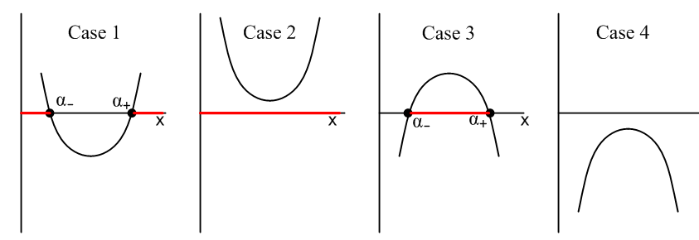 (2.6)

The red bars show the range of x for which $\sqrt{a+bx+cx2}$is real.

We shall initially work in Case 2 below. This means c > 0 and b2- 4ac < 0.

3. A substitution that fails, then three that succeed: A,B and C

One's first inclination in evaluating integrals including $\sqrt{a+bx+cx2}$might be to make the substitution

t(x) = $\sqrt{a+bx+cx2}$ (3.1)

so that

R(x,$\sqrt{a+bx+cx2}$) → R(x(t),t) . (3.2)

But,

t2 = a+bx+cx2 ⇒ cx2 + bx + (a-t2) = 0

⇒ x(t) = $\sqrt{b2 - 4c(a-t2)}$ . (3.3)

The result then is,

R(x,$\sqrt{a+bx+cx2}$) → R($\sqrt{b2 - 4c(a-t2)}$, t) . (3.4)

The goal is to remove square roots from the integrand, but this substitution just replaces one square root with another square root and is thus not very useful, so we reject this substitution.

We are then led to three substitutions which are credited to Leonhard (brave lion) Euler (1707-1783) and are now known as "the Euler substitutions". There is some disagreement about how these are numbered 1,2 and 3 so we instead call them substitutions A,B and C favoring the ordering of Piskunov :

Piskunov GR7 Boyadzhiev
A t + $\sqrt{c}$x = $\sqrt{a+bx+cx2}$ 1 2 1
B xt + $\sqrt{a}$ = $\sqrt{a+bx+cx2}$ 2 1 3
C t (x-α) = $\sqrt{a+bx+cx2}$ 3 3 2 (3.5)

Euler below is squinting at eiπ + 1 = 0 written on his blackboard and is wondering what it all means.

 (3.6)
https://en.wikipedia.org/wiki/Leonhard_Euler

Gradshteyn and Ryzhik

Another of Zwillinger's "methods" for doing an indefinite integral is "looking it up" in a table of integrals. The astounding Table of Integrals, Series, and Products associated with Gradshteyn and Ryzhik contains, as a small fraction of its content, about 200 pages of indefinite integrals of elementary functions which have accumulated over three centuries. Currently in the editorial hands of Dan Zwillinger and Victor Moll, the book is in its 8th edition, though we continue to use the 7th edition. During the period of each edition, new integrals and errata for old integrals are collected to be incorporated into the next edition. The first edition was published by Russian mathematician Ryzhik in 1941, and he was joined by Gradshteyn in 1951 for the 3rd edition, see wiki.

4. Substitution A

Instead of using the substitution (3.1), consider

t(x) = $\sqrt{a+bx+cx2}$ - $\sqrt{c}$x or t + $\sqrt{c}$x = $\sqrt{a+bx+cx2}$. (4.1)

When we finish this section we can replace $\sqrt{c}$→ -$\sqrt{c}$ everywhere and thereby generate an alternate result. One now has,

a + bx + cx2 = t2 + 2$\sqrt{c}$t x + cx2 . (4.2)

The key idea is that the two cx2 terms cancel out, giving

a + bx = t2 + 2$\sqrt{c}$t x ⇒ (b - 2$\sqrt{c}$t )x = (t2-a) ⇒

x(t) = $\sqrt{c}$ , (4.3)

an expression with no messy square roots, unlike (3.3). Then,

$\sqrt{a+bx+cx2}$ = t + $\sqrt{c}$x = t + $\sqrt{c}$$\sqrt{c}$ = $\sqrt{c}$$\sqrt{c}$ + $\sqrt{c}$$\sqrt{c}$$\sqrt{c}$
= $\sqrt{c}$$\sqrt{c}$$\sqrt{c}$ . (4.4)

Then our general replacement becomes

R(x,$\sqrt{a+bx+cx2}$) → R( $\sqrt{c}$, $\sqrt{c}$$\sqrt{c}$$\sqrt{c}$) . (4.5)

One may then compute

$\frac{dx}{dt}$ = $\frac{d}{dt}$($\sqrt{c}$) = $\sqrt{c}$$\sqrt{c}$$\sqrt{c}$ = $\sqrt{c}$$\sqrt{c}$$\sqrt{c}$$\sqrt{c}$

= 2 $\sqrt{c}$$\sqrt{c}$

so that

dx = 2 $\sqrt{c}$$\sqrt{c}$$\sqrt{c}$ dt . (4.6)

Our integral evaluation then becomes

$^{\int_{}^{x}{}}$dx R(x,$\sqrt{a+bx+cx2}$) = $^{\int_{}^{t(x)}{}}$dt 2 $\sqrt{c}$$\sqrt{c}$$\sqrt{c}$ * R( $\sqrt{c}$, $\sqrt{c}$$\sqrt{c}$$\sqrt{c}$)
where t(x) = $\sqrt{a+bx+cx2}$ - $\sqrt{c}$x . (4.7)

Notice that there are no messy square roots anywhere in the dt integrand. The integrand is now a rational function in the variable t : integrand = poly1(t)/poly2(t).

As noted earlier, one may replace $\sqrt{c}$→ -$\sqrt{c}$ (and c → c) to obtain the following alternative form,

$^{\int_{}^{x}{}}$dx R(x,$\sqrt{a+bx+cx2}$) = $^{\int_{}^{t(x)}{}}$dt 2 $\sqrt{c}$$\sqrt{c}$$\sqrt{c}$ * R( $\sqrt{c}$, $\sqrt{c}$$\sqrt{c}$$\sqrt{c}$)
where t(x) = $\sqrt{a+bx+cx2}$ + $\sqrt{c}$x . (4.8)

Example: Let R(x,$\sqrt{a+bx+cx2}$) = 1/$\sqrt{a+bx+cx2}$. Then using (4.8),

$^{\int_{}^{x}{}}$dx $\sqrt{a+bx+cx2}$ = $^{\int_{}^{t(x)}{}}$dt 2 $\sqrt{c}$$\sqrt{c}$$\sqrt{c}$ * $\sqrt{c}$$\sqrt{c}$$\sqrt{c}$

= 2$^{\int_{}^{t(x)}{}}$dt $\sqrt{c}$ = $\sqrt{c}$$^{\int_{}^{t(x)}{}}$dt $\sqrt{c}$

= $\sqrt{c}$ ln (t + [b/2$\sqrt{c}$] }|t(x)

= $\sqrt{c}$ln ( $\sqrt{a+bx+cx2}$ + $\sqrt{c}$x + [b/2$\sqrt{c}$] = $\sqrt{c}$ln ( $\sqrt{R}$ + $\sqrt{c}$x + [b/2$\sqrt{c}$] )

$\sqrt{c}$ ln [2 $\sqrt{c}$$\sqrt{R}$ + 2cx + b ] (4.9)

in agreement with (1.7) stated earlier without proof. To get the last line, we multiplied by 2$\sqrt{c}$ top and bottom inside the log, then dropped the constant term - (1/$\sqrt{c}$) ln (2$\sqrt{c}$), hence the sign .

From (4.7) we would have gotten instead

$^{\int_{}^{x}{}}$dx $\sqrt{a+bx+cx2}$ = - $\sqrt{c}$ln [- 2 $\sqrt{c}$$\sqrt{R}$ + 2cx + b ] . (4.10)

These seemingly different results are both valid since they differ by a constant independent of x :

$\sqrt{c}$ ln [2 $\sqrt{c}$$\sqrt{R}$ + 2cx + b ] - { - $\sqrt{c}$ln [- 2 $\sqrt{c}$$\sqrt{R}$ + 2cx + b ] }

= $\sqrt{c}$ln [ (2 $\sqrt{c}$$\sqrt{R}$ + 2cx + b)(- 2 $\sqrt{c}$$\sqrt{R}$ + 2cx + b) ] = $\sqrt{c}$ ln [ (2cx+b)2 - 4cR ]

= $\sqrt{c}$ ln [ (2cx+b)2 - 4c(a+bx+cx2 ] = $\sqrt{c}$ ln [ 4c2x2 + 4cbx + b2 - 4ca + 4cbx - 4c2x2 ]

= $\sqrt{c}$ ln [ b2 - 4ca ] . (4.11)

We then write,

$^{\int_{}^{x}{}}$dx $\sqrt{a+bx+cx2}$ $\sqrt{c}$ ln [2 $\sqrt{c}$$\sqrt{R}$ + 2cx + b ] - $\sqrt{c}$ln [- 2 $\sqrt{c}$$\sqrt{R}$ + 2cx + b ] . (4.12)

Just for the record, Maple comes up with the first of these forms (again apart from a constant),

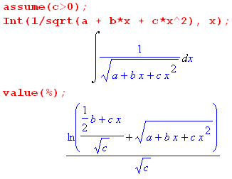 (4.13)
which is

$\sqrt{c}$ln [ $\sqrt{c}$$\sqrt{R}$$\sqrt{c}$] = $\sqrt{c}$ln [2 $\sqrt{c}$$\sqrt{R}$ + 2cx + b ] - $\sqrt{c}$ ln (2$\sqrt{c}$) .

In the special case that 4ac = b2 we know from (2.4) that $\sqrt{R}$ = $\sqrt{c}$[x + b/(2c)] so (4.9) becomes

$^{\int_{}^{x}{}}$dx $\sqrt{R}$ $\sqrt{c}$ln ( 2 $\sqrt{c}$$\sqrt{R}$ + 2cx + b )
= $\sqrt{c}$ln ( 2 $\sqrt{c}$[$\sqrt{c}$(x + b/(2c)] + 2cx + b )
= $\sqrt{c}$ln (2cx +b + 2cx + b ) = $\sqrt{c}$ln (4cx +2b )
$\sqrt{c}$ln (2cx +b ) . c > 0, 4ac = b2 (4.14)

5. Substitution B

Here we mimic the previous section as closely as possible, using matching equation numbers.

Instead of using the substitution (3.1), consider

t(x) = ( $\sqrt{a+bx+cx2}$ - $\sqrt{a}$) / x or xt + $\sqrt{a}$ = $\sqrt{a+bx+cx2}$. (5.1)

When we finish this section we can replace $\sqrt{a}$→ -$\sqrt{a}$ everywhere and thereby generate an alternate result. One now has,

a + bx + cx2 = x2t2 + 2xt$\sqrt{a}$+ a . (5.2)

The key idea is that the two a terms cancel out, giving

bx + cx2 = x2t2 + 2$\sqrt{a}$x t ⇒ b + cx = xt2 + 2$\sqrt{a}$t ⇒ x(c-t2) = 2$\sqrt{a}$t - b ⇒

x(t) = $\sqrt{a}$ , (5.3)

an expression with no messy square roots, unlike (3.3). Then,

$\sqrt{a+bx+cx2}$ = xt + $\sqrt{a}$ = $\sqrt{a}$ t + $\sqrt{a}$ = $\sqrt{a}$ + $\sqrt{a}$

= $\sqrt{a}$$\sqrt{a}$ . (5.4)

Then our general replacement becomes

R(x,$\sqrt{a+bx+cx2}$) → R( $\sqrt{a}$, $\sqrt{a}$$\sqrt{a}$) . (5.5)

One may then compute

$\frac{dx}{dt}$ = $\frac{d}{dt}$( $\sqrt{a}$) = $\sqrt{a}$$\sqrt{a}$ = $\sqrt{a}$$\sqrt{a}$$\sqrt{a}$

= 2$\sqrt{a}$$\sqrt{a}$
so that

dx = 2 $\sqrt{a}$$\sqrt{a}$ dt . (5.6)

Our integral evaluation then becomes

$^{\int_{}^{x}{}}$dx R(x,$\sqrt{a+bx+cx2}$) = $^{\int_{}^{t(x)}{}}$dt 2 $\sqrt{a}$$\sqrt{a}$ * R( $\sqrt{a}$, $\sqrt{a}$$\sqrt{a}$)
where t(x) = ( $\sqrt{a+bx+cx2}$ - $\sqrt{a}$) / x . (5.7)

Notice that there are no messy square roots anywhere in the dt integrand. The integrand is now a rational function in the variable t : integrand = poly1(t)/poly2(t).

As noted earlier, one may replace $\sqrt{a}$→ -$\sqrt{a}$ (and a → a) to obtain the following alternative form.

$^{\int_{}^{x}{}}$dx R(x,$\sqrt{a+bx+cx2}$) = $^{\int_{}^{t(x)}{}}$dt 2 $\sqrt{a}$$\sqrt{a}$ * R( $\sqrt{a}$, $\sqrt{a}$$\sqrt{a}$)
where t(x) = ( $\sqrt{a+bx+cx2}$ + $\sqrt{a}$) / x . (5.8)

Example: Let R(x,$\sqrt{a+bx+cx2}$) = 1/$\sqrt{a+bx+cx2}$. Then using (5.8),

$^{\int_{}^{x}{}}$dx $\sqrt{a+bx+cx2}$ = $^{\int_{}^{t(x)}{}}$dt 2 $\sqrt{a}$$\sqrt{a}$ * $\sqrt{a}$$\sqrt{a}$

= 2 $^{\int_{}^{t(x)}{}}$dt $\frac{1}{c-t2}$ = -2 $^{\int_{}^{t(x)}{}}$dt $\frac{1}{t2-c}$ .

Maple kindly computes this integral,

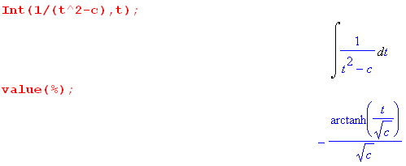 (5.8a)
so we continue,

$^{\int_{}^{x}{}}$dx $\sqrt{a+bx+cx2}$ = + $\sqrt{c}$ tanh-1 ($\sqrt{c}$)|t = t(x)

= $\sqrt{c}$ tanh-1$\sqrt{a+bx+cx2}$$\sqrt{a}$$\sqrt{c}$

= $\sqrt{c}$tanh-1($\sqrt{a}$$\sqrt{c}$) . (5.9)

From (5.7) we would have instead found

$^{\int_{}^{x}{}}$dx $\sqrt{a+bx+cx2}$ = $\sqrt{c}$tanh-1($\sqrt{a}$$\sqrt{c}$) . (5.10)

One might reasonably wonder how both these results can be correct since there is a sign difference. The answer again is that the two forms differ by a constant independent of x. To show this, one can use

tanh-1 u = $\frac{1}{2}$ ln ( $\frac{1+u}{1-u}$) |u| < 1 // Spiegel 8.57
with
u = $\sqrt{a}$$\sqrt{c}$ ⇒ 1 ± u = $\sqrt{c}$$\sqrt{c}$ ± $\sqrt{a}$$\sqrt{c}$ = $\sqrt{c}$$\sqrt{R}$$\sqrt{a}$$\sqrt{c}$

so that

tanh-1($\sqrt{a}$$\sqrt{c}$) = $\frac{1}{2}$ ln [ $\sqrt{c}$$\sqrt{R}$$\sqrt{a}$$\sqrt{c}$$\sqrt{R}$$\sqrt{a}$]

tanh-1($\sqrt{a}$$\sqrt{c}$) = $\frac{1}{2}$ ln [ $\sqrt{c}$$\sqrt{R}$$\sqrt{a}$$\sqrt{c}$$\sqrt{R}$$\sqrt{a}$] .

The difference between these two arctangents is then

tanh-1($\sqrt{a}$$\sqrt{c}$) - tanh-1($\sqrt{a}$$\sqrt{c}$) = $\frac{1}{2}$ ln [ $\sqrt{c}$$\sqrt{R}$$\sqrt{a}$$\sqrt{c}$$\sqrt{R}$$\sqrt{a}$] - $\frac{1}{2}$ ln [ $\sqrt{c}$$\sqrt{R}$$\sqrt{a}$$\sqrt{c}$$\sqrt{R}$$\sqrt{a}$]

= $\frac{1}{2}$ ln [ $\sqrt{c}$$\sqrt{R}$$\sqrt{a}$$\sqrt{c}$$\sqrt{R}$$\sqrt{a}$ * $\sqrt{c}$$\sqrt{R}$$\sqrt{a}$$\sqrt{c}$$\sqrt{R}$$\sqrt{a}$ ] = $\frac{1}{2}$ ln [ $\sqrt{c}$$\sqrt{a}$$\sqrt{c}$$\sqrt{a}$]

= $\frac{1}{2}$ ln [ $\sqrt{a}$$\sqrt{c}$$\sqrt{a}$$\sqrt{c}$] = $\frac{1}{2}$ ln [ $\sqrt{a}$$\sqrt{c}$$\sqrt{a}$$\sqrt{c}$]

= $\frac{1}{2}$ ln [ $\sqrt{a}$$\sqrt{c}$$\sqrt{a}$$\sqrt{c}$ ] .

Therefore

$\sqrt{c}$tanh-1($\sqrt{R}$$\sqrt{a}$$\sqrt{c}$) - $\sqrt{c}$tanh-1($\sqrt{R}$$\sqrt{a}$$\sqrt{c}$) = $\sqrt{c}$ $\frac{1}{2}$ ln [ $\sqrt{a}$$\sqrt{c}$$\sqrt{a}$$\sqrt{c}$ ] (5.11)

which is a constant independent of x. Therefore we write

$^{\int_{}^{x}{}}$dx $\sqrt{a+bx+cx2}$ $\sqrt{c}$tanh-1($\sqrt{a}$$\sqrt{c}$) $\sqrt{c}$tanh-1($\sqrt{a}$$\sqrt{c}$) (5.12)

and we have now accumulated two more forms for this integral. Both forms can be verified by direct differentiation as Maple shows,

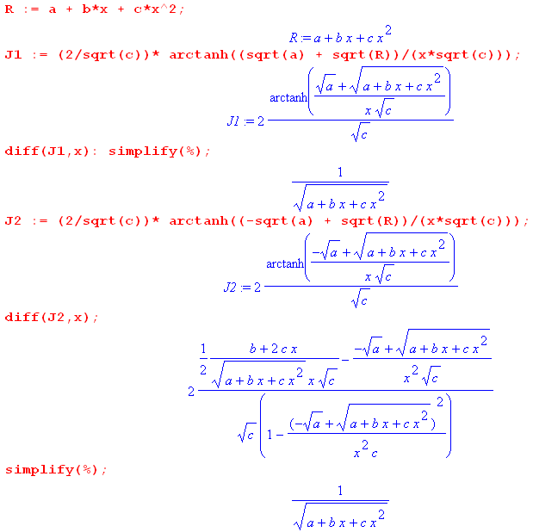 (5.13)

In the Maple language, a colon suppresses output from a command, while symbol % refers to the last computed quantity. In the diff(J1,x) line we suppress output and simplify to get 1/$\sqrt{R}$, but for J2 we show the typically messy expression Maple generates, followed by the simplified result.

6. Substitution C

Rename the roots of R = 0 to be α = α- and β = α+ . Recall that

a+bx+cx2 = c(x-α)(x-β) . (2.3)

Now, instead of using the substitution (3.1), consider

t(x) = $\sqrt{a+bx+cx2}$/ (x-α) = $\sqrt{c(x-α)(x-β)}$/ (x-α) = $\sqrt{c}$ $\frac{x - β}{x - α}$ . (6.1)

When we finish this section we can do α ↔ β everywhere and thereby generate an alternate result.

Solving for x one finds (there is no equation (6.2) because we are matching the previous sections),

t2 = c (x-β)/(x-α) ⇒ t2(x-α) = c(x-β) ⇒ x(t2-c) = (αt2- cβ) ⇒

x(t) = $\frac{αt2- cβ}{t2-c}$ , (6.3)

an expression with no messy square roots, unlike (3.3). Then,

$\sqrt{a+bx+cx2}$ = (x-α)t = ($\frac{αt2- cβ}{t2-c}$-α)t = $\frac{t(αt2- cβ)}{t2-c}$ - $\frac{αt(t2-c)}{t2-c}$ = $\frac{αt3 - cβt - αt3 + cαt}{t2-c}$

= $\frac{c(α-β)t}{t2-c}$ . (6.4)

Then our general replacement becomes

R(x,$\sqrt{a+bx+cx2}$) → R($\frac{αt2- cβ}{t2-c}$, $\frac{c(α-β)t}{t2-c}$) . (6.5)

One may then compute

$\frac{dx}{dt}$ = $\frac{d}{dt}$($\frac{αt2- cβ}{t2-c}$) = $\frac{(t2-c)2αt - (αt2-cβ)2t}{(t2-c)2}$ = $\frac{2αt3 - 2αct - 2αt3+ 2cβt}{(t2-c)2}$ = 2 $\frac{- αct + cβt}{(t2-c)2}$

= 2 $\frac{c(β-α)t}{(t2-c)2}$
so that

dx = 2 $\frac{c(β-α)t}{(t2-c)2}$dt . (6.6)

Our integral evaluation then becomes

$^{\int_{}^{x}{}}$dx R(x,$\sqrt{a+bx+cx2}$) = $^{\int_{}^{t(x)}{}}$dt 2 $\frac{c(β-α)t}{(t2-c)2}$ * R($\frac{αt2- cβ}{t2-c}$, $\frac{c(α-β)t}{t2-c}$)
where t(x) = $\sqrt{a+bx+cx2}$/ (x-α) = $\sqrt{R}$/(x-α) . (6.7)

Notice that there are no messy square roots anywhere in the dt integrand. The integrand is now a rational function in the variable t : integrand = poly1(t)/poly2(t).

As noted earlier, one may swap α ↔ β to obtain the following alternative form,

$^{\int_{}^{x}{}}$dx R(x,$\sqrt{a+bx+cx2}$) = $^{\int_{}^{t(x)}{}}$dt 2 $\frac{c(α-β)t}{(t2-c)2}$ * R($\frac{βt2- cα}{t2-c}$, $\frac{c(β-α)t}{t2-c}$) (6.8)
where t(x) = $\sqrt{a+bx+cx2}$/ (x-β) = $\sqrt{R}$/(x-β) .

Example: Let R(x,$\sqrt{a+bx+cx2}$) = 1/$\sqrt{a+bx+cx2}$. Then using (6.7),

$^{\int_{}^{x}{}}$dx $\sqrt{a+bx+cx2}$ = $^{\int_{}^{t(x)}{}}$dt 2 $\frac{c(β-α)t}{(t2-c)2}$* $\frac{t2-c}{c(α-β)t}$ = - 2$^{\int_{}^{t(x)}{}}$dt $\frac{1}{t2-c}$

= +$\sqrt{c}$tanh-1($\sqrt{c}$)|t(x) // using (5.8a)

= $\sqrt{c}$tanh-1($\frac{x - β}{x - α}$) . (6.9)
Thus we arrive at yet another form for our ∫dx/$\sqrt{R}$integral. Maple verifies it as follows,

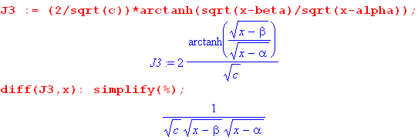

which is just 1/$\sqrt{a+bx+cx2}$. The result is clearly symmetric under α ↔ β, so one has

$^{\int_{}^{x}{}}$dx $\sqrt{a+bx+cx2}$ $\sqrt{c}$tanh-1($\frac{x - β}{x - α}$) $\sqrt{c}$tanh-1($\frac{x - α}{x - β}$) . (6.10)

We leave it to the reader to find the constant by which these two forms differ from each other and from those forms presented earlier.

7. More forms for the integral of R-1/2

Define

y ≡ $\sqrt{4ac-b2}$ . (7.1)

We wish to use the following identity with the above y,

sinh-1y = ln(y + $\sqrt{y2+1}$) |y| < ∞ // Spiegel 8.55 (7.2)

so we need to evaluate

y2 + 1 = ( $\sqrt{4ac-b2}$)2 + 1 = $\frac{(2cx+b)2}{4ac-b2}$+ 1 = $\frac{(2cx+b)2+ 4ac-b2}{4ac-b2}$ = $\frac{4c2x2 + 4cbx + b2+ 4ac-b2}{4ac-b2}$

= $\frac{4c(cx2+bx +a)}{4ac - b2}$ = $\frac{4cR}{4ac - b2}$ . (7.3)

Then

y + $\sqrt{y2+1}$ = $\sqrt{4ac-b2}$+ $\sqrt{c}$$\sqrt{R}$$\sqrt{4ac-b2}$ = $\sqrt{c}$$\sqrt{R}$$\sqrt{4ac-b2}$ .

Then from (7.2),

sinh-1( $\sqrt{4ac-b2}$) = ln ( $\sqrt{c}$$\sqrt{R}$$\sqrt{4ac-b2}$ ) ln (2cx + b + 2$\sqrt{c}$$\sqrt{R}$) (7.4)

where as usual we have thrown out a constant g(a,b,c). Comparing this result to (4.9),

$^{\int_{}^{x}{}}$dx $\sqrt{a+bx+cx2}$ $\sqrt{c}$ ln [2 $\sqrt{c}$$\sqrt{R}$ + 2cx + b ] , (4.9)

we may conclude that

$^{\int_{}^{x}{}}$dx $\sqrt{a+bx+cx2}$ $\sqrt{c}$ sinh-1($\sqrt{4ac-b2}$) (7.5)

giving a commonly appearing form for the integral valid for c > 0 and 4ac - b2 > 0.

Analytic Continuation. Consider this z-plane showing complex vectors z and z-α for |z| > α > 0,

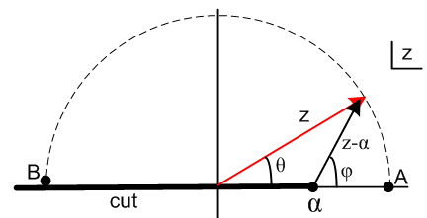 (7.6)

We are interested in the function f(z) = (z-α)r where 0 < r < 1. The function has a branch point at z = α and we draw the cut off to the left as shown in black. We declare that f(z) is real and positive for z > α, so we are viewing the "principle sheet" of our function. Angles θ and φ are phases of the vectors z and z-α,

z = |z|eiθ and (z-α) = |z-α| eiφ . (7.7)

At point A, one has θ = 0, φ = 0, z > 0 and z-α > 0 so,

z = |z|ei0 = z and (z-α) = |z-α|ei0 = (z-α) . (7.8)

At point B one has θ = +π, φ = +π, z < 0 and z-α < 0 so (z is just above the cut),

z = |z|eiπ = (-z)eiπ and (z-α) = |z-α|eiπ = (α-z)eiπ
so
zr = (-z)reiπr and (z-α)r = (α-z)r eiπr . (7.9)

For r = 1/2 the last line says

$\sqrt{z}$ = $\sqrt{-z}$eiπ/2 = + i $\sqrt{-z}$ and $\sqrt{z-α}$ = $\sqrt{α-z}$eiπ/2 = + i $\sqrt{α-z}$ (7.10)

Therefore at point B the phases of $\sqrt{z}$ and $\sqrt{z-α}$are the same, indicated by eiπ/2 = +i. If we move point B below the cut and redraw the picture so point B has θ = -π and φ = -π, both phases are -i instead of both +i. In either case the two phases are the same, and this fact follows from doing proper analytic continuation over a smooth path in the z-plane from z = A to z = B.

Application. Assume a > 0 and let z = 4ac and α = b2. Then taking point B above the cut,

$\sqrt{4ac}$ = +i $\sqrt{-4ac}$ and $\sqrt{4ac-b2}$ = +i $\sqrt{b2-4ac}$
or
$\sqrt{c}$ = +i $\sqrt{-c}$ and $\sqrt{4ac-b2}$ = +i $\sqrt{b2-4ac}$.... (7.11)

We can then analytically continue our integral (7.5) using these rules to get

$^{\int_{}^{x}{}}$dx (1/ = (1/$\sqrt{c}$) sinh-1 [ (2cx +b)/$\sqrt{4ac-b2}$] // (7.5)

= (1/[i $\sqrt{-c}$ ]) sinh-1 [ (2cx +b)/(i $\sqrt{b2-4ac}$)]

= (-i)(1/$\sqrt{-c}$) sinh-1 [ -i(2cx +b)/$\sqrt{b2-4ac}$]

= - (-i)(1/$\sqrt{-c}$) sinh-1 [ i(2cx +b)/$\sqrt{b2-4ac}$] // Spiegel 8.64

= - i (-i)(1/$\sqrt{-c}$ ) sin-1 [ (2cx +b)/$\sqrt{b2-4ac}$] // Spiegel 8.93

= - $\sqrt{-c}$sin-1[ $\sqrt{b2-4ac}$] = + $\sqrt{-c}$sin-1[ $\sqrt{b2-4ac}$] , (7.12)

giving forms valid for c < 0 and b2-4ac > 0. Next we use this relation

sin-1(z) = - cos-1(z) + π/2 // Spiegel 5.74

- cos-1(z) (7.13)

to obtain two more forms,

$^{\int_{}^{x}{}}$dx (1/ + $\sqrt{-c}$cos-1[ $\sqrt{b2-4ac}$] = - $\sqrt{-c}$cos-1[ $\sqrt{b2-4ac}$] . (7.14)

Trust but verify,

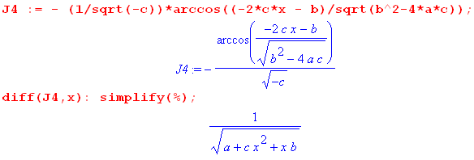 (7.15)

In these last integrals, we started with a > 0, but the results can be continued to part of the range a < 0 where we have

b2-4ac > 0 ⇒ b2+4a|c| > 0 ⇒ 4a|c| > -b2 ⇒

a > -(b2/|c|) . (7.16)

Goldstein Classical Mechanics

In the discussion of orbits with an inverse-square force law, Goldstein (1950) on page 77 writes the second evaluation in (7.14) omitting the leading minus sign. This error is repeated on page 93 of the later 2001 third edition of the book (Goldstein, Poole and Safko, all deceased), from which we quote, where a,b,c = α,β,γ ,

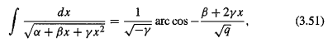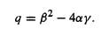

This results in another sign error in (3.54), but as it turns out, this error makes no difference in the key final result (3.55) due to the fact that cos(θ-θ') = cos(θ'-θ). That final result is this.

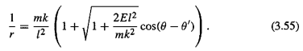

The inverse-square force law is F = -k/r2, a particle has mass m, energy E, and angular momentum l . This last result shows that the orbits are conic sections expressed in polar coordinates r,θ where the radical is the orbit eccentricity ε. For a sun-planet system, m,r,θ refer to an equivalent one-body problem where m is the reduced mass, and r,θ are relative to the center of mass.

A summary of forms appearing in this document : (7.17)

$^{\int_{}^{x}{}}$dx $\sqrt{R}$ R = a + bx + cx2

1 $\sqrt{c}$ln (2cx + b + 2 $\sqrt{c}$$\sqrt{R}$) // (4.9) c > 0

2 - $\sqrt{c}$ln (2cx + b - 2 $\sqrt{c}$$\sqrt{R}$) // (4.10) c > 0

3 $\sqrt{c}$ln (2cx +b ) // (4.14) c > 0, b2-4ac = 0

4 $\sqrt{c}$ ln [$\sqrt{c}$$\sqrt{R}$$\sqrt{4ac-b2}$] // (1.8) c > 0, b2-4ac < 0

5 $\sqrt{c}$tanh-1($\sqrt{a}$$\sqrt{c}$) // (5.9) c > 0, a > 0

6 $\sqrt{c}$tanh-1($\sqrt{a}$$\sqrt{c}$) // (5.10) c > 0, a > 0

7 $\sqrt{c}$tanh-1( $\frac{x - β}{x - α}$) // (6.9) c > 0, α,β roots of R

8 $\sqrt{c}$ sinh-1( $\sqrt{4ac-b2}$) // (7.5) c > 0, b2-4ac < 0

9 - $\sqrt{-c}$sin-1( $\sqrt{b2-4ac}$) // (7.10) c < 0, b2-4ac > 0

10 + $\sqrt{-c}$cos-1( $\sqrt{b2-4ac}$) // (7.12) c < 0, b2-4ac > 0

11 - $\sqrt{-c}$cos-1( $\sqrt{b2-4ac}$) // (7.12) c < 0, b2-4ac > 0

The evaluations 4, 8, 3, 9 appear in GR7 page 94,

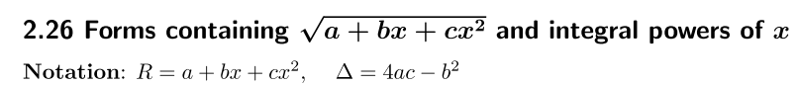 (7.18)
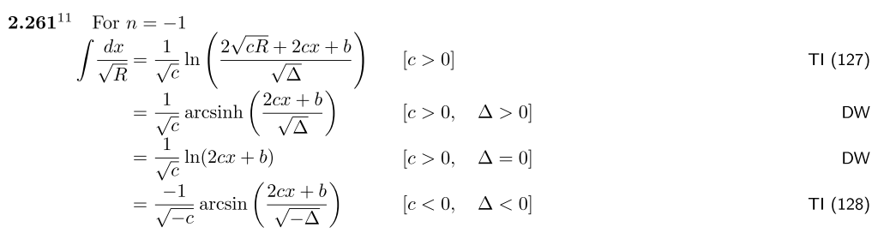

See also Spiegel 14.280 which, however, uses R = ax2+bx+c. Both Spiegel and GR7 present many integrals of the form xm ($\sqrt{R}$)n for m and odd n being various positive and negative integers.

Footnote concerning TI above. Adrian Fedorovich Timofeev (1882-1954) led a complicated life in Russia and wrote a few non-mathematical books about it (e.g., My Prison Diary).

http://adriantimofeev1.blogspot.com/2012/07/this-is-photos-from-life-in-1890-1915.html

Appendix A: About Euler's original paper

Euler's study of integrals of the form ∫dx xn/$\sqrt{R}$appears in this paper,

L. Euler, "Speculationes super formula integrali ∫ (x^{n}dx)/√(aa-2bx+cxx), ubi simul egregiae observationes circa fractiones continuas occurrunt", Acta Academiae Scientarum Imperialis Petropolitinae 1782, 1786, pp. 62-84.
or in English

L. Euler, "Speculations concerning the integral formula ∫ (x^{n}dx)/√(aa-2bx+cxx), where at the same time exceptional observations about continued fractions occur", Transactions of the Imperial Academy of Sciences in St. Petersburg 1782, 1786, pp. 62-84.

In 1775 Euler wrote about 60 (!) papers including the one above. The paper was formally presented in 1782 (a year before his death) but was not was published until 1786. The original paper can be viewed in the Euler Archive,

http://eulerarchive.maa.org//

by looking up Subject / Mathematics / Integration / index number 606.

His paper does not actually use any of our substitutions A,B,C. Instead, he plants the seed of the idea and someone at some later time extracted the three substitutions from his work. Below we shall display parts of the original paper, but first it is helpful to describe what he is doing. Here is a long-winded interpretation of Section 1 of his paper :

§. I. Consider the quantity a2 - 2bx + cx2. Make the substitution,

x = $\frac{b+z}{c}$ ⇒ z = cx - b and dx = $\frac{dz}{c}$ (A.1)

so that

(a2 - 2bx + cx2) = a2 - 2b (b+z)/c + c(b+z)2/c2 = (1/c2)[a2c2 - 2bc (b+z) + c(b+z)2]

= (1/c2)[a2c2 - 2b2c- 2bcz + cb2+ 2cbz + cz2] = (1/c2)[a2c2 - b2c + cz2]

= (a2c - b2 + z2)/c . // no linear z term (A.2)

Then, // Euler uses c = f2 but we keep it as c

∫dx $\sqrt{a2-2bx+cx2}$= ∫ $\frac{dz}{c}$ $\sqrt{c}$$\sqrt{a2c - b2 + z2}$ = $\sqrt{c}$ ∫ $\sqrt{a2c - b2 + z2}$. (A.3)

Euler's substitution (A.1) has not converted the integrand to a rational function R(t) of the form (1.2) as we did earlier with all the official "Euler substitutions". However, Euler was familiar with the following integral (having more or less invented the natural logarithm and e),

∫ $\sqrt{A2+z2}$ = ln [z + $\sqrt{A2+z2}$] + constant

so he continues the above,

$\sqrt{c}$∫ $\sqrt{a2c - b2 + z2}$ = $\sqrt{c}$ ln [ $\sqrt{a2c - b2 + z2}$ ] (A.4)

where C is a constant. He then replaces z = cx - b and $\sqrt{a2c - b2 + z2}$ = $\sqrt{c}$$\sqrt{a2-2bx+cx2}$to get

$^{\int_{}^{x}{}}$dx $\sqrt{a2-2bx+cx2}$ = $\sqrt{c}$ln [ $\sqrt{c}$$\sqrt{a2-2bx+cx2}$ ] c > 0 (A.5)
and then
$^{\int_{0}^{x}{}}$dx $\sqrt{a2-2bx+cx2}$ = $\sqrt{c}$ln [ $\sqrt{c}$$\sqrt{a2-2bx+cx2}$$\sqrt{c}$ ] . c > 0 (A.6)

He next considers the case c < 0 (which he writes as c = - g2) and finds,

$^{\int_{0}^{x}{}}$dx $\sqrt{a2-2bx+cx2}$ = $\sqrt{-c}$sin-1 ($\sqrt{b2 - a2c}$) + $\sqrt{-c}$sin-1 ($\sqrt{b2 - a2c}$) . c < 0 (A.7)

Comparison with GR7: With a2→ a and b → -b/2 one has a2 - 2bx + cx2 → a + bx + c2 = R. Then (A.5) and (A.6) become

∫dx $\sqrt{a+bx+cx2}$ = $\sqrt{c}$ln [ $\sqrt{c}$$\sqrt{a+bx+cx2}$ ] (A.5)'

∫dx $\sqrt{a+bx+cx2}$ = $\sqrt{-c}$sin-1 ($\sqrt{b2-4ac}$) . ?? (A.6')
Eq. (A.5) agrees with (7.16) line 1 (apart from an additive constant) while (A.6) disagrees with (7.16) line 4 by a minus sign. Euler does not really define the meaning of his g when he writes c = -g2, nor was the notion of analytic continuation much developed in 1775.

Here then is the original of Section 1, taken from the Euler Archive noted above, annotated with our equation numbers and a few small repairs,

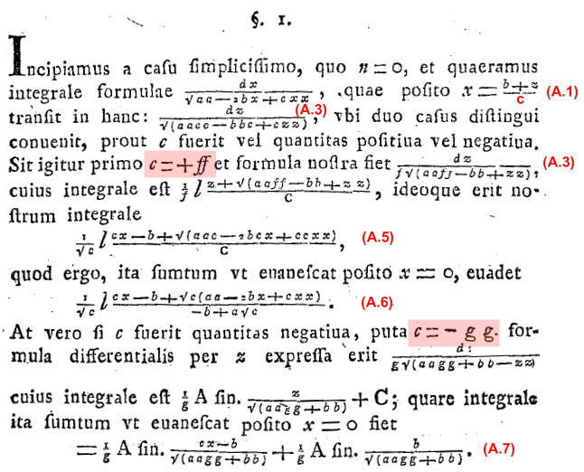 (A.8)

As was the custom of the time, the paper is written in Latin ("We begin with the simplest case, where n = 0, and we seek an integral formula for...."). The letter v is u, the number 1 is I, and s in most non-final positions is written f, known as a "long s", a usage that was dropped after 1800. Quadratic powers are written aa instead of a2, though higher powers are later written with exponents. A root $\sqrt{expression}$ is written √(expression). The ln symbol is a large italic lower-case letter l, and Arcsin(α) is written A fin. α

The Archive has this paper translated into German with clean typesetting (no English yet). One can only marvel at how printers of the day hand-typeset Euler's many equations for printing. The photocopy clips above and below are of modest quality, and we had to manually do some derotation of the text (Visio).

As his paper title shows, Euler was in pursuit of the integral ∫dx xn/$\sqrt{a2-2bx+cx2}$ and in the first Section above he has handled the case n = 0. He goes on to make more substitutions to obtain the cases n = 1,2,3... Here is his entire Section 4 with a new substitution s = $\sqrt{a2-2bx+cx2}$ - a to get the n = 1 integral expressed in terms of the n = 0 integral,

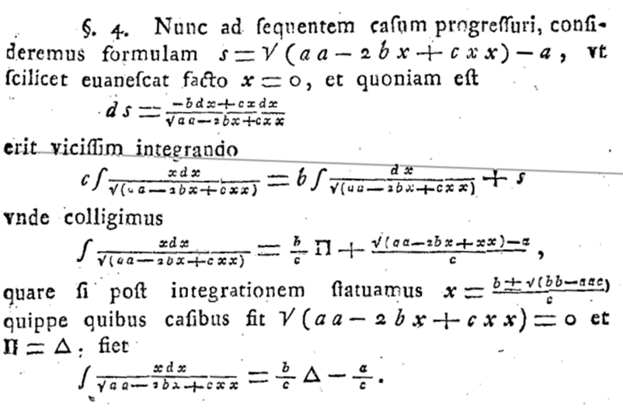 (A.9)

Note that Π ≡ $^{\int_{}^{x}{}}$dx/$\sqrt{a2-2bx+cx2}$and then Δ ≡ $^{\int_{}^{x=α}{}}$dx/$\sqrt{a2-2bx+cx2}$ where α = (b±$\sqrt{b2-a2c}$)/c is either root of a2-2bx+cx2 = 0. He does this to obtain the simple result$^{\int_{}^{x}{}}$dx x/$\sqrt{a2-2bx+cx2}$= $\frac{b}{c}$Δ - $\frac{a}{c}$.

Later Euler summarizes his results for n = 0,1,2,3 and 4 :
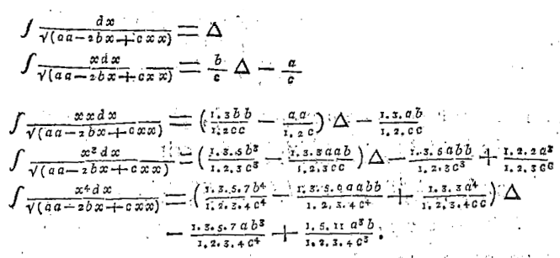 (A.10)

where I.3.5 means 1*3*5 = 15. He then obtains a recursion relation

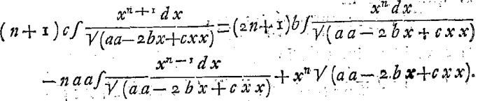 (A.11)

which appears in GR7 in a more general form (for R = a + bx + cx2),

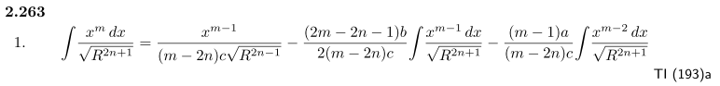
If in this GR7 integral we take n→0, m→n+1, a→a2 and b→ -2b so R→Q = $\sqrt{a2-2bx+cx2}$, we get

∫ $\sqrt{Q}$ = $\frac{xn}{(n+1)c}$$\sqrt{Q}$ – $\frac{(2n+1)(-2b)}{2(n+1)c}$ ∫ $\sqrt{Q}$ – $\frac{(n)a2}{(n+1)c}$ ∫ $\sqrt{Q}$
or
(n+1)c∫ $\sqrt{Q}$ = (2n+1)b ∫ $\sqrt{Q}$ – na2 ∫ $\sqrt{Q}$ + xn$\sqrt{Q}$ (A.12)

which gives Euler's recursion result (A.11) to the letter.

Euler next attempts to write a closed-form expression for the general case n = n with some partial success. The paper then ends with a long section on writing quantities as continued fractions, for example

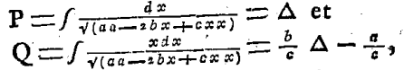

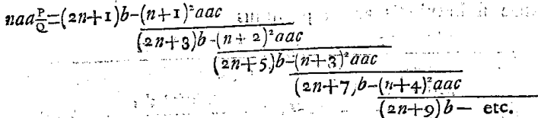 (A.13)

There are many pages showing such continued fractions and Euler seems to be fascinated with them. As the title says, this is the second topic of his paper,

"Speculations concerning the integral formula ∫ (x^{n}dx)/√(aa-2bx+cxx), where at the same time exceptional observations about continued fractions occur "

Euler (1707-1783) was Swiss but moved to St. Petersburg in 1727, to Berlin in 1741, and finally back to St. Petersburg in 1766 where he wrote the above paper. His presence in Russia is probably the reason that the "Euler substitutions" are commonly associated with Russian sources like Piskunov. He had a prolific and eventful life in eventful times and is often ranked the greatest mathematician of all time.

Appendix B. Summary of the three Euler substitutions

____________________________________________________________________________________

Substitution A t ± $\sqrt{c}$x = $\sqrt{a+bx+cx2}$ (B.1)

$^{\int_{}^{x}{}}$dx R(x,$\sqrt{a+bx+cx2}$) = $^{\int_{}^{t(x)}{}}$dt 2 $\sqrt{c}$$\sqrt{c}$$\sqrt{c}$ * R( $\sqrt{c}$, $\sqrt{c}$$\sqrt{c}$$\sqrt{c}$)
where t(x) = $\sqrt{a+bx+cx2}$ - $\sqrt{c}$x . (4.7)

$^{\int_{}^{x}{}}$dx R(x,$\sqrt{a+bx+cx2}$) = $^{\int_{}^{t(x)}{}}$dt 2 $\sqrt{c}$$\sqrt{c}$$\sqrt{c}$ * R( $\sqrt{c}$, $\sqrt{c}$$\sqrt{c}$$\sqrt{c}$)
where t(x) = $\sqrt{a+bx+cx2}$ + $\sqrt{c}$x . (4.8)

____________________________________________________________________________________

Substitution B xt ± $\sqrt{a}$ = $\sqrt{a+bx+cx2}$ (B.2)

$^{\int_{}^{x}{}}$dx R(x,$\sqrt{a+bx+cx2}$) = $^{\int_{}^{t(x)}{}}$dt 2 $\sqrt{a}$$\sqrt{a}$ * R( $\sqrt{a}$, $\sqrt{a}$$\sqrt{a}$)
where t(x) = ( $\sqrt{a+bx+cx2}$ - $\sqrt{a}$) / x . (5.7)

$^{\int_{}^{x}{}}$dx R(x,$\sqrt{a+bx+cx2}$) = $^{\int_{}^{t(x)}{}}$dt 2 $\sqrt{a}$$\sqrt{a}$ * R( $\sqrt{a}$, $\sqrt{a}$$\sqrt{a}$)
where t(x) = ( $\sqrt{a+bx+cx2}$ + $\sqrt{a}$) / x . (5.8)

____________________________________________________________________________________

Substitution C : t = $\sqrt{c}$ ($\frac{x - β}{x - α}$)±1 where a+bx+cx2 = c(x-α)(x-β) (B.3)

$^{\int_{}^{x}{}}$dx R(x,$\sqrt{a+bx+cx2}$) = $^{\int_{}^{t(x)}{}}$dt 2 $\frac{c(β-α)t}{(t2-c)2}$ * R($\frac{αt2- cβ}{t2-c}$, $\frac{c(α-β)t}{t2-c}$)
where t(x) = $\sqrt{a+bx+cx2}$/ (x-α) = $\sqrt{R}$/(x-α) . (6.7)

$^{\int_{}^{x}{}}$dx R(x,$\sqrt{a+bx+cx2}$) = $^{\int_{}^{t(x)}{}}$dt 2 $\frac{c(α-β)t}{(t2-c)2}$ * R($\frac{βt2- cα}{t2-c}$, $\frac{c(β-α)t}{t2-c}$) (6.8)
where t(x) = $\sqrt{a+bx+cx2}$/ (x-β) = $\sqrt{R}$/(x-β) .
___________________________________________________________________________________

References

Links were last checked on 9 Nov 2016.

https://en.wikipedia.org/wiki/Euler_substitution

http://planetmath.org/eulerssubstitutionsforintegration

K.N. Boyadzhiev, "Euler Substitutions" (Ohio Northern University, 2006), 5p. Has examples.
http://www2.onu.edu/~m-caragiu.1/bonus_files/EULER-SU.pdf

H. Goldstein, Classical Mechanics (Addison-Wesley, Boston, 1950).

H. Goldstein, C.P. Poole Jr. and J.L. Safko, Classical Mechanics, 3rd Ed. ( Addison-Wesley, New York, 2001) now rebranded by Pearson, London. Authors deceased 2005, 2015 and 2016.

[GR7] I.S. Gradshteyn and I.M. Ryzhik, Table of Integrals, Series, and Products, 7th Ed. (Academic Press, New York, 2007). The 8th edition came out Oct 2014. Editor Dan Zwillinger has errata for editions 6,7 and 8 at http://www.mathtable.com/errata .

N.S. Piskunov, Differential and Integral Calculus (Mir, Moscow, 1969). This 895 page text was translated from the Russian by G. Yankovsky (search the web). Section 12 pp 372-375 mentions the Euler substitutions with a few examples.

M.R. Spiegel, Schaum's Outlines: Mathematical Handbook of Formulas and Tables (McGraw-Hill, New York, 1968). Our page references are to this edition. The current version of this book is given below.

M.R. Spiegel, S. Lipschutz, M. and J. Liu, Schaum's Outlines: Mathematical Handbook of Formulas and Tables, 4th Ed. (McGraw-Hill, New York, 2012). John Liu was added for the 1999 2nd Ed, and Seymour Lipschutz joined for the 2008 3rd Ed. Not to be confused with a watered-down "Easy Outline" version. This low-cost paperback is an excellent fast reference for well-known mathematical facts.

D. Zwillinger, Handbook of Integration (Jones and Bartlett, Boston, 1992).

