Analytic Continuation. Consider this z-plane showing complex vectors z and z-α for |z| > α > 0,

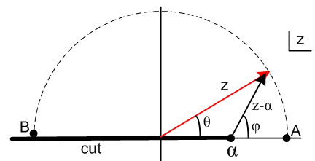 (7.6)

We are interested in the function f(z) = (z-α)r where 0 < r < 1. The function has a branch point at z = α and we draw the cut off to the left as shown in black. We declare that f(z) is real and positive for z > α, so we are viewing the "principle sheet" of our function. Angles θ and φ are phases of the vectors z and z-α,

z = |z|eiθ and (z-α) = |z-α| eiφ . (7.7)

At point A, one has θ = 0, φ = 0, z > 0 and z-α > 0 so,

z = |z|ei0 = z and (z-α) = |z-α|ei0 = (z-α) . (7.8)

At point B one has θ = +π, φ = +π, z < 0 and z-α < 0 so (z is just above the cut),

z = |z|eiπ = (-z)eiπ and (z-α) = |z-α|eiπ = (α-z)eiπ
so
zr = (-z)reiπr and (z-α)r = (α-z)r eiπr . (7.9)

For r = 1/2 the last line says

$\sqrt{z}$ = $\sqrt{-z}$eiπ/2 = + i $\sqrt{-z}$ and $\sqrt{z-α}$ = $\sqrt{α-z}$eiπ/2 = + i $\sqrt{α-z}$ . (7.10)

Therefore at point B the phases of $\sqrt{z}$ and $\sqrt{z-α}$are the same, indicated by eiπ/2 = +i. If we move point B below the cut and redraw the picture so point B has θ = -π and φ = -π, both phases are -i instead of both +i. In either case the two phases are the same, and this fact follows from doing proper analytic continuation over a smooth path in the z-plane from z = A to z = B.

Application. Assume a > 0 and let z = 4ac and α = b2. Then taking point B above the cut,

$\sqrt{4ac}$ = +i $\sqrt{-4ac}$ and $\sqrt{4ac-b2}$ = +i $\sqrt{b2-4ac}$
or
$\sqrt{c}$ = +i $\sqrt{-c}$ and $\sqrt{4ac-b2}$ = +i $\sqrt{b2-4ac}$ (7.11)

We can then analytically continue our integral (7.5) using these rules to get

$^{\int_{}^{x}{}}$dx (1/ = (1/$\sqrt{c}$) sinh-1 [ (2cx +b)/$\sqrt{4ac-b2}$] // (7.5)

= (1/[i $\sqrt{-c}$ ]) sinh-1 [ (2cx +b)/(i $\sqrt{b2-4ac}$)]

= (-i)(1/$\sqrt{-c}$) sinh-1 [ -i(2cx +b)/$\sqrt{b2-4ac}$]

= - (-i)(1/$\sqrt{-c}$) sinh-1 [ i(2cx +b)/$\sqrt{b2-4ac}$] // Spiegel 8.64

= - i (-i)(1/$\sqrt{-c}$ ) sin-1 [ (2cx +b)/$\sqrt{b2-4ac}$] // Spiegel 8.93

= - $\sqrt{-c}$sin-1[ $\sqrt{b2-4ac}$] = + $\sqrt{-c}$sin-1[ $\sqrt{b2-4ac}$] , (7.12)

giving forms valid for c < 0 and b2-4ac > 0. Next we use this relation

sin-1(z) = - cos-1(z) + π/2 // Spiegel 5.74

- cos-1(z) (7.13)

to obtain two more forms,

$^{\int_{}^{x}{}}$dx (1/ + $\sqrt{-c}$cos-1[ $\sqrt{b2-4ac}$] = - $\sqrt{-c}$cos-1[ $\sqrt{b2-4ac}$] . (7.14)

Trust but verify,

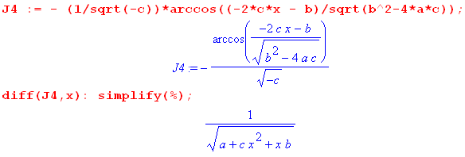 (7.15)

In these last integrals, we started with a > 0, but the results can be continued to part of the range a < 0 where we have

b2-4ac > 0 ⇒ b2+4a|c| > 0 ⇒ 4a|c| > -b2 ⇒

a > -(b2/|c|) . (7.16)

Goldstein Classical Mechanics

In the discussion of orbits with an inverse-square force law, Goldstein (1950) on page 77 writes the second integral in (7.12) omitting the leading minus sign. This error is repeated on page 93 of the later 2001 third edition of the book (Goldstein, Poole and Safko, all deceased), from which we quote, where a,b,c = α,β,γ ,

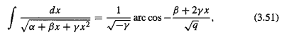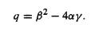

This results in another sign error in (3.54), but as it turns out, this error makes no difference in the key final result (3.55) due to the fact that cos(θ-θ') = cos(θ'-θ). That final result is this.

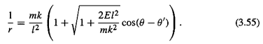

The inverse-square force law is F = -k/r2, a particle has mass m, energy E, and angular momentum l . This last result shows that the orbits are conic sections expressed in polar coordinates r,θ where the radical is the orbit eccentricity ε. For a sun-planet system, m,r,θ refer to an equivalent one-body problem where m is the reduced mass, and r,θ are relative to the center of mass.

A summary of forms appearing in this document : (7.17)

$^{\int_{}^{x}{}}$dx $\sqrt{R}$ R = a + bx + cx2

1 $\sqrt{c}$ln (2cx + b + 2 $\sqrt{c}$$\sqrt{R}$) // (4.9) c > 0

2 - $\sqrt{c}$ln (2cx + b - 2 $\sqrt{c}$$\sqrt{R}$) // (4.10) c > 0

3 $\sqrt{c}$ln (2cx +b ) // (4.14) c > 0, b2-4ac = 0

4 $\sqrt{c}$ ln [$\sqrt{c}$$\sqrt{R}$$\sqrt{4ac-b2}$] // (1.8) c > 0, b2-4ac < 0

5 $\sqrt{c}$tanh-1($\sqrt{a}$$\sqrt{c}$) // (5.9) c > 0, a > 0

6 $\sqrt{c}$tanh-1($\sqrt{a}$$\sqrt{c}$) // (5.10) c > 0, a > 0

7 $\sqrt{c}$tanh-1( $\frac{x - β}{x - α}$) // (6.9) c > 0, α,β roots of R

8 $\sqrt{c}$ sinh-1( $\sqrt{4ac-b2}$) // (7.5) c > 0, b2-4ac < 0

9 - $\sqrt{-c}$sin-1( $\sqrt{b2-4ac}$) // (7.10) c < 0, b2-4ac > 0

10 + $\sqrt{-c}$cos-1( $\sqrt{b2-4ac}$) // (7.12) c < 0, b2-4ac > 0

11 - $\sqrt{-c}$cos-1( $\sqrt{b2-4ac}$) // (7.12) c < 0, b2-4ac > 0

The evaluations 4, 8, 3, 9 appear in GR7 page 94,

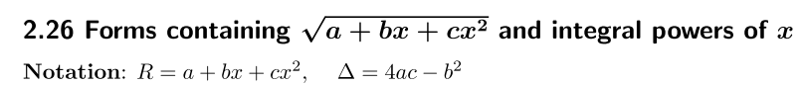 (7.18)
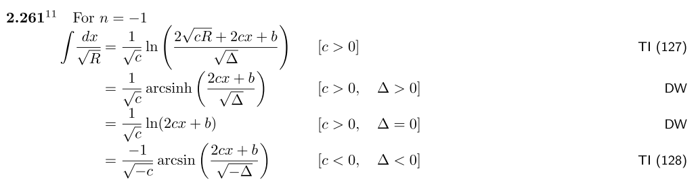

See also Spiegel 14.280 which, however, uses R = ax2+bx+c. Both Spiegel and GR7 present many integrals of the form xm ($\sqrt{R}$)n for m and odd n being various positive and negative integers.

Footnote concerning TI above. Adrian Fedorovich Timofeev (1882-1954) led a complicated life in Russia and wrote a few non-mathematical books about it (e.g., My Prison Diary).

http://adriantimofeev1.blogspot.com/2012/07/this-is-photos-from-life-in-1890-1915.html

