Sign Confusion Goldstein page 77 PhL 10.31.16

See treatment of this subject in my last doc on this subject. Goldstein has two sign errors and they are explained in that doc. No need to read below.

In 1st edition the integral (3.45) has a + sign, and in 3rd edition we also have a + sign,

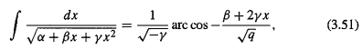

What do GR7 have to say? From their page 94 I quote:

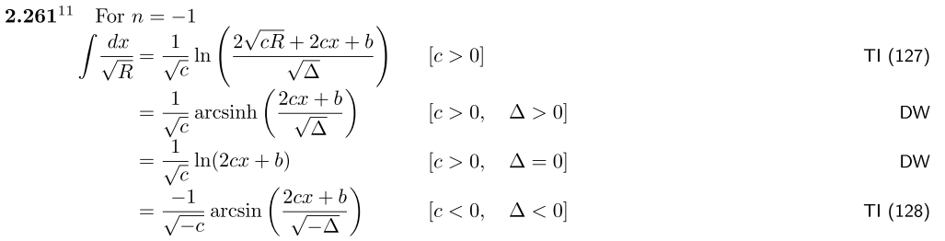

In our application, what GR7 call Δ is negative, so the last entry is relevant. Goldstein has q = -Δ. Now start with the above and use this rule

arcsin(α) + arccos(α) = π/2

Thus the above integral can be written,

I = $\sqrt{-c}$[ - arccos($\sqrt{q}$) + π/2]

But you can drop the π/2 since this is an indefinite integral. We then have

I = $\sqrt{-c}$arccos($\sqrt{q}$)

Now use another rule which says

arccos(α) = π - arccos(-α)

Again drop the π and you end up with

I = - $\sqrt{-c}$arccos( - $\sqrt{q}$)

If GR7 is correct, then both 1st and 3rd Ed are missing the leading overall minus sign. GR7 agrees with Schaum p 72.

Now let's assume for the moment that Goldstein is correct and that (3-44) is correct, which in 3rd and 1st is this

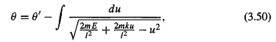

Now write

q = (2mk/l2)2 ( 1 + 2El2/mk2) which I have verified on scratch.

Then the ∫.... object in (3-44) is equal to this

IG = + $\sqrt{-c}$arccos( - $\sqrt{q}$) = arccos( - $\sqrt{q}$) c = -1

$\sqrt{q}$ = [ (2mk/l2) - 2u ] / { (2mk/l2) $\sqrt{1+ 2El2/mk2}$}
= [ 1 - 2u(l2/2mk) ] / { $\sqrt{1+ 2El2/mk2}$}

= [ 1 - ul2/mk ] / { $\sqrt{1+ 2El2/mk2}$}

and then

- $\sqrt{q}$ = [ ul2/mk - 1 ] / { $\sqrt{1+ 2El2/mk2}$}

This implies that

θ = θ' - [ arccos( [ 1 - ul2/mk ] / { $\sqrt{1+ 2El2/mk2}$} )

This matches both editions, and I quote it from 3rd ed

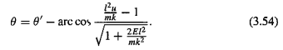

So everybody is in agreement except GR7 !! In particular Goldstein 1st and 3rd are self-consistent. Note that the GR7 integral is quoted from an obscure Russian source called TI shown above.

What does Maple have to say?

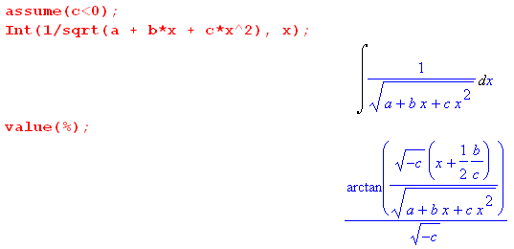

On scratch I show that this implies

I = arc cos ( 2$\sqrt{R}$/$\sqrt{q}$) c = -1 R = a + bx - x2

But the GR7 result was

I = - arccos( - $\sqrt{q}$)

and these do not agree!! So now we have three opinions on this integral that all disagree! I descend deeper into the abyss.

Comment added 11.15.16.

When you write θ(x) = arccos(x), you are implying that this function θ(x) is the standard principle branch of a function which has an infinite number of branches. This principle branch is shown on page 18 of Schaum. As x ranges from -1 to 1, the angle θ(x) ranges from 0 to +π. It is not negative. This is the branch that Maple uses internally. You could define θa(x) = arccosa(x) to be the branch which lies just under the principle branch, and you would then have - arccosa(x) = +arccos(x). If Goldstein were somehow to be using this branch, then his sign is correct. I should have commented about that in Euler doc.

