More study of the 1/sqrt(R) integral PhL 11.3.16

Here I summarize work done in two other docs, and derive new forms as well. It was a royal pain, but I think everything is down pat. Ultimately you just differentiate to test a result, perhaps with Maple help. But I wanted to derive results, not test results handed to me.

1. Derive the arcsinh formula 1
2. Obtain the arcsin formula 2
3. Obtain the arccos formula 5
4. Summary of formulas derived above 5
5. Goldstein page 77 Application 5
6. Other forms of the integral 7

1. Derive the arcsinh formula

Here is a statement of the arcsinh formula of interest from GR7 :

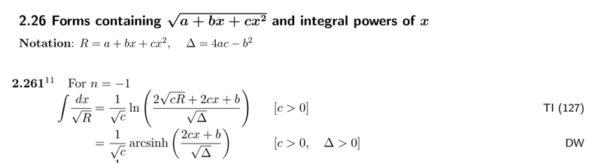

I have derived the first form involving the log. I understand that the denominator in the log result is not significant and the basic fact is this:

I = $^{\int_{}^{x}{}}$dx/$\sqrt{a+bx+cx2}$ = (1/$\sqrt{c}$) ln [ 2cx + b + 2$\sqrt{cR}$] + constant

where the constant can depend on a,b,c but not on x.

Question: How can one use this last result to derive the sh-1 version of the result stated above, namely,

I = $^{\int_{}^{x}{}}$dx/$\sqrt{a+bx+cx2}$ = (1/$\sqrt{c}$) sh-1 [ (2cx +b)/$\sqrt{4ac-b2}$] + constant

It must be possible to show that

sh-1 [ (2cx +b)/$\sqrt{4ac-b2}$] = ln [ 2cx + b + 2$\sqrt{cR}$] + constant that does not depend on x

In this case, differentiating both functions should give 1/$\sqrt{a+bx+cx2}$. The sh-1 form also appears in Schaum p 72. One thing I know is, from Schaum p 29,

sh-1y = ln(y + $\sqrt{y2+1}$) // valid for all real y

Using this, I can obtain a "result to show" that involves only logs.

y = (2cx +b)/$\sqrt{4ac-b2}$

y2+1 = (2cx +b)2/(4ac-b2) + 1 = [ (2cx +b)2 + (4ac-b2) ] / (4ac-b2)

= [ 4c2x2+ b2 + 4cbx + 4ac-b2 ] / (4ac-b2)

= [ 4c2x2 + 4cbx + 4ac] / (4ac-b2)

= 4c[ cx2 + bx + a] / (4ac-b2)

= 4cR/(4ac-b2)

$\sqrt{y2+1}$ = 2$\sqrt{c}$$\sqrt{R}$ / $\sqrt{4ac-b2}$.

Then

sh-1 [ (2cx +b)/$\sqrt{4ac-b2}$] = sh-1y = ln(y + $\sqrt{y2+1}$)

= ln [ (2cx +b)/$\sqrt{4ac-b2}$ + 2$\sqrt{c}$$\sqrt{R}$/$\sqrt{4ac-b2}$]

= ln [ 2cx + b + 2$\sqrt{c}$$\sqrt{R}$] - ln($\sqrt{4ac-b2}$)

and there you have it, case closed. Thus I have proven both these results,

I = $^{\int_{}^{x}{}}$dx/$\sqrt{a+bx+cx2}$ = (1/$\sqrt{c}$) ln [ 2cx + b + 2$\sqrt{cR}$] + constant

I = $^{\int_{}^{x}{}}$dx/$\sqrt{a+bx+cx2}$ = (1/$\sqrt{c}$) sh-1 [ (2cx +b)/$\sqrt{4ac-b2}$] + constant

This last form assumes that 4ac - b2 > 0 and c > 0. Let's summarize this as

I = (1/$\sqrt{c}$) sh-1 [ (2cx +b)/$\sqrt{4ac-b2}$] 4ac - b2 > 0 and c > 0 [ a > 0 is forced ]

This situation implies that 4ac > b2 and so a > b2/(4c) so it is implied that a > 0.

2. Obtain the arcsin formula

Let us now assume that a > 0 before continuing. Then 4ac-b2 is going to go negative for c < 0. Consider this picture
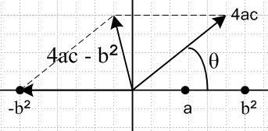

At θ = 0, the vector 4ac-b2 lies on the real axis and points to the right assuming 4ac-b2 > 0. But as we swing the vector c over to θ = +π, we end up with 4ac pointing to the left and 4ac-b2 also points even more to the left, so here is the status of things

angle(c) = 0 ⇒ angle(4ac-b2) = 0 // before swing
angle(c) = π ⇒ angle(4ac-b2) = π // after swing

We end up with 4ac - b2 = -4a|c| - b2 . Since we have assumed a > 0, we have 4ac - b2 < 0 after doing this swing operation, so this quantity changed sign. After the swing we have

c = |c| eiπ = (-c)eiπ

(4ac-b2) = |4ac-b2| eiπ = |b2-4ac| eiπ = (b2-4ac)eiπ

Therefore (note that the phases are determined here, you don't pick separate ± i for each one)

$\sqrt{c}$ = $\sqrt{-c}$i

$\sqrt{4ac-b2}$ = $\sqrt{b2-4ac}$ i

We can then modify our integral I above using these rules to get

I = (1/$\sqrt{c}$) sh-1 [ (2cx +b)/$\sqrt{4ac-b2}$]

= (1/$\sqrt{-c}$i ) sh-1 [ (2cx +b)/($\sqrt{b2-4ac}$ i)]

= (-i)(1/$\sqrt{-c}$ ) sh-1 [ -i(2cx +b)/$\sqrt{b2-4ac}$]

= (-i)2(1/$\sqrt{-c}$ ) sin-1 [ (2cx +b)/$\sqrt{b2-4ac}$]

= - (1/$\sqrt{-c}$ ) sin-1 [ (2cx +b)/$\sqrt{b2-4ac}$]

Therefore we find

I = - (1/$\sqrt{-c}$) sin-1 [ (2cx +b)/$\sqrt{b2-4ac}$] 4ac - b2 < 0 and c < 0 [ a > 0 assumed ]

and this is our first statement of the sin-1 evaluation of the I integral. Now recall from GR7

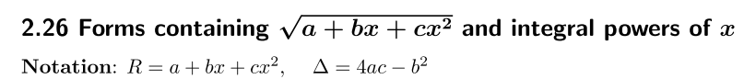

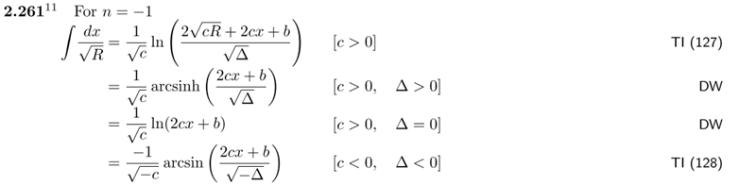

Recall our two results from above:

I = (1/$\sqrt{c}$) sh-1 [ (2cx +b)/$\sqrt{4ac-b2}$] 4ac - b2 > 0 and c > 0 [ a > 0 is forced ]

I = - (1/$\sqrt{-c}$) sin-1 [ (2cx +b)/$\sqrt{b2-4ac}$] 4ac - b2 < 0 and c < 0 [ a > 0 assumed ]

This agrees exactly with the lines 2 and 4 of the quotes above. I have already derived the other two lines in a separate doc, so all four forms are now derived.

Now in the first case a > 0 is forced, while in the second it was only assumed. In the second case we need

4ac < b2

-4a|c| < b2

4a|c| > -b2

a > -b2/(4|c|)

This in fact allows a range of negative a without impacting the sin-1 formula shown above. In the first case we have

4ac > b2

a > b2/(4c)

So let's restate the above two evaluations this way

I = (1/$\sqrt{c}$) sh-1 [ (2cx +b)/$\sqrt{4ac-b2}$] 4ac - b2 > 0 and c > 0 [ ⇒ a > b2/(4c) ] (1)

I = - (1/$\sqrt{-c}$) sin-1 [ (2cx +b)/$\sqrt{b2-4ac}$] 4ac - b2 < 0 and c < 0 [ ⇒ a > -b2/(4|c|) ] (2)

3. Obtain the arccos formula

It is a fact that

sin-1(x) + cos-1(x) = π/2

where x is real, this is a very obvious fact when stated in English text. There is no corresponding equation for hyperbolic functions!!!!

So we can shift the constant and write the second result above as

I = + (1/$\sqrt{-c}$) cos-1 [ (2cx +b)/$\sqrt{b2-4ac}$] 4ac - b2 < 0 and c < 0 [ ⇒ a > -b2/(4|c|) ] (3)

There is no simple cosh-1 formula. However, I did derive a certain cosh-1 formula with a completely different argument than that shown above. I will gather up my obscure formulas later on.

There is another version of the cos-1 which follows from (2),

I = (1/$\sqrt{-c}$) sin-1 [ -(2cx +b)/$\sqrt{b2-4ac}$] 4ac - b2 < 0 and c < 0 [ ⇒ a > -b2/(4|c|) ] (4)

Then

I = - (1/$\sqrt{-c}$) cos-1 [ -(2cx +b)/$\sqrt{b2-4ac}$] 4ac - b2 < 0 and c < 0 [ ⇒ a > -b2/(4|c|) ] (5)

You get this same result going directly from the previous cos result, using Schaum p 18.

4. Summary of formulas derived above

I = (1/$\sqrt{c}$) sh-1 [ (2cx +b)/$\sqrt{4ac-b2}$] 4ac - b2 > 0 and c > 0 [ ⇒ a > b2/(4c) ] (1)

I = - (1/$\sqrt{-c}$) sin-1 [ (2cx +b)/$\sqrt{b2-4ac}$] 4ac - b2 < 0 and c < 0 [ ⇒ a > -b2/(4|c|) ] (2)

I = + (1/$\sqrt{-c}$) cos-1 [ (2cx +b)/$\sqrt{b2-4ac}$] 4ac - b2 < 0 and c < 0 [ ⇒ a > -b2/(4|c|) ] (3)

I = (1/$\sqrt{-c}$) sin-1 [ -(2cx +b)/$\sqrt{b2-4ac}$] 4ac - b2 < 0 and c < 0 [ ⇒ a > -b2/(4|c|) ] (4)

I = - (1/$\sqrt{-c}$) cos-1 [ -(2cx +b)/$\sqrt{b2-4ac}$] 4ac - b2 < 0 and c < 0 [ ⇒ a > -b2/(4|c|) ] (5)

5. Goldstein page 77 Application

I claim that Goldstein page (3-45) is item (5) above but with an overall sign error. This was my conclusion a long time ago, though I did not document it at that time (it was marked in pencil). Let us now see if this sign error affects anything of significance.

He has a = 2mE/l2 and b = 2mk/l2 and c = -1. Going back to his (3.44) I would say

θ = θ' - I = θ' - { - (1/$\sqrt{-c}$) cos-1 [ -(2cx +b)/$\sqrt{b2-4ac}$] + K}

= θ' + (1/$\sqrt{-c}$) cos-1 [ -(2cx +b)/$\sqrt{b2-4ac}$] + K

Now consider

b2-4ac = [2mk/l2]2 + 4[ 2mE/l2] = [2mk/l2]2 { 1 +4[ 2mE/l2]/ [2mk/l2]2 }

= [2mk/l2]2 { 1 +4[ 2mE/l2]/ [4m2k2/l4]}

= [2mk/l2]2 { 1 +[ 2E]/ [mk2/l2]}

= [2mk/l2]2 { 1 +2El2/mk2} = q // agrees with page 77 α

and also

- 2cx - b = +2u - [2mk/l2] = [2mk/l2] { 2u/ [2mk/l2] - 1 }

= [2mk/l2] { ul2/ mk - 1 }

The above is then

θ = θ'+ K + cos-1 [ [2mk/l2] { ul2/ mk - 1 } / [2mk/l2] $\sqrt{1 +2El2/mk2}$ ]

= θ' + K + cos-1 [ (ul2/ mk - 1)/ $\sqrt{1 +2El2/mk2}$]

= θ' + cos-1 [ (ul2/ mk - 1)/ $\sqrt{1 +2El2/mk2}$] // set K = 0

So I claim he has a sign error as well in equation β. Continuing.

θ-θ' = cos-1 [ (ul2/ mk - 1)/ $\sqrt{1 +2El2/mk2}$]

cos(θ-θ') = (ul2/ mk - 1)/ $\sqrt{1 +2El2/mk2}$

Notice that this last equation is exactly the same with or without the sign error, because cos is even !! Continue along then

$\sqrt{1 +2El2/mk2}$cos(θ-θ') = (ul2/ mk - 1)

u(l2/mk) = 1 + $\sqrt{1 +2El2/mk2}$cos(θ-θ')

1/r = (mk/l2) [ 1 + $\sqrt{1 +2El2/mk2}$cos(θ-θ') ] // agrees with (3-46)

So Goldstein has a sign wrong in (3-45) and in β, but this does not affect (3-46) !!

6. Other forms of the integral

These other proven-valid forms I found by doing Euler substitutions,

I = GR7(x) = + (1/$\sqrt{c}$) ln [ +2cx + b + 2$\sqrt{cR}$]

I = PL(x) = - (1/$\sqrt{c}$) ln [ - 2cx - b + 2$\sqrt{cR}$]

I = (2/$\sqrt{c}$) tanh-1 [ $\sqrt{a}$$\sqrt{R}$$\sqrt{c}$ ]
I = (2/$\sqrt{c}$) tanh-1 [ $\sqrt{a}$$\sqrt{R}$$\sqrt{c}$ ]

I = (2/$\sqrt{c}$) sech-1 ( $\sqrt{c}$$\sqrt{a}$$\sqrt{R}$) = (2/$\sqrt{c}$) sech-1 ( $\sqrt{c}$$\sqrt{a}$$\sqrt{R}$)

I = (2/$\sqrt{c}$)cosh-1( $\sqrt{c}$$\sqrt{a}$$\sqrt{R}$)

In general these are unpleasant formulas because they involve $\sqrt{R}$and worse.

