This is the Title PhL 1.11.15

1. Introduction

There are many techniques for the exact analytic evaluation of indefinite integrals. For example, Zwillinger provides a solid list of methods in Section III of The Handbook of Integration. In any such list, the very first method is usually "change of variables" by means of a "substitution". To take a trivial example which establishes the variable names we use below, consider how the substitution t = sinx helps in evaluating a trigonometric integral,

t(x) = sinx dt = cosx dx
$^{\int_{}^{x}{}}$sinx cosx dx = $^{\int_{}^{t(x)}{}}$t dt = (1/2)t2|t(x) = (1/2) sin2x . (1.1)

The phrase "Euler substitutions" refers to three substitutions used for evaluating certain integrals involving powers of x along with powers of the radical $\sqrt{a+bx+cx2}$. These substitutions are briefly reviewed in Section 2.25 (p 92) of Gradshteyn and Ryzhik [GR7]. Wiki suggests that these substitutions appears in many Russian calculus texts, and we have found them mentioned in a book by Piskunov.

Our very elementary purpose in this document is to flesh out the details of using these substitutions and to state the results in a systematic manner.

As an illustration, ∫dx 1/$\sqrt{a+bx+cx2}$is evaluated using each of the substitutions. The results are then transformed into other forms, and all the results are collected in (7.15). This integral is of particular interest to the author because it is used in Goldstein's Classical Mechanics to derive equations for planetary orbits, and there seems to be a benign sign error in that development as noted below. Physicists spend a lot of time worrying about signs of things. Sometimes such errors are related to confusion about how branch cuts are "taken off" for functions of a complex variable, the choice of Riemann sheets, and other esoteric matters, but more often than not the sign error is caused by a trivial mistake in 7th grade algebra.

A certain class of functions of t are called rational functions and have the form

R(t) = $\frac{poly1(t)}{poly2(t)}$ (1.2)

where the numerator and denominator are just polynomials of t with non-negative powers. In fact negative powers are allowed and can be cleared by multiplying top and bottom by some tn . Any function having the form R(t) can easily be integrated using the method of partial fractions, and this topic is clearly outlined in Section 2.10 of GR7. In the discussion below, the Euler substitutions result in integrands of the form R(t) and then we know that the integration from that point on is just turning a crank.

Rational functions of two variables x and y are definite analogously to the above,

R(x,y) = $\frac{poly1(x,y)}{poly2(x,y)}$ (1.3)

where now the numerator and denominator are polynomials in x and y, such as 3x2 - 2xy9 + 4 - y.

The Euler substitutions apply to a class of functions of a single variable x which have this form

f(x) = R(x,$\sqrt{a+bx+cx2}$) . (1.4)

For example, a typical such function might be

R(x,$\sqrt{a+bx+cx2}$) = $\sqrt{a+bx+cx2}$$\sqrt{a+bx+cx2}$$\sqrt{a+bx+cx2}$ (1.5)

Since the numerator terms can be treated separately, one can limit one's interest to the following form,

R(x,$\sqrt{a+bx+cx2}$) = $\sqrt{a+bx+cx2}$$\sqrt{a+bx+cx2}$ . (1.3)

As noted, the specific example we shall study is the following, shown here in one of its forms (4.9),

∫dx $\sqrt{a+bx+cx2}$ = $\sqrt{c}$ ln [ 2cx + b + 2$\sqrt{c}$$\sqrt{a+bx+cx2}$ ] + constant c > 0 . (1.6)

The above example serves as a good model to look at while some comments are presented concerning the general case ***.
• In general, any indefinite integral should really be written$^{\int_{}^{x}{}}$dx f(x) = F(x) + constant where the constant is arbitrary. One can always test a candidate F(x) by computing dF/dx to see if the result is f(x). This task is made easy using Maple or another computer calculus program.

• When there are parameters such as a,b,c shown above, that integration constant can be any function g(a,b,c) which is of course not a function of x.

• We shall use the symbol A B to mean A = B + constant in the above sense. Thus we can write

∫dx $\sqrt{a+bx+cx2}$ $\sqrt{c}$ ln [ 2cx + b + 2$\sqrt{c}$$\sqrt{a+bx+cx2}$ ]
$\sqrt{c}$ ln [ $\sqrt{c}$$\sqrt{a+bx+cx2}$$\sqrt{4ac-b2}$] . (1.7)

On the second line we have added a denominator which in effect creates the additive constant g(a,b,c) =
- (1/$\sqrt{c}$) ln($\sqrt{4ac-b2}$). Both forms shown above are "correct" and well-defined when c > 0 and 4ac-b2> 0.

• If one thinks of x having units of distance L, then dim(x) = L, dim(a) = L2, dim(b) = L and dim(c) = 1 make the integral be dimensionless. Then the second form above involves the log of a dimensionless ratio, whereas the first form does not, somewhat clarifying the dimensionless nature of the integral.

• As discussed more below, $\sqrt{a+bx+cx2}$is real for certain ranges of a,b,c,x and one can imagine that the integral being evaluated is over a range of x where $\sqrt{a+bx+cx2}$ is real. One normally thinks of a,b,c as real parameters.

• Once an integral is evaluated for "reasonable" values of the parameters like a,b,c, one can extend one or more of these parameters to the complex plane allowing one to analytically continue both sides of an integral evaluation. We shall give an example below in Section 7.

Having stated these general comments, we now look specifically at the object $\sqrt{a+bx+cx2}$.

*********************************************************

We are then led to three substitutions which are credited to Leonhard (brave lion) Euler (1707-1783) and are now known as "the Euler substitutions". There is some disagreement about how these are numbered 1,2,3 so we instead call them substitutions A,B and C and we use the order of Piskkunov :

Piskunov GR7 Boyadzhiev
A t + $\sqrt{c}$x = $\sqrt{a+bx+cx2}$ 1 2 1
B xt + $\sqrt{a}$ = $\sqrt{a+bx+cx2}$ 2 1 3
C t (x-α) = $\sqrt{a+bx+cx2}$ 3 3 2

Euler below is squinting at eiπ + 1 = 0 on his blackboard and wondering what it all means.

*****************************************************8

One can similarly define a rational function of two variables

$^{\int_{}^{t(x)}{}}$

The astounding Table of Integrals, Series, and Products associated with Gradshteyn and Ryzhik contains about 200 pages of indefinite integrals of elementary functions which have been accumulated over many decades. Currently in the editorial hands of Zwillinger and ***. the book is in its 8th edition [GR8]. During the period of each edition, new integrals and errata for old integrals are collected and incorporated in the next edition.

has about 200 pages of indefinite integrals of elementary functions which have been accumulated over many decades, but even so errata are constantly being corrected in each new edition.

***********************8

Comment: Another of Zwillinger's "methods" for doing an indefinite integral is "looking it up" in a table of integrals. The astounding Table of Integrals, Series, and Products associated with Gradshteyn and Ryzhik contains, as a small fraction of its content, about 200 pages of indefinite integrals of elementary functions which have been accumulated over many decades. Currently in the editorial hands of Dan Zwillinger and Victor Moll, the book is in its 8th edition [GR8], though we continue to use the 7th edition [GR7]. During the period of each edition, new integrals and errata for old integrals are collected to be incorporated into the next edition. The first edition [GR1] was published by Russian mathematician Ryzhik in 1941, and he was joined by Gradshteyn in 1951 for the 3rd edition, see wiki.

**********************

Appendix A. About Euler's original paper

The "Euler substitution" idea first appeared in 1782 in this publication,

L. Euler, "Speculationes super formula integrali ∫ (x^{n}dx)/√(aa-2bx+cxx), ubi simul egregiae observationes circa fractiones continuas occurrunt", Acta Academiae Scientarum Imperialis Petropolitinae 1782, 1786, pp. 62-84.

or

L. Euler, "Speculations concerning the integral formula ∫ (x^{n}dx)/√(aa-2bx+cxx), where at once occur exceptional observations about continued fractions", Transactions of the Imperial Academy of Sciences in St. Petersburg 1782, 1786, pp. 62-84.

The original paper and a German translation with better typesetting can be viewed in the Euler archive

http://eulerarchive.maa.org//

by looking up Subject / Mathematics / Integration / index number 606.

Here is Euler's original text concerning Substitution A,

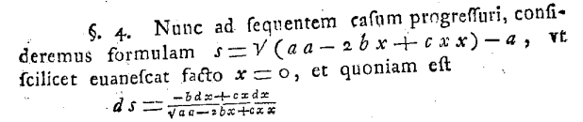

Math papers were written in Latin at that time and presumably everything was typeset by hand which must have been exceedingly painful, especially for equations. Note that cx2 is written cxx, So Euler here is studying the radical $\sqrt{a2 - 2bx + xc2}$ and proposes the substitution s + a = $\sqrt{a2 - 2bx + xc2}$ and he duly computes the derivative ds = (1/$\sqrt{a2 - 2bx + xc2}$)(-b+cx)dx which I casually type using custom control keys in Word. His presentation is not surprisingly a bit different from ours, but the idea is the same.

Euler was Swiss but moved to St. Petersburg, later to Berlin, and back to St. Petersburg where he published the above article. He had a very eventful life.

or

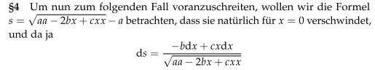

Speculations concerning the integral formula ∫ (x^{n}dx)/√(aa-2bx+cxx), where at once occur exceptional observations about continued fractions
L. Euler,

Originally published in Acta Academiae Scientarum Imperialis Petropolitinae 1782, 1786, pp. 62-84

(Transactions of the Imperial Academy of Sciences in St. Petersburg)

The above has methods 1 and 2.

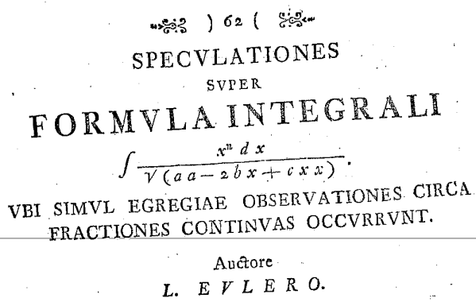

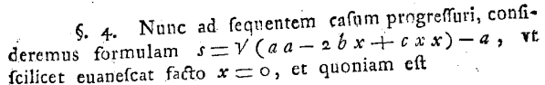

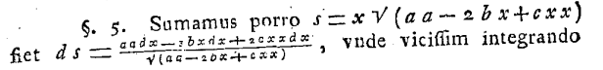

L. Euler, Speculationes super formula integrali ∫ (x^{n}dx)/√(aa-2bx+cxx), ubi simul egregiae observationes circa fractiones continuas occurrunt, Acta Academiae Scientarum Imperialis Petropolitinae 1782, 1786, pp. 62-84

To proceed to the following case, let us take the formula

respectively,

That it vanishes naturally for x = 0

