old appendix A

Appendix: About Euler's original paper

The Euler substitution idea first appeared in 1786 in the following publication,

L. Euler, "Speculationes super formula integrali ∫ (x^{n}dx)/√(aa-2bx+cxx), ubi simul egregiae observationes circa fractiones continuas occurrunt", Acta Academiae Scientarum Imperialis Petropolitinae 1782, 1786, pp. 62-84.
or

L. Euler, "Speculations concerning the integral formula ∫ (x^{n}dx)/√(aa-2bx+cxx), where at once occur exceptional observations about continued fractions", Transactions of the Imperial Academy of Sciences in St. Petersburg 1782, 1786, pp. 62-84.

Euler wrote this paper in 1775 (along with about 60 other papers and letters), presented it in 1782, and had it published in 1786.

The original paper and a German translation with better typesetting can be viewed in the Euler archive

http://eulerarchive.maa.org//

by looking up Subject / Mathematics / Integration / index number 606.

Here are two clips of Euler's original text concerning his substitutions,

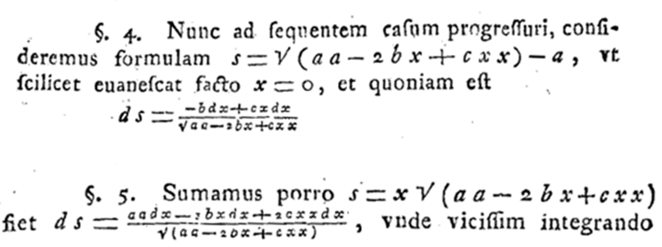

Papers were often written in Latin at the time and presumably everything was typeset by hand which must have been exceedingly painful, especially for equations. Note that a2 and cx2 are written aa and cxx. His presentation is, not surprisingly, quite different from ours. His logical thread differs so his substitutions do not match those shown in (3.5), but the end results are the same.

Euler was Swiss but moved to St. Petersburg, later to Berlin, and then back to St. Petersburg where he published the above paper. He had a prolific and eventful life in eventful times.

