Study of a certain Integral PhL 11.1.16

Motivation: This appears on page 77 of Goldstein.

The integral is the following indefinite integral whose results I quote from GR7 page 94

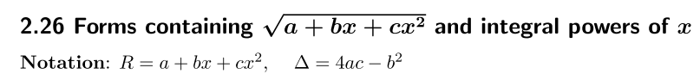

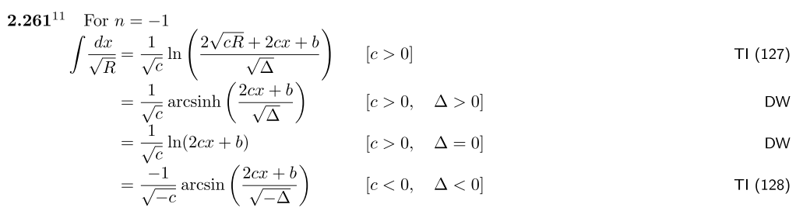

Here TI is a Russian source I don't have

The second DW result seems odd since a does not appear, but you are allowed to drop "constants" in expressing an indefinite integral, so maybe that is where it went!

Question: How do you actually manually do such an integral?

GR7 gives us a hint as follows, involving Euler substitutions,

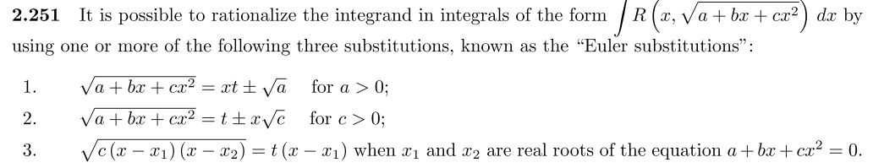

In my case we have c = -1, and a and b could have either sign, so none of these directly applies, but maybe something similar does. Wiki on these subs refers to a Zwillinger book "The Handbook of Integration" 1992. I have two of Z's books but not this one. I am taking a web look for this book, it does exist and is about integration methods, something I would like to have,

http://en.booksee.org/book/1423095 claims to have it, download is slow, we shall see. Yes, I have it!

Wiki mentions that above Euler things as well but has different expressions!!! Here they are from wiki

1. $\sqrt{R}$ = ±x$\sqrt{a}$+t

2. $\sqrt{R}$ = xt ± $\sqrt{c}$

3. $\sqrt{R}$ = (x-α)t where α is a root of R.

But wiki have a↔c from GR7, so I change wiki to read

1. $\sqrt{R}$ = ±x$\sqrt{c}$+t

2. $\sqrt{R}$ = xt ± $\sqrt{a}$

3. $\sqrt{R}$ = (x-α)t where α is a root of R.

These are numbered differently from GR7, but they are the same 3 subs! Relation is 1↔2.

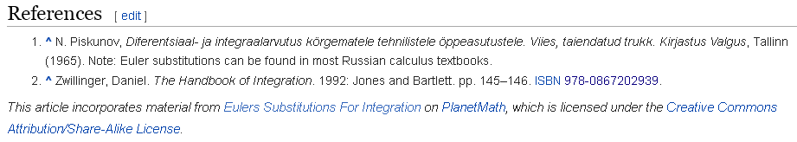

and they give a good example. Maybe Z will have nothing more than those subs.. // It is a good book, Z knows a lot of stuff. Z born 1957 so is age 43+15 = 58, has some miles to go, I have had some emails with him. The book however does not mention this kind of integral, index does not include Euler subs.

Try an Euler substitution

Consider:

R = (a + bx + cx2)

$\sqrt{R}$ = xt ± $\sqrt{a}$ (1) t(x) = ($\sqrt{R}$ ∓ $\sqrt{a}$)/x

I want this to have the form

x = f(t) and then we can do dx = f'(t) dt

So square (1)

R = (a + bx + cx2) = ( xt ± $\sqrt{a}$)2 = x2t2 ± 2$\sqrt{a}$xt + a

Notice that the a cancels on both sides, so left with

bx + cx2 = x2t2 ± 2$\sqrt{a}$xt
or
b + cx = xt2 ± 2$\sqrt{a}$t
or
x(c-t2) = ± 2$\sqrt{a}$t - b

x = ( ± 2$\sqrt{a}$t - b)(c-t2)-1

Maple confirms where I select the + sign

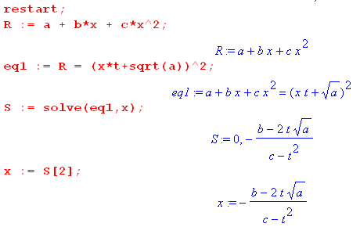

Now want to compute dx :

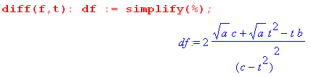

So at this point I have (still with just the + sign)

dx = 2 [$\sqrt{a}$c - bt + $\sqrt{a}$t2 ](t2-c)-2 dt

OK, now the next step is to get R as a function of t!

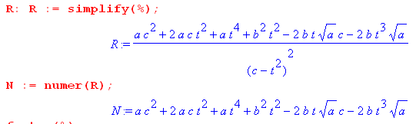

This does not look good because we want to talk about $\sqrt{R}$ . Write it out

N = a t4 - 2b$\sqrt{a}$t3 + (b2 + 2ac)t2 - 2b$\sqrt{a}$c t + ac2

How on earth is this going to "simplify" our integral? We will have square root of the above in the denominator. Maple says this does not factor. Write out 6 terms like so

N = a t4 - 2b$\sqrt{a}$t3 + b2t2 + 2act2 - 2b$\sqrt{a}$c t + ac2

Replace a by α2 and $\sqrt{a}$ = α :

N = α2 t4 - 2bαt3 + b2t2 + 2α2ct2 - 2bαc t + α2c2

This was the trick, Here is what Maple says,

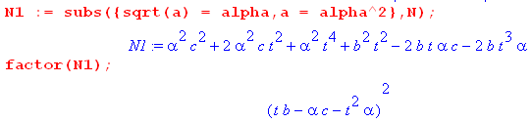

Then we can say

R = (αt2-bt+αc)2/ (c-t2)2

$\sqrt{R}$ = ± (αt2-bt+αc)/ (c-t2)

From above we have

dx = 2 [$\sqrt{a}$c - bt + $\sqrt{a}$t2 ](t2-c)-2 dt

= 2 [αc - bt + αt2 ](t2-c)-2 dt

= 2(αt2 - bt + αc)(t2-c)-2 dt

Then we get the payoff

dx/$\sqrt{R}$ = ± 2(αt2 - bt + αc)(t2-c)-2 dt // (αt2-bt+αc)/ (c-t2)

= ± 2(t2-c)-2 dt // 1/ (c-t2)

= ± 2(t2-c)-2 dt * (c-t2)

= ∓ 2(t2-c)-2 dt * (t2-c)

= ∓ 2(t2-c)-1 dt

Once again

$^{\int_{}^{x}{}}$ dx/$\sqrt{R}$ = ∓ 2 $^{\int_{}^{t(x)}{}}$ dt/(t2-c) where t(x) = ($\sqrt{R}$ ∓ $\sqrt{a}$)/x

and I do admit that is a significant simplification. Let's now just look up that integral, Schaum p 64 says

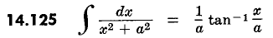

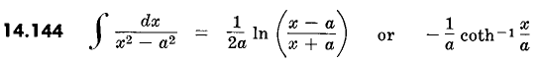

So lets take the second one with the log and see what we get with a2 = c

$^{\int_{}^{x}{}}$ dx/$\sqrt{R}$ = ∓ 2 $^{\int_{}^{t(x)}{}}$ dt/(t2-c) = ∓ 2 [ (1/2$\sqrt{c}$) ln $\sqrt{c}$$\sqrt{c}$]

t(x) = ($\sqrt{R}$ ∓ $\sqrt{a}$)/x

xt(x) = $\sqrt{R}$ ∓ $\sqrt{a}$

So mult up and down by x to get

$^{\int_{}^{x}{}}$ dx/$\sqrt{R}$ = ∓ (1/$\sqrt{c}$) ln$\sqrt{R}$$\sqrt{a}$$\sqrt{c}$$\sqrt{R}$$\sqrt{a}$$\sqrt{c}$

I am trying to end up with something like this,

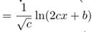

Pause at 1:30. I have at least made some progress using one of the Euler substitutions, but I have not been able to replicate any of the results that GR7 claims. This is the first time I have ever tried this in my life!

