Study of a certain Integral PhL 11.1.16

This was the first of my three docs on this integral. I had never heard of the Euler substitutions and was flailing around below a bit. In my next two documents all this stuff is nailed down.

Motivation: This appears on page 77 of Goldstein.

The integral is the following indefinite integral whose results I quote from GR7 page 94

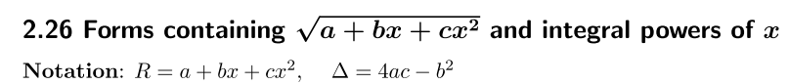

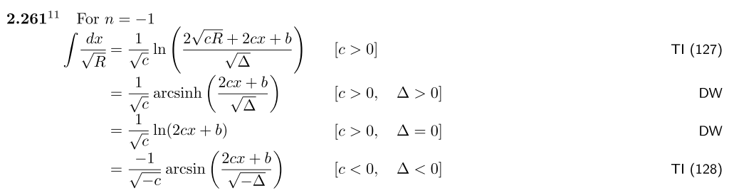

Here TI is a Russian source I don't have

Question: How do you actually manually do such an integral?

GR7 gives us a hint as follows, involving Euler substitutions,

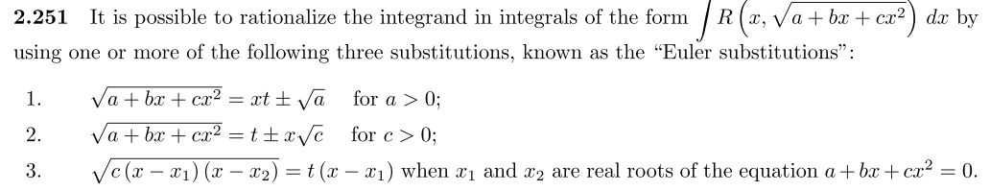

In my case we have c = -1, and a and b could have either sign, so none of these directly applies, but maybe something similar does. Wiki on these subs refers to a Zwillinger book "The Handbook of Integration" 1992. I have two of Z's books but not this one. I am taking a web look for this book, it does exist and is about integration methods, something I would like to have,

http://en.booksee.org/book/1423095 claims to have it, download is slow, we shall see. Yes, I have it!

Wiki mentions that above Euler things as well and they give a good example. Maybe Z will have nothing more than those subs.. // It is a good book, Z knows a lot of stuff. Z born 1957 so is age 43+15 = 58, has some miles to go, I have had some emails with him. The book however does not mention this kind of integral, index does not include Euler subs.

Try an Euler substitution

Let's try the first sub. Differentiate both sides

R = (a + bx + cx2)1/2

R = xt ± $\sqrt{a}$ t = (R ∓$\sqrt{a}$)/x = (R ∓$\sqrt{a}$)x-1

dR = (1/2)R-1 (b + 2cx) dx

dt = dR x-1 + (R ∓$\sqrt{a}$)(-1)x-2dx

dt = (1/2)R-1 (b + 2cx) dx x-1 - (R ∓$\sqrt{a}$)x-2dx

dt = [(1/2)R-1 (b + 2cx) x-1 - (R ∓$\sqrt{a}$)x-2]dx

dx = [(1/2)R-1 (b + 2cx) x-1 - (R ∓$\sqrt{a}$)x-2]-1

But I want this to have the form

dx = f(t) dt

and doing the subs would make a huge mess I think. So start over, assume +$\sqrt{a}$ to keep simple,

R2 = (a + bx + cx2) = ( xt + $\sqrt{a}$)2 = x2t2 + 2$\sqrt{a}$xt + a

Then have

bx + cx2 = x2t2 + 2$\sqrt{a}$xt

[x2]t2 + [2$\sqrt{a}$x] t + [ -bx - cx2] = 0

At2 + Bt + C = 0

t = [ -B ± $\sqrt{B2-4AC}$]/(2A)

Pause:

B2-4AC = [2$\sqrt{a}$x]2- 4x2 [ -bx - cx2] = 4ax2 + 4bx3 + 4cx4 = 4x2(a + bx + cx2) = 4x2R2

$\sqrt{B2-4AC}$ = 2xR

So that is very promising. Our solution is then

t = [ -2$\sqrt{a}$x ± 2xR]/(2x2) = 2x [-$\sqrt{a}$ ± R]/(2x2) = [-$\sqrt{a}$ ± R] / x

Not too bad really. But I already knew this at the very start!!

xt = $\sqrt{a}$ ± R

±xt = ±$\sqrt{a}$ + R

R = ±(xt - $\sqrt{a}$)

I went the wrong direction! So go back to

bx + cx2 = x2t2 + 2$\sqrt{a}$xt

bx + cx2 - x2t2 - 2$\sqrt{a}$xt = 0

I failed above to notice can divide by x, so

b + cx - xt2 - 2$\sqrt{a}$t = 0

[c-t2]x = 2$\sqrt{a}$t - b

x = (2$\sqrt{a}$t - b)(c-t2)-1

and that is the form I want, x = x(t). Now differentiate

dx = (2$\sqrt{a}$t - b)(-1)(c-t2)-2 (-2tdt) + 2$\sqrt{a}$dt (c-t2)-1

= 2(2$\sqrt{a}$t - b)(c-t2)-2 (tdt) + 2$\sqrt{a}$dt (c-t2)-1

= 2dt[(2$\sqrt{a}$t - b)(c-t2)-2t + $\sqrt{a}$(c-t2)-1 ]

= 2 (c-t2)-2 [ (2$\sqrt{a}$t - b) t + $\sqrt{a}$(c-t2)] dt

= 2 (c-t2)-2 [ 2$\sqrt{a}$t2 - bt + $\sqrt{a}$c-$\sqrt{a}$t2)] dt

= 2 (c-t2)-2 [ $\sqrt{a}$t2 - bt + $\sqrt{a}$c] dt

This does not seem very helpful! Let's get Maple to verify my algebra. But Maple makes a big mess worrying about signs of things.

Try factoring

Suppose we can write

R2 = (a + bx + cx2) = c (a/c+(b/c)x + x2) = c [x2 + (b/c)x + (a/c)]

= c(x-e)(x-f)

where e and f are the roots of x2 + (b/c)x + (a/c) = 0, which are the roots of a + bx + cx2. Then our integral of interest is this

$\sqrt{c}$∫ $\sqrt{x-e}$$\sqrt{x-f}$

Is this integral any easier to do? Partial fractions?

$\sqrt{x-e}$$\sqrt{x-f}$ = $\sqrt{x-e}$ + $\sqrt{x-f}$ need E(x) $\sqrt{x-f}$ + F(x) $\sqrt{x-e}$ = 0

That really goes nowhere!

Parts integration? (x-e)-1/2 = 2dx (x-e)+1/2 just makes things uglier.

I am always amazed at how little I know about actually doing integrals!

