Appendix A: About Euler's original paper

Euler's study of integrals of the form ∫xn/$\sqrt{R}$appears in this paper,

L. Euler, "Speculationes super formula integrali ∫ (x^{n}dx)/√(aa-2bx+cxx), ubi simul egregiae observationes circa fractiones continuas occurrunt", Acta Academiae Scientarum Imperialis Petropolitinae 1782, 1786, pp. 62-84.
or in English

L. Euler, "Speculations concerning the integral formula ∫ (x^{n}dx)/√(aa-2bx+cxx), where at once occur exceptional observations about continued fractions", Transactions of the Imperial Academy of Sciences in St. Petersburg 1782, 1786, pp. 62-84.

In 1775 Euler wrote about 60 (!) papers including the one above. The paper was formally presented in 1782 (a year before his death) but was not was published until 1786. The original paper can be viewed in the Euler Archive,

http://eulerarchive.maa.org//

by looking up Subject / Mathematics / Integration / index number 606.

His paper does not actually use any of our substitutions A,B,C. Instead, it plants the seed of the idea and someone at some later time extracted the three substitutions from his work. Below we shall display parts of the original paper, but first it is helpful to describe what he is doing. Here is a long-winded interpretation of Section 1 of his paper :

1. Consider the quantity a2 - 2bx + cx2. Make the substitution,

x = (b+z)/c ⇒ z = cx - b and dx = (1/c)dz (A.1)

so that

(a2 - 2bx + cx2) = a2 - 2b (b+z)/c + c(b+z)2/c2 = (1/c2)[a2c2 - 2bc (b+z) + c(b+z)2]

= (1/c2)[a2c2 - 2b2c- 2bcz + cb2+ 2cbz + cz2] = (1/c2)[a2c2 - b2c + cz2]

= (a2c - b2 + z2)/c . // no linear z term (A.2)

Then, // Euler uses c = f2 but we keep it as c

∫dx $\sqrt{a2-2bx+cx2}$= ∫ $\frac{dz}{c}$ $\sqrt{c}$$\sqrt{a2c - b2 + z2}$ = $\sqrt{c}$ ∫ $\sqrt{a2c - b2 + z2}$. (A.3)

Euler's substitution (A.1) has not converted the integral to a rational function R(t) of the form (1.2) as we did earlier with all the official "Euler substitutions". However, Euler was familiar with the following integral (having more or less invented the natural logarithm and e),

∫ $\sqrt{A2+z2}$ = ln [z + $\sqrt{A2+z2}$] + constant

so he continues the above,

$\sqrt{c}$∫ $\sqrt{a2c - b2 + z2}$ = $\sqrt{c}$ ln [ $\sqrt{a2c - b2 + z2}$ ] (A.4)

where C is a constant. He then replaces z = cx - b and $\sqrt{a2c - b2 + z2}$ = $\sqrt{c}$$\sqrt{a2-2bx+cx2}$to get

$^{\int_{}^{x}{}}$dx $\sqrt{a2-2bx+cx2}$ = $\sqrt{c}$ln [ $\sqrt{c}$$\sqrt{a2-2bx+cx2}$ ]
and then c > 0 (A.5)
$^{\int_{0}^{x}{}}$dx $\sqrt{a2-2bx+cx2}$ = $\sqrt{c}$ln [ $\sqrt{c}$$\sqrt{a2-2bx+cx2}$$\sqrt{c}$ ] .

He next considers the case c < 0 (which he writes as c = - g2) and finds,

$^{\int_{0}^{x}{}}$dx $\sqrt{a2-2bx+cx2}$ = $\sqrt{-c}$sin-1 ($\sqrt{b2 - a2c}$) + $\sqrt{-c}$sin-1 ($\sqrt{b2 - a2c}$) . c < 0 (A.6)

Euler then gives his integral a name Π and later he calls is Δ, so

Π = Δ = $^{\int_{0}^{x}{}}$dx $\sqrt{a2-2bx+cx2}$ . (A.7)

Comparison with GR7: With a2→ a and b → -b/2 one has a2 - 2bx + cx2 → a + bx + c2 = R. Then (A.5) and (A.6) become

∫dx $\sqrt{a+bx+cx2}$ = $\sqrt{c}$ln [ $\sqrt{c}$$\sqrt{a+bx+cx2}$ ] (A.5)'

∫dx $\sqrt{a+bx+cx2}$ = $\sqrt{-c}$sin-1 ($\sqrt{b2-4ac}$) . ?? (A.6')
Eq. (A.5) agrees with (7.16) line 1 (apart from an additive constant) while (A.6) disagrees with (7.16) line 4 by a minus sign. Euler does not really define the meaning of his g when he writes c = -g2, nor was the notion of analytic continuation much developed in 1775.

These then are the results of Euler's Section 1. Here is the original of that Section, taken from the Euler Archive noted above,

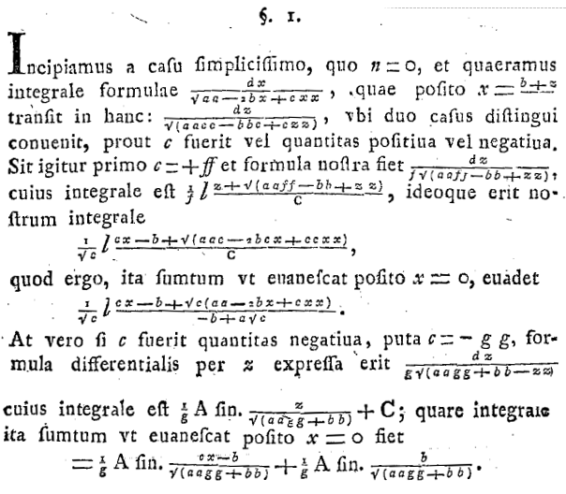 (A.8)

As was the custom of the time, the paper is written in Latin ("We begin with the simplest case, where n = 0, and we seek an integral formula for...."). The denominator c of x = (b+z)/c is obscured. Quadratic powers are written aa instead of a2, though higher powers are later written with exponents. The ln symbol is a large italic lower-case letter l, and arcsin(α) is written A sin.(α). The letter v is u, and s in most non-final positions is written f, known as a "long s", a usage that was dropped after 1800.

The Archive has this paper translated into German with clean typesetting (no English yet). One can only wonder how printers of the day hand-typeset Euler's many equations for printing. The photocopy clips above and below are of modest quality, and we had to manually do some derotation of the text (Visio).

As the paper title shows, Euler was in pursuit of the integral ∫dx xn/$\sqrt{a2-2bx+cx2}$ and in the first Section above he has handled the case n = 0. He goes on to make more substitutions to obtain the cases n = 1,2,3... Here is his entire Section 2 which uses a new substitution to get the n = 1 result,

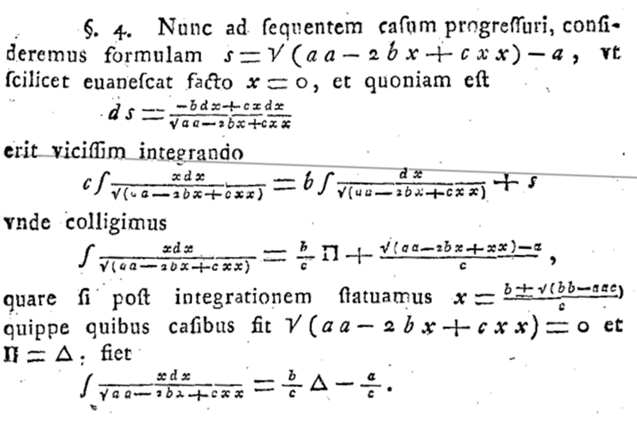 (A.9)
Note that Π = Δ = (the n=0 integral). Later he summarizes his results for n = 0,1,2,3 and 4 :
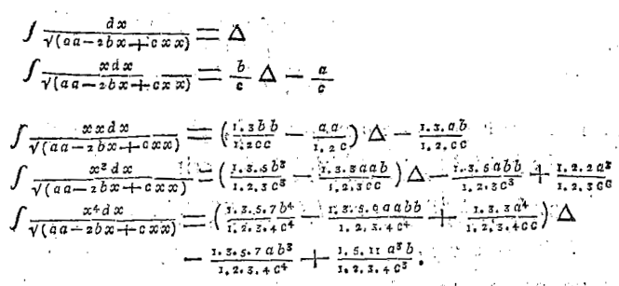 (A.10)

where 1.3.5 means 1*3*5 = 15. Euler then obtains a recursion relation

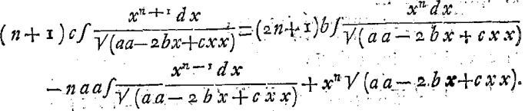 (A.11)

which appears in GR7 in a more general form (for R = a + bx + cx2),

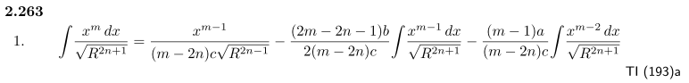
If in this GR7 integral we take n→0, m→n+1, a→a2 and b→ -2b so R→Q = $\sqrt{a2-2bx+cx2}$, we get

∫ $\sqrt{Q}$ = $\frac{xn}{(n+1)c}$$\sqrt{Q}$ – $\frac{(2n+1)(-2b)}{2(n+1)c}$ ∫ $\sqrt{Q}$ – $\frac{(n)a2}{(n+1)c}$ ∫ $\sqrt{Q}$
or
(n+1)c∫ $\sqrt{Q}$ = (2n+1)b ∫ $\sqrt{Q}$ – na2 ∫ $\sqrt{Q}$ + xn$\sqrt{Q}$ (A.12)

which gives Euler's recursion result to the letter.

Finally Euler attempts to write a closed-form expression for the general case n = n with some partial success. The paper then ends with a long section on writing quantities as continued fractions, for example

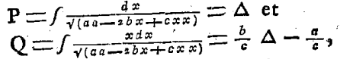

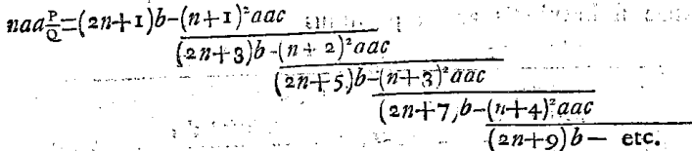 (A.13)

There are many pages showing such continued fractions and Euler seems to be fascinated with such fractions. As the title says, this is the second topic of his paper,

"Speculations concerning the integral formula ∫ (x^{n}dx)/√(aa-2bx+cxx), where at once occur exceptional observations about continued fractions"

Euler (1707-1783) was Swiss but moved to St. Petersburg in 1727, to Berlin in 1741, and finally back to St. Petersburg in 1766 where he wrote the above paper. His presence in Russia is the reason that the "Euler substitutions" are commonly associated with Russian sources like Piskunov. He had a prolific and eventful life in eventful times and is often ranked the greatest mathematician of all time.

