The Boeing sech^2 integral PhL 1.28.11

Leaving no stone unturned.... these are raw notes, read Overview below.

Overview. 1
Convert to the sech + sech form. 1
Plan A: Combined the sech's. 3
Plan B: Try x = t+a in a sech integral. 4
Plan C: Try x = cht in a sech integral. 5
Plan D: Integrate on parameter a. 5
Plan E: Try x = y+ cht. 6
Plan F: Find an ODE solved by the result. 6
Plan G: Use sech²(πτ) = 1 - th²(πτ) at the start. 6
Plan H: Other integral representations for P? 7
Plan I: Convolution Integral? 8
Plan J: Brute Force Search for tan-1 integrals. 10
Plan K. Successful evaluation of the sech² integral 13

Overview. It is here that I was first able to do the sech2 integral. The solution path is the first section, then Plan A, then Plan K. The results are best summarized in Section 10 of the doc "doing Mehler transform integrals.doc". The present doc just has the raw computational effort. As you can see, many of my "plans" did not pan out, I keep them in the record just for fun. Plan I was an interesting exercise which vindicated my T(1) convolution diagonalization work done elsewhere.

Convert to the sech + sech form.

The integral of interest is this:

I = $^{\int_{0}^{∞}{}}$dτ Piτ-1/2(y) cos(aτ) sech2(πτ) y > 1

and according to Boeing page 20 it evaluates to this result

($\sqrt{2}$/π) (1/$\sqrt{y-cha}$) tan-1 [ $\sqrt{y-cha}$ / $\sqrt{1+cha}$ ] at least for y > cha, so roots all +

I have two integral representations

P-1/2+iτ(chα ) = ($\sqrt{2}$/π) $^{\int_{0}^{α}{}}$dt (chα-cht)-1/2cos(τt)

P-1/2+iτ(chα) = ($\sqrt{2}$/π ) ch(πτ) $^{\int_{0}^{∞}{}}$dt (chα+cht)-1/2 cos(τt)

Aside: Here is verification of the constant:

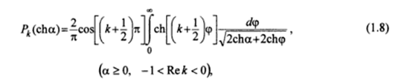

but the second seems better for our purposes. We then have

I = $^{\int_{0}^{∞}{}}$dτ Piτ-1/2(y) cos(aτ) sech2(πτ) y > 1

= $^{\int_{0}^{∞}{}}$dτ {($\sqrt{2}$/π ) ch(πτ)* $^{\int_{0}^{∞}{}}$dt (y+cht)-1/2 cos(τt)} cos(aτ)sech2(πτ)

= ($\sqrt{2}$/π ) $^{\int_{0}^{∞}{}}$dτ $^{\int_{0}^{∞}{}}$dt (y+cht)-1/2 cos(τt) cos(aτ) sech(πτ)

= ($\sqrt{2}$/π ) $^{\int_{0}^{∞}{}}$dt (y+cht)-1/2 $^{\int_{0}^{∞}{}}$dτ cos(τt) cos(aτ) sech(πτ)

and we are faced with this non-delta integral, where t lies in the range (0,∞)

$^{\int_{0}^{∞}{}}$dτ cos(τt) cos(aτ) / cosh(πτ)

We try this

cos(tτ) cos(aτ) = ch(ixτ) ch(iaτ) = (1/2){ ch[i(t+a)τ] + ch[i(t-a)τ] }

so we then have

$^{\int_{0}^{∞}{}}$dτ cos(τt) cos(aτ) / cosh(πτ) = (1/2)$^{\int_{0}^{∞}{}}$dτ { ch[i(t+a)τ] + ch[i(t-a)τ] }/ cosh(πτ)

Then I need

$^{\int_{0}^{∞}{}}$dτ cosh[i(t±a)τ]/cosh(πτ)

and here is an integral GR7 p 371

$^{\int_{0}^{∞}{}}$dτ cosh(aτ)/cosh(πτ) = (1/2) sec(a/2)

Aside: I am suspicious of the above integral in terms of its overall constant. Here is another formula

Set ν = 1/2, a = b and then 2β = a.

RHS = 4-1/2 / b * B(1/2+β/b, 1/2-β/b)

= (1/2) (1/b) B(1/2+a/2b,1/2-a/2b) = (1/2b) π/cos(πa/2b) = (π/2b)sec(πa/2b), so verified.

So set b = π and a = A to get

$^{\int_{0}^{∞}{}}$dτ cosh(Aτ)/cosh(πτ) = (1/2) sec (A/2)

Now set A = i(t+a) for our first term to get

=> $^{\int_{0}^{∞}{}}$dτ cosh[i(t+a)τ]/cosh(πτ) = (1/2) sec[i(t+a)/2] = (1/2) sech[(t+a)/2]

So here is what we have shown so far:

$^{\int_{0}^{∞}{}}$dτ cos(τt) cos(aτ) sech(πτ) = (1/2) { (1/2)sech[(t+a)/2] + (1/2)sech[(t-a)/2] }

= (1/4) { sech[(t+a)/2] + sech[(t-a)/2] }

which then tells us

I = ($\sqrt{2}$/π ) $^{\int_{0}^{∞}{}}$dt (y+cht)-1/2 $^{\int_{0}^{∞}{}}$dτ cos(τt) cos(aτ) sech(πτ)

= ($\sqrt{2}$/4π ) $^{\int_{0}^{∞}{}}$dt (y+cht)-1/2 { sech[(t+a)/2] + sech[(t-a)/2] }

=?= ($\sqrt{2}$/π) (1/$\sqrt{y-cha}$) tan-1 [ $\sqrt{y-cha}$ / $\sqrt{1+cha}$ ]

where I quote the Boeing result. So the big question is this: what substitution did they use?

Plan A: Combined the sech's. Write out the sech sum somehow:

sech[(t+a)/2] + sech[(t–a)/2] = 1/ch[(t+a)/2] + 1/ch[(t-a)/2]

= ( ch[(t-a)/2]+ ch[(t+a)/2] )/ ( ch[(t+a)/2] ch[(t-a)/2] )

= 2ch(t/2)ch(a/2) / ( ch[(t+a)/2] ch[(t-a)/2] )

= 2ch(t/2)ch(a/2) /[(1/2)( ch(t) + ch(a) ) ] = 4 ch(t/2)ch(a/2)/ ( ch(t) + ch(a) )

Here is a little confirmation of the last set of lines from Maple

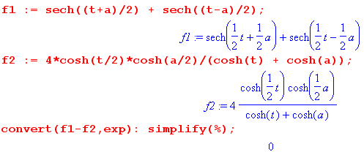
The last result then gives

I = ($\sqrt{2}$/4π ) $^{\int_{0}^{∞}{}}$dt (y+cht)-1/2 { sech[(t+a)/2] + sech[(t-a)/2] }

= ($\sqrt{2}$/π ) ch(a/2) $^{\int_{0}^{∞}{}}$dt (y+cht)-1/2 ch(t/2) /( ch(t) + ch(a) )

It is tempting at this point to try

x = cht => dx = sht dt dt = dx/sht = dx/$\sqrt{x2-1}$

ch(t/2) = (1/$\sqrt{2}$)$\sqrt{cht+1}$ = (1/$\sqrt{2}$)$\sqrt{x+1}$

I = ($\sqrt{2}$/π ) ch(a/2) $^{\int_{1}^{∞}{}}$ dx/$\sqrt{x2-1}$* (y+x)-1/2 (1/$\sqrt{2}$)$\sqrt{x+1}$ /( x + ch(a) )

= (1/π ) ch(a/2) $^{\int_{1}^{∞}{}}$ dx/$\sqrt{x-1}$* (y+x)-1/2 /( x + ch(a) )

= (1/π ) ch(a/2) $^{\int_{1}^{∞}{}}$ dx 1/[ $\sqrt{x-1}$ $\sqrt{y+x}$ ( x + ch(a) ) ]

Skip now to Plan K.

Plan B: Try x = t+a in a sech integral. Here is what we need to compute

$^{\int_{0}^{∞}{}}$dt (y+cht)-1/2 / ch(t+a)

Try x = t+a and get

$^{\int_{a}^{∞}{}}$dx (y+ch(x-a))-1/2 / ch(x)

But this is "hyperbolic with algebraic functions of hyperbolic", won't ever find that.

Plan C: Try x = cht in a sech integral.

Try x = cht. Then dx = sht dt = $\sqrt{x2-1}$dt so then have

$^{\int_{1}^{∞}{}}$dx (1/$\sqrt{x2-1}$)(1/$\sqrt{y+x}$) (1/ch[ ch-1x + a])

But

ch[ ch-1x + a] = x cha + sh[ch-1x] sha = x cha + $\sqrt{x2-1}$ sha

so we are looking then at

$^{\int_{1}^{∞}{}}$dx (1/$\sqrt{x2-1}$)(1/$\sqrt{y+x}$)(1/[ x cha + $\sqrt{x2-1}$ sha])

$^{\int_{1}^{∞}{}}$dx (1/$\sqrt{x2-1}$)(1/$\sqrt{y+x}$)[1/(Ax + B$\sqrt{x2-1}$) ]

So this is "algebraic", but what a mess, it is a no go.

Plan D: Integrate on parameter a. Start again with

I(a) = (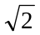/4π ) $^{\int_{0}^{∞}{}}$dt (y+cht)-1/2 [ sech[(t+a)/2] + sech[(t-a)/2] ]

Integrate both sides on a, I used Maple to integral sech(t+a),

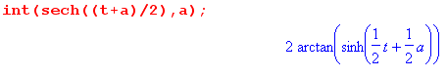

∫da I(a) = (/4π ) $^{\int_{0}^{∞}{}}$dt (y+cht)-1/2 2 [ tan-1(sh[(t+a)/2]) - tan-1(sh[(t-a)/2]) ]

Now we need an integral like this

$^{\int_{0}^{∞}{}}$dt (y+cht)-1/2 tan-1(sh[(t+a)/2])

Now maybe try parts

∂t(y+cht)1/2 = (y+cht)-1/2 (1/2) sht => (y+cht)-1/2 = (2/sht) ∂t(y+cht)1/2

It just gets ugly.

Plan E: Try x = y+ cht. Then dx = sht dt = $\sqrt{(x-y)2-1}$dt so then have

I(a) = (/4π ) $^{\int_{0}^{∞}{}}$dt (y+cht)-1/2 [ sech[(t+a)/2] + sech[(t-a)/2]]

= (/4π ) $^{\int_{0}^{∞}{}}$ dx( /$\sqrt{(x-y)2-1}$) (1/$\sqrt{x}$) [ sech[(t+a)/2] + sech[(t-a)/2]] etc etc

Plan F: Find an ODE solved by the result.

I(a) = $^{\int_{0}^{∞}{}}$dτ Piτ-1/2(y) cos(aτ) sech2(πτ) y > 1

∂a2I(a,y) = - a2I(a,y)

So whatever I is, it solves this little ODE. So maybe try a form like this

I(a,y) = exp[ iaf(y)] +

(∂a2 + a2)I(a) = 0

Plan G: Use sech2(πτ) = 1 - th2(πτ) at the start.

I = $^{\int_{0}^{∞}{}}$dτ Piτ-1/2(y) cos(aτ) sech2(πτ) y > 1

Now replace

sech2(πτ) = 1 - th2(πτ)

Then we have

I = $^{\int_{0}^{∞}{}}$dτ Piτ-1/2(y) cos(aτ) sech2(πτ) =

= $^{\int_{0}^{∞}{}}$dτ Piτ-1/2(y) cos(aτ) [1 - th2(πτ)]

But I already know the first integral to be

$^{\int_{0}^{∞}{}}$dτ Piτ-1/2(y) cos(aτ) = (1/$\sqrt{2}$) 1/$\sqrt{y - cha}$ θ(y > cha)

and then we have to do battle with a new integral

J = $^{\int_{0}^{∞}{}}$dτ Piτ-1/2(y) cos(aτ) th2(πτ)

Try the first integral rep to get

J = $^{\int_{0}^{∞}{}}$dτ { ($\sqrt{2}$/π) $^{\int_{0}^{α}{}}$dx cos(τx) / $\sqrt{chα - chx}$}cos(aτ) th2(πτ)

= ($\sqrt{2}$/π) $^{\int_{0}^{α}{}}$dx / $\sqrt{chα - chx}$} * $^{\int_{0}^{∞}{}}$dτ cos(τx) cos(τx) th2(πτ)

This looks more like a delta function thing.

Plan H: Other integral representations for P?

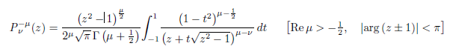
So set μ = 0 to get

Pν(z) = (1/π) $^{\int_{-1}^{1}{}}$dt (1-t2)-1/2 ( z + t$\sqrt{z2-1}$)-ν

P-1/2+iτ(z) = (1/π) $^{\int_{-1}^{1}{}}$dt (1-t2)-1/2 ( z + t$\sqrt{z2-1}$)-[-1/2+iτ]

But this is much worse than simple old cos(τx). You really could not ask more of an integral rep than what we already have! And that takes us to this point

= ($\sqrt{2}$/π ) $^{\int_{0}^{∞}{}}$dt (y+cht)-1/2 $^{\int_{0}^{∞}{}}$dτ cos(τt) cos(aτ) sech(πτ)

Plan I: Convolution Integral?

I = (/4π ) $^{\int_{0}^{∞}{}}$dt (y+cht)-1/2 [ sech[(t+a)/2] + sech[(t-a)/2]] // (10.10)

I(a) = (/8π ) $^{\int_{-∞}^{∞}{}}$dt (y+cht)-1/2 [ sech[(t+a)/2] + sech[(t-a)/2]]

Now that we have the full (-∞,∞) range, the two integrals here are really the same. For example, in the second integral we could replace t→-t and end up with sech[(-t-a)/2] which is the same as sech[(t+a)/2]. So now we can just write I(a) as twice the second term

I(a) = (/4π ) $^{\int_{-∞}^{∞}{}}$dt (y+cht)-1/2 sech[(t-a)/2]

But for purposes below, lets replace a→x and t→x', so the above then says

I(x) = (/4π ) $^{\int_{-∞}^{∞}{}}$dx' (y+chx')-1/2 sech[(x'-x)/2]

which I rewrite one more time in convolution ordering as

I(x) = (/4π ) $^{\int_{-∞}^{∞}{}}$dx' sech[(x-x')/2] (y+chx')-1/2 (I.1)

I now quote from my updated convolution doc in the group theory folder for the T(1) situation:

$^{\int_{-∞}^{∞}{}}$ dx ei(k-k')x = 2πδ(k-k') // orthogonality
$^{\int_{-∞}^{∞}{}}$ dk e-ik(x-x') = 2πδ(x-x') // completeness

A(k) = $^{\int_{-∞}^{∞}{}}$dx a(x) e-ikx // projection
a(x) = (1/2π) $^{\int_{-∞}^{∞}{}}$dk A(k) e+ikx // expansion (same for b and c below)

a(x) =$^{\int_{-∞}^{∞}{}}$dx' b(x-x') c(x') // convolution-form integral equation

A(k) = B(k) C(k) // its diagonalization by the Fourier Integral transform

We now want to identify (I.1) with our standard convolution form integral equation, so

a(x) =$^{\int_{-∞}^{∞}{}}$dx' b(x-x') c(x')

I(x) = (/4π ) $^{\int_{-∞}^{∞}{}}$dx' sech[(x-x')/2] (y+chx')-1/2

So let's then identify

a(x) = I(x)
b(x) = (/4π ) sech[(x)/2]
c(x) = (y+chx)-1/2

Now can we compute or look up the projections of our two functions b and c ?

B(k) = $^{\int_{-∞}^{∞}{}}$dx b(x) e-ikx = (/4π ) $^{\int_{-∞}^{∞}{}}$dx e-ikx sech (x/2)

C(k) = $^{\int_{-∞}^{∞}{}}$dx c(x) e-ikx = $^{\int_{-∞}^{∞}{}}$dx e-ikx (y+chx)-1/2

Both these integrals at least look convergent. A good lookup place for Fourier stuff is ET1. In each case above our integrand (apart from expo) is even, so we can do the Fourier Cosine transform which has a larger look up table in ET1. We then would say

B(k) = 2 (/4π )$^{\int_{0}^{∞}{}}$dx cos(kx) sech (x/2)
C(k) = 2 $^{\int_{0}^{∞}{}}$dx cos(kx) (y+chx)-1/2

The very first entry is of interest on page 30

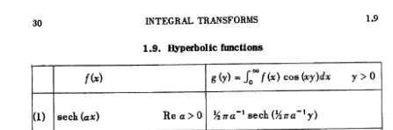

so we have found our first projection at least, and I set a = 1/2 and we get

B(k) = 2 (/4π ) $^{\int_{0}^{∞}{}}$dx cos(kx) sech(x/2) = 2 (/4π ) π sech(πk)

= (/2 ) sech(πk) = (1/$\sqrt{2}$) sech(πk)

Then later in the table on the same page we find

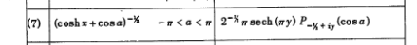

This is stated with cosa on the left being (-1,1). I think we can just analytically continue both sides in the complex variable a, as long as things continue to converge. So the above says

$^{\int_{0}^{∞}{}}$dx cos(xy) (cosh x +cosa)-1/2 = (π/$\sqrt{2}$)sech(πy) P-1/2+iy(cosa)

But we want to first change y to k to get

$^{\int_{0}^{∞}{}}$dx cos(xk) (cosh x +cosa)-1/2 = (π/$\sqrt{2}$)sech(πk) P-1/2+ik(cosa)

Then we want to change cosa to y to get

$^{\int_{0}^{∞}{}}$dx cos(xk) (cosh x +y)-1/2 = (π/$\sqrt{2}$) sech(πk) P-1/2+ik(y)

and now I see this is just our integral representation stated above as

P-1/2+iτ(chα) = ($\sqrt{2}$/π ) ch(πτ) $^{\int_{0}^{∞}{}}$dt (chα+cht)-1/2 cos(τt)

So we then have

C(k) = 2 $^{\int_{0}^{∞}{}}$dx cos(kx) (y+chx)-1/2 = 2 (π/$\sqrt{2}$) sech(πk) P-1/2+ik(y)

= $\sqrt{2}$π sech(πk) P-1/2+ik(y)

We then have

B(k) = (1/$\sqrt{2}$) sech(πk)
C(k) = ($\sqrt{2}$π) sech(πk)P-1/2+ik(y)

Then according to our diagonalized equation we should have

A(k) = B(k) C(k) = π sech2(πk) P-1/2+ik(y)

Now finally we compute our desired a(x) given the above A(k)

a(x) = (1/2π) $^{\int_{-∞}^{∞}{}}$dk A(k) e+ikx

= (1/2π) $^{\int_{-∞}^{∞}{}}$dk { π sech2(πk) P-1/2+ik(y) }e+ikx

= (1/2) $^{\int_{-∞}^{∞}{}}$dk { sech2(πk) P-1/2+ik(y) }e+ikx

= $^{\int_{0}^{∞}{}}$dk P-1/2+ik(y)cos(kx) sech2(πk)

And low and behold, we have recovered our starting point. So the diagonalization "method" did not in fact "do the integral for us". But since we got back to the right starting point, we draw two conclusions:

• the general Fourier Integral diagonalization facts quoted above are correct
• the [ sech[(t+a)/2] + sech[(t-a)/2]] intermediate form is vindicated

Plan J: Brute Force Search for tan-1 integrals. Look for a GR7 definite integral (ignore limits) which results in tan-1 (something). Maybe this will lead to finding "the right substitution". Remember that this is the claim

$^{\int_{0}^{∞}{}}$dτ Piτ-1/2(y) cos(aτ) sech2(πτ) = ($\sqrt{2}$/π) (1/$\sqrt{y-cha}$) tan-1 [ $\sqrt{y-cha}$ / $\sqrt{1+cha}$ ]

maybe I will construct a list:

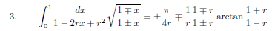
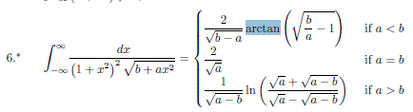 p 324, has promise?
363

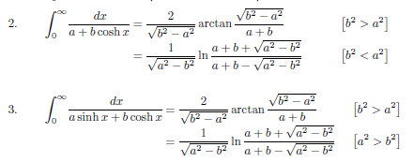 p 372
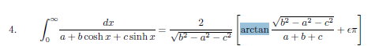p 373
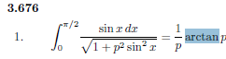 p 409
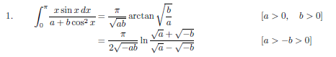p 453

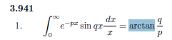p 497
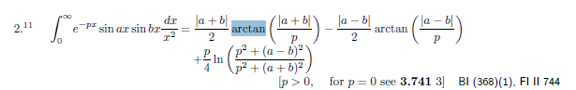500
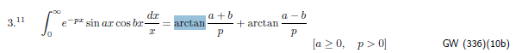"

Starting on page 500, lots of trig integrals produce arctan.
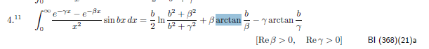501
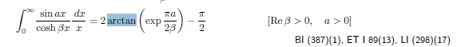516
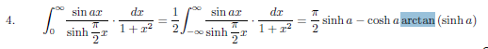 517

and several similar to the above
p 518

Starting on 518 there are too many now to copy. Most have a factor (1+x2)-1

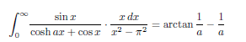 521

Then there are many with ln involved which I don't show here. Then that is about it.

Plan K. Successful evaluation of the sech2 integral

Come here from the end of Plan A. The results of this section are presented more clearly in Section 10 of the doc "doing Mehler transform integrals.doc".

I am trying to do this

I = (1/π ) ch(a/2) $^{\int_{1}^{∞}{}}$ dx 1/[ $\sqrt{x-1}$ $\sqrt{y+x}$ ( x + ch(a) ) ]

Let's now define α ≡ ch(a) and change to integration variable s = x+α, so x = s-α. Then we have

x-1 = s-α-1 = [s-(α+1)]
y+x = s-α+y = [s+(y-α)]
x+cha = [x+α]

and then we have

I = (1/π ) ch(a/2) $^{\int_{1+α}^{∞}{}}$ ds [s-(α+1)]-1/2 [s+(y-α)]-1/2s-1

Now rename the dummy variable back to x and shuffle the order of the factors

I = (1/π ) ch(a/2) $^{\int_{1+α}^{∞}{}}$ dx x-1 [x+(y-α)]-1/2 [x-(α+1)]-1/2

Now consider this GR7 page 317 integral [ it has an error! ]
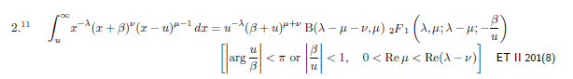
Aside: Why does this appear in ET II ? Well first off, this integral does NOT appear in ET II anywhere! It should appear in the "fractional integral transform" section with integration endpoints y to ∞. That section begins on page 147, but the above is not there in the Russian edition. Still, that does remind me that if you have a factor of the form (x-u)α then you can use Sneddon's theory of this transform to at least think about the integral.

In doc "Correcting GR7 Integral 3_197_2.doc" I derived the above formula and found an error, and I think I am write and will soon send in something to Dan. It was lucky I decided to check this thing (trust but verify). Here is the corrected integral from my doc (it is the c argument of the F that is wrong)

$^{\int_{u}^{∞}{}}$dx x-λ (x-u)μ-1 (x+β)ν = u-λ (β+u)μ+ν B(λ-μ-ν,μ) F(λ,μ; λ-ν; -β/u)

Now let's try to apply this formula to our desired integral from directly above

I = (1/π ) ch(a/2) $^{\int_{1+α}^{∞}{}}$ dx x-1 [x+(y-α)]-1/2 [x-(α+1)]-1/2

Here are the settings

u = 1+α λ = 1 β = y-α μ-1 = -1/2 so μ = 1/2 ν = -1/2
μ+ν = 1/2 + -1/2 = 0
λ-μ-ν = 1 - 1/2 +1/2 = 1
λ-ν = 1+1/2 = 3/2
β+u = y-α+1+α = y+1
β/u = (y-α)/(1+α)

Then we have

I = (1/π ) ch(a/2) u-λ (β+u)μ+ν B(λ-μ-ν,μ) F(λ,μ; λ-ν; -β/u)

= (1/π ) ch(a/2) u-1 (β+u)0 B(1,1/2) F(1,1/2; 3/2; -β/u)

= (2/π ) ch(a/2) u-1 F(1,1/2; 3/2; -β/u)

= (2/π ) ch(a/2) (1+α)-1 F(1,1/2; 3/2; -(y-α)/(1+α))

Meanwhile Maple tells us

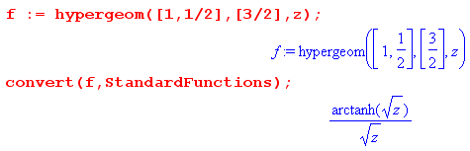
We then have

z = -(y-α)/(1+α)

Let's continue this so that

$\sqrt{z}$ = i $\sqrt{y-α}$/$\sqrt{1+α}$

in both numerator and denominator. Then we get

[tanh-1$\sqrt{z}$]/$\sqrt{z}$ = tanh-1[i $\sqrt{y-α}$/$\sqrt{1+α}$] / i $\sqrt{y-α}$/$\sqrt{1+α}$

= i tan-1[ $\sqrt{y-α}$/$\sqrt{1+α}$] / i $\sqrt{y-α}$/$\sqrt{1+α}$

= tan-1[ $\sqrt{y-α}$/$\sqrt{1+α}$] / $\sqrt{y-α}$/$\sqrt{1+α}$

= tan-1[ $\sqrt{y-α}$/$\sqrt{1+α}$] $\sqrt{1+α}$ / $\sqrt{y-α}$

So our answer is now

I = (2/π ) ch(a/2) (1+α)-1 F(1,1/2; 3/2; -(y-α)/(1+α))

= (2/π ) ch(a/2) (1+α)-1 tan-1[ $\sqrt{y-α}$/$\sqrt{1+α}$] $\sqrt{1+α}$ / $\sqrt{y-α}$

= (2/π ) ch(a/2) tan-1[ $\sqrt{y-α}$/$\sqrt{1+α}$]/ [ $\sqrt{1+α}$ $\sqrt{y-α}$ ]

But recall that α = cha, so this becomes

= (2/π ) ch(a/2) tan-1[ $\sqrt{y-cha}$/$\sqrt{1+cha}$]/ [ $\sqrt{1+cha}$ $\sqrt{y-cha}$ ]

But meanwhile we have

ch(a/2) = $\sqrt{1+cha}$/$\sqrt{2}$ => ch(a/2)/ $\sqrt{1+cha}$ = (1/$\sqrt{2}$)

so we continue

= (2/π ) (1/$\sqrt{2}$) (1/$\sqrt{y-cha}$) tan-1[ $\sqrt{y-cha}$/$\sqrt{1+cha}$]

= ($\sqrt{2}$/π ) (1/$\sqrt{y-cha}$) tan-1[ $\sqrt{y-cha}$/$\sqrt{1+cha}$] ****

This is exactly the Boeing result. Consider:

1/$\sqrt{(1/2)y-(1/2)cha}$ = 1/[$\sqrt{1/2}$$\sqrt{y-cha}$] = $\sqrt{2}$/$\sqrt{y-cha}$

=> 1/$\sqrt{y-cha}$ = (1/$\sqrt{2}$) (1/$\sqrt{(1/2)y-(1/2)cha}$)

so I can rewrite my result as

= ($\sqrt{2}$/π ) (1/$\sqrt{2}$) (1/$\sqrt{(1/2)y-(1/2)cha}$) tan-1[ $\sqrt{y-cha}$/$\sqrt{1+cha}$] (y+1)cha+1/2

= (1/π) (1/$\sqrt{(1/2)y-(1/2)cha}$) tan-1[ $\sqrt{y-cha}$/$\sqrt{1+cha}$]

Now set a = ib assuming we can continue both sides.

cos(aτ) = cos(ibτ) = ch(bτ)

ch(a) = ch(ib) = cos(b)

Then my result becomes

$^{\int_{0}^{∞}{}}$dτ Piτ-1/2(y) ch(bτ) sech2(πτ) = ($\sqrt{2}$/π ) (1/$\sqrt{y-cosb}$) tan-1[ $\sqrt{y-cosb}$/$\sqrt{1+cosb}$] ***

This is what page 20 #6 should show, but they do more stuff

tan-1(A/B) = π/2 - cot-1(A/B) = π/2- tan-1(B/A)

So my answer then becomes

=($\sqrt{2}$/π ) (1/$\sqrt{y-cosb}$)(π/2- tan-1[$\sqrt{1+cosb}$/ $\sqrt{y-cosb}$])

= ($\sqrt{2}$/π ) π/2(1/$\sqrt{y-cosb}$) – (1/$\sqrt{2}$π) ( 1/$\sqrt{y-cosb}$)tan-1[$\sqrt{1+cosb}$/ $\sqrt{y-cosb}$]

= (1/$\sqrt{2}$) (1/$\sqrt{y-cosb}$) – (1/$\sqrt{2}$π) (1/$\sqrt{y-cosb}$) tan-1[$\sqrt{1+cosb}$/ $\sqrt{y-cosb}$]

= { (1/$\sqrt{2}$) (1/$\sqrt{y-cosb}$) - ($\sqrt{2}$/π) (1/$\sqrt{y-cosb}$) tan-1[$\sqrt{1+cosb}$/ $\sqrt{y-cosb}$] } ****

And this agrees exactly with Boeing p 20 number 6 apart from their sign error as noted in pencil. So for sure, the Boeing table has the second exponent wrong, and that made its way into PBM,

which is completely correct in all regards except for this issue.

If we want the case y < cha we again make the same branch choice in two places to write

$\sqrt{y-cha}$ = i$\sqrt{cha-y}$

I = ($\sqrt{2}$/π ) (1/$\sqrt{y-cha}$) tan-1[ $\sqrt{y-cha}$/$\sqrt{1+cha}$]

= ($\sqrt{2}$/π ) (1/ i$\sqrt{cha-y}$) tan-1[i$\sqrt{cha-y}$/$\sqrt{1+cha}$]

= ($\sqrt{2}$/π ) (1/ i$\sqrt{cha-y}$) i tanh-1[$\sqrt{cha-y}$/$\sqrt{1+cha}$]

= ($\sqrt{2}$/π ) (1/ $\sqrt{cha-y}$) tanh-1[$\sqrt{cha-y}$/$\sqrt{1+cha}$]

Then we can use Schaum p 29 which says

tanh-1z = (1/2) ln [ (1+z)/(1-z)]

to get

I = (1 /π$\sqrt{2}$ ) (1/ $\sqrt{cha-y}$) ln [ (1+$\sqrt{cha-y}$/$\sqrt{1+cha}$)/(1-$\sqrt{cha-y}$/$\sqrt{1+cha}$)]

= (1 /π$\sqrt{2}$ ) (1/ $\sqrt{cha-y}$) ln [ ($\sqrt{1+cha}$+$\sqrt{cha-y}$)/($\sqrt{1+cha}$-$\sqrt{cha-y}$)]

Again setting

1/$\sqrt{y-cha}$ = (1/$\sqrt{2}$) (1/$\sqrt{(1/2)y-(1/2)cha}$)

1/$\sqrt{cha-y}$ = (1/$\sqrt{2}$) (1/$\sqrt{(1/2)cha-(1/2)chy}$)

this becomes

I = (1/2π ) (1/$\sqrt{(1/2)cha-(1/2)chy}$) ln [ ($\sqrt{1+cha}$+$\sqrt{cha-y}$)/($\sqrt{1+cha}$-$\sqrt{cha-y}$)]

and we now see that the Boeing result has the wrong power on the leading 2. Basically in terms of constants going from the first form to the second we pick up a factor of 1/2 from the Schaum p 29 result shown above.

