Web Search for Mehler integrals PhL 1.28.11

Searching on "integrals involving conical", I basically get one reference to a certain Felson, but it is in J. Math and Phys which only BYU has (discontinued journal).

Nothing in "integrals involving Mehler". But that led to this book:

Reference 1

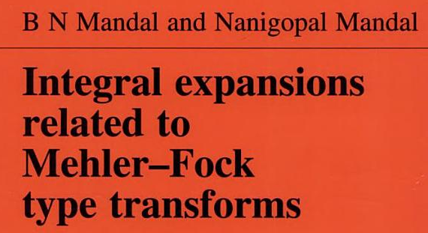

which certainly seems on topic, and a whole book! Here are some clips, where our friend Felson appears right away:

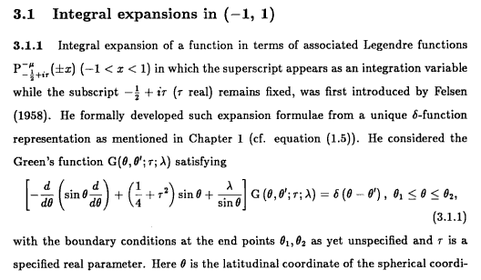
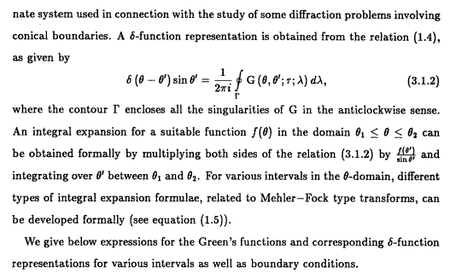
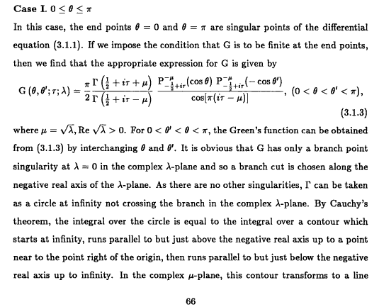

At this point we hit a missing page, but he is doing μ plane stuff, not so important to me. There is nothing else in this Google book view for this book. Here is the contents

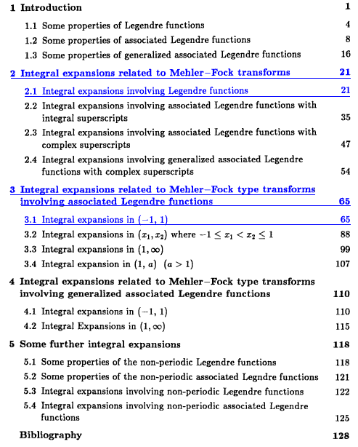

and perhaps Chapter 4 might have what I want. This book is not at Marriott.

Reference 2

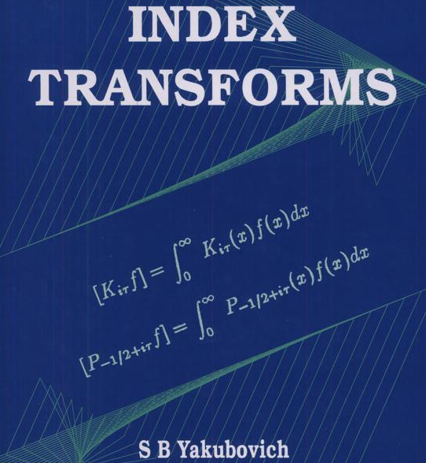

Certainly another on topic book!

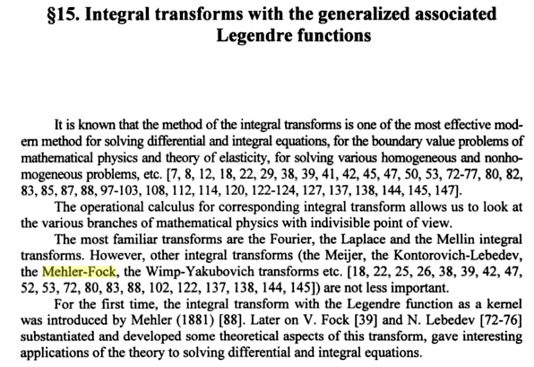

The book then goes on to prove technical Mehler related theorems and that fills out this chapter

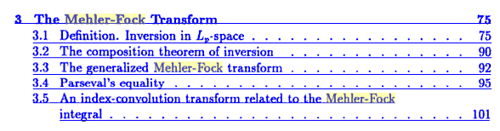

Really this is not what I am looking for right now, convergence theorems and such.

Reference 3

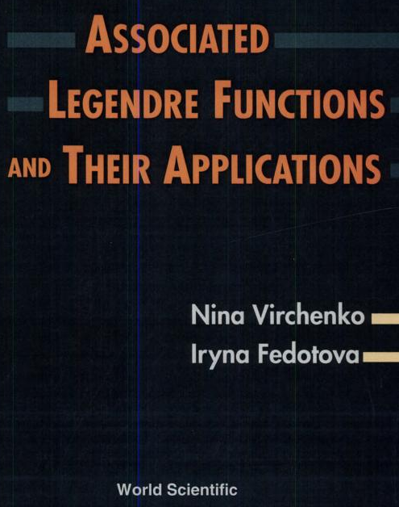

The contents are concealed, rather amazing. They do reel off some integral representations

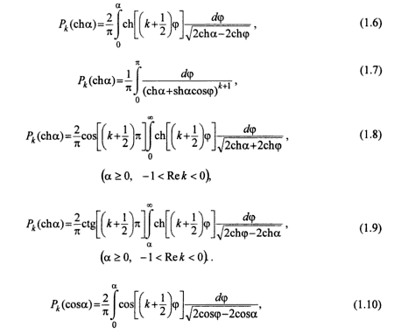

and then versions of the same with μ present. Then some interesting claims

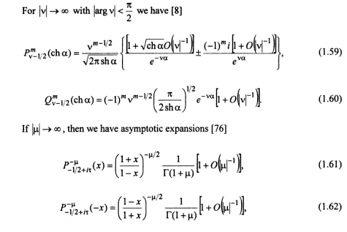
And here is a little discussion I was about to write, but they have done it for me

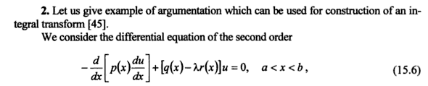
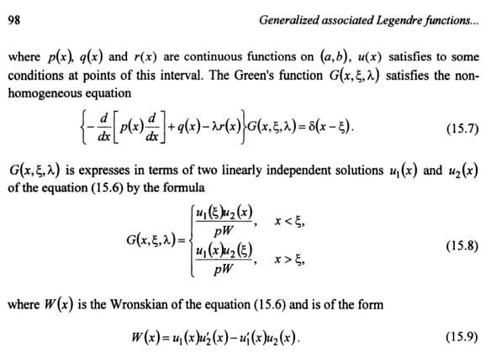

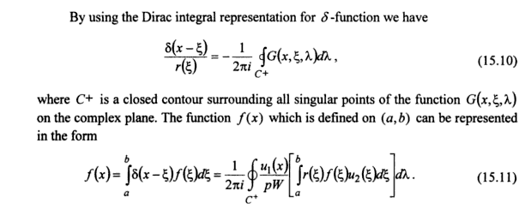
But nothing else useful to me in this preview. $73 for the PDF!

Reference 4.

Here is a paper I can probably get from Jstor

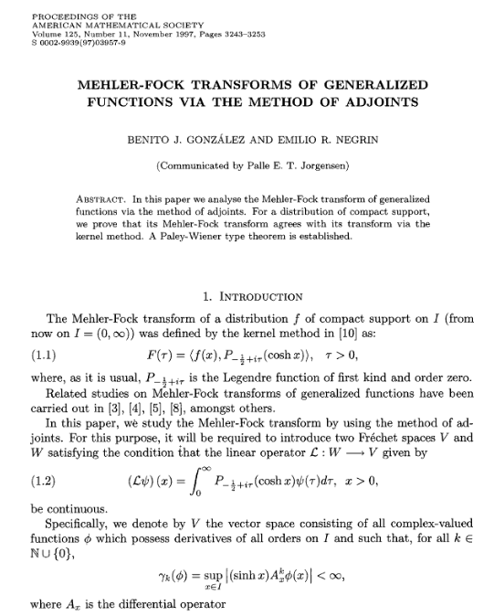

but it is not likely to have what I need.

Reference 5. This is from Encyclopedia of Mathematics by Hazewinkel

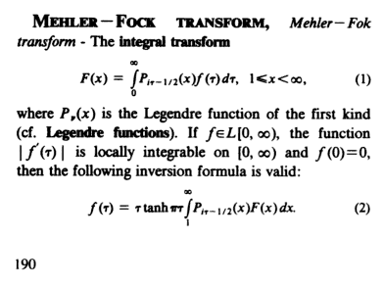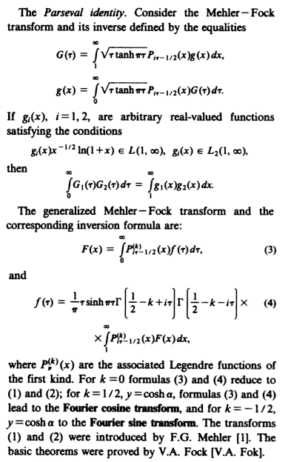
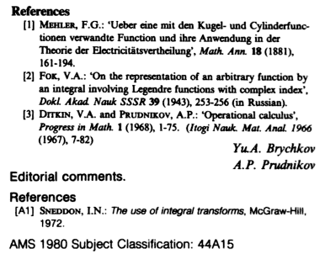

There is good old Sneddon again! That book might have something for me and is just sitting there

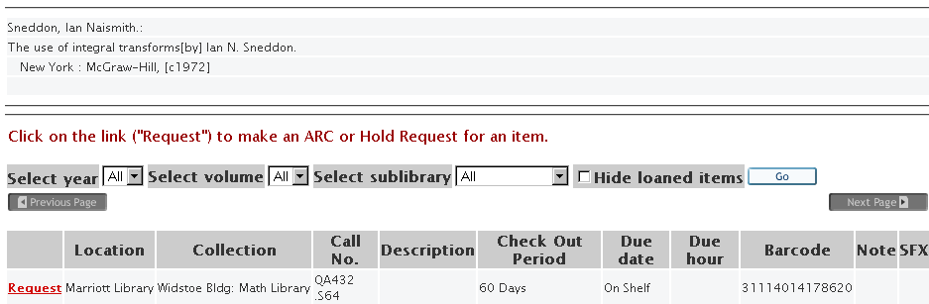

Reference 6 These are the guys who did the above encyclopedia entry:

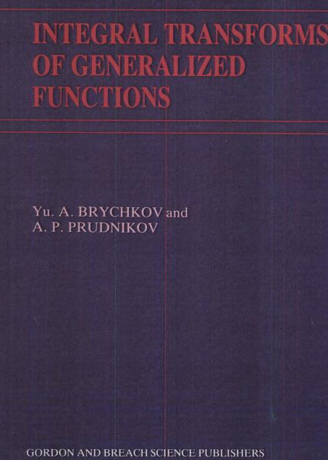

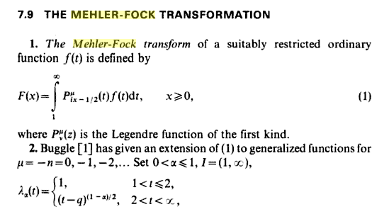

The section then gets very technical, reviewing lots of people's results. Nothing on how to do integrals!

Reference 7 Lectures by Sneddon specifically on M-F

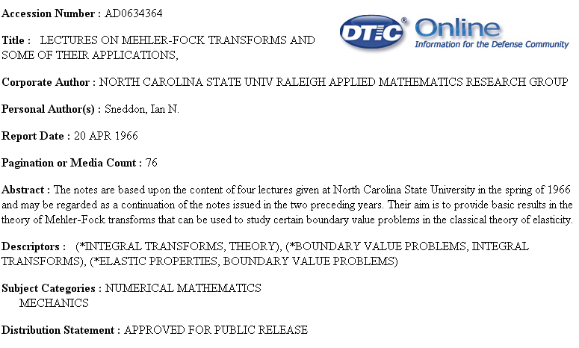

I don't know how to narrow down to finding a table of integrals or instructions how to do them! My web search has not really produced anything useful.

