Doing Mehler transform integrals PhL 1.27.11

Overview: 1
1. Statement of the transforms and summary of results found in later sections 1
2. Some Comments: 2
3. A look at the sources for Mehler expansion integrals. 3
3.1. GR7. 3
3.2. Bateman: 5
3.3. PBM. Special Functions v3 2003 6
3.4. nist gov site. 8
3.5. The Boeing doc of Ober and Higgins 8
4. Integral Evaluation: $^{\int_{0}^{∞}{}}$dτ P_{iτ-1/2}(y) 9
5. Integral Evaluation: $^{\int_{0}^{∞}{}}$dτ P_{iτ-1/2}(y) cos(aτ) 9
6. Failed Integral Evaluation: $^{\int_{0}^{∞}{}}$dτ P_{iτ-1/2}(y) cos(aτ)sech(πτ) 10
7. Successful Integral Evaluation: $^{\int_{0}^{∞}{}}$dτ P_{iτ-1/2}(y) cos(aτ)sech(πτ) 11
8. Failed Integral Evaluation: $^{\int_{0}^{∞}{}}$dτ P_{iτ-1/2}(y) cos(aτ)sech²(πτ) 13
9. Failed Integral Evaluation: $^{\int_{0}^{∞}{}}$dτ P_{iτ-1/2}(y) cos(aτ)sech²(πτ) 15
10. Successful Integral Evaluation: $^{\int_{0}^{∞}{}}$dτ P_{iτ-1/2}(y) cos(aτ)sech²(πτ) 15
11. Integral Evaluation: $^{\int_{0}^{∞}{}}$dτ P_{iτ-1/2}(y) cosh(aτ)sech²(πτ) 20
Appendix A: Hypergeometric Representation of the P function. 20
Appendix B: How do you do an integral of any special function? 22
Appendix C: Other References: 24

Overview: While working on the charged bowl in toroidals, I needed the sech2 integral shown here. I saw the integral quoted in Boeing, but I also noticed errors there as well, and decided I had better do this integral for myself. I found that I could not do it, so I started with simpler ones. Section 11 shows the final successful evaluation of the sech2 integral and this took me 2-3 solid days to figure out. I learned the lesson to recognize F(a,b;c;z) integral representations. Along the way I found new errata in GR7 which I reported to Dan Z, and corrected 2 errors in Boeing and found 1 error in PBM. The rest of this doc gives a clean statement of the Mehler expansion and projection, generalized and non-generalized, and I quote nearly all the basic P integrals I could find from all known sources.

1. Statement of the transforms and summary of results found in later sections

From Boeing Table C I quote ( note typo on page 27 where factor τ is missing, but it is correctly stated on page 2)

Generalized Mehler-Fock Transform: g(y) is a function defined on (1,∞)

g(y) = $^{\int_{0}^{∞}{}}$dτ Pμ-1/2+iτ(y) f(τ) // expansion
f(τ) = (τ/π)sinh(πτ) Γ(1/2-μ+iτ) Γ(1/2-μ-iτ) $^{\int_{1}^{∞}{}}$dy Pμ-1/2+iτ(y) g(y) // projection

Reference: Boeing page 27. but with factor τ added back in

Mehler-Fock Transform: (set μ = 0 in the above)

g(y) = $^{\int_{0}^{∞}{}}$dτ P-1/2+iτ(y) f(τ) // expansion
f(τ) = τ tanh(πτ) $^{\int_{1}^{∞}{}}$dy P-1/2+iτ(y) g(y) // projection

Reference: Boeing page 19; Canonical see below;

where we have used the identity Γ(1/2+iτ)Γ(1/2-iτ) = π/cosh(πτ) to get the last line. For some reason I have now gotten used to using variable τ . I used to use p, and Boeing uses x. Also, Boeing uses k for μ.

Note: If we set y = chξ and g(y) = G(ξ) then the Mehler Transform becomes

G(ξ) = $^{\int_{0}^{∞}{}}$dτ P-1/2+iτ(chξ) f(τ) // expansion
f(τ) = τ tanh(πτ) $^{\int_{0}^{∞}{}}$dξ shξ P-1/2+iτ(chξ) G(ξ) // projection

We can go on to say F(τ) = f(τ)/ [τ tanh(πτ)] and then we get

F(τ) = $^{\int_{0}^{∞}{}}$ dξ shξ P-1/2+iτ(chξ) G(ξ) // projection
G(ξ) = $^{\int_{0}^{∞}{}}$ dτ τ tanh(πτ) P-1/2+iτ(chξ) F(τ) // expansion

This is consistent with (3.1) and (3.2) in "charged bowl in toroidals 1_11.doc".
This is consistent with page 8 m=0 quote in "charged bowl in toroidals (INCOMPLETE).doc"

Here is a clip from Canonical which supports my first form above

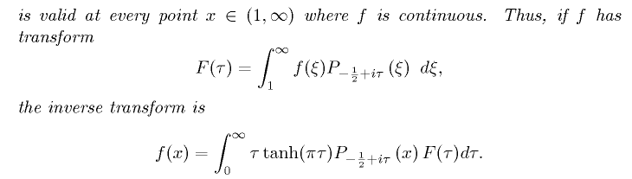

Here are the integrals calculated below in this doc, expressed in my simplest form for each:

$^{\int_{0}^{∞}{}}$dτ Piτ-1/2(y) = (1/$\sqrt{2}$) (1/$\sqrt{y - 1}$) // sec 4

$^{\int_{0}^{∞}{}}$dτ Piτ-1/2(y) cos(aτ) = (1/$\sqrt{2}$) 1/ $\sqrt{y - cha}$ θ(y>cha) // sec 5

$^{\int_{0}^{∞}{}}$dτ Piτ-1/2(y) cos(aτ) sech(πτ) = (1/$\sqrt{2}$) (y+cha)-1/2 // sec 7

$^{\int_{0}^{∞}{}}$dτ Piτ-1/2(y) cos(aτ) sech2(πτ) = ($\sqrt{2}$/π ) (1/$\sqrt{y-cha}$) tan-1[ $\sqrt{y-cha}$/$\sqrt{1+cha}$] // sec 10

$^{\int_{0}^{∞}{}}$dτ Piτ-1/2(y) ch(bτ) sech2(πτ) = ($\sqrt{2}$/π ) (1/$\sqrt{y-cosb}$) cot-1[$\sqrt{1+cosb}$/$\sqrt{y-cosb}$] (11.5)

This last result (11.5) is valid for -2π < b < 2π provided you allow the analytic sign change of $\sqrt{1+cosb}$ as you pass through b = ± π. See "Maple plots of sech..." which shows how the integral is a smoothly increasing function of b in the range b in (0,2π).

2. Some Comments:

1. There is some terminology confusion.

• GR7p 974 with regard to Pνμ(z) refers to ν and μ as the degree ν and order μ, but perhaps only when these are integers. But in their section on Pμ-1/2+iτ integrals on p 788 they refer to the lower index as the order. This small section (see below) has both Pνμ and Pν so they had a naming problem. I think the general idea is that for Legendre functions (μ=0) the only index ν is called the order, but when there is an upper index, then the lower index is called degree. A&S agree regarding Pνμ(z)'s two index names.

1. As with the Laplace Transform, projection is the easy direction. There you have to do a fancy Mellin vertical contour "inversion formula" for your actual expansion; here the expansion requires integration against the degree ν index (μ is the order). This is "hard" because we don't have much information on Legendre functions in terms of degree (or order) as "the variable". Here are a couple of forms that seemed Mehler-relevant ( see Appendix A below )

P-1/2+iτ(chα) = (chα)-1/2+iτ F(1/4– iτ/2, 3/4-iτ/2; 1; th2α)

P-1/2+iτ (chα) = e-(1/2)αeiατ F(1/2-iτ, 1/2; 1; 1 - e-2α)

where at least in the last form the variable τ appears in only one parameter. But for F(a,b;c;z) we just don't know much about this as a function of complex variable a.
In the easy direction for projections, the integral are "standard forms" you find in tables because they are integrals with respect to the argument z of Pνμ(z).

2. For toroidal atoms, the interval is y in (1,∞) and we usually write y = chξ or some such to get a (0,∞) range. For y in this range, the function Pμ-1/2+iτ(y) is real and oscillatory. But for spherical atoms, we use y=cos with on the cut P and Q with y in the range (-1,1), real and exponential in this case. In these two range cases the functions are called Mehler and Conical functions.

3. There are various sources of Mehler expansion integrals, but each source is fairly small. It is nothing like a Laplace Transform table with a few hundred entries. The largest sources are the Boeing report and PBM, all other sources are small.

3. A look at the sources for Mehler expansion integrals.

3.1. GR7. They are definite integrals of associated Legendre functions with respect to "order" (by which they the degree lower index, see note above). This is page 788, here is the entire offering, about 1 full page of integrals.

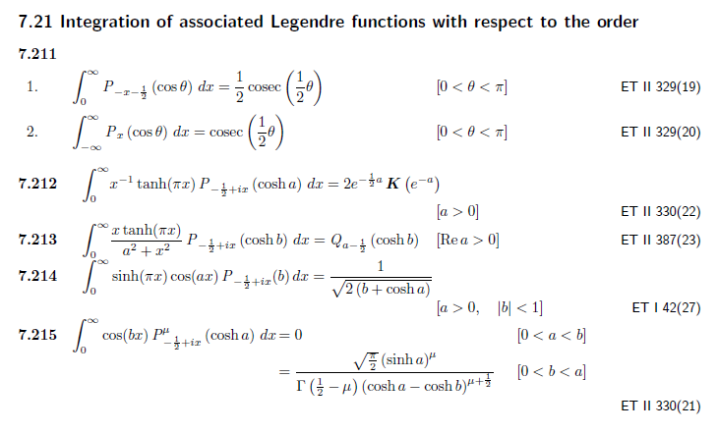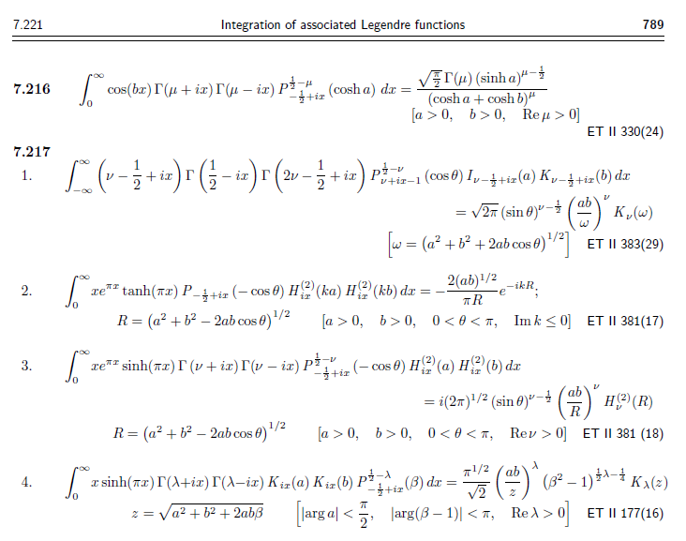
3.2. Bateman: Has only a 1 page mention of "conical functions" in the Legendre Chapter p 174, states the regular M transform only. But in ET II there are these integrals on page 233-4 (Russian), a very minimal offering:

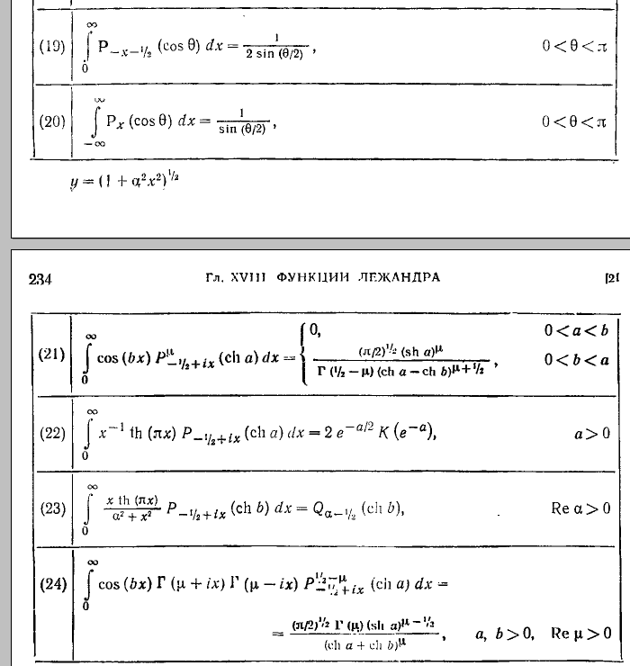

3.3. PBM. Special Functions v3 2003 has large 10-page collection, 181-190! Here I show the integrals of P against elementary functions only. The remaining pages show integrals of our P friend against Bessel functions, Gamma functions, and other P functions, with various combinations.

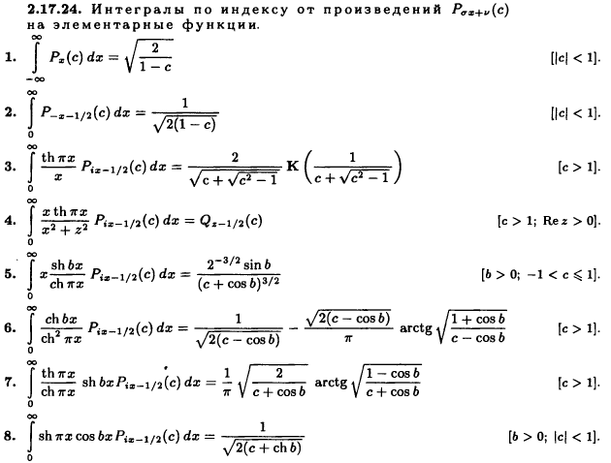

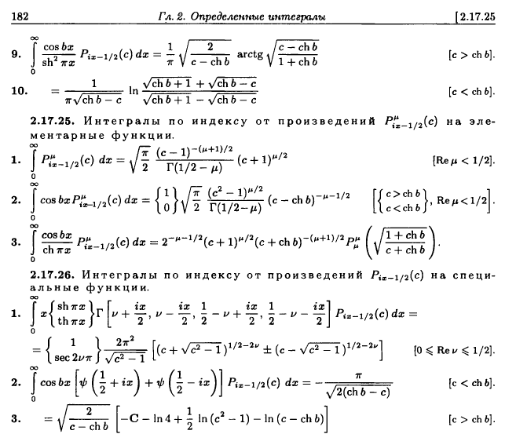

3.4. nist gov site. This site has exactly one integral, which strange appears in none of the above
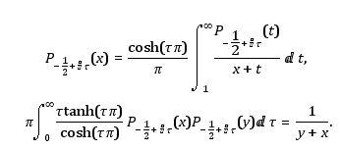

The first thing is the integral of interest. The second is an expansion of some sort. These two are mysterious to me at the moment.

3.5. The Boeing doc of Ober and Higgins is the largest collection, but does not have the nist item above. I have this only in hard copy. The regular P section only gives integrals that do not apply to general P.

4. Integral Evaluation: $^{\int_{0}^{∞}{}}$dτ Piτ-1/2(y)

This is the simplest one of all. It appears in the Boeing tables p 28 and in PBM 2.17.25 #1 (with μ=0) above. We want then to prove this claimed fact: ( I use y = chα)

I = $^{\int_{0}^{∞}{}}$dτ Piτ-1/2(y) = (1/$\sqrt{2}$)(1/$\sqrt{y-1}$) y = chα > 1

I started with this integral representation from GR7 page 960


which reduces for μ=0 and ν = -1/2+iτ to

P-1/2+iτ(chα ) = ($\sqrt{2}$/π) $^{\int_{0}^{α}{}}$dx cos(τx) / $\sqrt{chα - chx}$

Whereas P-1/2+iτ has a complicated and somewhat mysterious τ dependence, once we elevate into the integral expansion above, τ appears only in simple functions cos(τx). Inserting this expansion we get

I = $^{\int_{0}^{∞}{}}$dτ ($\sqrt{2}$/π) $^{\int_{0}^{α}{}}$dx cos(τx) / $\sqrt{chα - chx}$

= ($\sqrt{2}$/π) $^{\int_{0}^{α}{}}$dx/ $\sqrt{chα - chx}$$^{\int_{0}^{∞}{}}$dτ cos(τx)

But $^{\int_{-∞}^{∞}{}}$dτ eiτx = 2πδ(x) = $^{\int_{-∞}^{∞}{}}$dτ cos(τx) = 2 $^{\int_{0}^{∞}{}}$dτ cos(τx) => $^{\int_{0}^{∞}{}}$dτ cos(τx) = πδ(x)

Thus we get

I = ($\sqrt{2}$/π) $^{\int_{0}^{α}{}}$dx/ $\sqrt{chα - chx}$π δ(x)

= ($\sqrt{2}$) (1/$\sqrt{chα - 1}$) (1/2) // half a delta

= (1/$\sqrt{2}$) (1/$\sqrt{chα - 1}$) QED.

5. Integral Evaluation: $^{\int_{0}^{∞}{}}$dτ Piτ-1/2(y) cos(aτ)

I = $^{\int_{0}^{∞}{}}$dτ Piτ-1/2(y) cos(aτ) = (1/$\sqrt{2}$) 1/$\sqrt{y - cha}$ θ(y > cha)

Insert our same integral representation

I = $^{\int_{0}^{∞}{}}$dτ Piτ-1/2(y) cos(aτ)

= $^{\int_{0}^{∞}{}}$dτ ($\sqrt{2}$/π) $^{\int_{0}^{α}{}}$dx cos(τx) / $\sqrt{chα - chx}$ cos(aτ)

= ($\sqrt{2}$/π) $^{\int_{0}^{α}{}}$dx 1/ $\sqrt{chα - chx}$ $^{\int_{0}^{∞}{}}$dτ cos(τx) cos(aτ)

I think my transforms "summary case 2" is the right one, where I have

$^{\int_{0}^{∞}{}}$dτ cos(τx) cos(aτ) = (π/2)δ(x-a)

so we continue

= ($\sqrt{2}$/π) $^{\int_{0}^{α}{}}$dx 1/ $\sqrt{chα - chx}$ (π/2)δ(x-a)

= (1/$\sqrt{2}$) 1/ $\sqrt{chα - cha}$ θ(a < α) or θ(cha < chα)

= (1/$\sqrt{2}$) 1/ $\sqrt{y - cha}$ θ(cha < y) QED

and this is our second mini-victory. No half delta appears here. This result appears in GR7 page 788

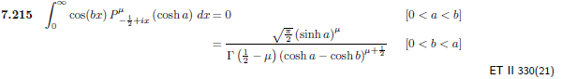

6. Failed Integral Evaluation: $^{\int_{0}^{∞}{}}$dτ Piτ-1/2(y) cos(aτ)sech(πτ)

My first attempt here failed, and it is worth noting what happens. I try using the same integral representation that I used above. So off we go:

I = $^{\int_{0}^{∞}{}}$dτ Piτ-1/2(y) cos(aτ)sech(πτ) = (1/$\sqrt{2}$) 1/$\sqrt{y + cha}$

= $^{\int_{0}^{∞}{}}$dτ { $^{\int_{0}^{α}{}}$dx cos(τx) / $\sqrt{y - chx}$} cos(aτ)sech(πτ)

= ($\sqrt{2}$/π) $^{\int_{0}^{α}{}}$dx / $\sqrt{y - chx}$ $^{\int_{0}^{∞}{}}$dτ cos(xτ) cos(aτ) sech(πτ)
.
This time I think we have a convergent τ integral, not a delta function. Write

cos(xτ) cos(aτ) = ch(ixτ) ch(iaτ) = (1/2){ ch[i(x+a)τ] + ch[i(x-a)τ] }

Then I need

$^{\int_{0}^{∞}{}}$dτ cosh[i(x±a)τ]/cosh(πτ)

and here is an integral GR7 p 371

So set b = π and a = A to get

$^{\int_{0}^{∞}{}}$dτ cosh(Aτ)/cosh(πτ) = (1/2) sec (A/2) = (1/2) sec[i(x±a)] = (1/2)sech(x±a)

So now we have

$^{\int_{0}^{∞}{}}$dτ cos(xτ) cos(aτ) sech(πτ) = (1/4) [ sech(x+a) + sech(x-a) ]

and then we get

I = ($\sqrt{2}$/π) $^{\int_{0}^{α}{}}$dx / $\sqrt{y - chx}$ {(1/4) [ sech(x+a) + sech(x-a) ]}

= ($\sqrt{2}$/4π) $^{\int_{0}^{α}{}}$dx / $\sqrt{chα - chx}$ { [ sech(x+a) + sech(x-a) ]} =?= (1/$\sqrt{2}$) 1/$\sqrt{chα + cha}$

where I show the known result. I was unable to evaluate this integral using GR7 at least. I tried (1) parts; (2) substitutions; (3) contour search. I think there is some fancy substitution that would work, but I gave up and got a hint on the web, see next section.

7. Successful Integral Evaluation: $^{\int_{0}^{∞}{}}$dτ Piτ-1/2(y) cos(aτ)sech(πτ)

We want to show the Boeing result

$^{\int_{0}^{∞}{}}$dτ Piτ-1/2(y) cos(aτ)sech(πτ) = (1/$\sqrt{2}$) 1/$\sqrt{y + cha}$

I got the hint on the web and did what it said, so I report that here.

(a) a different integral representation for P

So go to Bateman page 156, just like he (the web hinter) says, set μ = 0 in (11)

Pν(z) = (2/π)1/2 Γ(1/2) / [Γ(ν+1)Γ(-ν)]* $^{\int_{0}^{∞}{}}$dt (z+cht)-1/2 ch[(ν+1/2)t] dt

Now from gamma page

Γ(ν+1)Γ(-ν) = - π/sin(πν)

so write as

Pν(z) = -(2/π)1/2(1/π) Γ(1/2) sin(πν)* $^{\int_{0}^{∞}{}}$dt (z+cht)-1/2 ch[(ν+1/2)t] dt

Now set ν = -1/2+iτ and note that

-sin(πν) = -sin(-π/2+iπτ) = sin(π/2-iπτ) = cos(iπτ) = ch(πτ)

ch[(ν+1/2)t] = ch[iτt] = cos(τt)

to get

P-1/2+iτ(z) = (2/π)1/2(1/π) Γ(1/2) ch(πτ)* $^{\int_{0}^{∞}{}}$dt (z+cht)-1/2 cos(τt) dt

= ($\sqrt{2}$/π ) ch(πτ)* $^{\int_{0}^{∞}{}}$dt (z+cht)-1/2 cos(τt) dt

The key thing is that we have ch(πτ) sitting there, and this is going to cancel our unpleasant sech(πτ) factor and make things work by again making the τ integral become a delta function.

(b) So, we apply this new integral representation:

Using
P-1/2+iτ(y) == ($\sqrt{2}$/π ) ch(πτ)* $^{\int_{0}^{∞}{}}$dt (y+cht)-1/2 cos(τt) dt

we compute

I = $^{\int_{0}^{∞}{}}$dτ Piτ-1/2(y) cos(aτ)sech(πτ)

= $^{\int_{0}^{∞}{}}$dτ { ($\sqrt{2}$/π )ch(πτ) $^{\int_{0}^{∞}{}}$dt (y+cht)-1/2 cos(τt)} cos(aτ)sech(πτ)

= ($\sqrt{2}$/π ) { $^{\int_{0}^{∞}{}}$dt (y+cht)-1/2} $^{\int_{0}^{∞}{}}$dτ cos(τt)cos(aτ)

= ($\sqrt{2}$/π ) { $^{\int_{0}^{∞}{}}$dt (y+cht)-1/2} (π/2)δ(t-a)

$^{\int_{0}^{∞}{}}$dτ cos(τx) cos(aτ) = (π/2)δ(x-a)
= (1/$\sqrt{2}$) (y+cha)-1/2 QED

So in all three examples so far, we have obtained delta functions by using integral representations.

8. Failed Integral Evaluation: $^{\int_{0}^{∞}{}}$dτ Piτ-1/2(y) cos(aτ)sech2(πτ)

This integral appears in our PBM table above as [ note: this result is incorrect ]

It also appears just this way on page 20 of Boeing. Comparing it to the cos() version in Boeing on the same page, I felt that the cosh() result was wrong, but now what I thought was wrong seems supported as being right by the PBM result above. So I am very motivated to do this integral for myself! Moreover, this integral appears in my toroidal analysis of the bowl: the potential of a charged bowl seems to be

V(ξ,u)= (V0 /$\sqrt{2}$) $\sqrt{chξ - cosu}$$^{\int_{0}^{∞}{}}$dτ Piτ-1/2(chξ) { cosh[(2π-u)τ] + cosh[(2u0-u)τ]} / ch2(πτ)

So now I am doubly motivated to find a way to do this integral for myself.

The factor of sech2(πτ) is the problem here, only one factor cancels in our 2nd integral representation. But Here I will start off using our FIRST integral representation, expecting not much from it:

I = $^{\int_{0}^{∞}{}}$dτ Piτ-1/2(y) cosh[aτ] sech2(πτ) y > 1

= ($\sqrt{2}$/π) $^{\int_{0}^{α}{}}$dx / $\sqrt{chα - chx}$ * $^{\int_{0}^{∞}{}}$dτ cos(xτ) cosh(aτ) sech2(πτ)

So we are now faced with this non-delta-function convergent integral

J = (1/2) $^{\int_{-∞}^{∞}{}}$dτ cos(τx) ch[aτ] / ch2(πτ)

= $^{\int_{0}^{∞}{}}$dt/π * cos(xt/π) ch[at/π] / ch2(t)

= (1/4π) $^{\int_{0}^{∞}{}}$dt/ ch2(t) * [ exp(ixt/π) + exp(-ixt/π)] [ exp(at/π) + exp(-at/π)]

So can we do integrals of the form $^{\int_{0}^{∞}{}}$dt/ ch2(t) * exp(αt) ?

Aside on the "beta" function (not the usual B(x,y) )
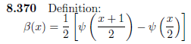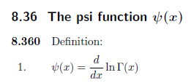

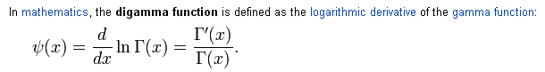
Not to be confused with dilogarithm which is a different animal. The main point is that the integral we need above is just this beta function,

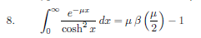

It appears from its definition that β(x*) = β(x)*. Then have the sum of four terms in which

μ1 = (ix+a)/π -1
μ2 = (ix-a)/π -1
μ3 = (-ix+a)/π = μ1*
μ4 = (-ix-a)/π = μ2*

so we then have

J(x) = (1/4π) { [(ix+a)/π] β[(ix+a)/2π] -1 + [(ix-a)/π] β[(ix-a)/2π] -1 } + c.c

But then we are faced with this second integral

I = ($\sqrt{2}$/π) $^{\int_{0}^{α}{}}$dx / $\sqrt{chα - chx}$ * J

so we need integrals of the form

$^{\int_{0}^{α}{}}$dx / $\sqrt{chα - chx}$ * ψ[(ix+a)/4π

At this point I gave up, cannot find integrals of this form.

9. Failed Integral Evaluation: $^{\int_{0}^{∞}{}}$dτ Piτ-1/2(y) cos(aτ)sech2(πτ)

Now we try again using the SECOND integral representation for P.

I = $^{\int_{0}^{∞}{}}$dτ Piτ-1/2(y) cos(aτ)sech2(πτ)

where the only difference is sech is now squared. So just add in this factor to the analysis shown above in Section XXX , and we get down to this point where you see the new sech(πτ) on the right.

= ($\sqrt{2}$/π ) { $^{\int_{0}^{∞}{}}$dt (y+cht)-1/2} $^{\int_{0}^{∞}{}}$dτ cos(τt)cos(aτ) sech(πτ)

I did this integral above in Section YYY and got

$^{\int_{0}^{∞}{}}$dτ cos(tτ) cos(aτ) sech(πτ) = (1/4) [ sech(t+a) + sech(t-a) ]

So now we face this kind of integral which is nicer due to the infinite endpoint

$^{\int_{0}^{∞}{}}$dt (y+cht)-1/2 [ sech(t+a) + sech(t-a) ]

But I could not do this integral and could not find it, so again I had to give up. Is there some 3rd integral representation which has two powers of ch(πτ) ?

I am headed to the web for more hints. [ Below I will do the above integral.]

10. Successful Integral Evaluation: $^{\int_{0}^{∞}{}}$dτ Piτ-1/2(y) cos(aτ)sech2(πτ)

It took me a long time to figure out how to do this integral, and the details are shown in "the Boeing sech^2 integral.doc". I will outline the key points here. The integral we want to do is this

I = $^{\int_{0}^{∞}{}}$dτ Piτ-1/2(y) cos(aτ) sech2(πτ) y > 1 (10.1)

The integral representation I use for P is this

P-1/2+iτ(chα) = ($\sqrt{2}$/π ) ch(πτ) $^{\int_{0}^{∞}{}}$dt (chα+cht)-1/2 cos(τt) (10.2)

When this is installed into the integral I, we get after shuffling factors

I = ($\sqrt{2}$/π ) $^{\int_{0}^{∞}{}}$dt (y+cht)-1/2 $^{\int_{0}^{∞}{}}$dτ cos(τt) cos(aτ) sech(πτ) (10.3)

and we now turn to evaluation of the dτ integration (which is NOT a delta function form)

J ≡ $^{\int_{0}^{∞}{}}$dτ cos(τt) cos(aτ) / cosh(πτ) (10.4)

The next step is to write out the product of cosines in this manner

cos(tτ) cos(aτ) = ch(ixτ) ch(iaτ) = (1/2){ ch[i(t+a)τ] + ch[i(t-a)τ] } (10.5)

and we are then left with

J ≡ (1/2)$^{\int_{0}^{∞}{}}$dτ { ch[i(t+a)τ] + ch[i(t-a)τ] }/ cosh(πτ) (10.6)

We find in GR7 p 371 the following integral of cosh(Aτ)/cosh(πτ),

$^{\int_{0}^{∞}{}}$dτ cosh(Aτ)/cosh(πτ) = (1/2) sec (A/2) (10.7)

which when applied to our case gives for the first term in (10.6),

$^{\int_{0}^{∞}{}}$dτ cosh[i(t+a)τ]/cosh(πτ) = (1/2) sec[i(t+a)/2] = (1/2) sech[(t+a)/2] (10.8)

Doing the same for the second term gets us to this result,

J = (1/4) { sech[(t+a)/2] + sech[(t-a)/2] } (10.9)

so that our integral of interest now becomes

I = ($\sqrt{2}$/4π ) $^{\int_{0}^{∞}{}}$dt (y+cht)-1/2 { sech[(t+a)/2] + sech[(t-a)/2] } (10.10)

We then combine 1/cosh + 1/cosh inside the curly brackets using standard identities to get

sech[(t+a)/2] + sech[(t–a)/2] = 4 ch(t/2)ch(a/2)/ ( ch(t) + ch(a) ) (10.11)

and then our integral becomes

I = ($\sqrt{2}$/π ) ch(a/2) $^{\int_{0}^{∞}{}}$dt (y+cht)-1/2 ch(t/2) /( ch(t) + ch(a) ) (10.12)

Upon change variables from t to x = cht, this becomes

I = (1/π ) ch(a/2) $^{\int_{1}^{∞}{}}$ dx 1/[ $\sqrt{x-1}$ $\sqrt{y+x}$ ( x + ch(a) ) ] (10.13)

This we recognize (somewhat belatedly) as heading to be an integral representation for F(a,b;c;z). We need to shift one of the factors to a simple power. Defining α = cha, we change variable from x to s = x+α, then rename the dummy integration variable back to x and shuffle factor order to get

I = (1/π ) ch(a/2) $^{\int_{1+α}^{∞}{}}$ dx x-1 [x+(y-α)]-1/2 [x-(α+1)]-1/2 α ≡ cha (10.14)

Digression

At this point we must digress to derive an appropriate integral representation for F(a,b;c;z), since the integral of interest in GR7 has a typo which we will correct along the way. We start with Bateman HTI 59 (10),
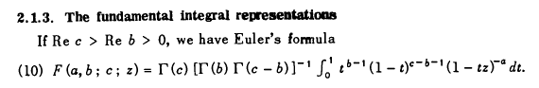
which we rewrite as

B(b,c-b) F(a,b;c;z) = $^{\int_{0}^{1}{}}$dt tb-1 (1-t)c-b-1 (1-tz)-a (10.15)

Changing variables to x = 1/t this becomes (which agrees with Bateman HTI p 115)

B(b,c-b) F(a,b;c;z) =$^{\int_{1}^{∞}{}}$dx xa-c (x-1)c-b-1 (x-z)-a (10.16)

Change variables again to s = ux and this becomes

B(b,c-b) F(a,b;c;z) = ub $^{\int_{u}^{∞}{}}$dy ya-c (y-u)c-b-1 (y-uz)-a (10.17)

Define β = -uz and this becomes

B(b,c-b) F(a,b;c;-β/u) = ub $^{\int_{u}^{∞}{}}$dy ya-c (y-u)c-b-1 (y+β)-a (10.18)

We then change constants from a,b,c to λ,μ,ν as follows

a = -ν b = λ-μ-ν c = λ-ν (10.19)

and our result becomes (last factor moved to be the middle factor)

$^{\int_{u}^{∞}{}}$dx x-λ (x+β)ν (x-u)μ-1 = u-(λ-μ-ν) B(λ-μ-ν,μ) F(-ν, λ-μ-ν; λ-ν; -β/u) (10.20)

The F function can be simplified using the first Kummer formula

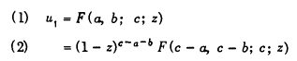 (10.21)

which maintains arguments c and z of the F function. We then find that

$^{\int_{u}^{∞}{}}$dx x-λ (x+β)ν (x-u)μ-1 = u-λ (β+u)μ+ν B(λ-μ-ν,μ) F(λ,μ; λ-ν; -β/u) (10.22)

This is the form we want, and we can compare it to GR7 p 317 (10.23)

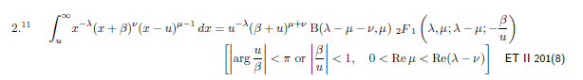

and we see that the GR7 integral has a typo in the c parameter of F. It should be λ-ν, not λ-μ. We note that in GR4 this c parameter appears correctly, though the result differs by the Kummer shuffle just noted. Marriott claims to have both ET volumes, so I could check to see where the error occurred.

Resume after Digression

So here is where we stand. We have our desired integral

I = (1/π ) ch(a/2) $^{\int_{1+α}^{∞}{}}$ dx x-1 [x+(y-α)]-1/2 [x-(α+1)]-1/2 α ≡ cha (10.14)
and we want to match the integral shown to our template integral

$^{\int_{u}^{∞}{}}$dx x-λ (x+β)ν (x-u)μ-1 = u-λ (β+u)μ+ν B(λ-μ-ν,μ) F(λ,μ; λ-ν; -β/u) (10.22)

We therefore set

β = y-α u = 1+α μ = 1/2 λ = 1 ν = -1/2 μ+ν = 0 (10.24)

and we find then that ( note that B(1,1/2) = 2 )

$^{\int_{1+α}^{∞}{}}$ dx x-1 [x+(y-α)]-1/2 [x-(α+1)]-1/2 = 2 (1+α)-1 F(1,1/2; 3/2; -(y-α)/(1+α)) (10.25)

and therefore we have

I = (1/π ) ch(a/2) 2 (1+cha)-1 F(1,1/2; 3/2; -(y-cha)/(1+cha))

Maple tells us that

F(1,1/2; 3/2; z) = [ tanh-1$\sqrt{z}$] /$\sqrt{z}$ (10.26)

Note added: for real z, both sides of 10.26 require that |z| < 1.

Applying this to our case, we have

z = -(y-α)/(1+α).
$\sqrt{z}$ = i $\sqrt{y-α}$/$\sqrt{1+α}$ (10.27)

where we make a certain choice in the branch of $\sqrt{z}$, but we make the same choice in both $\sqrt{z}$ factors, so the choice does not matter. Then we have

[tanh-1$\sqrt{z}$]/$\sqrt{z}$ = tan-1[ $\sqrt{y-α}$/$\sqrt{1+α}$] ( $\sqrt{1+α}$ / $\sqrt{y-α}$ ) (10.28)

and our integral of interest, adding back the leading (1/π ) ch(a/2) factor becomes

I = (2/π ) ch(a/2) (1+α)-1 tan-1[ $\sqrt{y-α}$/$\sqrt{1+α}$] ( $\sqrt{1+α}$ / $\sqrt{y-α}$ ) (10.29)

We now set α back to cha, and use ch(a/2)/ $\sqrt{1+cha}$ = (1/$\sqrt{2}$) to state the final result

I = ($\sqrt{2}$/π ) (1/$\sqrt{y-cha}$) tan-1[ $\sqrt{y-cha}$/$\sqrt{1+cha}$] y>cha (10.30a)

= (1/π) (1/$\sqrt{(1/2)y-(1/2)cha}$) tan-1[ $\sqrt{y-cha}$/$\sqrt{1+cha}$] y>cha (10.30b)

= $^{\int_{0}^{∞}{}}$dτ Piτ-1/2(y) cos(aτ) sech2(πτ)

where on the second line we write this in the form used in the Boeing table page 20 #5. So we have now verified this particular Mehler transformation after a lot of work.
If we want the case y < cha, we can set $\sqrt{y-cha}$ = i $\sqrt{cha-y}$ in both places it appears in (....), use
tan-1(iz) = i tanh-1z, and then finally use the fact that tanh-1z = (1/2) ln [ (1+z)/(1-z)] to get

I = (1 /π$\sqrt{2}$ ) (1/ $\sqrt{cha-y}$) ln [ ($\sqrt{1+cha}$+$\sqrt{cha-y}$)/($\sqrt{1+cha}$-$\sqrt{cha-y}$)] y < cha (10.31a)

= (1/2π ) (1/$\sqrt{(1/2)cha-(1/2)chy}$) ln [ ($\sqrt{1+cha}$+$\sqrt{cha-y}$)/($\sqrt{1+cha}$-$\sqrt{cha-y}$)] y < cha (10.31b)

This second line also appears in Boeing 20 #5, but it has an error in the leading power of 2. That power should be 2-1 and not 2-1/2. We can see an overall factor of (1/2) going from the y>cha form to the y<cha form which comes from the tanh-1z = (1/2) ln [ (1+z)/(1-z)] conversion.
I have plotted (10.30a) in Maple for a in the range (0,∞) more or less, and you get the expected monotonic decreasing function.

11. Integral Evaluation: $^{\int_{0}^{∞}{}}$dτ Piτ-1/2(y) cosh(aτ)sech2(πτ)

In the previous section we showed that

$^{\int_{0}^{∞}{}}$dτ Piτ-1/2(y) cos(aτ) sech2(πτ) = ($\sqrt{2}$/π ) (1/$\sqrt{y-cha}$) tan-1[ $\sqrt{y-cha}$/$\sqrt{1+cha}$] (10.30 a)

If we set a = ib then cos(aτ) becomes ch(bτ) on the left, and cha becomes cosb on the right, so

$^{\int_{0}^{∞}{}}$dτ Piτ-1/2(y) ch(bτ) sech2(πτ) = ($\sqrt{2}$/π ) (1/$\sqrt{y-cosb}$) tan-1[ $\sqrt{y-cosb}$/$\sqrt{1+cosb}$] (11.1)

If we define the LHS of (..) to be K, then we have

K = ($\sqrt{2}$/π ) (1/$\sqrt{y-cosba}$) tan-1[ $\sqrt{y-cosb}$/$\sqrt{1+cosb}$] (11.2)

which is my final answer. But Boeing wants to have the ratio inside the tan-1 be inverted, so we can write

tan-1(A/B) = π/2 - cot-1(A/B) = π/2- tan-1(B/A) (11.3)

which then leads to

K = (1/$\sqrt{2}$) (1/$\sqrt{y-cosb}$) - ($\sqrt{2}$/π) (1/$\sqrt{y-cosb}$) tan-1[$\sqrt{1+cosb}$/ $\sqrt{y-cosb}$] (11.4)

Comparing this to Boeing page 20 #6, we see that the Boeing result has the $\sqrt{y-cosb}$ of the second term incorrectly in the numerator instead of the denominator, which is just a wrong sign in an exponent.
Now, the form (11.1) for our integral is "problematic" as described in "maple plots of the sech..". The problem is that while the LHS is continuous through b = π, the RHS is not -- even if we account for the sign change as $\sqrt{1+cosb}$ passes through $\sqrt{0}$. The problem has to do with the usual branch used for the tan-1 function, and the problem can be fixed by replacing tan-1(A/B) = cot-1(B/A). This causes B to pass through a sign-changing 0, but the principle cot-1x branch is continuous there, etc etc etc. So here is our improved version of (11.1)

$^{\int_{0}^{∞}{}}$dτ Piτ-1/2(y) ch(bτ) sech2(πτ) = ($\sqrt{2}$/π ) (1/$\sqrt{y-cosb}$) cot-1[$\sqrt{1+cosb}$/$\sqrt{y-cosb}$] (11.5)
valid for -2π < b < 2π

Appendix A: Hypergeometric Representation of the P function.

I think in the Mehler context, you lose any benefit from having the P function be "a Legendre function" because data is not collected for Legendre functions in this way. So you need to work with the underlying F function. And in our case, we need a form which converges for arg > 1. Happily I have a doc "convergence for Bateman forms.doc" on this subject, and ...

Case 1. here is a candidate that appeals to me

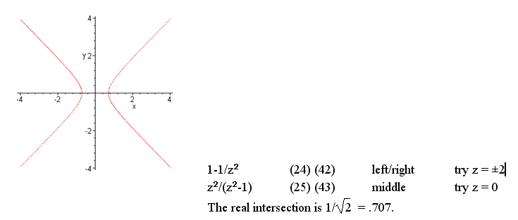
and this is suggesting form (24) which I now write out

Pν(z) = zν F(-ν/2, 1/2-ν/2; 1; 1-1/z2) // note that c = 1

What can we say about F(a,b;1;x). The series is this

1 + ab + a(a+1)b(b+1)/2! + etc

I don't think this reduces to anything in particular. Let's install z = chα to get

Pν(chα) = (chα)ν F(-ν/2, 1/2-ν/2; 1; th2α)

Then install ν = -1/2+iτ to get

P-1/2+iτ(z) = (chα)-1/2+iτ F(1/4– iτ/2, 3/4-iτ/2; 1; th2α)

The thα part is nice, but the rest is not promising.

Case 2. Form (28) provides something similar, with τ then only appearing in one index of F. Let's write it out as another candidate F form

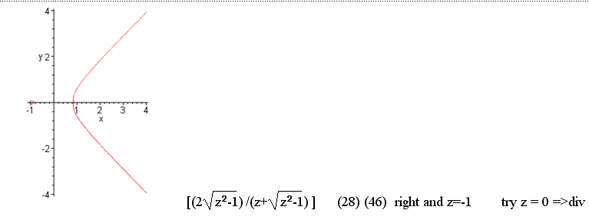

Pν(chα) = (chα + shα)ν F(-ν, 1/2; 1; 2shα/(chα+shα))

But now write chα+shα = eα and it gets better

Pν(chα) = eαν F(-ν, 1/2; 1; 2shα e-α)

P-1/2+iτ (chα) = e-(1/2)αeiατ F(1/2-iτ, 1/2; 1; 1 - e-2α)

This form has many nice features: two of the three parameters are constants, and τ appears only in the first parameter. The external τ factor is simple, the argument is pretty simple.

So now the problem is transcribed into doing dz integrals of a function F(z,1/2; 1; a) where the variable is a parameter and everything else is a constant. On page 68, Bateman HT1 says that for fixed |z|<1, the function F(a,b;c;z)/Γ(c) is analytic in a,b,c. Thus, our P function above is analytic in all τ, something we probably already knew, but this firms it up. No poles for you to wrap in some contour, sorry. There are no useful Bateman forms which have ν appearing only in c, the convergence range is not good for these.

So: how do you do a dz integral of F(z,1/2; 1; a) f(z)? Back to square zero! Wow, this is very mysterious, I have always wondered about it. How did those Boeing guys do that whole table?

Appendix B: How do you do an integral of any special function?

I am so used to just looking them up. Smythe page 156 gets the ball rolling.

(a) Example 1: One basic idea is to somehow cause a perfect differential to appear. Consider

a(x)∂x2f + b(x)∂xf + c(x) f = αf (1)
a(x)∂xg + b(x)∂xg + c(x)g = βg

Mult first by g, second by f, and subtract: (notice that the c(x) terms cancel, and assume there are some parameters we just call p buried in the coefficient functions)

a(x) g∂x2f +b(x) g∂x f + c(x) gf = α gf f and α f(x; p,α)
a(x) f ∂x2g+b(x) f ∂xg + c(x)f g = β fg g andβ g(x; p,β)

a(x) [g∂x2f- f ∂x2g] + b(x) [g∂x f - f ∂xg] = (α-β)fg (2)

Now use this fact, noting the cancellation between two terms which occurs,

∂x[ g∂xf - f ∂xg ] = ∂xg∂xf + g∂x2f - ∂xf∂xg- f∂x2g = g∂x2f - f∂x2g (3)

So we could then say

∂x{a(x)[ g∂xf - f ∂xg ]} = a(x) [ g∂x2f - f∂x2g ] + ∂xa(x) [ g∂xf - f ∂xg ] (4)

Now we will specialize so the Legendre case. Each case has its own specialization methods, shall we call them, this is just an illustration following Smythe page 156.

a(x) = (1-x2) b(x) = -2x c(x) = -m2/(1-x2) α = -n(n+1)

In this special case we have ∂xa(x) = b(x), so (4) becomes

∂x{a(x)[ g∂xf - f ∂xg ]} = a(x) [ g∂x2f - f∂x2g ] +b(x) [ g∂xf - f ∂xg ] (5)

But RHS(5) = LHS(2), so we get

∂x{a(x)[ g∂xf - f ∂xg ]} = (α-β)fg

Now we have a perfect differential on the left, and some integral we want on the right. So:

{a(x)[ g∂xf - f ∂xg ]}|cd = (α-β) dx f(x)g(x)

=> $^{\int_{c}^{d}{}}$dx f(x; p,α) g(x; p,β) = (α-β)-1 {a(x)[ g∂xf - f ∂xg ]}|cd

and for two Legendre functions this becomes

=> $^{\int_{c}^{d}{}}$dx Rmn(x) Smn'(x) = [-n(n+1)+ n'(n'+1)]-1{ (1-x2) [Smn'∂x Rmn - Rmn ∂x Smn' ]}|cd

and we can write

(n-n')(n+n'+1) = n2+nn' + n - nn' - n'2 - n' = n2 + n - (n'2 +n') = [-n(n+1)+ n'(n'+1)]

so we then get

$^{\int_{c}^{d}{}}$dx Rmn(x) Smn'(x) = [(n-n')(n+n'+1)]-1 { (1-x2) [Smn'∂x Rmn - Rmn ∂x Smn' ]}|cd

Smythe happens to be interested in endpoints c = x0 and d = 1, and here is his result page 156,

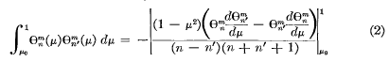

where the minus arises because he reordered the Wronskian terms. So our result is true for any two solutions of the Legendre equation, and m and n can be arbitrary complex numbers!

(b) Comments: In answer to the question of how you do any special function integrals, we have just seen an example. The idea is to create a perfect differential on one side. Another tool to this end is to use the special function recursion relations which always involve derivatives of the function and functions of shifted parameters. So I guess it is not a total mystery.

Appendix C: Other References:

This book "Index Transforms" by Yakubovich has a long tech chapter on the Mehler stuff.

http://books.google.com/books?id=f3h8ddSjfJ4C&pg=PA75&lpg=PA75&dq=%22Mehler-Fock+Transform%22+++-generalized&source=bl&ots=5uv5o9PC6n&sig=0bwwIOYfry5hondgYovrJ_7huAY&hl=en&ei=95dBTZ7tMJTAsAOrut3tCg&sa=X&oi=book_result&ct=result&resnum=2&ved=0CBwQ6AEwAQ#v=onepage&q=%22Mehler-Fock%20Transform%22%20%20%20-generalized&f=false

Here is from Polyanin's book, which refers to Abel as Euler I think.

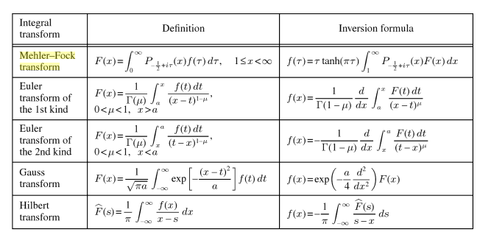

Appendix D. Another approach to

$^{\int_{0}^{∞}{}}$dτ Piτ-1/2(y) cos(aτ) / ch2(πτ)

Start with GR7 3.524 (16) page 377

Set b = 1 to get

$^{\int_{0}^{∞}{}}$dx x cosh(ax)/sh(x) = (π/2)2 sec2(aπ/2)

Now set a = ic so cosh(ax) = cosh(icx) = cos(cx) and sec(aπ/2) = sec(icπ/2) = sech(cπ/2)

Then we have

$^{\int_{0}^{∞}{}}$dx x cos(cx)/sh(x) = (π/2)2 sech2(cπ/2)

Now set c/2 = τ to get

$^{\int_{0}^{∞}{}}$dx x cos(2τx)/sh(x) = (π/2)2 sech2(πτ)

Can I find this integral directly? Yes, here it is on page 516 of GR7

So here I set β = 1 and a = τ to get

$^{\int_{0}^{∞}{}}$dx x cos(2τx) /shx = (π/2)2 sech2(τπ)

OK, now think of this as an integral rep so

1/ch2(πτ) = (2/π)2 $^{\int_{0}^{∞}{}}$dx x cos(2τx) /shx

Our desired integral is

$^{\int_{0}^{∞}{}}$dτ Piτ-1/2(y) cos(aτ) / ch2(πτ)

= $^{\int_{0}^{∞}{}}$dτ Piτ-1/2(y) cos(aτ) { (2/π)2 $^{\int_{0}^{∞}{}}$dx x cos(2τx) /shx }

= (2/π)2$^{\int_{0}^{∞}{}}$dx (x/shx) $^{\int_{0}^{∞}{}}$dτ Piτ-1/2(y) cos(aτ) cos(2τx)

Now write

2cos(aτ) cos(2τx) = cos( aτ/2 - τx) + cos( aτ/2 + τx)

I was hoping to use (7.1.4) but I see that does not fly.

What about making just ONE of the 1/ ch(πτ) go into an integral rep ?

