Theory of Infinite Products PhL 9.26.09

This is a subject I have never studied. There is some material in Ahlfors "product developments" in Chapter 5 which I have never read. Also see W&W. But as usual, the web gets us right to the point quickly. Let's look first at this wiki page http://en.wikipedia.org/wiki/Weierstrass_factorization_theorem which I have stored off line. This is just a fast arm-waving survey.

CONTENTS

(1) Preliminary comments on convergence of an infinite product. 1
(2) Motivation from the polynomial world. 2
(3) The Weierstrass Approach: elementary factors. 2
(3a) Proof of a Lemma. 3
(4) Factor term omission generalization. 3
(5) The Weierstrass Factorization Theorem 4
(6) Exponent term truncation generalization. 4
(7) The Hadamard Factorization theorem. 4
(8) Relabeling of the zeros. 4
(9) Adding an n-dependent constant. 5
(10) Restriction to P = 0 and P = 1 situations. 5
(11) Application to the sin(πz) and cos(πz) functions. 5
(12) Multiple sine formulas. 6
(13) How people prove the "Euler's product for the sine" formula. 7
(14) My own attempted proofs that did not fly. 10
(15) A combo Ahlfors-PL derivation 12

(1) Preliminary comments on convergence of an infinite product.

Ahlfors on page 191 shows that iff Σn=1∞ |bn| converges, then the product absolutely converges. But what does this mean? What is the absolute convergence of a product? Consider:

A = Πn (1+bn) lnA = Σn ln (1+bn)

Absolute convergence of the series shown here means Σn | ln (1+bn)| converges, which of course means that Σn ln (1+bn) also converges since ln (1+bn) ≤ | ln (1+bn)| term by term. So I think Ahlfors theorem really says this:

Σn=1∞ |bn| converges ⇔ Σn | ln (1+bn)| converges ⇔ Πn (1+bn) "converges absolutely"

Now we know that Σn | ln (1+bn)| converges => Σn ln (1+bn) => Πn (1+bn) converges so our logic tree is this:

Σn=1∞ |bn| converges ⇔ Σn | ln (1+bn)| converges ⇔ Πn (1+bn) "converges absolutely"
\
=> Σn ln (1+bn) converges ⇔ Πn (1+bn) converges

Notice that Πn (1+bn) converges does NOT imply that Σn=1∞ |bn| converges, only the other way! So you might come up with some bn such that Πn (1+bn) converges, but Σn=1∞ |bn| does not converge.

(2) Motivation from the polynomial world. We first have "motivation" as follows:

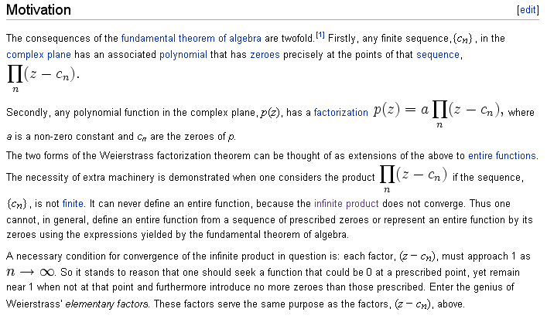

So the idea is that we try to express an analytic function like sin(z) as a "factorization" of all its roots, as we do for a polynomial. But the naive simple product diverges, so we need something else.

(3) The Weierstrass Approach: elementary factors. So along comes Mr. Weierstrass circa 1860 ±30 and he proposes replacing factor polynomial (1-z/an) with factor En(z/an) where En(z) is given by,

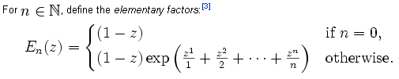

So, consider this infinite product

f(z) = Πn=1∞ En(z/an) = Πn=1∞ ( 1 + [En(z/an)- 1] ) = Πn=1∞ ( 1+bn ) (1)

where this last is the "usual way" of writing an infinite product, where we certainly require |bn|→ 0 to get something that converges. This function (1) has an infinite number of zeros, and they are located at z = an. This is because En(z/an) has a factor (1-z/an). So this is starting to look like our "fundy theorem of algebra" for functions which have an infinite number of zeros and are not just polynomials. Notice that this function has NO OTHER ZEROS than the an because the exp factors can never be 0.

Convergence: Our web site claims (lemma, see below) that if | z/an | ≤ 1, then |bn| = |En(z/an) - 1| ≤ |z/an|n+1. For this range of z, we know that Σn | z/an |n+1 converges, so therefore we know that Σn=1∞ |bn| converges and in turn we know that the product converges absolutely and therefore converges normally (see (0) above). If we order these zeros in a monotonically increasing order, then eventually (ie, for large enough n) | z/an| will be < 1, and so the "tail of the infinite product" will then converge, based on our lemma claim above.
This means that things converge for any z, the radius of convergence is infinite.
In our formula, we are enumerating the zeros a1, a2, ..... . There is no n=0 factor, a minor point. But a major point is that we can never represent a zero at z =a0 = 0 in this manner because a/a0 = ∞. So to allow for an mth order zero at z = 0, we add such a factor explicitly. Then we have a more general form

f(z) = zm Πn=1∞ En(z/an)

Furthermore, we know that eg(z) can have no zeros, where g(z) is some analytic function which maps z into some z' and we know ez' ≠ 0. So we can generalize our generic product representation to this:

f(z) = zm eg(z)Πn=1∞ En(z/an)

(3a) Proof of a Lemma. |En(z) - 1| ≤ |z|n+1 for | z | ≤ 1

I was able to show it in Maple but only for z on the positive real axis. The lemma is supposed to be true for the entire unit disk. I don't have an easy proof of this fact, wiki refers us to a 2006 Complex Analysis book by Walter Rudin. Amazingly, I was able to do a djvu download of this entire book from Vietnam,
http://www.thanhlongbook.co.cc (Google books allowed no preview). He proves this Lemma on page 293, a pretty short but crafty proof. So if I need it, there it is. It's significance is that it shows that the Weierstrass product converges.

(4) Factor term omission generalization. Now suppose in our infinite product we choose to omit certain factors. Suppose pn is some sequence of integers such as pn = n2 = 1,4,9... . It seems pretty clear that if we omit lots of factors in our infinite product, it will still converge. I think you could prove this by claiming that the product series Π'n=1∞ ( 1+bn ) converges if Σ'n=1∞ |bn| converges where prime means we have omitted factors and corresponding terms. Certainly Σ'n=1∞ |bn| < Σn=1∞ |bn| so Σ'n=1∞ |bn| converges, and I think that forces Π'n=1∞ ( 1+bn ) to converge. Let's just accept this for now. Then we can generalize our formula in this manner:

f(z) = zm eg(z)Πn=1∞ Epn(z/an) // such as zm eg(z)Πn=1∞ En2 (z/an)

where pn means pn and is something like n2 or n3 or whatever function of n you want that omits factors in the infinite product. Maybe should write this like so using a new notation En(z) = E(z; n),

f(z) = zm eg(z)Πn=1∞ E(z/an; pn) // such as zm eg(z)Πn=1∞ E(z/an; n2)

(5) The Weierstrass Factorization Theorem says that for any analytic function f(z), there exists an integer sequence pn (as described above) and an analytic function g(z) such that f(z) can be written in the form shown above.

(6) Exponent term truncation generalization. I think everything we have claimed so far is still true if we truncate the exponential factors at some integer P (called the rank). For example, we then have

En(z) = (1-z) exp(z +z2/2 + .. + zP/P) for n ≥ P
E1(z) = (1-z) exp(z)
E2(z) = (1-z) exp(z +z2/2) etc for n < P

This idea is presented here http://en.wikipedia.org/wiki/Infinite_product . Certainly we know that the truncated exponential is smaller than the untruncated for z positive and real. Again, let's just assume that for a given f(z), we can find some truncation integer P such that the product converges. Then we have another argument to add, so we have E(z; n; P). Then we have this expansion of a function whose zeros we know:

f(z) = zm eg(z)Πn=1∞ E(z/an; pn; P)

where P = ∞ would just indicate that we don't truncate the exponent series.
Given a sequence of zeros an , the claim is that there will exist a smallest P for which the expansion shown here converges. That expansion is called the canonical product, and P is called the genus. More generally P is just called the order.

(7) The Hadamard Factorization theorem. If we use the natural sequence pn = n, and if we pick a P, then if f(z) is analytic, there exists a factorization as shown above there g(z) is a polynomial. Moreover, the degree of this polynomial is max(ρ,P) ≤P where ρ is the "order" of f(z), a growth term I have not used:

order = ρ = lim supr→∞ [ ln (ln maxθ |f(r,θ)| / ln(r)

For example, f = zm has maxθ |f(r,θ)| = rm, so ρ = ln (mlnr)/ln(r) = 0
For example, f = emz has maxθ |f(r,θ)| = emr, so ρ = ln(mr)/ln(r) = 1
For example, f =exp(mz3) has maxθ |f(r,θ)| =exp(mr3), so ρ = ln(mr3)/ln(r) = 3
For example, f = exp(exp(mz) has maxθ |f(r,θ)| = exp(exp(mr)), so ρ = ln (emr)/ln(r) = mr/ln(r) = ∞

(8) Relabeling of the zeros. We chose arbitrarily to enumerate the zeros as an for n = 1,2,3... . For a function like sin(z), it might be more convenient to enumerate them using n = .....-2,-1,0,1,2,...... Then we could write our formula like this:

f(z) = zm eg(z)Πn=-∞∞ E(z/an; pn; P)

Suppose, however, as is the case with sin(z), we know that a0 = 0. Then, as noted above, we handle that zero with the leading zm factor, and we would then say

f(z) = zm eg(z)Πn≠0 E(z/an; pn; P) all positive and negative integers included

(9) Adding an n-dependent constant. I don't think any conclusions are altered if we add to the above expansion factor a constant Cn as long as Cn → 1 , and as long as the resultant product converges.
If you use Cn such that Σn |(Cn - 1)|n converges, then you know ΠnCn converges and therefore adding such a Cn does not affect the convergence of the product. However, other Cn might be possible, even if Σn |(Cn - 1)|n and ΠnCn both diverge. We will see an example below.
So assume Cn is OK on this. Then we have

f(z) = zm eg(z)Πn≠0 E(z/an; pn; P)Cn all positive and negative integers included

(10) Restriction to P = 0 and P = 1 situations. Then our formula is

f(z) = zm eg(z)Πn≠0 (1-z/n) Cn P = 0

f(z) = zm eg(z)Πn≠0 (1-z/n) ez/n Cn P = 1

where Π' means we are free to omit some factors, including for example only the n2 factors.

(11) Application to the sin(πz) and cos(πz) functions. The sin(πz) function fits into the above mold with these "settings"

an = n P = 1 pn = n g(z) = 0 m = 1 Cn = 1 K = π

Notice that sin(πz) has zeros at an = n, which is why the π is thrown in. And of course we have a zero at a0 = 0 which we have to handle with the leading zm factor, hence m = 1. Writing this out we get

sin(πz) = z π Πn≠0 (1-z/n) ez/n = π z Πn≠0 (1+z/n) e-z/n

where the second form follows from n→-n reordering of the sum. We have not proven the above sine formula, we have merely shown that it fits our general mold. We have proven that the product converges to something that has zeros at an = n.
What about cos (πz) ? It has zeros at an = (2n-1)/2 = n-1/2. It has no zero at 0, so m = 0. It turns out that these are the "settings" for this function expansion:

an = (2n-1)/2 P = 1 pn = n g(z) = 0 m = 1 Cn = 1 K = 1

and we get

cos(πz) = Πn≠0 (1-z/an) exp(z/an) = Πn≠0 (1+z/an) exp(-z/an) an = (2n-1)/2

Now, in either of the above product representations, we can write

Πn≠0 fn = (Πn<0 fn)( Πn>0 fn ) = (Πn>0 f-n) ( Πn>0 fn ) = (Πn>0 f-n fn) = Πn=1∞( f-n fn)

This then removes the expo factors in both cases and we can write

sin(πz) = z π Πn=1∞ (1-z2/n2)

cos(πz) = Πn=1∞(1– z2/an2) an = (2n-1)/2

All four of these formulas appear on http://en.wikipedia.org/wiki/Weierstrass_factorization_theorem . You could invert each of these to get a formul for csc(πx) and sec(πx). Notice that inverting does not affect the fact that the factor → 1 as n increases.

(12) Multiple sine formulas. Now, what happens if you divide two of our sine formulas for two different variable values? You get:

sin(πx)/sin(πy) = (x/y) Πn=1∞[ n2-x2]/[n2-y2]

Now I claim you can rewrite this in the very elegant form (all integers n in the product)

sin(πx)/sin(πy) = Πn [n-x]/[n-y]

To prove this, break it the last RHS into three products

Πn [n-x]/[n-y] = (x/y) Πn>0 [n-x]/[n-y] Πn<0 [n-x]/[n-y]

= (x/y) Πn>0 [n-x]/[n-y] Πn>0 [n+x]/[n+y] // n→-n in last product

= (x/y) Πn>0( [n-x]/[n-y]* [n+x]/[n+y]) = (x/y) Πn>0 [ n2-x2]/[n2-y2] QED.

In a separate document I show that Πn [n-x]/[n-y] converges for all x and y ! It took me a while.

So once we have this formula, we can make a fancier one like so

[sin(πx1) sin(πx2)] / [sin(πy1)sin(πy2)] = Πn [(n-x1) (n-x2)] / [(n-y1) (n-y2))]

where we just use our previous fact that (Πnfn )/ (Πngn ) = Πn(fn/gn).

Now here is an interesting special case of the above formula. Suppose we search for x1,2 such that

(n-x1) (n-x2) = (n-a)2 + b2

Solving for the quadratic formula for the roots of the RHS we find that x1,2 = a ± ib. Thus, we arrive at this special case of the above 4-sine formula

Πn [(n-a)2 + b2] / [(n-c)2 + d2] = [sin(π(a+ib)) sin(π(a-ib))] / [sin(π(c+id)) sin(π(c-id))]

Both of these sine formulas, namely the above and our previous

Πn [n-x]/[n-y] = sin(πx)/sin(πy)

appear in the collection at http://pi.physik.uni-bonn.de/~dieckman/InfProd/InfProd.html
(which I have captured), where they appear as :

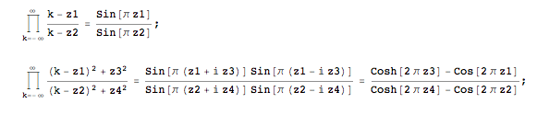
All these formulas depend on the basic sine formula which it would be nice now if we could prove.

(13) How people prove the "Euler's product for the sine" formula.

sin(πz) = z π Πn≠0 (1-z/n) ez/n = z π Πn=1∞ (1-z2/n2)

ln(sin(πz)) = ln { z π Πn=1∞ (1-z2/n2) } = ln(πz) + Σn=1∞ ln (1-z2/n2)

Σn=1∞ ln (1-z2/n2) = ln [sin(πz)/ (πz)] the sinc function

Comment: it is not very obvious that the RHS of sin(πz) above is periodic in z, although you can see that the poles still match. I have been probing on the web. Here is a book clip

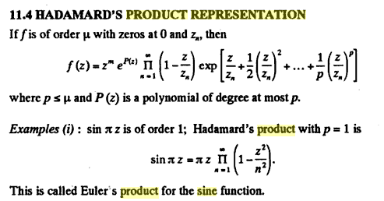

which assigns Hadamard to our general "form" object special case as noted earlier. And so his name is "Euler's product". Here is a proof which I will quote just to have something:

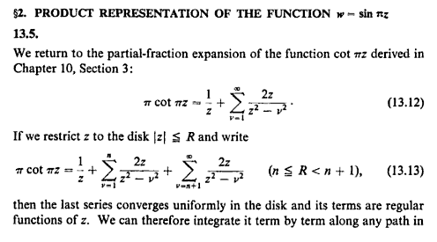
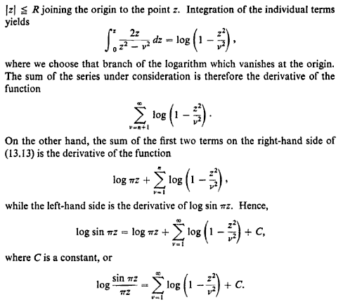
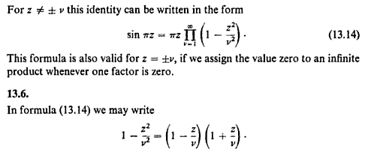

This same preview gives a proof of the starting position here. W&W have their own proof on page 137 which requires a bit of pre-reading in their book, but looks good.

I just found and stored a little PDF paper by Erica Chan 2006. Her proof is to first find Euler's formula for the gamma function, where you see all those negative axis poles.

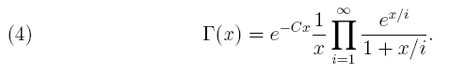

then she uses a famous formula connecting sine to gamma, and out it comes,

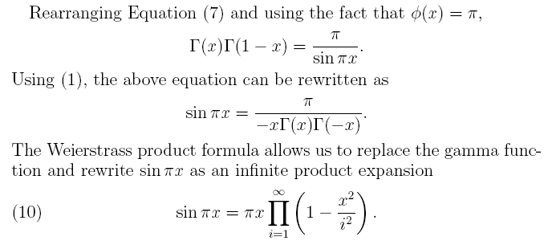

I just downloaded a whole Chapter of a book entitled Euler's Formula for sin(z) ,and it follows the path of the first long flip I have above. It is well written and if I want to do this thing, that is where I will go.

OK, I am happy with this. There is no "one line proof", but there are many proofs. The whole subject of analytic functions is filled with amazing facts, that must have amused Euler and friends.

(14) My own attempted proofs that did not fly.

Plan A. Here is a sum form of our desired theorem

Σn=1∞ ln (1-z2/n2) = ln [sin(πz)/ (πz)] = ln [ sinc(x) ] // normalized

What happens if we Fourier Transform both sides?

$^{\int_{-∞}^{∞}{}}$ln [sin(πx)/ (πx)] e-ikx dx // norm as on Schaum p 175

= $^{\int_{-∞}^{∞}{}}$ln [sin(πx)/ (πx)] (-ik)-1∂xe-ikx dx

The "parts" here will be

ln [sin(πx)/ (πx)] e-ikx |∞-∞ = -2i limx→∞ { sin(kx) ln (sinc(x)) }

This is a distributional limit where sin→0 and ln→-∞, not sure what to do, leave for now.

The other tern will then be

–(-ik)-1$^{\int_{-∞}^{∞}{}}$∂x ln [sinc(x))] e-ikx dx = –(-ik)-1$^{\int_{-∞}^{∞}{}}$ sinc'(x)/sinc(x) e-ikx dx

But sinc'(x)/sinc(x) = π cot(πx) - 1/x (Maple). This looks horrible to me, so kill off this attempt.

Plan B. Go back to

sin(πz) = z π Πn≠0 (1-z/n) ez/n

The RHS is periodic with period 1 because you offset by shifting n by one. Oops, it is not so obvious. I was going to show this and then do a Fourier Series projection on the related series. Let's try it anyway:

Σn=1∞ ln (1-z2/n2) = ln [sin(πz)/ (πz)]

But now RHS is not periodic in z. Write as ln [sin(πz)] - ln(πz). So

ln [sin(πz)] = - ln(πz) + Σn=1∞ ln (1-z2/n2)

Now LHS is periodic with period L = 2, but is not odd in z. So

an = (1/2) $^{\int_{0}^{2}{}}$ Σn=1∞ ln (1-x2/n2) cos(πnx/2) = (1/2) Σn=1∞ $^{\int_{0}^{2}{}}$ ln (1-x2/n2) cos(πnx/2)

But this is some Ei mess, so this hardy seems an easy path.

Plan C. Go back to

Σn=1∞ ln (1-z2/n2) = ln [sin(πz)/ (πz)] = ln(sinc(x))

Expand sinc(x) in a power series:

sin(πx) = –Σn=1,3.. (-1)n(πx)n/n!
sin(πx)/πx = –Σn=1,3.. (-1)n(πx)n-1/n! = Σn=1,3. (πx)n-1/n! = 1 + (πx)2/3! + (πx)4/5! + ...

Then use ln(1+x) = x - x2/2 + x3/3 – ... = – Σm=1(-1)m (x)m/m

ln(sinc(x)) = – Σm=1(-1)m/m * (sinc(x))m

= – Σm=1(-1)m/m [–Σn=1,3.. (-1)n(πx)n-1/n!] m = huge mess,

Plan D. Go back to

Σn=1∞ ln (1-x2/n2) = ln [sin(πx)/ (πx)] = ln(sinc(x))

Differentiate both sides term by term (Maple)

Σn=1∞ { -2 x/(n2-x2) } = π cot(πx) - 1/x

π cot(πx) = 1/x + Σn=1∞ { 2 x/(x2-n2) }

Notice that this is the identity which is used at the start of the previous proof! If we knew this to be true, we could integrate both sides to get our desired result.

(15) A combo Ahlfors-PL derivation

On page 187 Ahlfors compares π2/sin2(πz) to the series Σn 1/(z-n)2. The series is manifestly periodic, and the double pole at z = 0 is the same for these two objects. Thus, they have the same poles and same residues, so they differ by an analytic function he calls g(z). He then shows using limits that g = 0. In this part of the book, Ahlfors is talking compact sets and uniform convergence and such things, I will read this some day, but for now, I like his development of this fact:

π2/sin2(πz) = Σn 1/(z-n)2 (1)

Now consider this claimed identity

π cot(πz) = 1/z + Σn≠0 ( 1/(z-n) - 1/n) = 1/z + Σn=1∞2z/(z2-n2) (2)

If we differentiate both sides of (2) and multiply both sides by -1, we get

π2 csc2(πx) = 1/z2 + Σn≠0 1/(z-n)2 = Σn 1/(z-n)2 which is (1)

Thus, we obtain (2) from (1) by doing term-by-term integration. I ignore the questions of convergence here and justification of term by term, just trying to get a basic pathway. So we have now more or less started with his proof of (1) and that gives us (2) by integration.
Next, in a similar fashion consider this claimed identity:

ln [sin(πz)/ (πz)] = Σn=1∞ ln (1-z2/n2) (3)

If we differentiate both sides of (3) we get

πcot(πz) - 1/z = Σn=1∞ (1-z2/n2)-1(-2z/n2) = Σn=1∞ 2z/(z2-n2) which is (2) !

Now the last step is to exponentiate (3) to get

sin(πz)/ (πz) = exp[Σn=1∞ ln (1-z2/n2)] = Πn=1∞ exp ln (1-z2/n2) = Πn=1∞ (1-z2/n2) (4)

And of course we can rewrite Πn=1∞ (1-z2/n2) = Πn≠0 (1-z/n) ez/n

Πn≠0 (1-z/n) ez/n = Πn>0 (1+z/n) e-z/n Πn>0 (1-z/n) ez/n = Πn=1∞ (1-z2/n2)

and I take note that we might put other functions in place of ez/n such as exp[ -(z/n)3] , but probably ez/n is the simplest such function that gives convergence.

Summary:

A. Comparing the double pole structure and taking limits, we first show that

π2/sin2(πz) = Σn 1/(z-n)2 = 1/z2 + Σn=1∞ 2(z2+n2)/(z2-n2)2 (1)

B. Integrate (1) term by term to get

π cot(πz) = 1/z + Σn≠0 ( 1/(z-n) - 1/n) = 1/z + Σn=1∞2z/(z2-n2) (2)

C. Integrate (2) term to term to get

ln [sin(πz)/ (πz)] = Σn=1∞ ln (1-z2/n2) (3)

D. Exponentiate both sides of (3) to get

sin(πz)/(πz) = Πn=1∞ (1-z2/n2) = Πn≠0 (1-z/n) ez/n (4)

which is Euler's product for the sine function. I like this general derivation method because it is very simple logically, and along the way we derive lots of other identities that can go down in The Book.

While we're here, what about cos(πz) stuff? Since we know that

sin(π(z+1/2)) = cos(πz) cot(π(z+1/2)) = -tan(πz)

We can adapt all the formulas shown above making these replacements;

On left hand sides: sin(πz) → cos(πz) cot(πz) → -tan(πz)

Other appearances of z: z → (z+1/2)

Here are the results:

π2/cos2(πz) = Σn 1/(z+1/2-n)2 = 1/[z+1/2]2 + Σn=1∞ 2([z+1/2]2+n2)/( [z+1/2]2-n2)2 (1)

-π tan(πz) = 1/[z+1/2] + Σn≠0 ( 1/([z+1/2]-n) - 1/n) = 1/[z+1/2] + Σn=1∞2/[z+1/2]/(/[z+1/2]2-n2) (2)

ln [cos(πz)/ (π[z+1/2])] = Σn=1∞ ln (1-[z+1/2]2/n2) (3)

cos(πz)/(π[z+1/2]) = Πn=1∞ (1-[z+1/2]2/n2) = Πn≠0 (1-[z+1/2]/n) e[z+1/2]/n (4)

Notice that this does NOT give the wiki cosine formula which is this:

cos(πz) = Πn≠0 (1-z/an) exp(z/an) = Πn≠0 (1+z/an) exp(-z/an) an = (2n-1)/2

= Πn=1∞ ( 1 - [2z/(2n-1)]2)

Compare these side by side:

cos(πz) = Πn=1∞ ( 1 - [2z/(2n-1)]2 ) // wiki

cos(πz) = π[z+1/2] Πn=1∞ (1- [(2z+1)/(2n)]2 )

Maple can compute these with these lines:

f := evalf(product(1-((2*z)/(2*n-1))^2, n=1..5));

g := evalf( Pi*(z+1/2)* product( 1-((2*z+1)/(2*n))^2, n=1..20 ) );

If we try this at z = 1/6 meaning 30 degrees, we know the answer is .8660. The wiki upper version "converges" faster but both get to the same place. Here are some results:

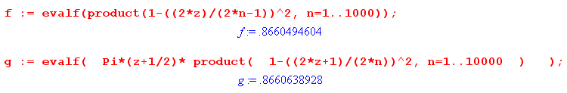
Euler would have had trouble doing that I just did!

So I don't have a derivation of the wiki cosine formula, and I don't need one.

