Section 5_5 Maxwell PhL 10.18.16

This was installed 10.22.16, do not edit here!

5.5 Example: The Maxwell-Boltzmann Distribution

The System

In the Sections 5.1-5.4 we dealt with a system having a finite number of discrete energy levels εi with degeneracy gi. In the current section we shall consider a situation which has an infinite number of energy levels which form a continuum which has no upper limit. However, we shall treat this continuum as if it were a finely grained set of discrete energy levels so we can use the methods developed in Section 5.1. In the end, we shall apply quantum mechanics to show that in fact the energy levels really are discrete.

The system of interest is a small box of helium gas near room temperature. Our "particles" then are the individual gas atoms. The gas is treated as an "ideal gas" : atoms are indistinguishable (identical); there are no at-distance interactions between the atoms; the atoms are small compared to the distances between them; collisions between atoms and at the walls of the box are elastic; no energy is stored in any kind of rotational or vibrational modes of the atoms. The atoms have "spin" 0 so they are bosons and therefore any number of them can be placed into any given energy state, as in our previous examples.

The atoms are in a stable state of "thermal equilibrium" at temperature T. The box is sealed and insulated to prevent the transfer of particles or energy in or out. The box contains some total large fixed number of atoms M (to be computed below) and has some total energy U = Mu where u is the average energy of a particle.

Connection to Sections 5.1 and 5.2

An atom of the helium gas has kinetic energy

εi = (1/2)mv2 ≡ ε(v) . (5.5.1)

This is the total energy of a particle having speed v = |v| and mass m. There is no potential energy because the particles don't interact and because we ignore gravity which is only a miniscule effect for a small box of gas. In classical mechanics, this energy ε(v) is continuous because the speed v is a continuous variable. So ε(ν) = (1/2)mv2 represents the continuum of "energy levels" for a box of helium.

Let dv be some small but finite speed difference. The amount of energy in the atoms with speed between v and v+dv is ε(v)dv. The number of atoms with speed in this range is taken to be N(v)dv, and the degeneracy of the states in the range we write as g(v)dv.

To get a number to represent the degeneracy gi, we hop into velocity space where the axes are vx,vy,vz and we note that the volume in this space corresponding to v in the range (v,v+dv) is 4πv2dv, since this is the volume of a shell of radius v and thickness dv. As an artificial (at this point) construct, we shall assume that velocity space is not continuous but is a 3D lattice of allowed values and that the volume of a lattice cube is V. Therefore, we write (at least for now),

gi = [4πv2dv]/V = g(v)dv where g(v) = (4πv2/V) . (5.5.2)

All the gi states in this thin shell have energy εi = ε(v). Note that volume V is the assumed cell size in velocity space, it is not the volume of our box of gas.

The number Ni of atoms having energy εi is now,

Ni = N(v)dv, (5.5.3)

and then

gi/Ni = [g(v) dv]/[N(v)dv] = g(v)/N(v) . (5.5.4)

We have the same two constraints as in Section 5.1, but here they take the form

M = ΣiNi = $^{\int_{0}^{∞}{}}$N(v)dv
U = ΣiεiNi = $^{\int_{0}^{∞}{}}$ε(v) N(v)dv . (5.5.5)

As noted, the distribution of atoms into the energy states is described by N(v). The elastic collisions between atoms and the walls do not affect N(v) but merely redirect an atom's velocity vector without changing the speed v. However, elastic collisions between atoms can and do alter velocities. Before a collision two atoms might have velocities v1 and v2, and after v'1 and v'2. But since the collisions are elastic one has E1 + E2 = E'1 + E'2, so the total energy U is not affected (nor is M affected). It is true that a collision rearranges the two atoms' positions in the energy level diagram since in general one won't have E1 = E1' and E2 = E'2. But for every such rearrangement, the exact reverse rearrangement is equally likely in some other collision in the box (which contains perhaps 1020 atoms), so overall the inter-atomic collisions don't affect N(v).

Recall from (5.1.3) that we had this microstate count, assuming gi >> Ni.

Ω(N) = $_{1}$$_{2}$ ....$_{m}$ = Πi=1m $_{i}$ . (5.1.3)

What happens to this expression for Ω when there are an infinite number of energy states which are spaced closely together? We might write

giN$_{i}$ = (g(v)dv)N(v)dv

Ni! = [N(v)dv]! (5.5.6)

and one gets a product of an infinite number of terms,

Ω(N) = Πn=0∞ $\frac{(g(ndv))N(ndv)dv}{(N(ndv)dv)!}$ . (5.5.7)

Just as an infinite sum Σnan can converge only if an → 0, an infinite product Πnan can only converge if an→ 1. There is a developed theory of such infinite products, but we leave this topic to the interested reader. Here are a few examples of infinite products,

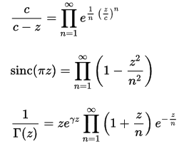
https://en.wikipedia.org/wiki/Infinite_product (5.5.8)

and one sees that an → 1 in all cases.

The object f = ln(Ω) shown in (5.2.3) is a little more tractable since it is merely an infinite sum,

f = Σi Ni [1 + ln(gi/Ni)] (5.2.3)

= Σn=0∞ N(ndv)dv [ 1 + ln{g(ndv)/N(ndv)}] . (5.5.9)

We shall avoid dealing directly with Ω or f = ln(Ω) and instead just make use of results derived in Sections 5.1 and 5.2 for a finite number of energy levels.

The Maxwell-Boltzmann speed distribution

Our main result of interest is (5.2.11) which says that the components Ni of the vector N which causes Ω to have a maximum are given by,

Ni = A gi e-βε$_{i}$ , (5.2.11)

where A ≡ eλ$_{1}$ and β ≡ - λ2 are the derived Lagrange multipliers. Using (5.5.1,2,3) for εi, gi and Ni we write the above as

{N(v)dv} = A {[4πv2dv]/V} {exp(-βmv2/2) }
or
N(v) = 4π(A/V) v2 exp(-βmv2/2) . (5.5.10)

By thus cribbing from earlier Sections, we have arrived with very little work at the very famous Maxwell-Boltzmann speed distribution. For now we ignore the constant 4π(A/V) -- it will be dealt with later. The general shape of this distribution is as follows :

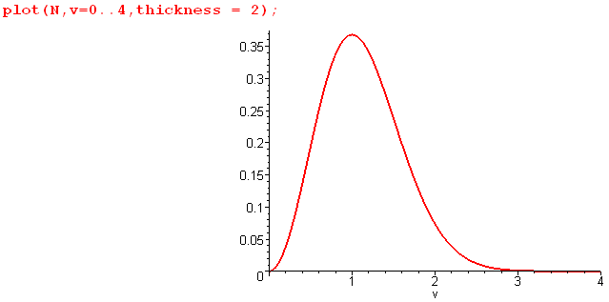 (5.5.11)

The quadratic left end of the plot arises from v2 where exp ≈ 1, while the right end comes from the decaying exponential which here is just exp(-v2).

Mean Values

Knowing the form of N(v) allows us to compute various mean values.

The first item of interest is the mean energy of a particle in the gas.

<ε> = u = $^{\int_{0}^{∞}{}}$$^{\int_{0}^{∞}{}}$ = (m/2) $^{\int_{0}^{∞}{}}$$^{\int_{0}^{∞}{}}$ (5.5.11)

We can make use of the following integral

$^{\int_{0}^{∞}{}}$vn exp(-av2)dv = (1/2) Γ[(n+1)/2] a-(n+1)/2 // Spiegel 15.77 (5.5.12)

with a = βm/2 to obtain

<ε> = u = (m/2) $\frac{Γ(5/2)(βm/2)-5/2}{Γ(3/2)(βm/2)-3/2}$ = (m/2) $\sqrt{π}$$\sqrt{π}$(2/βm) = (3/2)(1/β) = (3/2)kT (5.5.13)

a result we quoted earlier. This is an example of the "equipartition theorem" which says that each independent quadratic term in the energy expression ends up getting (1/2)kT of energy in equilibrium. In our case we have three terms since ε(v) = (1/2)mvx2 + (1/2)mvy2 + (1/2)mvz2.

Next we calculate the mean speed v of a particle,

vmean = <v> = $^{\int_{0}^{∞}{}}$$^{\int_{0}^{∞}{}}$= $^{\int_{0}^{∞}{}}$$^{\int_{0}^{∞}{}}$ = $\frac{Γ(2)(βm/2)-2}{Γ(3/2)(βm/2)-3/2}$

= $\sqrt{π}$(βm/2)-1/2 = (2/$\sqrt{π}$) $\sqrt{2/βm}$ = $\sqrt{8/βπm}$ = $\sqrt{8kT/πm}$ . (5.5.14)

The root mean square speed is given by

vrms ≡ $\sqrt{<v2>}$ = $\frac{<(1/2)mv2>}{(1/2)m}$ = $\frac{2}{m}$$\sqrt{<ε>}$ = $\frac{2}{m}$$\frac{3}{2}$ = $\frac{3kT}{m}$. (5.5.15)

Finally, the peak speed (most likely speed) occurs where the distribution slope is zero :

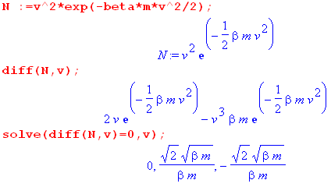 (5.5.16)

and the meaningful root is the second item, so

vpeak = $\frac{2kT}{m}$. (5.5.17)

We now summarize our conclusions about mean values,

<ε> = u = (3/2)kT

vpeak = $\frac{2kT}{m}$= 1.41 $\frac{kT}{m}$ = 1.00 vpeak

vmean = $\frac{8kT}{πm}$= 1.60 $\frac{kT}{m}$ = 1.13 vpeak

vrms = $\frac{3kT}{m}$= 1.73 $\frac{kT}{m}$ = 1.23 vpeak (5.5.18)

The three speed values are not very far apart.

Determination of the derived Lagrange Multiplier A

Recall from (5.5.10) that.

N(v) = 4π(A/V) v2 exp(-βmv2/2) . (5.5.10)

The total number constraint requires that

M = $^{\int_{0}^{∞}{}}$N(v)dv = 4π(A/V) $^{\int_{0}^{∞}{}}$v2 exp(-βmv2/2) = 4π(A/V) (1/2)($\sqrt{π}$/2)(βm/2)-3/2

= 4π(A/V)($\sqrt{π}$ /4) (βm/2)-3/2 . (5.5.19)
Therefore

4π(A/V) = M (4/$\sqrt{π}$) (βm/2)3/2

and then

N(v) = (4M/$\sqrt{π}$) (βm/2)3/2 v2 exp(-βmv2/2) (5.5.20)

which agrees with Zemansky p. 159 Eq. (6-25). Notice that the lattice cell size V in velocity space does not appear in this result, so it applies whether V is finite or V→0 which is the classical limit.

In our study of the discrete-state Boltzmann problem in Section 5.2 it was noted that N is the "solution vector" which has "components" Ni = Agie-βε$_{i}$. In the continuum problem the "solution vector" is the entire continuous function N(v) while the "components" are N(v)dv for specific values of v.

The other constraint U = $^{\int_{0}^{∞}{}}$ε(v) N(v)dv tells us what we already know from (5.5.13),

U = $^{\int_{0}^{∞}{}}$ε(v) N(v)dv = <ε>$^{\int_{0}^{∞}{}}$N(v)dv = <ε>M = uM = (3/2) kT M (5.5.21)

We would like now to verify that Ni << gi since (5.2.11) that Ni = A gi e-βε$_{i}$ depends on this assumption. From (5.5.4) we must therefore show that N(v) << g(v). But so far we have g(v) = (4πv2/V) from (5.5.2) where V was our assumed lattice cube size in v-space. Taking V→0 results in g(v) = ∞ and then certainly N(v) << g(v). We now consult the quantum mechanics department to obtain the correct value for V.

Quantum Mechanics and Determination of V

To determine the quantum theory value of V in (5.5.2), we consider the problem of a single theoretical point particle in a cubic box of edge L. The Schrodinger equation says ψ(r) = εψ(r) for a single particle wavefunction ψ, where the Hamiltonian operator is just 2/2m. Here = (-⁄/i)∇ (a key assumption of quantum theory), so 2 = - ⁄2∇2. The constant ⁄ is h/(2π) where h is Planck's constant,

h = 6.62607 x 10−34 J s ⁄ =1.0545718 x 10−34 J s ⁄ = h/(2π) // Joule-sec .

The Schrodinger equation then reads -(1/2m) ⁄2∇2ψ = εψ. We seek a solution to this equation which vanishes at the 6 walls of a cubic box of edge L. This is so because ψ must be continuous and ψ = 0 everywhere outside the box since there is no probability |ψ|2 that the particle is outside the box. That solution is

ψn$_{x}$n$_{y}$n$_{z}$(x,y,z) = K sin(πnxx/L)sin(πnyy/L)sin(πnzz/L) ni = 1,2,3... . (5.5.22)

The constant K is determined by requiring that the probability of the particle being in the box is 1,

$^{\int_{0}^{L}{}}$dx$^{\int_{0}^{L}{}}$dy$^{\int_{0}^{L}{}}$dz |ψn$_{x}$n$_{y}$n$_{z}$(x,y,z)|2 = 1 . (5.5.23)

Since$^{\int_{0}^{L}{}}$dx sin2(πnxx/L) = (L/2) the above says K2(L/2)3 = 1 so

K = (2/L)3/2. (5.5.24)

In (5.5.22) setting nx = 0 results in ψ = 0 which cannot be normalized to 1 and is a non-solution. The solution with nx = -2 is minus of the solution with nx = +2 and so these two solutions are really the same solution. Solutions must be linearly independent to be separately counted. That is why we have written
ni = 1,2,3... . .

The Schrodinger equation then says

ψ = εψ ⇒ - ⁄∇2ψ = εψ ⇒ - ⁄2∇2ψ = 2mεψ ⇒

- ⁄2 ( [ -(πnx/L)2 - (πny/L)2 - (πnz/L)2 ] )ψ = 2mεψ // using (5.5.22) for ψ
or
(π⁄/L)2 [ nx2+ny2+nz2] = 2mε
or
ε = (2m)-1 (π⁄/L)2 [ nx2+ny2+nz2] . (5.5.25)

We arrive at the interesting conclusion that the energy spectrum is not continuous but is discrete. It is quantized. Setting ε = (1/2)mv2 we find that

v2 = (π⁄/mL)2 [ nx2+ny2+nz2] (5.5.26)

so the speed variable is also discrete, not continuous.
If we now think of velocity space with v = (vx,vy,vz) then the above says

vx2 = (π⁄/mL)2nx2 vy2 = (π⁄/mL)2ny2 vz2 = (π⁄/mL)2nz2 (5.5.27)

so then

v = (vx,vy,vz) = (π⁄/mL)(nx,ny,nz) . (5.5.28)

In the space (nx,ny,nz) the lattice cube size is 1. Therefore, in v-space it is (π⁄/mL)3. We have now found a value for the parameter V in (5.5.2) :

gi = [4πv2dv]/V = g(v)dv where g(v) = (4πv2/V) . (5.5.2)

V = (π⁄/mL)3 . (5.5.29)

But now we make a correction. Since v = (π⁄/mL)(nx,ny,nz) and since ni = 1,2,3..., when we count states we should only include the first octant shell of v-space where vx,vy,vz are all positive. Thus, we correct (5.5.2) as follows:

gi = [(1/8)4πv2dv]/V = g(v)dv where g(v) = (1/8)(4πv2/V) . (5.5.2)corr
V = (π⁄/mL)3 . (5.5.30)

The degeneracy function is then

g(v) = πv2/2V = (1/2)πv2 (π⁄/mL)-3 = (1/2)πv2 (h/2mL)-3 = (1/2)πv2(2mL/h)3

= 4π(mL/h)3v2 . (5.5.31)

As a check on this result, integrating it from 0 to v' gives

(4π/3)(mL/h)3(v'2)3/2 = (4π/3)(mL/h)3(2ε'/m)3/2 = (4π/3)(L/h)3(2ε'm)3/2

and this agrees with Zemansky p. 272 Problem (10-2) (answers on p 645).

At this point we have determined that

N(v) = (4M/$\sqrt{π}$) (βmHe/2)3/2 v2 exp(-βmHev2/2), β = 1/(kT) (5.5.20)

g(v) = 4π(mHeL/h)3v2 (5.5.31) (5.5.32)

where mHe is the mass of a helium atom.

Numeric Values for N(v) and g(v) and g(v)/N(v)

We now seek numeric values for N(v) and g(v) for a 1 cm3 box of helium at room temperature. Before entering constants, we create expressions for N, g, g/N and vm (vmean from (5.5.124)) as follows, where the v -> construct is used to define a function of v :

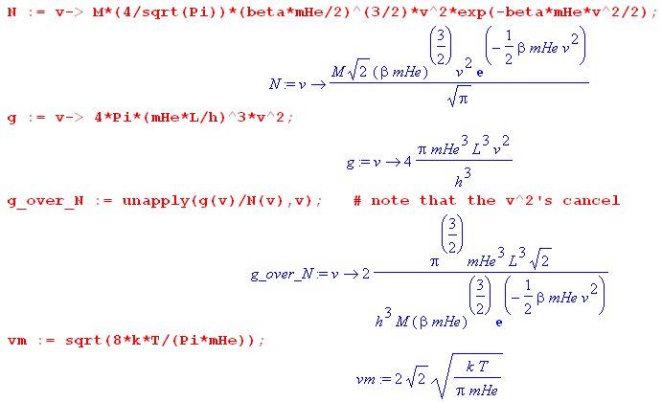 (5.5.33)

The strange "unapply" command causes g_over_N(v) to be a function of v, namely g(v)/N(v). If we don't do it this way, g_over_N(0) reports a divide by 0 error at v = 0 since N(0) = 0.

Notice that the g/N ratio takes its smallest value at v = 0 where exp(βmHev2/2) = 1. Since we want to show that g/N >> 1, showing this at v = 0 guarantees that g/N >> 1 for all v.

Our first task is to compute the number M of helium atoms in the box. This can be found from the ideal gas law PV = NkT which applied to our situation says PL3 = MkT. We display units as if they were Maple variables, which allows a "dimension check" for all our results.

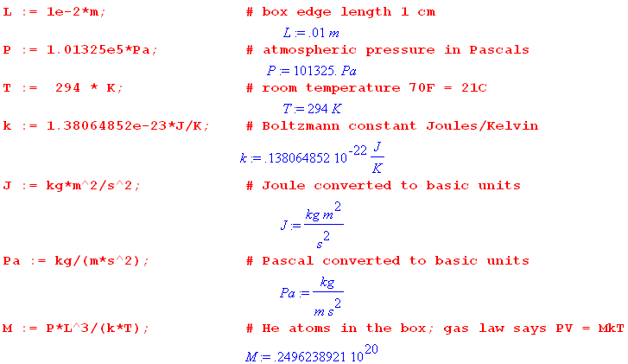 (5.5.34)

So there are M ≈ 2.5 x 1019 helium atoms in our 1 cm3 box.

Next compute the derived Lagrange multiplier value β = -λ2 = 1/(kT), and take a look at the basic energy scale for a helium atom kT:

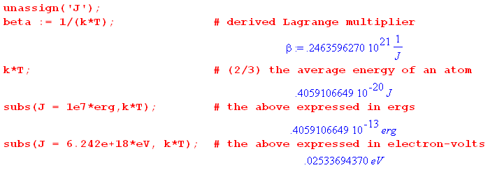 (5.5.35)

Since it takes 19.8 eV to excite helium out of its electronic ground state, and since (3/2)kT = .038 eV, the elastic collision aspect of our ideal gas assumption is well justified at room temperature.

Next, set the mass mHe of a helium atom,

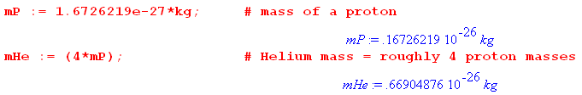 (5.5.36)

Recall that gi = g(v)dv and Ni = N(v)dv so we expect g and N to have units of inverse velocity. Here then are the numeric values for vm, N(vm) and g(vm) :

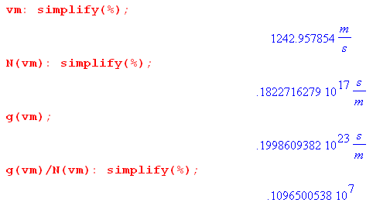 (5.5.37)

The helium atoms are moving along at a respectable clip, 1243 m/sec (2,780 mph). Of course they don't go far between collisions.

The ratio g(vm)/N(vm) is thus about 106, which justifies the assumption that g(v) << N(v) and gi << N, at least at the mean velocity vm. As noted above, the lower bound for this ratio occurs at v = 0 where we have,

(5.5.38)

and even here we have g(v) >> N(v). Here is plot of g(v)/N(v) from v = 0 up to 4 times the mean velocity,

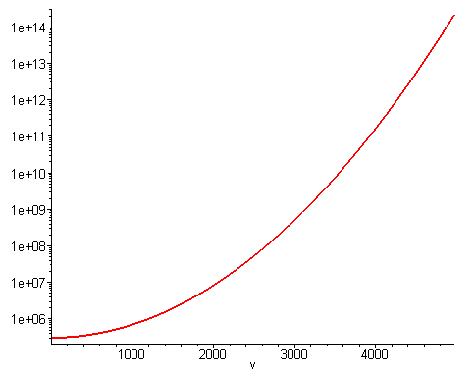 (5.5.39)

One can view the first octant of the velocity sphere as consisting of a large number of tiny cubes (size V) which are the available quantum states. Only a tiny fraction of these cubes are occupied by particles. For example, in the shell of the sphere at speed v = 2200 m/sec, the above graph shows that only about 1 in 107 cubes is occupied, all the rest are empty. The occupancy here is much sparser than in our 3-level example of Section 5.4 where the ε2 state had N2 = 268 out of g2 = 5000 states occupied.

The ensemble

The smooth N(v) distribution shows the ensemble average for Ni = N(v)dv at various speeds. If one were to examine a particular system in an ensemble of one billion 1 cm3 boxes of helium, and if one were to divide the distribution into a set of vertical strips each having a large number of atoms, one would measure a set of Ni values that do not quite match the distribution curve. For each such strip there is a "bell curve" of the type shown in Fig (5.3.18) which has a fractional half-width on the order of 1/$\sqrt{Ns}$where Ns is the (large) number of atoms in a strip. We illustrate this idea in the following drawing,

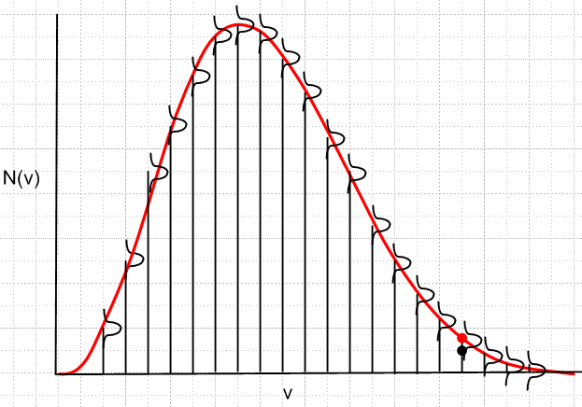 (5.5.40)

which is analogous to Fig (5.4.29) for the 3-level system of Section 5.4. One could display on this picture at set of red dots right on the curve, and black dots within the bell curve at each v (we drew one pair of such dots only), as discussed relative to (5.4.29). In the current situation, if one were to dramatically increase the number of strips to drive Ns down to a much lower number, the bell curve widths would increase dramatically, and a pattern of black dots if connected by lines would have a very noise-like appearance, hardly resembling the red curve.
In our study of the discrete-state Boltzmann problem it was noted that N is the "solution vector" which has "components" Ni = Agie-βε$_{i}$. In the continuum problem the "solution vector" is the continuous function N(v) as plotted above in red, while the "components" are N(v)dv for specific values of v.

Summary

Applying the discrete-energy-level result Ni = Agie-βε$_{i}$ developed in (5.2.11) (using the method of Lagrange multipliers) we have obtained a set of results concerning the nature of a small box of helium atoms at room temperature. The distribution of particle speeds has the Maxwell-Boltzmann shape shown in Fig (5.5.11) and the corresponding expression for the speed distribution N(v) is given in (5.5.32). The distribution of energy level degeneracies is given by g(v) also in (5.5.32). We used quantum theory only to determine the tiny lattice size V in v-space which causes the speed and energy of a helium atom to be quantized. For this specific example we showed that gi >> Ni thus justifying the use of (5.2.11). We showed along the way that the average helium atom energy is (3/2)kT and hinted how one might derive the equipartition theorem of which this is an example. Expressions were found for the mean, rms and peak speeds of the N(v) distribution.

