Ideal Gas Application PhL 10.15.16

How would my general analysis on Boltzmann be applied to the Maxwell distribution business.

I will first try to "roll my own" and see where I get, later I will look at Livesey.

1. Plan A

Box of simple point atoms (monatomic gas, no energy in rotation or vibration).

Energy of a particle is (1/2)mv2 and we are 3D. Energy levels are ε(vi) = (1/2)mvi2. Box contains M atoms and has N energy, so M = ΣiNi still applies. Imagine that the vi are discrete somehow. Ni is the number of particles having energy near ε(vi) . How would you write this in math?

I think the first step is to make v-space be a lattice of tiny cubes each of volume V = a3 where a is the edge of the cube. Take a spherical shell in v space and it has volume = 4πv2dv where dv is the shell thickness. How many states are in this shell, if each state has volume V? It must be number of states in shell = [4πv2dv]/V. I would then say

gi = [4πv2dv]/V = [4πv2/V] dv ≡ g(v) dv g(v) = (4πv2/V)

and this shell is sort of "the state i" in my analogy. How many particles Ni are in this shell? If you double the very thin shell thickness dv, this number doubles, so write

Ni = N(v)dv

where N(v) is of course not yet known. The normalization here would be

M = ΣiNi = $^{\int_{0}^{∞}{}}$N(v)dv

U = ΣiεiNi = $^{\int_{0}^{∞}{}}$ε(v) N(v)dv where ε(v) = (1/2)mv2

For later use,

gi/Ni = g(v) dv/N(v)dv = g(v)/N(v)

which I sort of like.

What then would you say about

Ω(N) = $_{1}$$_{2}$ ....$_{m}$ = Πi=1m $_{i}$ ?

This becomes somehow a product of an infinite number of factors. Each factor corresponds to a "shell" in v-space. I know a few infinite product formulas from GR7 page 14.

Now consider $_{i}$. The numerator and denominator are

giN$_{i}$ = (4πv2/V)N(v)dv = (g(v)dv)N(v)dv

Ni! = (N(v)dv)!

so then

Ω(N) = Πv $\frac{(4πv2/V)N(v)dv}{(N(v)dv)!}$ = Πv $\frac{(g(v)dv)N(v)dv}{(N(v)dv)!}$

What does this mean? It is a product over all the shells in v-space. I will try to label each shell with an integer n. Then write v = ndv for the nth shell. Then I can write the above as

Ω(N) = Πn=0∞ $\frac{(4π[ndv]2/V)N(ndv)dv}{(N(ndv)dv)!}$ = Πn=0∞ $\frac{(g(ndv))N(ndv)dv}{(N(ndv)dv)!}$

Once again, here dv is some very small but finite thickness that each shell has. This product has the general form

Πv h(v) = Πn=0∞ h(ndv) = h(0)h(dv)h(2dv) ......

which is a very strange object to me. At least GR7 mentions such objects for very simple cases. Left are from GR7, right are from wiki on infinite products :

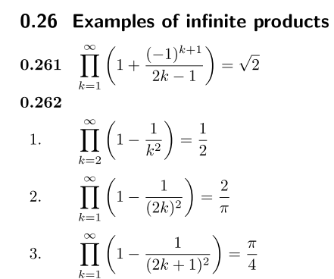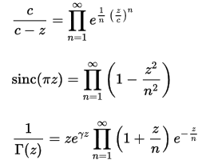

If N(v) → 0 for large v, we see that (g(v)dv)N(v)dv → (g(v)dv)0 = 1.
And we see that N1! = (N(v)dv)! → (0)! = 1. Thus if you look at the far right end of the infinite product of factors, you see a product of numbers that each approach 1, so it is then at least conceivable that this limit approaches a finite number. This is exactly what happens in all of the above examples. The multiplicand must approach 1, just as in an infinite sum the summand must approach 0.

I don't want to spend time worrying about this infinite product object. Instead, let's look at the log thing:

f = Σi Ni [1 + ln(gi/Ni)]

= Σv N(v)dv [ 1 + ln(g(v)/N(v))]

= $^{\int_{0}^{∞}{}}$dv N(v) [ 1 + ln(g(v)/N(v))]

= M + $^{\int_{0}^{∞}{}}$dv N(v) ln(g(v)/N(v)) // normalization of N(v) from above

Now that we have a sum instead of a product, we can show it as an integral. I want to think of N(v) as the vector N in my general discussion. How does f vary if I vary just one component of N as in Ni + ΔN ? I guess I could try this

N(v) → N(v) + ΔNδ(v)

where I am using δ(v) to vary just one of the vector components. If N is large and ΔN is small, N(v) does not change much, and maybe I can claim from the above that

df = $^{\int_{0}^{∞}{}}$dv {ΔNδ(v)| [ 1 + ln(g(v)/N(v))] = ΔN [ 1 + ln(g(v)/N(v))]

and then

df/ΔN = 1 + ln(g(v)/N(v))

This then is how the log of the microstate count Ω would change if you change just one component of the vector N. But I don't think this is very useful, because I don't have a theory of Lagrange multipliers for continuous situations, so I have to really go back to

f = Σi Ni [1 + ln(gi/Ni)]

= Σv N(v)dv [ 1 + ln(g(v)/N(v))]

= Σi=0∞ N(idv)dv [ 1 + ln(g(idv)/N(idv))]

= Σi=0∞ N(idv)dv [ 1 + ln(g(idv)/N(idv))] gi/Ni = g(iv)/N(iv)

where dv is a small but finite constant value. I can then apply all my "theory" I can still talk about N1 and N2 and do all the math as I did it. So what about the end result

$\frac{∂2F}{∂(Ni)2}$ = - [ ( $\frac{εi-ε2}{ε2-ε1}$)2 $\frac{1}{N1}$ + ( $\frac{εi-ε1}{ε2-ε1}$)2 $\frac{1}{N2}$ + $\frac{1}{Ni}$ ]

Well, εi-ε2 = (1/2)m(vi2 - v22) = (1/2)m([idv]2 - [2dv]2) = (1/2)m(i2-22) (dv)2

Then the ratio is

$\frac{εi-ε2}{ε2-ε1}$ = (i2-22) / (22- 12) = (i2-4)/3

$\frac{εi-ε1}{ε2-ε1}$ = (i2-12) / (22- 12) = (i2-1)/3

and then I have

$\frac{∂2F}{∂(Ni)2}$ = - [ ( (i2-4)/3)2 $\frac{1}{N1}$ + ( (i2-1)/3)2 $\frac{1}{N2}$ + $\frac{1}{Ni}$ ]

= - [ ( (i2-4)/3)2 $\frac{1}{N(dv)dv}$ + ( (i2-1)/3)2 $\frac{1}{N(2dv)dv}$ + $\frac{1}{N(idv)dv}$ ]

Meanwhile we have

$\frac{|ΔNi|}{Ni}$ ≈ $\sqrt{Ni}$ $\frac{εi-ε2}{ε2-ε1}$$\frac{εi-ε1}{ε2-ε1}$

I then argue that for any populated state of interest, Ni is very large, meaning N(v)dv is large. So

Now just jump to our major result which is

Ni = A gi e-βε$_{i}$

which we can translate to read

N(v)dv = A [4πv2dv]/V exp(-βmv2/2)
or
N(v) = 4π(A/V) v2 exp(-βmv2/2)

Remember that my N(v) is a shell radial density, and thus differs from N(v). Now integrate to get

M = $^{\int_{0}^{∞}{}}$N(v)dv = 4π(A/V)$^{\int_{0}^{∞}{}}$exp(-βmv2/2)v2dv

Evaluate the integral with α = βm/2 α = βm/2

$^{\int_{0}^{∞}{}}$exp(-βmv2/2)v2dv = $^{\int_{0}^{∞}{}}$exp(-αv2)v2dv

According to Schaum page 98 item 15.76 the integral is

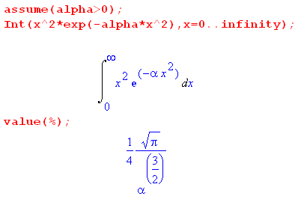

Therefore,

M = 4π(A/V) * ($\sqrt{π}$/4) [βm/2]-3/2 = (A/V) π3/2 [2/(βm)]3/2 = (A/V) [2π/(βm)]3/2

This lets you solve for A to be

A = MV [2π/(βm)]-3/2 = MV [βm/(2π)]3/2

and then we seem to have our solution

N(v) = 4π(A/V) v2 exp(-βmv2/2)

= 4π(1/V) * MV [βm/(2π)]3/2 * v2 exp(-βmv2/2)

= 4πM [βm/(2π)]3/2 * v2 exp(-βmv2/2)

= 4M π-1/2 [βm/(2)]3/2 v2 exp(-βmv2/2)

and this then is the traditional Maxwell velocity curve which has a smooth peak.

2. Let's look now at various in-house authors

Livesey page 16 gets results similar to me, but he does not quite state the final result with the constant evaluated. He uses symbol f(v) I think in the sense that I use Ni/dv above, and he gets f(v) = C v2exp(-βmv2/2).

Zemansky does his derivation starting page 147 and ends up with his final result on page 159 which is this, changing w→v and β = 1/(kT) :

dNv/dv = ( 4M/$\sqrt{π}$ )(mβ/2)3/2 v2 exp(-βmv2/2)

This agrees exactly with my Plan A result, hurray!

Big Reif: Page 267 gives this speed distribution

F(v) = 4πn (mβ/2π)3/2 v2 exp(-βmv2/2)

where I think his n is the particle density in volume space. Now π (1/π)3/2 = π π-3/2 = π-1/2 so he agrees with Zemansky apart from the definition of F(v).

3. Where is the super strong peak I keep talking about in Lagrange doc?

A box of gas has the Maxwell speed distribution which is a smooth peak. Based on the above discussion, you can regard it as a plot of Ni which solves the gas problem. This set of many Ni makes the vector N I talk about.
Now take an ensemble of 1 billion boxes of gas, and each has a solution vector N which means each one has a speed curve.

Fact: The speed curve and its peak are NOT the curve I am talking about with my billion systems comment. Each of the billion boxes of bas has a curve which is its N, and the curves of all the systems are very close. The speed curve IS the stationary point solution vector N.

4. Show that gi >> Ni.

Using results from above,

gi = g(v) dv g(v) = (4πv2/V)

Ni = N(v)dv = 4M π-1/2 [βm/(2π)]3/2 v2 exp(-βmv2/2) dv

Then look at the ratio

gi/Ni = (4πv2/V) / {4M π-1/2 [βm/(2π)]3/2 v2 exp(-βmv2/2)}

I want to show that this is large, but it is a function of my arbitrary volume element V in v-space.

How do the dimensions work here?

dim (4πv2/V) = 1/v

dim(gi/Ni) = (1/v) / {E-3/2 m3/2 v2 } = (1/v) E3/2m-3/2 v-2 = E3/2m-3/2v-3

= (mv2)3/2m-3/2v-3 = 1 correct!

I think I showed on scratch paper that

V = (h/2Lm)3

Don't do the ratio, do Ni and gi separately so can compare to Zemansky numbers.

Pausing probably for the day with scratch paper and 4 books open and active.

Oct 16 continue

If I insert my tentative V expression into gi I get

gi = g(v)dv = (4πv2/V)dv = (4πv2/(h/2Lm)3)dv = 4πv2 23L3m3 h-3dv

= 32πL3m3h-3v2dv

But Zemansky on page 272 gives this thing integrated up to some energy ε' . So first convert the above expression to energy ε as the variable:

2ε = mv2 2dε = 2mvdv dε = mvdv vdv = dε/m

v = (2ε/m)1/2

gi = 32πL3m3h-3 v vdv = 32πL3m3h-3(2ε/m)1/2dε/m

= 32πL3m3m-1 m-1/2h-321/2(ε)1/2dε

= 32πL3 m3/2h-3 21/2(ε)1/2dε // m factors are gone!!!

Now integrate this from ε = 0 to ε = ε'. We have

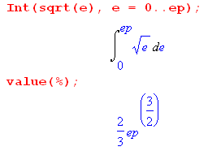

so that

$^{\int_{0}^{ε'}{}}$ε1/2dε = (2/3) e'3/2

And then my answer is

∫gi = 32πL3 m3/2 h-3 21/2 (2/3) ε'3/2 = 8 * 4πL3 m3/2 (3h3)-1 23/2ε'3/2 // me

But I think Zemansky answer page 272 is this (V = L3)

∫gi = 4πL3 (2mε')3/2/ (3h3) // Zeman

where I think V = L3 is the volume. We agree except I have a leading factor of 8.

Zem. dimensions: m3 ( kg-joule)3/2 / [ joule-sec ]3 = m3 kg3/2 joule3/2 joule-3 sec-3

= m3 kg3/2 joule-3/2 sec-3

But E = (1/2)mv2 so joule = kg m2 sec-2 so continue

= m3 kg3/2[ kg m2 sec-2]-3/2 sec-3

= m3 kg3/2[kg-3/2m-3 sec3 ] sec-3

= 1

so Zemansky's dimensions are correct.

Zem says the number of states is restricted to the positive octant.

My quantum mechanics box wavefunction is this

ψnxnynz(x,y,z) = K sin(πnxx/L)sin(πnyy/L)sin(πnzz/L)

Are both signs of the ni included as different states or not? Shchiff p 39 makes the statement I want: the negative integers give solutions which are not linearly independent; Other books like Messiah do it with no comment.

So what is the implication of "positive octant"? It means that when I counted things in terms of the entire shell in v-space, I should have introduced a factor of 1/8 somewhere. That explains why I have an extra factor of 8!

My missing mass problem? I will just go back and look for it now.

Here is my scratch paper derivation of my V object.

First, what is the wave function?

For a featureless particle in a 3D box of edge L in the first quadrant of space the wavefunction is

ψn$_{x}$n$_{y}$n$_{z}$(x,y,z) = K sin(πnxx/L)sin(πnyy/L)sin(πnzz/L) nx = 1,2.3.... etc

[ψn$_{x}$n$_{y}$n$_{z}$(x,y,z)]2 = K2 sin2(πnxx/L)sin2(πnyy/L)sin2(πnzz/L)

Now integrate over the box. Maple does our integral of interest:

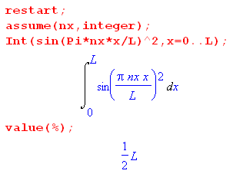

and then we find that

$^{\int_{0}^{L}{}}$dx$^{\int_{0}^{L}{}}$dy$^{\int_{0}^{L}{}}$dz [ψn$_{x}$n$_{y}$n$_{z}$(x,y,z)]2 = K2(L/2)3

For a single particle in the box, we want this result to be 1, so then

K2(L/2)3 = 1 K = (2/L)3/2

and then

ψn$_{x}$n$_{y}$n$_{z}$(x,y,z) = (2/L)3/2 sin(πnxx/L)sin(πnyy/L)sin(πnzz/L)

For M independent particles (Bosons) in the box, the total wavefunction is the product of M wavefunctions of the form shown above, where nx → nn(j) for the jth particle.

We know that the momentum operator is p = (⁄/i) ∇ so then p2 = - ⁄2∇2. The momentum for a particle in the above state is then

p = <ψn$_{x}$n$_{y}$n$_{z}$| (⁄/i)∇ | ψn$_{x}$n$_{y}$n$_{z}$>

px = <ψn$_{x}$n$_{y}$n$_{z}$| (⁄/i)∂x | ψn$_{x}$n$_{y}$n$_{z}$>

New integral to worry about.

$^{\int_{0}^{L}{}}$dx (2/L)3/2 sin(πnxx/L)sin(πnyy/L)sin(πnzz/L) * [(⁄/i)(πnx/L)] * (2/L)3/2 cos(πnxx/L)sin(πnyy/L)sin(πnzz/L)

= (2/L)3 [(⁄/i)(πnx/L)] [$^{\int_{0}^{L}{}}$dx sin(πnxx/L) cos(πnxx/L) ] (L/2)(L/2)

The integral vanishes for all integer nx, All of our eigenstates have <px> = 0 and <p> = 0.

This is because the probability of the wave "going left or right" is the same.

Now consider

p2 = <ψn$_{x}$n$_{y}$n$_{z}$| - ⁄2∇2 | ψn$_{x}$n$_{y}$n$_{z}$>

= <ψn$_{x}$n$_{y}$n$_{z}$| - ⁄2[ - (πnx/L)2 - (πny/L)2 - (πny/L)2| ψn$_{x}$n$_{y}$n$_{z}$>

= ⁄2 (π/L)2 [ nx2 + ny2 + nz2] <ψn$_{x}$n$_{y}$n$_{z}$| ψn$_{x}$n$_{y}$n$_{z}$>

= ⁄2 (π/L)2 [ nx2 + ny2 + nz2] ni = 1,2....

Then

v2 = (⁄/m)2 (π/L)2 [ nx2 + ny2 + nz2] = Q [ nx2 + ny2 + nz2]

Now define the following mathematical "helper objects"

vx ≡ (π⁄/mL)nx
vy ≡ (π⁄/mL)ny
vz ≡ (π⁄/mL)nz

Then we can write

v2 = vx2 + vy2 + vz2

We can then imagine a vector in this newly defined v-space having this form.

v = (vx,vy,vz) = (π⁄/mL)(nx,ny,nz)

If we look in n-space we see that states are spaced by 1 unit on each axis.
If we look in v-space we see that states are spaced by (π⁄/mL) unit on each axis.

Consider a spherical shell in v-space of thickness Δv which is restricted to the first octant of n-space. The volume of this octant sell is this

volume = (1/8) 4πv2 Δv

But each state occupies a volume of (π⁄/mL)3 in this v-space, so the number of states in the shell is this

number of states in octant shell = (1/8) 4πv2 Δv / (π⁄/mL)3

Now recall from above that

gi = [4πv2dv]/V = [4πv2/V] dv ≡ g(v) dv g(v) = (4πv2/V)

where we said that V was volume occupied by one state in v-space. We have just shown that

V = (π⁄/mL)3 = (h/2mL)3

so this result should become

gi = [4πv2/V] dv ≡ g(v) dv g(v) = (4πv2/V)

= [4πv2] (mL/π⁄)3 dv

which agrees with our number of states shown above, apart from the octant 1/8 factor.

So here is the correct answer:

gi = (1/8) [4πv2] (mL/π⁄)3 dv

= (1/8) [4πv2] (2mL/h)3 dv

∫gi = 4πL3 (2mε')3/2/ (3h3)

as the number of states up to energy ε'. He now assumes that the states just fill up from the bottom to a level ε'. How does this work exactly? Is it just like an atom? You are going to put your M particles into the states available. So forget my comment earlier about product of wavefunctions which just adds confusion. suppose you do this. Then you would have

∫gi = 4πL3 (2mε')3/2/ (3h3) = M

That seems like the T = 0 way things would work.

But that is not what he is doing. Where does he get his ε' from??

ε = (1/2)mv2 = (3/2)kT ?

That would be the mean energy of a particle in the gas. Let's see what this gives

k = 1.38064852 × 10⁻²³ m² kg s⁻² K⁻¹

T = 300oK

m(helium) = 4.0026 AMU = 4.0026 (1/12) mass carbon =

1.660539040(20)×10⁻²⁷ kg = unified atomic mass unit = dalton = (1/2) the mass of carbon-12

Therefore, the mass of a helium atom is this

4.0026 * 1.660539040 * 10-27 kg = 6.6464 x 10-27 kg = 6.6464 x 10-24g

If I use the average energy equation ε = (3/2)kT Maple says (using mks units until the last line)

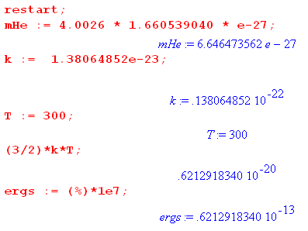

and Zemansky says "about 10-12 ergs".

I am having trouble visualizing the distribution of atoms into the states. Look at the Maxwell distribution graph with its gentle peak. We have Ni in ALL these states. The high-v tail roughly goes to zero at about twice the average speed. So that high end would correspond roughly to ε'. Then my answer would be that the states are filled up to about ergs = 1.2 x 10-12 which is exactly what Zemansky is saying.

So now let's compute his ∫gi = 4πL3 (2mε')3/2/ (3h3) using ε' = 10-19joule.

h = 6.62607004 × 10⁻³⁴ mks

Maple says

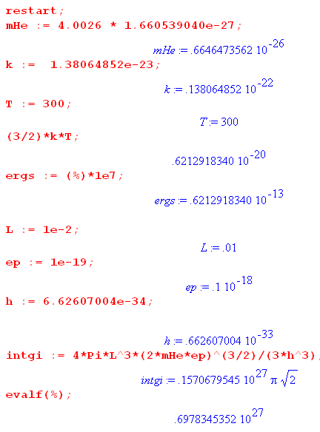

So I get that

∫gi = .7 x 1027

But on page 645 Zemansky claims 1027 so we agree.

How many particles are in the box? A mole of helium weighs 4.002 grams. how many atoms is this: Na = 6.022 x 1023. How many liters is this at STP? Someone says 0.176 grams. So our little 1 cm3 sample is 10-3 liter so

atoms of helium = 6.022 x 1023 * (0.176/ 4.002)*10-3

= 6.022 *( 0.176/ 4.002) x 1020 = 0.4 x 1020

Zemansky says about 1019 which I call close enough.

You really should use PV = nRT to get the density n.

Conclusion: I am finally happy with all aspects of Zemansky's problem (10-2).

Now let's try to repeat this at a value of v maybe near the middle of the curve. The corrected values are

gi = (1/8) [4πv2] (mL/π⁄)3 dv = g(v) dv // including 1/8 correction

Ni = A gi e-βε$_{i}$

which I translate here to read

g(v) = (1/8) [4πv2] (mL/π⁄)3

N(v) = A g(v) exp(-βmv2/2) = A (1/8) 4π (mL/π⁄)3 v2 exp(-βmv2/2)

= A (π/2) (mL/π⁄)3 v2 exp(-βmv2/2)

To normalize, we have

M = $^{\int_{0}^{∞}{}}$N(v)dv = A (π/2) (mL/π⁄)3$^{\int_{0}^{∞}{}}$exp(-βmv2/2)v2dv

= A (π/2) (mL/π⁄)3 * (1/4) $\sqrt{π}$ (βm/2)-3/2

Then

A = M (2/π) (mL/π⁄)-3 (4/$\sqrt{π}$)(βm/2)3/2

Then our final expression for N(v) is this

N(v) = [ M (2/π) (mL/π⁄)-3 (4/$\sqrt{π}$)(βm/2)3/2 ]* (π/2) (mL/π⁄)3 v2 exp(-βmv2/2)

= [ M (4/$\sqrt{π}$) (βm/2)3/2 ] v2 exp(-βmv2/2)

= [ M (22/$\sqrt{π}$) β3/2m3/2 2-3/2 ] v2 exp(-βmv2/2)

= [ M (21/2/$\sqrt{π}$) β3/2m3/2 ] v2 exp(-βmv2/2)

= M $\sqrt{2/π}$(βm)3/2 v2 exp(-βmv2/2)

Let's integrate this again to make sure I did the algebra right

$^{\int_{0}^{∞}{}}$N(v)dv = M $\sqrt{2/π}$(βm)3/2 * (1/4) $\sqrt{π}$ (βm/2)-3/2

= M $\sqrt{2/π}$(βm)3/2 * (1/4) $\sqrt{π}$ (βm)-3/2 23/2

= M $\sqrt{2/π}$(βm)3/2 * (1/4) $\sqrt{π}$ (βm)-3/2 23/2

= M (21/22-223/2) (π-1/2 π1/2)

= M (1) (1) = M verified

So here are my results, just for the record

N(v) = M $\sqrt{2/π}$(βm)3/2 v2 exp(-βmv2/2)

g(v) = (1/8) [4πv2] (mL/π⁄)3

I could then evaluate each one at some reasonable v and get the ratio.

Alternatively I could use

Ni = A gi e-βε$_{i}$

N(v) = A g(v) e-βε$_{i}$

and I could install A from above. Let's take the ratio of my "for the record" results,

g(v)/ N(v) = (1/8) [4πv2] (mL/π⁄)3 M-1$\sqrt{π/2}$(βm)-3/2 v-2 exp(βmv2/2)

= (1/2) [π] (mL/π⁄)3 M-1$\sqrt{π/2}$(βm)-3/2exp(βmv2/2)

= (1/2$\sqrt{2}$) π3/2 (2mL/h)3 M-1(βm)-3/2exp(βmv2/2)

= (8/2$\sqrt{2}$) π3/2 (mL/h)3 M-1(βm)-3/2exp(βmv2/2)

= (4/$\sqrt{2}$) π3/2 L3 h-3 m3 M-1 β-3/2m-3/2 exp(βmv2/2)

= (4/$\sqrt{2}$) π3/2 L3 h-3 M-1 β-3/2m3/2 exp(βmv2/2)

= (4/$\sqrt{2}$) (πm/β)3/2 L3 h-3 M-1 exp(βmv2/2)

= (4/$\sqrt{2}$) (πmkT)3/2 L3 h-3 M-1 exp(mv2/2kT)

The higher in v you go, greater is this ratio. This ratio is smallest near v = 0 where the exp is just 1. In that case we find that the ratio is about 200,000. Good! At all other points the ratio is larger.

We might use the average speed for v where we know that

(1/2)mv2 = (3/2)kT (4/$\sqrt{2}$) = 2 * 2/$\sqrt{2}$ = 2$\sqrt{2}$

then we have

g(v)/ N(v)|near peak = (2$\sqrt{2}$) (πmkT)3/2 L3 h-3 M-1 exp(3/2)

I will use the same numbers from the helium example. Doing this I get a ratio of about 900,000.

