This has been installed, do not edit here.

6.4 A numerical Boltzmann problem example

For this example we choose three energy levels (m = 3) so the state count is given by

Ω(N1,N2,N3) = $_{1}$$_{2}$ $_{3}$ (6.1.3) (6.4.1)

and correspondingly (this uses the Stirling approximation),

f = lnΩ = Σi=13 Ni [1 + ln(gi/Ni)] . (6.2.3) (6.4.2)

Assume the three energy levels are ordered in this manner, where ε1 is the lowest energy state,

ε1 < ε2 < ε3 . and recall u = U/M and ε1 ≤ u ≤ ε3 (6.4.3)

We regard both N1 and N2 as functions of N3 where, according to (6.3.1),

N1 = + (ε2- ε1)-1[ ε2M - U + (ε3- ε2)N3] = N1(N3)
N2 = - (ε2- ε1)-1[ ε1M - U + (ε3 - ε1)N3] = N2(N3) . (6.3.1) (6.4.4)

It seems clear that one must have

0 ≤ N1 ≤ M
0 ≤ N2 ≤ M. (6.4.5)

Using the expressions (6.4.4) in these inequalities and making use of (6.4.3) and the fact that ε1 ≤u ≤ ε3, one finds that all four inequalities can be summarized as just two inequalities which we write as,

N3min ≤ N3 ≤ N3max
N3min = max($\frac{u-ε2}{ε3- ε2}$M, 0)
N3max = min( $\frac{u-ε1}{ε3- ε1}$M, M) = $\frac{u-ε1}{ε3- ε1}$M // since u ≤ ε3 (6.4.6)

To find the Lagrange multiplier β we must solve (6.2.17),

Σi [ εi - u ] gi e-βε$_{i}$ = 0 . (6.2.17) (6.4.7)

Then the other derived multiplier is then given by (6.2.14)

A = $_{i}$ = $\frac{M}{Z}$ where Z ≡ Σigie-βε$_{i}$ . (6.2.14) (6.4.8)

The components Ni of the solution vector are then given by

Ni = A gi e-βε$_{i}$ . (6.2.11) (6.4.9)

The curvature of f at its peak is given by

$\frac{d2f}{d2N3}$ = – { $\frac{1}{N1}$ [ $\frac{ε3-ε2}{ε2-ε1}$ ]2 + $\frac{1}{N2}$[ $\frac{ε3-ε1}{ε2-ε1}$ ]2 + $\frac{1}{N3}$ } (6.3.8) (6.4.10)

The half-width of the Ω peak is then given by

dNi = $\frac{1.4}{|d2f/d2Ni|}$ (6.3.13) (6.4.11)

For our specific Maple plots, we shall assume

ε3= 3 M = 1000 = number of particles
ε2 =2 u = 1.5 = average energy
ε1= 1 g1= g2= g3 = 5000 = degeneracy (6.4.12)

Here then is our Maple code. We first enter Ω,

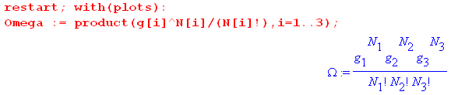

The quantities N1 and N2 are then replaced as in (6.4.4), [ we use ei in place of εi]

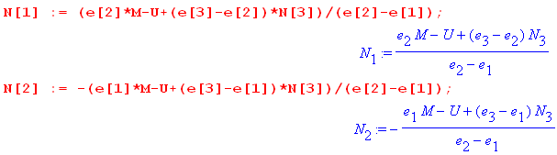

We next enter most of the data shown above and use it to compute N3min and N3max

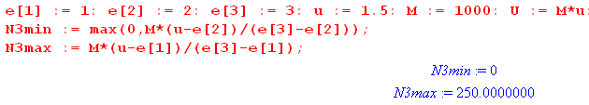

so the legal range of N3 is (0,250). Here is a plot of N1 (red) and N2(black) versus N3 :
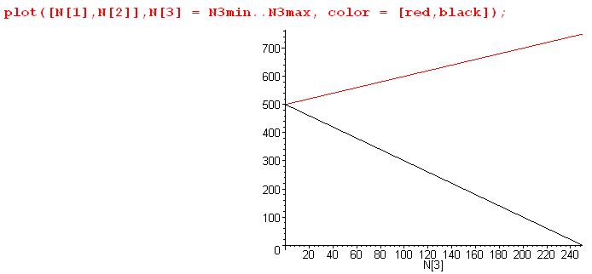 (6.4.13)

We then enter the degeneracies and take a look at Ω in its numerical form,

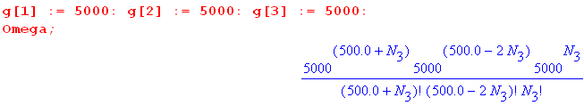 (6.4.14)

As is typical in statistical mechanics, at its peak the value of Ω is a very large number. Even with our relatively small number of particles M = 1000 and degeneracy g = 5000, the peak value is (see below)

Ωpeak = 6.71 x 101519 (6.4.15)

Maple is uncomfortable plotting numbers larger than about 1040 so we pre-scale Ω down by 101519 to make the scaled Ω be Maple-digestible. This scaling process in turn creates numbers smaller than 10-40 which are also rejected by the Maple plotter, so we use a Heaviside function to pin small numbers to 0 unless they are greater than the arbitrary value .01. Here then is a plot of Ω(N3),

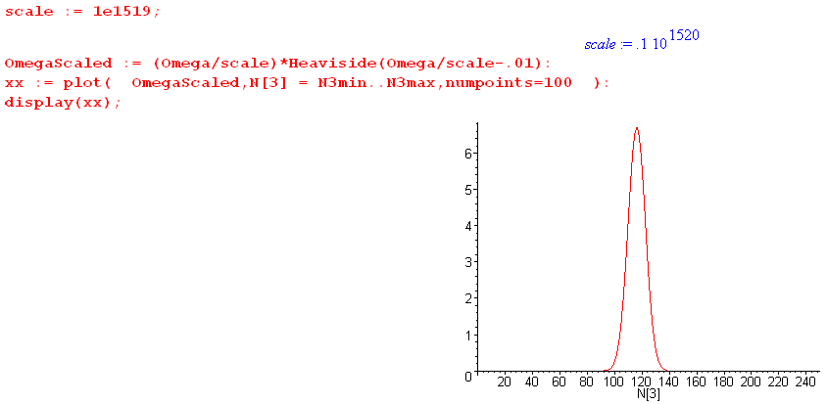
(6.4.16)

We broke the display command into two pieces: first create xx then plot xx. Replacing : with ; after the plot command gives one a list of numbers to be plotted, and from this list one can determine a reasonable scale factor. Once that is found, the plotting coordinates need not be displayed. The curve Ω(N3) has the typical Gaussian (normal) shape which no doubt the energetic reader could show results from the central limit theorem.

A plot of f = ln(Ω) has a much smoother and broader shape,

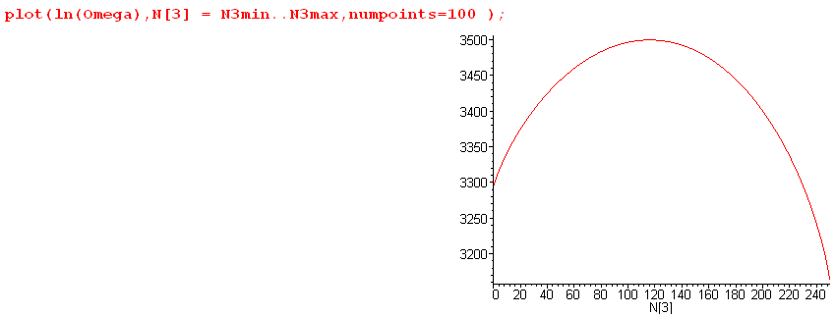
(6.4.17)

Recall from (6.3.8) that $\frac{d2f}{d2Ni}$ is everywhere negative, consistent with the cupping down seen in this plot.

Next, we have Maple solve (6.2.17) for the Lagrange multiplier β,

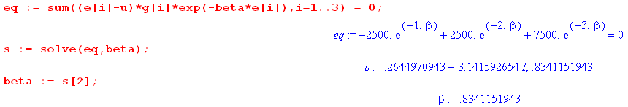

With w = e-β the above equation is 3w2+w-1 = 0 which has solutions w = ( -1 ± $\sqrt{13}$)/6. The minus sign gives the complex β noted, while the plus sign gives the physical solution β = - ln[( -1 + $\sqrt{13}$)/6] = .834.
From this β value we compute the other Lagrange parameter A from (6.2.14)

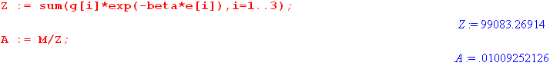

Once these parameters are known, we use (6.2.11) to display the solution vector N = {Ni}.

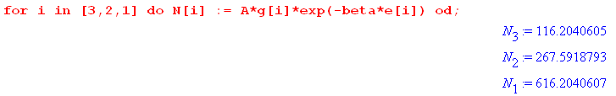

Since we set u < ε2, we see here a normal distribution where higher energy states have fewer particles.

Our final task is to use (6.3.8) and (6.3.13) to determine the half-width of the Ω peak,

which says ΔN ≈ 7.5. This width and the solution N3 = 616.2 can be verified from this blowup plot of Ω,

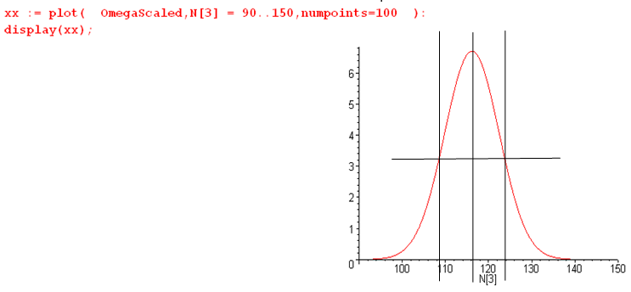

Notice that this Maple code does not use the Stirling approximation and provides a continuous interpolation of N! as Γ(N+1).

The peak value of Ω is found to be

In the above example we used u = 1.5 < ε2 = 2. If we instead use u = 2.5 > ε2 = 2, we find that the state populations are as shown above but in reverse order. Such a inverted situation corresponds to a negative absolute temperature T and cannot therefore arise in thermal equilibrium. It could arise in a laser medium which is driven by some power source.

