This is the Title PhL 1.11.15

This was installed on 6/6/15, do not edit here!

6. The Boltzmann factor in Statistical Mechanics

6.1 Statement of The Boltzmann Extremum Problem

Imagine a system which has m state levels into which particles can be placed. At a given energy level εi, the number of available states is gi, known as the degeneracy at energy εi. A particular state of the entire system of particles is characterized by the number of particles Ni in each of the states, so system state = (N1,N2...Nm) = N, a vector. The total number of particles in the system is fixed at M = ΣiNi, and the total energy is U = ΣiεiNi. The system is isolated so its initial energy U does not change, nor can particles be created or destroyed, so U and M are both fixed constants. The system of particles (perhaps a box of gas atoms) is assumed to be at thermal equilibrium so all its macroscopic characteristics (like pressure and temperature) are stable.

Imagine a billion of these particle systems (an "ensemble"). Each system settles into its own partition set {Ni} = N. If M is very large, one will find that those billion N vectors are all rather similar. This is so because certain {Ni} partitions are statistically favored over other partitions just because there are a lot more "states" available to a system with those favored {Ni} partitions.

So, how many states are available ("accessible") to such a system characterized by vector N which represents some partitioning of the particles {Ni}?

The number of different "ways" of placing N indistinguishable balls into g boxes is a fascinating elementary problem and the answer is $\left(\begin{matrix}N+g-1 \\ N\end{matrix}\right)$, a binomial coefficient.

Footnote: One arrives at this answer by thinking of N balls and g-1 "partitions" between boxes, all of which have to be laid out in a row, such as | * * * | * | | * for the case N = 5 and g-1 = 4. Here the leftmost bin is empty, as is the second bin from the right. Each layout of the 9 objects is characterized by picking a committee of 5 balls from the 9 positions (or a committee of 4 partitions). So in this case the number of unique layouts is $\left(\begin{matrix}9 \\ 5\end{matrix}\right)$ = $\frac{9!}{5!4!}$ = $\left(\begin{matrix}9 \\ 4\end{matrix}\right)$ . (6.1.1)

The count $\left(\begin{matrix}N+g-1 \\ N\end{matrix}\right)$ allows multiple balls to be in any given box. This count is then associated with so-called Bose-Einstein statistics -- multiple bosons are allowed in the same state (for example, photons or any integral-spin particles). If at most one ball is allowed in any given box , the count of ways is just the number of ways to pick a committee of N boxes from the set of g boxes, and this count is $\left(\begin{matrix}g \\ N\end{matrix}\right)$. This count is then associated with so-called Fermi-Dirac statistics -- only one fermion is allowed in a state (for example electrons or any half-integral spin particles). The fact that electrons are fermions is the reason the periodic table of elements exists.

However, we shall assume that gi >> Ni (known as the Boltzmann limit), and this allows a simplification of the state count. Both the Bose and Fermi state counts reduce to the same count in this limit:

ways = $\left(\begin{matrix}N+g - 1 \\ N\end{matrix}\right)$ ≈ $\left(\begin{matrix}g \\ N\end{matrix}\right)$ = $\frac{g!}{N! (g-N)!}$ = $\frac{g(g-1)..(g-N+1)}{N!}$ ≈ $\frac{gN}{N!}$ . (6.1.2)

So in our particle problem, the number of ways of having N1 particles in states with energy ε1 is $\frac{g1N}{N1!}$. For each of these ways, we have $\frac{g2N}{N2!}$ways of putting N2 particles in energy level ε2. And so on. Thus, the total number of available states ("microstates") for a partition {Ni} of the M particles is given by

Ω(N1,N2...Nm) = $_{1}$$_{2}$ ....$_{m}$ . (6.1.3)

So here is our initial extremum problem:

Find N which maximizes Ω(N) = $_{1}$$_{2}$ ....$_{m}$ subject to these two constraints:
ΣiNi = M and ΣiεiNi = U . (6.1.4)

When M is a very large number (like Avogadro's number), it turns out that Ω(N) has a very strong and sharp maximum at a certain N which is the solution value N for this extremum problem. Thus, when one examines an ensemble of such systems, this solution N is the overwhelmingly likely partitioning of the particles into {Ni}. Our task is then to solve this problem for N.

This vector N = (N1, N2...Nm) is the vector r = (x1, x2...xN) of our general Lagrange Multiplier presentation, so in this application the number of components in the vector is N = m, and we don't want to confuse this previous use of symbol N with N or Ni of the present problem!

One might observe that the xi in the general analysis were reals, whereas the Ni here are integers. We can dispense with this issue by simply writing Ni! = Γ(Ni+1) which then serves to interpolate Ni between its integer values. Another approach is to replace Ni everywhere in the above problem statement by ni ≡ Ni/M. Since M and the solution Ni values are very large integers, one can regard this ni as essentially a continuous real (albeit rational) variable.

It should be noted that the value of U is restricted to a certain range.

Mεmin ≤ U ≤ Mεmax (6.1.5)

The limits represent the two extreme possible partitions {Ni} of the particles (all in lowest energy state, or all in highest energy state). It is useful to define the average energy of a particle,

u ≡ U/M = average energy of particle in the system (6.1.6)

and then (6.1.5) says,

εmin ≤ u ≤ εmax (6.1.7)

6.2 Solution of The Boltzmann Extremum Problem

Maximizing the state count Ω of (6.2) is the same as maximizing f ≡ lnΩ, and from (6.1.3),

f(N1, N2...Nm) ≡ lnΩ(N1,N2...Nm) = Σi [ Ni ln gi ] - Σi [ ln Ni! ] (6.2.1)

where Σi means Σi=1m. Assuming all the Ni are very large numbers, we may use Stirling's formula,

x! ≈ $\sqrt{2πx}$xx e-x ⇒ lnx! ≈ ln$\sqrt{2π}$+ (1/2) lnx + xlnx - x ≈ xlnx - x, x >> 1 . (6.2.2)

Then ln Ni! ≈ NilnNi- Ni so that,

f = lnΩ = Σi [ Ni lngi ] - Σi [ ln Ni! ] ≈ Σi [ Ni lngi ] - Σi [NilnNi- Ni]

= Σi [(1+lngi)Ni - NilnNi ] = Σi Ni [1 + ln(gi/Ni)] . (6.2.3)

Here then is a restatement of our extremum problem:

Find N which maximizes f(N) = Σi [(1+ln gi)Ni - NilnNi ] subject to these two constraints: a(N) = ΣiNi - M = 0
b(N) = ΣiεiNi-U = 0 . (6.2.4)

Following now the prescription of Section 2, we write our "Lagrangian" H as

H(N,λ) ≡ f(N) + λ1a(N) + λ2 b(N)

= Σi [(1+ln gi)Ni - NilnNi ] + λ1 [ ΣiNi - M] + λ2 [ΣiεiNi-U] . (6.2.5)

The next step (b) is to compute the m derivatives with respect to Ni :

fi = ∂f/∂Ni = (1+lngi) - Ni (1/Ni) - lnNi = lngi - lnNi = ln(gi/Ni)

ai = ∂a/∂Ni = ∂i [ ΣjNj - M] = 1

bi = ∂b/∂Ni = ∂i [ΣjεjNj-U] = εi . (6.2.6)

In step (c) we set the partials of H to zero, so

0 = Hi(N,λ) = fi + λ1ai + λ2 bi = ln(gi/Ni) + λ1 + λ2εi i = 1,2...m
or
ln(gi/Ni) + λ1 + λ2εi = 0 i = 1,2...m
or
ln(Ni/gi) = λ1 + λ2εi . i = 1,2...m

For step (d) we just write down the set of equations we have to solve (6.2.7)

ln(Ni/gi) = λ1 + λ2εi i = 1,2...m

ΣiNi = M // a(N) = 0

ΣiεiNi = U // b(N) = 0 . (6.2.8)

We have a system of m+2 equations in m+2 unknowns which are the Ni, λ1 and λ2. To solve these equations, we first solve the first set of m equations for Ni, leaving λ1 and λ2 as unknowns:

ln(Ni/gi) = λ1+ λ2εi
or
Ni = gi eλ$_{1}$ eλ$_{2}$ε$_{i}$ . (6.2.9)

Already a major result has emerged from our Lagrange Multiplier analysis! The population Ni of states at energy level εi depends exponentially on εi. We intuitively expect higher energy levels to be less populated than lower ones, so we expect λ2 to be negative. For this reason, and following tradition, we set λ2 = - β where β > 0. And while we're at it, we can set eλ$_{1}$ = A to simplify notation. So

β ≡ - λ2

A ≡ eλ$_{1}$ (6.2.10)
and then (6.2.9) reads,

Ni = A gi e-βε$_{i}$ . (6.2.11)

A study of the statistical mechanics of thermal equilibrium in fact shows that

β = 1/kT (6.2.12)

where T is absolute temperature and k is Boltzmann's constant. The factor e-βε$_{i}$ in (6.2.11) is referred to as the Boltzmann factor. The idea that β = 1/kT is really the definition of absolute temperature, but these matters are not of immediate interest, and we continue onward.

From (6.2.11) the probability of a particle having energy εi is given by

pi = $\frac{Ni}{M}$ = $\frac{A}{M}$ gi e-βε$_{i}$ . (6.2.13)

Since Σipi = 1 one finds that 1 = $\frac{A}{M}$ [Σigi e-βε$_{i}$] which then determines the derived Lagrange multiplier constant A (expressed in terms of β),

A = $_{i}$ . (6.2.14)

The denominator Z ≡ Σigie-βε$_{i}$ is called the partition function for the system.

Using (6.2.11) for Ni, the two constraint equations shown in (6.2.4) [ΣiNi= M and ΣiNiεi= U] read

A Σigie-βε$_{i}$ = M
A Σiεig e-βε$_{i}$ = U . (6.2.15)

Dividing these two equations and using (6.1.6) that u = U/M, one gets this self-consistent result,

u = $\frac{U}{M}$ = $_{i}$$_{i}$ = $_{i}$$_{i}$ = $\frac{Σipiεi}{1}$ = Σipiεi = <εi> . (6.2.16)

To find the derived Lagrange multiplier constant β = -λ2 we write out the second equation of (6.2.15),

Σigiεi e-βε$_{i}$ = U/A = (U/M)(M/A) = (u) ( Σigi e-βε$_{i}$)
or
Σi [ εi - u ] gi e-βε$_{i}$ = 0 (6.2.17)

so this is the equation one must solve for β. Recall that εi, gi, and u all known quantities. For the lowest energy states one will have εi < u ( recall that u = <εj> ) so [εi - u] will be negative. For high energy states [ εi - u ] will be positive, so that is why (6.2.17) at least stands a chance of having a solution for β. As noted in (6.2.12), the solution for β indicates the temperature of the system of particles. Changing u changes the solution β, so one concludes that the mean particle energy u is a function of temperature.
For general values of εi (6.2.17) is a transcendental equation which must be solved numerically for β. If it happens that all the εi are ratios of integers, the equation can be written as a polynomial equation, but since those integers are likely to be large, the order of this polynomial is large and again one must do a numerical solution.

Notice that the solution to our particle system problem has the same general form regardless of the number m of energy levels εi. If we take m very large and make the energy levels εi be very closely spaced, they approach a continuum of energy values and the conclusions apply to a classical system. For small finite m, the discrete energy levels indicate a quantum mechanical system.

To summarize, we have used the method of Lagrange multipliers to solve the Boltzmann extremum problem stated in either (6.1.4) or (6.2.4). Since the problem has two constraints, there are two Lagrange multipliers λ1 and λ2 which we replaced with the numbers A ≡ eλ$_{1}$ and β ≡ - λ2 . We showed how β is determined by numerically solving (6.2.17), and then A is determined by (6.2.14). Then the solution (extremum) vector N = {Ni} is given by (6.2.11) which says Ni = A gi e-βε$_{i}$ .

What we have not shown is that this extremum solution is a maximum. nor have we shown the fact that Ω(N) has a very sharp peak at the solution value N, which then statistically forces a system to assume a value N very close to this solution N. We shall deal with these questions in the following section.

6.3 More details of the Boltzmann problem solution

Start with

f = lnΩ = Σi [(1+lngi)Ni - NilnNi ] = Σi Ni [1 + ln(gi/Ni)] . (6.2.3)

The constraints ΣiNi= M and ΣiNiεi= U can be regarded as two equation in the two unknowns N1 and N2 which are easily solved to obtain,

N1 = + (ε2- ε1)-1[ ε2M - U + Σi=3m (εi- ε2)Ni] = N1(N3,...Nm)
N2 = - (ε2- ε1)-1[ ε1M - U + Σi=3m (εi - ε1)Ni] = N2(N3,...Nm) . (6.3.1)

Notice that, for i = 3,4...m,

$\frac{∂N1}{∂Ni}$ = + (ε2- ε1)-1 [ (εi- ε2) ] = $\frac{εi-ε2}{ε2-ε1}$
$\frac{∂N2}{∂Ni}$ = - (ε2- ε1)-1 [ (εi- ε1) ] = - $\frac{εi-ε1}{ε2-ε1}$ . (6.3.2)

Now think of f as function of N3,,,,Nm ,

f(N1(N3,...Nm), N2(N3,...Nm), N3, .....Nm) . (6.3.3)

Compute the total derivative df/dNi for i = 3,4...n:

$\frac{df}{dNi}$ = f1 $\frac{∂N1}{∂Ni}$ + f2 $\frac{∂N2}{∂Ni}$ + fi where fi ≡ $\frac{∂f}{∂Ni}$
= f1 $\frac{εi-ε2}{ε2-ε1}$ - f2 $\frac{εi-ε1}{ε2-ε1}$ + fi (6.3.2)
= ln(g1/N1) $\frac{εi-ε2}{ε2-ε1}$ - ln(g2/N2) $\frac{εi-ε1}{ε2-ε1}$ + ln(gi/Ni) (6.2.6) (6.3.4)

Installing the solution values ln(Ni/gi) = λ1 + λ2εi shown in (6.2.8) this becomes

= (λ1 + λ2ε1) $\frac{εi-ε2}{ε2-ε1}$ - (λ1 + λ2ε2) $\frac{εi-ε1}{ε2-ε1}$ + (λ1 + λ2εi)
= λ1 [ $\frac{εi-ε2}{ε2-ε1}$ - $\frac{εi-ε1}{ε2-ε1}$ + 1] + λ2 [ ε1 $\frac{εi-ε2}{ε2-ε1}$ - ε2 $\frac{εi-ε1}{ε2-ε1}$ + εi ]

= λ1 [ $\frac{εi-ε2}{ε2-ε1}$ - $\frac{εi-ε1}{ε2-ε1}$ + $\frac{ε2-ε1}{ε2-ε1}$] + λ2 [ ε1 $\frac{εi-ε2}{ε2-ε1}$ - ε2 $\frac{εi-ε1}{ε2-ε1}$ + εi $\frac{ε2-ε1}{ε2-ε1}$ ]

= λ1 [0] + λ2[0] = 0 (6.3.5)

This is the expected result since the solution is supposed to be a critical point of f given in (6.3.3).

Our main interest is in the second derivative d2f/dNi2 . If this comes out negative at the solution point, we know we have a maximum. Applying d/dNj to the second line in (6.3.5),

$\frac{d2f}{d2Ni}$ = $\frac{df1}{dNi}$ $\frac{εi-ε2}{ε2-ε1}$ - $\frac{df2}{dNi}$ $\frac{εi-ε1}{ε2-ε1}$ + $\frac{dfi}{dNi}$

= [ f11 $\frac{εi-ε2}{ε2-ε1}$ - f12 $\frac{εi-ε1}{ε2-ε1}$ + f1i] $\frac{εi-ε2}{ε2-ε1}$ fij ≡ $\frac{∂2f}{∂Ni∂Nj}$
- [ f21 $\frac{εi-ε2}{ε2-ε1}$ - f22 $\frac{εi-ε1}{ε2-ε1}$ + f2i] $\frac{εi-ε1}{ε2-ε1}$
+ [ fi1 $\frac{εi-ε2}{ε2-ε1}$ - fi2 $\frac{εi-ε1}{ε2-ε1}$ + fii] i = 3,4....m (6.3.6)

Recall now that

f = lnΩ = Σi [(1+lngi)Ni - NilnNi ] (6.2.3)

fi = lngi - lnNi (6.2.6)

fij = - δij(1/Ni) (6.3.7)

Therefore (6.3.6) simplifies to

$\frac{d2f}{d2Ni}$= f11 [ $\frac{εi-ε2}{ε2-ε1}$ ]2 + f22 [ $\frac{εi-ε1}{ε2-ε1}$ ]2 + fii

= – { $\frac{1}{N1}$ [ $\frac{εi-ε2}{ε2-ε1}$ ]2 + $\frac{1}{N2}$[ $\frac{εi-ε1}{ε2-ε1}$ ]2 + $\frac{1}{Ni}$} (6.3.8)

This says that the curvature of f in all independent directions Ni for i = 3,4...m is negative and this is true for all vectors N = {Ni}. This is of course then true for the solution vector N. But for the solution vector N we also have df/dNi = 0 from (6.3.5) and therefore the solution is a maximum of f and therefore of Ω.

Finally, we may estimate the width of the peak of f and then of Ω. The energy fractions in (6.3.8) are on the ballpark order of unity and the Ni are on the order of M, the total number of particles. If we do Taylor expansion of f(N) in the i direction only (i = 3,4...m) about the solution N, then

f(Ni + dNi) ≈ f(Ni) + (df/dNi)dNi + (1/2)(d2f/d2Ni) (dNi)2 (6.3.9)

But at the solution point (df/dNi) = 0 so we find

df ≈ (1/2)(d2f/d2Ni) (dNi)2 (6.3.10)

so
(dNi)2 ≈ $\frac{2 |df|}{|d2f/d2Ni|}$ (6.3.11)

Suppose we are interested in finding dNi such that the Ω(N) drops to half its peak value. Then

Ωhalf/Ωpeak = 1/2 ⇒ ln Ωhalf - ln Ωpeak = 1/2 ⇒

fhalf - fpeak = ln(1/2) ⇒ |df| = fpeak - fhalf = ln(2) = 0.7 (6.3.12)

In this case, the half width of the Ω plot is

dNi = $\frac{1.4}{|d2f/d2Ni|}$ (6.3.13)

For a ballpark estimate, we can interpret (6.3.8) as saying

$\frac{d2f}{d2Ni}$~ -3/M ⇒ dNi ≈ $\frac{1.4 M}{3}$~ $\sqrt{M}$ (6.3.14)

so the fractional half width is roughly.

$\frac{dNi}{M}$ ~ $\frac{1}{M}$ (6.3.15)

For a macroscopic box of gas particles, one might have M = 1020 and then $\frac{dNi}{M}$ ~ 10-10 . Since this is the fractional half-width of the peak in Ω, the peak is extremely sharp. This then is why, in an ensemble of macroscopic particle systems, all systems will have almost the same N value.

6.4 A numerical Boltzmann problem example

For this example we choose three energy levels (m = 3) so the state count is given by

Ω(N1,N2,N3) = $_{1}$$_{2}$ $_{3}$ (6.1.3) (6.4.1)

and correspondingly (this uses the Stirling approximation),

f = lnΩ = Σi=13 Ni [1 + ln(gi/Ni)] . (6.2.3) (6.4.2)

Assume the three energy levels are ordered in this manner, where ε1 is the lowest energy state,

ε1 < ε2 < ε3 . and recall u = U/M and ε1 ≤ u ≤ ε3 (6.4.3)

We regard both N1 and N2 as functions of N3 where, according to (6.3.1),

N1 = + (ε2- ε1)-1[ ε2M - U + (ε3- ε2)N3] = N1(N3)
N2 = - (ε2- ε1)-1[ ε1M - U + (ε3 - ε1)N3] = N2(N3) . (6.3.1) (6.4.4)

It seems clear that one must have

0 ≤ N1 ≤ M
0 ≤ N2 ≤ M. (6.4.5)

Using the expressions (6.4.4) in these inequalities and making use of (6.4.3) and the fact that ε1 ≤u ≤ ε3, one finds that all four inequalities can be summarized as just two inequalities which we write as,

N3min ≤ N3 ≤ N3max
N3min = max($\frac{u-ε2}{ε3- ε2}$M, 0)
N3max = min( $\frac{u-ε1}{ε3- ε1}$M, M) = $\frac{u-ε1}{ε3- ε1}$M // since u ≤ ε3 (6.4.6)

To find the Lagrange multiplier β we must solve (6.2.17),

Σi [ εi - u ] gi e-βε$_{i}$ = 0 . (6.2.17) (6.4.7)

Then the other derived multiplier is then given by (6.2.14)

A = $_{i}$ = $\frac{M}{Z}$ where Z ≡ Σigie-βε$_{i}$ . (6.2.14) (6.4.8)

The components Ni of the solution vector are then given by

Ni = A gi e-βε$_{i}$ . (6.2.11) (6.4.9)

The curvature of f at its peak is given by

$\frac{d2f}{d2N3}$ = – { $\frac{1}{N1}$ [ $\frac{ε3-ε2}{ε2-ε1}$ ]2 + $\frac{1}{N2}$[ $\frac{ε3-ε1}{ε2-ε1}$ ]2 + $\frac{1}{N3}$ } (6.3.8) (6.4.10)

The half-width of the Ω peak is then given by

dNi = $\frac{1.4}{|d2f/d2Ni|}$ (6.3.13) (6.4.11)

For our specific Maple plots, we shall assume

ε3= 3 M = 1000 = number of particles
ε2 =2 u = 1.5 = average energy
ε1= 1 g1= g2= g3 = 5000 = degeneracy (6.4.12)

Here then is our Maple code. We first enter Ω,

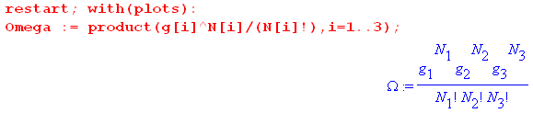

The quantities N1 and N2 are then replaced as in (6.4.4), [ we use ei in place of εi]

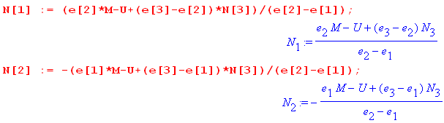

We next enter most of the data shown above and use it to compute N3min and N3max

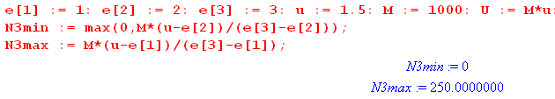

so the legal range of N3 is (0,250). Here is a plot of N1 (red) and N2(black) versus N3 :
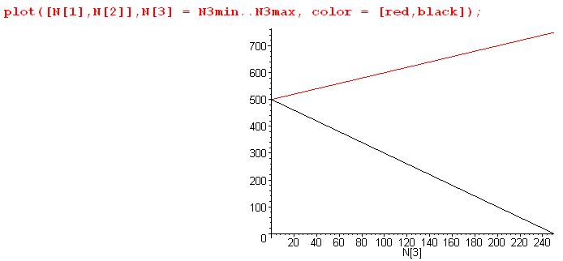 (6.4.13)

We then enter the degeneracies and take a look at Ω in its numerical form,

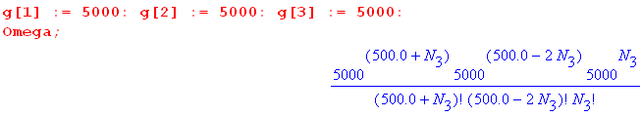 (6.4.14)

As is typical in statistical mechanics, at its peak the value of Ω is a very large number. Even with our relatively small number of particles M = 1000 and degeneracy g = 5000, the peak value is (see below)

Ωpeak = 6.71 x 101519 (6.4.15)

Maple is uncomfortable plotting numbers larger than about 1040 so we pre-scale Ω down by 101519 to make the scaled Ω be Maple-digestible. This scaling process in turn creates numbers smaller than 10-40 which are also rejected by the Maple plotter, so we use a Heaviside function to pin small numbers to 0 unless they are greater than the arbitrary value .01. Here then is a plot of Ω(N3),

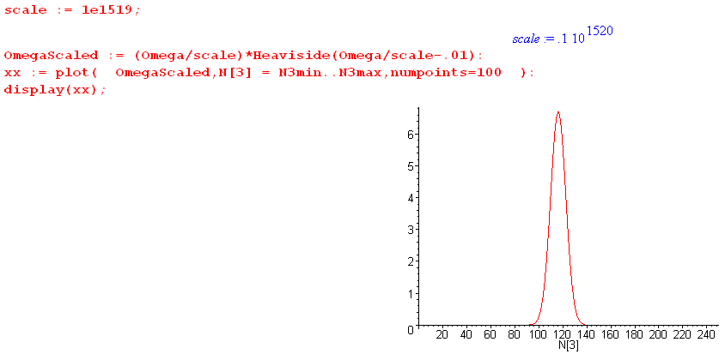
(6.4.16)

We broke the display command into two pieces: first create xx then plot xx. Replacing : with ; after the plot command gives one a list of numbers to be plotted, and from this list one can determine a reasonable scale factor. Once that is found, the plotting coordinates need not be displayed. The curve Ω(N3) has the typical Gaussian (normal) shape which no doubt the energetic reader could show results from the central limit theorem.

A plot of f = ln(Ω) has a much smoother and broader shape,

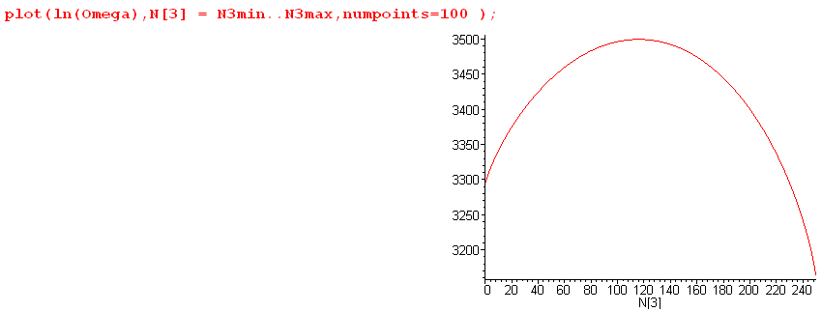
(6.4.17)

Recall from (6.3.8) that $\frac{d2f}{d2Ni}$ is everywhere negative, consistent with the cupping down seen in this plot.

Next, we have Maple solve (6.2.17) for the Lagrange multiplier β,

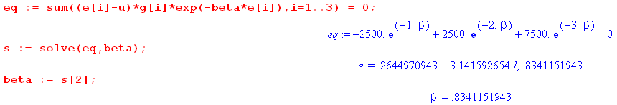

With w = e-β the above equation is 3w2+w-1 = 0 which has solutions w = ( -1 ± $\sqrt{13}$)/6. The minus sign gives the complex β noted, while the plus sign gives the physical solution β = - ln[( -1 + $\sqrt{13}$)/6] = .834.
From this β value we compute the other Lagrange parameter A from (6.2.14)

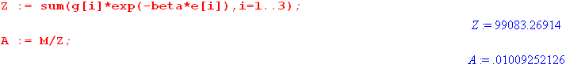

Once these parameters are known, we use (6.2.11) to display the solution vector N = {Ni}.

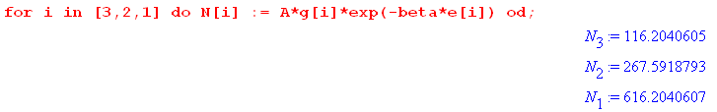

Since we set u < ε2, we see here a normal distribution where higher energy states have fewer particles.

Our final task is to use (6.3.8) and (6.3.13) to determine the half-width of the Ω peak,

which says ΔN ≈ 7.5. This width and the solution N3 = 616.2 can be verified from this blowup plot of Ω,

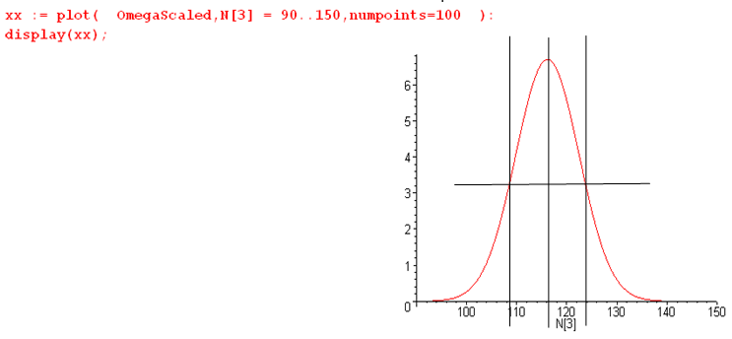

Notice that this Maple code does not use the Stirling approximation and provides a continuous interpolation of N! as Γ(N+1).

The peak value of Ω is found to be

In the above example we used u = 1.5 < ε2 = 2. If we instead use u = 2.5 > ε2 = 2, we find that the state populations are as shown above but in reverse order. Such a inverted situation corresponds to a negative absolute temperature T and cannot therefore arise in thermal equilibrium. It could arise in a laser medium which is driven by some power source.

