The Method of Lagrange Multipliers
Phil Lucht
Rimrock Digital Technology, Salt Lake City, Utah 84103
last update: June 8, 2015

Maple code is available upon request. Comments and errata are welcome.
The material in this document is copyrighted by the author.

The graphics look ratty in Windows Adobe PDF viewers when not scaled up, but look just fine in this excellent freeware viewer: http://www.tracker-software.com/pdf-xchange-products-comparison-chart .

The table of contents has live links. Most PDF viewers provide these links as bookmarks on the left.

Overview and Summary 1
1. The R matrix and its Rank 2
2. The Method of Lagrange Multipliers 5
3. Proof of Theorem 1 9
(a) Proof for N = 6 and S = 4. 9
(b) Proof for general S ≤ N 13
4. The Gradient Interpretation: Example 1 16
5. Example 2: Extremal distances between an ellipse and a circle 21
6. Example 3: The Boltzmann factor in Statistical Mechanics 28
6.1 Statement of The Boltzmann Extremum Problem 28
6.2 Solution of The Boltzmann Extremum Problem 30
6.3 More details of the solution 33
6.4 A numerical example with plots 36
Appendix A : Proof that matrix rank is the number of independent columns and rows 42
References 45

Overview and Summary

The intent of the following presentation is to provide a reasonable derivation of why the Method of Lagrange Multipliers works. Although we do discuss the relevant "gradient approach", it seems more convincing to use a "matrix approach" where the solution points of a constrained extremum problem are associated with the points at which a certain matrix drops below full rank (an approach used by Buck, see References). Then the gradient statement of "why it works" follows at once. It certainly is a mind-boggling exercise to visualize the solution sets as intersections of multiple surfaces in a space of more than three dimensions.
Every document on this subject needs a "Theorem 1" and ours is no exception. Fortunately for the reader, there are no other theorems (ignoring Appendix A), and Theorem 1 is fairly easy to prove. The reader should be at least dimly familiar with basic linear algebra facts.
We first state our Theorem 1 in Section 1, then show in Section 2 how it provides an immediate derivation of the Method of Lagrange Multipliers. Section 3 then proves Theorem 1. Section 4 gives the gradient interpretation and provides an example which at least can be visualized with simple surfaces. Section 5 presents another example which, though simple, requires numeric work to solve. Finally, Section 6 provides an extended standard example involving statistical mechanics. Appendix A proves for a general matrix that column rank = row rank = rank.
What the reader will not find below is a treatment of questions of continuity and whether solutions do or do not exist for special situations. These topics seems well treated in other papers.
The general tone is more that of an engineer or physicist, not that of an abstract mathematician. Maple code is used where it seems useful to implement calculations or display graphs.
When an earlier equation is quoted, its equation number is put in italics.
A very short list of References is provided on the last page.

1. The R matrix and its Rank

We shall operate in N dimensional space EN with coordinates r = (x1, x2 ... xN).

We seek an extremum of a real function f(r) subject to S-1 constraints a(r) = 0, b(r) = 0, ... q(r) = 0 where we use q generically to represent the last constraint function. For example, if there are two constraints, then S = 3 and the two constraint equations are a(r) = 0 and b(r) = 0. So here is the problem:

find extremum of f(r) subject to constraints a(r)=0, b(r)=0, c(r)=0, .... q(r)=0 . (1.1)
1 2 3 S-1

Construct the following matrix of partial derivatives, where fi(r) ≡ ∂if(r) = ∂f(r)/∂xi. That is, the subscript on f indicates which of the arguments x1,x2, x3....xN the partial is with respect to. So here is that matrix, which we shall call R :

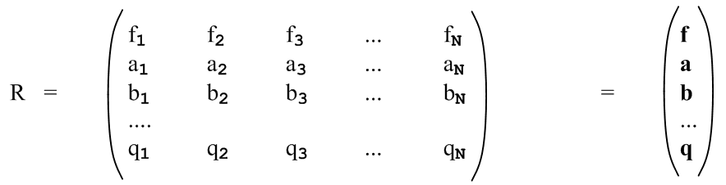 (1.2)

For example, f2 ≡ ∂f(x1,x2, x3....xN)/∂x2.
On the far right we abbreviate each row of functions in bold, indicating a row vector like f .
The matrix has S rows and N columns. We shall only be interested in S ≤ N (see comment below). If S = N, the matrix is square, otherwise it has more columns than rows, so has a horizontal band shape.
The maximum possible rank of the above matrix is S since this is the smaller of the number of rows and columns (see below).
Since all the functions are functions of r, we really have R(r). As the point r is varied, the elements of the matrix R(r) generally change.

If S = N, the matrix is square and we can talk about the determinant det(R). In this case there is only one SxS "submatrix" and it is the entire matrix R.

If S < N, the matrix is wider than it is tall. In this case, we can talk about square submatrices within R which are of shape SxS. For example, for N = 6 and S = 4 we have three constraints and the R matrix is this,
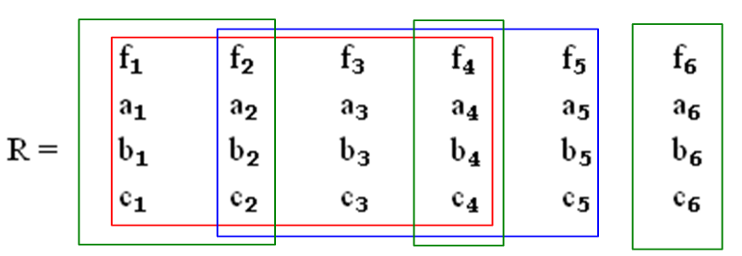 (1.3)
Here we have outlined two 4x4 submatrices in red and blue. The columns of a submatrix need not be contiguous, so the three green boxes indicate another 4x4 submatrix. In this example, the number of submatrices is given by the binomial factor (6,4) -- pick a committee of 4 columns from 6 candidates. So we have shown only 3 out of (6,4) = 6!/(4!2!) = 15 possible 4x4 submatrices. We can indicate a submatrix using this notation:

red = (f1,f2,f3,f4) blue = (f2,f3,f4,f5) green = (f1,f2,f4,f6) (1.4)

That is to say, we abbreviate the submatrix by stating only the values in the first row of the submatrix. Since our main interest will be whether or not the determinants of these 4x4 submatrices vanish, the ordering of the columns within a submatrix is not important.

For the general R matrix shown above with S columns and N rows, there are (N,S) possible submatrices of size SxS. A particular submatrix is then indicated by a sequence of S subscripted f values.

Why not S>N? One can regard u = f(x1,x2, x3....xN) as an N-dimensional surface in EN+1 where the extra dimension is u. For example, for N = 2, u = f(x,y) is a 2-dimensional surface in E3.
The constraint equation a(x1,x2, x3....xN) = 0 is an N-1 dimensional surface in EN. Again for N = 2, a(x,y) = 0 is a 1-dimensional surface (a curve) in E2. If a(x,y) = x2-y2-1, that curve is a circle.
A constraint surface can be "extruded" in the u direction of EN to give an N dimensional surface in EN+1. For N=2, if the constraint is a circle, that extruded surface is a cylinder in E3.
The intersection of the N-dimensional surface u = f with the N-dimensional surface a = 0 is a surface of dimension N-1. In our N = 2 example, the 2D surface u = f intersects the cylinder in a curve.
Each extra constraint lowers the dimensionality of the final intersection surface. If S = 2 (one constraint), the intersection surface was just seen to be of dimension N-1. For S = 3 (two constraints), that surface is down to dimension N-2. The dimension of the final intersecting surface is thus N-S+1. When S = N, the final surface is a 1D curve. If we try to set S > N, the intersection has no degree of freedom at all and one cannot have a continuous extremum situation.
An N = 2 example of this paragraph's discussion is presented in Section 4.

We now quote a few facts from linear algebra concerning the rank of a matrix:

Definition: The rank r of an m x n matrix A is the dimension of the largest non-vanishing subdeterminant (minor) within A. [Shilov 1.92 ] Thus, r ≤ min(m,n). (1.5)

Definitions: [Shilov 2.21] Consider an m x n matrix A. Let r1, r2, ...rN be an arbitrary selection of N rows (row vectors) from the matrix A. This set of N rows is linearly dependent if one can find a set of constants ki at least one of which is non-zero such that

k1 r1 + k2 r2 + .... + kN rN = 0 . (1.6)

There could be several such equations, or there could be only one. This generally means that at least one row can be expressed as a linear combination of the other rows. A legal such equation would be r2 = 0 in which case k2 = 1. One could then say that r2 is a linear combination of the other rows with coefficients all zero. In any event, if one or more rows are all zeros, a set of N rows are linearly dependent. If no such equation (1.6) exists, then the set of N rows is linearly independent. For example, the set of vectors r1 = (1,0) and r2 = (0,1) are linearly independent.
The above discussion also applies to columns. Take "row" → "column" and ri → ci .

Facts: The rank r as defined in (1.5) has these properties for any m x n matrix A: (1.7)
(a) the rank r equals the number of linearly independent columns of A [Shilov 3.12 ]
(b) the rank r equals the number of linearly independent rows of A [Shilov 3.13 ]

See Appendix A below for a brief proof of the claims of (1.7).

With the above as background, the following theorem is fundamental to our Lagrange Multiplier presentation:

Theorem 1. If the point r is a solution to the extremal problem (1.1), then rank[R(r)] < S. (1.8)

According to the rank definition (1.5),

rank(R) < S ⇔ all SxS submatrices must have zero determinant (1.9)

If, for example, the red submatrix in Fig 1.3 had a non-zero determinant, then rank(R) = 4 = S.

The point of Theorem 1 is that the solution point r of the constrained extremum problem must be a point where the R(r) matrix drops below full rank. We shall prove this theorem in Section 1.3 by showing that, if r is a solution to the extremum problem, then all those SxS submatrices discussed above have zero determinant and thus rank(R) < S. If one is searching for candidate solutions r to the extremum problem, one can restrict one's search to points r for which rank[R(r)] < S.

Comment on the R matrix. Imagine a general transformation from x-space x = (x1, x2, ....xN) to u-space with coordinates u = (u1, u2, ... uS). One might write such a transformation as u = F(x) where F:EN→ ES. Although this transformation in general is non-linear, in a tiny neighborhood of point x in x-space (and the corresponding point u in u-space), the transformation will be linear if certain conditions are met. That local linear relation is then described by du = Rdx where R is a matrix (N columns, S rows) whose matrix elements are Rij = ∂ui/∂xj. If we think of

f = u1(x1, x2, ....xN) R11 = ∂u1/∂x1 = ∂f/∂x1 = f1 R12 = f2 etc.
a = u2(x1, x2, ....xN) R21 = ∂u2/∂x1 = ∂a/∂x1 = a1 R22 = a2 etc
b = u3(x1, x2, ....xN)
...
q = uS(x1, x2, ....xN) (1.10)

then the matrix shown in (1.2) is exactly the R matrix for this general transformation u = F(x). If S < N, then the R matrix is not square, the relation du = Rdx is a "projection" of a larger space into a smaller one, and the equation therefore cannot be inverted. This notation "R" is used extensively in our Tensor Analysis document, see in particular Chapter 2, though only invertible transformations F:EN→ EN are considered there. Sometimes R is referred to as "the differential" of a transformation.
Before proving Theorem 1, we want to cut to the chase and state the Method of Lagrange Multipliers to create a framework in which candidate solutions for the extremum problem can be found.

2. The Method of Lagrange Multipliers

The extremum problem stated above in (1.1),

find extremum of f(r) subject to constraints a(r)=0, b(r)=0, c(r)=0, .... q(r)=0 . (1.1)
1 2 3 S-1
can be solved in the following manner:

(a) Define the following function H [ the λi are the "Lagrange multipliers" ]

H(r,λ) ≡ f(r) + λ1a(r) + λ2 b(r) + ...... + λS-1 q(r) . (2.1)

Notice that H is a function of N + (S-1) = N+S-1 variables which are the xi and λi.

(b) Compute all N+S-1 partial derivatives of H, which as usual we denote by Hi.

For the first N partials i = 1,2..N one gets

Hi = fi + λ1ai + λ2 bi+ ...... + λS-1 qi i = 1,2....N . (2.2)

For the final S-1 partials one finds,

HN+1 = a
HN+2 = b
...
HN+S-1 = q . (2.3)

(c) Now set all N+S-1 partials of H to 0, that is, set Hi = 0 for i = 1 to N+S-1. Then (2.2) and (2.3) read

fi(r) + λ1ai(r) + λ2 bi(r) + ...... + λS-1 qi(r) = 0 i = 1,2....N

a(r) = 0 b(r) = 0 .... q(r) = 0 i = N+1...N+S-1 (2.4)
The second group of S-1 equations is a statement of the S-1 constraints of the problem.

The first set of equations in (2.4) an be written in this vector notation

f(r) + λ1a(r) + λ2 b(r) + ...... + λS-1 q(r) = 0 (2.5)

where each bolded vector is a row of the R matrix (1.2). This equation has the form (1.6) and certainly the coefficient of f(r) is non-zero, being one.

Equation (2.5) thus says that the S rows of the R matrix are linearly dependent! According to (1.7), this means that rank[R(r)] < S. If one had rank(R) = S, all S rows of R would be linearly independent and then an equation of the form (2.5) could not exist. According to Theorem 1 of (1.8), any point r which makes (2.5) be true is therefore a candidate for a solution to the constrained extremum problem (1.1). Such a solution value of r will be associated with solution values for the λi.

(d) It is then incumbent on the problem solver to solve the following N+S-1 equations for the N+S-1 unknowns which are r = ( x1, x2 .....xN) and λ1, λ2.....λS-1 . Here again are the equations to solve:

f1(r) + λ1a1(r) + λ2 b1(r) + ...... + λS-1 q1(r) = 0
f2(r) + λ1a2(r) + λ2 b2(r) + ...... + λS-1 q2(r) = 0 // recall: b2 means ∂b/∂x2
....
fN(r) + λ1aN(r) + λ2 bN(r) + ...... + λS-1 qN(r) = 0 // N equations

a(r) = 0
b(r) = 0
...
q(r) = 0 // S-1 constraint equations (2.6)

Since all the functions in these equations are known (since f(r) and all the constraints are known), it is in principle possible to solve the equations for r and the λi. Then those solution r values are candidate solutions to the constrained extremum problem and need to be studied more to see if they really solve the problem of interest (max, min, saddle, etc). In general the various functions of r are non-linear and not just polynomials, and there are likely to be multiple candidate solutions. A numeric solution may be required. At least this method very significantly reduces the search for solutions to the initial problem (1.1). The Method of Lagrange Multipliers does not provide a silver bullet for solving these equations. Most examples one sees in texts and on the web have very simple functions allowing a straightforward analytic solution.

Since the λi appear linearly in the first N equations in (2.6), it is possible to obtain solution values for the λi as follows. First, write the first N equations of (2.6) in matrix form,

- $\left(\begin{matrix}f1 \\ f2 \\ ... \\ fN\end{matrix}\right)$ = $\left(\begin{matrix}a1 & b1 & ... & q1 \\ a2 & b2 & ... & q2 \\ ... & ... & ... & ... \\ aN & bN & ... & qN\end{matrix}\right)$$\left(\begin{matrix}λ1 \\ λ2 \\ ... \\ λS-1\end{matrix}\right)$ (2.7)

where the matrix has S-1 columns (one column for each constraint) and N rows. Since S ≤ N, one has S-1 < N so there are fewer columns than rows. This matrix is the transpose of the R matrix (1.2) with the fi elements removed.

Taking only the first S-1 rows of the above matrix equation, one finds

- $\left(\begin{matrix}f1 \\ f2 \\ ... \\ fS-1\end{matrix}\right)$ = $\left(\begin{matrix}a1 & b1 & ... & q1 \\ a2 & b2 & ... & q2 \\ ... & ... & ... & ... \\ aS-1 & bS-1 & ... & qS-1\end{matrix}\right)$$\left(\begin{matrix}λ1 \\ λ2 \\ ... \\ λS-1\end{matrix}\right)$ (2.8)

where the matrix is now square. Assuming this matrix has non-zero determinant, one can invert (2.8) to obtain solution values of the Lagrange multipliers λi(r) as functions or r. These λi functions can be inserted into the first N equations of (2.6) and then one can proceed to solve those N equations for r.
By making different versions of (2.8) taking different sets of S-1 rows from (2.7), one may produce several different sets of {λi(r)} corresponding to different candidate solutions r.

Comments

1. Some authors use the notation fx$_{i}$≡ ∂f/∂xi and the constraints are g(s)(x) = 0 where s is a label, Then the first derivative of a constraint function is g(s)x$_{i}$(x). Another choice is to refer to the constraint functions as gs(x) where s is a label, and then one just writes out $\frac{∂gs}{∂xi}$. We feel that our simple though less rigorous notation provides more clarity. Writing ∂f/∂xi = fi is a notation promoted by Buck.

2. The λi terms in (2.1) often appear with minus signs in place of plus signs. This then removes the minus sign in (2.7) and (2.8). These signs are just a convention and have no effect on the solution points r.

3. The function H in (2.1) is sometimes referred to as "the Lagrangian" and is written as L. This Lagrangian differs from that which appears in the Lagrangian formulation of particle motion. In Lagrangian dynamics, the motion of a set of particles (perhaps comprising a rigid body) can be determined from a certain Lagrangian L ≡ T - V where T and V are the kinetic and potential energies of the set of particles. L is a function of the "generalized coordinates" qk and velocities k = dqk/dt of the particles, and of time t, so one writes L(qk,k, t). The equations of motion in the absence of constraints are known as the Euler-Lagrange equations, ( $\frac{∂L}{∂qk}$– $\frac{d}{dt}$ ) = 0. One may add a set of differential constraints to the problem of the form Σkaikdqk = 0 where the aik are functions causing the particles to be constrained in their motion. For example, the particles may be constrained to move only along certain curves like beads on a wire. The adjusted Euler-Lagrange equations then have the form ( $\frac{∂L}{∂qk}$– $\frac{d}{dt}$ ) + Σiλiaik = 0. This equation is similar to the first line of our equation (2.4). See Goldstein page 41 (2.23) and (2.27). Goldstein refers to this method of incorporating constraints into particle dynamics as the method of Lagrange undetermined multipliers.

3. Proof of Theorem 1

Theorem 1. If the point r is a solution to the extremal problem (1.1), then rank[R(r)] < S. (1.8)

(a) Proof for N = 6 and S = 4

The more general the proof is made, the less clear it becomes due to the notational baggage that must be added. Therefore we shall prove Theorem 1 for the specific case shown above in Fig (1.3) where N = 6 and S = 4 (3 constraints). The reader should have no trouble following each step for this sample case. When we reach the proof conclusion for the sample case, we start over again doing the general case and compare each step to the steps of this sample case. Although a lot of equations appear below (and a lot of column inches are consumed), everything is really quite simple.

So, for our sample case we start off with this R matrix, again with bolded row vectors on the right,

f1 f2 f3 f4 f5 f6 f
a1 a2 a3 a4 a5 a6 a
R = b1 b2 b3 b4 b5 b6 = b (3.1)
c1 c2 c3 c4 c5 c6 c

We want then to find an extremum of f(x1, x2, x3, x4, x5, x6) subject to these constraints:

a(x1, x2, x3, x4, x5, x6) = 0
b(x1, x2, x3, x4, x5, x6) = 0
c(x1, x2, x3, x4, x5, x6) = 0 . (3.2)

In practice, a person solving this problem might try to eliminate variables. For example, somehow with enough labor one should be able to "use up" the three constraint equations to eliminate three of the six variables xi. There are of course (6,3) ways to select three variables for elimination.
For starters, imagine that we have used up the 3 constraints to eliminate variables x1, x2 and x3. Then we write

a(x1, x2, x3, x4, x5, x6) = 0 x1 = X1(x4, x5, x6)
b(x1, x2, x3, x4, x5, x6) = 0 ⇒ x2 = X2(x4, x5, x6)
c(x1, x2, x3, x4, x5, x6) = 0 x3 = X3(x4, x5, x6) (3.3)

where X1, X2 and X3 are three resulting functions. This is a "theoretical" elimination, one does not actually have to do the process, one need only understand that in principle it could be done and the functions Xi could in principle be found.

Now rewrite the function f and the three constraint functions in this manner, substituting for example the function X1 for x1 everywhere it appears,

f(X1(x4, x5, x6), X2(x4, x5, x6), X3(x4, x5, x6), x4, x5, x6) ≡ F(x4, x5, x6)
a(X1(x4, x5, x6), X2(x4, x5, x6), X3(x4, x5, x6), x4, x5, x6) ≡ A (x4, x5, x6)
b(X1(x4, x5, x6), X2(x4, x5, x6), X3(x4, x5, x6), x4, x5, x6) ≡ B(x4, x5, x6)
c(X1(x4, x5, x6), X2(x4, x5, x6), X3(x4, x5, x6), x4, x5, x6) ≡ C(x4, x5, x6) . (3.4)

In this way we have defined four new functions F,A,B,C each of the 3 variables shown (those that were not eliminated).

Next, compute the first partial derivatives of F using the chain rule. For example

$\frac{∂F}{∂x4}$ = $\frac{∂f}{∂x1}$$\frac{∂X1}{∂x4}$ + $\frac{∂f}{∂x2}$$\frac{∂X2}{∂x4}$ + $\frac{∂f}{∂x3}$$\frac{∂X3}{∂x4}$ + $\frac{∂f}{∂x4}$ . (3.5a)

In our compact notation where Fi means ∂F/∂xi this can be restated as

F4 = f1X14 + f2X24 + f3X34 + f4 . (3.5b)

Doing this for each of the non-eliminated variables one gets,

F4 = f1X14 + f2X24 + f3X34 + f4
F5 = f1X15 + f2X25 + f3X35 + f5
F6 = f1X16 + f2X26 + f3X36 + f6 . (3.6)

Notice that the subscripts on the leftmost three fi correspond to those of the eliminated variables i = 1,2,3.

Now, since we are seeking an extremal point of F(x4, x5, x6) with no constraints at all (the three initial constraints have all been absorbed in the process of eliminating three variables), we require that (x4, x5, x6) be a "critical point" for the function F, which means we require that F4 = F5 = F6 = 0. Then the above equations become,

f1X14 + f2X24 + f3X34 + f4 = 0
f1X15 + f2X25 + f3X35 + f5 = 0
f1X16 + f2X26 + f3X36 + f6 = 0 . (3.7)

Now apply the same process to the three constraint functions A,B,C. First compute the derivatives, and then set the derivatives to zero. One does this for A(x4, x5, x6), for example, because the constraint condition a = 0 says that that A(x4, x5, x6) = 0 = a constant, for all values of x4, x5, x6 , so all first derivatives must vanish. Doing this for function A then gives these three equations,

a1X14 + a2X24 + a3X34 + a4 = 0
a1X15 + a2X25 + a3X35 + a5 = 0
a1X16 + a2X26 + a3X36 + a6 = 0 . (3.8)

We have just taken the previous equations and replaced f→ a everywhere. Then do this for B and C. One ends up then with this set of 12 equations:

f1X14 + f2X24 + f3X34 + f4 = 0
f1X15 + f2X25 + f3X35 + f5 = 0
f1X16 + f2X26 + f3X36 + f6 = 0

a1X14 + a2X24 + a3X34 + a4 = 0
a1X15 + a2X25 + a3X35 + a5 = 0
a1X16 + a2X26 + a3X36 + a6 = 0

b1X14 + b2X24 + b3X34 + b4 = 0
b1X15 + b2X25 + b3X35 + b5 = 0
b1X16 + b2X26 + b3X36 + b6 = 0

c1X14 + c2X24 + c3X34 + c4 = 0
c1X15 + c2X25 + c3X35 + c5 = 0
c1X16 + c2X26 + c3X36 + c6 = 0 . (3.9)

Here there are S = 4 equation groups, and each group has N-S+1 = 6-4+1 = 3 equations (this last 3 is the number of non-eliminated variables).

Next reorder these equations into three groups of four, for example taking the first equation in each group above to make the first new group below,

f1X14 + f2X24 + f3X34 + f4 = 0
a1X14 + a2X24 + a3X34 + a4 = 0
b1X14 + b2X24 + b3X34 + b4 = 0
c1X14 + c2X24 + c3X34 + c4 = 0

f1X15 + f2X25 + f3X35 + f5 = 0
a1X15 + a2X25 + a3X35 + a5 = 0
b1X15 + b2X25 + b3X35 + b5 = 0
c1X15 + c2X25 + c3X35 + c5 = 0

f1X16 + f2X26 + f3X36 + f6 = 0
a1X16 + a2X26 + a3X36 + a6 = 0
b1X16 + b2X26 + b3X36 + b6 = 0
c1X16 + c2X26 + c3X36 + c6 = 0 . (3.10)

Now there are N-S+1 = 3 equation groups, and each group has S = 4 equations.

Next, write each of these three equation sets as a matrix equation,

$\left(\begin{matrix}0 \\ 0 \\ 0 \\ 0\end{matrix}\right)$ = $\left(\begin{matrix}f1 & f2 & f3 & f4 \\ a1 & a2 & a3 & a4 \\ b1 & b2 & b3 & b4 \\ c1 & c2 & c3 & c4\end{matrix}\right)$$\left(\begin{matrix}X14 \\ X24 \\ X34 \\ 1\end{matrix}\right)$ = (f1,f2, f3, f4) $\left(\begin{matrix}X14 \\ X24 \\ X34 \\ 1\end{matrix}\right)$

$\left(\begin{matrix}0 \\ 0 \\ 0 \\ 0\end{matrix}\right)$ = $\left(\begin{matrix}f1 & f2 & f3 & f5 \\ a1 & a2 & a3 & a5 \\ b1 & b2 & b3 & b5 \\ c1 & c2 & c3 & c5\end{matrix}\right)$$\left(\begin{matrix}X15 \\ X25 \\ X35 \\ 1\end{matrix}\right)$ = (f1,f2, f3, f5) $\left(\begin{matrix}X15 \\ X25 \\ X35 \\ 1\end{matrix}\right)$

$\left(\begin{matrix}0 \\ 0 \\ 0 \\ 0\end{matrix}\right)$ = $\left(\begin{matrix}f1 & f2 & f3 & f6 \\ a1 & a2 & a3 & a6 \\ b1 & b2 & b3 & b6 \\ c1 & c2 & c3 & c6\end{matrix}\right)$$\left(\begin{matrix}X16 \\ X26 \\ X36 \\ 1\end{matrix}\right)$ = (f1,f2, f3, f6) $\left(\begin{matrix}X16 \\ X26 \\ X36 \\ 1\end{matrix}\right)$ . (3.11)

On the right we show our abbreviated notation for a matrix, just showing the first row.

Now we claim that the three matrices shown must have zero determinant! Suppose the first matrix equation had a non-zero determinant. It could then be inverted to give

$\left(\begin{matrix}X14 \\ X24 \\ X34 \\ 1\end{matrix}\right)$ = (f1,f2, f3, f4)-1 $\left(\begin{matrix}0 \\ 0 \\ 0 \\ 0\end{matrix}\right)$ = $\left(\begin{matrix}0 \\ 0 \\ 0 \\ 0\end{matrix}\right)$ . (3.12)

But this produces a blatant contradiction that 1 = 0 (not to mention the other rows), and therefore we must have

det (f1,f2, f3, f4) = 0
det (f1,f2, f3, f5) = 0
det (f1,f2, f3, f6) = 0
or
det (f1,f2, f3, fm) = 0 m ≠ 1,2,3 . (3.13)

Therefore, we have shown that three of the SxS = 4x4 submatrices of Fig (1.3) vanish. But there are 15 such submatrices, and in order to show that rank(R) < S, we have to show that all 15 SxS determinants vanish.

But that can be demonstrated by starting over several times and each time choosing to eliminate three different variables. Notice in the det = 0 equations above that the first three fi values correspond to the three eliminated variables x1, x2 and x3, Had we instead chosen to eliminate x1, x2 and x4, we would have obtained,

det (f1,f2, f4, f3) = 0
det (f1,f2, f4, f5) = 0
det (f1,f2, f4, f6) = 0
or
det (f1,f2, f4, fm) = 0 m ≠ 1,2,4 (3.14)

More generally, had we chosen to eliminate variables xi, xj and xk, we would obtain

det (fi,fj, fk, fm) = 0 m ≠ i,j,k (3.15)

As i,j,k range over all possible values 1,2,3,4,5,6, we clearly hit all possible 4x4 subdeterminants, and thus we have shown that they all vanish, and therefore rank(R) < S, QED.
Lest it be overlooked, one must keep in mind that r = (x1, x2, x3, x4, x5, x6) must be a solution to the extremum problem (or at least a critical point as in (3.7) ) including meeting all the constraints. And then the conclusion is that, for such a solution point r, one has rank[R(r)] < S .

Having now shown that rank[R(r)] < S for a solution point r, we know from (1.7) (b) that the S rows of the R matrix must be linearly dependent for that r. This means that one can find a set of constants λ1,λ2,λ3 such that

f(r) + λ1a(r) + λ2 b(r) + λ3 c(r) = 0 . (2.5)

These constants are the Lagrange Multipliers and we see that the fact that they exist follows directly from the fact that rank[R(r)] < S.

To summarize, one theoretically eliminates N-S+1 of the N variables to create the functions F,A,B,C of (3.4). One then looks for the normal (unconstrained) critical points of F where all partials vanish. Since the constraints all have the form A = 0, B = 0, C = 0, their partials vanish as well. Writing all these equations in matrix form (for various sets of eliminated variables) leads to the conclusion that all the SxS minors of matrix R vanish so that rank(R) < S.

(b) Proof for general S ≤ N

To generalize now to general N and S, we restate some of the previous equations (adding a prime to the equation number) using a more generalized notation. The reader will note how even our simple notation becomes rather unpleasant.

Comment: This complexity increases further if one denotes the constraint functions by a notation like a = g(1), b = g(2) .... q = g(S-1). We avoid the idea of a = g1, b = g2 etc because we want a subscript to indicate a partial derivative, not a label.

We start off with this R matrix which has N columns and S ≤ N rows. The S-1 constraint functions are a,b,....q. Remember that f2 means ∂f/∂x2.

f1 f2 f3 ... fN f
a1 a2 a3 ... aN a
R = b1 b2 b3 ... bN = b (3.1)'
.... ...
q1 q2 q3 ... qN q

Here are the S-1 constraint equations,

a(x1, x2, ...xN) = 0 // S-1 constraint equations
b(x1, x2, ...xN) = 0
...
q(x1, x2, ...xN) = 0 . (3.2)'

Eliminate the first S-1 variables x1,x2....xS-1 using the S-1 constraint equations:

a(x1, x2, ...xN) = 0 x1 = X1(xS, xS+1 ... xN)
b(x1, x2, ...xN) = 0 ⇒ x2 = X2(xS, xS+1 ... xN)
... ...
q(x1, x2, ...xN) = 0 xS-1 = XS-1(xS, xS+1 ... xN) . (3.3)'

Substitute to get the F,A,B...Q equations (a set now of S equations),

f(X1(xS, xS+1 ... xN), X2(xS, xS+1 ... xN), .. XS-1(xS, xS+1 ... xN) , xS, xS+1 ... xN) ≡ F(xS, xS+1 ... xN)
a(X1(xS, xS+1 ... xN), X2(xS, xS+1 ... xN), .. XS-1(xS, xS+1 ... xN) , xS, xS+1 ... xN) ≡ A(xS, xS+1 ... xN)
b(X1(xS, xS+1 ... xN), X2(xS, xS+1 ... xN), .. XS-1(xS, xS+1 ... xN) , xS, xS+1 ... xN) ≡ B(xS, xS+1 ... xN)
...
q(X1(xS, xS+1 ... xN), X2(xS, xS+1 ... xN), .. XS-1(xS, xS+1 ... xN) , xS, xS+1 ... xN) ≡ Q(xS, xS+1 ... xN) .

(3.4)'
Now take first derivatives as shown in (3.5) to get this generalized version of (3.6),

FS = f1X1S + f2X2S + f3X3S + ... + fS-1XS-1S + fS
FS+1 = f1X1S+1 + f2X2S+1 + f3X3S+1 + ... + fS-1XS-1S+1 + fS+1 FS+2 = f1X1S+2 + f2X2S+2 + f3X3S+2 + ... + fS-1XS-1S+2 + fS+2
...
FN = f1X1N + f2X2N + f3X3N + ... + fS-1XS-1N + fN . // N-S+1 equations (3.6)'

Requiring (xS, xS+1 ... xN) to be a "critical point", we set all the these first derivatives to 0 to get,

f1X1S + f2X2S + f3X3S + ... + fS-1XS-1S + fS = 0
f1X1S+1 + f2X2S+1 + f3X3S+1 + ... + fS-1XS-1S+1 + fS+1 = 0 f1X1S+2 + f2X2S+2 + f3X3S+2 + ... + fS-1XS-1S+2 + fS+2 = 0
...
f1X1N + f2X2N + f3X3N + ... + fS-1XS-1N + fN = 0 . // N-S+1 equations (3.7)'

A similar set of equations is obtained for a,b,c...q. Just replace f→a, then f→ b and so on. We shall not write out all these equations as we did in (3.9). We have then S sets of equations, each set containing N-S+1 equations. As in the sample case, we then reorder the equations to get first this group,

f1X1S + f2X2S + f3X3S + ... + fS-1XS-1S + fS = 0
a1X1S + a2X2S + a3X3S + ... + aS-1XS-1S + aS = 0
b1X1S + b2X2S + b3X3S + ... + bS-1XS-1S + bS = 0
....
q1X1S + q2X2S + q3X3S + ... + qS-1XS-1S + qS = 0 . // S equations (3.10)'S

The next group has S→S+1 in all subscript positions. The last group has S→N, and here is that last group,

f1X1N + f2X2N + f3X3N + ... + fS-1XS-1N + fN = 0
a1X1N + a2X2N + a3X3N + ... + aS-1XS-1N + aN = 0
b1X1N + b2X2N + b3X3N + ... + bS-1XS-1N + bN = 0
....
q1X1N + q2X2N + q3X3N + ... + qS-1XS-1N + qN = 0 . // S equations (3.10)'N

So there are now N-S+1 groups of equations and each group has S equations.
The next task is to write each set of S equations as a matrix equation. Here we do that just using the abbreviated notation for the matrix,

$\left(\begin{matrix}0 \\ 0 \\ ... \\ 0 \\ 0\end{matrix}\right)$ = (f1,f2, f3, ... fS-1, fS) $\left(\begin{matrix}X1S \\ X2S \\ ... \\ XS-1S \\ 1\end{matrix}\right)$
$\left(\begin{matrix}0 \\ 0 \\ ... \\ 0 \\ 0\end{matrix}\right)$ = (f1,f2, f3, ... fS-1, fS+1) $\left(\begin{matrix}X1S+1 \\ X2S+1 \\ ... \\ XS-1S+1 \\ 1\end{matrix}\right)$
••••
$\left(\begin{matrix}0 \\ 0 \\ ... \\ 0 \\ 0\end{matrix}\right)$ = (f1,f2, f3, ... fS-1, fN) $\left(\begin{matrix}X1N \\ X2N \\ ... \\ XS-1N \\ 1\end{matrix}\right)$ . (3.11)'

We then argue as before that, in order to avoid the contradiction 0 = 1, we must have the determinants of these SxS submatrices be zero,

det(f1,f2, f3, ... fS-1, fS) = 0
det(f1,f2, f3, ... fS-1, fS+1) = 0
...
det(f1,f2, f3, ... fS-1, fN) = 0

or

det(f1,f2, f3, ... fS-1, fm) = 0 m ≠ 1,2,3...S-1 . (3.13)'

Finally, if we start off by eliminating the S-1 variables xi, xj, xk.... xr, we would find that

det(fi,fj, fk, ... fr, fm) = 0 m ≠ i,j,k...r . (3.15)'

Since this includes any possible SxS subdeterminant of the R matrix, we have then shown that all (N,S) SxS subdeterminants vanish, and therefore rank[R(r)] < S when r is a solution or critical point of the extremum problem.

Having now shown that rank[R(r)] < S for a solution point r, we know that the S rows of the R matrix must be linearly dependent for that r. This means that one can find a set of constants λ1,λ2,λ3 such that

f(r) + λ1a(r) + λ2 b(r) + ...... + λS-1 q(r) = 0 . (2.5)

These constants are the Lagrange Multipliers and we see that the fact that they exist follows directly from the fact that rank[R(r)] < S.

4. The Gradient Interpretation: Example 1

Recall that for r such that rank[R(r)] < S we can find Lagrange multipliers λi such that

f(r) + λ1a(r) + λ2 b(r) + ...... + λS-1 q(r) = 0 (2.5)

where the bolded letters are the rows of the R matrix shown in (1.2). In component notation this equation reads

fi(r) + λ1ai(r) + λ2 bi(r) + ...... + λS-1 qi(r) = 0 i = 1,2...N (4.1)

where recall fi = ∂f/∂xi. With the usual gradient operator ∇ this can be written

∇f(r) + λ1∇a(r) + λ2 ∇b(r) + ...... + λS-1 ∇q(r) = 0 ∇ = (∂1,∂2...∂N) . (4.2)

How might one interpret this gradient sum being 0? If we use N = 2 and S = 2, we can at least obtain some visualization, then we can generalize the conclusion in a logical fashion.

A Simple Example with One Constraint

Let u = f(x,y) represent the surface of a sphere (radius R = 2) in E3, centered at the origin.
We consider only the upper half of this surface, and we want to find (x,y) that maximizes f. If there are no constraints, then (4.2) above says ∇f = 0. The only place on our u = f surface having ∇f = 0 is the north pole of the sphere. This is just a regular "critical point" where ∂xf = 0 and ∂yf = 0, so we are happy with this interpretation of (4.2) with no constraints.
We now add a constraint a(x,y) = 0 where a(x,y) = y-1. This constraint is the line y=1 in the x-y plane E2. We can extrude this line into a plane y = 1 in E3. The hemispherical surface is a 2D surface in E3, and the extruded constraint is also a 2D surface in E3. These 2D surfaces intersect in a 1D surface which is a curve. There is hopefully some point on this curve that maximizes f.
Below is a picture of the sphere. The intersection of the upper spherical surface with the plane y = 1 is shown as a red curve (a half circle). Due to the constraint, we cannot get to the north pole so the maximum value of f is some value less than that u = 2 at the north pole. The extremum of this constrained problem will be at point A, and point B is not an extremum.

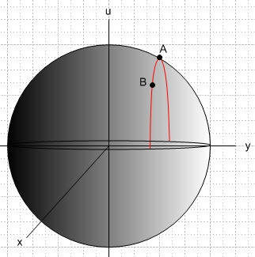 (4.3)

Since N = 2, the gradients in (4.2) are 2D gradients and so are parallel to the x,y plane. To view these gradients, we draw a top view of the sphere, looking toward the sphere center from the positive u axis:

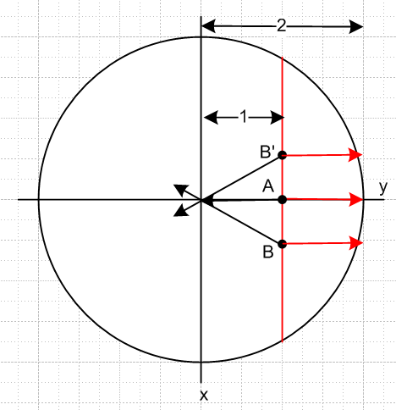 (4.4)

The three black arrows show ∇f at the points A, B and B'. It seems clear that on the spherical surface ∇f always points toward the north-south axis of the sphere. We can put the gradient arrow tails at the points of interest, but the gradient arrows are all parallel to the x,y plane since for example ∇f = (∂xf, ∂yf).
Meanwhile, the three red arrows show the direction of ∇a at points A, B and B'. Since a = y-1, this direction is of course ∇f = (∂xa ∂ya) = (0,1) which points to the right no matter where on the extruded constraint surface the arrow tail is placed.
As point B or B' moves toward point A, the black and red arrows become more aligned and finally at point A (the extremum) they are exactly collinear.
Equation (4.2) says that at the solution point r = A for the extremum, we have

∇f(r=A) + λ1∇a(r=A) = 0 (4.5)

and indeed, this equation says that at the solution point the two gradients must be collinear.

More details of the Example 1.

f(x,y) = $\sqrt{4 - x2- y2}$ since the sphere has u2+x2+y2 = R2 = 4

∇f(x,y) = - (x/f)- (y/f)

f(r,θ) = $\sqrt{4 - r2}$ polar coordinates

∇f(r,θ) = [-r/$\sqrt{4-r2}$] points toward the sphere's vertical axis (and ∇f = 0 at r = 0, north pole)

a(x,y) = y-1 = 0 the constraint

∇a = [1] points toward the right

At point A = (x,y) = (0,1) one has r = 1, = and f = $\sqrt{3}$. Then (4.5) reads

[-1/$\sqrt{3}$] + λ1[ 1/$\sqrt{3}$] = 0 ⇒ λ1 = 1/$\sqrt{3}$. (4.6)

At the solution point A the Lagrange multiplier λ1 can thus be interpreted as the negative of the ratio of the two gradient vectors ∇f and ∇a. Note that at the solution point, the two gradients really are collinear.

At point B, we can consider a differential movement dr = |dx|(-) along the constraint surface toward point A (in Fig (4.4) the x axis points down). We find that

df(B) = ∇f • dr = [ - (x/f)- (y/f)] • |dx|(-) = |dx| (x/f) > 0 since x>0 and f>0 . (4.7)

Thus, as we move toward point A, f increases since df>0, suggesting that A is indeed a maximum.

Consider the mirror point B' located above point A in Fig (4.4). The differential vector dr = |dx| lies along the constraint surface and points from B' toward A. Then

df(B') = ∇f • dr = [ - (x/f)- (y/f)] • |dx| = |dx| (-x/f) > 0 since -x>0 and f>0 . (4.8)

Once again, df > 0 showing indeed that point A is a maximum.

Finally, we have claimed that at the solution point, the Lagrangian function H(x,y) should have a maximum, since the whole theory is based on H being the function to maximize without constraints. On has,

H(x,y) = f(r) + λ1a(r) = $\sqrt{4 - x2- y2}$+ (1/$\sqrt{3}$) (y-1). (4.9)

Now u = (1/$\sqrt{3}$) (y-1) is a plane sloping up to the right in Fig (4.3). This is different from the plane y = 1 which is a vertical plane in that figure. In (4.9) we are adding a spherical surface to a plane sloping up to the right, and the result is an ellipsoidal-like surface (really a quartic surface) which has a maximum at the point A = (0,1). Here is a plot of that surface:

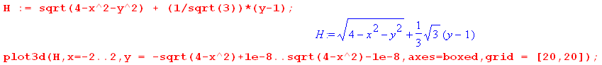

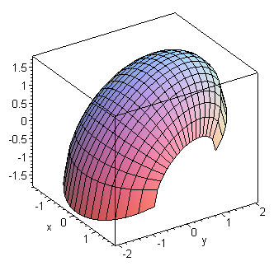 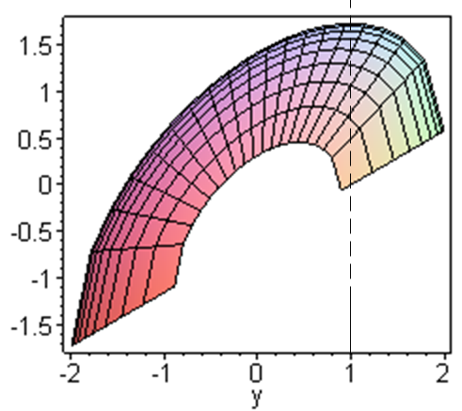 (4.10)

A direct method of confirming the maximum is provided by examining Hii :

Hi = fi + λ1ai Hii = fii + λ1aii aii = ∂2(y-1)/∂xi2 = 0

f = $\sqrt{4 - x2- y2}$ = $\sqrt{4 - x12- x22}$ ⇒ fi = - xi/f f > 0

fii = - [f * 1 - xifi]/f2 = - [f - xi(-xi/f)]/f2 = - (1/f) - (xi/f)2

Hii = fii + λ1aii = fii = - (1/f) - (xi/f)2 < 0 .

This shows that the function H(x,y) is "cupping down" at all locations, as the graph suggests. The point A where Hi = 0 (see (4.6) ) thus also has Hii < 0 and is thus a maximum.

If we were to upgrade this example to u = f(x,y,z) and have two constraints a=0 and b=0, the final intersection path of the hypersphere surface with the two constraint surfaces is again a 1D curve. If we consider dr along this curve, that dr will be perpendicular to both ∇a and ∇b, which says

(λ1∇a + λ2∇b) • dr = 0 . (4.11)

At an extremum point, if (4.2) is valid, we find that

∇f • dr = - (λ1∇a + λ2∇b) • dr = 0 . (4.12)

Since this dr movement is perpendicular to ∇f, there can be no change in f by moving along the intersecting constraint surface, and that is why we are at an extremum.

So this then provides an interpretation for the general solution case where this equation is true:

∇f + λ1∇a + ... λS-1 ∇q = 0 (4.2)

and thus,

∇f • dr = - (λ1∇a + λ2∇b + .... + λS-1∇q) • dr (4.13)

In general the intersection surface of f with all the constraint surfaces will be of dimension N-S+1 in En. A tiny displacement dr along this surface is perpendicular to all the local constraint surface gradients, so the right side of (4.8) is 0. At a solution point where equation (4.2) is true, we then have ∇f • dr = 0 so a small displacement dr in any constraint-legal direction results in df = 0, hence we are at an extremum.

5. Example 2: Extremal distances between an ellipse and a circle

Many examples of the use of the Method of Lagrange Multipliers can be found in texts and on the web. See for example Trench or the wiki Lagrange Multiplier page.

Our example has 2 constraints so S = 3. There are four coordinates so N = 4. It happens that these four coordinates are not those of a single point in E4 but represent two points in E2. Our example is a bit more complex than the toy examples in texts and we obtain a numerical solution after carrying out the analytic steps of the Lagrange Multiplier algorithm.

Consider then these two curves in E2:

x2/A2 + y2/B2 = 1 ellipse centered at the origin, semimajor/minor axes A and B

(x'-α)2 + (y'-β)2 = R2 . circle of radius R centered at (α,β) (5.1)

What is the minimum and maximum distance between these two curves?

The distance squared is given by

f = (x-x')2 + (y-y')2 = f(x,y,x',y') N = 4 coordinates (5.2)

while the constraint functions are

a(x,y,x',y') = x2/A2 + y2/B2 - 1 a(x,y,x',y') = 0

b(x,y,x',y') = (x'-α)2 + (y'-β)2 - R2 b(x,y,x',y') = 0 . (5.3)

Notice that the vector r for this problem is r = (x,y,x',y').

The various derivatives are,

f1 = ∂xf = 2(x-x') a1 = ∂xa = 2x/A2 b1 = ∂xb = 0
f2 = ∂yf = 2(y-y') a2 = ∂ya = 2y/B2 b2 = ∂yb = 0
f3 = ∂x'f = -2(x-x') a3 = ∂x'a = 0 b3 = ∂x'b = 2(x'-α)
f4 = ∂y'f = -2(y-y') a4 = ∂y'a = 0 b4 = ∂y'b = 2(y'-β) . (5.4)

The H function of (2.1) is then,

H(x,y,x',y',λ1,λ2) = f + λ1a + λ2 b

= (x-x')2 + (y-y')2 + λ1 [x2/A2 + y2/B2 - 1] + λ2 [(x'-α)2 + (y'-β)2 - R2] . (5.5)

Compute the four first derivatives as in (2.2),

H1 = f1 + λ1a1 + λ2 b1 = 2(x-x') + λ1 2x/A2
H2 = f2 + λ1a2 + λ2 b2 = 2(y-y') + λ1 2y/B2
H3 = f3 + λ1a3 + λ2 b3 = -2(x-x') + λ22(x'-α)
H4 = f4 + λ1a4 + λ2 b4 = -2(y-y') + λ22(y'-β) . (5.6)

Set these derivatives to 0 as in (2.4) to find this set of six equations (2.6)

(x-x') + λ1 x/A2 = 0 1
(y-y') + λ1 y/B2 = 0 2
- (x-x') + λ2 (x'-α) = 0 3
- (y-y') + λ2 (y'-β) = 0 4

x2/A2 + y2/B2 - 1 = 0 5
(x'-α)2 + (y'-β)2 - R2 = 0 6 (5.7)

where the 6 unknowns are x,y,x',y',λ1,λ2 .

Notice that a possible λi solution is λ1= λ2 = 0 in which case one gets x = x' and y = y'. Certainly this is an extremum situation since distance squared is f = (x-x')2 + (y-y')2 = 0, a minimum. Insertion of x' = x and y' = y into 5 and 6 above and elimination of x yields an equation for y of the form

k1y4 + k2y3 + k3 y2 + k4 y + k4 = 0. x = ± A $\sqrt{1-(y/B)2}$ (5.8)

If the ellipse and circle intersect, one will find that the above equation has 1,2,3 or 4 real roots which then represent the intersection point(s) of the two curves. If the curves don't intersect, the solution y values will be complex so there are no physical solutions for λ1= λ2 = 0 .

So how does one go about solving the set of 6 equations shown in (5.7)? The possible first step is to find a viable set of λi. From a version of (2.8) using the first and third rows of (2.7) one may write,

- $\left(\begin{matrix}f1 \\ f3\end{matrix}\right)$ = $\left(\begin{matrix}a1 & b1 \\ a3 & b3\end{matrix}\right)$$\left(\begin{matrix}λ1 \\ λ2\end{matrix}\right)$ ≡ M $\left(\begin{matrix}λ1 \\ λ2\end{matrix}\right)$ (2.8)

where

M = $\left(\begin{matrix}a1 & b1 \\ a3 & b3\end{matrix}\right)$ = $\left(\begin{matrix}a1 & 0 \\ 0 & b3\end{matrix}\right)$ (5.9)

so that

M-1 = $\left(\begin{matrix}b3 & 0 \\ 0 & a1\end{matrix}\right)$/ det(M) = $\frac{1}{a1b3}$$\left(\begin{matrix}b3 & 0 \\ 0 & a1\end{matrix}\right)$ . (5.10)

Therefore,

- $\left(\begin{matrix}λ1 \\ λ2\end{matrix}\right)$ = M-1 $\left(\begin{matrix}f1 \\ f3\end{matrix}\right)$ = $\frac{1}{a1b3}$$\left(\begin{matrix}b3 & 0 \\ 0 & a1\end{matrix}\right)$$\left(\begin{matrix}f1 \\ f3\end{matrix}\right)$ (5.11)

and thus

-λ1 = $\frac{1}{a1b3}$b3f1 -λ2 = $\frac{1}{a1b3}$a1f3 ⇒

λ1 = -f1/a1 = -2(x-x')/[2x/A2] = - A2(x-x')/x

λ2 = - f3/b3 = 2(x-x')/[2(x'-α)] = (x-x')/(x'-α)

and we then have a candidate solution set {λi}. The first four equations of (5.7) become

(x-x') + [- A2(x-x')/x] x/A2 = 0 1
(y-y') + [- A2(x-x')/x] y/B2 = 0 2
- (x-x') + [ (x-x')/(x'-α)] (x'-α) = 0 3
- (y-y') +2[ (x-x')/(x'-α)] (y'-β) = 0 4

or
(x-x') - (x-x') = 0 1
(y-y') - (A/B)2(x-x')y/x = 0 2
- (x-x') + (x-x') = 0 3
- (y-y') + (y'-β)(x-x')/(x'-α) = 0 4 . (5.12)

Two of these equations are identities, while the other two are

(y-y') - (A/B)2(x-x')y/x = 0 2
- (y-y') + (y'-β)(x-x')/(x'-α) = 0 4
or
(y-y')x - (A/B)2(x-x')y = 0 2
- (y-y')(x'-α) + (y'-β)(x-x') = 0 4 . (5.13)

Including the last two equations (5.7), one has four equations in four unknowns x,y,x',y' :

(y-y')x - (A/B)2(x-x')y = 0 2
- (y-y')(x'-α) + (y'-β)(x-x') = 0 4

x2/A2 + y2/B2 - 1 = 0 5
(x'-α)2 + (y'-β)2 - R2 = 0 6 (5.14)

This is a system of four 2nd degree polynomial equations in four variables. When we ask Maple to analytically solve these equations for the four unknowns x,y,x',y' the results are very messy and involve roots of fourth degree polynomials. In this situation, the analytic solution exists, but is so complicated it hardly seems very useful. We selected this example just to show that even a relatively simple problem can be nearly intractable analytically.

We turn then to a numerical solution for the particular ellipse + circle case shown in this scaled figure where the background boxes are 1 unit squares,

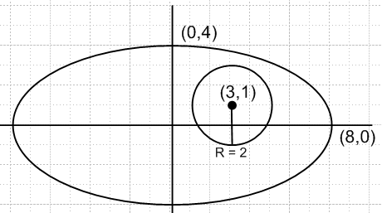 (5.15)

The circle has radius R = 2 and is centered at (α,β) = (3,1). The semi ellipse axes are A = 8 and B = 4. We enter into Maple the 6 original equations (5.7) in the 6 unknowns x,y,x',y',λ1,λ2 (xp = x', L1 = λ1, etc) :

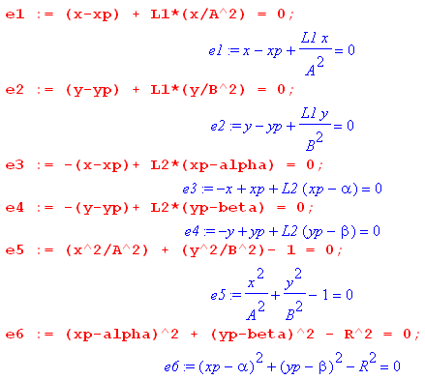 (5.16)

We next set in the specific parameters for the figure shown above

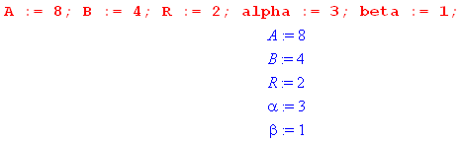 (5.17)

Without given a starting point, Maple finds the following solution

which we approximate as

λ1 = -2.8 λ2 = .32 (x,y) = (3.66, 3.56) (x',y') = (3.50, 2.94) . (5.18a)

Plotting this on our figure,

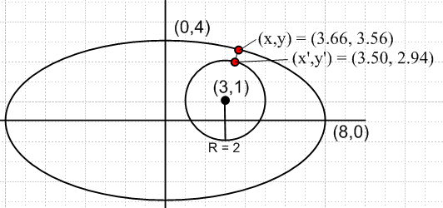 (5.18b)

we see that this solution corresponds to the minimum distance between the two curves. Maple computes this minimum distance to be .6406470846 units.

Another solution is found by giving Maple a search starting point (-8,0) on the ellipse and (5,1) on the circle :

which we approximate as

λ1 = -104 λ2 = -6.5 (x,y) = (-7.99, -.22) (x',y') = (4.99, 1.22) . (5.19a)

Plotting this solution,

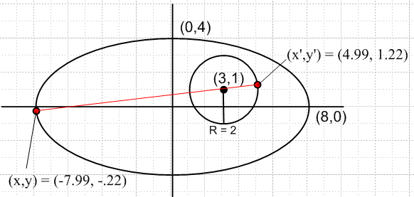 (5.19b)

we see that this solution corresponds to the maximum distance between the two curves. Maple computes this maximum distance to be 13.05541338 units.

A third candidate solution is found by giving Maple a starting point (-8,0) on the ellipse and (1,1) on the circle:

which we approximate as

λ1 = -72 λ2 = 4.5 (x,y) = (-7.99, -.22) (x',y') = (1.01, 0.78) . (5.20a)

Plotting this solution,

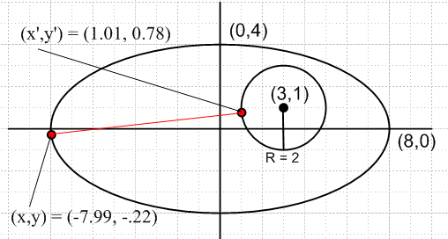 (5.20b)

one sees that this solution represents a "stationary point" but is not in fact a solution to the problem.

Finally, we find this fourth solution,

which we approximate as

λ1 = -20.2 λ2 = -2.3 (x,y) = (3.66, 3.56) (x',y') = (2.50, -.94) . (5.21a)

Plotting this solution,

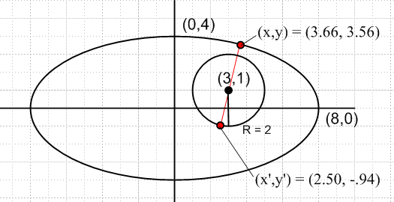 (5.21b)

we find a situation similar to the third candidate solution -- a stationary point which is neither a global maximum nor a global minimum.

6. Example 3: The Boltzmann factor in Statistical Mechanics

6.1 Statement of The Boltzmann Extremum Problem

Imagine a system which has m state levels into which particles can be placed. At a given energy level εi, the number of available states is gi, known as the degeneracy at energy εi. A particular state of the entire system of particles is characterized by the number of particles Ni in each of the states, so system state = (N1,N2...Nm) = N, a vector. The total number of particles in the system is fixed at M = ΣiNi, and the total energy is U = ΣiεiNi. The system is isolated so its initial energy U does not change, nor can particles be created or destroyed, so U and M are both fixed constants. The system of particles (perhaps a box of gas atoms) is assumed to be at thermal equilibrium so all its macroscopic characteristics (like pressure and temperature) are stable.

Imagine a billion of these particle systems (an "ensemble"). Each system settles into its own partition set {Ni} = N. If M is very large, one will find that those billion N vectors are all very similar. This is so because certain {Ni} partitions are statistically favored over other partitions just because there are a lot more "states" available to a system with those favored {Ni} partitions.

So, how many states are available ("accessible") to such a system characterized by vector N which represents some partitioning of the particles {Ni}?

The number of different "ways" of placing N indistinguishable balls into g boxes is a fascinating elementary problem and the answer is $\left(\begin{matrix}N+g-1 \\ N\end{matrix}\right)$, a binomial coefficient.

Footnote: One arrives at this answer by thinking of N balls and g-1 "partitions" between boxes, all of which have to be laid out in a row, such as | * * * | * | | * for the case N = 5 and g-1 = 4. Here the leftmost bin is empty, as is the second bin from the right. Each layout of the 9 objects is characterized by picking a committee of 5 balls from the 9 positions (or a committee of 4 partitions). So in this case the number of unique layouts is $\left(\begin{matrix}9 \\ 5\end{matrix}\right)$ = $\frac{9!}{5!4!}$ = $\left(\begin{matrix}9 \\ 4\end{matrix}\right)$ . (6.1.1)

The count $\left(\begin{matrix}N+g-1 \\ N\end{matrix}\right)$ allows multiple balls to be in any given box. This count is then associated with so-called Bose-Einstein statistics -- multiple bosons are allowed in the same state (for example, photons or any integral-spin particles). If at most one ball is allowed in any given box , the count of ways is just the number of ways to pick a committee of N boxes from the set of g boxes, and this count is $\left(\begin{matrix}g \\ N\end{matrix}\right)$. This count is then associated with so-called Fermi-Dirac statistics -- only one fermion is allowed in a state (for example electrons or any half-integral spin particles). The fact that electrons are fermions is the reason the periodic table of elements exists.

However, we shall assume that gi >> Ni (known as the Boltzmann limit), and this allows a simplification of the state count. Both the Bose and Fermi state counts reduce to the same count in this limit:

ways = $\left(\begin{matrix}N+g - 1 \\ N\end{matrix}\right)$ ≈ $\left(\begin{matrix}g \\ N\end{matrix}\right)$ = $\frac{g!}{N! (g-N)!}$ = $\frac{g(g-1)..(g-N+1)}{N!}$ ≈ $\frac{gN}{N!}$ . (6.1.2)

So in our particle problem, the number of ways of having N1 particles in states with energy ε1 is $\frac{g1N}{N1!}$. For each of these ways, there are $\frac{g2N}{N2!}$ways of putting N2 particles in energy level ε2. And so on. Thus, the total number of available states ("microstates") for a partition {Ni} of the M particles is given by

Ω(N1,N2...Nm) = $_{1}$$_{2}$ ....$_{m}$ . (6.1.3)

So here is our initial extremum problem:

Find N which maximizes Ω(N) = $_{1}$$_{2}$ ....$_{m}$ subject to these two constraints:
ΣiNi = M and ΣiεiNi = U . (6.1.4)

When M is a very large number (like Avogadro's number), it turns out that Ω(N) has a very strong and sharp maximum at a certain N which is the solution value N for this extremum problem. Thus, when one examines an ensemble of such systems, this solution N is the overwhelmingly likely partitioning of the particles into {Ni}. Our task is then to solve this problem for N.

This vector N = (N1, N2...Nm) is the vector r = (x1,x2...xN) of our general Lagrange Multiplier presentation in Section 2, so in this application the number of components in the vector is N = m, and we don't want to confuse this previous use of symbol N with N or Ni of the present problem!

One might observe that the xi in the general analysis were reals, whereas the Ni here are integers. We can dispense with this issue by simply writing Ni! = Γ(Ni+1) which then serves to interpolate Ni between its integer values. Another approach is to replace Ni everywhere in the above problem statement by ni ≡ Ni/M. Since M and the solution Ni values are very large integers, one can regard this ni as essentially a continuous real (albeit rational) variable.

It should be noted that the value of U is restricted to a certain range.

Mεmin ≤ U ≤ Mεmax . (6.1.5)

The limits represent the two extreme possible partitions {Ni} of the particles (all in lowest energy state, or all in highest energy state). It is useful to define the average energy of a particle,

u ≡ U/M = average energy of particle in the system (6.1.6)

and then (6.1.5) says,

εmin ≤ u ≤ εmax . (6.1.7)

6.2 Solution of The Boltzmann Extremum Problem

Maximizing the state count Ω of (6.2) is the same as maximizing f ≡ lnΩ, and from (6.1.3),

f(N1, N2...Nm) ≡ lnΩ(N1,N2...Nm) = Σi [ Ni ln gi ] - Σi [ ln Ni! ] (6.2.1)

where Σi means Σi=1m. Assuming all the Ni are very large numbers, we may use Stirling's formula,

x! ≈ $\sqrt{2πx}$xx e-x ⇒ lnx! ≈ ln$\sqrt{2π}$+ (1/2) lnx + xlnx - x ≈ xlnx - x, x >> 1 . (6.2.2)

Then ln Ni! ≈ NilnNi- Ni so that,

f = lnΩ = Σi [ Ni lngi ] - Σi [ ln Ni! ] ≈ Σi [ Ni lngi ] - Σi [NilnNi- Ni]

= Σi [(1+lngi)Ni - NilnNi ] = Σi Ni [1 + ln(gi/Ni)] . (6.2.3)

Here then is a restatement of the extremum problem given in (6.1.4):

Find N which maximizes f(N) = Σi [(1+ln gi)Ni - NilnNi ] subject to these two constraints: a(N) = ΣiNi - M = 0
b(N) = ΣiεiNi-U = 0 . (6.2.4)

Following now the prescription of Section 2, we write our "Lagrangian" H as

H(N,λ) ≡ f(N) + λ1a(N) + λ2 b(N)

= Σi [(1+ln gi)Ni - NilnNi ] + λ1 [ ΣiNi - M] + λ2 [ΣiεiNi-U] . (6.2.5)

The next step (b) is to compute the m derivatives with respect to Ni :

fi = ∂f/∂Ni = (1+lngi) - Ni (1/Ni) - lnNi = lngi - lnNi = ln(gi/Ni)

ai = ∂a/∂Ni = ∂i [ ΣjNj - M] = 1

bi = ∂b/∂Ni = ∂i [ΣjεjNj-U] = εi . (6.2.6)

In step (c) we set the partials of H to zero, so

0 = Hi(N,λ) = fi + λ1ai + λ2 bi = ln(gi/Ni) + λ1 + λ2εi i = 1,2...m
or
ln(gi/Ni) + λ1 + λ2εi = 0 i = 1,2...m
or
ln(Ni/gi) = λ1 + λ2εi . i = 1,2...m (6.2.7)
Step (d) just displays the set of equations one needs to solve :

ln(Ni/gi) = λ1 + λ2εi i = 1,2...m

ΣiNi = M // a(N) = 0

ΣiεiNi = U // b(N) = 0 . (6.2.8)
This is a system of m+2 equations in m+2 unknowns which are the Ni, λ1 and λ2. To solve these equations, we first solve the first set of m equations for Ni, leaving λ1 and λ2 as unknowns:

ln(Ni/gi) = λ1+ λ2εi
or
Ni = gi eλ$_{1}$ eλ$_{2}$ε$_{i}$ . (6.2.9)

Already a major result has emerged from our Lagrange Multiplier analysis! The population Ni of states at energy level εi depends exponentially on εi. We intuitively expect higher energy levels to be less populated than lower ones, so we expect λ2 to be negative. For this reason, and following tradition, we set λ2 = - β where β > 0. And while we're at it, we can set eλ$_{1}$ = A to simplify notation. So

β ≡ - λ2

A ≡ eλ$_{1}$ (6.2.10)
and then (6.2.9) reads,

Ni = A gi e-βε$_{i}$ . (6.2.11)

A study of the statistical mechanics of thermal equilibrium in fact shows that

β = 1/kT (6.2.12)

where T is absolute temperature and k is Boltzmann's constant. The factor e-βε$_{i}$ in (6.2.11) is referred to as the Boltzmann factor. The quantity S = k lnΩ = kf is the entropy of a system. The idea that β = 1/kT is really the definition of absolute temperature, but all these matters are not of immediate interest, so we continue onward.

From (6.2.11) the probability of a particle having energy εi is given by

pi = $\frac{Ni}{M}$ = $\frac{A}{M}$ gi e-βε$_{i}$ . (6.2.13)

Since Σipi = 1 one finds that 1 = $\frac{A}{M}$ [Σigi e-βε$_{i}$] which then determines the derived Lagrange multiplier constant A (expressed in terms of β),

A = $_{i}$ . (6.2.14)

The denominator Z ≡ Σigie-βε$_{i}$ is called the partition function for the system.

Using (6.2.11) for Ni, the two constraint equations shown in (6.2.4) [ΣiNi= M and ΣiNiεi= U] read

A Σigie-βε$_{i}$ = M
A Σiεig e-βε$_{i}$ = U . (6.2.15)

Dividing these two equations and using (6.1.6) that u = U/M, one gets this self-consistent result,

u = $\frac{U}{M}$ = $_{i}$$_{i}$ = $_{i}$$_{i}$ = $\frac{Σipiεi}{1}$ = Σipiεi = <εi> . (6.2.16)

To find the derived Lagrange multiplier constant β = -λ2, write out the second equation of (6.2.15),

Σigiεi e-βε$_{i}$ = U/A = (U/M)(M/A) = (u) ( Σigi e-βε$_{i}$)
or
Σi [ εi - u ] gi e-βε$_{i}$ = 0 (6.2.17)

so this is the equation one must solve for β. Recall that εi, gi, and u are all known quantities. For the lowest energy states one will have εi < u ( recall that u = <εj> ) so [εi - u] will be negative. For high energy states [ εi - u ] will be positive, so that is why (6.2.17) at least stands a chance of having a solution for β. As noted in (6.2.12), the solution for β indicates the temperature of the system of particles. Changing u changes the solution β, so one concludes that the mean particle energy u is a function of temperature.
For general values of εi (6.2.17) is a transcendental equation which must be solved numerically for β. If it happens that all the εi are ratios of integers, the equation can be written as a polynomial equation, but since those integers are likely to be large, the order of this polynomial is large and again one must do a numerical solution.

Notice that the solution to our particle system problem has the same general form regardless of the number m of energy levels εi. If we take m very large and make the energy levels εi be very closely spaced, they approach a continuum of energy values and the conclusions apply to a classical system. For small finite m, the discrete energy levels indicate a quantum mechanical system.

To summarize, we have used the method of Lagrange multipliers to solve the Boltzmann extremum problem stated in either (6.1.4) or (6.2.4). Since the problem has two constraints, there are two Lagrange multipliers λ1 and λ2 which we replaced with the numbers A ≡ eλ$_{1}$ and β ≡ - λ2 . We showed how β is determined by numerically solving (6.2.17), and then A is determined by (6.2.14). Then the solution (extremum) vector N = {Ni} is given by (6.2.11) which says Ni = A gi e-βε$_{i}$ .

What we have not shown is that this extremum solution is a maximum. nor have we shown the fact that Ω(N) has a very sharp peak at the solution value N, which then statistically forces a system to assume a value N very close to this solution N. We shall deal with these issues in the following section.

6.3 More details of the solution

Start with

f = lnΩ = Σi [(1+lngi)Ni - NilnNi ] = Σi Ni [1 + ln(gi/Ni)] . (6.2.3)

The constraints ΣiNi= M and ΣiNiεi= U can be regarded as two equation in the two unknowns N1 and N2 which are easily solved to obtain,

N1 = + (ε2- ε1)-1[ ε2M - U + Σi=3m (εi- ε2)Ni] = N1(N3,...Nm)
N2 = - (ε2- ε1)-1[ ε1M - U + Σi=3m (εi - ε1)Ni] = N2(N3,...Nm) . (6.3.1)

Notice that, for i = 3,4...m,

$\frac{∂N1}{∂Ni}$ = + (ε2- ε1)-1 [ (εi- ε2) ] = $\frac{εi-ε2}{ε2-ε1}$
$\frac{∂N2}{∂Ni}$ = - (ε2- ε1)-1 [ (εi- ε1) ] = - $\frac{εi-ε1}{ε2-ε1}$ . (6.3.2)

Now think of f as function of N3,,,,Nm (analogous to the first line of (3.4)) ,

f(N1(N3,...Nm), N2(N3,...Nm), N3, .....Nm) . (6.3.3)

Compute the total derivative df/dNi for i = 3,4...n:

$\frac{df}{dNi}$ = f1 $\frac{∂N1}{∂Ni}$ + f2 $\frac{∂N2}{∂Ni}$ + fi where fi ≡ $\frac{∂f}{∂Ni}$
= f1 $\frac{εi-ε2}{ε2-ε1}$ - f2 $\frac{εi-ε1}{ε2-ε1}$ + fi (6.3.2)
= ln(g1/N1) $\frac{εi-ε2}{ε2-ε1}$ - ln(g2/N2) $\frac{εi-ε1}{ε2-ε1}$ + ln(gi/Ni) . (6.2.6) (6.3.4)

Installing the solution values ln(Ni/gi) = λ1 + λ2εi shown in (6.2.8) we continue,

$\frac{df}{dNi}$ = (λ1 + λ2ε1) $\frac{εi-ε2}{ε2-ε1}$ - (λ1 + λ2ε2) $\frac{εi-ε1}{ε2-ε1}$ + (λ1 + λ2εi)
= λ1 [ $\frac{εi-ε2}{ε2-ε1}$ - $\frac{εi-ε1}{ε2-ε1}$ + 1] + λ2 [ ε1 $\frac{εi-ε2}{ε2-ε1}$ - ε2 $\frac{εi-ε1}{ε2-ε1}$ + εi ]

= λ1 [ $\frac{εi-ε2}{ε2-ε1}$ - $\frac{εi-ε1}{ε2-ε1}$ + $\frac{ε2-ε1}{ε2-ε1}$] + λ2 [ ε1 $\frac{εi-ε2}{ε2-ε1}$ - ε2 $\frac{εi-ε1}{ε2-ε1}$ + εi $\frac{ε2-ε1}{ε2-ε1}$ ]

= λ1 [0] + λ2[0] = 0 . (6.3.5)

This is the expected result since the solution is supposed to be a critical point of f given in (6.3.3).

Our main interest is in the second derivative d2f/dNi2 . If this comes out negative at the solution point, we know we have a maximum. Applying d/dNi to the second line in (6.3.4),

$\frac{d2f}{d2Ni}$ = $\frac{df1}{dNi}$ $\frac{εi-ε2}{ε2-ε1}$ - $\frac{df2}{dNi}$ $\frac{εi-ε1}{ε2-ε1}$ + $\frac{dfi}{dNi}$

= [ f11 $\frac{εi-ε2}{ε2-ε1}$ - f12 $\frac{εi-ε1}{ε2-ε1}$ + f1i] $\frac{εi-ε2}{ε2-ε1}$ fij ≡ $\frac{∂2f}{∂Ni∂Nj}$
- [ f21 $\frac{εi-ε2}{ε2-ε1}$ - f22 $\frac{εi-ε1}{ε2-ε1}$ + f2i] $\frac{εi-ε1}{ε2-ε1}$
+ [ fi1 $\frac{εi-ε2}{ε2-ε1}$ - fi2 $\frac{εi-ε1}{ε2-ε1}$ + fii] . i = 3,4....m (6.3.6)

Recall now that

f = lnΩ = Σi [(1+lngi)Ni - NilnNi ] (6.2.3)

fi = lngi - lnNi (6.2.6)

fij = - δij(1/Ni) . (6.3.7)

Therefore (6.3.6) simplifies to

$\frac{d2f}{d2Ni}$= f11 [ $\frac{εi-ε2}{ε2-ε1}$ ]2 + f22 [ $\frac{εi-ε1}{ε2-ε1}$ ]2 + fii

= – { $\frac{1}{N1}$ [ $\frac{εi-ε2}{ε2-ε1}$ ]2 + $\frac{1}{N2}$[ $\frac{εi-ε1}{ε2-ε1}$ ]2 + $\frac{1}{Ni}$} . (6.3.8)

This says that the curvature of f in all independent directions Ni for i = 3,4...m is negative and this is true for all vectors N = {Ni}. This is of course then true for the solution vector N. But for the solution vector N we also have df/dNi = 0 from (6.3.5) and therefore the solution is a maximum of f and therefore of Ω.

Finally, we may estimate the width of the peak of f and then of Ω. The energy fractions in (6.3.8) are on the ballpark order of unity and the Ni are on the order of M, the total number of particles. If we do a Taylor expansion of f(N) in the i direction only (i = 3,4...m) about the solution N, then

f(Ni + dNi) ≈ f(Ni) + (df/dNi)dNi + (1/2)(d2f/d2Ni) (dNi)2 . (6.3.9)

But at the solution point (df/dNi) = 0 so one finds

df = f(Ni + dNi) - f(Ni) ≈ (1/2)(d2f/d2Ni) (dNi)2 (6.3.10)

so
(dNi)2 ≈ $\frac{2 |df|}{|d2f/d2Ni|}$ . (6.3.11)

Suppose we are interested in finding dNi such that the Ω(N) drops to half its peak value. Then

Ωhalf/Ωpeak = 1/2 ⇒ ln Ωhalf - ln Ωpeak = 1/2 ⇒

fhalf - fpeak = ln(1/2) ⇒ |df| = fpeak - fhalf = ln(2) = 0.7 . (6.3.12)

In this case, the half-width (6.3.11) of the Ω plot is

dNi = $\frac{1.4}{|d2f/d2Ni|}$. (6.3.13)

For a ballpark estimate, we can interpret (6.3.8) as saying

$\frac{d2f}{d2Ni}$~ -3/M ⇒ dNi ≈ $\frac{1.4 M}{3}$~ $\sqrt{M}$ (6.3.14)

so the fractional half-width is roughly.

$\frac{dNi}{M}$ ~ $\frac{1}{M}$. (6.3.15)

For a macroscopic box of gas particles, one might have M = 1020 and then $\frac{dNi}{M}$ ~ 10-10 . Since this is the fractional half-width of the peak in Ω, the peak is extremely sharp. This then is why, in an ensemble of macroscopic particle systems, all systems will have almost the same N value.

6.4 A numerical example with plots

For this example we choose three energy levels (m = 3) so the state count is given by

Ω(N1,N2,N3) = $_{1}$$_{2}$ $_{3}$ (6.1.3) (6.4.1)

and correspondingly (this uses the Stirling approximation),

f = lnΩ = Σi=13 Ni [1 + ln(gi/Ni)] . (6.2.3) (6.4.2)

Assume the three energy levels are ordered in this manner, where ε1 is the lowest energy state,

ε1 < ε2 < ε3 . and recall u = U/M and ε1 ≤ u ≤ ε3 . (6.4.3)

We regard both N1 and N2 as functions of N3 where, according to (6.3.1),

N1 = + (ε2- ε1)-1[ ε2M - U + (ε3- ε2)N3] = N1(N3)
N2 = - (ε2- ε1)-1[ ε1M - U + (ε3 - ε1)N3] = N2(N3) . (6.3.1) (6.4.4)

It seems clear that one must have

0 ≤ N1 ≤ M
0 ≤ N2 ≤ M . (6.4.5)

Using the expressions (6.4.4) in these inequalities and making use of (6.4.3) and the fact that ε1 ≤u ≤ ε3, one finds that all four inequalities can be summarized as just two inequalities which we write as,

N3min ≤ N3 ≤ N3max
N3min = max($\frac{u-ε2}{ε3- ε2}$M, 0)
N3max = min( $\frac{u-ε1}{ε3- ε1}$M, M) = $\frac{u-ε1}{ε3- ε1}$M . // since u ≤ ε3 (6.4.6)

To find the Lagrange multiplier β we must solve (6.2.17),

Σi=13 [ εi - u ] gi e-βε$_{i}$ = 0 . (6.2.17) (6.4.7)

Then the other derived multiplier is given by (6.2.14)

A = $_{i}$ = $\frac{M}{Z}$ where Z ≡ Σigie-βε$_{i}$ . (6.2.14) (6.4.8)

The components Ni of the solution vector are then given by

Ni = A gi e-βε$_{i}$ . (6.2.11) (6.4.9)

The curvature of f at its peak is,

$\frac{d2f}{d2N3}$ = – { $\frac{1}{N1}$ [ $\frac{ε3-ε2}{ε2-ε1}$ ]2 + $\frac{1}{N2}$[ $\frac{ε3-ε1}{ε2-ε1}$ ]2 + $\frac{1}{N3}$ } . (6.3.8) (6.4.10)

The half-width of the Ω peak is then given by

dNi = $\frac{1.4}{|d2f/d2Ni|}$. (6.3.13) (6.4.11)

For our specific Maple plots, we shall assume

ε3= 3 M = 1000 = number of particles
ε2 =2 u = 1.5 = average energy
ε1= 1 g1= g2= g3 = 5000 = degeneracy (6.4.12)

Here then is our Maple code. We first enter Ω,

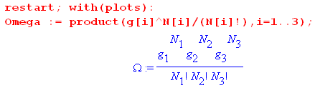

The quantities N1 and N2 are then replaced as in (6.4.4) [ we use ei in place of εi] ,

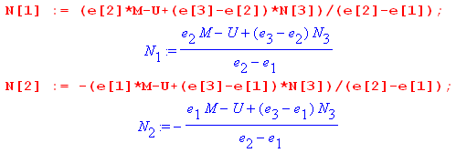

We next enter most of the data shown above and use it to compute N3min and N3max

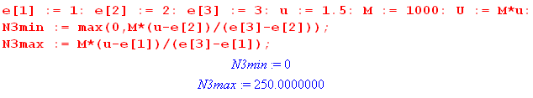

so the legal range of N3 is (0,250). Here is a plot of N1 (red) and N2(black) versus N3 :

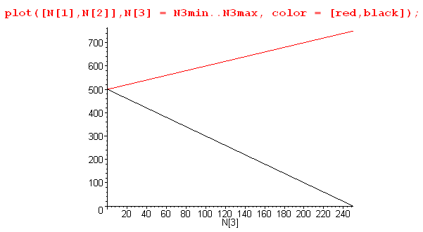 (6.4.13)

We then enter the degeneracies and take a look at Ω in its numerical form,

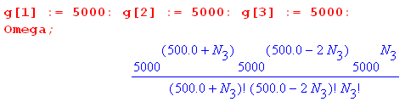 (6.4.14)

As is typical in statistical mechanics, at its peak the value of Ω is a very large number. Even with the relatively small number of particles M = 1000 and degeneracy g = 5000, the peak value is (see below)

Ωpeak = 6.71 x 101519 (6.4.15)

Maple is uncomfortable plotting numbers larger than about 1040 so we pre-scale Ω down by 101519 to make the scaled Ω be Maple-digestible. This scaling process in turn creates numbers smaller than 10-40 which are also rejected by the Maple plotter, so we use a Heaviside function to pin small numbers to 0 unless they are greater than the arbitrary value .01. Here then is a plot of Ω(N3),

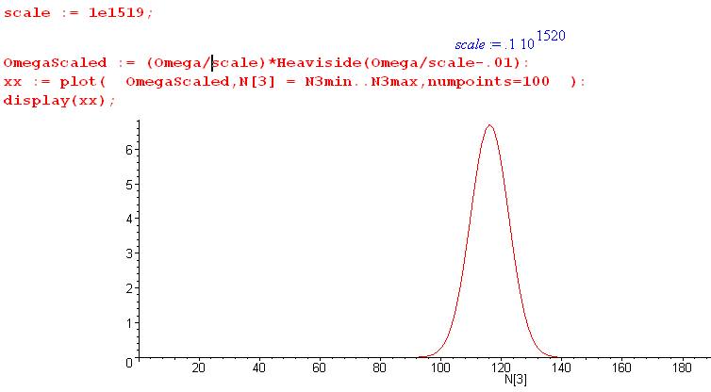
(6.4.16)

We broke the display command into two pieces: first create xx then plot xx. Replacing : with ; after the plot command gives one a list of numbers to be plotted, and from this list one can determine a reasonable scale factor. Once that is found, the plotting coordinates need not be displayed. The curve Ω(N3) has the typical Gaussian (normal) shape which no doubt the energetic reader could show results from the central limit theorem.

A plot of f = ln(Ω) has a much smoother and broader shape,

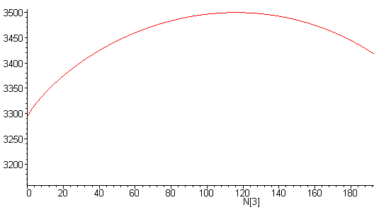
(6.4.17)
Recall from (6.3.8) that $\frac{d2f}{d2Ni}$ is everywhere negative, consistent with the cupping down seen in this plot.

Next, we have Maple solve (6.2.17) for the Lagrange multiplier β,

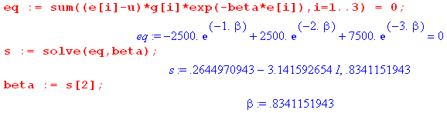

With w = e-β the above equation is 3w2+w-1 = 0 which has solutions w = ( -1 ± $\sqrt{13}$)/6. The minus sign gives the complex β noted, while the plus sign gives the physical solution β = - ln[( -1 + $\sqrt{13}$)/6] = .834.
From this β value we compute the other Lagrange parameter A from (6.2.14),

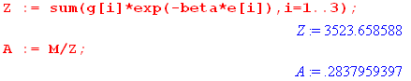

Once these parameters are known, we use (6.2.11) to display the solution vector N = {Ni}.

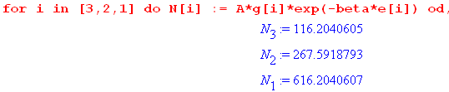

Since we set u < ε2, we see here a normal distribution where higher energy states have fewer particles.

Our final task is to use (6.3.8) and (6.3.13) to determine the half-width of the Ω peak,

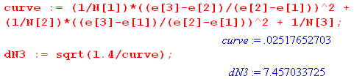

which says ΔN1/2 ≈ 7.5. This width and the solution N3 = 116.2 can be verified from this blowup plot of the Ω peak,

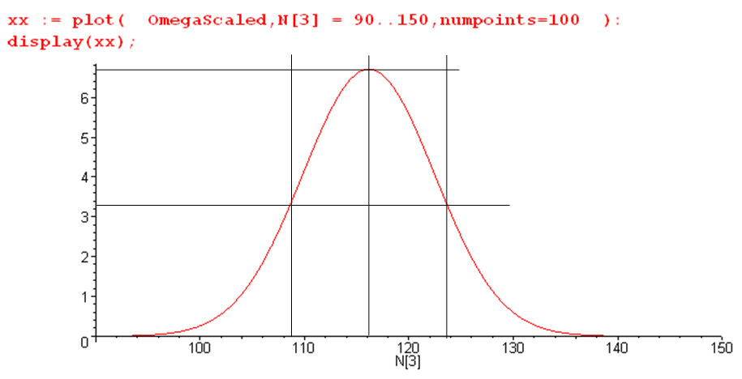
(6.4.18)

Notice that this Maple code does not use the Stirling approximation and provides a continuous interpolation of N! as Γ(N+1).

The peak value of Ω is found to be

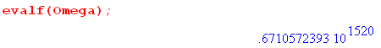

In the above example we used u = 1.5 < ε2 = 2. If we instead use u = 2.5 > ε2 = 2, we find that the state populations are as shown above but in reverse order. Such a inverted situation corresponds to a negative absolute temperature T (β = -.834 = 1/(kT) ) and cannot therefore arise in thermal equilibrium. It does arise in a laser medium which is driven by some power source ("population inversion").

Appendix A : Proof that matrix rank is the number of independent columns and rows

Shilov proves these facts but the proof is a bit spread out over several sections. Here we provide an alternative proof that is perhaps more direct. Recall the definition (1.5) of the rank of a matrix :

Definition: The rank r of an m x n matrix A is the dimension of the largest non-vanishing subdeterminant (minor) within A. [Shilov 1.92 ] Thus, r ≤ min(m,n). (1.5) (A.1)

The following well-known linear algebra fact will be used below (theorem and contrapositive):

the columns/rows of a square matrix M are linearly independent ⇔ det(M) ≠ 0
the columns/rows of a square matrix M are linearly dependent ⇔ det(M) = 0 . (A.2)

Roughly speaking, if the rows of M are linearly independent, we expect the system of linear equations y = Mx to be solvable by Cramer's Rule x = M-1y = [det(M)]-1 cof(MT) y which requires det(M) ≠ 0. More obscurely, if a set of n column vectors ci is linearly independent, we expect the volume of the n-piped spanned by these vectors in En to be non-zero, and that volume is given by |det(c1,c2...cn)| = |det(M)|. See our Tensor Analysis document (B.6.10).

Once Theorem 1 below is established, the rest is easy.
Theorem 1. If all kxk minors in k columns of matrix A vanish, the k columns are linearly dependent. (A.3)

Contrapositive: If k columns are linearly independent, they must contain at least one non-zero kxk minor.

Proof: Assume matrix A has m rows and n columns. In order for kxk minors to exist, one must have k ≤ min(m,n). Gather up the k columns and make them be the leftmost k columns of a new matrix B. Since these columns have m elements, and since k ≤ m, add m-k arbitrary new columns to the right of the k columns so that matrix B is then a square matrix. On the left below we show the k columns taken from matrix A in red, and then the arbitrary added columns are shown in blue.

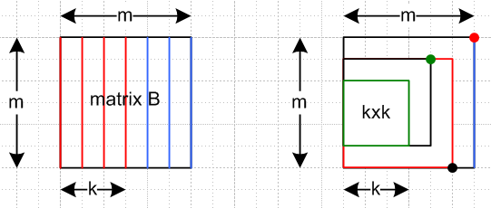 (A.4)

Consider now the process of computing det(B) by going down the rightmost column using the standard cofactor sum formula. This det(B) is a linear combination of (m-1)x(m-1) minors all in the left m-1 columns. Consider one of these minors. If we evaluate it using the same cofactor formula (of one less dimension), it will be a linear combination of (m-2)x(m-2) minors in the left m-2 columns. We keep going until we are evaluating a set of kxk cofactors in the left k columns. But these all vanish by the theorem premise. Thus, reversing this stack we conclude that det(B) = 0. The picture on the right above shows one minor at each level of the descent just described (red dot goes with red minor, etc).
Now suppose it were possible that the k red columns were independent. Since the added blue columns are arbitrary, we could certainly find a set of added blue columns so that all m columns were independent. But then we would have det(B) ≠ 0. But we just showed that det(B) = 0, so it must not be possible to have the k red columns be independent, so they must be dependent. QED.

Theorem 2. Rank(A) = r ⇒ A has r linearly independent columns. (A.5)

Proof: If rank(A) = r, A must have at least one non-vanishing rxr minor. The r columns of this minor are therefore linearly independent (each of these mini-columns has r elements). This means that the r full columns containing these mini-columns are also independent (see * below). So matrix A has at least r independent columns. Now let k = r+1. We know that all kxk minors in A vanish. By Theorem 1, any set of k columns must be linearly dependent. Since k = r+1, any r+1 columns are linearly dependent, so the number of independent columns is r.

* Since the mini-columns Ci are independent, one cannot write ΣikiCi = 0 (with at least one kj ≠ 0). If the corresponding full columns ci were dependent, one could write Σikici = 0. But if Σikici = 0, then one must have ΣikiCi = 0 since the latter is just a subset of the former equation set. But ΣiλiCi = 0 says that the mini-columns are dependent, which they are not. Thus, one cannot write Σikici = 0 and thus the full columns are independent. (A.6)

Theorem 3. A has r linearly independent columns ⇒ Rank(A) = r (A.7)

Proof: If there are r linearly independent columns, then at least one rxr minor within those columns must be non-zero (contrapositive of Theorem 1). Suppose there were an (r+k)x(r+k) non-vanishing minor. Then the r+k mini-columns of that minor would be independent, and thus there would be r+k independent full columns. But the theorem premise says there are only r independent columns, so all minors larger than rxr must vanish. Therefore rank(A) = r.

Making trivial replacements in the above three theorems and proofs (column → row, leftmost → topmost and so on), one finds that all three theorems are valid for rows as well as columns. Thus:

Theorem 1' . If all kxk minors in k rows of matrix A vanish, the k rows are linearly dependent. (A.8)

Theorem 2'. Rank(A) = r ⇒ A has r linearly independent rows. (A.9)

Theorem 3'. A has r linearly independent rows ⇒ Rank(A) = r (A.10)

Comment: Sometimes the number of linearly independent rows of a matrix is called the row rank, and the number of independent columns is called the column rank. Theorems 2 and 3 show that column rank = rank, while Theorems 1' and 2' show that row rank = rank. Therefore:

column rank = row rank = rank = dimension of largest non-vanishing minor (A.11)

Basis Minors and Basis Columns. If rank(A) = r, we know there must exist at least one non-vanishing rxr minor in A. Shilov refers to such a minor as a basis minor and the columns passing through this minor are called basis columns. We showed in Theorem 2 that the set of such basis columns is linearly independent (which is why they are called basis columns). Obviously any of these columns can be written as a linear combination of the basis columns, such as c2 = Σi=1k kici = 1 c2. If k = r+1, all kxk minors vanish and by Theorem 1 all sets of k = r+1 columns are linearly dependent. Thus, every non-basis column is a linear combination of the basis columns. We have thus proved Shilov's Basis Minor Theorem which we quote from section 1.93 of his book (p 25)

(A.12)

In his proof that column rank = rank, Shilov uses the above theorem as a starting point.

References

The method of Lagrange multipliers often makes cameo appearances in texts on the calculus of multiple variables. There are also a moderate number of sites and pdf's on web, search on "Lagrange Multipliers". Whole books on the use the Lagrange multipliers for specialized applications may be found online.

R.C. Buck with E.F. Buck, Advanced Calculus, 2nd Ed. (McGraw-Hill, New York, 1965). The discussion of extremum problems with constraints occupies pp 359-363. In the 3rd Edition (McGraw-Hill, New York, 1978), reprinted by (Waveland Press, Long Grove IL, 2003), this discussion has moved to pages 536-540. This excellent and now classic book was first published in 1956.

H. Goldstein, Classical Mechanics (Addison-Wesley, Boston, 1950), another classic. There is a 3rd edition 2001 by Goldstein, Safco and Poole.

S. Jensen, An Introduction to Lagrange Multipliers, http://www.slimy.com/~steuard/teaching/tutorials/Lagrange.html ( includes video lectures)

P. Lucht, Tensor Analysis and Curvilinear Coordinates (2014), http://user.xmission.com/~rimrock . If not there, search on .

G.E. Shilov, Linear Algebra (Dover Publications, 1977).

W. F. Trench, The Method of Lagrange Multipliers, http://digitalcommons.trinity.edu/mono/7/ ,
Supplement 2 (31p). This paper also has a "Theorem 1" which is related to but different from ours.

