This is the Title PhL 1.11.15

Note that page numbering is turned on in this template and view is 125%,
located in phil/roaming/microsoft/templates size about 219K.

lve the problem, we write out ** and insert **

The circled dot in the center marks the north pole and represents the direction of according to the right hand rule. On the right, since our slicing plane is closer to the north pole, the sphere slices are of course smaller than they are at the left which is a drawing of the concentric sphere slices at the equator of our desired but not shown 3D drawing.
The solution value of r for the problem is indicated by the black dot in the left slice. We intuitively know that this is the point of closest approach to the sphere center and thus corresponds to the maximum value of f(x,y,z) = $\sqrt{4 - x2- y2- z2}$ = $\sqrt{4 - r2}$.

The black arrow points toward the center of all the concentric spheres, and since this picture is equatorial, that vector is coplanar with the two red constraint normals!

∇f(r=A) + λ1∇a(r=A) = 0 (4.5)

and indeed, this equation says that at the solution point the two gradients must be collinear.

More details of the Example 1.

f(x,y) = $\sqrt{4 - x2- y2}$ since the sphere has u2+x2+y2 = R2 = 4

∇f(x,y) = - (x/f)- (y/f)

f(r,θ) = $\sqrt{4 - r2}$ polar coordinates

∇f(r,θ) = [-r/$\sqrt{4-r2}$] points toward the sphere's vertical axis (and ∇f = 0 at r = 0, north pole)

a(x,y) = y-1 = 0 the constraint

∇a = [1] points toward the right

At point A = (x,y) = (0,1) one has r = 1, = and f = $\sqrt{3}$. Then (4.5) reads

[-1/$\sqrt{3}$] + λ1[ 1/$\sqrt{3}$] = 0 ⇒ λ1 = 1/$\sqrt{3}$. (4.6)

At the solution point A the Lagrange multiplier λ1 can thus be interpreted as the negative of the ratio of the two gradient vectors ∇f and ∇a. Note that at the solution point, the two gradients really are collinear.

At point B, we can consider a differential movement dr = |dx|(-) along the constraint surface toward point A (in Fig (4.4) the x axis points down). We find that

df(B) = ∇f • dr = [ - (x/f)- (y/f)] • |dx|(-) = |dx| (x/f) > 0 since x>0 and f>0 . (4.7)

Thus, as we move toward point A, f increases since df>0, suggesting that A is indeed a maximum.

Consider the mirror point B' located above point A in Fig (4.4). The differential vector dr = |dx| lies along the constraint surface and points from B' toward A. Then

df(B') = ∇f • dr = [ - (x/f)- (y/f)] • |dx| = |dx| (-x/f) > 0 since -x>0 and f>0 . (4.8)

Once again, df > 0 showing indeed that point A is a maximum.

Finally, we have claimed that at the solution point, the Lagrangian function H(x,y) should have a maximum, since the whole theory is based on H being the function to maximize without constraints. One has,

H(x,y) = f(r) + λ1a(r) = $\sqrt{4 - x2- y2}$+ (1/$\sqrt{3}$) (y-1). (4.9)

Now u = (1/$\sqrt{3}$) (y-1) is a plane sloping up to the right in Fig (4.2.1). This is different from the plane y = 1 which is a vertical plane in that figure. In (4.9) we are adding a spherical surface to a plane sloping up to the right, and the result is an ellipsoidal-like surface (really a quartic surface) which has a maximum at the point A = (0,1). Here is a plot of that surface:

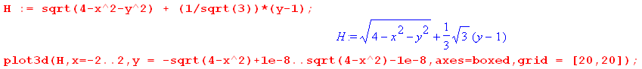

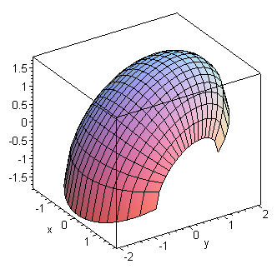 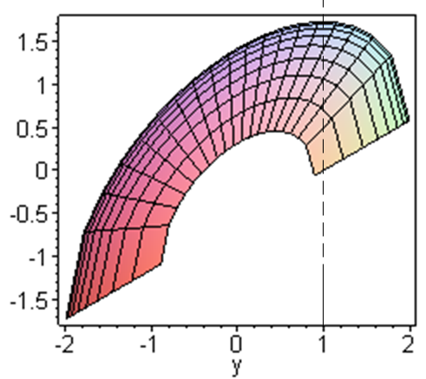 (4.10)

A direct method of confirming the maximum is provided by examining Hii :

Hi = fi + λ1ai Hii = fii + λ1aii aii = ∂2(y-1)/∂xi2 = 0

f = $\sqrt{4 - x2- y2}$ = $\sqrt{4 - x12- x22}$ ⇒ fi = - xi/f f > 0

fii = - [f * 1 - xifi]/f2 = - [f - xi(-xi/f)]/f2 = - (1/f) - (xi/f)2

Hii = fii + λ1aii = fii = - (1/f) - (xi/f)2 < 0 .

This shows that the function H(x,y) is "cupping down" at all locations, as the graph suggests. The point A where Hi = 0 (see (4.6) ) thus also has Hii < 0 and is thus a maximum.

The general case

Consider first a 2D surface in 3D space defined by F(x,y,z) = C. If one is on this surface and moves around on the surface, one always has F = C.

Fact: At any point r, ∇F(r) is locally normal to the surface.

The reason is very simple. Suppose an ant starts at point r on the surface and move dr in some arbitrary direction on the surface. Saying the ant stays on the surface says that dF = 0 for this motion. But dF = dr • ∇F. Since dF= 0, and since this is true for any on-surface direction dr, ∇F must be normal to the surface at that point r.

Now consider F(x1,x2.....xn) = C. This is an n-1 dimensional surface in En. For any motion dr along this surface, one finds the same thing as above, dF = dr • ∇F = 0 so ∇F is normal to the surface in En.

In the extremum problem with constraints in n dimensions, for any constant C the equation f(x1,x2.....xn) = C defines an n-1 dimensional surface. This surface is called a level surface of f. If one takes a set values for C, one gets a set of level surfaces. They might look like a set of concentric spherical shells in E3, but in general the shape changes slightly as C makes a small change in value. In Example 1 above, the half sphere shown in Fig (4.2.1) is a level surface for x2+y2+

For a surface of dimension n-1 in En that same thing is true.

Given a surface F(x,y,z) = C in 3D space, at any point on that surface∇F is a normal vector, so if an ant crawls some small distance dr away from the point that surface, dr • ∇F = 0. The reason this is true is very simple. A motion of dr along the surface results in a change in F of dF = 0 and since dF = dr • ∇F, and since dr could be any direction along the surface. it must be that ∇F must be a normal vector (in general it is not a unit normal vector).

If we were to upgrade this example to u = f(x,y,z) and have two constraints a=0 and b=0, the final intersection path of the hypersphere surface with the two constraint surfaces is again a 1D curve. If we consider dr along this curve, that dr will be perpendicular to both ∇a and ∇b, which says

(λ1∇a + λ2∇b) • dr = 0 . (4.11)

At an extremum point, if (4.1.2) is valid, we find that

∇f • dr = - (λ1∇a + λ2∇b) • dr = 0 . (4.12)

Since this dr movement is perpendicular to ∇f, there can be no change in f by moving along the intersecting constraint surface, and that is why we are at an extremum.

So this then provides an interpretation for the general solution case where this equation is true:

∇f + λ1∇a + ... λS-1 ∇q = 0 (4.1.2)

and thus,

∇f • dr = - (λ1∇a + λ2∇b + .... + λS-1∇q) • dr (4.13)

In general the intersection surface of f with all the constraint surfaces will be of dimension N-S+1 in En. A tiny displacement dr along this surface is perpendicular to all the local constraint surface gradients, so the right side of (4.8) is 0. At a solution point where equation (4.1.2) is true, we then have ∇f • dr = 0 so a small displacement dr in any constraint-legal direction results in df = 0, hence we are at an extremum.

