A&S 2009 Handbook Notes PhL 2.13.11

I just discovered this today, it is a 2009 update of my 1964 A&S.

Here are some of the changes I noted:

• Web friendly PDF with live click links
• Improved graphic quality of the headings
• Clearer section organization
• New whole chapters
• Removal of all digital tables since we can just use Maple etc nowadays to get values.
• Addition of modern graphics, including 3D graphs
• retaining of a set of editors to manage the thing!
• new formulas certainly in the Legendre Section
• total pages is now only about 600, even with new sections and data, due to removal of value tables.

All in all, this is excellent. I found it here

http://rapidshare.com/#!download|883l32|402815502|HandMathFunc10.pdf|29152

I am now converting it to DJVU to see what happens. The word search is slow in the PDF and I think the DJVU will make that better. Doing about 1 page per second, amazing! Today I wanted to know if there was some "toroid capacitance function" floating around in there with some strange name. I would think that searching on the word toroid ought to be sufficient. // Conversion required at least an hour of post-processing but finally finished.

1. Legendre Functions

Some dangerous new notation is used here that the reader must understand. Let's look at the key paragraph

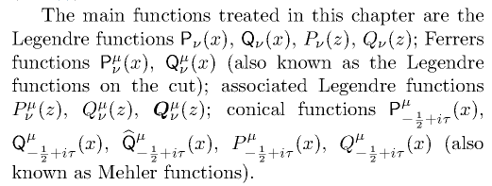

The non-italic P and Q are "on the cut" functions. This is the same notation as page 143 Bateman. The italic P and Q are the general P and Q functions "off the cut". The Bold Q is completely new, here is how it works. This guy Olver in 1997 made a suggestion to introduce the following:

F(a,b,c,z) ≡ F(a,b,c,z)/Γ(c)

Recall from page 68 Bateman that F(a,b,c,z) is analytic in a,b,c since the Γ(c) removes the poles which F(a,b,c,z) has when c = 0,-1,-2 and so on. So I am OK with that.
Also, A&S are referring to "on the cut" Legendre functions as "Ferrers Functions", since they really had no name in Bateman.
Now, in many of Bateman's Q forms, you see that Q = Γ(ν+μ+1) * stuff, an example being the 1/z2 form which is form (41) page 134. So the Bold Q function divides this out

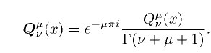

and at the same time, it absorbs that famous phase that appears in all the Bateman pages.
So notice that F and Q are somewhat unrelated because no form of the Q function has c = ν+μ+1.

Now Olver wrote a book published in 1997 in which I guess he did a lot of limit work.

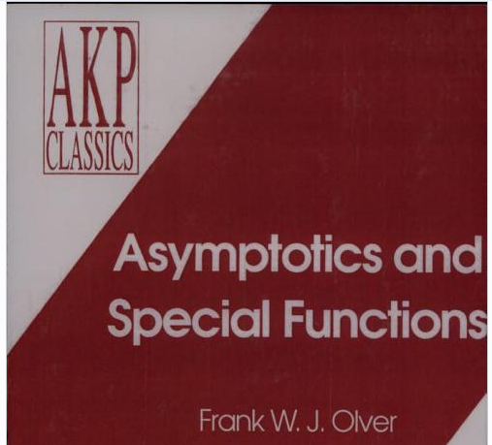

Google books seems to have the whole book. It opens with an excellent discussion of asymptotic series with two simple examples, then it defines notions of "order of" with various symbols. Also has a little bit of history on how people reacted to these divergent series!

Amazon says: (at $141 !!!)



eknigu has a 1974 edition. But someone says that the 1997 is just a reprint:

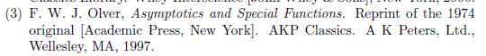

OK. eknigu's version is in fact English, and it is the 1997 reprint, it is done!

So Olver page 159 has this

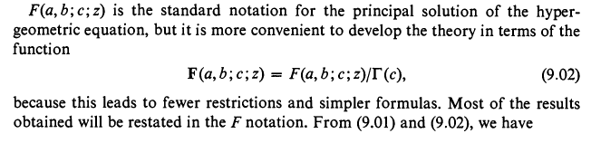
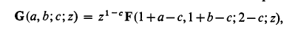

The book goes on in great detail. It is like Bateman, but I think everything is derived right in front of the reader. This is a good book to have. The index

