Bateman Integral Transforms PhL 3.31.10

Note added 7.11.10. Around page 773 of GR7 I see lots of references to ET II which don't match my Russian book. Either they are all bad references, or the English version has transforms of P and Q functions which don't exist in the Russian book! // Just did a Marriott visit, easy parking in this 2nd summer session, right on the circle. They had ET II and yes, it is different. The Russian version's last page is 327, but the English goes to page 451, an extra 125 pages of stuff, which includes a Legendre section. But, now I think I have the answer: I think the Russians packaged their stuff more densely and saved 125 pages, and then they had to make a new index in which they omitted P Q references but inserted them under the Russian function name! So it is all there. I have updated my index list below!

affiliated Legendre enterprise/business/ "stuff" maybe

Executive Summary:

I have all the Bateman volumes now, but ET II is in Russian. Luckily, the fact that I cannot read Russian does not stop me from seeing what lies in this volume. Most of its 320 pages is simply a table of integrals where the integrand is "some function" times a certain Bessel function. The integral is regarded then as the "Bessel transform" of that "some function". The "some function" is listed in the left column, and the integral is listed in the right column. Things are grouped by the different kinds of Bessel functions. A large part of the table involves Jν(xy); such transforms are historically called Hankel transforms, not Bessel transforms, even though the Bessel function is not in fact a Hankel function. Here is the general ordering of the integrals (the symmetric form is explained below). [ list is incomplete, see below! ]

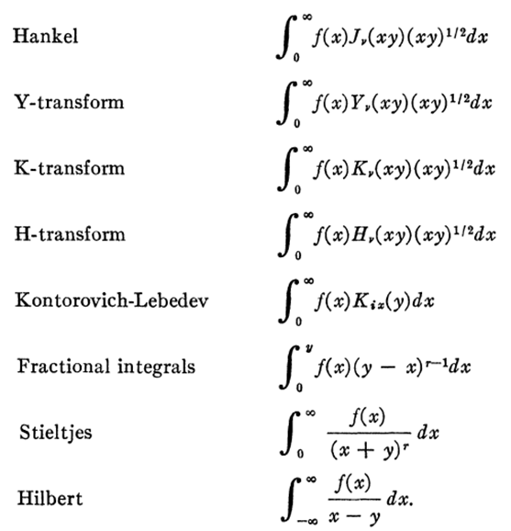

And here is a crude contents of the volume including the above stuff:

12-82 J transforms (Hankel)
83-98 Y transforms
99-118 K transforms
119-130 H transforms (Hν is the Struve function, one of about ten Bessel cousin functions)
130-134 Kontorovich-Lebedev transforms
135-154 fractional integral transforms
155-172 Stieltjes transforms
173 -187 principle part integrals and Hilbert transforms
188 -211 orthogonals
211-218 gamma
218-222 error function
222- Assoc Legendre transforms on finite interval
227- Assoc Legendre transforms on infinite intervals
231 Legendre
235 Bessel and Bessel with others
267 multiple Bessel
273 fancier Bessel, then H s and other Bessel relateds
284 D functions
287 Hypergeometrics and F21 and F11, Whittaker etc
298 McRoberts E function
300 the fancy G function with 4 indices
304 notation

The peanut gallery of functions closely related to Bessel functions is quickly enumerated, and each has a little section in Bateman volume 3.

On Neumann's polynomials. These are the coefficients you get expanding 1/(x-y) in Jn(x).

Sn Schlafli's polynomial. Closely related to the above

Rm,ν Lommel's polynomials, coefficients which appear in recursion relations of Jν+m Jν and Jν-1.

Jν Ander's function, matches Jν for ν = integer only.

Eν Weber's function. This and the previous are imaginary and real parts of a simple integral form.

Hν Struve's function

Lν modified Struve's function

sμ,ν, Sμ,ν these are Lommel functions, solutions to the Bessel ODE driven by zμ+1.

berν, kerν, beiν,keiν, herν . Kelvin functions, Jν of fancier arguments (aka Thomson fnctns)

Uν, Vν Lommel functions of two variables

This volume also brings in certain other special functions not really in the Bessel stable

M, W Whittaker functions (confluent hypergeometrics)

D a parabolic cylinder function (special case of Whittaker)

Ei, Erf, the elliptical family of functions, error family

Gm,np,q Meijer's functions

E McRoberts function

P(α,β) Jacobi polynomials and related functions like si etc.

Pairings: Projection and Expansion

Most "transforms" really do have an expansion and projection part. We know that the Hankel or J-transform is symmetric, as indicated by this Bateman entry,

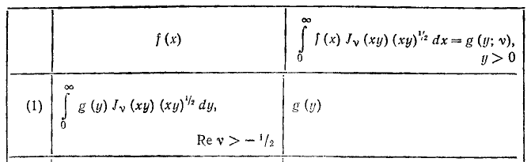

so if you think of g(y) as the projection, you recover your f(x) as shown on the left. In this case, Jν appears in both the expansion and the recovery.
For other transforms, we do have pairs, but things are not symmetric. For example, consider:

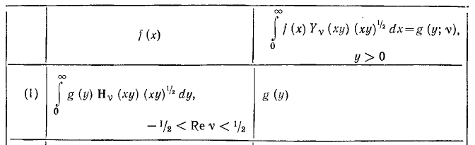

which says that the Struve H-transform is in fact the inversion of the Y-transform projection, and note also the very limited range of ν.
The inversion of the K projection is a Mellin-like recovery formula using the I function

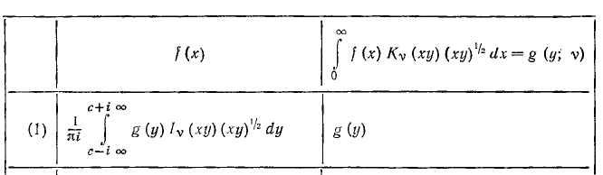

The Kix case is not symmetric, but has Kix appearing in both directions:

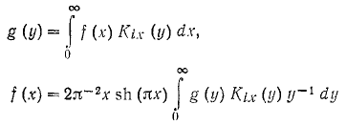

1. Possible trip to the library.

I would like to decipher my Russian version by looking at a copy of the English version. Marriott:

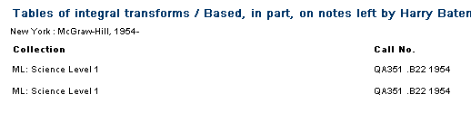
Both the checked in. I could copy at least the index, and perhaps any internal pages of text. Most pages are just tables of functions.

On this same trip, I would want to copy the Bateman errata. Naturally today it is snowing out, now that I am thinking about making this trip. I am currently converting the integral transforms book I found to DJVU so I can use it better. That is going quite fast (and is now done). I am concerned that some of these transforms are going to be relevant for my Green's function of a disk problem done in cylindricals, I would hate to be missing crucial information causing extra flailing. Also, these last two volumes have always been somewhat of a mystery to me, since I never owned them.

2. Russian to English?

I have just found an interesting review of volume II which explains a few words"

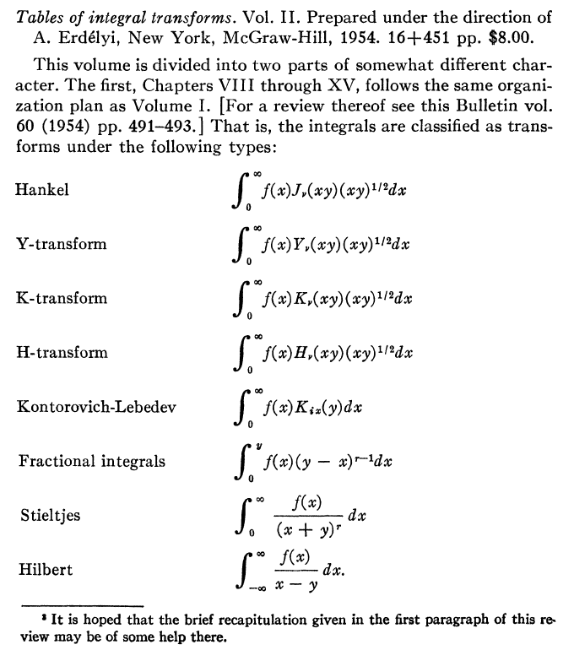
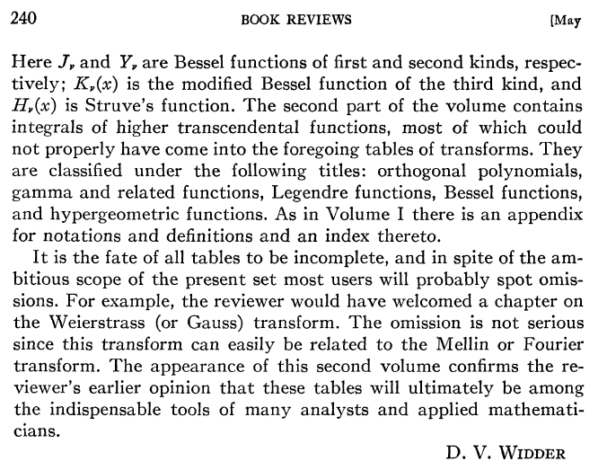

Then we also have this

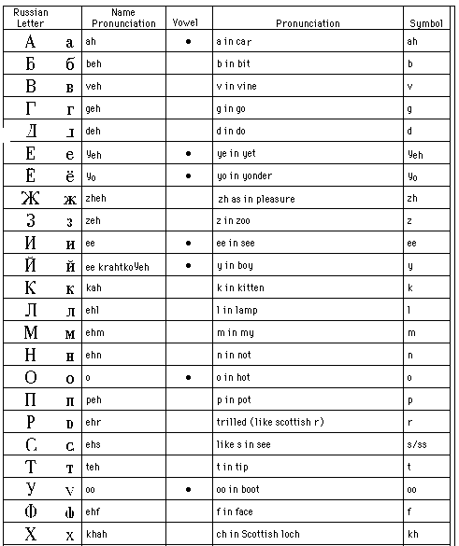

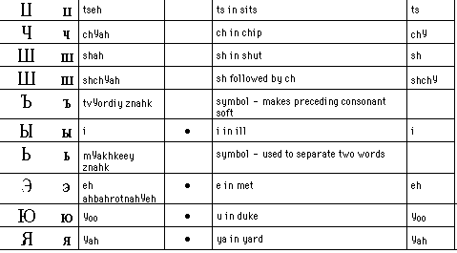

The Russian alphabet is Cyrillic and seems Greek-like, but there are many surprises.

Russian letter looks like English letter
B b or v
Γ g, as you would expect
Π p
Π with tilted left d
Π with curved left leg L (not p)
E ye or yo
backwards R ya
X with vertical var zsh
backwards 3 z
backwards N ee
backwards N with twiddle y as in boy
H n
P r
C s
Y oo
Φ f
backwards Y ch
W thing sh
bI i
b word separator
backwards ε e
IO long u

Using this simple list and the obvious letters, maybe I can translate a few math words

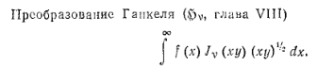

Some Russian math words:

преобразовать = transform

глава = chapter

интеграл = integral

3. Why do the transforms seem in the wrong format?

In my Jackson notes we have

Fν(μ) = $^{\int_{0}^{∞}{}}$dx xJν(μx)f(x) f(x) = $^{\int_{0}^{∞}{}}$dμ μJν(μx) Fν(μ)

What would happen if I made a redefinition like this:

Gν(μ) ≡ Fν(μ) $\sqrt{u}$

g(x) ≡ f(x) $\sqrt{x}$

Then the above would read projection and expansion would read

Gν(μ) / $\sqrt{u}$ = $^{\int_{0}^{∞}{}}$dx xJν(μx) g(x) / $\sqrt{x}$

g(x) / $\sqrt{x}$ = $^{\int_{0}^{∞}{}}$dμ μJν(μx) Gν(μ) / $\sqrt{u}$

which we can then write as

Gν(μ) = $^{\int_{0}^{∞}{}}$dx { $\sqrt{xu}$ Jν(μx) } g(x)

g(x) = $^{\int_{0}^{∞}{}}$dμ { $\sqrt{xu}$ Jν(μx) } Gν(μ)

The object in {} is completely symmetric, I guess that is the advantage.

4. Organization of this Bateman Volume II of Integral transforms:

12 Jν general rules, like scaling and multiply by a power, derivatives, some integral ops

14 Jo for certain simple functions. Here, due to the symmetrization above, we see endless x1/2 in the two columns. We can sort of ignore that and we see on the left we see a list of rational functions, then exponential ones. Basically this is like GR's organization of integrals. Bateman wants to list off all the functions you might want to compute Hankel transforms for, in this part of the table with ν = 0 only. We start seeing special functions on the left, including Legendre and other Bessel, Whittakers etc.

23 J1 for various functions.

26-82 Jν for various functions. I think they show the Russian and English page numbers! Sometimes they will just give a reference for a transform instead of the result, maybe just too messy. This is an amazing table, it just goes on and on and on! Every possible thing you can imagine in the left column. Sometimes the notation is not clear what the special function appearing on the left is. Like D2μ(ax).

83-98 New chapter. Integrating now against Yν which I presume is Jackson's Nν second kind function.

99 New chapter. Integrating against Kν now. I am beginning to think these integrals might be very useful to me in my potential theory problems. I recall integrals with Kν against messy other functions, and here is a gold mine of other functions.

119 New chapter against Hν , not clear what this function is. (bolded)

130 Now against Kix(y) instead of against Kν(xy), so quite a different world! Kontorovich-Lebedev

135 Now we are integrating against (y-x)μ-1 instead of Jν(x), this is some other kind of transform. The review above calls these "fractional integrals".

155 Next come the Stieltjes transforms against (x+y)-n . First part has n = 1.

167 Now we have n = ρ, I guess a general complex number.

173 Principle part integrals! Wow a whole pile of these things. Against 1/(x-y) of course.

188 Here we have the definition of some of our functions! And then a table of integrals against these functions, like Tn(x) and U, ultrasphere ones. Ah! Then integrals against Legendre functions. You would think these would all be in GR. Some or (0,1), most are (-1,1), This must be the orthogonal polys section.
We have integrals against gamma functions, and then associated Legendres! Then integrals of Bessel functions. Then some Sμ,ν(x) functions.

282 More definitions of functions. Here is that D thing as a special Whittaker. Then integrals of 2F1

305 More definitions of functions and symbols used in the tables I think. They are all here!

Finally there is an index!

Watson's Bessel Book: A Treatise on the Theory of Bessel Functions, 800+ pages, 1922. (2nd ed 1944)

I found this as a PDF at http://www.archive.org/details/treatiseontheory00watsuoft some 53 MB. I will bring it in and convert locally. Then I found a DJVU version here, same edition.

http://lib.org.by/info/M_Mathematics/MC_Calculus/MCsf_Special%20functions/Watson%20G.A.%20Treatise%20on%20the%20Theory%20of%20Bessel%20Functions%20%282ed.,%20CUP,%201944%29%28400dpi%29%28T%29%28799s%29.djvu#

