Comments on Vector Analysis by Gibbs and Wilson PhL 7.26.12

After much fiddling, I found a small 10 MB version of this book somewhere in PDF, did OCR and index, then made the djvu. Now I can scan it quickly. Date is 1901, so this book gives me a picture of how the leading edge people were thinking in terms of notation at the time. There is no G Rule mentioned in the book, nothing about rotating frames. They are just dealing with one frame and that is plenty of work.

Book has sections labeled eg 49.] which are referred to as Articles. These just run 1 to 162 going through the 7 chapters as was the tradition at that time. There is Contents but no Index.

The cover is an interesting screw up (probably a library temporary replacement cover made too fast).

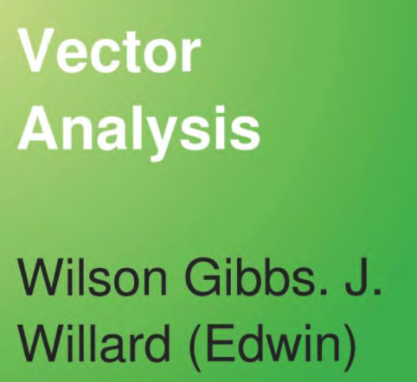

considering that the authors names are the famous J. Willard Gibbs and a student Edwin Bidwell Wilson, both at Yale, the latter who wrote the book from Gibbs notes and improved them I suspect. The notes on which this book is based are circa 1881-1884 says Gibbs, while the books publication date is 1901.
I just want to describe some basics of notation. I think this is the first book ever that uses bold letters for vectors and then uses the dot and cross ("skew") products a • b and a x b just as I use them in 2012. There is a lot of geometry with segment denotations like RS. Early on a vector is called $\overline{PP'}$with an overbar, a vector from point P to point P'. Bold letters introduced on p 4. I think PP' without an overbar denotes a full line through those points. ABC is a triangle. So I think this book is making the transition from vectors expressed as $\overline{PP'}$to those expressed as v. Year is 1901. Unit vectors are i, j, k bold but no hats. Page 48 has my little area projection theorem. Center of gravity in vectors.

[A B C] = A • B x C = A x B • C = usual other four forms. = det(A,B,C)

Notice no parens used, I would use them. Book does all the messy combinations of • and x expressions. Some classic sphere surface patch theorems. The reciprocal vectors are found just as in M&M but no volume symbol v, just write out [ a b c ] all the time. Vectors form a "reciprocal system". Forces are fi which sum to total force R. Torque is called moment and is written

MO{f} = d x f = 2 OPQ

where OPQ is the vector area of a triangle OPQ going around CCW, so the cross product is twice this area, being that of the 2-piped. This MO is the "moment" about origin O.
The letter a is used for what we always call ω. So he has

v = a x r as we have v = ω x r circular motion.

Point in a rotating rigid body has v = v0 + ω x r in usual sense.

Chapter 3 is doing derivatives with vectors. Lots of details. Then on page 136 for the first time he talks about a scalar function of space V(x,y,z). It is not called a vector field, I notice. Then we have gradient ∇ and normal n and piece dr all as I would do it now. Page 151 is upside down. On page 150 we see divergence and curl operators but the are called del dot and del cross, on page 54 we see word divergence and next page curl. This Chapter 3 ends with lots of stuff but no Laplacian yet.

Chapter 4 does integrals on vectors. Limit definition of divergence page 187. Theorems of Stokes and Gauss by those names. Triple integrals are always written ∫∫∫ and doubles as ∫∫. On page 206 you can integrate ρdV/r to get the gravitational potential, but this is written out always as

I(x1, y1, z1) = ∫∫∫ V(x2, y2, z2)/r12 dx2dy2dz2
potential ρ

but later he uses a denser notation as in I = ∫dm/r12 page 206.
Here is strange usage

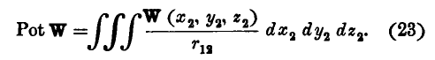

PotW = ∫W/r12 dV

which is a potential but you integral over a vector field, and then PotV for a scalar case. So Pot is just a name for this integral operator, very strange.
More strangeness to come! He has "integrating operators" Newtonian, Laplacian and Maxwellian!!

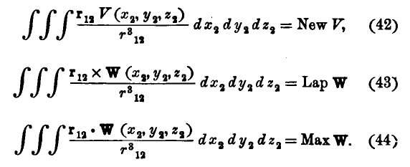

Poisson's Equation is written on page 230 as

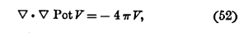

where he likes using V for charge or mass density, and then PovV is the potential that produces. The operator here is NOT called the Laplacian because he has already used up that word above! He never calls ∇•∇ anything, and he does not use ∇2.

Chapter 4 is called "linear vector functions". I think this means a linear combination of vectors. Well it is really linear algebra in the clumsy language of dyadics, before they had tensors. We are then off into the world of dyads and dyadics as in M&F and as in tensor doc. Φ is the "idemfactor" which we now write as 1 or I. All this stuff has been supplanted by ordinary matrices and vectors. It goes on and on, however. The word "tensor" does not appear, but that is what these dyads are (rank 2, matrices) . We even have this fancy thing:

[a ⊗ b]T c ⊗ d = aTc , bTd

which today would be some kind of direct product space notation. He calls it "double multiplication". And
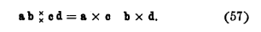
It just never caught on.

Chapter 6 on "rotations and strains" is a place to apply the dyads instead of current day matrices.

Chapter 7 is "misc". Quadric surfaces. Word ellipsoid appears. Then light in crystals. Surfaces, and then finally some wave stuff where he always writes out $\sqrt{-1}$but on page 429 it does become just i. A bivector is like a + ib, that is, a complex vector. So we are not into complex variables a bit.
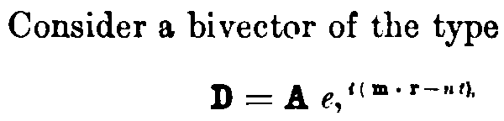

Ignore the comma, a funny place to put it in grammar. And that is it!

Aside: I just scanned Crowe's PDF on history of vectors, very interesting. Gibbs won out with this book.

