Bateman and other errata PhL 1.6.10

My little Bateman PDF gives a few errata, but then references work of H&K 1983.

The title of this paper seems to be "Table Errata". Well, I found a Beebe list of articles, and I see that these two people have done lots of work on errata.

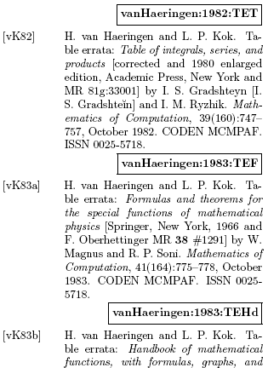
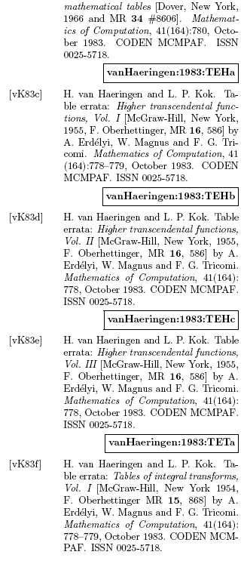
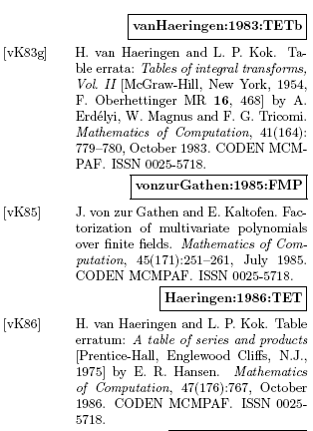

I would have to go to the library and copy all this stuff, it would perhaps be worth doing next time I go!

April 19, 2010. Bike rid to campus, Bob Cady office, we downloaded all of the above references (fewer than they appear), and only one had Bateman errata in it, which I have now added to my volumes 1 and 2 in pencil. Other volumes I have only in PDF so will have to keep these errata in mind.

