Simple Examples of Non-Square R PhL 3.26.16

I should have done examples earlier, but better late than never.

Example 1: Suppose in x-space we have a unit square centered at the origin as the domain. Take these equations:

x'1 = x1
x'2 = x2
x'3 = (R2- (x1)2-(x2)2)1/2 = height of dome at (x1,x2) =

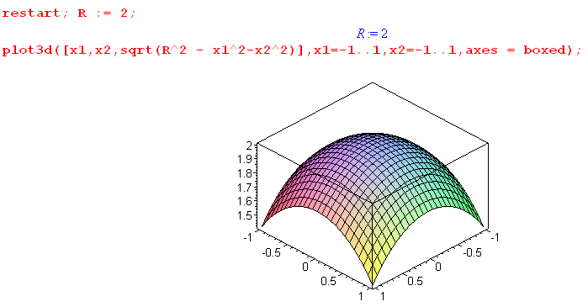

So this example maps the unit square in x-space to a spherical dome in x'-space. Now let's compute everything in sight! First

x'3 = (R2- (x1)2-(x2)2)1/2

∂jx'3 = (1/2) (R2- (x1)2-(x2)2)-1/2 * (-2xj) = - xj (R2- (x1)2-(x2)2)-1/2 = -xj/h

Rij ≡ (∂x'i/∂xj):

R11 = (∂x'1/∂x1) = 1 R12 = (∂x'1/∂x2) = 0
R21 = (∂x'2/∂x1) = 0 R22 = (∂x'2/∂x2) = 1
R31 = (∂x'3/∂x1) = - x1 (R2- (x1)2-(x2)2)-1/2 R31 = (∂x'3/∂x1) = - x2 (R2- (x1)2-(x2)2)-1/2

So

1 0
R = 0 1 = the "tall" R matrix
-x1/h -x2/h

I have this all going in Maple now.

So what do I think is the inverse equation x = F-1(x') ?

Well, try this

x1 = x'1
x2 = x'2

This seems to "exist". Then what is S?

Sij ≡ (∂xi/∂x'j)

S11 = (∂x1/∂x'1) = 1 S12 = (∂x1/∂x'2) = 0 S13 = (∂x1/∂x'2) = 0
S21 = (∂x2/∂x'1) = 0 S22 = (∂x2/∂x'2) = 1 S23 = (∂x1/∂x'2) = 0

So then

1 0 0
S = 0 1 0

There is my "non-existent" S matrix. I am able to do the derivative (∂xi/∂x'j) in the j axis direction in x'-space even though this takes me off the surface of the sphere. This is probably because my initial transformation functions are "diffeomorphic".
Recall from "inverting non-square matrices":

Theorem: If R is a "tall" matrix of full rank, then (R-1l) exists and (R-1r) does not exist.

So here is what Maple has to say:

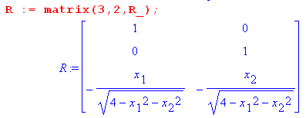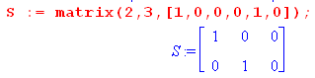

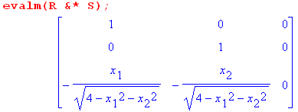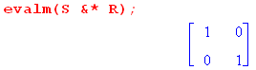

Here you see that my tall R matrix has SR = 1 so (R-1l) exists and in fact (R-1l) = S.

On the other hand, you see that with this same S and R, RS = a 3x3 matrix which is not 1. This shows only that (R-1r) ≠ S, but from the simple theory I know that there exists no S shaped matrix B so RB = 1.

Conclusions:

(1) My Section 10.6 v6 doc which claims that "S does not exist" and "anything depending on S does not exist" is completely wrong! Here we have a simple counterexample which shows that S does exist for a tall R matrix. You write out the inverse transformation, and you compute the S derivatives. Yes, the inverse transformation x = F-1(x') is defined only for x' on the sphere manifold. But we write out the detailed equations for x = F-1(x') with x' on the manifold and we find that we can differentiate those equations to get S just fine, even though derivatives take us in directions off the manifold.

(2) We compute R and compute S and we find that SR = 1 while RS ≠ 1 and this would be true for any size tall R matrix. Specifically I know that for a tall R matrix, you can find at least one left inverse if R is full rank, but you cannot find any right inverse. That is consistent with SR = 1 and RS ≠ 1/

(3) What does the chain rule have to say here?

RijSjk = (∂x'i/∂xj) (∂xj/∂x'k) = $\frac{∂x'i}{∂xj}$$\frac{∂xj}{∂x'k}$ ≠ δik RS ≠ 1

So how do I explain that "the chain rule fails in this direction? Totally new to me. How do you prove the chain rule in the first place? Bucks do a very long proof starting on page 250 for the case that you have the same number of variables on each side. It is a non-trivial proof.
Wiki suggests that the chain rule should be valid in the non-square situation as well.

But this is not really what the chain rule says! The "chain rule" is a statement about the derivative of a concatenation of two functions for example

f(x') x' = F(x) f(F(x)) = (f o F)(x)

∂fk(x')/∂xi = Σj $\frac{∂fk(x')}{∂x'j}$ $\frac{∂x'j}{∂xi}$

Now suppose you take this particular function

f(x') = x' fk(x') = x'k

Then the chain rule above says

∂x'k/∂xi = Σj $\frac{∂x'k}{∂x'j}$ $\frac{∂x'j}{∂xi}$ = $\frac{∂x'k}{∂xi}$ = a triviality, no δ is involved here

On the other hand consider

f(x) x = F-1(x') f(F-1(x')) = (f o F-1)(x')

∂fk(x)/∂x'i = Σj $\frac{∂fk(x)}{∂xj}$ $\frac{∂xj}{∂x'i}$

Now suppose you take this particular function

f(x) = x fk(x) = xk

Then the chain rule above says

∂xk/∂x'i = Σj $\frac{∂xk}{∂xj}$ $\frac{∂xj}{∂x'i}$
or
∂xk/∂x'i = $\frac{∂xk}{∂x'i}$ = a triviality, no δ is involved here.

So where am I getting the idea that you should have

$\frac{∂x'i}{∂xj}$$\frac{∂xj}{∂x'k}$ = δik

This fact does not "follow from the chain rule" in the non-square world!

Discussion of coordinate lines for this example

The inverse transformation (for points on M) was given above as

x1 = x'1
x2 = x'2

Let's now look at the "coordinate lines" in x-space generated by reverse-mapping lines of constant coordinate in x'-space. For example, if we fix x'2 and x'3 and vary only x'1, we get a horizontal line in x-space which lies at vertical position x2 = x'2. Conversely, if we fix x'1 and x'3 and vary only x'2, we get a vertical line in x-space located at position x'1.
But if we fix x'1 and x'2 and vary only x'3, the coordinate line in x-space is just a point!
So the coordinate lines exist, but they might be points instead of lines.

What are the three en vectors in x-space? From my tensor doc definition,

en ≡ Se'n.

I did these on scratch paper using the S matrix shown above and I find that

e1 = (1,0) tangent to the x'1 varying coordinate line discussed above
e2 = (0,1) tangent to the x'2 varying coordinate line discussed above
e3 = (0,0) the x'3 coordinate line is just a point, what is the tangent to a point?

Notice that the S matrix does have full rank 2. These en are the columns of matrix S just as it says in tensor doc.

So this is what happens in my simple example. What happens in a more general case?

Do some coordinate lines always become points? I need to do some more simple examples!!

Tilted plane example.

Here are my equations (the Maple plot shows a nice flat tilted plane at a weird angle).

x'1 = x1+2x2 x' = Rx
x'2 = 2x1+x2
x'3 = x1 + 3x2

To invert this, we have to solve 3 equations in 2 unknowns. In theory solution is not unique. So let's try a few methods:

Solution 1. From first two have

2x'1 = 2x1+4x2
x'2 = 2x1+x2 ⇒ 2x'1 - x'2 = 3x2 ⇒ x2 = (2x'1 - x'2)/3 = 2/3 x'1 - 1/3 x'2

Then first one says

x'1 = x1+2x2 = x1 + 2(2x'1 - x'2)/3 = x1 + 4/3 x'1 - 2/3 x'2

⇒ x'1 - 4/3 x'1 + 2/3 x'2 = x1 = -1/3 x'1 + 2/3 x'2

So my solution then is

x1 = -1/3 x'1 + 2/3 x'2
x2 = 2/3 x'1 - 1/3 x'2

This should satisfy the first two equations. The third equation then says

x'3 = x1 + 3x2 = -1/3 x'1 + 2/3 x'2 + 2 x'1 - x'2 = 5/3 x'1 - 1/3 x'2

and this then must be the equation of the tilted plane. Write as

5/3 x'1 - 1/3 x'2 - x'3 = 0

Solution 2. From the last two we have

x'2 = 2x1+x2
2x'3 = 2x1 + 6x2 ⇒ x'2 - 2x'3 = -5 x2 ⇒ x2 = - 1/5 x'2 +2/5 x'3

Now pick either of our last two equations of the triplet, such as

x'3 = x1 + 3x2 ⇒ x1 = x'3 - 3x2 = x'3 - 3[ - 1/5 x'2 +2/5 x'3] = x'3 + 3/5 x'2 - 6/5 x'3

= - 1/5 x'3 + 3/5 x'2

So my solution so far is

x1 = 3/5 x'2 - 1/5 x'3
x2 = - 1/5 x'2 +2/5 x'3

Then first equation x'2 = 2x1+x2 says

x'1 = x1+2x2 = 3/5 x'2 - 1/5 x'3 - 2/5 x'2 +4/5 x'3

= 1/5 x'2 + 3/5 x'3

which is the plane equation, write as

x'1 - 1/5 x'2 - 3/5 x'3 = 0

Multiply through by 5/3 to get

5/3 x'1 - 1/3 x'2 - x'3 = 0

and this agrees with the plane from Solution 1.

If I picked the first and third equations, I would get a third solution. But forget that, here are the two solutions I found :

Solution 1
x1 = -1/3 x'1 + 2/3 x'2
x2 = 2/3 x'1 - 1/3 x'2

S11 = -1/3 S12 = 2/3 S13 = 0
S21 = 2/3 S22 = -1/3 S23 = 0

I have Maple "examples non-squre v2" and I enter things.

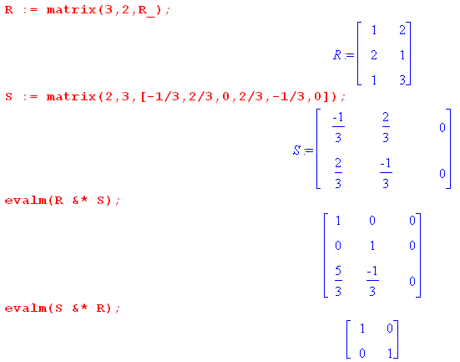

As expected, I get RS ≠ 1 and SR = 1. Now consider the second solution

Solution 2
x1 = 3/5 x'2 - 1/5 x'3
x2 = - 1/5 x'2 +2/5 x'3

S11 = 0 S12 = 3/5 S13 = -1/5
S21 = 0 S22 = -1/5 S23 = 2/5

I enter this different S matrix and get

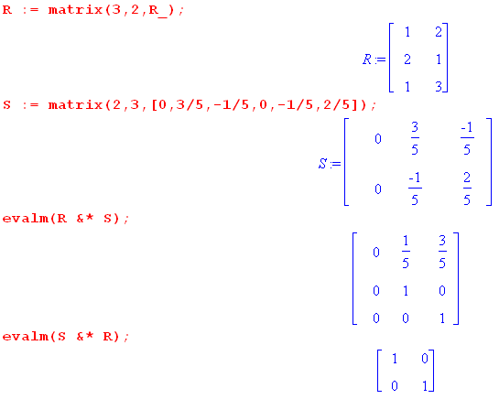

Again we get RS ≠ 1 and SR = 1, and the RS matrix is not the same as with the solution 1 S.

Comments: The new feature of this Example is there are at least two solutions for matrix S, and for the two that I found, both have RS ≠ 1 and SR = 1. The previous Example had only one solution matrix S. This problem has a third solution matrix S and it would do the same thing. We know from SR = 1 that R must have a left inverse called S, and we know that S = Dx/Dx', and any S we find will be a left inverse.

Discussion of coordinate lines for this example

x'1 = x1+2x2 x' = Rx
x'2 = 2x1+x2
x'3 = x1 + 3x2

x1 = -1/3 x'1 + 2/3 x'2 Solution 1 from first two of triplet
x2 = 2/3 x'1 - 1/3 x'2

Let's now look at the "coordinate lines" in x-space generated by reverse-mapping lines of constant coordinate in x'-space. For example,
If we fix x'2 and x'3 and vary only x'1, then both x1 and x2 vary according to the doublet. They must vary according to T2 x'2 = 2x1+x2 which gives the coordinate line as a certain line in x-space. For different fixed values of x'2 we get a family of parallel lines in x-space.
If we fix x'1 and x'3 and vary only x'2, then both x1 and x2 vary according to the doublet. They must vary according to T1 x'1 = x1+2x2 which gives the coordinate line as a certain line in x-space. For different fixed values of x'1 we get a family of parallel lines in x-space. These lines have a different slope from the previous set of lines.
If we fix x'1 and x'2 and vary only x'3, then x1 and x2 of the doublet do not vary at all, so the coordinate line is a point.

What about the en ? They are the columns of the solution 1 matrix S, so

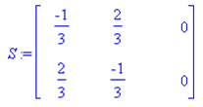

you read off the first two, and e3 = (0,0). As in our first example, when a coordinate line comes out being a point, the tangent base vector is 0. !!

What happens with +? Same triplet, but doublet is

x1 = 3/5 x'2 - 1/5 x'3
x2 = - 1/5 x'2 +2/5 x'3

In this case we get lines if we vary either x'2 or x'3, holding others constant. But if we vary x'1 we get a point for the coordinate. Line. The S matrix is then

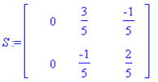

In this case we get e1 = 0 which matches the fact that varying x'1 must has a point for the coordinate line.

So look at this general idea

en = ∂x/∂xn'

It seems that you are going have three tangent base vectors, but one of the coordinate lines degenerates to a point and its corresponding tangent base vector is null. So the good news is that you end up with two reasonable tangent base vectors in x-space.

I am not sure what the general case would be. My second example really covers all the linear cases.

