Inverting non-square matrices v 2 PhL 3.3.16

I think my original document is very incomplete and I need to go read about this topic in some good exposition.
My matrix binder deals only with square matrices!!!
What books do I already have? Well, I am pretty sure that no physical book I have talks about this subject! It is really a Linear Algebra topic and I have no physical books on LA.
What about pdf books in stock? I have a LA section both in math and in mathdownloads. In the first I have

Toomas: (188 pages) (no TOC, no index, yes OCR). I see nothing paging through on non-square.

Matthews: only PDF chunks, does not seem useful

Allen: Separate PDF's for chapters. TOC does not seem to show what I want.

In the downloads area I have

Allen all in one: nada

Beezer: mentions left and right inverses only in a few places, no go

Hefferon: talks about left inverses of maps, but I don't really see what I want in notation I want.

Horn: nada

Schaum: nada on left inverse

Only Shilov has anything!

Shilov: he does have some stuff. For example on page 97

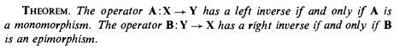

Now you have to go look up those words:

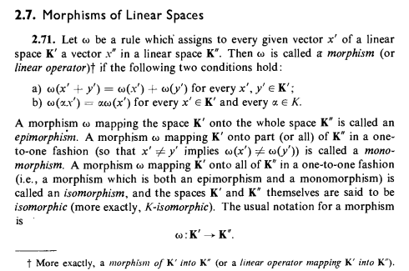

I would say that morphism = linear operator, find. I think epimorphism means onto and also surjection, confirmed by web. Now monomorphism means 1-to-1 between K' and part or all of K" as range. If all of K" is involved you have an isomorphism. Fine! So he is saying above

In AX = Y, A has a left inverse iff this is 1-to-1 between domain and range. Very reasonable. It is then just the obvious "inverse mapping".
In BY = X suppose B is onto. Then for every X in the entire range space there must some Y in the domain. Not sure why this is called a right inverse. I would need a left inverse to write Y = B-1X.

As usual in Shilov, there is no proof, you are referred to a scattered tree of past results. I started into this below but then gave up parsing. It is the above result that I really wanted to see.

******************************************************************************

So there you are, a well stated theorem, something I wanted to see. I think the proof is on page 94. Let's see if I can follow it, clip at a time. First we need this definition

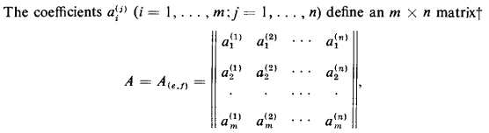

so for me this says

Aij = ai(j) Now we start:

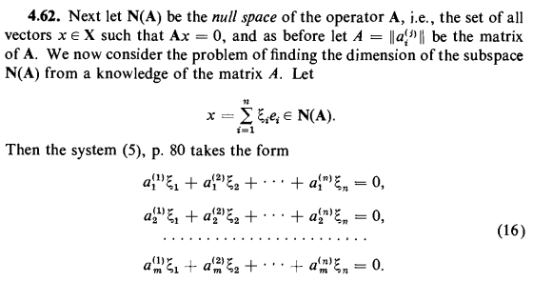

OK, he is going to focus on the nullspace of A, and for some strange reason he writes Aij as ai(j), fine. The nullspace means Ax = 0 which then means

A [ Σiξiei] = 0 ⇒ Σiξi Aei = 0 ⇒ Σiξi [Aei]k = 0

⇒ Σiξi Σs Aks (ei)s = 0 ⇒ Σs Σiξi Aks δi,s = 0

⇒ Σs ξs Aks = 0
Write this out to get

k = 1 ξ1A11 + ξ2A12 +... = 0
k = 2 ξ1A21 + ξ2A22 + ... = 0

which I rewrite as

k = 1 a1(1)ξ1 + a1(2)ξ2 +... = 0
k = 2 a2(1)ξ1 + a2(2)ξ2 + ... = 0

So I agree with (16) above. This involves the coefficients ξi and assumes (ei)s = δi,s so this is a certain standard basis I use but here not in covariant notation. The equations involve matrix elements of A and the coefficients. All just fine, so go for the next clip:

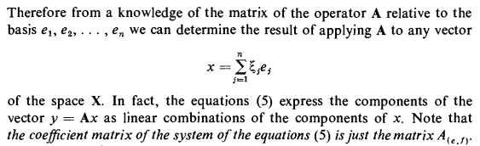

This does not seem to add anything new, just a restatement of what we just did. Continue,

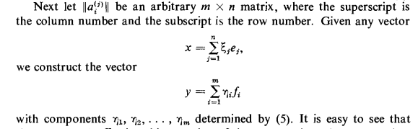

But what are the fi here? Have to go back. Our context is A: X → Y where X and Y are spaces of different dimension if A is non-square. Back up:

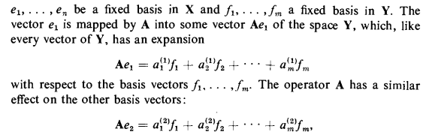

OK, so in our clip above we have Ax = y where x is in x-space of dimension n and basis ei and where y is in y-space of dimension m and basis fi. So the above expansions of x and y are fine by me and we can continue to another clip:

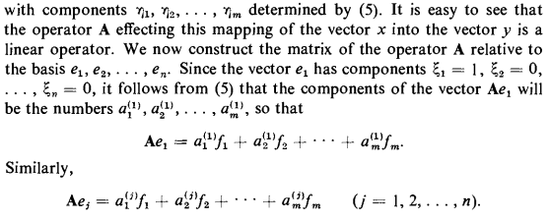

OK, here he confirms my understanding of his basis vectors ei But then what he next says seems illogical to me. I agree that e1 = (1,0,0...) as he says. Now here is equation (5) for y = Ax

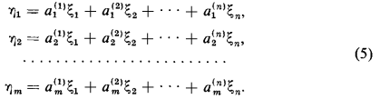

where ηi are the components of y in its appropriate space. So for e1 we get

η1 = a1(1)
η2 = a2(1) etc

so then I agree

Ae1 = η1f1 + η2f2 + .... = a1(1)f1 + a2(1)f2 + ....

so I agree with the first of his equations, and the generalization seems obvious as his last line above. Now on to the next clip:

