M&F on ODEs PhL 12.17.09

I am pretty hot on ODE's right now, so maybe today is a good time to scan MF and see what little gems it might have to add. Chap 5 is on ODE's. I have already read much of Section 5.1 on separable coordinates, so let's start there to get up to speed, then get on to the ODE section 5.2,

Section 5.1 (tail end only, since this material is needed as background for Section 5.2)

M&F are not going to talk here about ODE's in general. They are interested in a specific ODE (Helmholtz which includes Laplace if k1= 0), and they are interested in this specific ODE in the various separable coordinate systems. So this is a very different slant than we had in W&W or Stakgold, and one that is close to what I am interested in right now with Smythe and the Q functions and completeness.

Some background is needed before we can get rolling here. I have not studied the Stackel determinant theory, but I know what it is about. In 3D space, if you write the Helmholtz equation out in some weird curvilinear coordinates, and assume ψ = X1X2X3 as your separated form, you get equations of this type as the "separated equations"

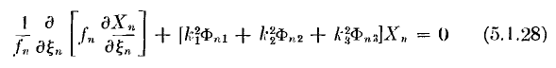

where the fn(ξn) are certain functions related to the coordinates chosen, where ξn are the three coordinates, and where the functions Φnj(ξn) are certain other functions that just arise from doing the separation. Elsewhere he shows what these f and Φ functions are for various coordinate systems. The Φij functions are the elements of the "Stackel matrix" whose determinant S plays a key role in the theory of separation, but we don't need to learn that theory right now. The constant k12 is the Helmholtz constant, while the other two ki are the "separation constants". We also have certain Mi objects,

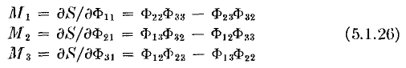

and if we process our first equation above, we get ( S = det(Φij) )

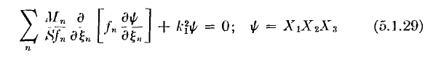

and we want the thing on the left to be ∇2ψ written out in the usual curvilinear way,
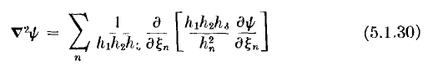

But this can only be realized in certain coordinate systems, and this is the discussion on pages 509-510 which I am skipping for now. It is the conditions that make the above identification true which causes only the famous 11 systems to be "separable". The hi are of course the scale factor functions.
Now comes some important stuff: [ p 515 ]

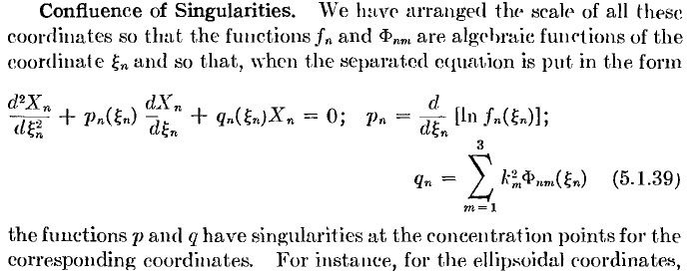

He is now casting each separated ODE into the canonical form with the famous p and q functions! And we see exactly the general form these functions have for our specific ODE in some curvilinear coordinates! His phrase "concentration points" refers to places which are limits of the curvilinear coordinates of interest. Recall for ellipsoidals that 0 ≤ ξ3≤ b ≤ ξ2 ≤ a ≤ ξ1 ≤ ∞ so we expect that maybe the p and q functions will be singular at perhaps 0,b,a,∞. They continue,

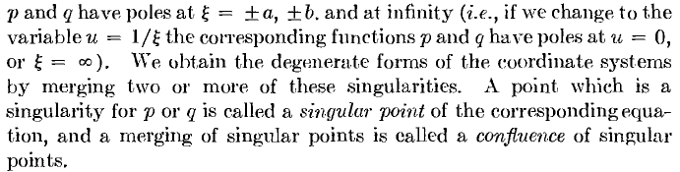

So NOW I finally think I understand what is going on here. In W&W we saw that generalized Lamé equation with its 5 regular singular points, and we did various confluences to get other families of equations. That same concept is going to be operative here. Maybe the ellipsoidal most general coordinates will give that same generalized Lamé equation, or something like it! Continue:

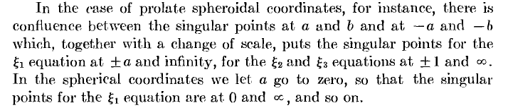

I think I get the point. I won't keep quoting text, but M&F are making a lot of sense, and they say that yes, the ellipsoidal equation does have those 5 singular points, but they are just commenting. [ p 516 ]
They also comment that when a coordinate is a simple azimuth, two of the three related Φij vanish,

[ p 517 ] If we start out blindly and work toward separation, we get this situation with just slight processing of the Helmholtz,
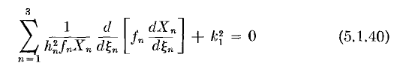

They are pointing out that separability depends on the nature of the hi functions -- what variables they are functions of. They now want to consider some general cases. Recall that you are trying to get an isolated term in the above sum that involves only one coordinate, then you can set that term to a separation constant.
In Case A, he assumes that two of the three coordinates fall out that way at once and their separation constants are then k22 and k32 and he assumes these are generic coordinates ξ2 and ξ3. He then states the remaining third equation, and how the separated functions depend on the constants:

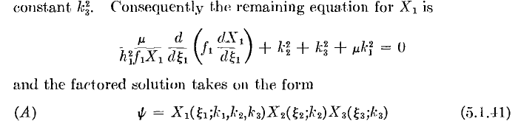

The obvious nice feature here is that X2 and X3 each depend only on one constant. Obviously, this is the case you would like to have, and it is the simplest case. Sadly, only the Cartesian and cylindrical coordinate systems work this way. [ for Cartesian, those constants are integers which set ψ = 0 on the box walls ? For cylindrical the z constant is such an integer, while azimuth has its usual m; ] Now on to the next case:

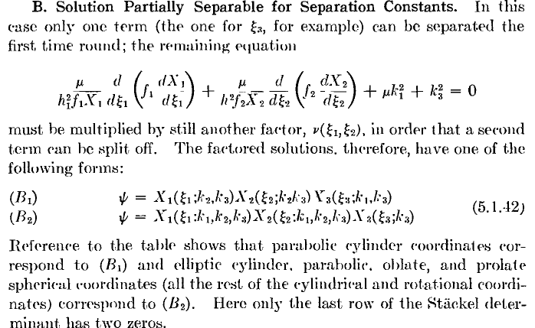

The main point is to notice how the constants k2 and k3 are distributed into the three Xi functions. And he treats k1 as being of interest at the same time, even though it is not a separation constant. They are smart I think to be handling Helmholtz throughout! Continuing:

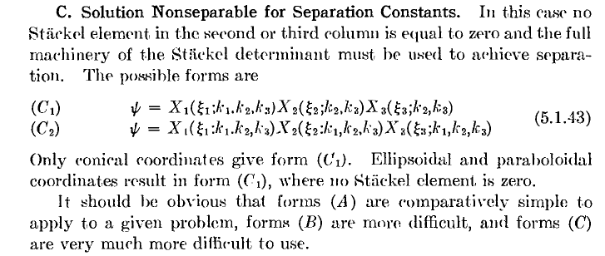

So this is the ugliest case where all the ki appear everywhere as in the C2 case.
MF then ask if perhaps there are not more separable systems for Laplace than for Helmholtz? The answer is a modified yes, and this involves a certain "modification factor" and a variation in the Stackel theory. I skip this detail for now.

[ p 520-523] My interest has been in the quadric surface type coordinate systems, but there are fancier systems known as confocal cyclides which are quartic (4th order) instead of quadric (2nd order). This cyclides discussion goes on through p 523, and I skip it for now. MF want to be encyclopedic in their work, and I praise them for that. Some day I will be back for these details and I can add them right here.

Section 5.2 general properties of ODEs and their series solutions"

Now to the main act. Here is our starting point:

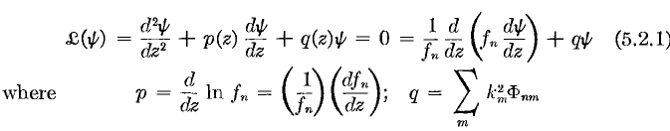

They comment that the p and q functions have only "poles". They have not used the terms regular or irregular yet, but if the poles are "right", we know we can have some regular points here.
We have some text hinting at linear operators and dimensions of nullspace and such, all in very soft terms.

p 524: The Wronskian. This thing is defined it seems for the first time to the reader in this book. They show how, if you start with one solution, you can "build out" a second one where the Wronskian of the two does not vanish, and in this way they construct a "second solution", given a "first solution". This discussion of course relates to my general question of "how do you know there are n independent solutions to an nth order ODE?". So fine. By the way, in this discussion I think they have developed Abel's Theorem, all of which is more clearly presented in Stakgold. MF refer to the Wronskian as Δ(u,v), not W(u,v) which is the Stak notation.

p 525: Independent Solutions.

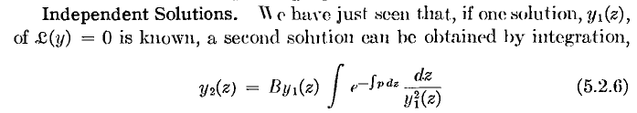

This is a famous result where you see the second solution as a multiple of the first, and it involves an integral of the first squared in the bottom, and the exponentiated but first integrated p(z) function in the top. The notation here is a little vague, but that is OK. Later they use this to get second kind solutions from first kind ones. Note that often the integral fzctor will cancel out the leading y1(z) factor, so the result is not really a "multiple" of y1(z). I don't think this little gem appears in Stakgold. I wonder if it has a name associated with it? They go on to show that y1 and y2 is all there is, there cannot be some third independent solution. They talk about these two independent functions as spanning a "plane", meaning a 2D space. For me, we have L2 as an infinite dimensional Hilbert Space, and we have our ODE as Lu=0 and the dimension of the nullspace is 2. So only a very tiny set of functions solves the ODE compared to the size of L2. They note that a nth order linear differential operator L would have nullspace of dimension n.

p 526: Integration Factors and Adjoint Equations. Some excellent text here! The point is made that doing an integral (by looking up in tables) is earlier than solving an ODE, so maybe we can convert an ODE into "looking up an integral". Even if the integral cannot be done, it would be nice to have the solution of the ODE as some integrals which could at least be treated by expansion or numerically.

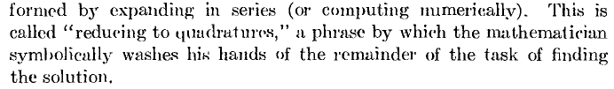

Here then is the notion of an "integration factor", something I have not heard of in a long time:

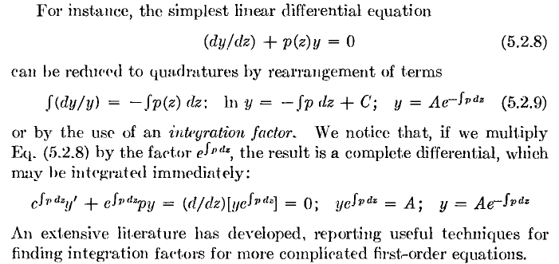

So here, using an integration factor, we have our solution written "as an integral". Notice how that p function likes to end up in the position shown, we saw it earlier in our "second solution" stuff. Maybe we can't do the integral in the exponent, but we have an answer, we are reduced to "quadratures", a word which means integrals. [OED quadrature: the expression of an area bounded by a curve, esp. a circle, by means of an equivalent square. More widely, the calculation of the area bounded by, or lying under, a curve.]
Now, before getting into the 2nd order ODE version of "integration factors", let's digress to Stakgold page 40 in his PDE chapter 5 where we have

vLu - uL*v = div J(u,v)

and its integral form where J is seen to be a Green's boundary surface current. I invested a lot of effort into understanding this idea (see "parts and greens.doc") where I realized this is just an expression of generalized parts integration, and the J you get is not unique. Stak did not give J a name, I called it a surface current, and he does point out that it is "bilinear" in u and v. I show it is bilinear just from the parts integration basics. I don't know if Stak has this in Volume 1. He has something dimly like it on page 269 where he does not use the adjoint symbol on L, and where the J current seems to be the product of the p function and the Wronskian of u and v.
Now, what do we get if we apply this PDE result to a 1D ODE? We get this:

vLu - uL*v = d/dz J(u,v)

which MF represent in this way

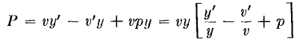

So their solutions are v and y, not u and v, and their "current" is P, not J. And MF now have a name for this thing: the "bilinear concomitant", which name I remember very dimly from ages past. Notice that I have quoted the form of L* above, the formal adjoint. L* does not look any simpler than L, really.

L(u) = u" + p u' + q u.

So how does this help us solve our ODE Lu=0 ? "Suppose", they say, that for some reason L*v=0 is easy to solve for v. Then 5.2.10 above says vLy = dP/dz. If you could solve P(v,y) = constant for y, given your known v, then that y would solve Ly = 0, the thing you really want to solve. Here then is how this works:

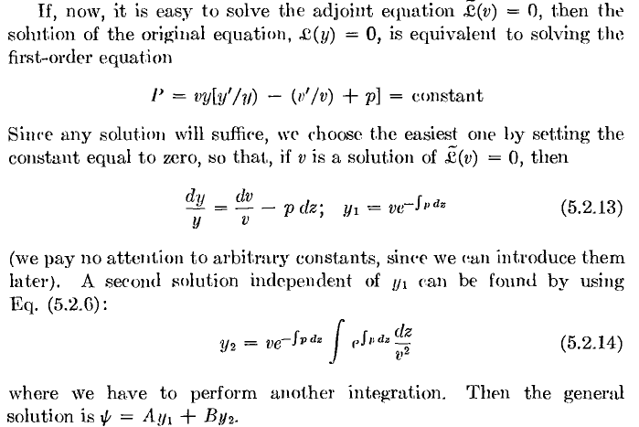

So fine, IF L*v=0 can be solved for v, we have our two solutions to Ly = 0 in "reduced to quadratures" form. Now we yet again get that exp(±∫p(z)dz) structure appearing. The second equation above is just our usual (by now) "second solution" finder. I guess I would like to see an example where Ly=0 is hard to solve, but L*v = 0 is easy to solve. Well this is their next little effort:

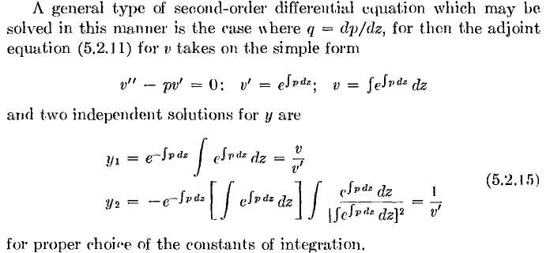

On scratch I have verified all these results. The very last one involves ∫v' dz / v2 = ∫ ∂z(v-1) = 1/v. Of course I don't know how common it is to have q = p' to get this special case. Well, they go on to claim that this does in fact exactly happen "in certain coordinate" systems, I will skip the details.

[p 529] Solution of inhomogeneous equation. In this section, whose details I skip, MF show how you can solve the inhomo equation Lψ = r (where r is the driving function). The solution is this

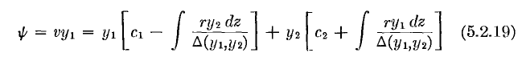

where y1 and y2 are our homo solutions and Δ is the Wronskian. There are four terms shown, and obviously two of them are the homo solution, so the two terms with integrals are the particular solution, and he writes this out in the following more compact form

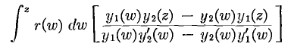

This seems a bit new to me. In one sense, you would think that the square bracket thing was a Green's function and we are just saying that ψ(z) = ∫dw r(w) g(w|z), but it is not obvious to me that this fits with any of the "forms" I saw in Stak Chapter 4. Well go to Stak p 272 where you see W = C/p and where you also see g = - w z/C = -wz / [ pW] where w and z are homo solutions for the appropriate "sides". I might then rename things and say g = - y1 y2 / p Δ and we are then pretty close, but where is his p ? Also, he has a Volterra type endpoint which I know changes things a bit, so w ≤ z always in his case. He gets p to go away in his processing. I can only conclude that this is some kind of "Volterra Green's Function" approach. Just something to keep in mind, another way to solve the inhomo equation !

[ p 530] Series solutions about ordinary points. Now we are where I want to be, reviewing familiar ground to see if "new gems" somehow appear in the MF presentation. Well, their approach is quite different, and I will try to just quote results.

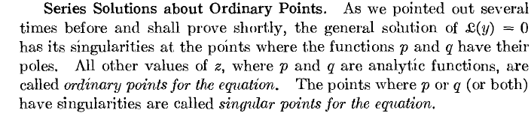

Notice the phrase "general solution" which I guess means a lincom of the two independent solutions. The first point here is that the solutions of Ly=0 will never have singularities at a point where p and q are analytic, and that seems reasonable to me. If the solutions have singularities, they will be at places where p and q are singular. Note also that they talk about p and q having "poles". It is not clear to me whey p and q could not have other singularities. [ They could, but this always leads to solutions with essential singularities which are pretty ugly, I think that is the point. ]
Next, MF expand everything around some point z=a and get the recursion stuff, but they then write the solutions as follows,
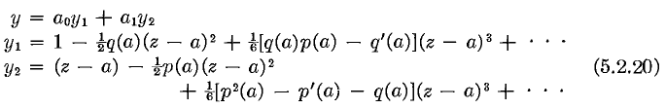

[ Note: when I first saw the above result, I was quite confused. But then I updated my ODE meta notes to include a solution at an ordinary point, and the above just falls out, the exponents are r = 0 and 1, etc. So this was a good benefit of reading MF, to get this little matter cleared up. ]

To recap: we assume everything is analytic, so we are at an ordinary point. We expand everything. We stumble in this way into series for what appear to be the two independent solutions. These solutions have a name in fact, called the basic set of solutions at the ordinary point z = a. Notice these facts:

y1(a) = 1 y1'(a) = 0
y2(a) = 0 y2'(a) = 1

Then consider y = Ay1 + By2. We then have y(0) = A and y'(0) = B. So this set is very useful if you want to have "initial" BC's like this. Can write

y(z) = y(a) y1(z) + y'(a) y2(z)

as your solution at an ordinary point z = a with initial BC's there. This is new to me (and now in meta).

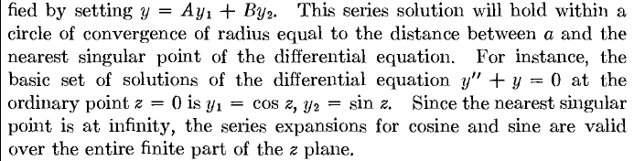

An impressive result. Now they start looking into pole situations for p and q. First an observation, where the word "pole" on the first line means a pole of any finite order,

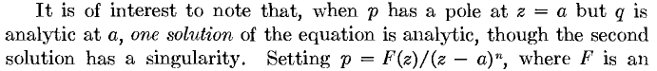

They go on to show that if p has a pole of order n, as shown above, then a1 thru an = 0 so one of your solutions is killed off. You still have your a0 solution which is y1-like, but now the terms are all different because we have thrown in this pole thing so we now have F-dependent stuff. As an example, they set n = 2 and then write out the series for y1 and it is just a series. In order to obtain another independent solution, we do the usual 5.2.6 "trick" (see above quoted), and he shows that this solution has an "essential singularity". This was defined back on page 380 (unread by me).

Digression: In that section, MF first talk about Taylor series with positive only powers. The Laurent series can be infinite in both positive and negative powers. If, when you expand a function near a singularity of interest, you find that the Laurent series has an infinite number of negative powers, then this singularity is "stronger than a pole of any order", you might say, and this is exactly what the essential singularity is. The simple example is that e1/z has such a problem at z = 0. We sort of know this blows up worse than any order pole. If f(z) has an ES at z=a, then 1/f also has an ES at z=a. They quote the famous fact that near an ES, f(z) takes all possible values.
By the way, earlier on page 481 MS state that poles (of any finite order) and essential singularities are isolated singularities, which means there is no branch cut to them and you can put a contour around the singularity (as they just did above). The Branch Point is NOT an isolated singularity and if you go around it, you don't get back where you started.

[ p 532 ] So when we have an n=2 pole in p(z), we get a nice analytic y1(z) solution near z = a, but the other solution has an essential singularity at z = a. In this case z = a is called an irregular singularity. If we only have an n = 1 pole in p(z), be instead get a branch cut in the y2 second solution, and this is going to be called an example of a being a regular singular point.

Singular points, Indicial Equation. Here is a nice summary to this point: (again, "pole" means a pole of some finite order)

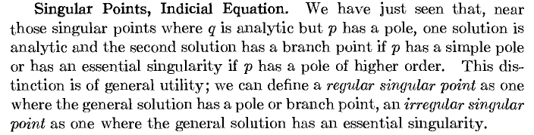

Then we go on (ignore the details of what J is). He is asking how "bad" p and q can be where you avoid the essential singularity problem so that z = a is a regular singular point. He arrives at the classical conclusion, but I must admit is new to me: if things are worse than the pole situation shown, that does mean P and Q are not analytic, and that in fact causes one of the two solutions to have an essential singularity! I did not know that. The first solution remains analytic it seems in all cases ??? I don't think that is true, since both exponents could be fractional, so both have branch cuts. Hold on that for now:

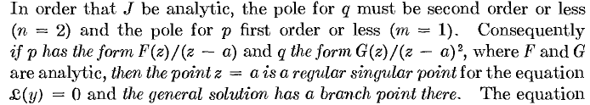

[ p 533] MF then go on to the usual discussion of the indicial equation, the two exponents they call s1 and s2, and then they treat the usual special cases of equal or differ by integer.

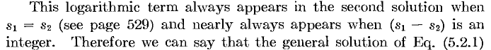

Now here is more new information:

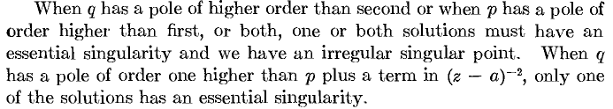

They give a proof of this which I did not trace. They then claim that not all essential singularities are the same, some are "worse" than others. We finally see the word species appear :

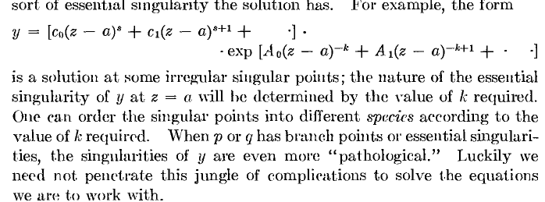

So our example e1/z would have k = 1 and perhaps be "first species". I don't know if this species word is the same word which appears in the Lamé discussion. Allowing functions p or q to themselves have essential singularities (or even just branch points) does really sound horrible!

[ p 534 ] Classification of Equations, Standard Forms. This is all just what I want. We open here with an excellent paragraph:

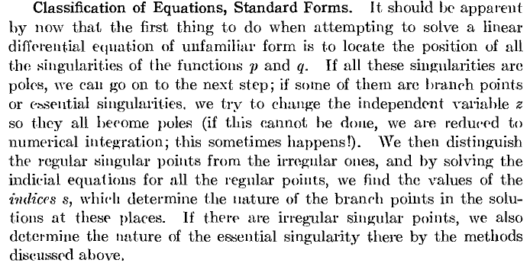

I like the part about changing variable to try to get things more regular. They call things indices and not exponents. They then deal with the z = ∞ singularity situation, where W&W just gave a result . Here is the MF analysis:

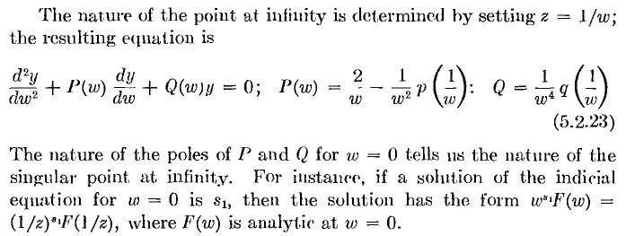

And here is a pretty important thing to note:

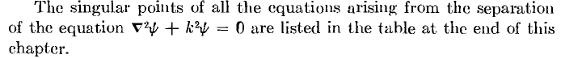

Now the next piece of advice seems pretty sound:

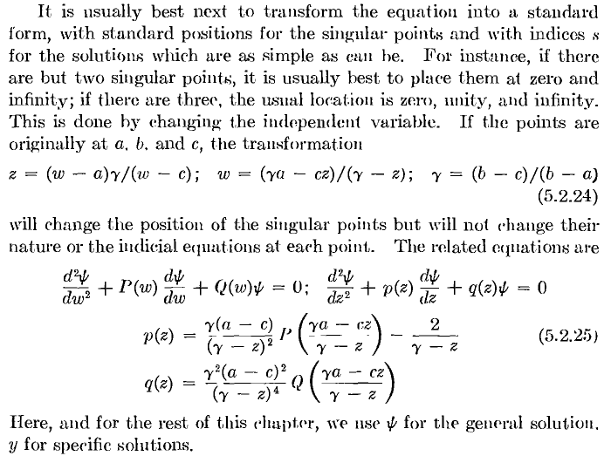

So in other words, if you have three singular points at a,b,c in your z-world, shift to the w-world as shown. I imagine these are the usual Riemann P equation ideas. They go on:

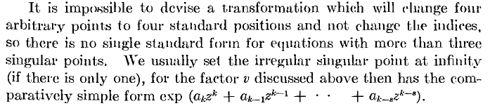

This chapter is a gold mine of important comments!

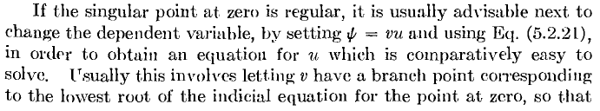
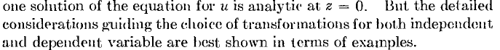

Above they say "change variable", but I think they mean to change the "functional form". I have certainly seen many examples of such form changes.
They now propose to consider ODEs with 1,2,3,4.... singular points, building up from the simple to the more complicated.

N =1: I don't follow this little discussion, let's just move on to the next case:

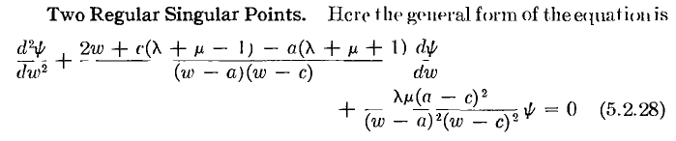

OK, the points in question are a and c. Recall from now on, they said, we have P(w), Q(w), ψ(w) etc. I am not sure I would have done that notational change. The general form here is carefully tuned to make w = ∞ be an ordinary point! Let's read through the treatment of this example:

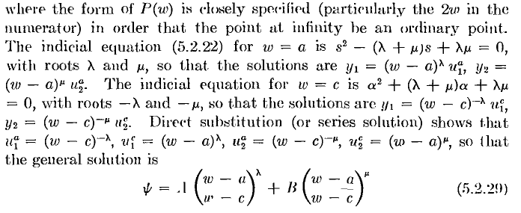

I have several comments. First, somehow the exponents are λ and μ for a, and -λ and -μ at c. I guess his form shown does this, but in general you would expect exponents α and β at c, and somehow they are able to move these to "standard positions", nothing said about that. Second. u1a(w) is the power series part of the solution, and they separate off the possible branch cut factor. WW did not do this separation. It is OK, no problem. This problem is simple enough that one can just write down the solution as shown (I wonder why the photocopy loses the horizontal lines so completely in the two ratios shown? )
They then show how you could move the points a,c to 0,∞ and everything gets simpler. No quote.
And finally, if λ = μ, we get a log appearing, as expected. So much for two regular points. All solutions are "elementary functions".

[ p 537: ]
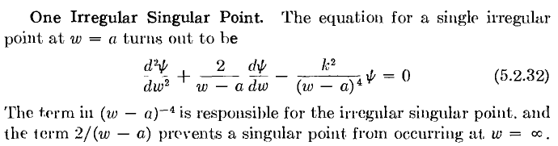

When they say "the equation", they must mean this is "the simplest form" and any other equation you might have with one irregular singular point can somehow be jockeyed into this standard simple form. The point is of course at w=a and is "induced" by too high a pole in the q function. I wonder why a third order pole would not have been adequate? Again, this thing is tuned so that w=∞ is ordinary (factors of 2 often are required to do this, I see). So [ recall these expos are the essential singularity poster children]

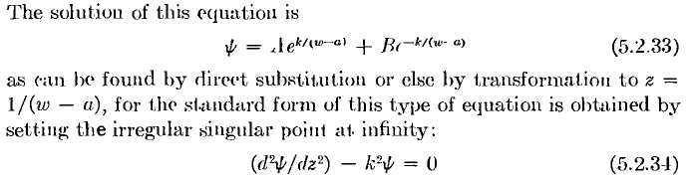

The solutions are then just e±kz which means z=∞ is now where the exponent blows up instead of w=a. Very good. We continue:

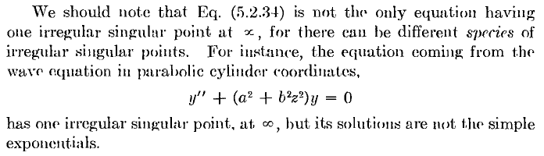

where the word species mentioned a bit above comes back. At this point they do a little confluence example letting the c→a and letting the exponents get infinite, a very strange limit. A nice addition, but I will ignore it.

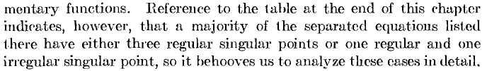

[ p 538] MF go on to explicitly (with full explanation and derivation) derive the most general form of the equation with three regular points at a,b,c. This is of course the same Papperitz or Riemann P equation quoted in WW.

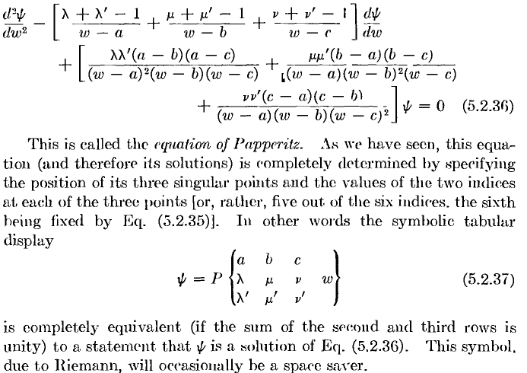

MF then go on to consider series expansions at each of the three singular points. At each point, you end up with a triple recursion relation, as I well know. It is not very pleasant. You can regard such a recursion relation as a second order difference equation, and so we have basically replaced our 2nd order ODE with continuous variable w with an infinite set of difference equations with integer index n, a kind of transform we have seen many times. How here are some ideas of what to do next:

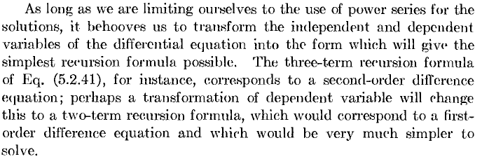

[ p 541 ] This leads directly to the hypergeometric equation. We have already assumed in the above that our singular points a,b,c and going to be at 0,1,∞ which is where they are in the HG equation. With lots of words, they do some transformations to clear out some of the exponents (they claim you can alter the differences, but not the sums). They don't quote the full blown transformations that we have in Bateman or WW. When the dust settles, we this situation:

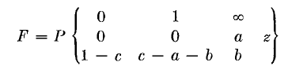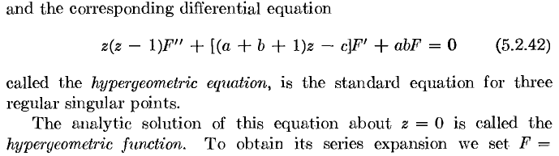

Notice that we have managed to get one exponent at z = 0 and one at z = 1 to be 0, so one solution will always be analytic, no branch cut, no muss no fuss. That solution at z = 0 is "F". This situation gives a simple two-term recursion relation ( I am not clear on what knocks out the third term, but I know you just do it and that is how it comes out). We can solve the recursion formula, and out pops our old friend,

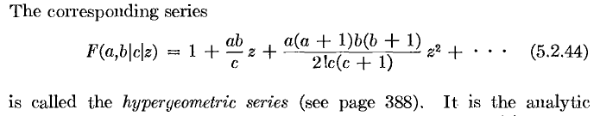

where now we have a "vertical bar" notation I have never seen used before. Now we know that the "other" solution at z=0 has exponent 1-c, so he "tries" a solution of the form z1-cF2 and then writes out the ODE for F2 and low and behold, it has the same HG form, so we can read off its solution. So here then is the full solution expanded at z = 0:

They then shuffle things and end up with the general solution of the full Papperitz at w = a as 5.2.46 which is this:

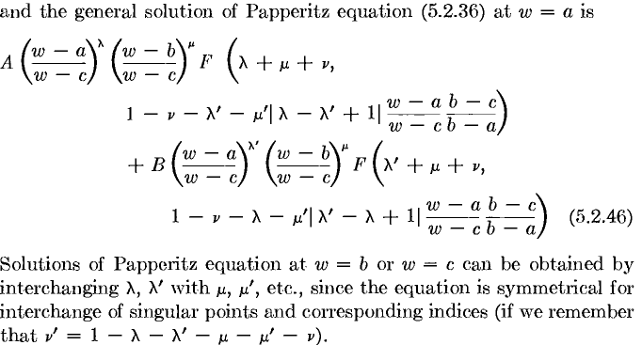

Notice the sort of "characteristic form" of the solution above (expansion at w = a): out front we have certain w-wi ratios raised to powers which are some of the exponents, and then we have the analytic F functions/series of the same weird argument which is a scaled w-a. Recall from above that we might "think of" the above solution in this notation

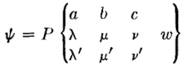

If I were fiddling with this, I would try for a more "cyclic looking" notation.
So, if someone hands you a Papperitz matrix, you can at once write down the general solution as above if you want an expansion about w=a, and similarly for w = b or w = c.

PL Question: What to you do if, say, c = ∞ in the above Papperitz solution? There is a rule here which I remember from somewhere but I cannot find it right now. The rule is this (which rule of course could be derived with some effort by me) If you have a linear factor like w-c and c = ∞, you just replace that factor by a 1. This rule makes both the Chubby and Legendre stuff come out right below. It does seem odd that the encyclopedic M&F don't mention this rule.

[ p 543] He then points out that if |1-c| is an integer, one of the terms above diverges, and this is nothing more than the case of exponents different by an integer, which we already know requires special treatment. Picking such a singular point, one of the above terms is OK, then we have to get "the other solution" using our usual second kind "trick" (they use this a lot!). Using symbols that look very much like those of WW, the second solution then looks like this ( c = positive integer, so second term above is divergent).
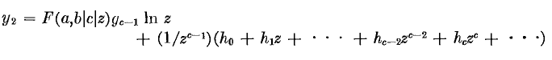

Recall those hn from WW and that unusual g factor that might be zero in certain cases, killing off the log term.

[ p 544] Functions Expressible as HG Series. They first show some very elementary functions that can be written as HG functions,

and then they start into those separated curvilinear Helmholtz equations1 For certain cases I am not interested in right now, you get the fat functions (Chebychev written in Russian by them) which of course have the corresponding fat polynomials -- as I like to call them -- they're chubby. Then he comes to something more interesting to me. In sphericals and spheroidal-Laplace we get a Legendre equation which they write in this interesting way, (for Laplace, so k1 = 0)

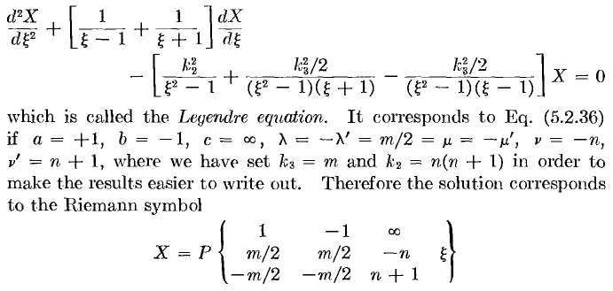
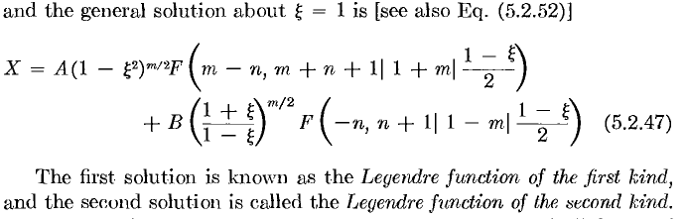

Verify the Rule for Legendre. Let me explicitly verify my little "rule" claimed above. First, here is the general Papperitz solution:
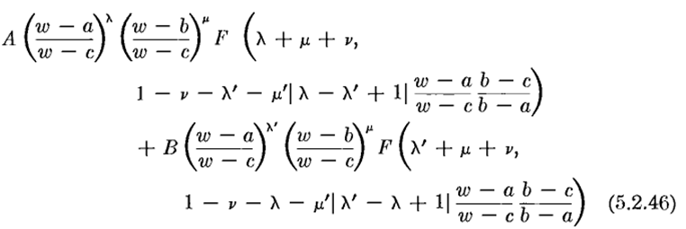

and we want to set in the values (and w = ξ)

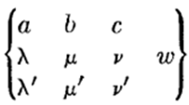= 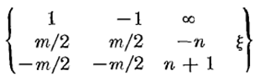

We then have (setting c factors to 1)

A (w – 1)m/2 (w + 1)m/2 F(m/2 + m/2 - n, 1 - (-n) - (-m/2) - (-m/2) | m+1 | (w-1)/(-1-1) )

+ B (w – 1)-m/2 (w+1)m/2 F(-m/2 + m/2 - n, 1 - (-n)-m/2 +m/2 | -m+1|((w-1)/(-1-1) )

= A (w2 – 1)m/2 F(m-n, 1+n+m | m+1 | (1-w)/2 )

+ B [(w+1)/(w-1)]m/2 F(-n, 1+n | 1-m | (1-w)/2 )

and we can compare this to the MF result
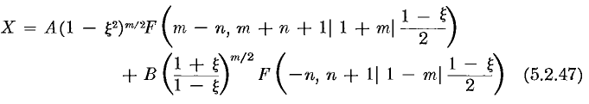

The only difference is a factor (-1)m/2 phase in the first term. Since A and B are general constants, this is irrelevant. I have therefore shown that if you take the Papperitz general solution, you should set linear factors to 1 if the constant is infinite. As I said, I read this somewhere but cannot find it today.

Now one comment on the above Legendre form. These two series are expansions at the ξ=1 singular point, so you see (1-ξ)m/2 out in front for the first solution, and (1-ξ)-m/2 for the second, where these are the exponents in the first column of the matrix for this singular point.

Main Point: The Legendre equation is just a special case of the general Papperitz equation with certain values of the singular points (1,-1,∞) and certain values of the exponents.

MF's comments about first and second kind seem wrong. If you look at Bateman p 122 you see that in fact the second term above (the one with the B) is in fact proportional to Pnm(ξ) which is the first kind function. Moreover, the first term is not the corresponding Q function, but is some combination of P and Q. Here are their comments which I think are wrong:

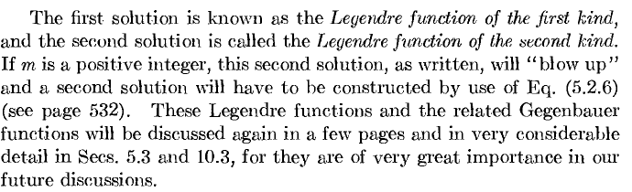

Maybe this error snuck in because they are going to do most of their "work" with the more general Gebenbauers.

[ p 545 ] Analytic Continuation of the HG Series. Their first exercise here is to write the z=0 HF function as a linear combination of the z=1 expansions which we already know. In other words, they first establish that the "general solution" at z = 1 (using the various exponents) is this:

Then if we set this equal to F(a,b,c,z), there must be some A and B that "work", since there are after all only two possible independent solutions. They call A and B by names α and β and then solve for α and β by looking close to the point z = 1. Their result is then this:

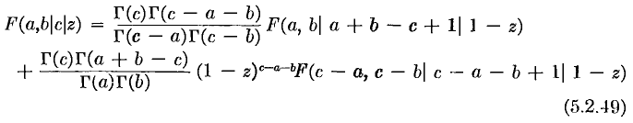
and this is then one of those Kummer relations seen on pages 107,8 of Bateman. MF are calling this analytic continuation because the original series F(a,b,c,z) does not converge in a region near z = 1, but the form shown here does, so we have found a way to "continue" the meaning of the function F(a,b,c,z) beyond its normal range. In this general manner I know we can continue it everywhere. MF call this relation a "joining relation".
Next, they derive this interesting fact:

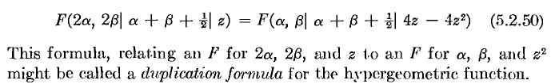

[ p 547 ] Gegenbauer Functions.

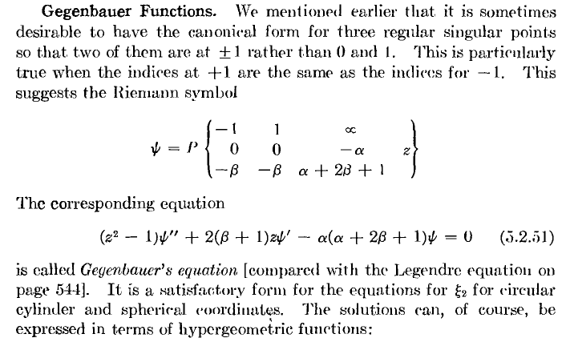

Before continuing, I would like to see what "the world" has to say about Gegenbauer stuff. I think the most basic idea is this:

(1 - 2hz + h2)-ν = Σn=0 Cnν(z) hn

(1 - 2hz + h2)-1/2 = Σn=0 Pn(z) hn

This type of formula is called a "generating function" . As MM say p 132, the generating function is a function of two variables such that, if you expand in a power series in one variable, the coefficients are a set of polynomials of interest. [ There are other math meanings of generating function.] So you see that the Gegenbauer polynomial is a generalization of the Legendre where the negative power is ν and not just 1/2. So obviously we have this connection

Pn(z) = Cn1/2(z)

so in some sense we are generalized "by one parameter". You can of course then think of ν and n as general complex numbers along with z, and then you have Gegenbauer functions. I think this is now the standard notation for Gegenbauer. Then we go to GR p 1031 and we see that the ODE does NOT agree with that used by MF, which is annoying.

(z2-1)ψ" + (2ν+1)zψ' - n(2ν+n)ψ = 0 solution Cnν(z)

So we have to say 2ν+1 = 2β + 2 and n(2ν+n) = α(α+2β+1)

ν = β+1/2 and α = n

The MF functions will be called Tαβ(z) [ their "Gegenbauer function" ] so we generally have

Tαβ(z) = constant(α,β) * Cαβ+1/2(z)

If we set β = 0, we get

Tα0(z) = constant(α,0) * Cα1/2(z) = 1 * Pα(z)

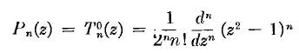
This fact is also interesting
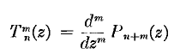 = tesseral polynomials

Notice that the "direction" of the Gegenbauer generalization is not that of the Pnm(z) associated Legendre functions. Yes, we have an extra parameter, but it is a different parameter.
The Gegenbauer polynomials are sometimes called ultraspherical polynomials.
If we consider Cnν(z) and set ν = 1 ( β = 1/2) , we are talking Cn1(z) and a peek at GR page 1033 shows that these functions must be the same as the "second kind Chebyshev polynomials" called Un(z).

Un(z) ~ Cn1(z) ~ Tn1/2(z) // see cases listed on GR p 1032.

Interestingly, this completely disagrees with MF who say on p 549,

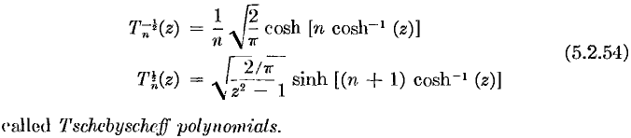

At least they certainly don't LOOK the same. For example, GR say U0(z) = 1. On the other hand, Maple tells us

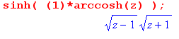

so perhaps they are the same. GR shows some forms that are similar to the above, but with trig and not hyperbolic functions. Let's let this strange subject lie. MF are just trying to pack in stuff they will use way later in their book. [ I don't see anyone else that does Gegenbauer functions the MF way. ]

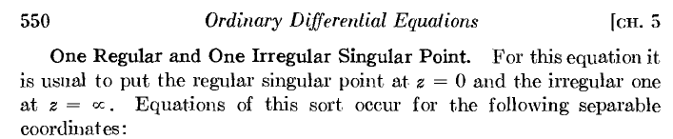

MF list off 4 examples they yield this kind of equation. One is the Bessel function in several coordinates, and another is the SE with a Coulomb potential in spherical coordinates. So these all seem to have a certain form, we MF look into this form:

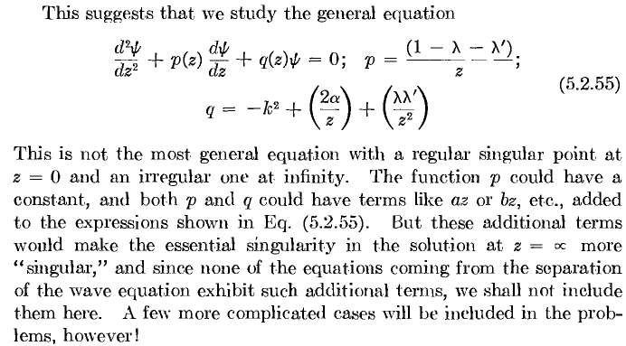

The first let ψ = zλf(z) . Next they go to z = 1/w. Next, they go to f = e-k/wF and then we have
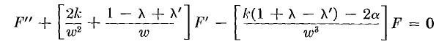
OK, this is just leading them to the confluent hypergeometric function stuff F(a|c|x). This seems a very strange and painful way to introduce the student to all these special functions! But the main point is that this CHG function falls into the class of one irregular (put at ∞) and one regular(put at 0) point. We are conflowing two of the HG's three regular points somehow, and this is creating an irregular point. I think I noted this earlier.

[ p 554] Here they look into a 1/z series expansion for the CHG function

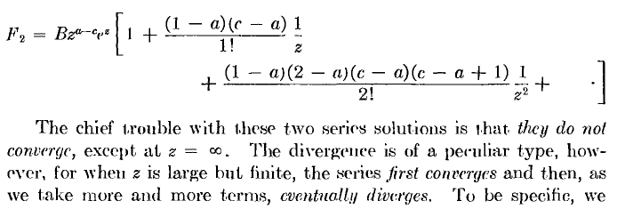

so they are taking this CHG example to introduce the (famous) subject of "asymptotic series" which I have run into before.

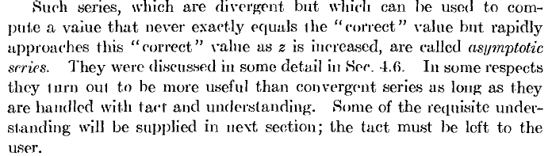

He claims this applies for ξ1 and ξ2 of both prolate and oblate spheroidal coordinates! In my notes, I thought that these things were Legendre P and Q function guys, one of imaginary coordinates. Maybe somehow the z = ∞ point is going to change from regular to irregular. But here MF claim we end up somehow with Mathieu's Functions! I am rapidly losing interest now because I feel we are just randomly doing things in this chapter. Mention of Floquet's Theorem of some sort, periodicity issues.

[ p 558] Next subject is "continued fractions". I am not interested.

[ p 560 ] The Hill Determinant. On and on, don't care.

[ p 562 ] Mathieu Functions.

OK, so Section 5.2 sort of dies with a whimper. I have no interest in Section 5.3 on integral representations of things right now. I know that special functions have integral representations and these help you "continue" things and all that stuff.

The end of this huge Chapter 5 contains two huge summary sections:

1) data for all the separable coordinate systems

2) review of the various classes of ODE solutions in terms of their singular points! That really was the main thrust of Section 5.2.

More MF Notes on Gegenbauer.

They introduce this T function above in Section 5.2

Tαβ(z) = constant(α,β) * Cαβ+1/2(z)

but they are going to say a lot more about it in Section 5.3, so let's right now wander into that section and see what they are saying about the T functions. We got to page 600 in Section 5.3. We have

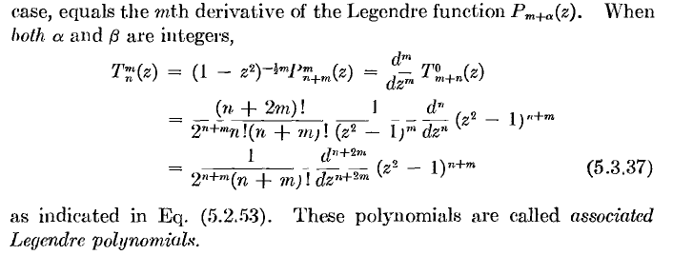

He calls these "associated Legendre" but I would call Pnm(z) associated Legendre, so MF are being confusing to the reader here. In any event, we see how T and P are related in this "both integers" case. If n = 0, the derivative is this [ he is assuming m ≥ 0, there is some phase rule for negative m ]

∂z2m (z2-1)m

Now (z2-1)m is a poly of order 2m, so this derivative will be a constant. So Tom(z) has no z dependence. But the above says

Pmm(z) = (1-z2)m/2T0m(z) = = sinmθ T0m(z) // one node at equator for z.

so Pmm has only the z=dependence shown. For any m, is something that is 0 at the poles and peaks at the equator. So for any value of m, this looks more or less the same.

Viewing Spherical Harmonics.

Here is a java deal that draws these things, I will clip some pix:

http://icgem.gfz-potsdam.de/ICGEM/potato/Tutorial.html

Well, all I really want is a few pictures, here we are:

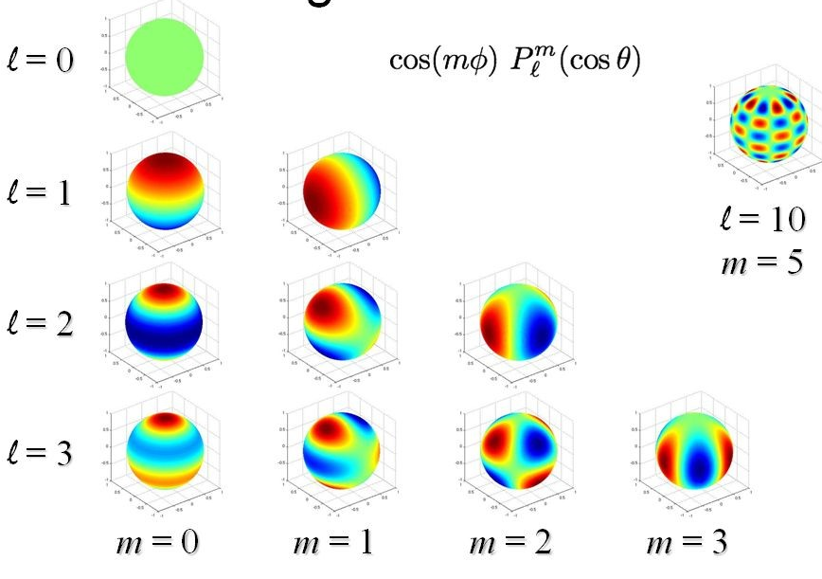

So now we see clearly why the m = 0 are called zonal, and why the m = l (also -l) are called sectorial, and why everything else is tesseral, for example,

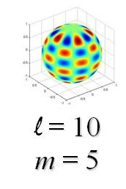

The zonal ones really are constant along a latitude line, whereas the sectorial are not really constant on a longitude line, but have the simple one node shape noted above.

So, perhaps this T function is better at showing this kind of stuff. Back to page 600 MF now.

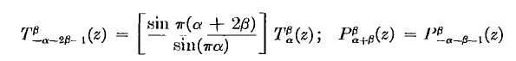

This I think shows the normalization of his functions:

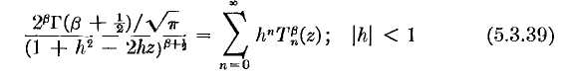

I don't see much more crucial T stuff in this general book section.

The next Gegenbauer cache of data is on page 782, a sort of summary section. The "density function" is the weight function that will show up in orthogonality below.

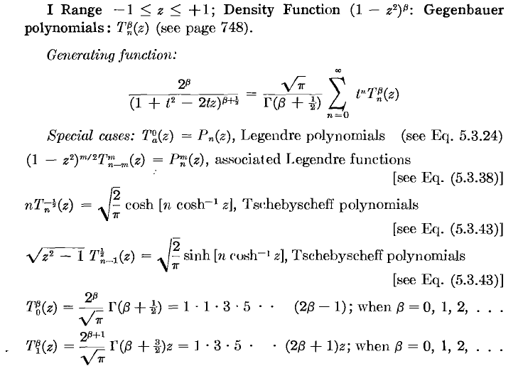

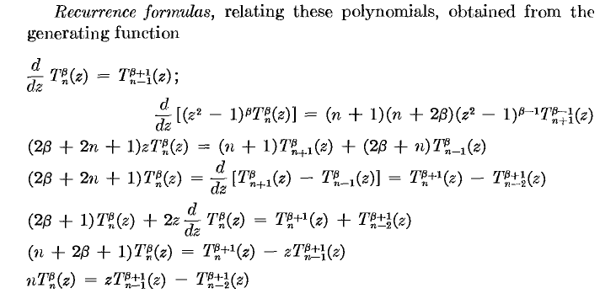

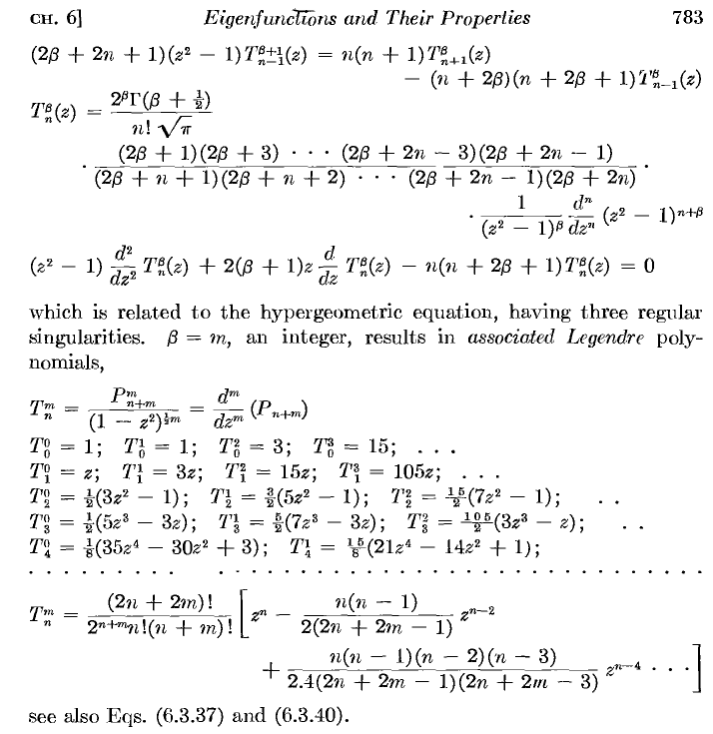

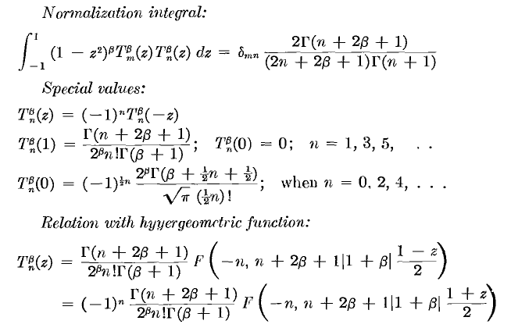

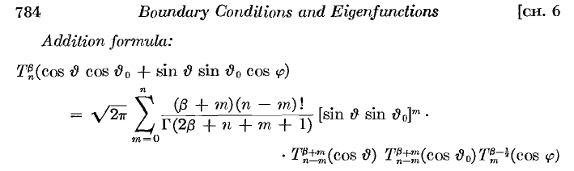
Good heavens! I wonder if anyone else deals with these functions in this manner and notation. AS mention a T thing in Legendre stuff, but not the same thing. GR nothing. Bateman nothing. This is really an alternative to "associated Legendre" notation.
I have been hunting for some other source that uses this T notation, and I found (amazingly) what seems to be the article that proposed it in 1935, and I saved it. It is by Stratton, also at MIT. Here is a quip

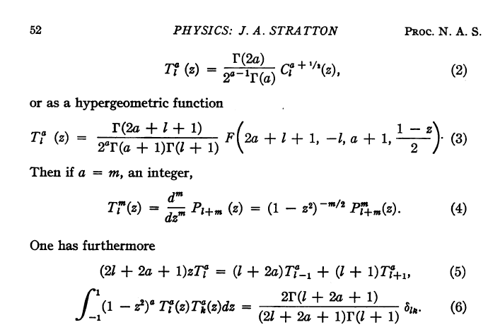

[ warning: l in the above is assumed to be a positive integer l = 1,2,3,.. When people talk about the C functions, they always have the lower index a positive integer or maybe 0. It is never a complex ν. ]

which finally directly shows the connection to the other notation. But he uses l and a instead of α and β, but OK. Stratton says he invented this notation because it makes a simple connection to the associated Legendres as shown above. By the way, the above article is from PNAS which is not a free journal, but if you poke around there are free PDF's. Stratton has another paper where he does a Q version of this T function, and he calls it T .
So OK, Morse was around MIT at this time and I think we can assume he has all the stuff right. It is a little local pool of usage, probably long forgotten now. We can just think of T as defined by (4) above.

