Differential Equations PhL 12.12.08
last update: 4.18.09

These notes are extremely disorganized, I am just accumulating and then refining information. We are talking about second order ODE's with general function coefficients. The issue of the differential operator L being self-adjoint never comes up in these notes which are strongly oriented to the Frobenius style series solutions.

My Problem with Stakgold: 1
Question: What is a regular point or a singular point of an ODE? 1
Examples: Bessel, Legendre, Hermite, Hypergeometric 2
Appendix A. 5
1. The Riemann sphere 5
2. A holomorphic function 5
3. A meromorphic function 5
4. Mobius transformation. 6
5. Frobenius Method 6
Clarification of the Frobenius Method from WW. (4/18/09). 7
Notes and clips from Special Functions By Z. X. Wang, D. R. Guo 9
1. What does Fuchsian Mean? 9
2. Index for first 2 chapters of Wang Guo 9
3. What is the significance of a point being ordinary, regular singular, or irregular singular ? 10
Here is another statement of the above theorem, with some other stuff. 13
Taylor Series, Maclaurin Series, definitions: 14
Regular solutions of an ODE. 15
Confluent defined 16
Euler Transform 16
What is the significance of a Wronskian and Abel's Theorem? 17

My Problem with Stakgold: Stakgold's Chapter 4 is about "differential equations", but only in a general sense where L is a general second-order differential operator and we want to learn about the spectrum of this operator under specific circumstances which include a certain range on the real axis, and a specified norm, usually the L2 norm of square-integrable functions. His second volume then discusses the main partial differential equations of physics. His book just does not really address the ordinary differential equations of physics (1 variable) which lead to the so-called Special Functions. You don't really learn about singular and regular points, Frobenius is not even mentioned, etc etc.
When I am wondering about ODE's, Stakgold is the only book I own that really has differential equations as its topic, but it never has the information I want, so I should stop opening it! It is all about Hilbert Space and formal theorems, although they are at least readable, to his credit.
The Bateman books have more information on ODE's for special functions, but they are not teaching you the basics, such as what is the Frobenius method, or what are branch cuts, etc. My "library" needs a good book on this stuff, but I don't know what the title would be. "Modern Analysis" ? " Differential Equations for Dummies" ? Maybe Whittaker and Watson is what I am missing, some book like that. Dover has lots of no-name books but not this one. // Just ordered Whittaker and Watson at $22.50!

Question: What is a regular point or a singular point of an ODE?

Wiki:

"In mathematics, in the theory of ordinary differential equations in the complex plane C, the points of C are classified into ordinary points, at which the equation's coefficients are analytic functions, and singular points, at which some coefficient has a singularity. Then amongst singular points, an important distinction is made between a regular singular point, where the growth of solutions is bounded (in any small sector) by an algebraic function, and an irregular singular point, where the full solution set requires functions with higher growth rates. This distinction occurs, for example, between the hypergeometric equation, with three regular singular points, and the Bessel equation which is in a sense a limiting case, but where the analytic properties are substantially different."

So, one of these "points" relates to the coefficient functions in your ODE, not to some abstract general thing about the equation overall, though that is likely also true.

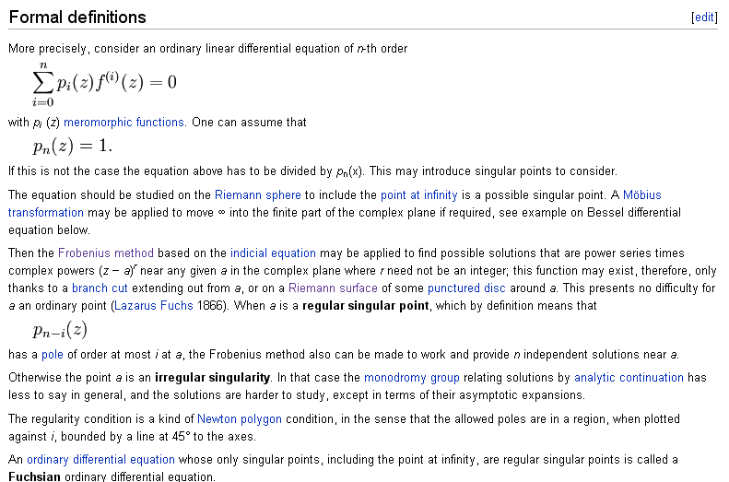

There are lots of words here I am not familiar with. I will dispense with them in Appendix A, so we can not loose track of the main thread here.
So, for an nth order ODE with various weird coefficient functions, if you can do Frobenius, you will get an nth degree polynomial in r for your indicial polynomial and that means in general that there will be n distinct solutions. For our normal ODE with n=2, there are normally 2 solutions for this reason. An example I think would be spherical Bessels where you get j and n functions with different "r".

Examples: Bessel, Legendre, Hermite, Hypergeometric

Now consider second order only:

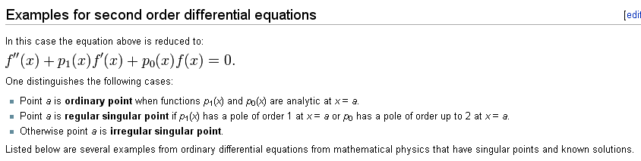
Remember that you have to first divide through by anything that might multiply f"(x). Then if the two functions are analytic at a point x, point x is an "ordinary point" for this ODE. If there are poles at some point x that are not too bad (it says first order max in p1 or second order max in p2) then the point x is singular, but it is regular singular. If the poles are higher order than this, or if there is a branch cut at x or what have you, then point x is irregular singular. I presume you only care about points in general that are in the range over which you work with your ODE (but maybe you do still care).
Wiki then provides some down to earth examples:

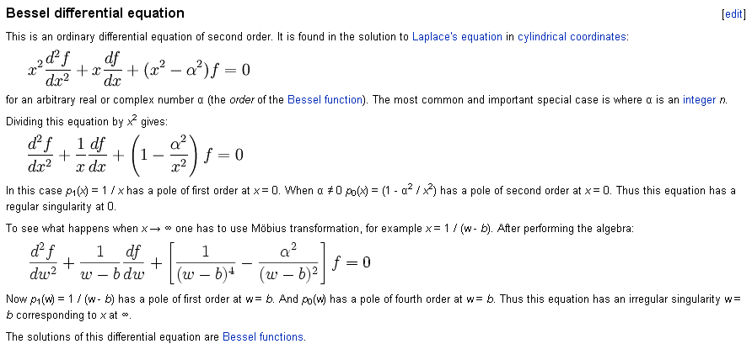

Yes, you see that x=0 is just "regular singular". It is not obvious to me that x=∞ has the fourth order pole when you Mobius it, but once you know it has that, you know that x = ∞ is "irregular singular"

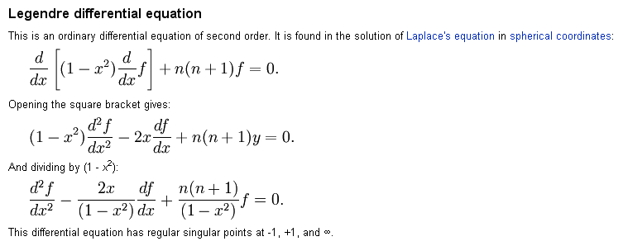
Here you see there are only single poles in both functions, so x= 1 and x = -1 are regular singular points. Not obvious to me that x=∞ is also regular. [ For x= ∞, see the WW test in meta notes. ]

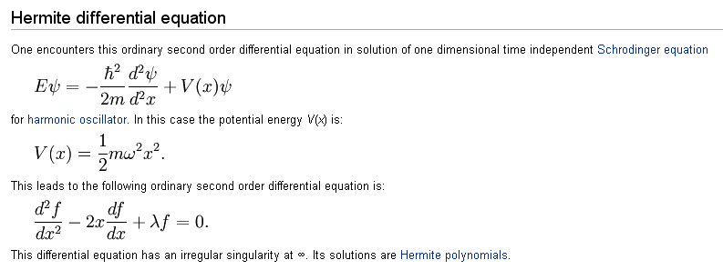

For the HO as shown, x=0 is just an ordinary point. We have p(x) = -2x which is analytic at z = 0, and we have q(x) = λ which is analytic as well. They claim irregular at x=∞ . [ See WW test.]
As outlined below, at an ordinary point I expect the indicial exponents to be r = 0 and r = 1. Is this correct? Well here is what http://mathworld.wolfram.com/HermiteDifferentialEquation.html has to say:

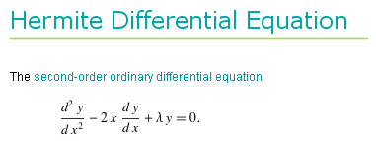\

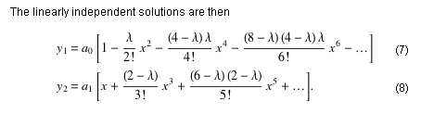
So there you are! The y1 solution is r = 0 (and odd powers are missing), the y1 solution has r = 1 since you could factor out an x. You can see that if λ = even integer, both types of solutions will truncate. In this case, y1 and y2 are providing the even and odd Hermite Polynomials.

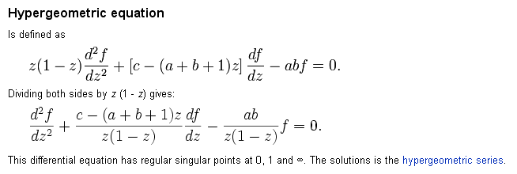
You see that z=0 and z=1 have single poles so we are regular singular at both these points. I guess if you try the Frobenius method here, your indicial equation will give r=0 as one solution, which would then apply for the usual HG series.

Appendix A.

1. The Riemann sphere is a way of extending the plane of complex numbers with one additional point at infinity, in a way that makes expressions such as

1 / 0 = ∞

well-behaved and useful, at least in certain contexts. It is named after 19th century mathematician Bernhard Riemann. In the picture below, the x-y plane is the complex plane C, and point A on it maps to a point α on the sphere. The entire boundary of C at ∞ them maps to the north pole.

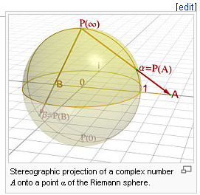

2. A holomorphic function is one (in a region D of the complex plane) which is fully "complex-differentiable" at all points in the region, meaning you can differentiate as many times as you want, which in turn implies that you can make a Taylor series at each point.
"Holomorphic functions are sometimes called regular functions.[1] A function that is holomorphic on the whole complex plane is called an entire function. The phrase "holomorphic at a point z" means not just differentiable at z, but differentiable everywhere within some open disk centered at z in the complex plane."
"The term analytic function is often used interchangeably with holomorphic function, although the term analytic is also used in a broader sense of any function (real, complex, or of more general type) that is equal to its Taylor series in a neighborhood of each point in its domain. The fact that the class of analytic functions coincides with the class of holomorphic functions is a major theorem in complex analysis."

I have always used the term analytic. Their point is that sometimes this just means Taylor-series-able at every point, while holomorphic seems to be a slightly stronger term meaning infinitely differentiable and I think then that holomorphic would imply analytic when this sense of "analytic" is used. So we might say that holomorphic => analytic. With the other meaning of analytic, you have holomorphic = analytic.

3. A meromorphic function is one that is holomorphic except at points where it has simple poles. An example is the gamma function

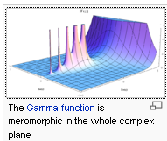

Thus, a function that has branch points is not meromorphic in the entire complex plane.

4. Mobius transformation. See example below, just a transform from z to w such that z=∞ is mapped into some w = b where you can think about it. For example, z = 1/(w-b).

5. Frobenius Method. [ see clarification below ] This is the name of the method that Schiff used many times in his book. You try to find a power series solution of the form f(x) = xr Σ0,1,2 anxn . When you plug this into an ODE, you get an indicial equation for r which you solve for the values of r that make such a solution work. Here is what the math looks like in a nutshell:

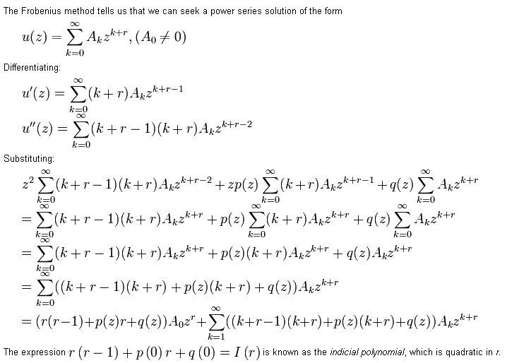

where he has separated out the Ao term as shown and we know A0≠ 0. Since we are near z ≈ 0, we set z=0 in the coefficient functions like p(z). If there are two different r values, there are normally two different solutions to the ODE, which, by the way, is this for the above work

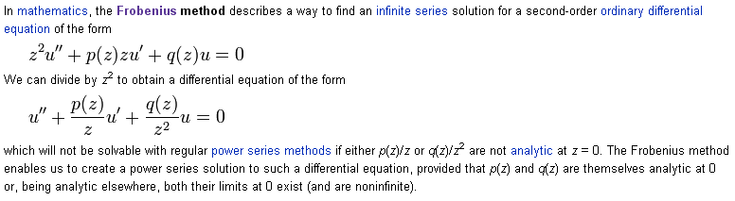

You can see there are conditions of p(z) and q(z) which make this possible or impossible.

Clarification of the Frobenius Method from WW. (4/18/09).

(1) The assumed starting form for the ODE is this:

[z2D2 + z P(z) D + Q(z) ] u(z) = 0 u(z) = Σk=0∞ Ak zr+k

First of all, this is a homo equation Lu=0. Second, different people use different starting forms for different purposes, and the above form is right for the Frobenius purpose. Our wiki author includes a coefficient A0≠ 0 in the series, but W&W just set it to A0 = 1 since we can always scale the solution in that manner. I will retain A0 since it makes things look more regular below.

(2) Whittaker and Watson say the right words on page 191-192 that the above author does not provide. First of all, in the above we need to assume that z=0 is a "clean point" so that P(z) and Q(z) are analytic at z = 0 and may therefore be expanded in power series at z = 0. We then install the assumed form of the solution as shown above. However, we then need to expand both Q(z) and P(z) as power series with coefficients Qi and Pi. When this is done, if you start with the lowest power and work upward, you get a list of equations. Here, according to W&W page 192, are the first several, where I translate into the notation above: ( α = r, c=0, ai =Ai) [ I write A0 but will treat it as Ao = 1 as do W&W ]

0 zr: A0[ r2 + (P0-1)r + Q0] = 0 // or r(r-1) + P0r + Q0 = 0
1 zr+1: A1[ (r+1)2 + (P0-1)(r+1) + Q0] + A0 [ rP1 + Q1] = 0
2 zr+2: A2[ (r+2)2 + (P0-1)(r+2) + Q0] + A1 [ (r+1)P1 + Q1] + A0 [ rP2 + Q2] = 0
....

Each of the above expressions is the coefficient of a power of z, and I have labeled each equation by a number which is (the exponent of z) less r. The coefficient in equation 0 is the indicial equation, and this equation MUST be satisfied or we are dead meat with our solution, so this determines two possible values for r. The coefficient of equation 1 involves only A1 so we can solve that equation for A1. Then knowing A1 we can solve equation 2 for A2 , and on and on. The nth equation will involve An, An-1....A2,A1

(3) The conclusion is this: if we ignore issues like series convergence, we have in general two complete formal solutions to our ODE of the quite general form shown above. There are always two solutions, each corresponding to one of the values of r, which we can call r1 and r2 . Obviously the Ai are different for the two different solutions, call them eg Ai(1). We have assumed that P(z) and Q(z) are analytic at z = 0.
As we shall see later, saying that P and Q are analytic at z=0 is saying that either z = 0 is an ordinary point (P has a zero and Q has double zero at z=0) or z= 0 is a regular singular point (P and Q analytic).

(4) The entire analysis above could be repeated replacing z → (z-c) as done by W&W. In that case, we would be assuming that P and Q were analytic at z = c and we would expand them around that point, and our solution would be around that point.

(5) What happens if r1 = r2 ≡ r? The two series solutions are then identical, so there must be some other independent solution. This is given in equation p 195 A where notice the h sum starts at n=1. In this case we have

w1(z) = zr [ 1 + Σn=1∞ Anzn]

w2(z) = zr [Σn=1∞ hnzn ] + w1(z) ln(z)

where we are not given a rule for computing the hn, we just know they exist. You must include the series part of the second solution for w2 to actually solve the ODE; the term w1(z) ln(z) alone, although independent from w1(z), would not be a solution of the ODE.

(6) What happens if r1 = r2 + s with s = positive integer ? In this case the solutions are p 195 B:

w1(z) = zr1 [ 1 + Σn=1∞ Anzn]

w2(z) = zr2 [ - 1/s + Σn=1∞ hnzn ] + gs w1(z) ln(z)

where r2 is the "smaller" exponent. The constant gs depends in a complicated way on both P and Q and so is really a function of the ODE itself. It is the coefficient of the power zs in a function g(z) shown on page 194 which you see is a messy combination of an exponentiated integral of P(z) and w1(z).
The main point about gs is that for some ODE's it might vanish. If that happens, there is no ln(z) term, and the second solution is just the power series part. I would guess that in this case, the hn would be obtained from the ladder of equations just as the An are, as shown above, just a different value of r. Probably in the gs ≠ 0 case, the ladder causes some An(2) = ∞ and that is why we have the ln(z) thing.
Here is an "alternate form" for the w2 solution where we just multiply through by constant -s,

w2(z) = zr2 [ 1 + Σn=1∞ (-shn)zn ] +(-sgs) w1(z) ln(z)

The nice feature here is that the n=0 term in the series part is 1, just as in the w1(z) series. And of course the issue of gs = 0 is unaltered.

Notes and clips from Special Functions By Z. X. Wang, D. R. Guo

1. What does Fuchsian Mean?

The following is from google book Special Functions By Z. X. Wang, D. R. Guo

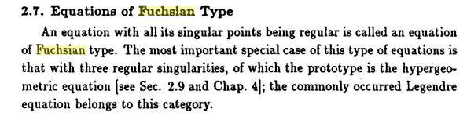

The first two chapters of this book are pedagogical , remaining chapters are specific to special functions. It is these "teaching chapters" that are missing from the Bateman and A&S books!

2. Index for first 2 chapters of Wang Guo

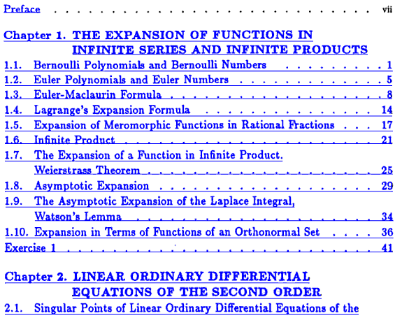
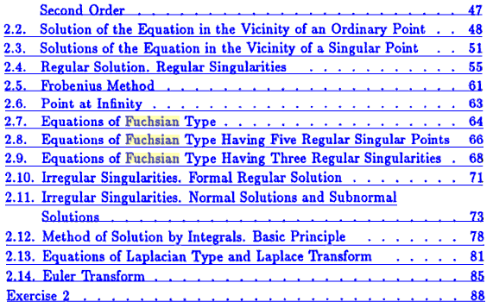

3. What is the significance of a point being ordinary, regular singular, or irregular singular ?

In the wiki notes above, we saw the definition of the three kinds of points, and examples, but nothing was said about why we should care. So I have scanned to find some of the basic facts:

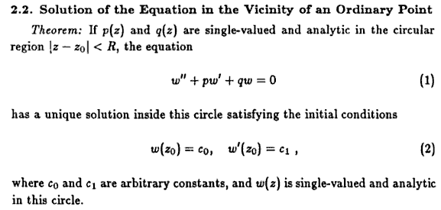

[ The above is proved at the start of W&W Chapter 10 ]

So this is my idea that away from any singular points of any kind, a solution will be smooth. If you apply some BC's as shown, this solution is unique.

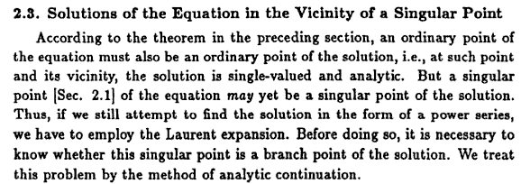

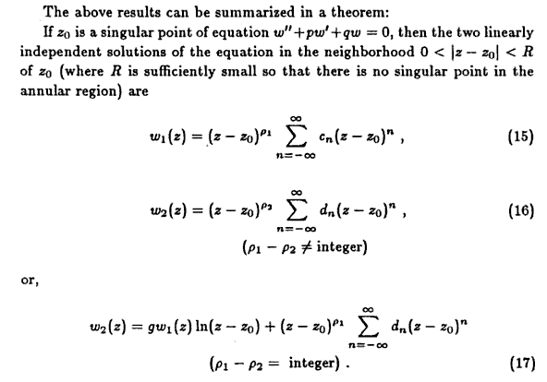

Comment: (1) Notice that all sums are -∞ to +∞ in the above results. WW above gave us more specific results. (2) For infinite sums, it does not matter which exponent you put as the power in (17), since they differ by a shift of the series. (3) The special case that g = 0 is not mentioned, but g is sitting there.

Comment on Significance of ordinary, regular singular, and irregular singular.

The classification into these three bins depends on the nature of the P(z) and Q(z) functions. The indicial polynomial says [ r2 + (P0-1)r + Q0] = 0. Whether the two roots are the same or not depends on the constant value in the series for P and Q. If z = 0 is an "ordinary point", we know that P has a zero and Q has a double zero at z = 0. This means that P0 = 0 and Q0 = Q1 = 0. In this case, our indicial equation becomes simply r2 - r = 0 = r(r-1), so the roots are r=0 and r=1. I suspect that in this case, g1 = 0. The two solutions are then just power series

w1(z) = z1 [ 1 + Σn=1∞ A(1)nzn]
w2(z) = z0 [ 1 + Σn=1∞ A(2)nzn]

Each solution is analytic in a disc about z = 0. So that is the main idea of an "ordinary point".
If on the other hand z = 0 is a regular singular point, then our various forms of "the theorem" apply, and we can have different cases of r1 and r2 and we get some cases which have a ln(z) as part of the solution. In these cases, apart from the ln(z) branch point, things are smooth near z = 0.
If z = 0 is an irregular singular point, then somehow all bets are off. Our "theorem" does not apply, things are not analytic, we don't have a general form for the solution. That is my guess.

Note Added: I think there are exceptions to the above theorem (g=0)

One exception is for spherical Bessel functions. The "indices" for the spherical Bessel ODE (I think) are l and -l-1 ,and they differ by an integer assuming l = integer, BUT the second solution is of the first form shown above for w2 and does not require the logarithm! [ Well, this is the g=0 case.] I quote from Sadri Hassani p 428 Google book:

http://books.google.com/books?id=BCMLOp6DyFIC

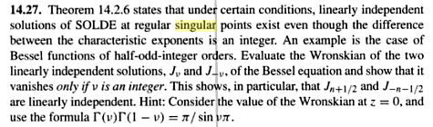

Here is the theorem that the above refers to from page 409 of the same book

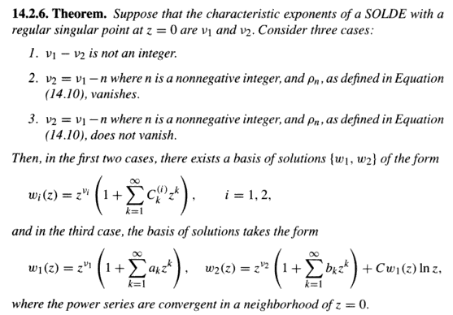

The spherical Bessel functions must be in Case 2 above, and that is why j and n are independent solutions without a log deal.

Comments : (1) What does Hassini then say for n=0? He seems to say it could be either case 2 or 3 depending on his ρn which is WW -sgs. But we know from WW that it is in fact case 3 and the ln(z) term is present. (2) If n > 0, we know from WW that we can get case 2 or 3 and I agree with the forms written for case 3. His form suggests that in case 2, the coefficients are just obtained from ladder equations.

Here is another statement of the above theorem, with some other stuff.

www4.ncsu.edu/~lkn/MA401/handouts/SummaryOfFrobeniusMethod.pdf

One issue might be what form you assume for your original ODE. Notice that the form here differs a little from the WW form which is z2D2 + zP(z) D + Q(z). If we divide through we get WW saying D2 + (P(z)/z) D + (Q(z)/z2). Then p(z) = (P(z)/z) and q(z) = (Q(z)/z2) below. I guess as long as you examine things near but away from z=0, this division makes no difference. Here is the first quote of this new author:

So this means that at an ordinary point, both P(z)/z must be analytic, and Q(z)/z2 must be analytic. This really means that in this case, P(z) must have a zero at z=0 and Q(z) must have a double zero there. A less stringent condition on P(z) and Q(z) would be that they be analytic at z=0, not both having the required zeros. In this case, the point z=0 is a regular singular point. In all other cases of P(z) and Q(z) at z=0, the point z=0 is an irregular singular point. (Again, P = zp and Q = z2q)

Now here then is this author's offering on the nature of the two independent Frobenius solutions. He is allowing that z=0 is a regular singular point, but I think his theorem would also apply to the softer situation where z = 0 was an ordinary point. His basis is then that the WW functions P and Q are merely analytic at z = 0. He takes r1 to be the larger root.

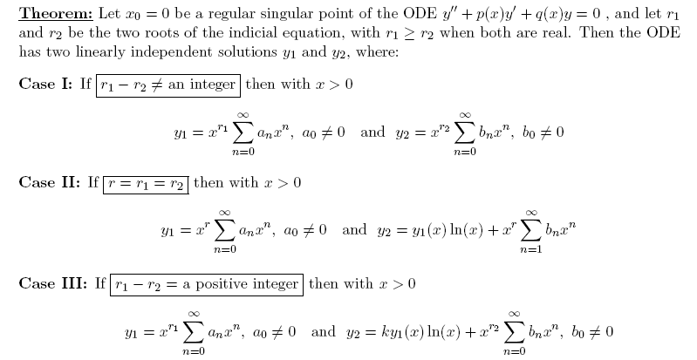

This author breaks out the case r1 = r2 and the sum there starts at n=1 which agrees with WW. In the third case where the difference is a positive integer, then the sum starts at n = 0 which also agrees with WW. We could take b0 = -1/s or 1 as we like, just scaling the whole result.

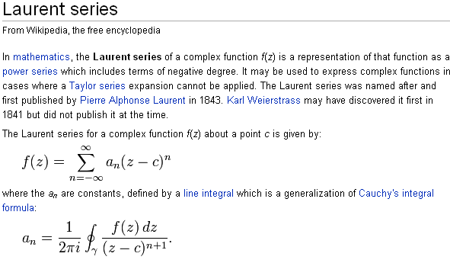

Taylor Series, Maclaurin Series, definitions:

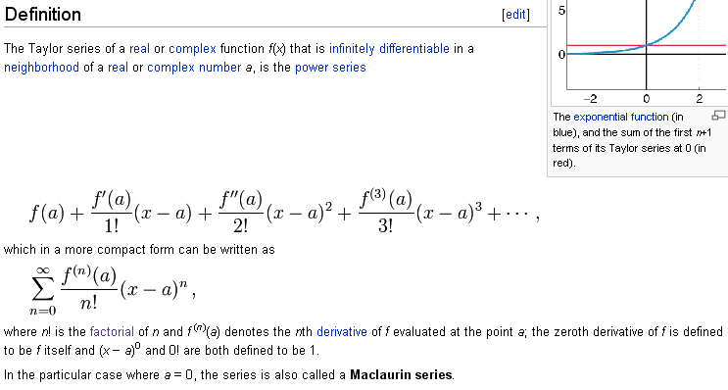

Regular solutions of an ODE.

Here is a discussion of the notion of a "regular solution" to an ODE.

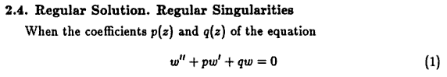

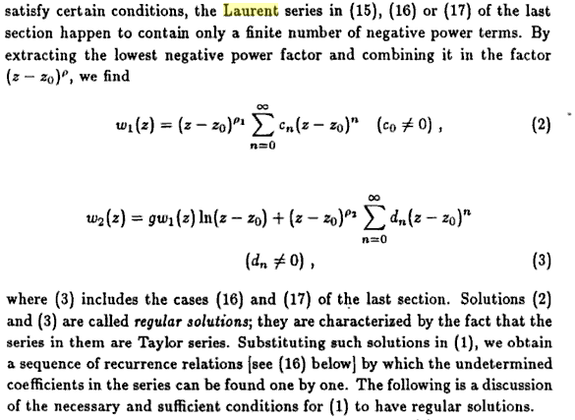

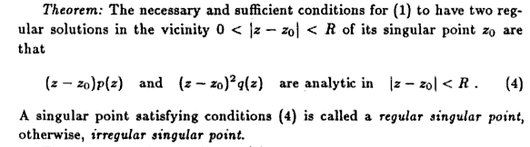

They go on to prove this. So there is the answer. If a singular point zo is "regular", then your ODE will have two solutions in a disk around this singularity. So I suspect that an irregular singular point "may not" have two solutions in such a disk. [ except the ln(z-z0) does have a well defined branch point at z =z0 ]

Confluent defined (just in passing)

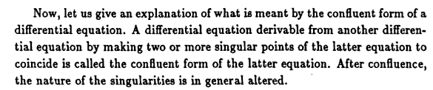

Euler Transform

This is an alternative to the Laplace Method, and allows the first coefficient function to be a quadratic. Laplace requires them all to be linear.

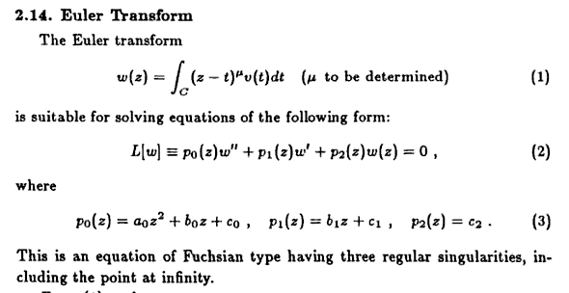

So there are a few comments from these two energetic guys.

I just found that Whittaker and Watson is available new for $23 on Amazon. // And I just ordered it along with the Iliad at 3.50 for total 26.00 to make free shipping. Finally I will have this book which I have been reading about for many years.

What is the significance of a Wronskian and Abel's Theorem?

Look at Stakgold I page 59. If a set of n functions are linearly dependent, then 1.44 is true for some ci that are not all zero. This means you can express one of the functions as a lincomb of some others. Now, differentiate this equation to get a second equation that looks the same, then keep doing that. You get

c1 f1 + c2 f2 + c3f3 = 0 // 1.44
c1 f1' + c2 f2' + c3f3' = 0
c1 f1" + c2 f2" + c3f3" = 0

Write this in matrix form as

$\left(\begin{matrix}c1 & c2 & c3 \\ c1 & c2 & c3 \\ c1 & c2 & c3\end{matrix}\right)$$\left(\begin{matrix}f1 & f1' & f1" \\ f2 & f2' & f2" \\ f3 & f3' & f3"\end{matrix}\right)$ = 0 or CW = 0

If the Wronskian matrix shown here is invertible (at some position x), we can compute W-1 and conclude that C = 0 W-1 = 0, which says that the three ci are zero, which contradicts our assumption that you could write the first equation above for some ci not all zero. Thus we conclude that

fi are linearly dependent => can write matrix equation for some ci≠ 0
=> if detW ≠ 0 then C = 0 = contradiction, so must have detW = 0

So we find

fi are linearly dependent => detW = 0 for all x in your "interval" theorem
detW ≠ 0 => fi are linearly independent contrapositive

Stakgold notes the converse is not necessarily true and gives the example f1 = x2 and f2 = x|x| on -1,1. These are linearly independent, but W = 0. Here are some web comments:

The Wronskian can be used to determine whether a set of differentiable functions is linearly independent on a given interval:
- If the Wronskian is non-zero at some point in an interval, then the associated functions are linearly independent on the interval.
This is useful in many situations. For example, if we wish to verify that two solutions of a second-order differential equation are independent, we may use the Wronskian. Note that if the Wronskian is zero everywhere in the interval, the functions may or may not be linearly independent. A common misconception is that W = 0 everywhere implies linear dependence; the third example below shows that this is not true.

Now here is an interesting theorem

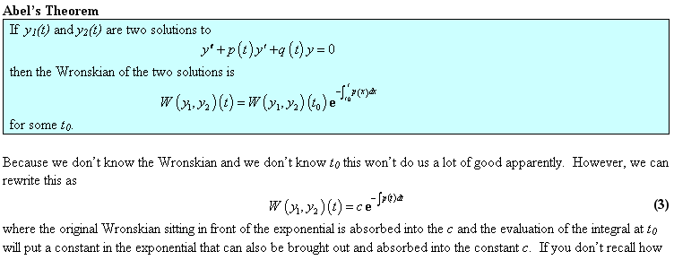

If you have an ODE with no linear term, then this says the Wronskian will be a constant ! The Coulomb Wave Function ODE of AS page 538 is a good example, and 14.2.4 then shows W = constant.

