Helmholtz equation plots PhL 7.2.14

Motivation: In lines doc I get some transverse Helm equations and wonder what their solutions look like

1. 1D equation with f(+1) = 1 and f(-1) = -1

(∂x2 + k2)f(x) = 0

f(x) = Asin(kx)+Bcos(kx)

Suppose we insist on these boundary conditions

f(+1) = 1
f(-1) = -1

Then

Asin(k)+Bcos(k) = 1
-Asin(k)+Bcos(k) = -1

Add and subtract to get

2Bcos(k) = 0
2Asin(k) = 2 => A = 1/sin(k) B = 0

Solution is then

f(x; k) = sin(kx)/sin(k)

(a) Plots for real values of k.

Obviously f(x; -k) = f(x; k) so we need only consider positive k values.

If you plot this for various real values of k, you get a simple sinusoid which manages to match the boundary conditions specified at each end. Here are some of the solutions:

k=1 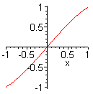 // k = 0 just gives a straight line

k=2.34 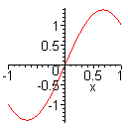

k = 6.3 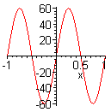

(b) Plots for imaginary values of k.

k=i 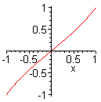

k = 2.34i 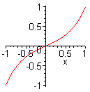

k = 6.3i 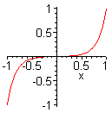

For larger k values, you get an increased "skin effect" where the solutions sucks up against the endpoints.

k := 20*I; 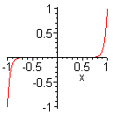

How explain this behavior? If we write k = a+ib and only k = ib, we get

f(x; k) = sinh(bx)/sinh(b)

= $\frac{ebx- e-bx}{eb- e-b}$

If you are not near an endpoint and b is large, then the bottom one wins over the top and forces the result to be very small! For example

sinh(100*.9)/ sinh(100*1.0) = sh(90)/sh(100) = e90/e100 = e-10 = very small.

This then is the mechanism that allows the function to explode out to a finite value only near the endpoints.

(c) Plots for complex values of k

Let's start out in the first quadrant for k, and now we have to plot real and imag parts:

k := (1+2.3*I); 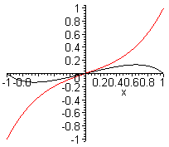

k := 2*(1+2.3*I); 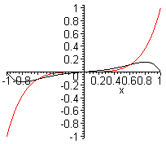

k := 4*(1+2.3*I); 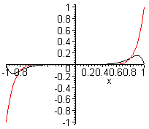

k := 8*(1+2.3*I); 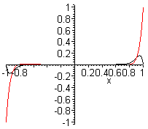

Now let k = a + ib so

f(x) = Asin(kx)+Bcos(kx) k = a+ib

Then Maple tells us that f(x) is equal to

Both Re and Im parts are exponential in nature! Now look at our actual function of interest

f(x; k) = sin(kx)/sin(k)

Here are the Re and Im parts of this function:

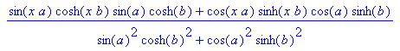

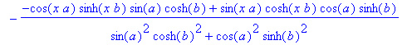

and it is easy to see how the BC's are met. You can see in Re that both terms are positive regardless of the sign of a and b.

Both the Re and Im parts exhibit the same mechanism described above. Each part is forced to be tiny until you get near the end, then there they do what they have to do to meet the BC's.

Fact 0: This is the skin effect in 1D, and would apply to a parallel plate capacitor. The E field gets strong near the plates, driving up surface charge n, driving up capacitance C. ,

Fact 1: if you complex conjugate k, you change the sign of b, and this just changes the sign of the Im curve.

k := 8*(1-2.3*I); 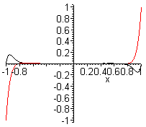

Fact 2: if you negate just the real part, it is like doing k→-k and then negating the Im part. But k→-k does nothing, so result is the same as Fact 1 and you get the same curve.

Thus, things in each of the four quadrants of k are very similar. Quadrant 1 is the same as 3, 2 the same as 4 since simple negation of k, and then you get the sign of Im rule for each pair of quadrants.

Fact 3: The only way you can ever get a sinusoidal type behavior is if k has a very small Im part. In general all solutions are of the skin effect type shown above.

Conjecture: I think all the above observations extend to the 2D Helm equation as you would expect.

Recall that Maple cannot do a numerical solution to a PDE, so I cannot quickly get simple plots of things in the 2D case, but I think I understand now the nature of the results by having looked at the 1D case.

Question Added Later. Think of the above as describing a 1D capacitor, and think of f = φ, the potential. We know that E = -∂xφ and then the voltage V = φ(1)- φ(-1) which is 1 - (-1) = V, so for all the cases above we have V = 2. The question is this: does the capacitance increase as the skin effect increases? The surface charge is something like n = -(∂xφ)x=1 so it certainly seems that this is increasing! Consider:

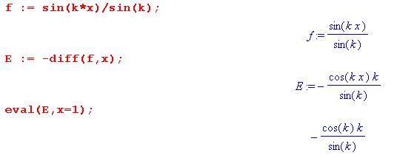

So I would say that n = -kcot(k), so then the constant surface charge is a strong function of k in the Helm equation. Then we would have Q = CV and Q is now a function of k, V = 2, so C varies with k !! I guess this is really to be expected.

Fact: Capacitance for a Helmholtz capacitor is a function of k.

Another example:

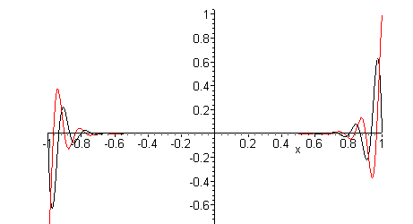

This one happens if k is mostly real, but still has an imaginary part. The Im part determines the skin effect distance, while the Re part controls oscillation.

Side Question: I often say that in Cartesian 2D Laplace, the sum of the curvatures is zero. In Helmholtz above, the sum is instead some complex number instead of 0. The question is this: for a point charge in the 2D Laplace world, we know that φ(r) = (1/2π) ln(1/r) = -(1/2π) ln(r). Here is a plot of this function in x,y space, where f(x,y) = - ln($\sqrt{x2+y2}$)

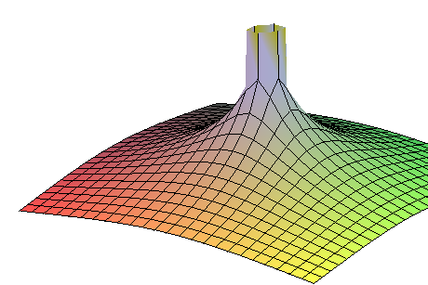

The grid lines are aligned with the x and y axes. Thus you can see clearly two facts:

(1) the grid lines cup up in the local radial direction
(2) the grid lines cup down in the local azimuthal direction

These curvatures are exactly equal and opposite because this is a 2D Laplace solution.

We can calculate this quite easily

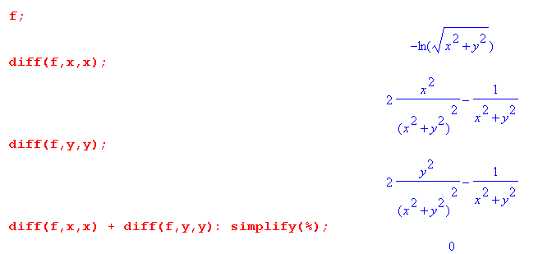

Implication for my 2D transverse equations:

[ ∇t2 + (βd2-k2)] φt(x,y) = 0 φt(C1) = K1 φt(C2) = K2 K1- K2 = K (5.3.10)

If (βd2-k2) = 0, then the solution here is going to be the conventional Laplace "rubber sheet" solution which meets the two boundary conditions. For cylindrical conductors, it is pretty easy to imagine what this looks like, but I don't have an easy way to plot this because Maple cannot do numerical work with a PDE, only an ODE. I would have to pay money for something that would numerically solve this problem. Actually I just found FreeFem++ which is freeware that I think could do it, but it has a whole world to learn before you can use it. Back burner.

Now, suppose (βd2-k2) ≠ 0. If (βd2-k2) has a significant imaginary part (either sign), then I know that the solution is going to be similar to the Laplace solution, but the rubber sheet is going to suck down tighter to the boundaries in proportion to the size of that imaginary part.

I have jumped the gun here, so go back:

1. The 2D Helmholtz equation

Now I don't have such a simple boundary condition situation. What should I use to get a simple example going? I think polar coordinates is best and perhaps we have boundary conditions asserted on circles. If we look at Moon and Spencer, Helmholtz and cylindrical coordinates, what do we see? The subject arises on page 16 where we can look at z-independent solutions to the Helm equation. The atoms shown there are these

{ e±jmθ , Jm(kr) }

for full azimuth problems. I guess this is not a surprise to me. If you exclude r= 0 then you can have the Y functions as well. If you want symmetric solutions, then m = 0. Here k2 is the Helm parameter. So here is the most general azisym solution

f(r) = a J0(kr) + bY0(kr)

Then my boundary conditions are

f(1) = 1
f(2) = -1

Maple quickly tells me the values of a and b:

Here then are some plots of f(r) for various k values:
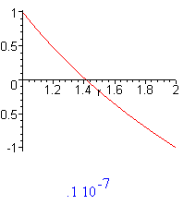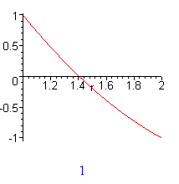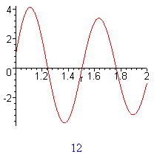

These show default very smooth solution at k = 0 on the left, similar at k = 1, oscillates at k = 12.
We then start adding in some imaginary part:

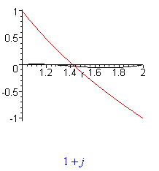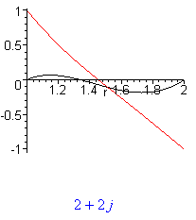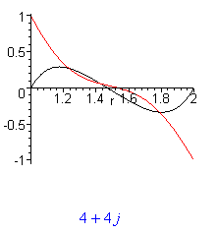
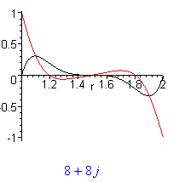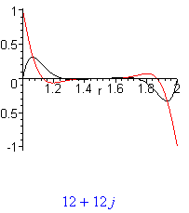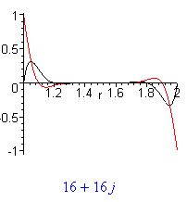

Here you see the same idea as we say in 1D: The solution curves "suck in" towards the boundaries. The solution becomes 0 away from boundaries. So my conjecture was correct. Think of the above as slices of a surface of revolution, and you see how the Laplace rubber sheet is distorting. In terms of electric field which for these pictures would be -E = gradφ = ∂r(r∂rφ) I think, you can see that the field will be much stronger near the boundaries. Think of this as the potential and E field in a coax cable!

Does the distortion affect capacitance? Q = CV.

